

**Application Development for Mobile Device  
Coursework and Logbook**

|  |  |
| --- | --- |
| **No** | Team Member |
| 1 | Full name: Nguyen Thanh Hai  Student UoG: 000865530 |

1. **Logbook 1**Logbook 1 requirements:

|  |  |
| --- | --- |
| 1.1 Student Name |  |
| 1.2 Who did you work with? Note that for logbook exercises you are allowed to work with one other person as long as you give their name and login id  and both contribute to the work. | **Name: Nguyen Thanh Hai Login Id :**  I just did it individually, so that I’m not work with another person. |
| 1.3 Which exercise is this ? | Create a phonegap app data entry screen.  Try to create confirmation dialog and notice user to ring a bell and vibrate your phone. |
| 1.4 How did u complete the exercise? Tick as appropriate ? | I did it but I think I should have done better. |
| 1.5 Briefly explain your answer to question 1.4 | Because when I got the requirement. Maybe I can do it better. With the good UI, and good responsive for this website. |

Some UI Interface:  
 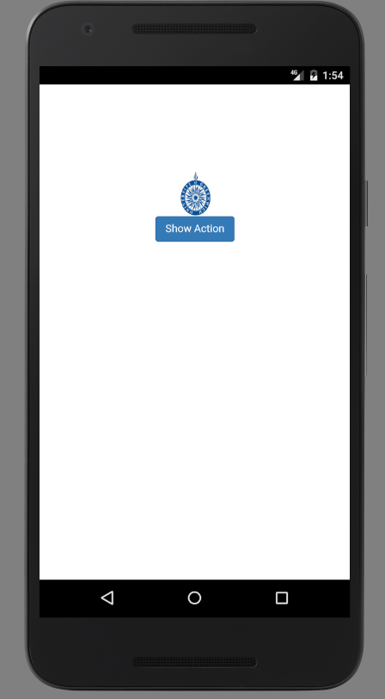  
 Click the show action button, and the dialog will be display.  
 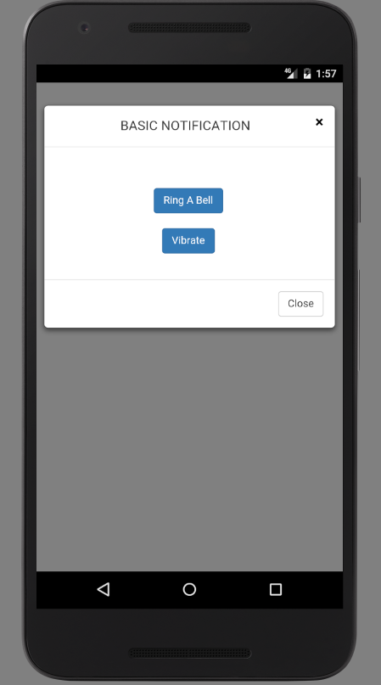  
 Click the button “Ring a bell “, phone will play a ringtone or bell.  
 Click the button “Vibrate a phone”, phone will be vibrated.  
 Code Sample:  
 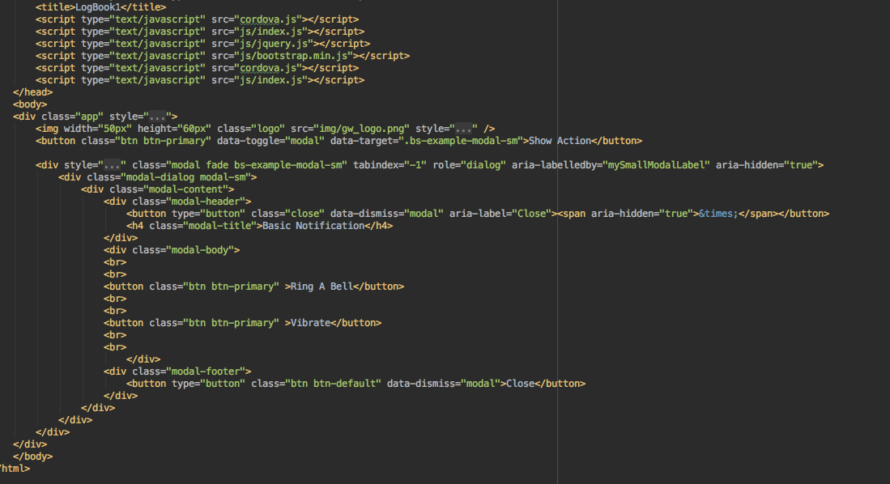  
 This code will display modal, and display two buttons.  
  
 Usecase:  
 logbook1.png

|  |  |
| --- | --- |
| Name | Action in Logbook 1 |
| Actor | User |
| Goal | Logbook 1 |
| Scenario | 1- Show dialog + When click the “Show Action” button. The dialog will be show.  2- Play ringtone + When click the “Ring a bell “ button. The phone will play ringtone  3- Vibrate phone + When click the “Vibrate” button. The phone will be vibrated. |

1. **Logbook 2**

|  |  |
| --- | --- |
| 1.1 Student Name |  |
| 1.2 Who did you work with? Note that for logbook exercises you are allowed to work with one other person as long as you give their name and login id  and both contribute to the work. | **Name: Nguyen Thanh Hai Login Id:** I just did it individually, so that I’m not work with another person. |
| 1.3 Which exercise is this ? | Create a PhoneGap App that displays a form that allows a user to enter the five fields specified in the coursework  After input name, location, date and time, if forgot to input name and location, date and time is not correct format. |
| 1.4 How did u complete the exercise? Tick as appropriate ? | I did it but I think I should have done better. |
| 1.5 Briefly explain your answer to question 1.4 | After got requirement. Create the website UI, with 5 form text field. Try to get be responsive screen. |

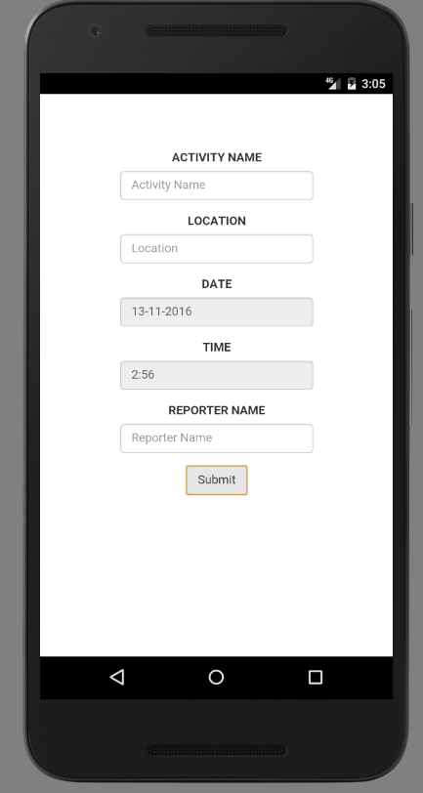Click the app icon, and app will open display above.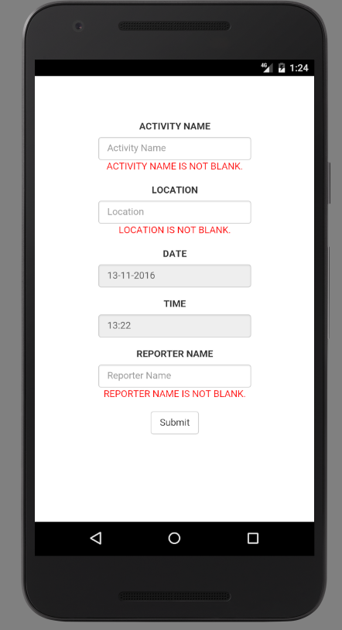After input and eraser value , and the message will be displayed.  
 If after submit, it reaches target, the message will show “Validation successfully.”  
 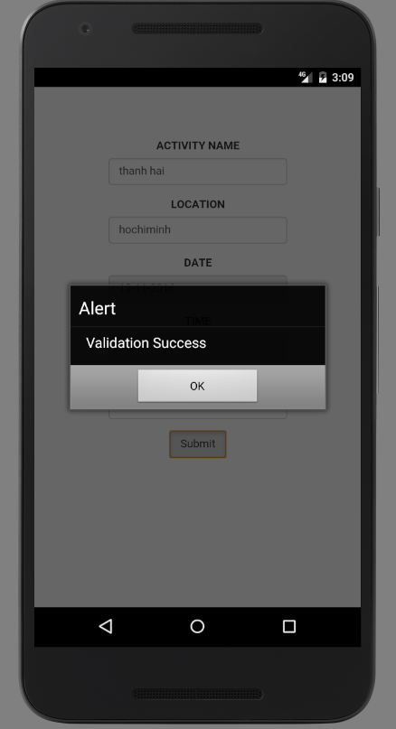  
 Else, the message will show “Validation Fail”.  
 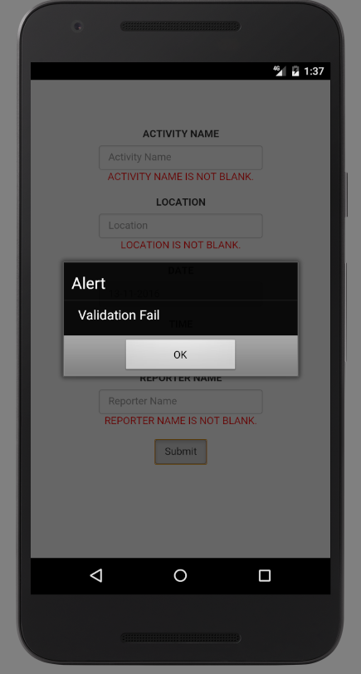  
  
  
  
 **Use case:**  
  
 logbook2.png

|  |  |
| --- | --- |
| Name | Action in Logbook 2 |
| Actor | User |
| Goal | Logbook 2 |
| Scenario | 1- Input form field, if not required, the message will show  2- Submit form + If required, the successfully message will show. + If not, the fail message will show. |

1. **Logbook 3**

|  |  |
| --- | --- |
| 1.1 Student Name |  |
| 1.2 Who did you work with? Note that for logbook exercises you are allowed to work with one other person as long as you give their name and login id  and both contribute to the work. | **Name: Nguyen Thanh Hai Login Id:** I just did it individually, so that I’m not work with another person. |
| 1.3 Which exercise is this ? | Create an SQLite database to store the event details entered into the kiddy App |
| 1.4 How did u complete the exercise? Tick as appropriate ? | I did it but I think I should have done better. |
| 1.5 Briefly explain your answer to question 1.4 | Create the Android Native App, can access SQLite , insert update , read and delete row and column. |

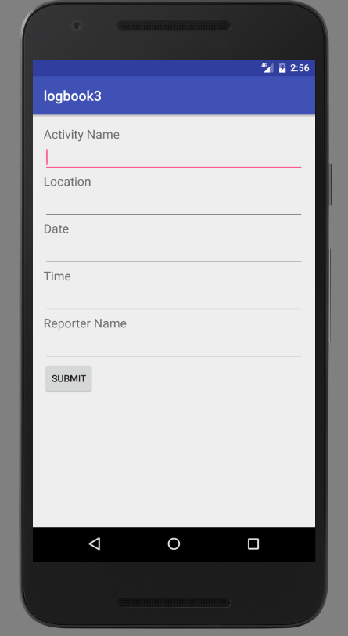Click the app icon, and the app will be open like that.  
 After that, if u didn’t input field follow format or require, app will show errors, and display message.  
 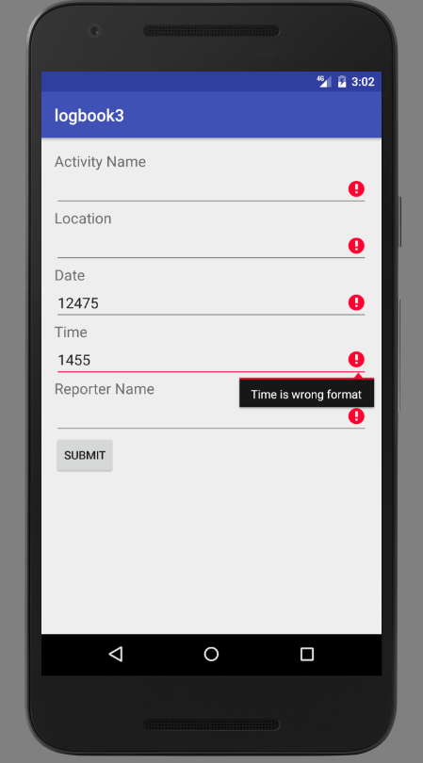

After input right format, the record will be input SQLite.  
 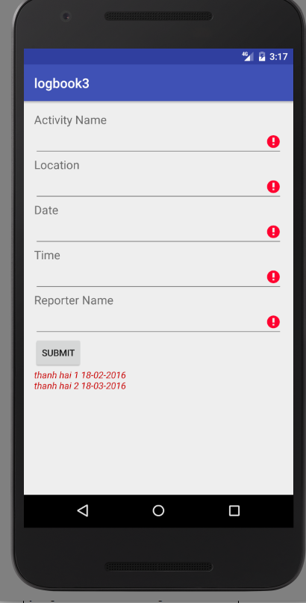  
  
 **Use case:**  
   
  
 logbook3.png

|  |  |
| --- | --- |
| Name | Action in Logbook 3 |
| Actor | User |
| Goal | Logbook 3 |
| Scenario | 1- Input form field, if not required, the message will show  2- Submit form + If required, the successfully message will show. + If not, the fail message will show.  3- Save Database Save into SQLite. |

1. **Logbook 4**

|  |  |
| --- | --- |
| 1.1 Student Name |  |
| 1.2 Who did you work with? Note that for logbook exercises you are allowed to work with one other person as long as you give their name and login id  and both contribute to the work. | **Name: Nguyen Thanh Hai Login Id:** I just did it individually, so that I’m not work with another person. |
| 1.3 Which exercise is this ? | Create a Native App that displays a screen that allows a user to enter the five fields specified in the coursework  After input name, location, date and time, if forgot to input name and location, date and time is not correct format. |
| 1.4 How did u complete the exercise? Tick as appropriate ? | I did it but I think I should have done better. |
| 1.5 Briefly explain your answer to question 1.4 | After got requirement. Create the Android activity, with 5 text fields. Try to get be responsive screen. |

Click the app icon, and the app will be open like that.  
 After that, if u didn’t input field follow format or require, app will show errors, and display message.  
   
  
  
  
  
  
  
**Use case:**  
  
 logbook2.png

|  |  |
| --- | --- |
| Name | Action in Logbook 4 |
| Actor | User |
| Goal | Logbook 4 |
| Scenario | 1- Input form field, if not required, the message will show  2- Submit form + If required, the successfully message will show. + If not, the fail message will show. |

1. **Coursework**With the phonegap app, I will try to develop by phonegap. But I meet an issues with call activities from web browser activity. So that why, I still use phonegap app, but I develop it by native Java.

|  |  |
| --- | --- |
| 1.1 Student Name |  |
| 1.2 Who did you work with? Note that for logbook exercises you are allowed to work with one other person as long as you give their name and login id  and both contribute to the work. | **Name: Nguyen Thanh Hai Login Id:** I just did it individually, so that I’m not work with another person. |
| 1.3 Which exercise is this ? | Create the phonegap app for parents and children. Name of App is Kiddy, feature of app should support and will be called Kiddy.  1- Design app screen, main activity. 2- Validation field 3- Store Field. 4- Search 5- Add report  6- Additional feature |
| 1.4 How did u complete the exercise? Tick as appropriate ? | I did it but I think I should have done better. |
| 1.5 Briefly explain your answer to question 1.4 | After got requirement. Design UI screen, and try to validation, and use SQL Class,  Search Activity By Name. View Report Of Activity |

Click the icon app, we will see two button:  
  
 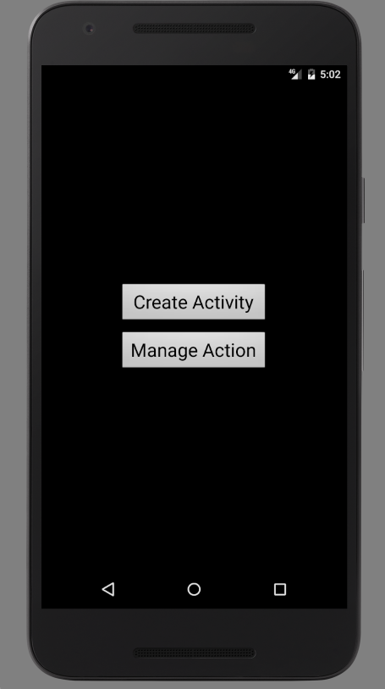  
  
 After click button “Create Activity”, we will display the screen.  
 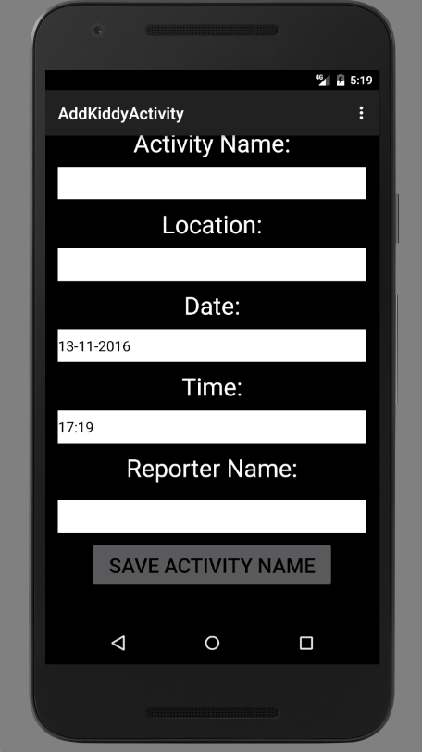  
  
 We will see the errors:  
 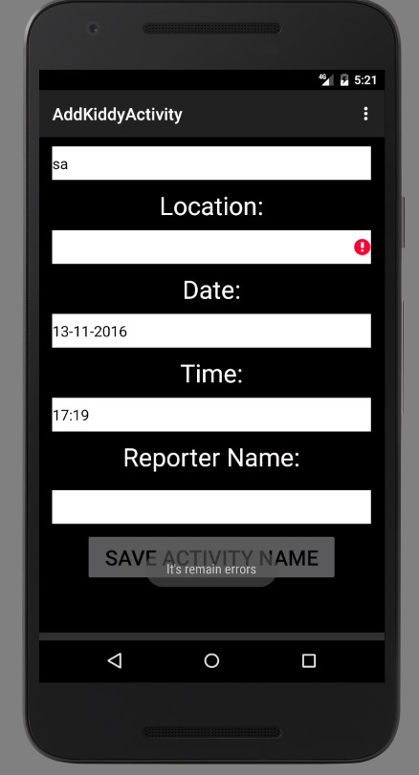  
   
 After input correct format, and follow this, we will see the successfully.  
 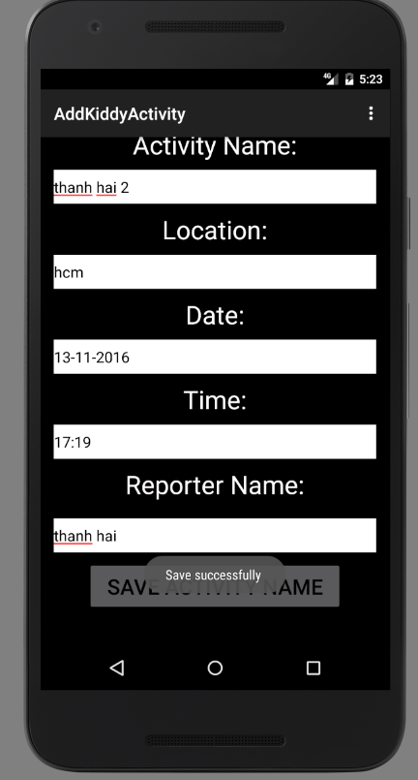  
  
 Back to main screen, and click button Manage Action, and we will see this screen.  
 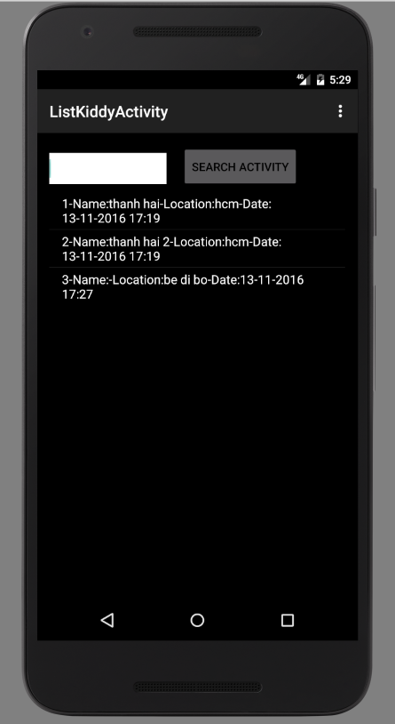  
 After that, search input:  
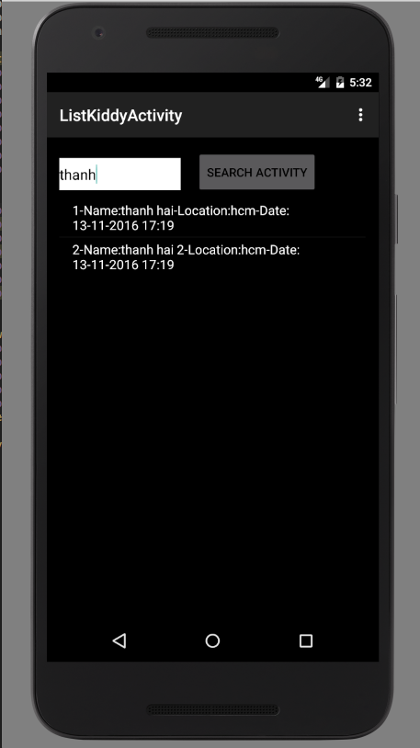  
  
After that, click into one of them result.  
  
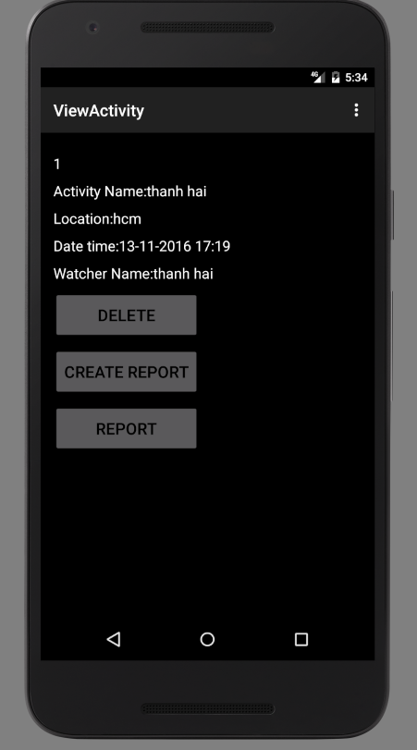  
After that, create button “Create Report”, the screen will be displayed  
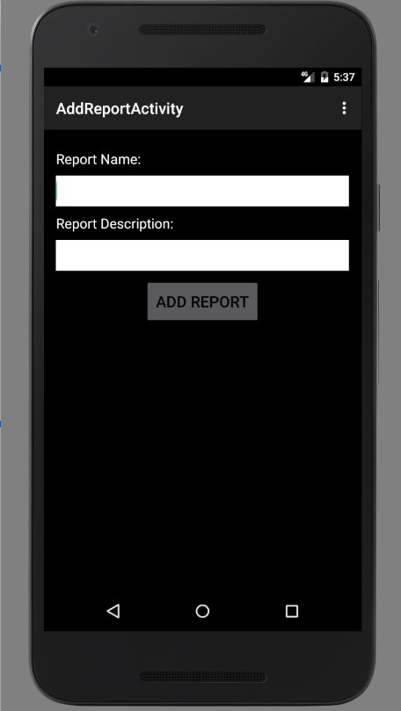  
Input it, and activity back to last screen, and we will see result of report activity results by click Report button.  
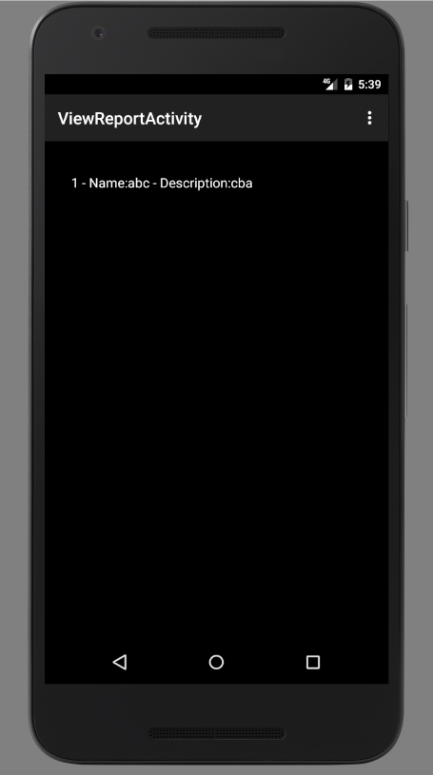  
  
 We can delete the activity by click the Delete button.  
  
 Use case:  
 usecase.png

|  |  |
| --- | --- |
| Name | Action in Logbook 4 |
| Actor | User |
| Goal | Logbook 4 |
| Scenario | 1- Create activity, The activity to create activity will be displayed. And we will validate data, if data will be saved into the SQLite database.  2- See list activity : We will see list and search the data of activity.  3- Show detail of activity: We will see the detail of the activity, full information about activity. And we can delete the activity.  4- Create report for activity : We can create report for activity, with name and description  5- We can see list report: See list of the report based on this activity. |

1. **Conclusion:**As the documentation, I know I have a lot of mistakes, but I try with my best.   
     
   During the time I developed this android app, the tutor help me to know and analyze our product. I would like to thank my tutors. Mr. ….  
   He help me to analyze coursework, and help me to understand Android API, and phonegap also.