**Note:** The protocol is slightly different for aerial or reef videos, but the overall workflow is the same. Start with the appropriate subsection below depending on the application.

**Note:** The quality of the model will greatly depend on the target area. Reefscapes with high densities of moving organisms, such as fish and soft corals, will prevent good alignment of points across photos. Likewise, aerial videos over large areas may result in variability due to trees or birds moving. In highly variable areas, it is suggested to reduce the size of the video area and make sure your target of interest (corals, buildings, etc.) are not too close to moving objects.

**Aerial Videography**

**Note:** We are using a DJI Inspire 1 with Zenmuse X3 camera as it produces very little lens distortion, shoots in 4K, and has excellent video stabilization.

1. Locate the boundaries of the area to be mapped and determine the optimum number of tracks needed to cover the entire area with a single quadcopter flight.
2. Deploy the quadcopter and ascend to a preset altitude. We find that 400ft allows for sufficient ground coverage and sufficient image quality for mapping.
3. Orient the camera to 90° facing downwards and maintain the same quadcopter heading.
4. Fly a grid pattern over the entire target area (Figure 1), maintaining the same altitude and heading (do not adjust the quadcopter yaw; this requires you to move side-to-side and backwards).
5. Take continuous video along the flight, ensuring complete coverage with overlapping features.
   1. If mapping a large area over multiple flights, try to maintain lighting consistency by either flying immediately after the first flight, or flying at the same time of day.

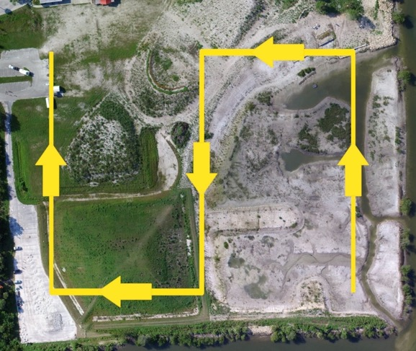

Figure 1. A target area to be mapped, and the grid pattern used to capture all the downward-facing photos. At each 90° turn, the heading of the quadcopter does not change.

**Reef Videography**

1. The type of underwater camera should not matter for model generation, however, ensure it shoots in sufficient quality (1080p). If using a GoPro, make sure the field of view is set to narrow, sharpness to medium, frame rate of at least 30 fps, and white balance of 6500K. External lights should not be needed
   1. **Note:** We use a Canon G16 with the underwater mode, shooting at 60 fps. There is very little lens distortion, and it has an excellent sensor for video stabilization.
2. Once you have identified a target area, lay down some kind of scaling reference. You can build a 2 x 2 m PVC quadrat as in Young et al. (2017), or have several individual pieces of the same length PVC arranged in a square shape. It helps to add some kind of tape marker to each piece, such as a 10 cm scaling band.
3. Swim over the target area and scaling references in a lawnmower pattern while recording a single video (Figure 2). The diver should maintain a constant altitude (0.5–1 m off bottom) and relatively slow speed. Keep the camera oriented straight down and do not change the orientation in between adjacent passes.
   1. The number of passes depends on the overall size of the target area. For a 2 x 2 m area, six adjacent passes should be sufficient to maintain >50% overlap between passes.
4. At the end of the first set of passes, rotate the camera 90° and complete another set of passes, continuing to record.
5. A full set of two passes should take anywhere between 1–3 minutes.

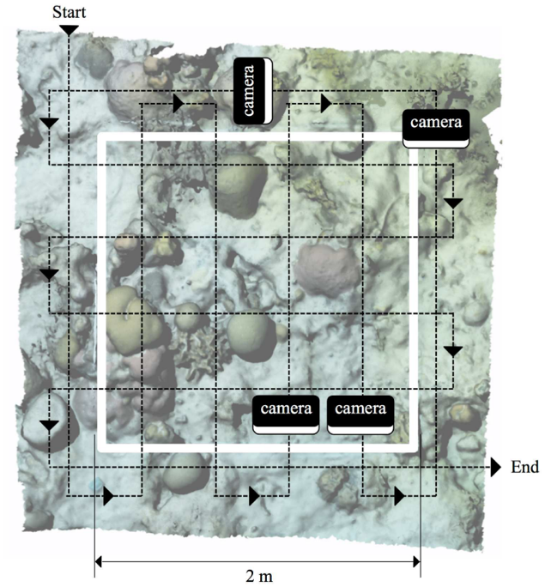

Figure 2. Method for filming 2 x 2 m underwater quadrat, from Young et al. (2017).

**Video Processing**

**Note:** Dealing with high quality video, hundreds of stills, and high resolution models can require immense storage and computing requirements. I would suggest using a high speed, high capacity external drive for storage and local access. Most networked drives will likely be too slow for model generation and data curation.

1. Install FFmpeg on your computer from <http://www.ffmpeg.org/download.html>. It is available for any OS and they provide several guides for installation.
   1. Personally, I find it easiest to use on a Mac due to the Unix interface already set up in the Terminal app. The subsequent instructions are tailored for a Mac OS.
   2. You may need additional software to run this on a Windows OS. Something like Cygwin (<https://cygwin.com/install.html>) should work.
2. Navigate to the directory containing your video.

cd /path/to/video/directory

1. To pull still images from the video, use the following code:

ffmpeg -i movie_filename.MP4 -vf fps=3 output_name_%d.png

* 1. -i denotes the input video filename
  2. -vf deinterlaces the video to produce crisp still images
  3. fps=3 specifies that 3 frames should be taken per second of video, which should be sufficient to produce images with enough overlap
  4. Start the output filename as a text string of your choice, and %d inserts a consecutive number to each individual image file.

1. Once the process finishes, you should have 100–500 still images depending on the length of the input video.

**3D Model Generation**

**Note:** While both software applications, Photoscan and Rhino 3D, are not free, they offer educational licenses that are relatively affordable. Additionally, older versions of Netfabb are available for free on Windows and Mac OS (<https://github.com/3DprintFIT/netfabb-basic-download/releases/tag/v7.4.0>). Netfabb is less performance-intensive, but I have not figured out an easy way to scale the models and quantify area of user-specified polygons.

**Note:** Also, the two software applications, Photoscan and Rhino 3D, require some serious computing power. It is recommended to meet their requirements, and to not attempt additional processing for other tasks while the models are being generated.

1. Open Photoscan and select Preferences. Under the GPU tab, make sure any available GPU devices are selected.
2. Select the Add Photos icon in the Workspace window. Navigate to your working directory and select all of the still images. Once imported, they will show up as a Chunk (set of photos). Save the project.
3. Start the image alignment process by selecting Workflow, Align Photos. Set the Accuracy to Medium. This process may take some time, since it finds common points among the photos.
4. Check the alignment by looking at the Photos window under View. Each photo will show up as a thumbnail; if it has aligned, you will see a green check mark. You can also check the aligned photo placement in the sparse point cloud in the Model window. Select the Show Cameras icon to see where the program thinks they were taken. The blue camera icons should approximately match the path taken in the original video. Use each of the three colored axes on the model sphere to move in 3 dimensional space, and scroll to zoom in and out.
   1. If all the photos aligned correctly, proceed to the next step.
   2. If some did not align properly, you can select the particular photos and Select Align Photos again.
5. Once enough photos are aligned, select Build Dense Cloud under Workflow. Set the Quality to Medium and start the process. This step takes the longest, and I would suggest selecting Background, which moves the process to the background and automatically saves the project upon completion.
6. Once finished, you should have a decent representation of the model features built from many small points.
   1. Check all angles of the point cloud, looking for aberrant features (“floaters”), or areas with moving features such as soft corals or trees.
   2. Since these will not be well represented in the finished model, they should be removed. Position the model so that the problem features are isolated from the other parts of the model (nothing behind the features). Use the Rectangle Selection tool on the toolbar to highlight any offending points, and select the Delete Selection tool on the toolbar.
   3. Don’t worry if this creates small gaps, as they will be filled in when the mesh is made. You do, however, have to remove all the problem features at this stage, otherwise you will have holes in your mesh.
7. Start the Build Mesh process from the Workflow menu. Change the Face Count to 3,000,000 for high accuracy. This process is much shorter, but still can take 5–10 minutes.
   1. Now you should have a smoothed version of the point cloud. Check for any lingering problem features.
   2. If anything is found, switch back to the Dense Point Cloud using the button on the toolbar, remove them as described above, and regenerate the mesh.
8. Start the Build Texture process from the Workflow menu, which may take another 5–10 minutes. Once completed, the photo texture will be mapped to the 3D model.
9. Export the model by selecting File, Export, Export Model. Save it as a Wavefront OBJ (.obj) file. Make sure that Export Texture is selected in the following window.

**3D Model Scaling and Analysis**

**Note:** Protocol in progress, see Grace Young’s blog for information on texture troubleshooting (<https://www.graceunderthesea.com/thesis/photoscan-gt-rhino-not-importing-texture>), orientation and scaling (<https://www.graceunderthesea.com/thesis/how-to-rotate-3-points-flat-in-rhino>), and quantitative analysis (<https://www.graceunderthesea.com/thesis/rhino-3d-tutorials>).