Measuring surface area for microfragmenting growth rate assessments using MeshLab

Modified from Wyatt Million’s protocols on phenotyping 3D coral models in Meshlab (https://par.nsf.gov/servlets/purl/10214897) by Kamryn Herbison

Last Updated: Kamryn Herbison 8/17/22

-----------------------------------------------------------------------------------------

Importation and scaling of 3D models generated in Metashape

* Open files and select desired “OBJ” file. Meshlab will automatically open with the selected model.
* Select the yellow measuring tape labeled “measuring tool” located in the top toolbar.

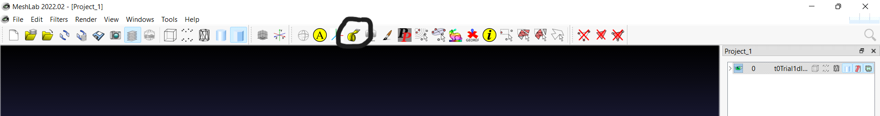

* Take three measurements of 2 cm, one on each of the rulers in the model. The measurement outputs will display in the layer dialog located in the bottom right corner of the screen.
* Calculate the average of these three measurements. Divide the actual measurement (2 cm) by the average previously calculated. This is the scale factor.
* Navigate to the toolbar. Select Filters > Normals, Curvatures and Orientation > Transform: Scale, Normalize.
* Input the calculated scale factor into the “X Axis” box and select “Apply to all visible layers”. Apply the filter.
* Now take three more measurements on three different rulers in the model and ensure the measurement outputs are correct.

-----------------------------------------------------------------------------------------

Removal of all undesired components in preparation of surface area measurements

* Select the irregular shaped polygon from the toolbar, labeled “Select Faces/Vertices inside polyline area”. Outline just the model(s) of interest by placing points surrounding the model.

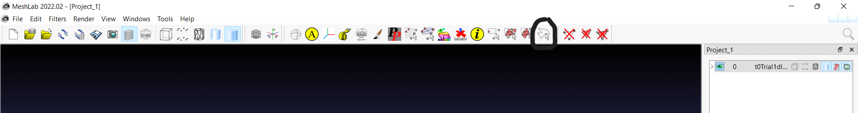

* Press “q” on the keyboard to select the area inside the polyline area that was just created. Then press “i” to inverse the function and select everything other than the model(s).
* Navigate to the three crossed out triangles in the toolbar. Select the center triangle, labeled “Delete Selected Faces”.

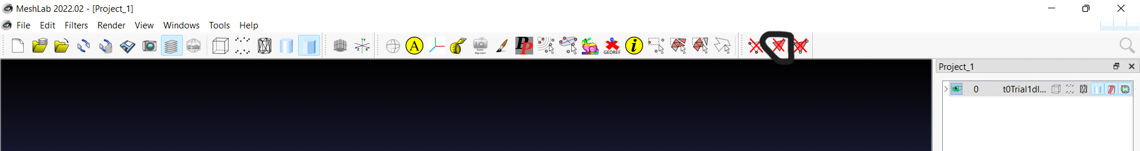

* There is a different protocol for single larger models (wild) versus multiple smaller models (frags).

For a single larger model (wild):

* Select the paintbrush from the toolbar, labeled “Z-painting”. Then select the paintbrush with the red bristles.
* Outline the specific component of the model that is going to be measured for surface area (all live tissue). Use a zigzag pattern to “paint” undesired areas of the model.

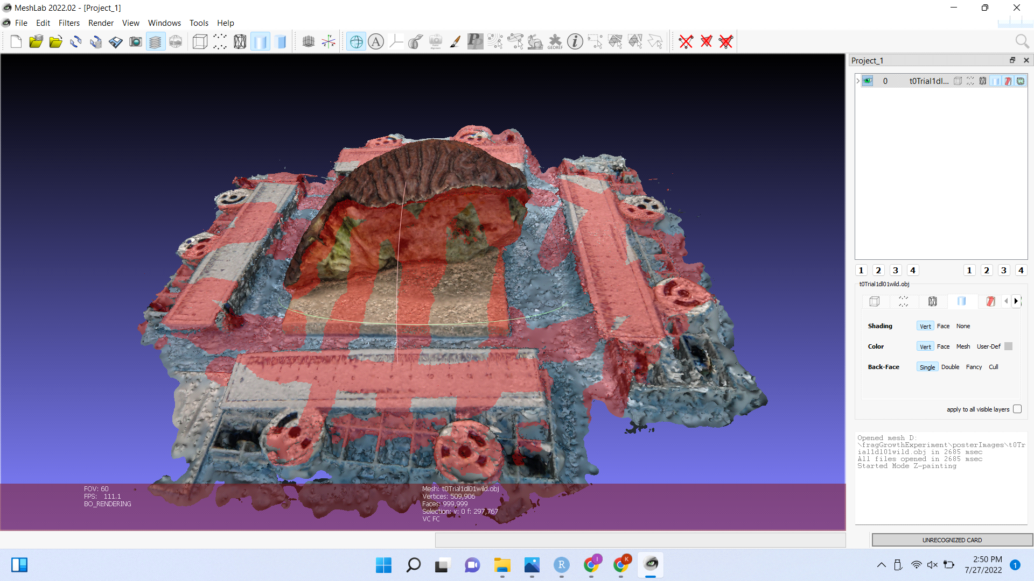

* Once the model is completely outlined, select the previously used triangle labeled “Delete Selected Faces”.
* To delete the rest of the undesired components select Filters > Selection > Select small disconnected component. Then select the center triangle again.

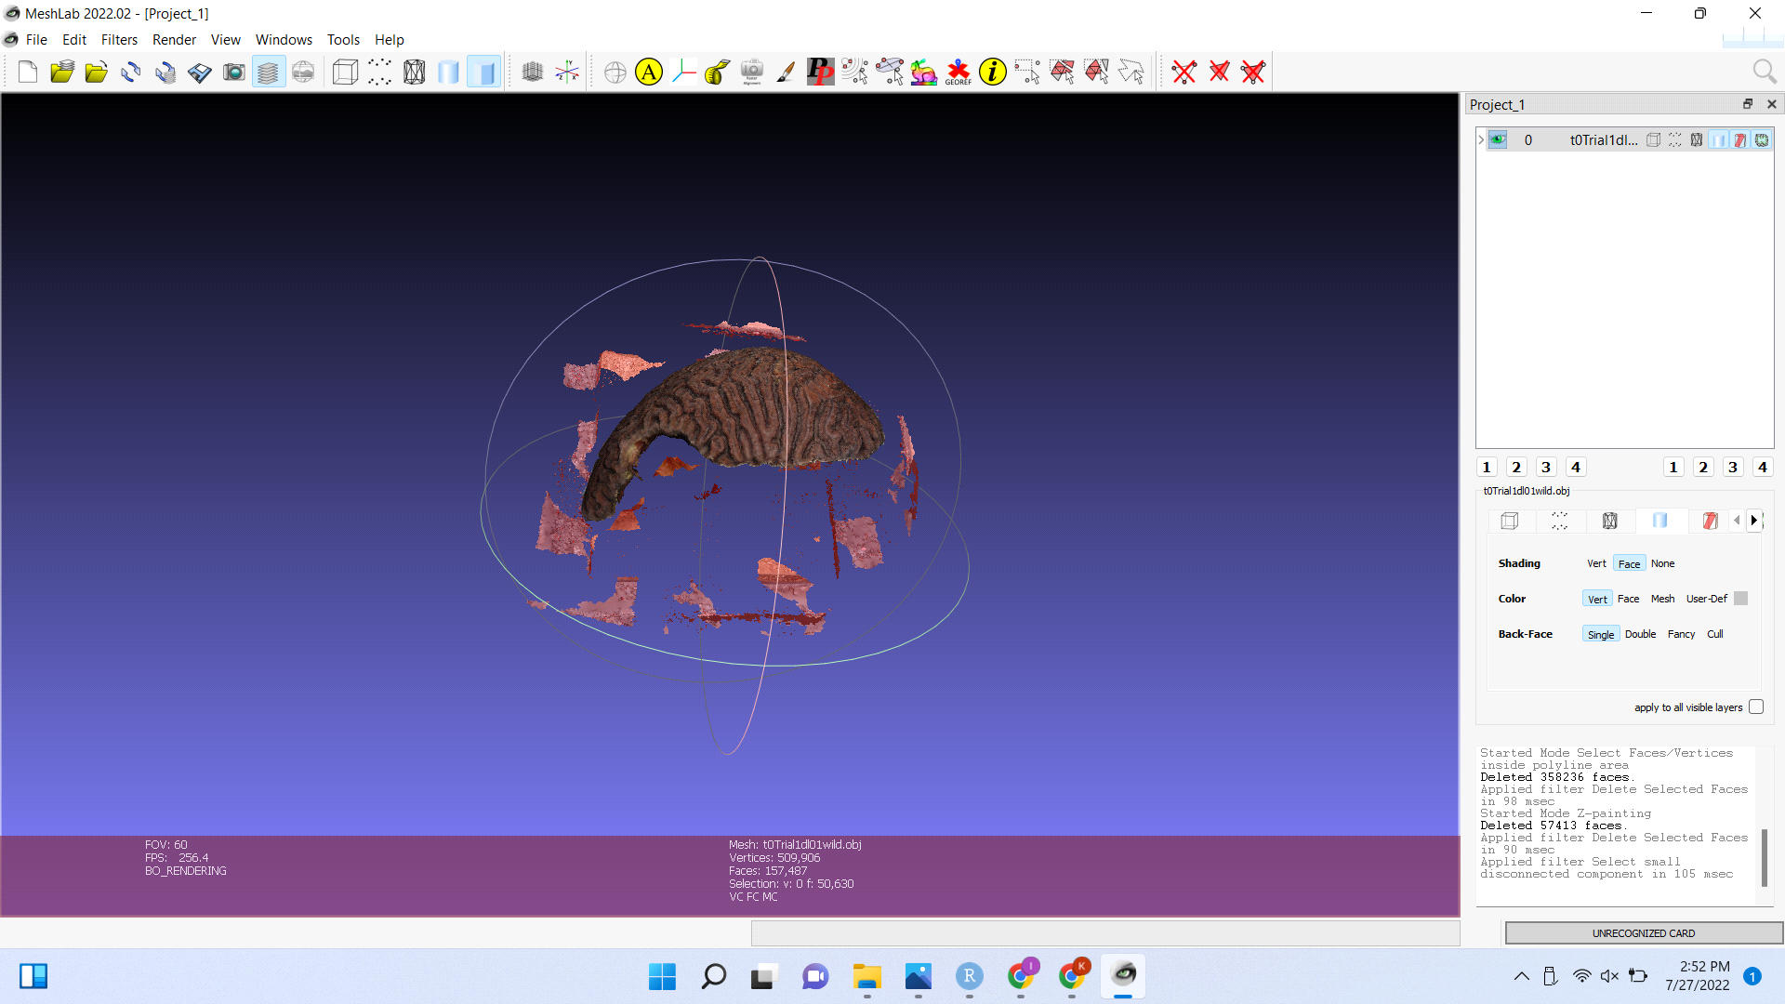

* Remove any other undesired components by selecting them with the red paintbrush and selecting the center triangle.

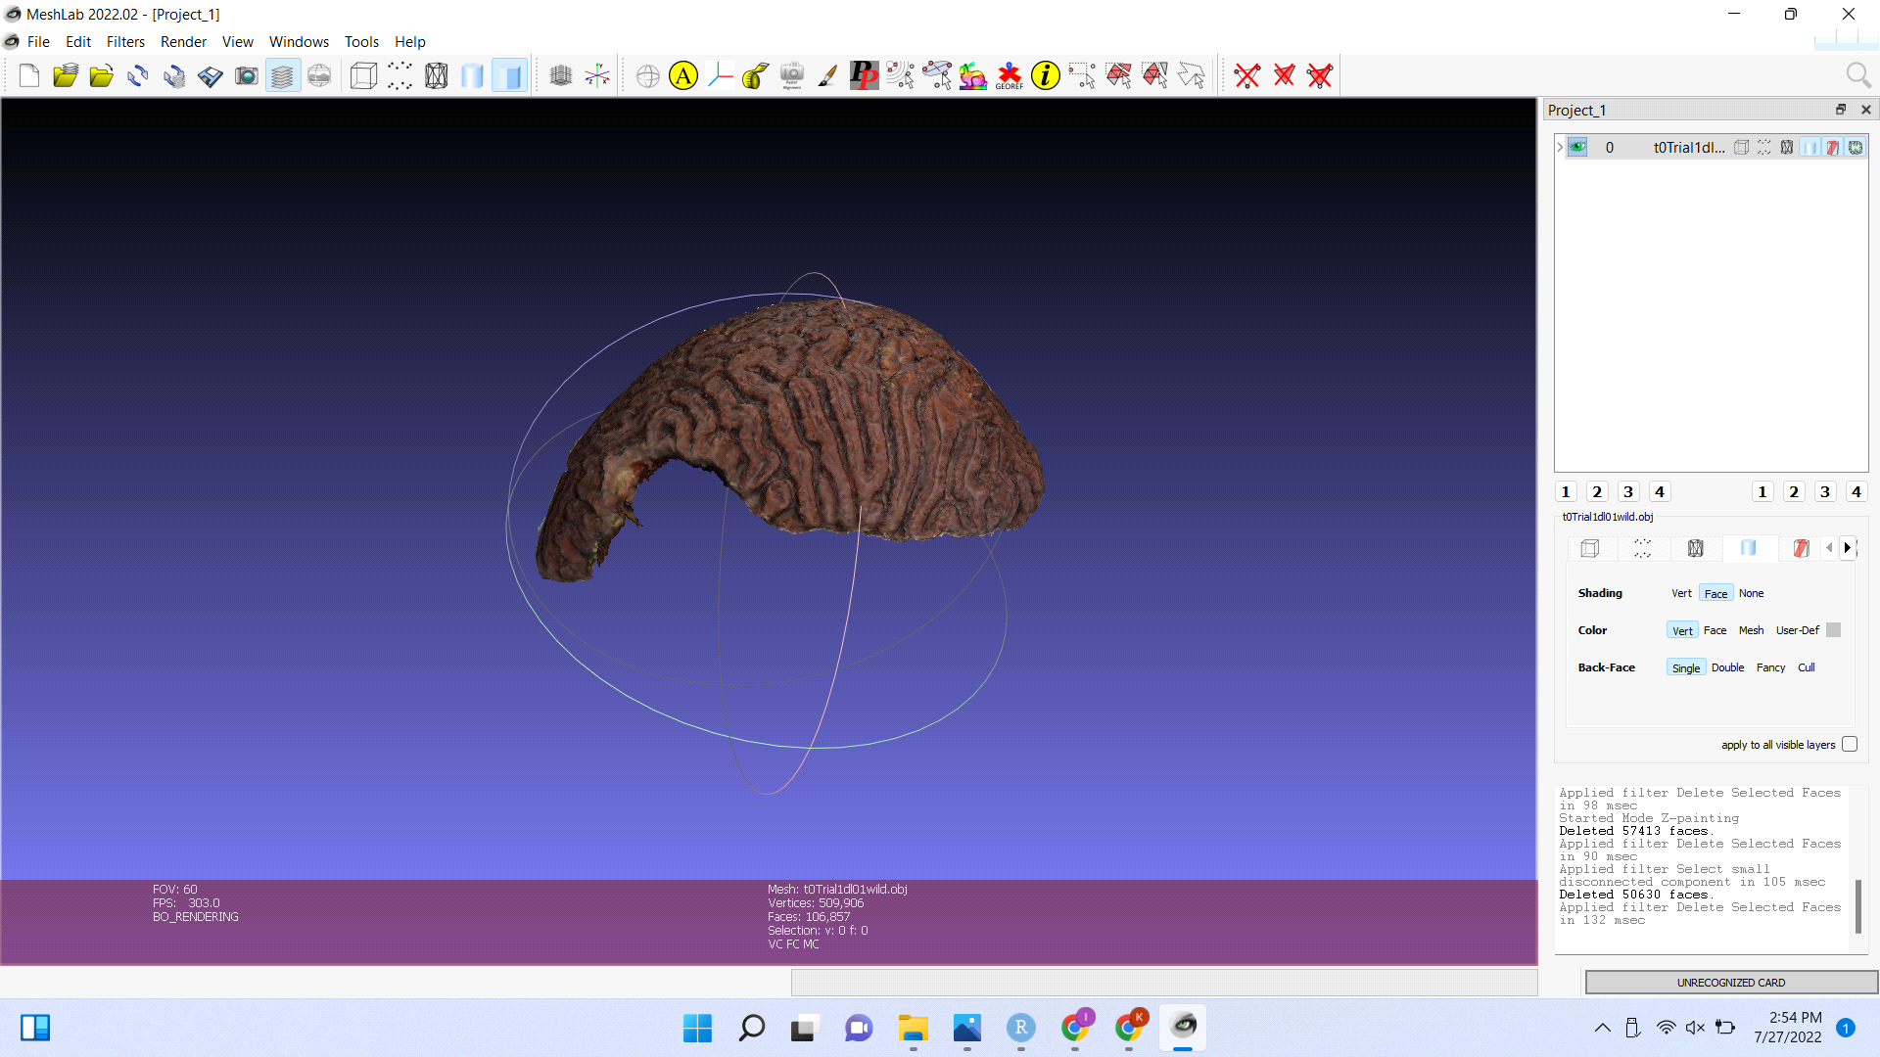

For multiple smaller models (frags):

* Select the paintbrush from the toolbar, labeled “Z-painting”. Then select the paintbrush with the red bristles.
* Outline the specific components of the model that are going to be measured for surface area (all live tissue).
* Once the models are completely outlined, select the previously used triangle labeled “Delete Selected Faces”.
* To delete the rest of the undesired components select Filters > Selection > Select small disconnected component. This should select the live tissue of the frags.
* Select the irregular shaped polygon from the toolbar, labeled “Select Faces/Vertices inside polyline area” and press “i” on the keyboard to inverse the function and select everything except the desired models.
* Select the previously used triangle labeled “Delete Selected Faces”.
* Remove any other undesired components by selecting them with the red paintbrush and selecting the center triangle.

-----------------------------------------------------------------------------------------

Surface area measurements

* Close any accidental holes in the tissue by selecting Filters > Remeshing, Simplification and Reconstruction > Close Holes.
* Unselect all of the boxes and set the “Max size to be closed” to 50. Hit apply. If a hole was not closed, increase the threshold in increments of 50. Be careful not to raise the number too high, as it may add tissue that was not there to begin with.
* Select Filters > Quality Measure and Computations > Compute Geometric Measures.
* Scroll though the outputs generated in the layer dialog. The surface area measurement will be labeled in cm^2, or whatever units were originally used to scale the model.