Goal 3: Ecosystem Monitoring

**Photogrammetry equipment (including cameras, housings, mounts, PC, and ancillary field equipment) was purchased and constructed in Q1 2020. However, strong winter winds followed by fieldwork restrictions caused by COVID-19, delayed establishment of the initial outplant sites. Prior to COVID-19 shutdowns we were able to train on and field test the entire photogrammetry workflow successfully (Figure 15). This has allowed us to make necessary modifications to our photogrammetry protocols. Furthermore, we have narrowed down potential experimental sites by cross referencing prior outplant and reef-scale data, allowing for relatively rapid site selection and surveying in Q2 that will facilitate the start of outplanting activities as close to on schedule as possible. Initial data collection for variables 1-6 will begin once final sites have been mapped and approved.**

After cross-referencing prior outplant and reef-scale data, six experimental plots were established across three separate sites (Figure 1). All sites are similar in depth, bathymetry, and benthic structure, both within reefs and across reefs. Following successful modifications to the photogrammetry protocols, images were captured pre-restoration for downstream 3D ecological analysis. All sites (n=6) have been rendered and 3D dense point clouds (Figure 2) have been produced for further analysis using the custom visual analysis software Viscore (variables 1-3, Petrovic et al. 2014). Twelve settlement tiles (n=72, variable 5) were deployed at each site pre-restoration and coinciding with the coral spawning window and will be collected in Q4. Sea grass assays (variable 6) will occur in early Q4 prior to outplanting. Outplanting will occur in early Q4. Immediately after outplanting, linear video transects will be conducted to assess baseline fish communities (variable 4).

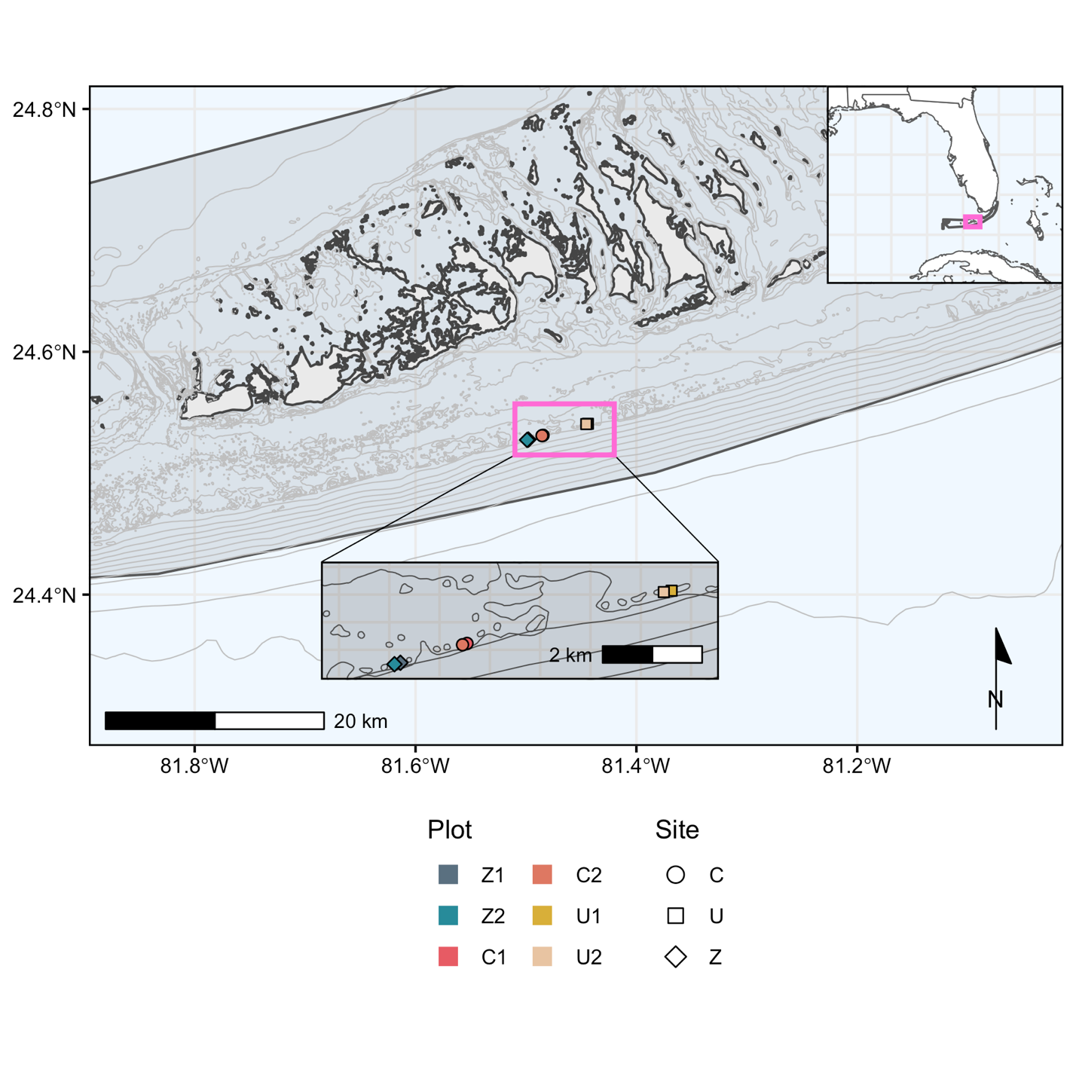

Figure 1. Map of experimental sites. Each site consists of paired 10m x 10m plots separated by roughly 100m. Plots are similar in depth, bathymetry, and benthic structure both among and across reefs.

Figure 2. Example of a fully rendered 3D dense point cloud to be used in downstream analysis.

References:

Petrovic, V., Vanoni, D. J., Richter, A. M., Levy, T. E., & Kuester, F. (2014). Visualizing high

resolution three- dimensional and two-dimensional data of cultural heritage sites. Mediterranean Archaeology and Archaeometry, 14(4), 93–100.