Alliance Facility Solutions

**General Notes**

* To help facility owners find qualified contractors & vice versa. Collect data and contacts for project management. Contractors search for projects. Owners search for contractors.
* We plan to use this theme and extend it where needed: <http://themeforest.net/item/directory-portal-wordpress-theme/3840053>
* Should we look at using BuddyPress? http://buddypress.org/
* Users self register & have personal profiles (included in theme)
* Membership management – Payment processing will be in place but not configured. (Theme includes simple form of payment processing)
* AFS Quality Approved – a quality assurance system
  + What is the process? What does a user have to do? Points system?
* Internal Messaging System: <http://premium.wpmudev.org/project/messaging/>, <http://codecanyon.net/item/wp-ajax-private-messages-wordpress-plugin/4446743>,
* Strong search function with filters (projects, contractors, name, state, within 20, 50, 100 miles, etc)
* Possible media library specific to Owners & Contractors
* Referral link for both Owners & Contractors

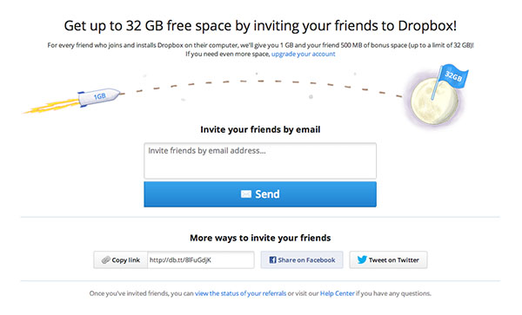

**Facility Managers**

* Register for an account & setup their profile
  + What data fields for owners profile?
    - Name
    - Company name
    - Title
    - Contact phone
    - Email
    - Location/ City / State (Can we do a Regional Search vs Exact City name)
    - Hours / Requested Availability
    - Insured
    - TYPE OF FACILITY MANAGED (dropdown or checkboxes)
      * Restaurant / food service
      * Retail
      * Hospitality
      * Institutional /
      * Hospital / medical
      * OTHER
    - FACILITY CONTRACTOR NEEDS (checkboxes)
      * GC
      * Paint / GWB
      * Flooring / tile and grout
      * handy man services
      * Electrical
      * Plumbing
      * HVAC - Refrigeration
      * Specialty trade/Other
* Owners have the ability to post “projects” open for bid (custom post type)
  + What data fields for a project?
    - Project Name
    - Budget
    - Service Dates (Timeline)
    - Specific Requirements (Description)
* Owners can also search for contractors and invite them to bid on a project.
  + Owner selects which contractors to invite & an invitation is sent via email/message system.

**Contractors**

* Register for an account & setup their profile
  + What data fields for contractor’s profile? (custom post type)
    - Name
    - Company name
    - Title
    - Contact phone
    - Email
    - Location/ City / State (Can we do a Regional Search vs Exact City name)
    - Hours of Availability
    - Insured?
    - TYPE OF FACILITY EXPERIENCE (checkboxes)
      * Restaurant / food service
      * Retail
      * Hospitality
      * Institutional /
      * Hospital / medical
      * OTHER
    - FACILITY CONTRACTOR DESCRIPTION
      * GC
      * Paint / GWB
      * Flooring / tile and grout
      * handy man services
      * Electrical
      * Plumbing
      * HVAC - Refrigeration
      * specialty trade/Other
    - ACCREDITATION
      * General Contractors License # (State)
      * Better Business Bureau
      * Insurance Company Name and Acct Number
      * Years of Experience
      * General Contractors License # (State)
      * Other
    - Project Media Gallery
* Rating system for contractors (1-5 stars)
* Contractors search for projects & can contact an owner via messaging system.