**Logging into Your Back Office**

1. Go to [LocalSharingTree.com](http://www.localsharingtree.com)
2. Click Login in the top right of your screen and login to your User/Merchant Account.

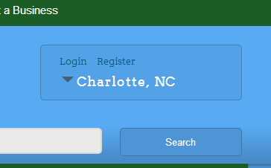

1. If you are not automatically re-directed to your Account page, click “My Account” in the top right corner of the page.

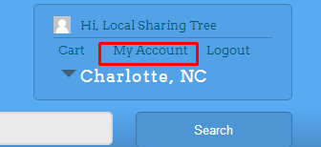

1. From your account page, you can view all of your information.
2. Your Account Settings
3. Business Account
4. Your Credit Account Balance
5. Your Purchase Overview
6. 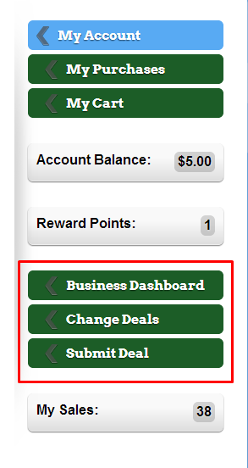On the right hand side of Your Account Page you can also access your Business Dashboard, Change Deals or Submit Deals.
7. Your Merchant Dashboard is where you can see your sales reports for each deal under your merchant account
8. You can change current deals by clicking the link “Change Deals” and submitting the Deal Change form.
9. You can submit a new deal by submitting the New Deal Form.
10. From your Business Dashboard, you can view Purchases and Voucher Reports and you can also redeem your vouchers! You can also download a CSV Report!

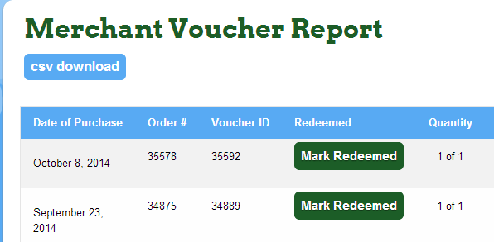

If you have any questions or concerns about your Back Office Access or about your information, please contact our support team at [support@localsharingtree.com](mailto:support@localsharingtree.com), 704-380-3250, or via our Live Chat accessable on our website. Our Business hours are Monday – Friday from 9am to 5pm.

Thank you for Giving, Saving and Growing with us!