[](http://www.localsharingtree.com)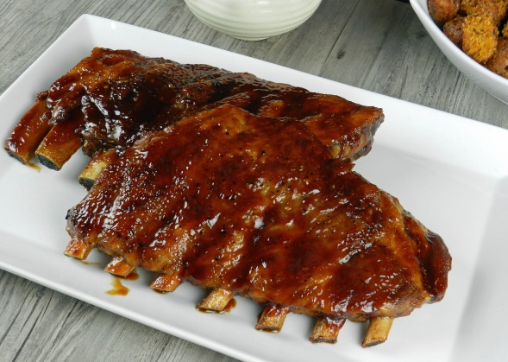[](http://www.rescueranch.com/)

**[Buy It! $10](http://localsharingtree.com/deals/15-gift-certificate-for-uncle-cs-bbq-for-10/)**

**Buy It! $10**

**Thank You for Supporting Rescue Ranch!**

◊ [Local Sharing Tree](http://localsharingtree.com/home/) ◊ <mailto:support@localsharingtree.com> ◊ 704-380-3250 ◊

Check Out This New Deal!

Save $5 at Uncle C’s BBQWhile Supporting Rescue Ranch!

**Get a $15 Gift Certificatefor Uncle C’s BBQfor Only $10!**

Thank you so much for your support! We are excited to announce a new fundraising partnership with Local Sharing Tree!Local Sharing Tree is a website that negotiates with businesses in our area to offer up to 90% in savings for the things you do and use everyday!

Local Sharing TreeDonates 10% of EVERY purchase on their website to the Organization or School of the customer’s choice!

Save Money WhileSupporting Rescue Ranch!

It’s not WHAT we do, but WHY we do it”-Jeffrey E. PaynePresident and CEO—Local Sharing Tree