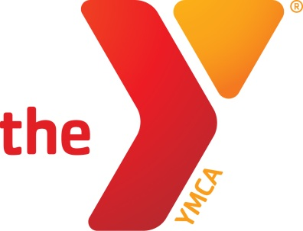

Check Out This New Deal!

Save 50% at Big Shotz Tavernwhile Supporting Statesville Family YMCA!

**Get a $40 Gift CertificatePLUS an Additional $20 Gift Certificate with Big Shotz Tavern!**

Thank you so much for your support! We are excited to announce a new fundraising partnership with Local Sharing Tree!Local Sharing Tree is a website that negotiates with businesses in our area to offer up to 90% in savings for the things you do and use everyday!

Thank You for Supporting Statesville Family YMCA!

Local Sharing Tree wants to know what YOU, the customer, would like to seeon their website or if you have any business contact suggestions!If you have any suggestions for what businesses you would like to post deals on Local Sharing Tree, please [CLICK HERE](http://localsharingtree.com/suggest-merchant/) and fill out their short form!

[**Buy Now - $30**](http://localsharingtree.com/deals/40-gift-certificate-plus-a-20-gift-certificate-with-big-shotz-tavern/)

Save Money WhileSupporting Statesville Family YMCA!

It’s not WHAT we do, but WHY we do it”-Jeffrey E. PaynePresident and CEO—Local Sharing Tree

◊ Local Sharing Tree ◊ <mailto:support@localsharingtree.com> ◊ 704-380-3250 ◊

Local Sharing TreeDonates 10% of EVERY purchase on their website to the Organization or School of the customer’s choice!