[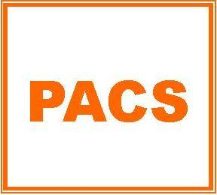](http://localsharingtree.com/charities/parents-assisting-children-in-sports/)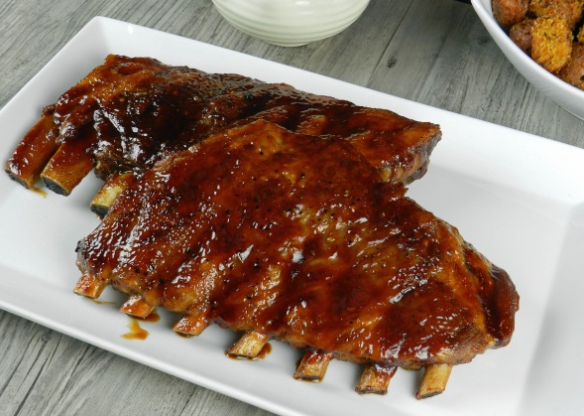

**Local Sharing Tree wants to know what YOU, the customer, would like to seeon their website or if you have any business contact suggestions!If you have any suggestions for what businesses you would like to post deals on Local Sharing Tree, please** [**CLICK HERE**](http://localsharingtree.com/suggest-merchant/) **and fill out their short form!**

Check Out This New Deal!

Save $5 at Uncle C’s BBQWhile Supporting PACS!

**Get a $15 Gift Certificatefor Uncle C’s BBQfor Only $10!**

◊ [Local Sharing Tree](http://localsharingtree.com/home/) ◊ [support@localsharingtree.com](mailto:support@localsharingtree.com) ◊ 704-380-3250 ◊

Thank you so much for your support! We are excited to announce a new fundraising partnership with Local Sharing Tree!Local Sharing Tree is a website that negotiates with businesses in our area to offer up to 90% in savings for the things you do and use everyday!

Save Money WhileSupporting Parents Assisting Children in Sports!

**[Buy It! $10](http://localsharingtree.com/deals/15-gift-certificate-for-uncle-cs-bbq-for-10/)**

**Thank You for Supporting PACS!**

Local Sharing TreeDonates 10% of EVERY purchase on their website to the Organization or School of the customer’s choice!

It’s not WHAT we do, but WHY we do it”-Jeffrey E. PaynePresident and CEO—Local Sharing Tree