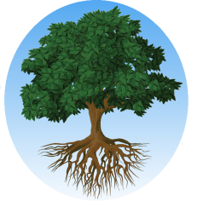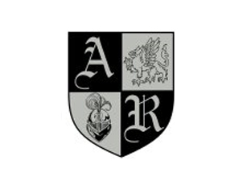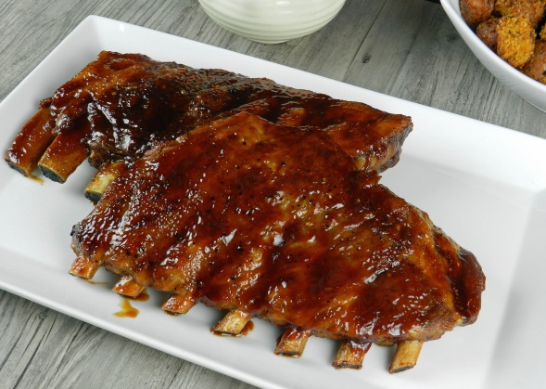

Local Sharing Tree wants to know what YOU, the customer, would like to seeon their website or if you have any business contact suggestions!If you have any suggestions for what businesses you would like to post deals on Local Sharing Tree, please [CLICK HERE](http://localsharingtree.com/suggest-merchant/) and fill out their short form!

Thank You for Supporting American Renaissance School!

[**Buy It! $10**](http://localsharingtree.com/deals/15-gift-certificate-for-uncle-cs-bbq-for-10/)

Save Money WhileSupporting American Renaissance School

It’s not WHAT we do, but WHY we do it”-Jeffrey E. PaynePresident and CEO—Local Sharing Tree

Thank you so much for your support! We are excited to announce a new fundraising partnership with Local Sharing Tree!Local Sharing Tree is a website that negotiates with businesses in our area to offer up to 90% in savings for the things you do and use everyday!

◊ [Local Sharing Tree](http://localsharingtree.com/home/) ◊ <mailto:support@localsharingtree.com> ◊ 704-380-3250 ◊

Check Out This New Deal!

Save $5 at Uncle C’s BBQWhile Supporting American Renaissance School

**Get a $15 Gift Certificatefor Uncle C’s BBQfor Only $10!**

Local Sharing TreeDonates 10% of EVERY purchase on their website to the Organization or School of the customer’s choice!