Relocation and Retention Grant: extension decision
To: County Workforce Board members From: RRG evaluation Meeting: 22 October 2026
Recommendation: extend the RRG for a second term, 1 July 2027 to 30 June 2030. Both tests in the evaluation agreement are met, narrowly. The effect is +1.886 points per 1,000, 0.086 above the 1.80 bar. The parallel-movement check is -1.404, inside the 1.50 limit by 0.096. Both are compared before rounding, as section 7 requires.

The board's measure, year by year
Per 1,000 residents at start of year | Check year 2022-23 | Base year 2023-24 | Program year 2024-25
Dallas County | -6.24 | -11.15 | -10.18
Rest of Texas | +13.22 | +9.72 | +8.80
Dallas County moved by +0.969 points from the base year to the program year; the rest of Texas moved by -0.917. The difference is the effect.

Where the change came from
- Dallas County: natural change -0.058, domestic migration +1.027, together +0.969 points per 1,000.
- Rest of Texas: natural change -0.088, domestic migration -0.829, together -0.917 points per 1,000.
Of the 1.886 effect, domestic migration contributes +1.856 and natural change +0.030. Dallas County's net domestic out-migration eased from 48,472 to 46,226 people while the rest of Texas's domestic gain slowed.
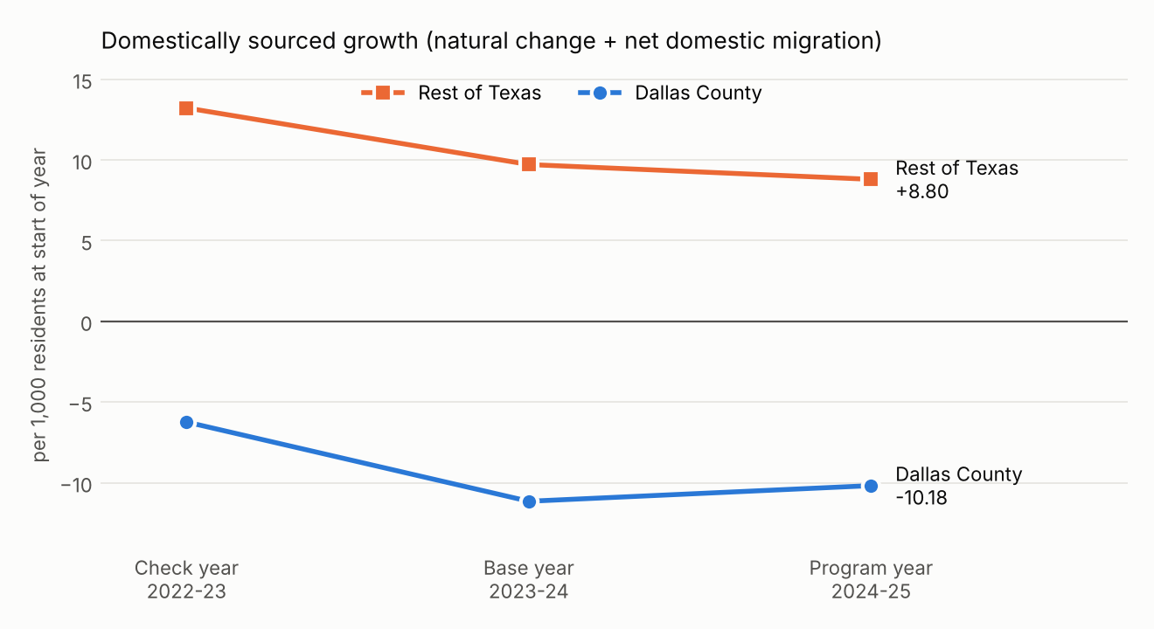

Points for members
- Did Dallas County's growth collapse? Total population change fell from +26,620 to -2,616, almost entirely because net international migration dropped from 55,809 to 24,912. The agreement leaves international migration out; on total growth the comparison would read -4.43, which is not the board's question.
- Rates are formed on the resident population at the start of each estimate year, the basis of the board's own calculation in Annex A: it returns Dallas -6.2, rest of Texas +13.2 and a gap of 19.5 for the check year. Census's published rate columns use the year's average population; on that basis the effect would be 1.787 and the program would lapse, but that basis does not reproduce Annex A.
- The rest of Texas is the other 253 counties taken as one area (counts summed, then the rate formed). The Census residual is not a component of change and is left out, as is international migration.
- Census's release notes say the 2024-25 domestic migration estimates used incomplete inputs and will be revised in Vintage 2026. The agreement fixes Vintage 2025 as published, and with a 0.086 margin a later revision could land either side of the bar.

