Breadth Fund 2026 round: notices, reserve and the Medina gap
Notices and reserve. One county gets an Article 4 notice: Wilson County, whose draw falls from $117,147 to $103,409 (-11.7%). The transition reserve pays Wilson $6,869, half the fall. No other county falls by more than ten per cent; Gillespie is closest at -9.1%.
Why the finance office's projection should not be issued. Model v2 names Gillespie for the notice and a $8,240 payment, and shows Wilson rising 37.0%. It reproduces the 2023 to 2025 rounds, but not 2020 to 2022: the fund backs an industry only once the region has carried it two years running, and model v2 counts every industry carried in the latest year. Two industries are in their first year in the 2025 counts, pulp and paper mills (one establishment in Bexar) and household appliances (two in Wilson), so they take no part in the 2026 round. Counting them hands Wilson a whole industry's part it is not yet due.
What happened to Medina. The fund splits each round equally across the industries the region has carried two years running (82 in the 2025 round, $60,975.61 each), and each industry's part follows the counties' shares of its establishments. Medina had the region's only yarn and fiber mill (NAICS 3131), so it held that industry's whole part, $60,240.96, in the 2024 round. The mill is gone from the 2024 counts, the industry left the region, and Medina's draw fell to $77,368. The June projection moved Medina's 2024 draw with its own establishment count (26 to 25) and so showed $144,482. The confirmed round was right; the projection method was the cause of the gap.
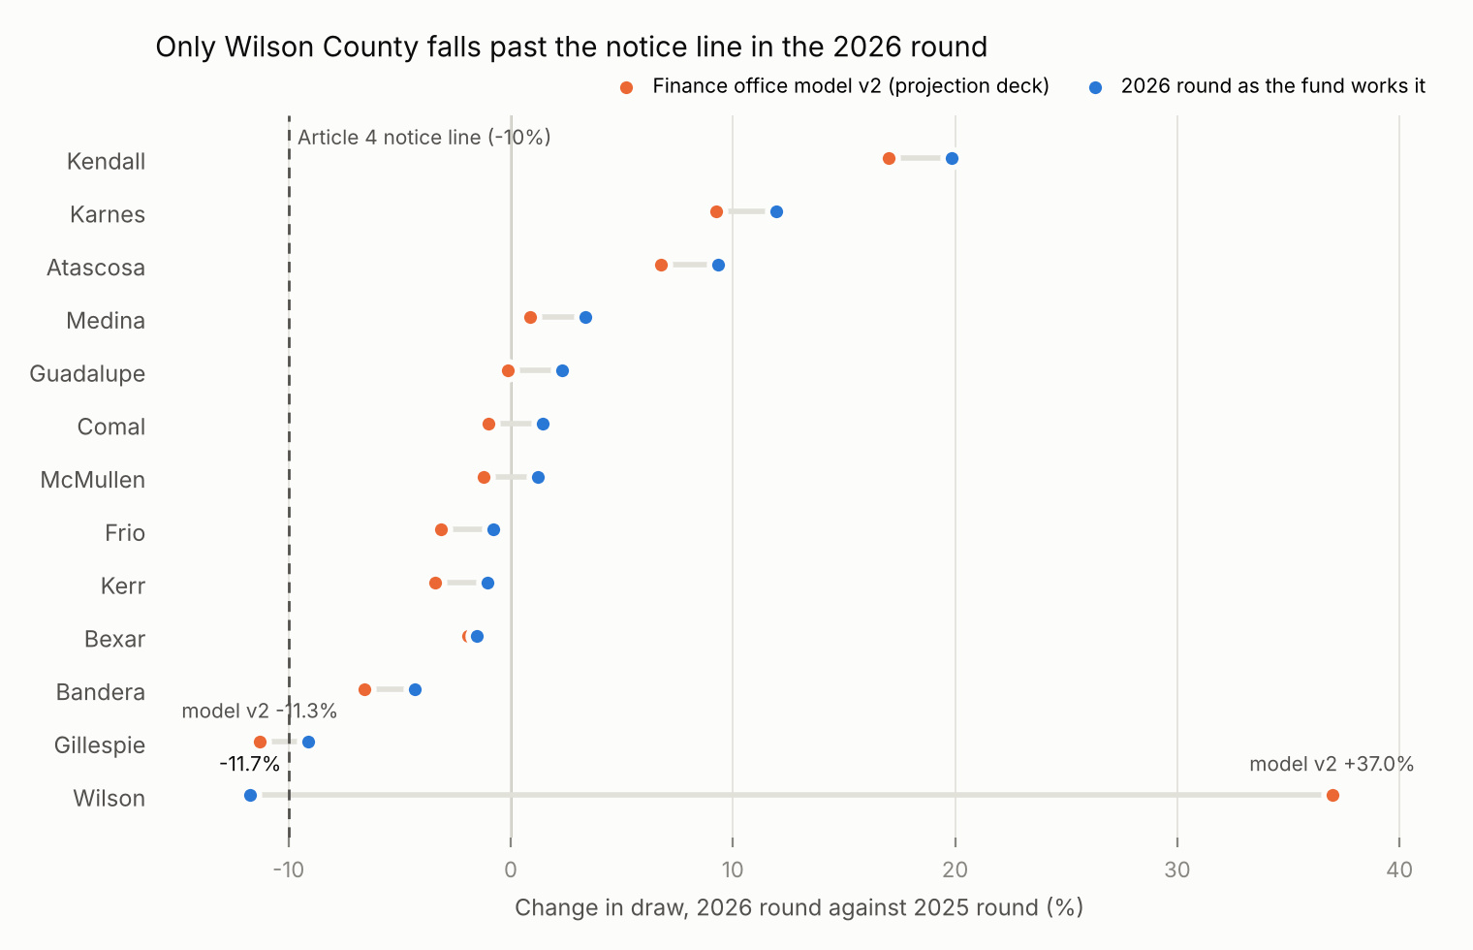
County | 2025 draw | 2026 draw | Change
Atascosa | $79,734 | $87,189 | +9.3%
Bandera | $35,349 | $33,828 | -4.3%
Bexar | $3,033,114 | $2,986,255 | -1.5%
Comal | $643,896 | $653,087 | +1.4%
Frio | $8,074 | $8,011 | -0.8%
Gillespie | $146,097 | $132,778 | -9.1%
Guadalupe | $458,536 | $469,198 | +2.3%
Karnes | $35,919 | $40,205 | +11.9%
Kendall | $215,416 | $258,211 | +19.9%
Kerr | $144,532 | $142,998 | -1.1%
McMullen | $4,818 | $4,876 | +1.2%
Medina | $77,368 | $79,953 | +3.3%
Wilson | $117,147 | $103,409 | -11.7%
Every figure is rebuilt from the BLS annual average private establishment counts in the pack; the same method reproduces all 78 confirmed draws in the round ledger from 2020 to 2025 to the dollar.

