**Project Name:** Factors Influencing Students to Shift to Bachelor of Science in Information Technology From Other Courses.

**MEMBERS :**

Nico De Mesa

Julianne Mary Pabale

Dianne Zotomayor

Axelross Dionisio

Aljen Jovi Roxas

Jhon Mikel Ingote Felipe

**DATE : January 3 2024**

1. **INTRODUCTION**

* The goal of the Factors Influencing Students To Shift To Bachelor of Science in Information Technology From Other Courses research project is to comprehend the dynamics and consequences involved in students switching courses while attending a college or university. Examining the factors that influence students' decisions to alter their courses, the difficulties they encounter in making this adjustment, and the impact of programs intended to assist and encourage these modifications are the main objectives.
* Name, age, course, and reasoning come from students who transfer to the Bachelor of Science in Information Technology curriculum.
* The reason behind the student's decision to transfer from a different field to the bachelor of science in information technology

1. **DATA**

* **Data Set Details**
* 7 Collumns 11 Rows
* String, Integers
* No missing values that we need to handle in this data.
* Data may be easily visualized by using Matplotlib to turn data into a bar graph and Pandas for data import.

1. **Visualization Techniques**
   * Plot and Bar
   * Our goal is to offer our findings in a straightforward graphic format that highlights the various aspects and percentages of our data.
   * A multitude of bar graphs and plots are used to display the percentages of various data sets.
   * We load our data into Google Collab using mat plot lib and pandas for libraries.
2. **Implementation in Google Collab**

* import pandas as pd

dataset = pd.read_csv("shifty_2.csv")

print(dataset.head())

* from matplotlib import pyplot as plt

import seaborn as sns

_df_2.groupby('Gender').size().plot(kind='barh', color=sns.palettes.mpl_palette('Dark2'))

plt.gca().spines[['top', 'right',]].set_visible(False)

* bar_df= df['Course Before'].value_counts().to_frame('count').reset_index()

bar_df= bar_df.sort_values('index')

bar_df.plot.bar(x='index', figsize=(14,8))

plt.xlabel("Course Before")

plt.ylabel("Count")

plt.title("Shifter Course Before")

* Pandas are used to import data into Google Collab.

To display the data's bar graph form, use Mat Plot Lib.

To examine the research data representation, only a bar graph and basic color are needed.

* The main finding of this study is the reason they switch or transfer to this course, which gives us a sense of the most likely reasons why students change their majors and how they choose BSIT without hesitation.

1. **Results and Interpretation**

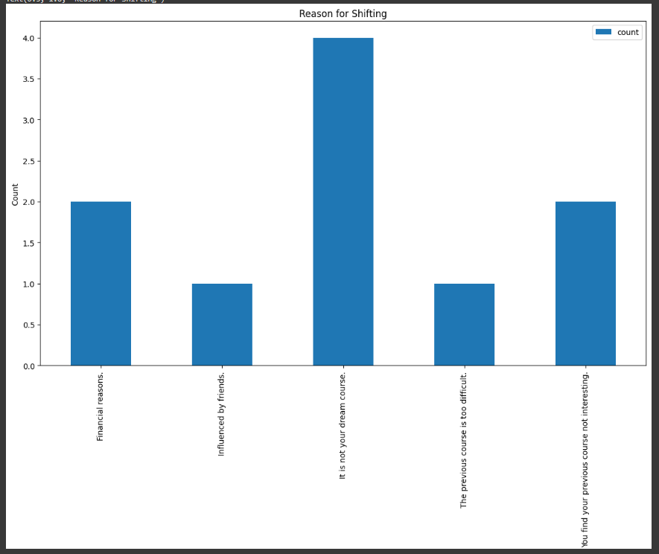

* As you can see from our graphic, the primary finding of our study is a common explanation for a departmental shift in a bachelor's degree in information technology.
* The Graphic shows that the main reason why students switch degrees is because the course they were taking before is not the one they are interested in. They choose to pursue a Bachelor of Science in Information Technology because they aren't sure what kinds of courses they want to study. They're still figuring out what's best for them.
* One of our research's drawbacks is that we limited our analysis to a particular year level in information technology bachelor's degrees. There aren't many students left for interviews. This is biased since we select our own degree in order to have accurate knowledge about the shifter based solely on our year level.

**6. Conclusion**

* One of the project's main conclusions is that some students choose to major in information technology for their bachelor's degree despite not knowing what to expect from the course. They changed their direction as their previous degree was not what they wanted to pursue.
* Interviews with all campus shifters will be conducted as part of this study's future plans. For them to provide information about the course they plan to pursue and for us to comprehend the primary cause of their course changes. to remain stationary in a single degree.

1. **Appendix**

|  |  |  |  |  |  |
| --- | --- | --- | --- | --- | --- |
| **Column Name** | **Data Type** | **Data Format** | **Filed Size** | **Description** | **Example** |
| **Time Stamp** | **Date, Time** | **DD/MM/YYYY** | **10** | **Automatic Time and date based on respond** | **1/1/2024 10:41:00 AM** |
| **Data Privacy Notice** | **Text** |  | **10** | **Answering I agree or not Agree for data privacy.** | **I Agree** |
| **Name (Optional)** | **Text** |  | **20** | **Full Name of Student** | **COL** |
| **Gender** | **Text** |  | **6** | **Gender of Student** | **Male** |
| **Age** | **Integer** | **NN** | **2** | **Age of Student** | **20** |
| **Course Before** | **Text** |  | **50** | **Degree Before of Respondent** | **CIT** |
| **Reason For Shifting** | **Text** |  | **50** | **Reason of Student for shifting** | **The previous course is too difficult.** |

* **pd.read_csv('shifty_2.csv').head()**

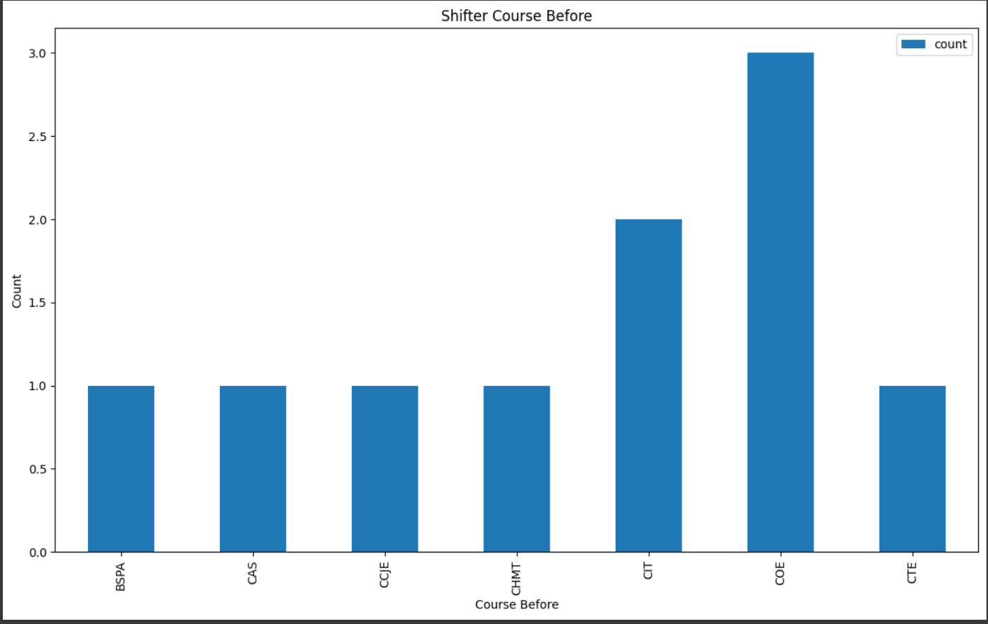

* The Additional Visualization were going to show you is about the course that was taken prior to shifting students, which gives us a high proportion of the course that shifters take in Bachelor's in Science Information Technology Programs. As you can see, a large number of them are engineering college students pursuing a Bachelor's Degree in Computer Engineering.