# How-to: Developing with Linux on eBox-3100EX

## Introduction

The eBox-3100EX is compact, headless unit built on the Vortex86EX platform. It does not contain a GPU (graphics processing unit). This document describes a reasonable workflow for developing and deploying Linux on the eBox-3100EX. This document is provided as is and assumes you have a reasonable knowledge of Linux and related technologies.

## Hardware Requirements

* PC running Linux *
* Serial cable or USB-to-Serial cable
* SD card and USB card reader.
* Hyperterminal application such as minicom

* You can also run Linux in a Virtual Machine such as Virtualbox, however your build time may increase substantially.

## Demo Build

1. Download Buildroot.   
   git clone git://git.buildroot.net/buildroot ~/buildroot
2. Download and copy Buildroot config files.   
   git clone https://gist.github.com/7312889.git ~/br-config  
   cp ~/br-config/buildroot-config ~/buildroot/.config  
   cp ~/br-config/linux-config ~/buildroot/
3. Download and copy buildroot-custom.sh  
   git clone https://gist.github.com/7406068.git ~/br-custom  
   cp ~/br-custom/buildroot-custom.sh ~/buildroot/
4. Compile your build.  
   make
5. Boot the system.

The configuration files provided above will generate a basic working Linux environment with Busybox and SSH installed. Udev is enabled for device management and LAN is configured for DHCP. The kernel image and root file system are located at output/images.

## Customizing

The demo system is very basic, so you will need to customize to your specific needs. You may need to build several times before generating a fully functional system. Be sure you backup your config file just in case. If you need to start over you can always copy over the original config file from Step 2 above.

1. Clean your build environment after each build so that a new kernel image and root file system can be generated.  
   make clean
2. Make any necessary configuration changes.  
   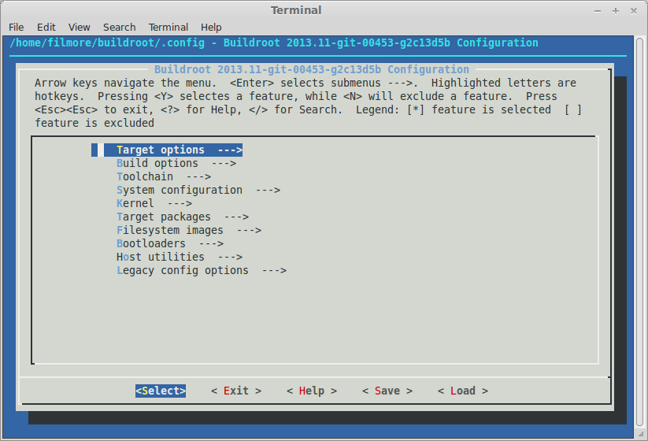make menuconfig
3. Rebuild your system. Output files will be generated in output/target  
   make

## Deploy and Login

Great, now we have a kernel image and root file system. Next, we'll install the system with Syslinux as the boot loader and login via Console Redirection.

1. Download the installation script  
   git clone https://gist.github.com/7521272.git ~/br-install  
   cp ~/br-install/* ~/buildroot/
2. Run the install script; connect your USB storage device to your system and run the following commands.  
   sudo fdisk -l ; confirm your device and **note it's device name**  
   sudo ./install-sys.sh /dev/sdb ; **change /dev/sdb** to reflect your own device name
3. After the system has been installed, remove your storage device and insert it into the eBox-3100EX.
4. Connect the 3100EX to your computer via a USB-to-Serial cable.
5. Configure your Hyperterminal application with the following settings. For our purposes we are using minicom. *Baud: 115200, Parity: None, Data: 8, Stopbits: 1, Flow Control: None*  
   sudo minicom -s

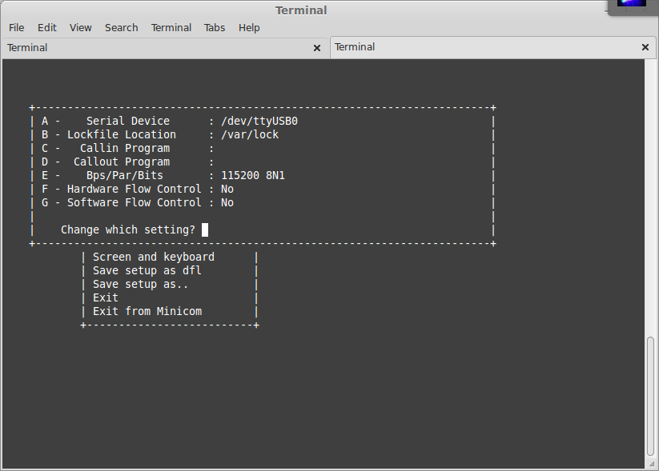

1. Select Exit from the minicom menu to drop to the application window. Turn on your 3100EX and if all went well you should be presented with a login prompt. Login with username: root and no password.

The first time you boot the demo system, SSH keys will be generated for you and saved in /etc. You may use these keys to log into your device via SSH which may be more convenient than Serial + Console Redirection. In order to use SSH, make a note of the device's IP address and issue yourself a password using the passwd command. Open a new terminal window and issue ssh root@<3100ex ip address> to login.