Theme analysis for camera trap publications

Ada Y. Sánchez-Mercado and José R. Ferrer Paris

2020-04-03

Load required packages

library(bibliometrix) #the library for bibliometrics  
require(topicmodels) #for topic modeling  
library(quanteda) #a library for quantitative text analysis  
require(ggplot2) #visualization  
library(dplyr) #for data munging  
library("RColorBrewer") # user friendly color palettes  
library(tidytext)  
library("ldatuning")

Load data from previous step:

load(file=sprintf("%s/ISI-camera-corpus.rda",Rdata.dir))  
load(file=sprintf("%s/%s.rda",Rdata.dir,data.set.id))

This analysis is based on the data-set created from the search with ID: ISI-20191211.

# Standard bibliometric analysis

This would output several summaries for the dataset, de-activating the output for now.

# Document Term Matrix

Create DTM (Document Term Matrix). Common format for text analysis. A DTM is a matrix in which rows are documents, columns are terms, and cells indicate how often each term occurred in each document.

ISI.camera.dfm <- dfm(ISI.camera.bigram, thesaurus = camera_thesaurus)  
ISI.camera.dfm

## Document-feature matrix of: 2,415 documents, 179,997 features (99.9% sparse) and 1 docvar.  
## features  
## docs BEHAVIOUR HOME_RANGE POPULATION DENSITY_ESTIMATION  
## ISI000498887100006 0 0 0 0  
## ISI000497781700009 0 0 0 0  
## ISI000496589200033 0 0 0 0  
## ISI000496310100006 6 0 0 0  
## ISI000496310100011 1 0 0 0  
## ISI000492419000009 0 0 0 0  
## features  
## docs OCCUPANCY_MODEL CAPTURE_RECAPTURE DISTRIBUTION RARITY  
## ISI000498887100006 0 0 0 0  
## ISI000497781700009 0 1 0 0  
## ISI000496589200033 0 0 0 0  
## ISI000496310100006 0 0 0 0  
## ISI000496310100011 1 0 0 0  
## ISI000492419000009 7 0 0 0  
## features  
## docs WIDESPREAD REPROD_LIFEHISTORY  
## ISI000498887100006 0 0  
## ISI000497781700009 0 0  
## ISI000496589200033 0 0  
## ISI000496310100006 0 0  
## ISI000496310100011 0 0  
## ISI000492419000009 0 0  
## [ reached max_ndoc ... 2,409 more documents, reached max_nfeat ... 179,987 more features ]

There are too many features. Lets simplify it by trimming the dfm to include words that have appeared at least 20 times in the corpus.

ISI.camera.dfm <- dfm_trim(ISI.camera.dfm, min_termfreq = 20)

Better?

# Feature co-occurrence matrix

ISI.camera.fcm <- fcm(ISI.camera.dfm)

Extract top 50 keywords based on abstracts and create a feature co-occurrence matrix based on the top 50.

topfeatures(ISI.camera.fcm, 50)

## PROTECTED_AREAS MAMMALS FOREST BEAR   
## 7560 6961 6618 4415   
## PREDATOR_PREY TIGER CONSERVATION_PLAN DENSITY_ESTIMATION   
## 4323 4320 4282 3884   
## CAPTURE_RECAPTURE HUMAN_IMPACT FRAGMENTATION OCCUPANCY_MODEL   
## 3705 3440 3374 3253   
## SPECIES_STATUS WILDLIFE ANIMAL_PLANT snow_leopard   
## 3042 2936 2438 2292   
## HABITAT SEASONALITY wild_boar LARGE_MAMMALS   
## 2271 2128 2046 1819   
## SMALL_MAMMALS BEHAVIOUR HABITAT LOSS CONSERVATION   
## 1765 1696 1673 1648   
## leopard_cat feral_cat cloud_leopard BIOTIC_INTERACTIONS   
## 1564 1557 1492 1484   
## atlant_forest red_fox BIRDS spatial_tempor   
## 1468 1402 1350 1312   
## PALM_PLANTATION leopard_panthera medium_larg DISTRIBUTION   
## 1285 1255 1247 1245   
## MONITORING panthera_pardus detect_speci REPROD_LIFEHISTORY   
## 1205 1186 1127 1119   
## IND_IDENTIFICATION RARITY panthera_tigri panthera_onca   
## 1101 1083 1053 1032   
## pine_marten tiger_panthera DIVERSITY whitetail_deer   
## 1010 982 981 981   
## line_transect puma_concolor   
## 958 946

feat <- names(topfeatures(ISI.camera.fcm, 50))  
ISI.camera.fcm <- fcm_select(ISI.camera.fcm, feat)

We could use this to plot the network, but this step takes time, we are skipping this for now.

size <- log(colSums(dfm_select(ISI.camera.dfm, feat)))  
  
textplot_network(ISI.camera.fcm, min_freq = 0.5, vertex_size = size/max(size) * 3)

Plot top keywords frequencies instead:

freq <- textstat_frequency(ISI.camera.dfm, n = 50)  
ISI.camera.dfm %>%  
textstat_frequency(n = 20) %>%  
ggplot(aes(x = reorder(feature, frequency), y = frequency)) +  
geom_point() +  
coord_flip() +  
labs(x = NULL, y = "Frequency") +  
theme_minimal()

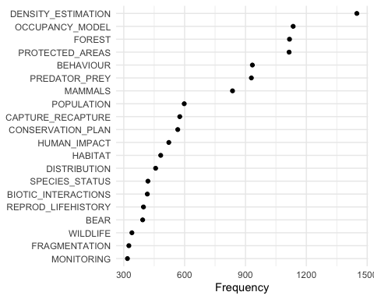

Also plot a word cloud (but note that some words are excluded due to their size).

textplot_wordcloud(ISI.camera.dfm, max_words = 100,  
 random.order=FALSE, rot.per=0.35,  
 colors=brewer.pal(8, "Dark2"))

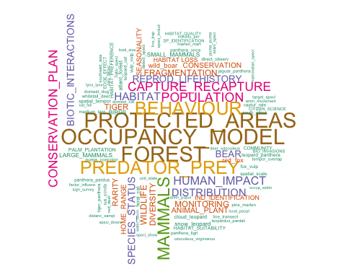

# LDA model

Now,apply Natural Language Processing and Topic Modeling to abstracts to identify the topics published in camera trap research.

We transform the DFM to DTM

ISI.camera.dtm <- convert(ISI.camera.dfm, to = "topicmodels")

Now we need determine what is the optimal number of topics we should specify in the LDA model

Package ldatuning realizes 4 metrics to select perfect number of topics for LDA model.

if (!exists("result")) {  
 result <- FindTopicsNumber(  
 ISI.camera.dtm,  
 topics = c(5:15,seq(from = 16, to = 61, by = 5)),  
 metrics = c("CaoJuan2009"),  
 method = "Gibbs",  
 control = list(seed = 77),  
 mc.cores = 2L,  
 verbose = TRUE  
 )  
}

## fit models... done.  
## calculate metrics:  
## CaoJuan2009... done.

plot(CaoJuan2009~topics,result)

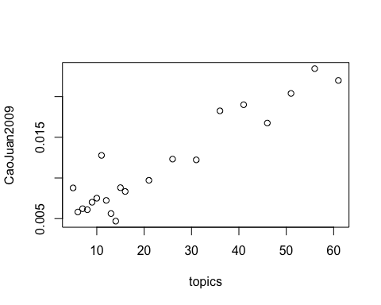

We will set the number of terms to 10

Now, we can fit our first LDA model

ISI.camera.lda <- LDA(ISI.camera.dtm, control=list(seed=0), k = 10)

Show top 10 words pertaining to each topic

terms(ISI.camera.lda, 10)

## Topic 1 Topic 2 Topic 3   
## [1,] "DENSITY_ESTIMATION" "MAMMALS" "PREDATOR_PREY"   
## [2,] "POPULATION" "DIVERSITY" "REPROD_LIFEHISTORY"  
## [3,] "CAPTURE_RECAPTURE" "SMALL_MAMMALS" "pine_marten"   
## [4,] "IND_IDENTIFICATION" "LARGE_MAMMALS" "panthera_pardus"   
## [5,] "HOME_RANGE" "BIRDS" "leopard_panthera"   
## [6,] "CONSERVATION_PLAN" "DISTRIBUTION" "mammalian_carnivor"  
## [7,] "RARITY" "PROTECTED_AREAS" "sika_deer"   
## [8,] "SPECIES_STATUS" "COMMUNITY" "carnivor_popul"   
## [9,] "distanc_sampl" "medium_larg" "south_africa"   
## [10,] "individu_per" "captur_rate" "wild_dog"   
## Topic 4 Topic 5 Topic 6   
## [1,] "FOREST" "BIOTIC_INTERACTIONS" "BEAR"   
## [2,] "FRAGMENTATION" "TIGER" "PROTECTED_AREAS"   
## [3,] "HABITAT" "ANIMAL_PLANT" "CONSERVATION_PLAN"   
## [4,] "HABITAT LOSS" "wild_boar" "SPECIES_STATUS"   
## [5,] "atlant_forest" "PROTECTED_AREAS" "SEASONALITY"   
## [6,] "PALM_PLANTATION" "panthera_tigri" "cloud_leopard"   
## [7,] "SPECIES_STATUS" "tiger_panthera" "CONSERVATION"   
## [8,] "DISTRIBUTION" "sus_scrofa" "WILDLIFE"   
## [9,] "EDGE_EFFECT" "red_deer" "HABITAT_SUITABILITY"  
## [10,] "HABITAT_QUALITY" "tree_speci" "leopard_cat"   
## Topic 7 Topic 8 Topic 9   
## [1,] "MONITORING" "BEHAVIOUR" "OCCUPANCY_MODEL"   
## [2,] "WILDLIFE" "HUMAN_IMPACT" "whitetail_deer"   
## [3,] "feral_cat" "HABITAT" "unit_state"   
## [4,] "RARITY" "spatial_tempor" "deer_odocoileus"   
## [5,] "line_transect" "puma_concolor" "water_sourc"   
## [6,] "target_speci" "panthera_onca" "occup_estim"   
## [7,] "direct_observ" "HOME_RANGE" "odocoileus_virginianus"  
## [8,] "CITIZEN_SCIENCE" "jaguar_panthera" "wild_pig"   
## [9,] "CONSERVATION_PLAN" "tempor_overlap" "survey_site"   
## [10,] "live_trap" "puma_puma" "fox_squirrel"   
## Topic 10   
## [1,] "PROTECTED_AREAS"   
## [2,] "red_fox"   
## [3,] "snow_leopard"   
## [4,] "fox_vulp"   
## [5,] "vulp_vulp"   
## [6,] "CONSERVATION_PLAN"  
## [7,] "domest_dog"   
## [8,] "DISTRIBUTION"   
## [9,] "domest_cat"   
## [10,] "cani_latran"