Can ids recorded:
-1 B3=120
11 (all zero)
-12
13 (all zero)
-21 B4=90 B5=90 B6=90 B7=90
-22 B1=15 B3=71
-23 (all zero)
-24 -132 – 3 -132 – 3 -132 – 3 -132 – 3 (low byte=132, high byte=2)
-25 -2 -90 -0 -0 -200 -20 -180 -0
-26 (all zero)
-31 (all zero)
-32 -90 –90 –89 –89 –0 –0 –0 -0 (+-1 in 4 first byte)
-33 -15 –71 –0 –0 –0 –9 –7 -0
-34 - 131- 0- 0- 0- 0- 1- 0- 0 (+-1 in first byte)
-51 - 0- 0- 0- 16- 0- 48- 0- 0
-99 (all zero)
-100 (all zero)
200 - 0- 0- 0- 0- 28- 0- 0- 0
CAN frames controlling the operation of an autonomous field robot
Warsaw University of Technology controller -> PIMR controller

ID | bits | B0 | B1 | B2 | B3 | B4 | B5 | B6 | B7
1 | 8 | 0-1 | 0-1 | 0-1 | 0-255 | 0-1 | 0-1 | 0-100 | 0-1
120
B0 - drives STOP; 0 - inactive; 1 - STOP of all drives active
B1 - engine STOP; 0 - the internal combustion engine can work; 1 - engine shutdown
B2 - COMMISSIONING; 0 - inactive; 1 - ignition of the internal combustion engine
B3 - Idle engine speed; 0 - 255 (255 means 2550 rpm)
B4 - Brake off; 0 - brake active; 1 - brake off
B5 - Turning on the distributors (valves arming); 0 - manifolds not active; 1 – manifolds ready to go
B6 - Robot speed from GPS; 0 - the robot is not moving; 100 - robot speed = 10 km / h
B7 - Safe mode; 0 - inactive; 1 - emergency mode active

Information parameter - control parameter
…… ..

The following frame is included when the automatic operating mode is activated: (ID 100 B2 -> 1)
The frame should be sent on a different CAN bus than the other frames
ID | bits | B0 | B1 | B2 | B3 | B4 | B5 | B6 | B7
12 | 8 | 0-2 | 0-2 | 0-1 | 0-1 | 0-1 | 0-1 | 0-1 | 0-1

B0 - Section 1 of a foliar sprayer ; 0 - closed; 1 - open
B1 - Section 2 of a foliar sprayer ; 0 - closed; 1 - open
B2 - Section 3 of a foliar sprayer ; 0 - closed; 1 - open
B3 - Section 4 of a foliar sprayer ; 0 - closed; 1 - open
B4 - Section 1 of the arable sprayer; 0 - closed; 1 - open
B5 - Section 2 of the arable sprayer; 0 - closed; 1 - open
B6 - Section 3 of the arable sprayer; 0 - closed; 1 - open
B7 - Section 4 of the arable sprayer; 0 - closed; 1 - open

The following frame is included when the turn mode is activated: 1 ( ID 25)
ID | bits | B0 | B1 | B2 | B3 | B4 | B5 | B6 | B7
21 | 8 | 0-2 | 0-100 | 0-2 | 0-100 | 0-180 | 0-180 | 0-180 | 0-180
B4=90 B5=90 B6=90 B7=90
B0 - Direction of wheels rotation on the LEFT side; 0 - STOP wheels; 1 - forward; 2 - backwards
B1 - Wheel speed setting on the LEFT side; 0 - STOP wheels; 100 - maximum speed
B2 - Direction of rotation of the wheels on the RIGHT side; 0 - STOP wheels; 1 - forward; 2 - backwards
B3 - Wheel speed setting on the RIGHT side; 0 - STOP wheels; 100 - maximum speed
B4 - Turn PL (left front wheel turn);
0 - max turn left (-90 degrees);
90 - circle on straight (0 degrees);
180 - max turn right (90 degrees)
B5 - PP turn (right front wheel turn); 0 - max turn left (-90 degrees); 90 - circle on
straight (0 degrees); 180 - max turn right (90 degrees)
B6 - TL turn (left-hand rear wheel turn); 0 - max turn left (-90 degrees); 90 - circle on
straight (0 degrees); 180 - max turn right (90 degrees)
B7 - TP turn (right-hand rear wheel turn); 0 - max turn left (-90 degrees); 90 - circle on
straight (0 degrees); 180 - max turn right (90 degrees)

ID | bits | B0 | B1 | B2 | B3 | B4 | B5 | B6 | B7
22 | 8 | 0-2 | 0-100 | 0-1 | 0-100 | 0-2 | 0-2 | 0-1 | 0-1

B0 - Vertical tool correction; 0 - disabled; 1 - manual correction; 2 - automatic correction
(dependent on tool level sensors)
B1 - Setting the position of the vertical actuator (correcting the vertical position of the tools);
0 - maximum lowering of tools; 100 - maximum lifting of tools
B2 - Horizontal tool correction; 0 - disabled; 1 - manual correction
B3 - Setting the position of the horizontal actuator (correcting the horizontal position of the tools);
0 - maximum shift to the left side; 100 - maximum shift to the right
B4 - Rotary cultivator conversion; 0 - no reaction; 1 - move to the left; 2 - move to the right
B5 - Tiller drive; 0 - disabled; 1 - anti-clockwise rotation; 2 - clockwise rotation
B6 - Manual drive of the hydraulic oil cooler; 0 - disabled; 1 - radiator engine on
B7 - Suction fan drive; 0 - off; 1 - enabled

ID | bits | B0 | B1 | B2 | B3 | B4 | B5 | B6 | B7
23 | 8 | 0-2 | 0-50 | 0-1 | 0-1 | 0-1 | 0-1 | 0-255 | 0-255

B0 - Seeding shaft drive; 0 - shaft does not rotate; 1 - automatic settings according to the algorithm; 2 - manual seeding control;
B1 - Rotation of the sowing shaft in manual mode; 0-32 - value specifying the quantity of rpm
B2 - Sprayer hydraulic drive; 0 - off; 1 - drive enabled
B3 - Electric drive of the sprayer; 0 - off; 1 - drive enabled
B4 - Lights 1; 0 - disabled; 1 - enabled
B5 - Lights 2; 0 - disabled; 1 - enabled
B6 - Additional tool 1 (optional element); 0 - disabled; 255 - maximum value of the setting
B7 - Additional tool 2 (optional element); 0 - disabled; 255 - maximum value of the setting

ID | bits | B0 | B1 | B2 | B3 | B4 | B5 | B6 | B7
24 | 8 | LSB | MSB | LSB | MSB | LSB | MSB | LSB | MSB

B0 and B1 - Turn PL (turn of the front wheel on the left side); 0 - max turn left (-90 degrees); 900 - wheel straight ahead (0 degrees); 1800 - max turn right (90 degrees); a double-byte variable WORD type; B0 - LSB (low byte); B1 - MSB (high byte)
B2 and B3 - PP turn (right front wheel turn); 0 - max turn left (-90 degrees);
900 - wheel straight ahead (0 degrees); 1800 - max turn to the right (90 degrees); a double-byte variable
WORD type; B2 - LSB (low byte); B3 - MSB (high byte)
B4 and B5 - TL turn (left-hand rear wheel turn); 0 - max turn left (-90 degrees);
900 - wheel straight ahead (0 degrees); 1800 - max turn to the right (90 degrees); a double-byte variable
WORD type; B4 - LSB (low byte); B5 - MSB (high byte)
B6 and B7 - TP turn (right rear wheel turn); 0 - max turn left (-90 degrees);
900 - wheel straight ahead (0 degrees); 1800 - max turn right (90 degrees); a double-byte variable
WORD type; B6 - LSB (low byte); B7 - MSB (high byte)

ID | bits | B0 | B1 | B2 | B3 | B4 | B5 | B6 | B7
25 | 8 | 0-5 | 0-180 | 0-2 | 0-100 | 1-250 | 1-30 | 124-188 | 0
-2 -90 -0 -0 -200 -20 - 180 -0
B0 - Wheels turning mode;
0 - inactive;
1 - each wheel turns independently;
2 - car mode (front swivel wheels);
3 - machine mode (swivel front and rear wheels to the opposite page);
4 - parallel mode (all wheels turn in parallel);
5 - winding mode w place (the wheels adjust automatically, allowing the robot to rotate in place) (fig. 1)

B1 - Steering angle of the wheels (works in the following steering modes: 2, 3 and 4);
0 - max turn left (-90 degrees);
90 - circle on straight (0 degrees);
180 - maximal turn to the right (90 degrees) (in mode 2 the angle is limited in the range of 40-140 degrees, and in mode 3 in the range of 50-130 degrees)
B2 - Driving direction (works in modes 2, 3, 4, 5);
0 - the robot is not moving;
1 - forward drive (or around to the right in 5);
2 - driving backwards (or around to the left in mode 5)
B3 - Robot speed setting;
0 - the robot is not moving;
100 - the maximum speed of the wheels
B4 - Distance between seeds;
1-250 - a value that determines the distance between seeds during
seeding (mm)
B5 - Number of holes in the shield;
1-30 - a value specifying the number of holes in the seeder's disc
B6 - Robot wheel track;
124-188 - track width range (cm) ???????
B7 - Inactive

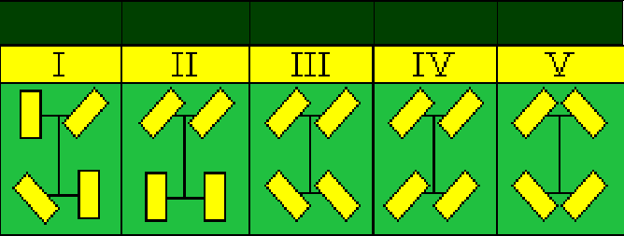
Fig 1. Steering modes for the ID 25 B0

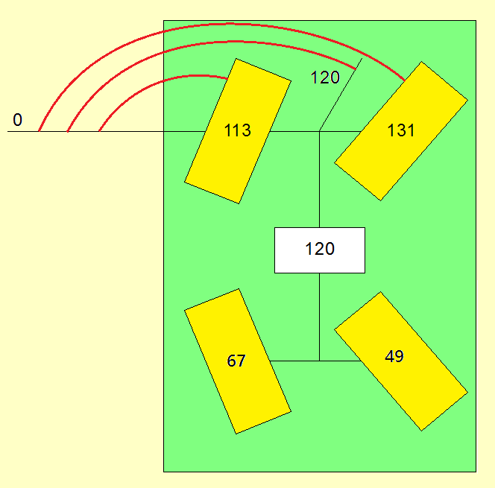
Fig 2. Turn mode 3; angle setting of 120 degrees

ID | bits | B0 | B1 | B2 | B3 | B4 | B5 | B6 | B7
26 | 8 | 0-1 | 0-1 | 0-1 | 0-1 | 0 | 0 | 0 | 0

B0 - Mixing solenoid valve in the arable system of the sprayer; 0 - off; 1 - enabled
B1 - Solenoid valve for opening the arable system of the sprayer; 0 - off; 1 - enabled
B2 - Solenoid valve for venting in the soil system of the sprayer;
0 - off; 1 - enabled
B3 - Solenoid valve for venting in the foliar system of the sprayer; 0 - off; 1 - enabled
B4 - Inactive
B5 - Inactive
B6 - Inactive
B7 - Inactive

MASTER CAN frame that controls the operation of an autonomous field robot
CONTROL REMOTE -> other controllers

ID | bits | B0 | B1 | B2 | B3 | B4 | B5 | B6 | B7
100 | 8 | 0-1 | 0-1 | 0-1 | 0 | 0 | 0 | 0 | 0

B0 - drives STOP; 0 - inactive; 1 - STOP of all drives active
B1 - engine STOP; 0 - the internal combustion engine can work; 1 - engine shutdown
B2 - MAN / AUTO; 0 - manual mode; 1 - automatic mode
B3 - Inactive
B4 - Inactive
B5 - Inactive
B6 - Inactive
B7 - Inactive

CAN frames with information from measuring sensors
PIMR driver -> control drivers
ID | bits | B0 | B1 | B2 | B3 | B4 | B5 | B6 | B7
31 | 8 | LSB | MSB | LSB | MSB | LSB | MSB | LSB | MSB
Time interval: 220 ms;
B0 i B1 - Rotational speed PL; a two-byte variable of the WORD type that specifies the speed value
left front rotating wheel ( imp / s) * 100; B0 - LSB (low byte); B1 - MSB
(high byte)
B2 and B3 - Rotational speed of the PP; a two-byte variable of the WORD type that specifies the speed value
right-hand front wheel rotating ( imp / s) * 100; B0 - LSB (low byte); B1 - MSB
(high byte)
B4 and B5 - Rotational speed TL; a two-byte variable of the WORD type that specifies the speed value
left-hand rear wheel rotating ( imp / s) * 100; B0 - LSB (low byte); B1 - MSB
(high byte)
B6 and B7 - Rotational speed TP; a two-byte variable of the WORD type that specifies the speed value
right-hand rear wheel rotating ( imp / s) * 100; B0 - LSB (low byte); B1 - MSB
(high byte)
1 revolution of the wheel equals 54 pulses
ID | bits | B0 | B1 | B2 | B3 | B4 | B5 | B6 | B7
32 | 8 | 0-180 | 0-180 | 0-180 | 0-180 | 0-60 | 0-60 | 0-60 | 0-60
Time interval: 125 ms;
B0 - Turn PL (left front wheel turn); 0 - max turn left (-90 degrees); 90 - circle on
straight (0 degrees); 180 - max turn right (90 degrees);
B1 - PP turn (right front wheel turn); 0 - max turn left (-90 degrees); 90 - circle on
straight (0 degrees); 180 - max turn right (90 degrees);
B2 - TL turn (left-hand rear wheel turn); 0 - max turn left (-90 degrees); 90 - circle on
straight (0 degrees); 180 - max turn right (90 degrees);
B3 - TP turn (right-hand rear wheel turn); 0 - max turn left (-90 degrees); 90 - circle on
straight (0 degrees); 180 - max turn right (90 degrees);
B4 - Rotational speed PL; value representing the rotational speed of the left front wheel
( rpm );
B5 - PP rotational speed; value representing the rotational speed of the front wheel on the right
( rpm );
B6 - TL rotational speed; value representing the rotational speed of the left rear wheel
( rpm );
B7 - TP rotational speed; value representing the rotational speed of the rear right wheel
( rpm );

ID | bits | B0 | B1 | B2 | B3 | B4 | B5 | B6 | B7
33 | 8 | 0-100 | 0-100 | 0-1 | 0-1 | 0-50 | 0-100 | 0-100 | 0
33 -15 –71 –0 –0 –0 –9 –7 -0
Time Interval: 425 ms;
B0 - Position of the vertical actuator (corrects the vertical position of the tools);
0 - maximum lowering of tools; 100 - maximum lifting of tools
B1 - Position of the horizontal actuator (corrects the horizontal position of the tools);
0 - maximum shift to the left side; 100 - maximum shift to the right
B2 - LEFT end of the tiller; 0 - limit switch is not enabled; 1 - the tiller is located from left side
B3 - RIGHT end stop of the tiller; 0 - limit switch is not enabled; 1 - the tiller is located from
right side
B4 - Rotation speed of the sowing shaft; 0 - shaft does not rotate; 0-50 - value specifying
shaft rotational speed in rpm
B5 - Level of fertilizer filling in 1 tank; 0-100 - value specifying% of tank filling
B6 - Level of fertilizer filling in the 2nd hopper; 0-100 - value specifying% of tank filling
B7 - Inactive

ID | bits | B0 | B1 | B2 | B3 | B4 | B5 | B6 | B7
34 | 8 | 0-120 | 0 | 0-100 | 0-250 | 0-1 | 0-1 | 0-60 | 0
- 131- 0- 0- 0- 0- 1- 0- 0 (+-1 in first byte)
Time Interval: 1050 ms;
B0 - Tool level sensor; value specifying the tool level in degrees minus 60
(e.g. 65 means 65-60 = 5 degrees)
B1 - Inactive
B2 - hydraulic oil temperature at the selected point; 0-100 - value specifying
temperature ( º C )
B3 - hydraulic oil pressure at the selected point; 0-250 - value determining pressure (bar)
B4 - minimum condition of hydraulic oil; 0 - more than min; 1 - minimum condition
B5 - maximum level of hydraulic oil; 0 - below max; 1 - maximum state
B6 - average rotational speed of the wheels; value representing the average rotational speed of the wheels
( rpm );
B7 - Inactive

ID | bits | B0 | B1 | B2 | B3 | B4 | B5 | B6 | B7
99 | 8 | 0-1 | 0-1 | 0-1 | 0-1 | 0 | 0 | 0 | 0

Time interval: 1540 ms;
B0 - Failure of turning a wheel PL; 0 - correct operation; 1 - faulty sensor or connection
B1 - PP wheel turning failure; 0 - correct operation; 1 - faulty sensor or connection
B2 - TL wheel turning failure; 0 - correct operation; 1 - faulty sensor or connection
B3 - TP wheel turning failure; 0 - correct operation; 1 - faulty sensor or connection
B4 - Failure of the vertical actuator; 0 - correct operation; 1 - faulty sensor or connection
B5 - Horizontal actuator failure; 0 - correct operation; 1 - faulty sensor or connection
B6 - Tool level sensor failure; 0 - correct operation; 1 - faulty sensor or
connection
B7 - Inactive

CAN frame sent by the internal combustion engine controller

ID | bits | B0 | B1 | B2 | B3 | B4 | B5 | B6 | B7
51 | 8 | LSB | MSB | 0-1 | 0-100 | 0 | 0-100 | 0 | 0-100
- 0- 0- 0- 16- 0- 48- 0- 0
B0 and B1 - Rotational speed of the combustion engine; a two-byte variable of the WORD type that determines
the value of the rotational speed of the combustion engine ( rpm ); B0 - LSB (low byte);
B1 - MSB (high byte)
B2 - Internal combustion engine operation; 0 - off; 1 - the engine is running
B3 - Coolant temperature; 0 - 100 - value determining the temperature ( º C )
B4 - Inactive
B5 - Fuel level in the tank; 0-100 - value specifying% of tank filling
B6 - Inactive
B7 - Oil pressure in the internal combustion engine; 0 - 100 (100 means 10 bar)

