IBM Cloud Private 3.1.2

**Lab Exercise # Security 1**

**Enable TLS with custom CA Issuer and certificate at Ingress**

**Duration: 45 mins**

**Objective**

The objective of this lab is to know how to enable TLS communication in the applications. Also get to know different ways of using certificates in IBM Cloud Private environment and manage the Issuers.

**Pre-requisites**

We are going to use a helloworld application for this lab.

Deploy a helloworld app using the YAML file provided below.

**Note**: Please change the service name, which is highlighted in the section below, before making the deployment.

***kubectl apply -f <yaml file> --namespace <your-namespace>***

apiVersion: v1

kind: Service

metadata:

name: **helloworld<your-user-id>**

labels:

app: helloworld

spec:

ports:

- port: 5000

name: http

selector:

app: helloworld

---

apiVersion: extensions/v1beta1

kind: Deployment

metadata:

name: helloworld-v1

spec:

replicas: 1

template:

metadata:

labels:

app: helloworld

version: v1

spec:

containers:

- name: helloworld

image: ilon1.icp:8500/helloworld-v1

resources:

requests:

cpu: "100m"

imagePullPolicy: IfNotPresent #Always

ports:

- containerPort: 5000

**Instructions**

1. Check the Issuer in the IBM Cloud Private environment.

$ kubectl get clusterissuer

NAME AGE

icp-ca-issuer 132d

Get the issuer specific to the namespace, if any available

$ kubectl get issuer

NAME AGE

hello-deployment-tls 1h

hello-self-tls 1h

In the next step let’s create a custom “Issuer” specific to namespace and use that in “Ingress” to access the helloworld application.

1. Create a self-signed Issuer. Use the following .yaml file to define a self-signed Issuer.

**Note:** Replce **<your-namespace>** and **<user-id>** with the namespace given to you, in the yaml given below.

***kubectl apply -f <yaml file> --namespace <your-namespace>***

apiVersion: certmanager.k8s.io/v1alpha1

kind: Issuer

metadata:

name: hello-**<user-id>**-tls

namespace: **<your-namespace>**

spec:

selfSigned: {}

1. After you create the self-signed Issuer, create a CA certificate that references the self-signed Issuer and specifies the isCA field.

**Note:** Replce **<user-id>** with the user-id given to you, in the yaml given below.

***kubectl apply -f <yaml file> --namespace <your-namespace>***

apiVersion: certmanager.k8s.io/v1alpha1

kind: Certificate

metadata:

name: **hello-<user-id>-cert-tls**

spec:

# name of the tls secret to store

# the generated certificate/key pair

secretName: **hello-<user-id>-tls-ca-key-pair**

isCA: true

issuerRef:

# issuer created in step 1

name: **hello-<user-id>-tls**

kind: Issuer

commonName: "**foo<user-id>.bar**"

dnsNames:

# one or more fully-qualified domain name

# can be defined here

- **foo<user-id>.bar**

1. Edit the following sample of an Issuer that references the previous secret. Edit the <name> and <namespace> from the metadata section of the .yaml file. Be sure that secretName from the spec section matches the secretName from the previous step:

**Note:** Replce **<your-namespace>** and **<user-id>** with the namespace given to you, in the yaml given below.

***kubectl apply -f <yaml file> --namespace <your-namespace>***

apiVersion: certmanager.k8s.io/v1alpha1

kind: Issuer

metadata:

name: **self-ca-issuer-<user-id>**

namespace: blueworld

spec:

ca:

secretName: **hello-<user-id>-tls-ca-key-pair**

**Now a custom issuer called ‘self-ca-issuer-<user-id>’ is created, you can create custom CA issuer with third party or enterprise provider.**

1. Define the certificate using the custom CA issuer created in Step 3. helloworld.x.x.x.x.nip.io is the CN for the certificate. X.X.X.X is the IP address of proxy

**Note:** Replce **<your-namespace>** and **<user-id>** with the namespace given to you, in the yaml given below.

***kubectl apply -f <yaml file> --namespace <your-namespace>***

apiVersion: certmanager.k8s.io/v1alpha1

kind: Certificate

metadata:

name: **helloworld-tls-cert-<user-id>**

namespace: **<your-namespace>**

spec:

# name of the tls secret to store

# the generated certificate/key pair

secretName: **helloworld-tls-certs-<user-id>**

isCA: true

issuerRef:

# issuer created in step 1

name: **self-ca-issuer-<user-id>**

kind: Issuer

commonName: **helloworld<user-id>.172.16.70.58.nip.io**

dnsNames:

# one or more fully-qualified domain name

# can be defined here

- **helloworld<user-id>.172.16.70.58.nip.io**

1. Add the Secret to the Kubernetes Ingress. The following step defines a TLS-enabled Kubernetes Ingress that is integrated with cert-manager. Here, **helloworld-tls-certs** matches the secretName that you previously defined and host matches the DNS name that you previously defined in the certificate.

apiVersion: extensions/v1beta1

kind: Ingress

metadata:

name: **helloworld-<user-id>-ingress-tls**

annotations:

kubernetes.io/ingress.class: "nginx"

ingress.kubernetes.io/rewrite-target: "/"

spec:

tls:

# k8s ingress defines different tls certificates

# for each nginx server blocks.

# k8s ingress default cert is used if

# no host-specific secret specified

- hosts:

# this is the fully-qualified domain name

# of the first server block

- hello.9.202.178.184.nip.io

# certificate hello-k8s-ingress-tls-1

# is only used by foo1.bar1

secretName: **helloworld-tls-certs-<user-id>**

rules:

# each server block redirects request

# to its own backend service

- host: **helloworld<user-id>.172.16.70.58.nip.io**

http:

paths:

- backend:

serviceName: helloworld

servicePort: 5000

1. Access the application using <https://helloworld.x.x.x.x.nip.io/hello>

If you are using self-signed key, probably a warning message on the certificate would appear, try to view the detail of the certificate

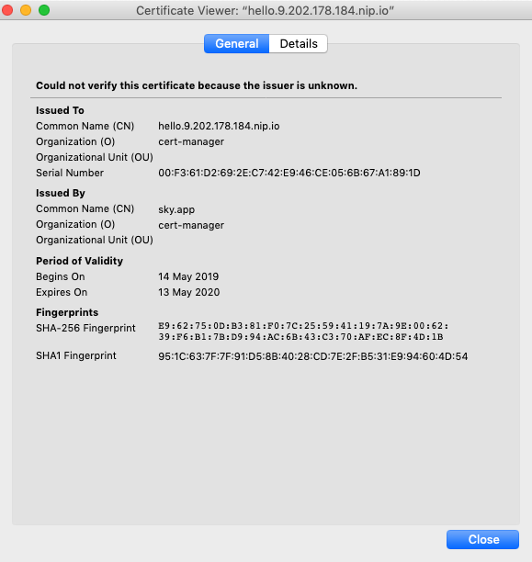

**Summary**

You have gone through the steps of deploying Ingress with self-signed certificate generated through custom CA Issuer.

**Try the following**

* Enabling SSL with third-party certificates for IBM Cloud Private and deploy the Liberty server

<https://www.ibm.com/support/knowledgecenter/SSD28V_9.0.0/com.ibm.websphere.wlp.core.doc/ae/twlp_icp_auto_ssl3.html>

* Try to deploy liberty application with default ICP issuer

<https://www.ibm.com/support/knowledgecenter/en/SSBS6K_3.1.2/manage_applications/create_issuer.html>