Control Theory: Tutorial with Julia

Iacopo Moles

Table of contents

# 1. Introduction

## 1.1 Intro

This is a collection of write ups on how to solve the various problems presented by [Github user](https://janismac.github.io/ControlChallenges/) “Janismac”.

## 1.2 What do I need?

### 1.2.1 Software

* A real OS like Linux or Windows. [1]
* The [Julia Programming Language](https://julialang.org/install/)
  + Clone the [repo](https://github.com/icpmoles/controlchallengessolutions)
  + Activate the package by running in your terminal:
  + julia --project -e 'using Pkg; Pkg.instantiate()'
* (Nice to have) [OpenModelica Editor](https://openmodelica.org/)

### 1.2.2 Theory

* Basic Julia knowledge
* Basic JS knowledge
* Control Theory knowledge
  + Frequency Based Control
  + State Space Based control
* Misc knowledge:
  + Linear Algebra
  + Differential Equations

# 2. The Damped Mass problem

## 2.1 Modeling

To better understand the problem let’s take a [peek](https://github.com/janismac/ControlChallenges/blob/gh-pages/js/models/BlockOnSlope.js) at how the simulated model works.

Models.BlockOnSlope.prototype.vars =   
{  
 g: 9.81,  
 x: 0, // distance from objective s  
 dx: 0, // velocity v  
 slope: 1, // slope coefficient alpha = dy/dx in the cartesian plane  
 F: 0, // Requested u  
 F_cmd: 0, // Saturated u  
 friction: 0, // Coulomb friction coefficient mu  
 T: 0, // Simulation Time  
};  
  
Models.BlockOnSlope.prototype.simulate = function (dt, controlFunc)  
{  
 this.F_cmd = controlFunc({x:this.x,dx:this.dx,T:this.T});  
 if(typeof this.F_cmd != 'number' || isNaN(this.F_cmd)) throw "Error: The controlFunction must return a number.";  
 this.F_cmd = Math.max(-20,Math.min(20,this.F_cmd));  
 integrationStep(this, ['x', 'dx', 'F'], dt);  
}  
  
Models.BlockOnSlope.prototype.ode = function (x)  
{  
 return [  
 x[1],  
 (x[2]) - (Math.sin(this.slope) * this.g) - (this.friction * x[1]),  
 20.0 * (this.F_cmd - x[2])  
 ];  
}

Line 2

The model has obviously some default values for the parameters that can be modified for the different scenarios.

Line 17

The control command $u$ is generated by the controlFunction(block) function provided by us. There are some checks to see if it’s a number. If it’s acceptable then it passes through a saturation between $±20$.

Lines 24-26

The model is a simple ODE with equations:

$$\left\{\begin{matrix}\dot{s}=v \\ \dot{v}=F−sin\left(α\right)⋅g−μ⋅v \\ \dot{F}=−20⋅F+20⋅u_{sat} \\ \end{matrix}\right.$$

Converting it in state-space representation:

$$\left[\begin{matrix}\dot{s} \\ \dot{v} \\ \dot{F}\end{matrix}\right]=\left[\begin{matrix}0 & 1 & 0 \\ 0 & −μ & 1 \\ 0 & 0 & −20\end{matrix}\right]\left[\begin{matrix}s \\ v \\ F\end{matrix}\right]+\left[\begin{matrix}0 \\ 0 \\ u_{sat}\end{matrix}\right]+\left[\begin{matrix}0 \\ −sin\left(α\right)⋅g \\ 0\end{matrix}\right]$$

$$\left[\begin{matrix}s \\ v\end{matrix}\right]=\left[\begin{matrix}1 & 0 & 0 \\ 0 & 1 & 0\end{matrix}\right]\left[\begin{matrix}s \\ v \\ F\end{matrix}\right]$$

Obviously the gravitational term acts as a disturbance.

# 3. Block without Friction

Position Control with friction. Using Pole Placement + PD.

## 3.1 State Space representation

We can convert the set of ODE into a state space representation. The final bode plot of the block position is:

using DiscretePIDs, ControlSystems, Plots, LinearAlgebra  
  
# System parameters  
Ts = 0.02 # sampling time  
Tf = 2.5; #final simulation time  
g = 9.81 #gravity  
α = 0.0 # slope  
μ = 1.0 # friction coefficient  
x_0 = -2.0 # starting position  
dx_0 = 0.0 # starting velocity  
τ = 20.0 # torque constant   
  
# State Space Matrix  
A = [0 1 0  
 0 -μ 1  
 0 0 -τ];  
B = [0  
 0  
 τ];  
C = [1 0 0  
 0 1 0];  
  
sys = ss(A, B, C, 0.0) # Continuous  
  
plot!(bodeplot(tf(sys)),pzmap(tf(sys)))

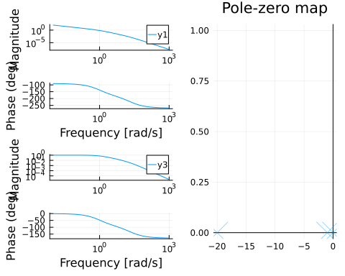

Starting Bode Plot and PZ Map

It has the shape we expect from a motor + friction. Slow pole for the mass + friction and a faster pole for the current & inductance.

Numerically they are:

display(eigvals(A))

3-element Vector{Float64}:  
 -20.0  
 -1.0  
 0.0

We see that we start with all the pole in the left-half plane, which is good.

## 3.2 Pole Placement

We can design a controller with pole placement.

For some reason pole placement doesn’t work for the observer, I use a Kalman Filter with random fast values.

observability(A, C).isobservable &   
controllability(A, B).iscontrollable; #OK  
  
ε = 0.01;  
pp = 15.0;  
poles_cont = -2.0 * [pp + ε, pp - ε, pp];  
L = real(place(sys, poles_cont, :c));  
  
poles_obs = poles_cont * 10.0;  
K = place(1.0 * A', 1.0 * C', poles_obs)'  
cont = observer_controller(sys, L, K; direct=false);

We can check the effect of the new controller on the loop

closedLoop = feedback(sys * cont)  
print(poles(closedLoop));  
setPlotScale("dB")  
plot!(bodeplot(closedLoop[1, 1], 0.1:40), pzmap(closedLoop))

ComplexF64[-29.979998924597755 + 0.0im, -30.000002152199972 + 0.0im, -30.019998923202337 + 0.0im, -300.0000000000004 + 0.0im, -300.1999999999752 + 0.0im, -299.80000000004117 + 0.0im]

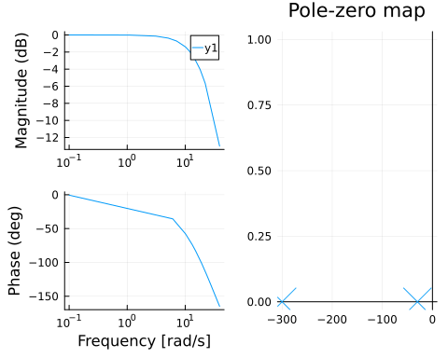

We can compare this to the open-loop response in @start-bode. We can see that we achieve unitary gain throughout the whole low-frequency range.

We can convert the pole placement controller into the standard PD gain form.

K = L[1];  
Ti = 0;  
Td = L[2] / L[1];  
pid = DiscretePID(; K, Ts, Ti, Td);

## 3.3 Simulation

We can simulate this with a motor that only outputs the position:

sysreal = ss(A, B, [1 0 0], 0.0)  
ctrl = function (x, t)  
 y = (sysreal.C*x)[] # measurement  
 d = 0 * [1.0] # disturbance  
 r = 2.0 * (t >= 1) # reference  
 # u = pid(r, y) # control signal  
 # u + d # Plant input is control signal + disturbance  
 # u =1  
 e = x - [r; 0.0; 0.0]  
 e[3] = 0.0 # torque not observable, just ignore it in the final feedback  
 u = -L * e + d  
 u = [maximum([-20.0 minimum([20.0 u])])]  
end  
t = 0:Ts:Tf  
  
res = lsim(sysreal, ctrl, t)  
  
display(plot(res,   
 plotu=true,   
 plotx=true,   
 ploty=false  
 ))  
ylabel!("u", sp=1);  
ylabel!("x", sp=2);  
ylabel!("v", sp=3);  
ylabel!("T", sp=4);

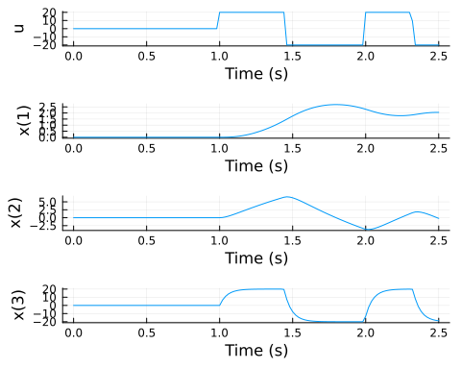

For more stats:

si = stepinfo(res);  
plot(si);title!("Step Response")

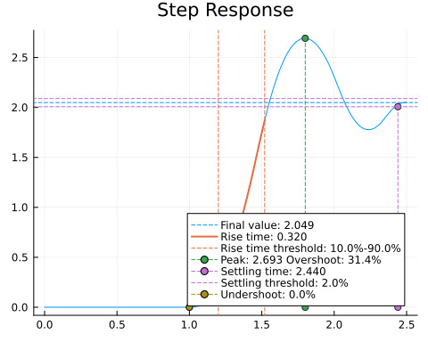

We can also simulate it in a SIMULINK-like environment:

using FMI, DifferentialEquations  
fmuPath = abspath(joinpath(@__DIR__,  
 "..","..",  
 "modelica",  
 "ControlChallenges",  
 "ControlChallenges.BlockOnSlope_Challenges.Examples.WithFriction.fmu"))  
fmu = loadFMU(fmuPath);  
simData = simulateME(  
 fmu,  
 (0.0, 5.0);  
 recordValues=["blockOnSlope.x",   
 "blockOnSlope.xd",   
 "blockOnSlope.usat"],  
 showProgress=false);  
unloadFMU(fmu);  
plot(simData, states=false, timeEvents=false)

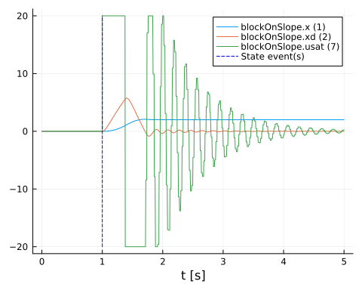

There is a slight difference between the lsim simulation and the FMU simulation. I need to recheck some stuff.

# 4. Block With Friction

Position Control with friction. Using Pole Placement + PD.

## 4.1 Response Analysis

using CCS  
using ControlSystems, Plots, LinearAlgebra, RobustAndOptimalControl  
CCS.setupEnv()  
  
contSys = CCS.blockModel.csys(;g = 0, α = 0 , μ = 1, τ =20)  
plot!(bodeplot(contSys[1,1]),pzmap(contSys))

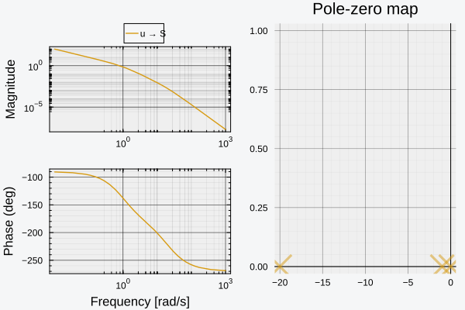

Starting Bode Plot and PZ Map

It has the shape we expect from a motor + friction. Slow pole for the mass + friction and a faster pole for the current & inductance.

Numerically they are:

display(eigvals(contSys.A))

3-element Vector{Float64}:  
 -20.0  
 -1.0  
 0.0

We see that we start with all the poles in the left-half plane, which is good.

## 4.2 Pole Placement

We can design a controller with pole placement.

For some reason pole placement doesn’t work for the observer, I use a Kalman Filter with random fast values.

observability(contSys.A,contSys.C).isobservable || error("System is not observable")  
controllability(contSys.A,contSys.B).iscontrollable || error("System is not controllable")  
  
ε = 0.01;  
pp = 15.0;  
poles_cont = - [pp + ε, pp - ε, pp];  
L = real(place(contSys, poles_cont, :c));  
  
  
poles_obs = poles_cont * 10.0;  
K = place(contSys, poles_obs, :o)  
obs_controller = observer_controller(contSys, L, K; direct=false);  
fsf_controller = named_ss(obs_controller, u = [:ref_S, :ref_V], y = [:u]);

We can check the effect of the new controller on the loop

closedLoop = feedback( contSys * fsf_controller);  
print(poles(closedLoop));  
setPlotScale("dB")  
plot!(bodeplot(closedLoop[1,1], 0.1:40), pzmap(closedLoop))

ComplexF64[-14.990000366343788 + 0.0im, -14.999999266673722 + 0.0im, -15.010000366982666 + 0.0im, -149.99999999999986 + 0.0im, -150.10000000002432 + 0.0im, -149.8999999999607 + 0.0im]

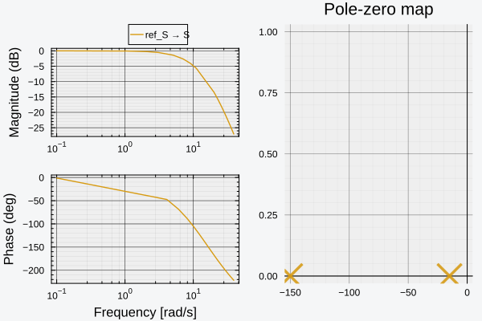

We can compare this to the open-loop response in @start-bode. We can see that we achieve unitary gain throughout the whole low-frequency range.

We can convert the pole placement controller into the standard PD gain form.

using DiscretePIDs  
Ts = 0.02 # sampling time  
Tf = 2.5; #final simulation time  
  
K = L[1];  
Ti = 0;  
Td = L[2] / L[1];  
  
pid = DiscretePID(; K, Ts, Ti, Td);

## 4.3 Simulation

We can simulate this with a motor that only outputs the position:

sysreal = ss(contSys.A, contSys.B, [1 0 0], 0.0)  
ctrl = function (x, t)  
 y = (sysreal.C*x)[] # measurement  
 d = 0 * [1.0] # disturbance  
 r = 2.0 * (t >= 1) # reference  
 # u = pid(r, y) # control signal  
 # u + d # Plant input is control signal + disturbance  
 # u =1  
 e = x - [r; 0.0; 0.0]  
 e[3] = 0.0 # torque not observable, just ignore it in the final feedback  
 u = -L * e + d  
 u = [maximum([-20.0 minimum([20.0 u])])]  
end  
t = 0:Ts:Tf  
  
res = lsim(sysreal, ctrl, t)  
  
display(plot(res,   
 plotu=true,   
 plotx=true,   
 ploty=false  
 ))  
ylabel!("u", sp=1);  
ylabel!("x", sp=2);  
ylabel!("v", sp=3);  
ylabel!("T", sp=4);

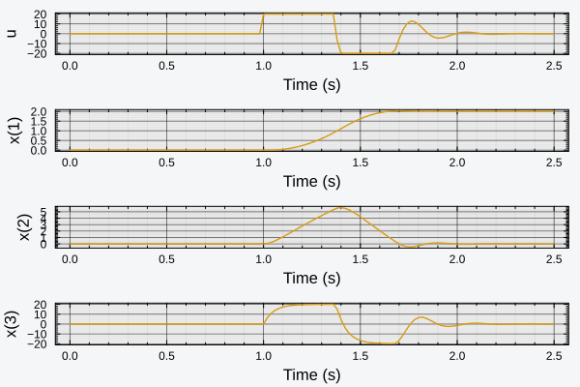

For more stats:

si = stepinfo(res);  
plot(si);title!("Step Response")

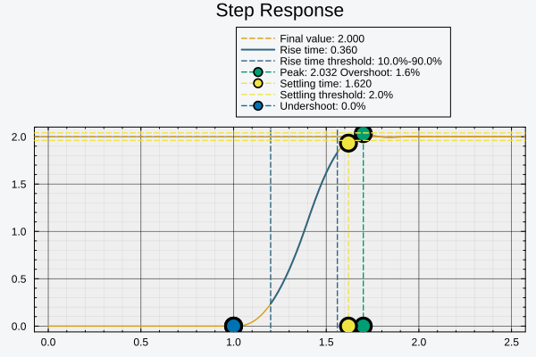

We can also simulate it in a SIMULINK-like environment:

using FMI, DifferentialEquations  
fmuPath = abspath(joinpath(@__DIR__,  
 "..","..",  
 "modelica",  
 "ControlChallenges",  
 "ControlChallenges.BlockOnSlope_Challenges.Examples.WithFriction.fmu"))  
fmu = loadFMU(fmuPath);  
simData = simulateME(  
 fmu,  
 (0.0, 5.0);  
 recordValues=["blockOnSlope.x",   
 "blockOnSlope.xd",   
 "blockOnSlope.usat"],  
 showProgress=false);  
unloadFMU(fmu);  
plot(simData, states=false, timeEvents=false)

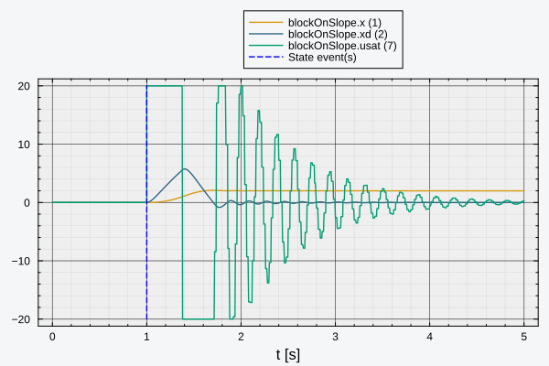

There is a slight difference between the lsim simulation and the FMU simulation. I need to recheck some stuff.

# 5. Block on a slope

Position Control with friction. Using Pole Placement + PD.

## 5.1 Response Analysis

using CCS  
using ControlSystems, Plots, LinearAlgebra, RobustAndOptimalControl  
CCS.setupEnv()  
  
contSys = CCS.blockModel.csys(;g = 0, α = 0 , μ = 1, τ =20)  
plot!(bodeplot(contSys[1,1]),pzmap(contSys))



Starting Bode Plot and PZ Map

It has the shape we expect from a motor + friction. Slow pole for the mass + friction and a faster pole for the current & inductance.

Numerically they are:

display(eigvals(contSys.A))

3-element Vector{Float64}:  
 -20.0  
 -1.0  
 0.0

We see that we start with all the poles in the left-half plane, which is good.

## 5.2 Pole Placement

We can design a controller with pole placement.

For some reason pole placement doesn’t work for the observer, I use a Kalman Filter with random fast values.

observability(contSys.A,contSys.C).isobservable || error("System is not observable")  
controllability(contSys.A,contSys.B).iscontrollable || error("System is not controllable")  
  
ε = 0.01;  
pp = 15.0;  
poles_cont = - [pp + ε, pp - ε, pp];  
L = real(place(contSys, poles_cont, :c));  
  
  
poles_obs = poles_cont * 10.0;  
K = place(contSys, poles_obs, :o)  
obs_controller = observer_controller(contSys, L, K; direct=false);  
fsf_controller = named_ss(obs_controller, u = [:ref_S, :ref_V], y = [:u])

NamedStateSpace{Continuous, Float64}  
A =   
 -150.0 8.033684828490095e-12 0.0  
 1.0915557686859107e-5 -279.9999999999851 1.0  
 -3374.9970813429577 -17530.98989999806 -44.0  
B =   
 150.0 0.9999999999919663  
 -1.0915557686859107e-5 278.9999999999851  
 -0.0014186570429435138 16899.989999998063  
C =   
 168.74992500000002 31.549995000000003 1.2000000000000002  
D =   
 0.0 0.0  
  
Continuous-time state-space model  
With state names: x1 x2 x3  
 input names: ref_S ref_V  
 output names: u

We can check the effect of the new controller on the loop

closedLoop = feedback( contSys * fsf_controller);  
print(poles(closedLoop));  
setPlotScale("dB")  
plot!(bodeplot(closedLoop[1,1], 0.1:40), pzmap(closedLoop))

ComplexF64[-14.990000366343788 + 0.0im, -14.999999266673722 + 0.0im, -15.010000366982666 + 0.0im, -149.99999999999986 + 0.0im, -150.10000000002432 + 0.0im, -149.8999999999607 + 0.0im]



We can compare this to the open-loop response in @start-bode. We can see that we achieve unitary gain throughout the whole low-frequency range.

We can convert the pole placement controller into the standard PD gain form.

using DiscretePIDs  
Ts = 0.02 # sampling time  
Tf = 2.5; #final simulation time  
  
K = L[1];  
Ti = 0;  
Td = L[2] / L[1];  
  
pid = DiscretePID(; K, Ts, Ti, Td);

## 5.3 Simulation

We can simulate this with a motor that only outputs the position:

sysreal = ss(contSys.A, contSys.B, [1 0 0], 0.0)  
ctrl = function (x, t)  
 y = (sysreal.C*x)[] # measurement  
 d = 0 * [1.0] # disturbance  
 r = 2.0 * (t >= 1) # reference  
 # u = pid(r, y) # control signal  
 # u + d # Plant input is control signal + disturbance  
 # u =1  
 e = x - [r; 0.0; 0.0]  
 e[3] = 0.0 # torque not observable, just ignore it in the final feedback  
 u = -L * e + d  
 u = [maximum([-20.0 minimum([20.0 u])])]  
end  
t = 0:Ts:Tf  
  
res = lsim(sysreal, ctrl, t)  
  
display(plot(res,   
 plotu=true,   
 plotx=true,   
 ploty=false  
 ))  
ylabel!("u", sp=1);  
ylabel!("x", sp=2);  
ylabel!("v", sp=3);  
ylabel!("T", sp=4);



For more stats:

si = stepinfo(res);  
plot(si);title!("Step Response")



We can also simulate it in a SIMULINK-like environment:

using FMI, DifferentialEquations  
fmuPath = abspath(joinpath(@__DIR__,  
 "..","..",  
 "modelica",  
 "ControlChallenges",  
 "ControlChallenges.BlockOnSlope_Challenges.Examples.WithFriction.fmu"))  
fmu = loadFMU(fmuPath);  
simData = simulateME(  
 fmu,  
 (0.0, 5.0);  
 recordValues=["blockOnSlope.x",   
 "blockOnSlope.xd",   
 "blockOnSlope.usat"],  
 showProgress=false);  
unloadFMU(fmu);  
plot(simData, states=false, timeEvents=false)



There is a slight difference between the lsim simulation and the FMU simulation. I need to recheck some stuff.

# Appendix A — Performance tricks

## A.1 Hurwitz Check

Create our nice model. Assume to have run the poles function and that you have a vector of eigenvalues. For simplicity I will create an arbitrary vector with the first 100 values in $−1$ and the last 100 values as random around $0$.

using BenchmarkTools  
  
vbig = [zeros(ComplexF64,100).-1 ; rand(ComplexF64,100).-0.5];  
  
vbig[[1,end]]

2-element Vector{ComplexF64}:  
 -1.0 + 0.0im  
 -0.030437584033531584 + 0.17283801604223903im

### A.1.1 for loop

With a naive approach we check if all the elements are in the LHP: make a function that iterates and returns false if it hits a pole with positive real part.

function isHurwitz(v)  
 for i in eachindex(v)  
 if real(v[i])>0.0  
 return false  
 end  
 end  
 return true  
end  
  
@benchmark isHurwitz($(Ref(vbig))[])

BenchmarkTools.Trial: 10000 samples with 987 evaluations per sample.  
 Range (min … max): 49.949 ns … 969.301 ns ┊ GC (min … max): 0.00% … 0.00%  
 Time (median): 54.306 ns ┊ GC (median): 0.00%  
 Time (mean ± σ): 57.041 ns ± 22.237 ns ┊ GC (mean ± σ): 0.00% ± 0.00%  
  
 ▆▇▆█▇▅▄▃▂▂▁▁▁▁ ▂  
 ██████████████▇█▇▇▆▆▆▆▇▆▆▅▅▅▆▅▆▄▄▅▄▅▅▅▅▅▅▄▄▅▄▁▅▃▃▄▄▆▇▁▁▅▆▇▆▆ █  
 49.9 ns Histogram: log(frequency) by time 126 ns <  
  
 Memory estimate: 0 bytes, allocs estimate: 0.

We have our baseline. We can probably squeeze out some more performance but I’m still a Julia noob.

### A.1.2 all()

Let’s try using some of the built-in declarative functions:

@benchmark all(real($vbig).<=0.0)

BenchmarkTools.Trial: 10000 samples with 746 evaluations per sample.  
 Range (min … max): 183.378 ns … 22.068 μs ┊ GC (min … max): 0.00% … 97.78%  
 Time (median): 261.662 ns ┊ GC (median): 0.00%  
 Time (mean ± σ): 445.850 ns ± 864.436 ns ┊ GC (mean ± σ): 32.85% ± 16.78%  
  
 █▇▅▃▁▁▁▁ ▂  
 ██████████▇▆▅▅▅▄▄▅▃▃▁▁▁▁▁▃▅▆▅▅▃▃▃▄▃▃▄▄▃▄▅▆▇▇▇▇▇▆▅▆▅▆▅▅▅▅▅▅▅▅▆ █  
 183 ns Histogram: log(frequency) by time 5.1 μs <  
  
 Memory estimate: 1.75 KiB, allocs estimate: 5.

Simple all(), when given a tuple it checks if all the values are True, otherwise it stops when it encounters the first False.

We can see that it’s a tad slower. This is because it’s creating a new vector with just the real parts, then it’s creating a new vector with only the boolean results and then it’s checking if there are any False results.

This results in a lot of allocations and wasted resources.

@benchmark all(<=(0.0),real($vbig))

BenchmarkTools.Trial: 10000 samples with 759 evaluations per sample.  
 Range (min … max): 144.664 ns … 31.398 μs ┊ GC (min … max): 0.00% … 97.98%  
 Time (median): 226.746 ns ┊ GC (median): 0.00%  
 Time (mean ± σ): 344.335 ns ± 699.060 ns ┊ GC (mean ± σ): 22.41% ± 15.26%  
  
 ▂██▆▃▂▁ ▁▂▁▁▁ ▂  
 ████████▇▇▆▅▇███████▇▇▇▆▅▅▃▄▄▄▁▄▃▃▃▁▁▄▃▃▃▁▁▁▁▁▁▁▁▃▄▆▆▇███▇▆▇▆ █  
 145 ns Histogram: log(frequency) by time 2.44 μs <  
  
 Memory estimate: 1.62 KiB, allocs estimate: 2.

A smarter way is to skip on of the allocations by creating the vector of real parts and then checking row by row if the non-positivity check fails.

@benchmark all(i -> real(i)<=0.0,$vbig)

BenchmarkTools.Trial: 10000 samples with 987 evaluations per sample.  
 Range (min … max): 49.139 ns … 2.022 μs ┊ GC (min … max): 0.00% … 0.00%  
 Time (median): 51.773 ns ┊ GC (median): 0.00%  
 Time (mean ± σ): 53.295 ns ± 22.061 ns ┊ GC (mean ± σ): 0.00% ± 0.00%  
  
 ▅▆█▃▂▂ ▁  
 ███████▇▅▆▆▅▄▅▃▄▄▁▅▅▅▄▃▄▅▄▄▄▁▃▃▃▅▁▄▃▄▃▃▃▄▁▄▃▃▃▃▃▁▃▃▃▃▃▄▄▃▁█ █  
 49.1 ns Histogram: log(frequency) by time 116 ns <  
  
 Memory estimate: 0 bytes, allocs estimate: 0.

We can do better: Instead of converting into real the full vector it checks element by element if it’s in the LHP. It returns false at the first failure. We finally have a comparable result to the benchmark function but in a more compact way.

Is it cleaner? That’s subjective.

### A.1.3 mapreduce()

Finally we try the MapReduce approach. This allows a better utilization of your processor without the necessity of learning parallel programming.

@benchmark mapreduce(i->real(i)<=0.0, &, $vbig)

BenchmarkTools.Trial: 10000 samples with 993 evaluations per sample.  
 Range (min … max): 42.095 ns … 692.346 ns ┊ GC (min … max): 0.00% … 0.00%  
 Time (median): 43.807 ns ┊ GC (median): 0.00%  
 Time (mean ± σ): 46.318 ns ± 15.245 ns ┊ GC (mean ± σ): 0.00% ± 0.00%  
  
 ▇█▆▄▅▄▂▁ ▁ ▁ ▂  
 █████████████▆▆▆▆▅▇▆█▆▆▅▄▅▄▄▃▆▆▃▁▄▅▅▁▃▄▃▁▄▄▄▃▄▄▅▆▃▄▃▄▄▅▇▆▇▆▆ █  
 42.1 ns Histogram: log(frequency) by time 102 ns <  
  
 Memory estimate: 0 bytes, allocs estimate: 0.

We squeeze the last bit of performance and beat the initial benchmark, not by much but still appreciable.

1. MacOs should be supported in theory but it’s not tested.