Control Challenges: Solutions

Iacopo Moles

Table of contents

# 1. Introduction

## 1.1 What is this?

This is a collection of write ups on how to solve the various problems presented by [Github user](https://janismac.github.io/ControlChallenges/) “Janismac”.

# 2. Block With Friction

Position Control with friction. Using Pole Placement + PD.

## 2.1 State Space representation

We can convert the set of ODE into a state space representation. The final bode plot of the block position is:

using DiscretePIDs, ControlSystems, Plots, LinearAlgebra  
  
# System parameters  
Ts = 0.02 # sampling time  
Tf = 2.5; #final simulation time  
g = 9.81 #gravity  
α = 0.0 # slope  
μ = 1.0 # friction coefficient  
x_0 = -2.0 # starting position  
dx_0 = 0.0 # starting velocity  
τ = 20.0 # torque constant   
  
# State Space Matrix  
A = [0 1 0  
 0 -μ 1  
 0 0 -τ  
]*1.0;  
B = [0  
 0  
 τ]*1.0;  
C = [1 0 0  
 0 1 0]*1.0  
  
sys = ss(A, B, C, 0) # Continuous  
  
bodeplot(tf(sys))

|  |
| --- |
| Figure 2.1: Starting Bode Plot |

It has the shape we expect from a motor + friction. Slow pole for the mass + friction and a faster pole for the current & inductance.

Numerically they are:

display(eigvals(A)) # -20 , -1, 0   
display(pzmap(tf(sys)))

|  |  |  |
| --- | --- | --- |
| |  | | --- | | 3-element Vector{Float64}:  -20.0  -1.0  0.0  (a) Starting PZ map |  |  | | --- | | (b) |   Figure 2.2 |

In Figure 2.2 we see that we start with all the pole in the left-half plane, which is good.

## 2.2 Pole Placement

We can design a controller with pole placement.

For some reason pole placement doesn’t work for the observer, I use a Kalman Filter with random fast values.

display(observability(A, C)); #OK  
display(controllability(A, B)); #OK  
ϵ = 0.01;  
pp = 15;  
p = -2* [pp + ϵ , pp - ϵ , (pp / 4)];  
L = real(place(sys, p, :c));  
  
poles_obs = p*5.0  
K = place(1.0*A',1.0*C', poles_obs)'  
cont = observer_controller(sys, L, K; direct=false);

┌ Warning: Max iterations reached  
└ @ ControlSystemsBase C:\Users\icpmoles\.julia\packages\ControlSystemsBase\IeuPW\src\synthesis.jl:310

(isobservable = true, ranks = [3, 3, 3], sigma_min = [0.05255163155979671, 1.0000000000000002, 1.0])

(iscontrollable = true, ranks = [3, 3, 3], sigma_min = [18.82217025796643, 0.7247734159618929, 0.46815777001494974])

We can check the effect of the new controller on the loop

closedLoop = feedback(sys*cont)  
print(poles(closedLoop));  
setPlotScale("dB")  
display(bodeplot(closedLoop[1, 1], 0.1:40))  
display(pzmap(closedLoop))

ComplexF64[-150.09999999999997 + 0.0im, -149.89999999999995 + 0.0im, -7.500000000000134 + 0.0im, -29.979999999868912 + 0.0im, -30.020000000130636 + 0.0im, -37.50000000000044 + 0.0im]

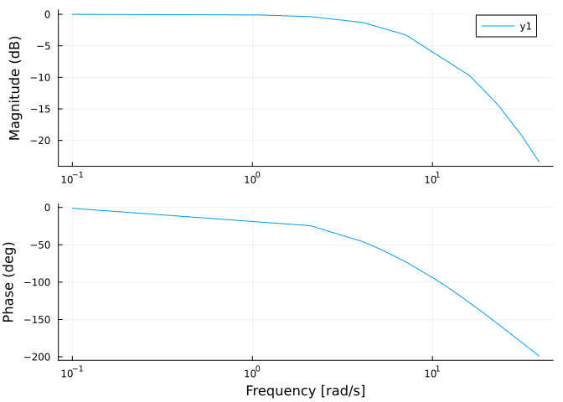

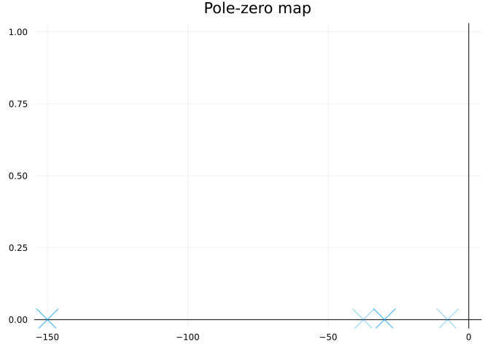

We can compare this to the open-loop response in Figure 2.1. We can see that we achieve unitary gain throughout the whole low-frequency range.

We can convert the pole placement controller into the standard PD gain form.

K = L[1];  
Ti = 0;  
Td = L[2] / L[1];  
pid = DiscretePID(; K, Ts, Ti, Td);

## 2.3 Simulation

We can simulate this with a motor that only outputs the position:

sysreal = ss(A, B, [1 0 0], 0)  
ctrl = function (x, t)  
 y = (sysreal.C*x)[] # measurement  
 d = 0 * [1.0] # disturbance  
 r = 2 * (t >= 1) # reference  
 # u = pid(r, y) # control signal  
 # u + d # Plant input is control signal + disturbance  
 # u =1  
 e = x - [r; 0; 0]  
 e[3] = 0 # torque not observable, just ignore it in the final feedback  
 u = -L * e + d  
 u = [maximum([-20 minimum([20 u])])]  
end  
t = 0:Ts:Tf  
  
  
res = lsim(sysreal, ctrl, t)  
  
plot(res, plotu=true, plotx=true, ploty=false);ylabel!("u", sp=1);ylabel!("x", sp=2);ylabel!("v", sp=3);ylabel!("T", sp=4)

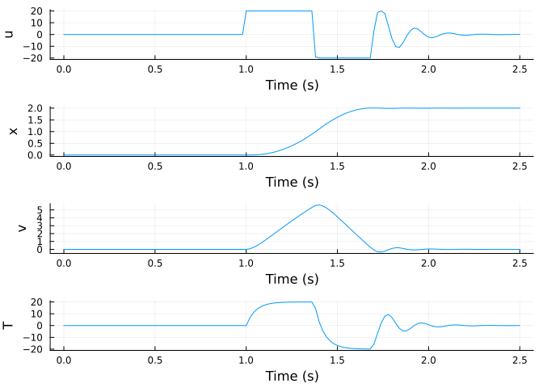

For more stats:

si = stepinfo(res);  
plot(si);title!("Step Response")

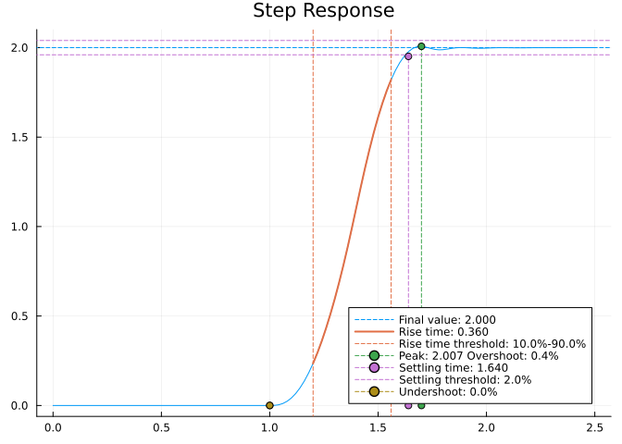

We can also simulate it in a SIMULINK-like environment:

using FMI, DifferentialEquations  
fmu = loadFMU(abspath("../modelica/ControlChallenges/ControlChallenges.BlockOnSlope_Challenges.Examples.WithFriction.fmu"));  
simData = simulateME(fmu, (0.0, 5.0); recordValues=["blockOnSlope.x","blockOnSlope.xd","blockOnSlope.usat"]);  
unloadFMU(fmu);  
plot(simData, states=false, timeEvents=false)

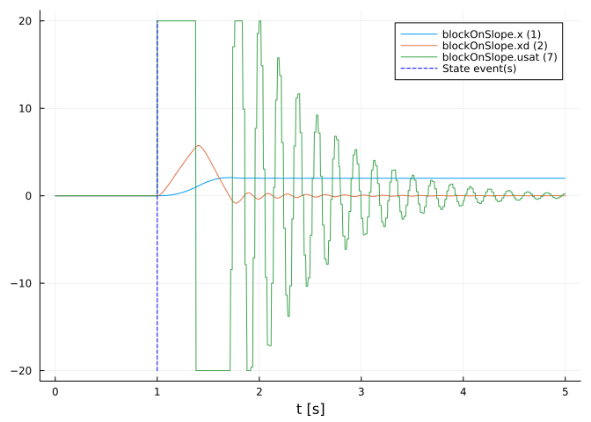

There is a slight difference between the lsim simulation and the FMU simulation. I need to recheck some stuff.