Control Challenges: Solutions

Iacopo Moles

Table of contents

# 1. Introduction

## 1.1 Intro

This is a collection of write ups on how to solve the various problems presented by [Github user](https://janismac.github.io/ControlChallenges/) “Janismac”.

## 1.2 What do I need?

### 1.2.1 Software

* A real OS like Linux or Windows. [1]
* The [Julia Programming Language](https://julialang.org/install/)
  + Clone the [repo](https://github.com/icpmoles/controlchallengessolutions)
  + Activate the package by running in your terminal:
  + julia --project -e 'using Pkg; Pkg.instantiate()'
* (Nice to have) [OpenModelica Editor](https://openmodelica.org/)

### 1.2.2 Theory

* Basic Julia knowledge
* Basic JS knowledge
* Control Theory knowledge
  + Frequency Based Control
  + State Space Based control
* Misc knowledge:
  + Linear Algebra
  + Differential Equations

# 2. Block without Friction

Position Control with friction. Using Pole Placement + PD.

## 2.1 State Space representation

We can convert the set of ODE into a state space representation. The final bode plot of the block position is:

using DiscretePIDs, ControlSystems, Plots, LinearAlgebra  
  
# System parameters  
Ts = 0.02 # sampling time  
Tf = 2.5; #final simulation time  
g = 9.81 #gravity  
α = 0.0 # slope  
μ = 1.0 # friction coefficient  
x_0 = -2.0 # starting position  
dx_0 = 0.0 # starting velocity  
τ = 20.0 # torque constant   
  
# State Space Matrix  
A = [0 1 0  
 0 -μ 1  
 0 0 -τ];  
B = [0  
 0  
 τ];  
C = [1 0 0  
 0 1 0];  
  
sys = ss(A, B, C, 0.0) # Continuous  
  
plot!(bodeplot(tf(sys)),pzmap(tf(sys)))

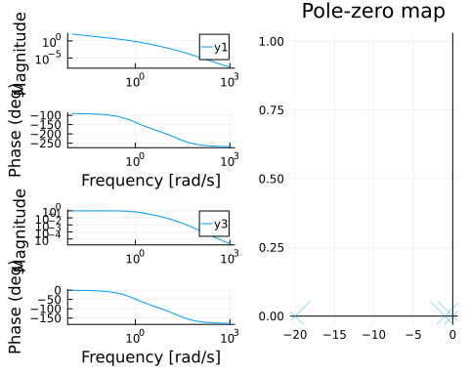

Starting Bode Plot and PZ Map

It has the shape we expect from a motor + friction. Slow pole for the mass + friction and a faster pole for the current & inductance.

Numerically they are:

display(eigvals(A))

3-element Vector{Float64}:  
 -20.0  
 -1.0  
 0.0

We see that we start with all the pole in the left-half plane, which is good.

## 2.2 Pole Placement

We can design a controller with pole placement.

For some reason pole placement doesn’t work for the observer, I use a Kalman Filter with random fast values.

observability(A, C).isobservable &   
controllability(A, B).iscontrollable; #OK  
  
ε = 0.01;  
pp = 15.0;  
poles_cont = -2.0 * [pp + ε, pp - ε, pp];  
L = real(place(sys, poles_cont, :c));  
  
poles_obs = poles_cont * 10.0;  
K = place(1.0 * A', 1.0 * C', poles_obs)'  
cont = observer_controller(sys, L, K; direct=false);

We can check the effect of the new controller on the loop

closedLoop = feedback(sys * cont)  
print(poles(closedLoop));  
setPlotScale("dB")  
plot!(bodeplot(closedLoop[1, 1], 0.1:40), pzmap(closedLoop))

ComplexF64[-29.979998924597755 + 0.0im, -30.000002152199972 + 0.0im, -30.019998923202337 + 0.0im, -300.0000000000004 + 0.0im, -300.1999999999752 + 0.0im, -299.80000000004117 + 0.0im]

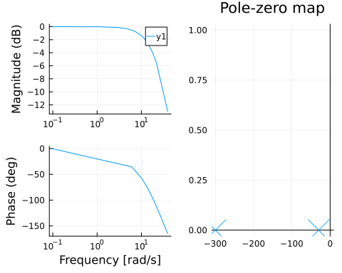

We can compare this to the open-loop response in @start-bode. We can see that we achieve unitary gain throughout the whole low-frequency range.

We can convert the pole placement controller into the standard PD gain form.

K = L[1];  
Ti = 0;  
Td = L[2] / L[1];  
pid = DiscretePID(; K, Ts, Ti, Td);

## 2.3 Simulation

We can simulate this with a motor that only outputs the position:

sysreal = ss(A, B, [1 0 0], 0.0)  
ctrl = function (x, t)  
 y = (sysreal.C*x)[] # measurement  
 d = 0 * [1.0] # disturbance  
 r = 2.0 * (t >= 1) # reference  
 # u = pid(r, y) # control signal  
 # u + d # Plant input is control signal + disturbance  
 # u =1  
 e = x - [r; 0.0; 0.0]  
 e[3] = 0.0 # torque not observable, just ignore it in the final feedback  
 u = -L * e + d  
 u = [maximum([-20.0 minimum([20.0 u])])]  
end  
t = 0:Ts:Tf  
  
res = lsim(sysreal, ctrl, t)  
  
display(plot(res,   
 plotu=true,   
 plotx=true,   
 ploty=false  
 ))  
ylabel!("u", sp=1);  
ylabel!("x", sp=2);  
ylabel!("v", sp=3);  
ylabel!("T", sp=4);

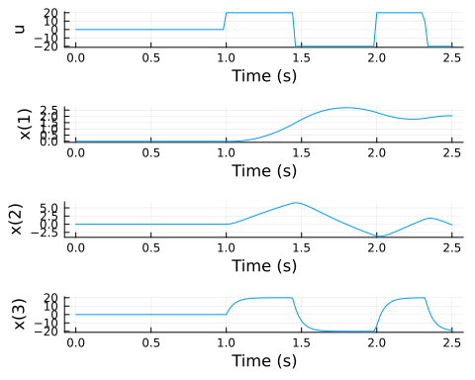

For more stats:

si = stepinfo(res);  
plot(si);title!("Step Response")

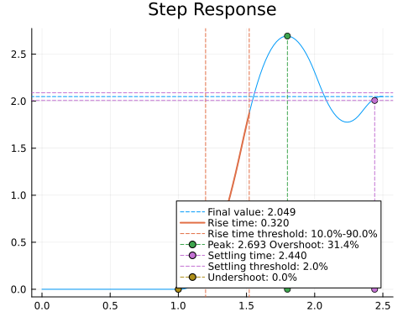

We can also simulate it in a SIMULINK-like environment:

using FMI, DifferentialEquations  
fmuPath = abspath(joinpath(@__DIR__,  
 "..","..",  
 "modelica",  
 "ControlChallenges",  
 "ControlChallenges.BlockOnSlope_Challenges.Examples.WithFriction.fmu"))  
fmu = loadFMU(fmuPath);  
simData = simulateME(  
 fmu,  
 (0.0, 5.0);  
 recordValues=["blockOnSlope.x",   
 "blockOnSlope.xd",   
 "blockOnSlope.usat"],  
 showProgress=false);  
unloadFMU(fmu);  
plot(simData, states=false, timeEvents=false)

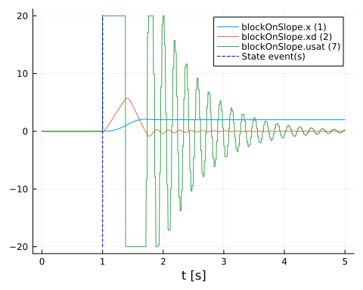

There is a slight difference between the lsim simulation and the FMU simulation. I need to recheck some stuff.

# 3. Block With Friction

Position Control with friction. Using Pole Placement + PD.

## 3.1 Response Analysis

using CCS: blockModel  
using ControlSystems, Plots, LinearAlgebra, RobustAndOptimalControl  
theme(:wong2)  
contSys = blockModel.csys(;g = 0, α = 0 , μ = 1, τ =20)  
  
plot!(bodeplot(contSys[1,1]),pzmap(contSys))

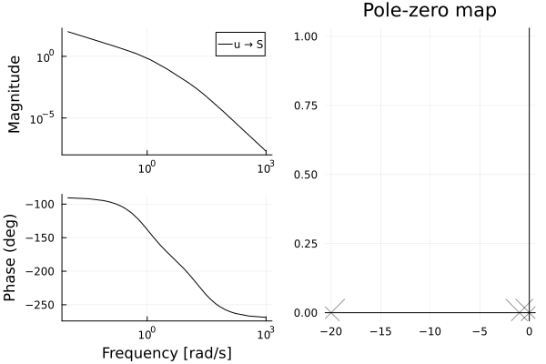

Starting Bode Plot and PZ Map

It has the shape we expect from a motor + friction. Slow pole for the mass + friction and a faster pole for the current & inductance.

Numerically they are:

display(eigvals(contSys.A))

3-element Vector{Float64}:  
 -20.0  
 -1.0  
 0.0

We see that we start with all the poles in the left-half plane, which is good.

## 3.2 Pole Placement

We can design a controller with pole placement.

For some reason pole placement doesn’t work for the observer, I use a Kalman Filter with random fast values.

observability(contSys.A,contSys.C).isobservable || error("System is not observable")  
controllability(contSys.A,contSys.B).iscontrollable || error("System is not controllable")  
  
ε = 0.01;  
pp = 15.0;  
poles_cont = - [pp + ε, pp - ε, pp];  
L = real(place(contSys, poles_cont, :c));  
  
  
poles_obs = poles_cont * 10.0;  
K = place(contSys, poles_obs, :o)  
obs_controller = observer_controller(contSys, L, K; direct=false);  
fsf_controller = named_ss(obs_controller, u = [:ref_S, :ref_V], y = [:u]);

We can check the effect of the new controller on the loop

closedLoop = feedback( contSys * fsf_controller);  
print(poles(closedLoop));  
setPlotScale("dB")  
plot!(bodeplot(closedLoop[1,1], 0.1:40), pzmap(closedLoop))

ComplexF64[-14.990000366343788 + 0.0im, -14.999999266673722 + 0.0im, -15.010000366982666 + 0.0im, -149.99999999999986 + 0.0im, -150.10000000002432 + 0.0im, -149.8999999999607 + 0.0im]

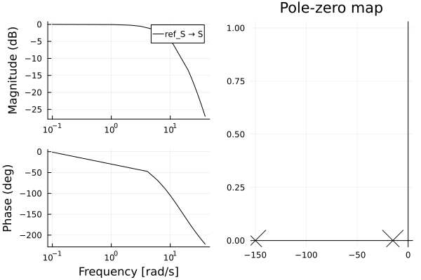

We can compare this to the open-loop response in @start-bode. We can see that we achieve unitary gain throughout the whole low-frequency range.

We can convert the pole placement controller into the standard PD gain form.

using DiscretePIDs  
Ts = 0.02 # sampling time  
Tf = 2.5; #final simulation time  
  
K = L[1];  
Ti = 0;  
Td = L[2] / L[1];  
  
pid = DiscretePID(; K, Ts, Ti, Td);

## 3.3 Simulation

We can simulate this with a motor that only outputs the position:

sysreal = ss(contSys.A, contSys.B, [1 0 0], 0.0)  
ctrl = function (x, t)  
 y = (sysreal.C*x)[] # measurement  
 d = 0 * [1.0] # disturbance  
 r = 2.0 * (t >= 1) # reference  
 # u = pid(r, y) # control signal  
 # u + d # Plant input is control signal + disturbance  
 # u =1  
 e = x - [r; 0.0; 0.0]  
 e[3] = 0.0 # torque not observable, just ignore it in the final feedback  
 u = -L * e + d  
 u = [maximum([-20.0 minimum([20.0 u])])]  
end  
t = 0:Ts:Tf  
  
res = lsim(sysreal, ctrl, t)  
  
display(plot(res,   
 plotu=true,   
 plotx=true,   
 ploty=false  
 ))  
ylabel!("u", sp=1);  
ylabel!("x", sp=2);  
ylabel!("v", sp=3);  
ylabel!("T", sp=4);

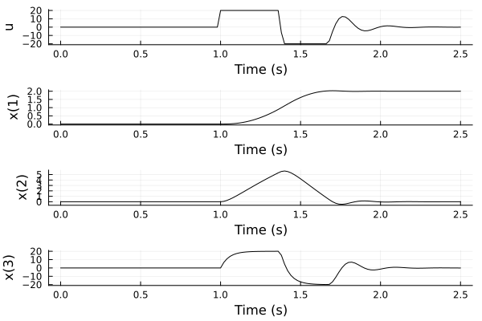

For more stats:

si = stepinfo(res);  
plot(si);title!("Step Response")

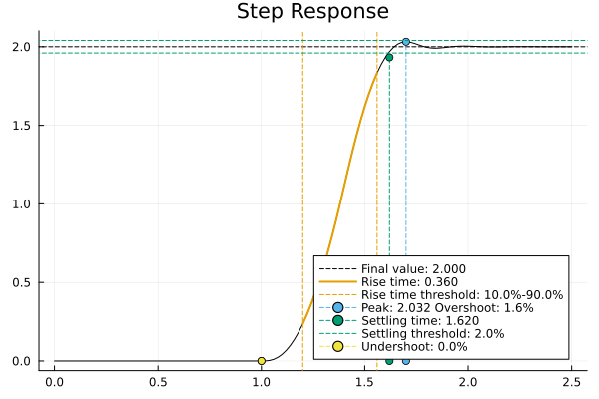

We can also simulate it in a SIMULINK-like environment:

using FMI, DifferentialEquations  
fmuPath = abspath(joinpath(@__DIR__,  
 "..","..",  
 "modelica",  
 "ControlChallenges",  
 "ControlChallenges.BlockOnSlope_Challenges.Examples.WithFriction.fmu"))  
fmu = loadFMU(fmuPath);  
simData = simulateME(  
 fmu,  
 (0.0, 5.0);  
 recordValues=["blockOnSlope.x",   
 "blockOnSlope.xd",   
 "blockOnSlope.usat"],  
 showProgress=false);  
unloadFMU(fmu);  
plot(simData, states=false, timeEvents=false)

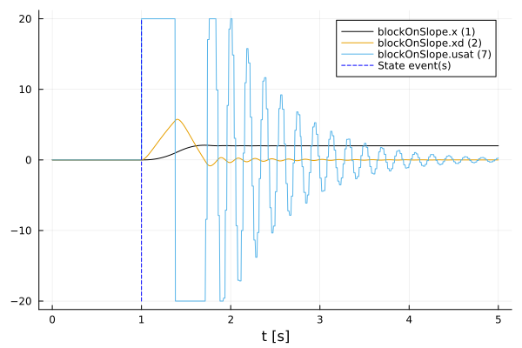

There is a slight difference between the lsim simulation and the FMU simulation. I need to recheck some stuff.

# 4. Block on a slope

Position Control with friction. Using Pole Placement + PD.

## 4.1 Response Analysis

using CCS: blockModel  
using ControlSystems, Plots, LinearAlgebra, RobustAndOptimalControl  
  
contSys = blockModel.csys(;g = 0, α = 0 , μ = 1, τ =20)  
  
plot!(bodeplot(contSys[1,1]),pzmap(contSys))

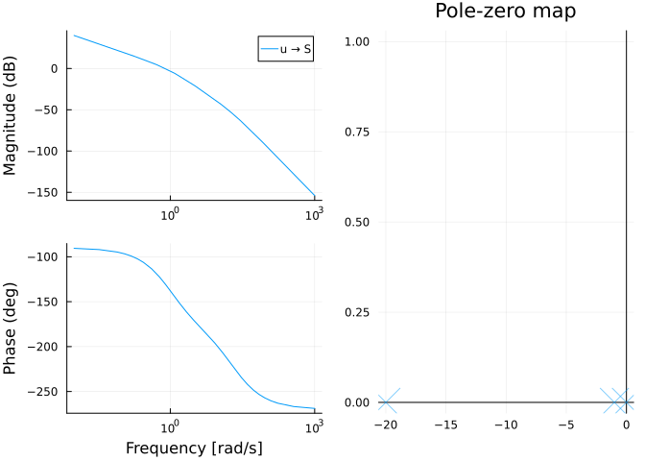

Starting Bode Plot and PZ Map

It has the shape we expect from a motor + friction. Slow pole for the mass + friction and a faster pole for the current & inductance.

Numerically they are:

display(eigvals(contSys.A))

3-element Vector{Float64}:  
 -20.0  
 -1.0  
 0.0

We see that we start with all the poles in the left-half plane, which is good.

## 4.2 Pole Placement

We can design a controller with pole placement.

For some reason pole placement doesn’t work for the observer, I use a Kalman Filter with random fast values.

observability(contSys.A,contSys.C).isobservable || error("System is not observable")  
controllability(contSys.A,contSys.B).iscontrollable || error("System is not controllable")  
  
ε = 0.01;  
pp = 15.0;  
poles_cont = - [pp + ε, pp - ε, pp];  
L = real(place(contSys, poles_cont, :c));  
  
  
poles_obs = poles_cont * 10.0;  
K = place(contSys, poles_obs, :o)  
obs_controller = observer_controller(contSys, L, K; direct=false);  
fsf_controller = named_ss(obs_controller, u = [:ref_S, :ref_V], y = [:u])

NamedStateSpace{Continuous, Float64}  
A =   
 -150.0 8.033684828490095e-12 0.0  
 1.0915557686859107e-5 -279.9999999999851 1.0  
 -3374.9970813429577 -17530.98989999806 -44.0  
B =   
 150.0 0.9999999999919663  
 -1.0915557686859107e-5 278.9999999999851  
 -0.0014186570429435138 16899.989999998063  
C =   
 168.74992500000002 31.549995000000003 1.2000000000000002  
D =   
 0.0 0.0  
  
Continuous-time state-space model  
With state names: x1 x2 x3  
 input names: ref_S ref_V  
 output names: u

We can check the effect of the new controller on the loop

closedLoop = feedback( contSys * fsf_controller);  
print(poles(closedLoop));  
setPlotScale("dB")  
plot!(bodeplot(closedLoop[1,1], 0.1:40), pzmap(closedLoop))

ComplexF64[-14.990000366343788 + 0.0im, -14.999999266673722 + 0.0im, -15.010000366982666 + 0.0im, -149.99999999999986 + 0.0im, -150.10000000002432 + 0.0im, -149.8999999999607 + 0.0im]

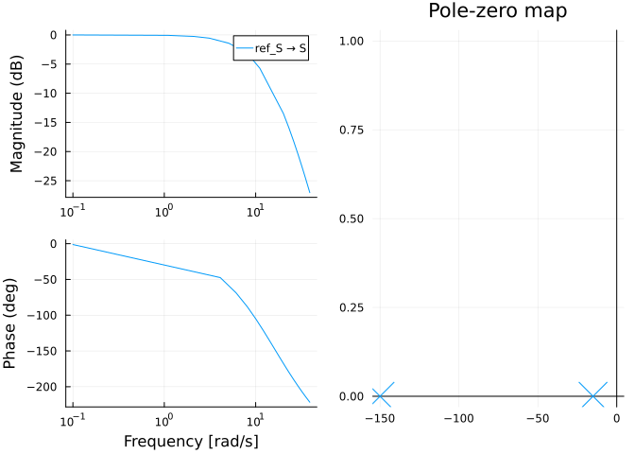

We can compare this to the open-loop response in @start-bode. We can see that we achieve unitary gain throughout the whole low-frequency range.

We can convert the pole placement controller into the standard PD gain form.

using DiscretePIDs  
Ts = 0.02 # sampling time  
Tf = 2.5; #final simulation time  
  
K = L[1];  
Ti = 0;  
Td = L[2] / L[1];  
  
pid = DiscretePID(; K, Ts, Ti, Td);

## 4.3 Simulation

We can simulate this with a motor that only outputs the position:

sysreal = ss(contSys.A, contSys.B, [1 0 0], 0.0)  
ctrl = function (x, t)  
 y = (sysreal.C*x)[] # measurement  
 d = 0 * [1.0] # disturbance  
 r = 2.0 * (t >= 1) # reference  
 # u = pid(r, y) # control signal  
 # u + d # Plant input is control signal + disturbance  
 # u =1  
 e = x - [r; 0.0; 0.0]  
 e[3] = 0.0 # torque not observable, just ignore it in the final feedback  
 u = -L * e + d  
 u = [maximum([-20.0 minimum([20.0 u])])]  
end  
t = 0:Ts:Tf  
  
res = lsim(sysreal, ctrl, t)  
  
display(plot(res,   
 plotu=true,   
 plotx=true,   
 ploty=false  
 ))  
ylabel!("u", sp=1);  
ylabel!("x", sp=2);  
ylabel!("v", sp=3);  
ylabel!("T", sp=4);

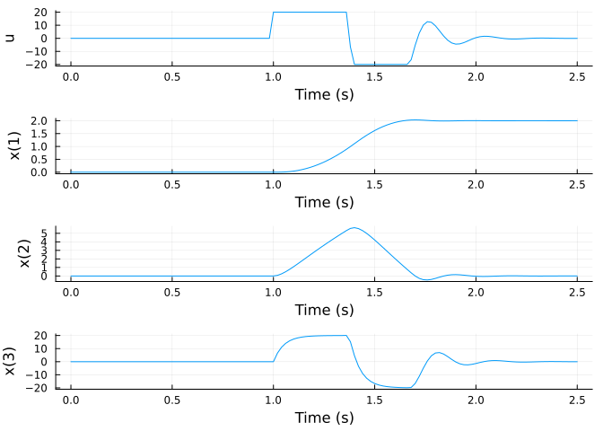

For more stats:

si = stepinfo(res);  
plot(si);title!("Step Response")

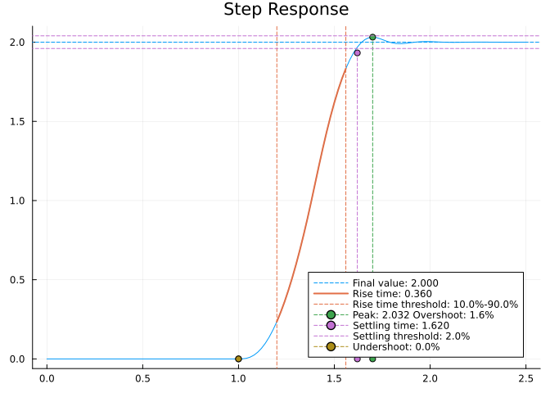

We can also simulate it in a SIMULINK-like environment:

using FMI, DifferentialEquations  
fmuPath = abspath(joinpath(@__DIR__,  
 "..","..",  
 "modelica",  
 "ControlChallenges",  
 "ControlChallenges.BlockOnSlope_Challenges.Examples.WithFriction.fmu"))  
fmu = loadFMU(fmuPath);  
simData = simulateME(  
 fmu,  
 (0.0, 5.0);  
 recordValues=["blockOnSlope.x",   
 "blockOnSlope.xd",   
 "blockOnSlope.usat"],  
 showProgress=false);  
unloadFMU(fmu);  
plot(simData, states=false, timeEvents=false)

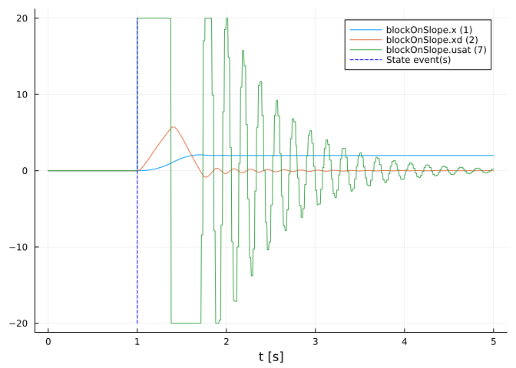

There is a slight difference between the lsim simulation and the FMU simulation. I need to recheck some stuff.

# 5. Performance tricks

## 5.1 Hurwitz Check

Create our nice model. Assume to have run the poles function and that you have a vector of eigenvalues. For simplicity I will create an arbitrary vector with the first 100 values in $−1$ and the last 100 values as random around $0$.

using BenchmarkTools  
  
vbig = [zeros(ComplexF64,100).-1 ; rand(ComplexF64,100).-0.5];  
  
vbig[[1,end]]

2-element Vector{ComplexF64}:  
 -1.0 + 0.0im  
 0.00483281192168783 + 0.17985528493688896im

Then with a naive approach we check if all the elements are in the LHP.

@benchmark all(real(vbig).<=0)

BenchmarkTools.Trial: 10000 samples with 264 evaluations per sample.  
 Range (min … max): 298.864 ns … 64.470 μs ┊ GC (min … max): 0.00% … 98.48%  
 Time (median): 335.227 ns ┊ GC (median): 0.00%  
 Time (mean ± σ): 532.914 ns ± 1.490 μs ┊ GC (mean ± σ): 27.39% ± 11.09%  
  
 █▂▁▄▂ ▁  
 ██████▇▅▄▆▃▄▄▃▄▁▁▄▁▁▁▁▁▁▁▁▁▁▁▁▁▁▁▁▁▁▅▄▆▅▄▃▁▃▁▃▃▁▁▁▁▁▁▁▃▁▁▁▁▄ █  
 299 ns Histogram: log(frequency) by time 8.4 μs <  
  
 Memory estimate: 1.78 KiB, allocs estimate: 6.

The *whole* vector of complex numbers gets converted to real and then we check row by row if it’s non-positive. The whole check one by one results in a vector with booleans that gets checked one by one if it contains false values.

@benchmark all(<=(0),real(vbig))

BenchmarkTools.Trial: 10000 samples with 205 evaluations per sample.  
 Range (min … max): 366.341 ns … 82.638 μs ┊ GC (min … max): 0.00% … 98.99%  
 Time (median): 400.976 ns ┊ GC (median): 0.00%  
 Time (mean ± σ): 584.449 ns ± 1.508 μs ┊ GC (mean ± σ): 15.43% ± 8.87%  
  
 ██▄▂▂ ▁▃▃▁ ▄▃▂ ▂  
 █████▇▇▇▇▆▅▅▅██████████▇▇▆▆▆▆▅▆▅▄▆▅▄▄▄▄▄▄▄▃▆▄▁▄▅▄▄▄▁▄▃▁▃▁▁▁▄ █  
 366 ns Histogram: log(frequency) by time 2.27 μs <  
  
 Memory estimate: 1.62 KiB, allocs estimate: 2.

For now we can skip the full evaluation of non-positivity: the first time it encounters a positive numbers it returns false. This improves the performance a little bit.

@benchmark all(i -> real(i)<=0,vbig)

BenchmarkTools.Trial: 10000 samples with 340 evaluations per sample.  
 Range (min … max): 257.353 ns … 999.706 ns ┊ GC (min … max): 0.00% … 0.00%  
 Time (median): 266.765 ns ┊ GC (median): 0.00%  
 Time (mean ± σ): 273.065 ns ± 44.546 ns ┊ GC (mean ± σ): 0.00% ± 0.00%  
  
 ▆█▆▄▂ ▁  
 ██████▇▆▇▆▆▆▅▆▆▅▄▅▄▄▄▃▃▃▄▃▁▄▅▃▃▄▁▃▁▁▃▃▃▁▃▄▄▃▁▁▃▃▄▄▁▃▁▁▃▃▃▃▄▅▆ █  
 257 ns Histogram: log(frequency) by time 591 ns <  
  
 Memory estimate: 0 bytes, allocs estimate: 0.

This is the final form. Instead of converting into real the full vector it checks element by element if it’s in the LHP. It returns false at the first failure.

1. MacOs should be supported in theory but it’s not tested.