Bureau of Reclamation Projections

Cherie Schultz

Sep-Oct, 2019

## Import Data

The Bureau of Reclamation (BR) climate change website, <https://gdo-dcp.ucllnl.org/downscaled_cmip_projections/dcpInterface.html>, provides easy access to a variety of climate change projections. Their baseline period is 1970-1999 and their simulation period is 1950-2099. To begin with, I want to focus on the BCSD (bias-corrected statistically downscaled) and raw GCM data. These are both monthly datasets, so each can be downloaded via a single data request. We also add the observed time series provided by the BR website, which extends from 1950 through 1999, based on Mauer, 2002. I have downloaded time series for spatially averaged results, where the averaged area is the Potomac River watershed above the USGS’s Little Falls gage (lat/long input as 38.9375/-77.1875).

### BCSD data

The BCSD data was downloaded on July 31, 2019, by C. Schultz. The provided directories were /1_8obs (Prcp_SpatialStat_mean.csv and Tavg_SpatialStat_mean.csv) for the 1/8th degree observed data and /bcsd5 (pr_SpatialStat_mean.csv and tas_SpatialStat_mean.csv) for the 1/8th degree bias-corrected downscaled CMIP5 data. [The file, COLS_SpatialStat.txt, is supposed to list the run names, but I discovered there was a mismatch between the number of columns in the precip and temp data files and the number of names in COLS_SpatialStat.txt. I inquired at BR, and was told on Aug 6 by Tom Pruitt that I’d found a bug. He said that Precip and Tave had more runs than Tmin and Tmax. He said I could find a more complete list of runs in Projections.txt. So I have created COLS_SpatialStat_pr_tas.txt for use with Precip and Tave.]

### PRISM data

Alimatou Seck downloaded average monthly temperature and precipitation gridded data for the time period, Oct 1895, through Aug 2018 from Oregon State’s PRISM website at <http://www.prism.oregonstate.edu/>. She then computed area-weighted averages for Potomac basin sub-basins, and for the entire watershed above Little Falls. Temperature is in degrees Celsius and precipitation is in millimeters per month. [I need to find the metadata for this download - for grid size, base period.] Because the BR observed datasets only extend up through 1999, and my tentative baseline period is 1975-2004, I am instead using time series derived from the PRISM datasets for comparison’s of simulated versus observed temperature and precipitation.

## Characterize meteorological data

Because we are interested in “long-term” average conditions, the record will be divided up into “eras”, each about 30 years in length. The first era is 1950-1979, and it will be used as the “base” time period for measuring changes in long-term mean flows. Mean flow at Little Falls for the base era is 350 mm (11,741 cfs), just 0.5% less than mean flow for the period, 1897-1979, 351 mm (11,772 cfs). Mean precipitation is 992 mm in both periods! [The only thing that doesn’t match so well is mean temperature: 11.2 deg C for 1896-1979 and 11.0 deg C for 1950-1979.] This latter period, 1896-1979, was used to generate the coefficients for the regression model which predicts flow, as a percent of mean flow, precipitation as a percent of mean precipitation, precipitation squared as a percent of mean precipitation squared, and change in temperature, from mean temperature in 1897-1979.

## Examine stats by rcp of unfiltered run

Below is a table with the number of unfiltered runs for each RCP. Also shown are graphs of predicted trends by RCP. For each run, stats were computed for the 25-30 year “eras”. Then the median of the run stats were computed for each RCP and for the observed data.

|  |  |
| --- | --- |
| rcp | n |
| obs_br | 1 |
| obs_prism | 1 |
| rcp26 | 53 |
| rcp45 | 71 |
| rcp60 | 37 |
| rcp85 | 70 |

## Warning: Removed 1 rows containing missing values (geom_path).

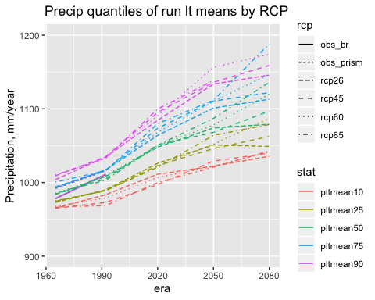

## Warning: Removed 1 rows containing missing values (geom_path).

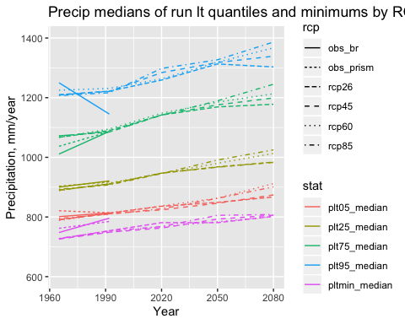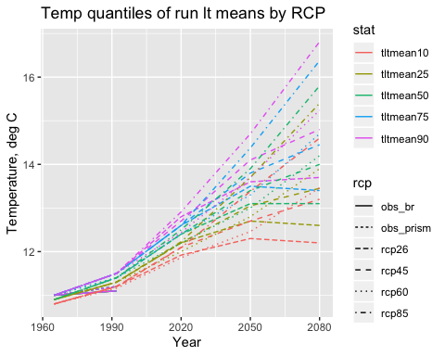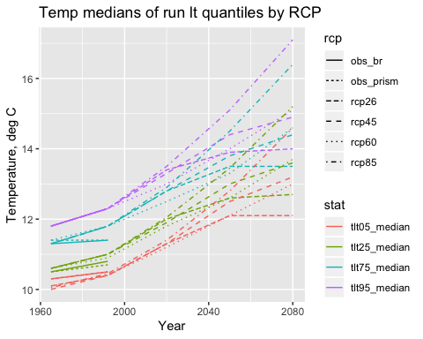

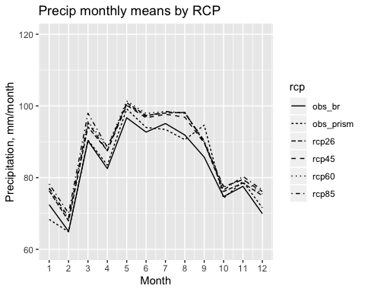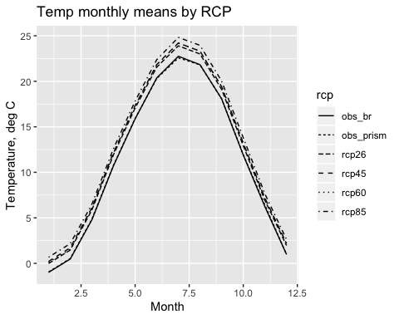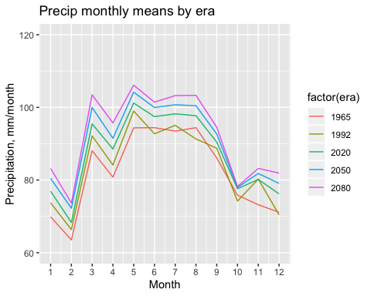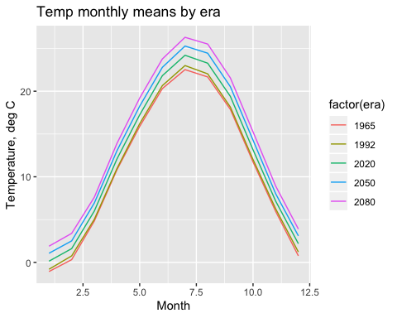

## Filter runs

Runs are filtered based on performance in the historical base period, 1950-1979. Performance is judged via 10 statistics each for annual average precipitation and annual average temperature: mean, standard deviation, minimum, maximum, and the following percentiles: 5th, 10th, 25th, 50th, 75th, 90th, 95th.

### Results

The filtering criteria is (can change at the beginning of this file): % difference between run stats and observed stats is < 0.1 for precip and 0.1 for temp. The pmax criteria has been dropped. The total number of passing runs is 120. We look at some graphs of trends as well:

|  |  |
| --- | --- |
| rcp | n |
| obs_br | 1 |
| obs_prism | 1 |
| rcp26 | 27 |
| rcp45 | 37 |
| rcp60 | 19 |
| rcp85 | 37 |

## Warning: Removed 1 rows containing missing values (geom_path).

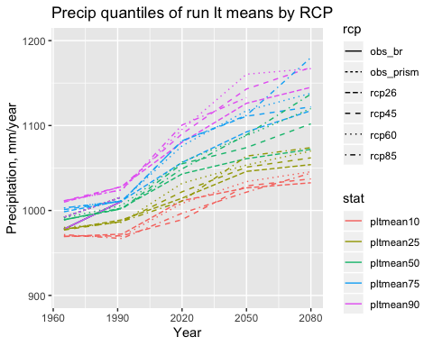

## Warning: Removed 1 rows containing missing values (geom_path).

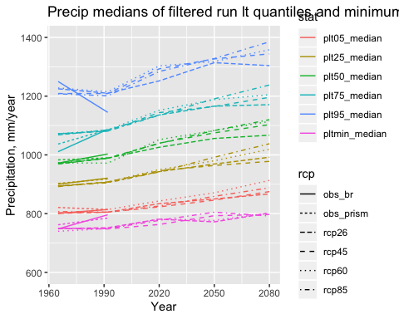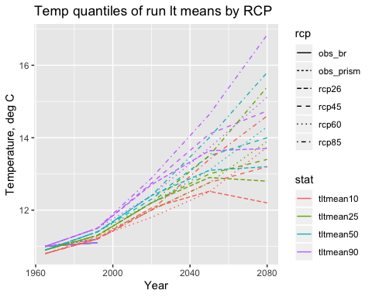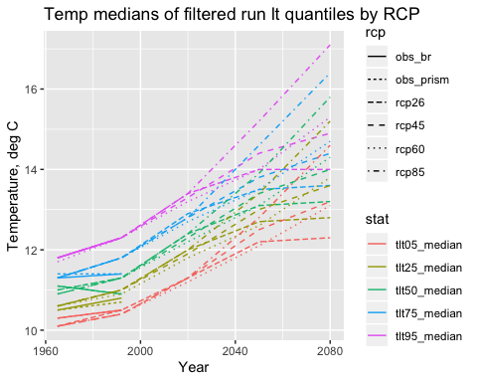

## Predicted changes in flow

Our simple annual flow sensitivity equation is used to compute average annual flow as a function of average annual temperature and precipitation. No q lag term is present in the regression equation used to generate these preliminary results.

First, a table of the stats of the long-term run means:

|  |  |  |  |  |  |  |  |  |  |  |  |  |  |  |  |  |  |  |  |  |  |
| --- | --- | --- | --- | --- | --- | --- | --- | --- | --- | --- | --- | --- | --- | --- | --- | --- | --- | --- | --- | --- | --- |
| era | dqltmean_min | dqltmean_025 | dqltmean_050 | dqltmean_100 | dqltmean_175 | dqltmean_200 | dqltmean_250 | dqltmean_325 | dqltmean_400 | dqltmean_425 | dqltmean_500 | dqltmean_575 | dqltmean_600 | dqltmean_675 | dqltmean_750 | dqltmean_800 | dqltmean_825 | dqltmean_900 | dqltmean_950 | dqltmean_975 | dqltmean_max |
| 1965 | 0.97 | 0.97 | 0.97 | 0.98 | 0.99 | 0.99 | 1.00 | 1.00 | 1.01 | 1.01 | 1.02 | 1.03 | 1.03 | 1.03 | 1.04 | 1.05 | 1.05 | 1.06 | 1.06 | 1.07 | 1.11 |
| 1992 | 0.90 | 0.94 | 0.94 | 0.96 | 0.96 | 0.98 | 0.98 | 0.99 | 1.00 | 1.00 | 1.01 | 1.01 | 1.02 | 1.02 | 1.03 | 1.05 | 1.05 | 1.06 | 1.07 | 1.08 | 1.08 |
| 2020 | 0.85 | 0.89 | 0.90 | 0.92 | 0.94 | 0.96 | 0.98 | 1.00 | 1.02 | 1.02 | 1.03 | 1.05 | 1.06 | 1.07 | 1.09 | 1.10 | 1.12 | 1.13 | 1.17 | 1.22 | 1.29 |
| 2050 | 0.77 | 0.84 | 0.85 | 0.88 | 0.92 | 0.93 | 0.95 | 0.99 | 1.00 | 1.01 | 1.03 | 1.04 | 1.06 | 1.07 | 1.08 | 1.10 | 1.11 | 1.18 | 1.24 | 1.25 | 1.28 |
| 2080 | 0.56 | 0.70 | 0.73 | 0.80 | 0.89 | 0.90 | 0.91 | 0.96 | 1.00 | 1.02 | 1.03 | 1.05 | 1.06 | 1.08 | 1.09 | 1.12 | 1.12 | 1.18 | 1.23 | 1.28 | 1.32 |

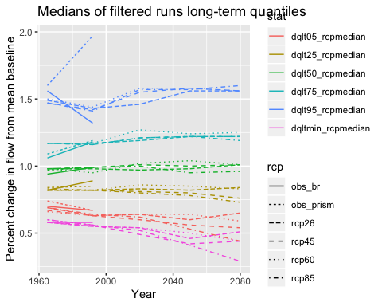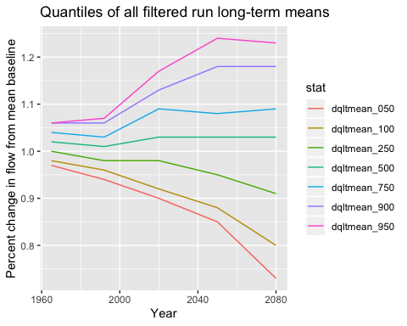 ## Climate change scenarios

### Plot the filtered runs, grouped by the long-term mean flow in era=2050:

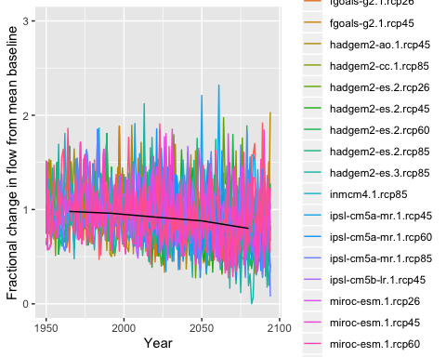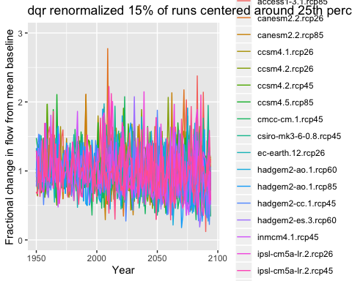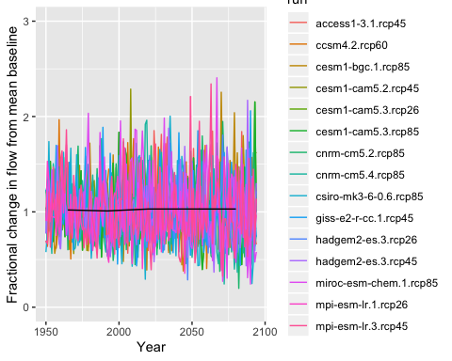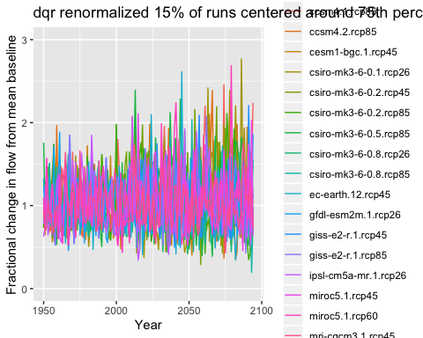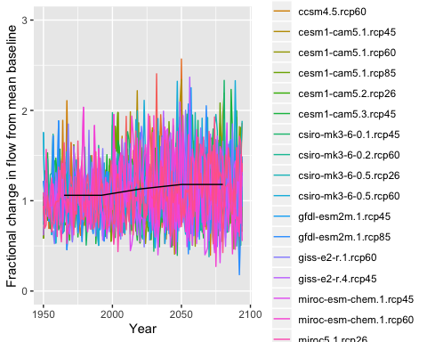

### Also want to characterize temperature and precipitation. For now just focus on cc50. dq_cc50.df

## Warning: Removed 3 rows containing missing values (geom_path).

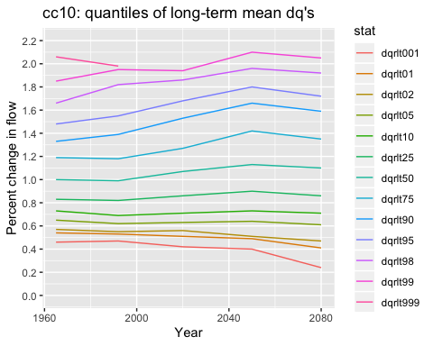

## Warning: Removed 4 rows containing missing values (geom_path).

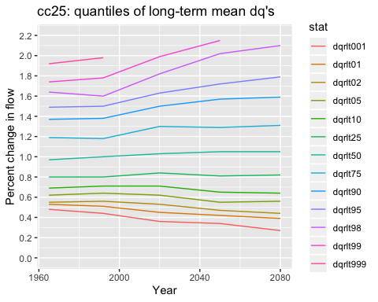

## Warning: Removed 2 rows containing missing values (geom_path).

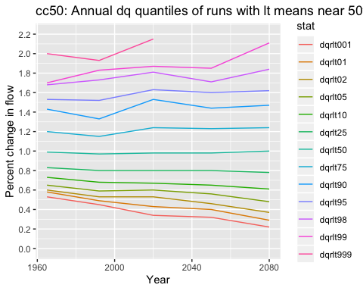

## Warning: Removed 1 rows containing missing values (geom_path).

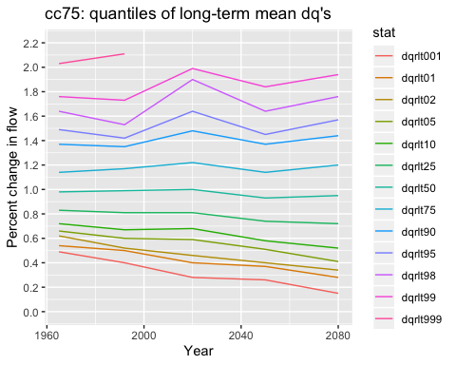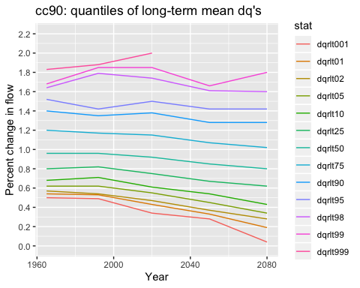

### Flow changes for very dry scenario (cc90 - 10% risk in terms of drought)

|  |  |  |  |  |  |  |  |  |  |  |  |  |  |  |  |  |  |  |  |  |
| --- | --- | --- | --- | --- | --- | --- | --- | --- | --- | --- | --- | --- | --- | --- | --- | --- | --- | --- | --- | --- |
| era | dqrlt001 | dqrlt01 | dqrlt02 | dqrlt05 | dqrlt10 | dqrlt25 | dqrlt35 | dqrlt50 | dqrlt65 | dqrlt75 | dqrlt90 | dqrlt95 | dqrlt98 | dqrlt99 | dqrlt999 | dqrcount | dqrmean | dqrsd | pltave | tltave |
| 1965 | 0.50 | 0.54 | 0.57 | 0.62 | 0.68 | 0.80 | 0.86 | 0.96 | 1.10 | 1.20 | 1.40 | 1.52 | 1.64 | 1.68 | 1.83 | 570 | 1.01 | 0.28 | 982 | 10.95 |
| 1992 | 0.49 | 0.53 | 0.54 | 0.62 | 0.71 | 0.82 | 0.89 | 0.96 | 1.09 | 1.17 | 1.35 | 1.42 | 1.79 | 1.85 | 1.88 | 475 | 1.01 | 0.27 | 999 | 11.33 |
| 2020 | 0.34 | 0.43 | 0.47 | 0.55 | 0.61 | 0.75 | 0.83 | 0.92 | 1.05 | 1.15 | 1.38 | 1.50 | 1.74 | 1.85 | 2.00 | 570 | 0.97 | 0.30 | 1019 | 12.48 |
| 2050 | 0.28 | 0.33 | 0.37 | 0.45 | 0.54 | 0.67 | 0.75 | 0.85 | 0.98 | 1.07 | 1.28 | 1.42 | 1.61 | 1.66 | 2.26 | 570 | 0.89 | 0.30 | 1030 | 13.84 |
| 2080 | 0.04 | 0.19 | 0.28 | 0.34 | 0.43 | 0.62 | 0.69 | 0.80 | 0.91 | 1.02 | 1.28 | 1.42 | 1.60 | 1.80 | 1.97 | 570 | 0.83 | 0.33 | 1047 | 15.10 |

### Flow changes for moderately dry scenario (cc75 - 25% risk)

|  |  |  |  |  |  |  |  |  |  |  |  |  |  |  |  |  |  |  |  |  |
| --- | --- | --- | --- | --- | --- | --- | --- | --- | --- | --- | --- | --- | --- | --- | --- | --- | --- | --- | --- | --- |
| era | dqrlt001 | dqrlt01 | dqrlt02 | dqrlt05 | dqrlt10 | dqrlt25 | dqrlt35 | dqrlt50 | dqrlt65 | dqrlt75 | dqrlt90 | dqrlt95 | dqrlt98 | dqrlt99 | dqrlt999 | dqrcount | dqrmean | dqrsd | pltave | tltave |
| 1965 | 0.49 | 0.54 | 0.62 | 0.66 | 0.72 | 0.83 | 0.89 | 0.98 | 1.08 | 1.14 | 1.37 | 1.49 | 1.64 | 1.76 | 2.03 | 540 | 1.02 | 0.26 | 988 | 10.94 |
| 1992 | 0.40 | 0.50 | 0.52 | 0.60 | 0.67 | 0.81 | 0.88 | 0.99 | 1.07 | 1.17 | 1.35 | 1.42 | 1.53 | 1.73 | 2.11 | 450 | 1.00 | 0.27 | 996 | 11.38 |
| 2020 | 0.28 | 0.40 | 0.46 | 0.59 | 0.68 | 0.81 | 0.89 | 1.00 | 1.11 | 1.22 | 1.48 | 1.64 | 1.90 | 1.99 | 2.48 | 540 | 1.04 | 0.33 | 1054 | 12.41 |
| 2050 | 0.26 | 0.37 | 0.40 | 0.51 | 0.58 | 0.74 | 0.83 | 0.93 | 1.05 | 1.14 | 1.37 | 1.45 | 1.64 | 1.84 | 2.14 | 540 | 0.96 | 0.31 | 1051 | 13.48 |
| 2080 | 0.15 | 0.28 | 0.34 | 0.41 | 0.52 | 0.72 | 0.81 | 0.95 | 1.08 | 1.20 | 1.44 | 1.57 | 1.76 | 1.94 | 2.27 | 540 | 0.97 | 0.36 | 1083 | 14.25 |

### 

### Flow changes for average scenario (cc50 - 50% risk)

|  |  |  |  |  |  |  |  |  |  |  |  |  |  |  |  |  |  |  |  |  |
| --- | --- | --- | --- | --- | --- | --- | --- | --- | --- | --- | --- | --- | --- | --- | --- | --- | --- | --- | --- | --- |
| era | dqrlt001 | dqrlt01 | dqrlt02 | dqrlt05 | dqrlt10 | dqrlt25 | dqrlt35 | dqrlt50 | dqrlt65 | dqrlt75 | dqrlt90 | dqrlt95 | dqrlt98 | dqrlt99 | dqrlt999 | dqrcount | dqrmean | dqrsd | pltave | tltave |
| 1965 | 0.53 | 0.58 | 0.60 | 0.65 | 0.73 | 0.83 | 0.91 | 0.99 | 1.12 | 1.20 | 1.43 | 1.53 | 1.68 | 1.70 | 2.00 | 450 | 1.03 | 0.27 | 997 | 10.93 |
| 1992 | 0.45 | 0.49 | 0.53 | 0.59 | 0.68 | 0.80 | 0.87 | 0.97 | 1.08 | 1.15 | 1.33 | 1.52 | 1.73 | 1.83 | 1.93 | 375 | 1.00 | 0.28 | 993 | 11.36 |
| 2020 | 0.34 | 0.43 | 0.53 | 0.60 | 0.67 | 0.80 | 0.86 | 0.98 | 1.11 | 1.24 | 1.53 | 1.63 | 1.81 | 1.87 | 2.15 | 450 | 1.03 | 0.33 | 1048 | 12.43 |
| 2050 | 0.32 | 0.40 | 0.46 | 0.56 | 0.65 | 0.80 | 0.89 | 0.98 | 1.10 | 1.23 | 1.44 | 1.60 | 1.71 | 1.85 | 2.28 | 450 | 1.03 | 0.32 | 1086 | 13.48 |
| 2080 | 0.22 | 0.29 | 0.37 | 0.48 | 0.61 | 0.78 | 0.88 | 1.00 | 1.12 | 1.24 | 1.47 | 1.62 | 1.84 | 2.11 | 2.34 | 450 | 1.02 | 0.35 | 1117 | 14.43 |

### Flow changes for moderately wet scenario (cc25)

|  |  |  |  |  |  |  |  |  |  |  |  |  |  |  |  |  |  |  |  |  |
| --- | --- | --- | --- | --- | --- | --- | --- | --- | --- | --- | --- | --- | --- | --- | --- | --- | --- | --- | --- | --- |
| era | dqrlt001 | dqrlt01 | dqrlt02 | dqrlt05 | dqrlt10 | dqrlt25 | dqrlt35 | dqrlt50 | dqrlt65 | dqrlt75 | dqrlt90 | dqrlt95 | dqrlt98 | dqrlt99 | dqrlt999 | dqrcount | dqrmean | dqrsd | pltave | tltave |
| 1965 | 0.48 | 0.53 | 0.55 | 0.62 | 0.69 | 0.80 | 0.87 | 0.97 | 1.09 | 1.19 | 1.37 | 1.49 | 1.64 | 1.74 | 1.92 | 510 | 1.01 | 0.27 | 983 | 10.95 |
| 1992 | 0.44 | 0.51 | 0.56 | 0.64 | 0.71 | 0.80 | 0.87 | 1.00 | 1.10 | 1.18 | 1.38 | 1.50 | 1.60 | 1.78 | 1.98 | 425 | 1.01 | 0.27 | 1003 | 11.36 |
| 2020 | 0.36 | 0.45 | 0.53 | 0.62 | 0.71 | 0.84 | 0.89 | 1.03 | 1.17 | 1.30 | 1.50 | 1.63 | 1.82 | 1.99 | 2.25 | 510 | 1.07 | 0.32 | 1064 | 12.25 |
| 2050 | 0.34 | 0.42 | 0.47 | 0.55 | 0.65 | 0.81 | 0.92 | 1.05 | 1.19 | 1.29 | 1.57 | 1.72 | 2.02 | 2.15 | 2.51 | 510 | 1.08 | 0.37 | 1103 | 13.26 |
| 2080 | 0.27 | 0.39 | 0.44 | 0.56 | 0.64 | 0.82 | 0.90 | 1.05 | 1.19 | 1.31 | 1.59 | 1.79 | 2.10 | 2.29 | 2.73 | 510 | 1.09 | 0.39 | 1137 | 14.13 |

### Flow changes for very wet scenario (cc10)

|  |  |  |  |  |  |  |  |  |  |  |  |  |  |  |  |  |  |  |  |  |
| --- | --- | --- | --- | --- | --- | --- | --- | --- | --- | --- | --- | --- | --- | --- | --- | --- | --- | --- | --- | --- |
| era | dqrlt001 | dqrlt01 | dqrlt02 | dqrlt05 | dqrlt10 | dqrlt25 | dqrlt35 | dqrlt50 | dqrlt65 | dqrlt75 | dqrlt90 | dqrlt95 | dqrlt98 | dqrlt99 | dqrlt999 | dqrcount | dqrmean | dqrsd | pltave | tltave |
| 1965 | 0.46 | 0.54 | 0.57 | 0.65 | 0.73 | 0.83 | 0.91 | 1.00 | 1.11 | 1.19 | 1.33 | 1.48 | 1.66 | 1.85 | 2.06 | 600 | 1.02 | 0.27 | 992 | 10.93 |
| 1992 | 0.47 | 0.53 | 0.55 | 0.62 | 0.69 | 0.82 | 0.90 | 0.99 | 1.10 | 1.18 | 1.39 | 1.55 | 1.82 | 1.95 | 1.98 | 500 | 1.03 | 0.29 | 1010 | 11.38 |
| 2020 | 0.42 | 0.51 | 0.56 | 0.63 | 0.71 | 0.86 | 0.94 | 1.07 | 1.18 | 1.27 | 1.53 | 1.68 | 1.86 | 1.94 | 2.29 | 600 | 1.09 | 0.32 | 1070 | 12.17 |
| 2050 | 0.40 | 0.49 | 0.51 | 0.64 | 0.73 | 0.90 | 1.02 | 1.13 | 1.30 | 1.42 | 1.66 | 1.80 | 1.96 | 2.10 | 2.45 | 600 | 1.17 | 0.37 | 1144 | 13.19 |
| 2080 | 0.24 | 0.41 | 0.47 | 0.61 | 0.71 | 0.86 | 0.98 | 1.10 | 1.23 | 1.35 | 1.59 | 1.72 | 1.92 | 2.05 | 2.66 | 600 | 1.13 | 0.36 | 1153 | 14.06 |

### Flow changes for all filtered runs

|  |  |  |  |  |  |  |  |  |  |  |  |  |  |  |  |  |  |  |  |  |  |
| --- | --- | --- | --- | --- | --- | --- | --- | --- | --- | --- | --- | --- | --- | --- | --- | --- | --- | --- | --- | --- | --- |
| era | dqrlt001 | dqrlt01 | dqrlt02 | dqrlt05 | dqrlt10 | dqrlt25 | dqrlt35 | dqrlt50 | dqrlt65 | dqrlt75 | dqrlt90 | dqrlt95 | dqrlt98 | qrlt99 | dqrlt999 | dqrmax | dqrcount | dqrmean | dqrsd | pltave | tltave |
| 1965 | 0.47 | 0.55 | 0.58 | 0.64 | 0.71 | 0.82 | 0.89 | 0.98 | 1.10 | 1.18 | 1.39 | 1.53 | 1.67 | 1.74 | 2.06 | 2.11 | 3660 | 1.02 | 0.27 | 989 | 10.93 |
| 1992 | 0.44 | 0.51 | 0.53 | 0.61 | 0.69 | 0.81 | 0.88 | 0.98 | 1.08 | 1.17 | 1.37 | 1.48 | 1.70 | 1.84 | 2.11 | 2.35 | 3045 | 1.01 | 0.28 | 1000 | 11.37 |
| 2020 | 0.32 | 0.44 | 0.49 | 0.58 | 0.66 | 0.80 | 0.88 | 1.00 | 1.12 | 1.23 | 1.46 | 1.62 | 1.82 | 1.94 | 2.25 | 2.77 | 3600 | 1.04 | 0.32 | 1048 | 12.35 |
| 2050 | 0.27 | 0.37 | 0.41 | 0.52 | 0.61 | 0.78 | 0.86 | 0.98 | 1.12 | 1.23 | 1.48 | 1.66 | 1.90 | 2.07 | 2.43 | 2.91 | 3600 | 1.03 | 0.35 | 1083 | 13.46 |
| 2080 | 0.08 | 0.29 | 0.35 | 0.45 | 0.55 | 0.75 | 0.84 | 0.98 | 1.11 | 1.23 | 1.50 | 1.66 | 1.91 | 2.08 | 2.43 | 3.14 | 3600 | 1.01 | 0.38 | 1107 | 14.41 |