The main idea behind this small, practical project is to demonstrate the possibility to do data muling on a larger scale (compared to WSN-only) using heterogeneous environment. Typically, data muling would include a static cluster of interconnected nodes and a static sink (base station), the data is moved between these two by the means of a special, mobile node called “data mule”. For our demonstration we used the following setup:

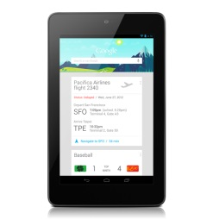 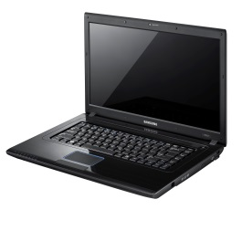

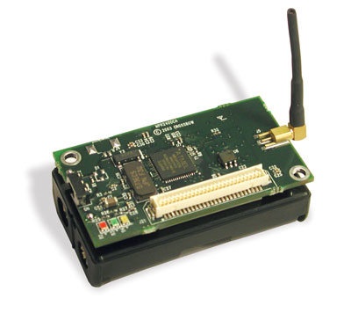

1. WSN cluster: MicaZ nodes (in principle, any type can be used)
2. Mobile phone / tablet as data mule
3. Laptop as sink

The biggest problem was to find out what technologies are available and can be easily adapted for the project. MicaZ (and most other wireless sensor platforms on the market) only support 802.15.4/Zigbee standard. There is no mobile phone / tablet on the market that would support 802.15.4. To resolve this issue we decided to use an extra node as an adapter between the WSN cluster and the data mule. So, the new setup looks as follows:

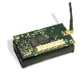 



The local connection between the adapter WSN node and the data mule is established using a special USB On-The-Go cable. For the data mule we chose an android-based Nexus 7 device. The reason is that USB OTG requires hardware/software support on the device (so-called USB-host mode). Android-based mobile phones and iOS-based devices do not provide the USB-host capability. There are only few devices on the market (one of them is Nexus 7) which has this feature. It is also worth to mention that Android version >= 3.1 must be used.

The data mule can communicate to the sink in multiple ways depending on the requirements (distance, load, cost, etc.): 3G, Wi-Fi, Bluetooth, NFC. The two most appropriate solutions in our case are WiFi-direct and Bluetooth. Since WiFi-direct is a new standard and is not yet fully supported in software, so we decided to use Bluetooth to relay data to the sink. Bluetooth can work at a distance of up to 100m. The initial handshaking of 12s might be seen as a shortcoming but peering is needed only once. So, the final communication chain looks as follows:

802.1.5.4 --> USB OTG --> Bluetooth

Nodes in the WSN cluster can run various data collection protocols (CTP, BCP, etc). The relay node contains an extra software component that allows to upload data to the Android device. The Android side of the project consists of an UI and an FTDI serial communication system library. It also has an internal message buffer.

On the laptop we have a Python demon listening for incoming data. This is a sink point.

Required external software:

* Sensor node: TinyOS 2.1.2, fixed UISP
* Tablet: Android >= 3.1 (rooted!!!), FTDI library
* Laptop: Ubuntu 12.04, PyBluez library

MicaZ relay Nexus 7 (Android) laptop

 





802.15.4 USB-OTG Bluetooth