Streamlining Real Estate Management: Development of a Web-Based Solution for Day-to-Day Operations

A Special Problem Presented to the Faculty of

The Institute of Computer Science University of the Philippines Los Baños

Luis Dominic B. Laserna June 2024

Streamlining Real Estate Management: Development of a Web-Based Solution for Day-to-Day Operations

by

Luis Dominic B. Laserna

In partial fulfillment of the requirements for the degree of Bachelor of Science in Computer Science

Mylah Rystie U. Anacleto Adviser

Date Signed

Dr. Maria Art Antonette D. Clariño, Ph.D.

Director

Institute of Computer Science

Date Signed

# ABSTRACT

A web-based application for managing real estate operation was created for use by landlords and tenants of apartments, dormitories, and similar properties, in order to handle their day-to-day operations more efficiently. The system allows tracking of financial transactions, communication between tenants and landlords, and contactless property management. Two user types, tenant, and manager, were created and different features were implemented for each user type allowing the application to cater to the needs of both user types. The application obtained a System Usability Scale (SUS) score of 79.5 showing that users found it effective and usable.

i

# ACKNOWLEDGEMENTS

I would like to give thanks to my adviser, Ma’am Mylah, who supported and guided me throughout the process of creating this paper and application.

I am also thankful for my family who have been nothing but supportive of me while I was working on my SP.

To Angela and all my friends who were with me through the ups and downs of creating this project, thank you.

# TABLE OF CONTENTS

|  |  |
| --- | --- |
| ABSTRACT…………………………………………………………………………… | i |
| ACKNOWLEDGEMENTS…………………………………………………………… | Ii |
| TABLE OF CONTENTS……………………………………………………………… | Iii |
| I. INTRODUCTION…………………………………………………………………... | 1 |
| A. Background of the Study……………………………………………………….. | 1 |
| B. Significance of the Study………………………………………………………. | 1 |
| C. Objectives of the Study………………………………………………………… | 1 |
| D. Scope and Limitations………………………………………………………….. | 1 |
| II. REVIEW OF RELATED LITERATURE……………………………………......... | 2 |
| III. METHODOLOGY…………………........…………………................................... | 7 |
| A. Streamlined Process…...……………........………………….............................. | 7 |
| B. System Requirements and Specifications……................................................... | 7 |
| C. Types of Users………………………….……................................................... | 8 |
| IV. RESULTS AND DISCUSSION…………………………………………………... | 10 |
| Application………………………………………………………………………… | 10 |
| Testing and Deployment…...……………………………………………………… | 12 |
| V. CONCLUSION……………………………………...……………………………... | 15 |
| VI. RECOMMENDATION…………………………………….................................. | 16 |
| LITERATURE CITED……………………………………...………………………… | 17 |
|  |  |
|  |  |
|  |  |
|  |  |
|  |  |
|  |  |
|  |  |

1. **INTRODUCTION**
2. *Background of the Study*

Online platforms are essential for managing businesses with technologies continuously being developed and innovated [4]. Online management systems have been developed in the past two decades. However, even up to the present, most real estates do not have their own management systems here in the Philippines. There has been a consistent rise in the real estate market, even generating nearly 126 billion Philippine pesos as of the second quarter of 2021[1]. However, there has been no significant management system designed for real estate management that focus on the maintenance, daily operations, and monthly rentals in the Philippines.

1. *Significance of the Study*

The design and development of an automated solution for the management of day-to-day operations of apartment complexes, dormitories, and other real estate properties offers significant advantages to property management groups.

1. *Objectives of the Study*

The main objective of the study was to develop a property management system application that automates required operations and transactions between the landlords and tenants. This study specifically aimed to:

1. To create a web-based platform tailored for Filipino landlords and tenants in order to streamline day-to-day operations and aid in the management of rental properties, focusing on apartments, dormitories, and similar real estate assets.
2. To enable landlord-tenant interactions: Enable landlords to manage property-related tasks, including rent tracking, making announcements, and communicating with tenants. Simultaneously, enable tenants with an interface to monitor payments, and receive notifications or announcements from property managers.
3. To implement iterative development: Employ an iterative development approach, soliciting feedback from a group of landlords and tenants to refine and improve the application’s functionality and usability.
4. *Scope and Limitations*

This study focused on creating an application that focuses on the day-to-day operations management of real estate, monthly maintenance, and miscellaneous operations, and not on the sales aspect of real estate management. This study does not include exclusive payment gateway systems.

# REVIEW OF RELATED LITERATURE

In the realm of real estate management and homeowner association affairs, there is a growing trend towards the adoption of web-based platforms to optimize operational processes. This trend is evident in a similar project focused on the Villa Remedios East Homeowners Association (VREHOA). Both works share a common goal of enhancing day-to-day operations through the implementation of digital solutions tailored to the specific needs of their target user groups. While the current study focused on providing a web-based application for landlords and tenants to manage their properties, the VREHOA project addressed the needs of a homeowners association through a proposed Management Reporting System. Despite differences in target audiences and specific functionalities, both projects underscore the importance of centralizing data management, streamlining communication, and facilitating task assignments within their respective domains. This shared emphasis on using technology to improve operational efficiency highlights a broader recognition of the benefits offered by digital solutions in the realm of real estate [1]. Similarly, the development of a Web-Based Billing System aimed to overcome problems faced by the users for manually distributing and giving bills, highlighting the necessity of automated systems in response to the constant improvement of technology [2].

Real estate management systems exist but are rarely adopted for use in the Philippines. The use of property management systems is more common, however. In the case of hotels, a Property Management System often used which is a software that automates administrative and reservation administration work. Among the features are front desk operations, reservations, channel management, housekeeping, rate and occupancy management, and payment processing. Condominiums, apartments, and dormitories, often resort to manual method of managing operations.

Creating an application specifically suited for condominiums, apartments, and dormitories are relatively unexplored in the Philippines. There are currently no applications designed specifically for this type of management. However, doing and building the application is not as hard as one would usually envision. The tenants’ due dates can be retraced on the same way certain existing applications keep track of our subscriptions. These cannot be implemented, however, without the use of payment gateway systems. For instance, several subscription management apps have push notification features employed for bill payment reminders [2]. The same algorithm can be used to keep track of the tenants’ due dates.

Additionally, The adoption of web-based systems, particularly in industries like real estate, offered numerous ad- vantages for businesses. These included lower operational costs, easier maintenance, accessible from anywhere, enhanced data sharing and collaboration, centralized security, increased efficiency, and greater availability of information [3]. Such systems streamlined processes, make communication easier, and provide real-time access to data, leading to more effective management practices.

The way hotel management systems manage their day-to- day operations was adopted by the application. The following features from hotel management system were considered as a good basis for identifying the key features for the application:

a. Drag and Drop Calendar,

b. Automated Communications,

c. Housekeeping features for maintenance schedules [2].

Launching a real estate management system involved following the law, making smart IT decisions, checking technical setup, and ensuring people are willing to use it [5]. Tracking tenant payments in the system required a good billing setup [3]. Given that these systems were not yet widely used in the Philippines, it was important for the application to demonstrate how it simplified work, especially for older property owners who had less interest in using automated systems due to the generational gap [6]. The system needed to be user-friendly and show that it made managing properties contactless for everyone involved. It was also taken into account that a vast majority of apartment or real estate property owners are a part of the older generation [7].

# METHODOLOGY

1. *Streamlined Process*
2. **Requirements Gathering**

* Defined user needs: Gathered detailed requirements from landlords and tenants to understand their needs and pain points.
* Prioritized features: Identified essential functionalities such as rent tracking, making announcements, and tenant communication.

1. **Design and Prototyping**

* Prototype development: Developed a basic prototype to demonstrate the flow and interaction within the application.

1. **Development**

* Backend setup: A database (MongoDB)and server (Express, Node.js) was set up for storing and managing application data.
* Frontend development: Coded the user interface using React and JavaScript with CSS features, for responsiveness and accessibility.

1. **Feature Implementation**

* Developed manager-specific features: Implemented functionalities like bill assignment, transaction viewing, announcement making, and sending messages.
* Built tenant-specific features: Created features such as bill payment, sending messages, announcement viewing, and transaction viewing.

1. **Testing and Debugging**

* Functional testing: Verified each feature’s functionality, ensuring they work as intended and meet user requirements.
* Debugging and refinement: Addressed any bugs or issues identified during testing and refine the application accordingly.

1. **User Feedback Integration**

* User testing: Gathered feedback from landlords and tenants through usability testing to improve application usability.
* Iterate based on feedback: Implemented changes based on user suggestions to enhance user experience.

1. **Deployment and Launch**

* Deployment planning: Selected a suitable hosting platform and deploy the application on a reliable web server accessible to users.
* Launch strategy: Planned a strategy and communicate the application launch to targeted users.

1. **User Training and Support**

* Training resources: Developed user guides and documentations to help landlords and tenants navigate and utilize the application.

1. *System Requirements and Specifications*
2. Development Tools

The application was developed on a machine with the following specifications:

* + **Operating System:** Windows 10 64-bit
  + **Processor:** 10th Generation Intel Core i7-10510U
  + **Memory:** 16GB DDR4 RAM
  + **Storage:** 1TB HDD

The following software development tools and technology stack was used for the

development of the system:

* 1. **Environment**
* Visual Studio Code: A feature-rich source code editor that will serve as the main environment for developing the application.
  1. **Technologies**
* HTML, CSS, JavaScript: Core web technologies used for the front-end development of the application.
* ExpressJS and NodeJS: JavaScript frameworks used for the back-end development.
* MongoDB Cloud and MongoDB: Database technologies used through a setup called MERN (MongoDB, Express.js, React, Node.js).

Other necessary software includes:

* Web Browsers: Mozilla Firefox, Google Chrome, Microsoft Edge (for testing and running the application).
* IDEs: Visual Studio Code.

The application was created using the above technologies and tools. The project was completed on June 2024.

1. Types of Users

The application has two types of users, the manager, and the tenant. Manager users have access to the data stored which will show all the previous transactions of all tenant users that are under the manager’s jurisdiction. Manager users also have access to all features but still have exclusive ones such as Create Bills, Create Announcements, and Mark Bill as paid. Tenant users on the other hand, only have access to their previous transactions and two other features, Pay Bills and Create Messages. Pay Bills is a feature that allows the tenant to submit payment for existing bills, and Create Messages is a feature that allows the tenant to privately message the user’s manager. To better show the features of each user, a use case diagram for the features are shown below [4].

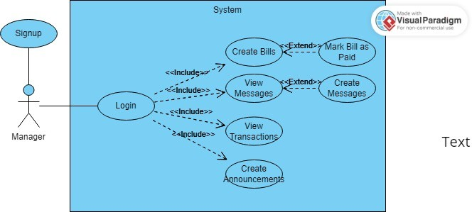

Fig. 1. Use Case Diagram (Manager)

|  |
| --- |
| **Manager User Features** |
| Create Messages - for messaging tenants privately |
| Create Announcements - for posting notices or announcements to be received by the tenants under the manager’s jurisdiction |
| View Transactions - for accessing previous transactions made by tenants under user’s jurisdiction |
| Create Bill - for assigning billing statements to tenants under the manager’s jurisdiction |

TABLE I

MANAGER USER FEATURES

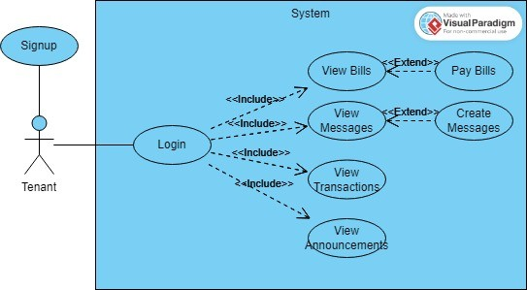

Fig. 2. Use Case Diagram (Tenant)

|  |
| --- |
| **Tenant User Features** |
| Pay Bill - submitting payment by adding a payment reference number to a bill |
| Create Messages - for privately messaging managers |
| View Transactions - to access previous transactions made by the user |
| View Announcements - to view announcements made by their respective managers |

TABLE II

TENANT USER FEATURES

# RESULTS AND DISCUSSION

# Application

After running the application, users will be directed to the home page, where they will be asked whether to login (if they already have an existing account) or signup (for first-time users). After clicking signup, users will be asked to sign up wherein they will choose to be a tenant or a manager user as seen in the figure below. Once a successful signup is achieved, users will be redirected to the login page where they will enter their login credentials. If the login is successful, users will be sent to the bills section of the application.

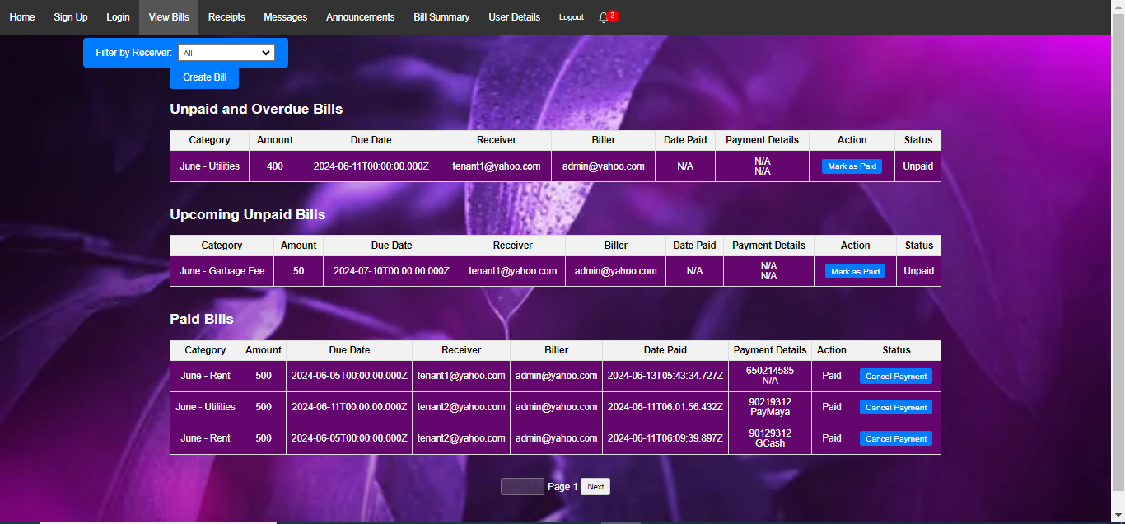

Fig. 3. View Transactions (Manager)

If the user is a tenant, they have an option to submit a Payment Reference Number to the bill of their choice if they want to submit a request to mark that bill as paid.

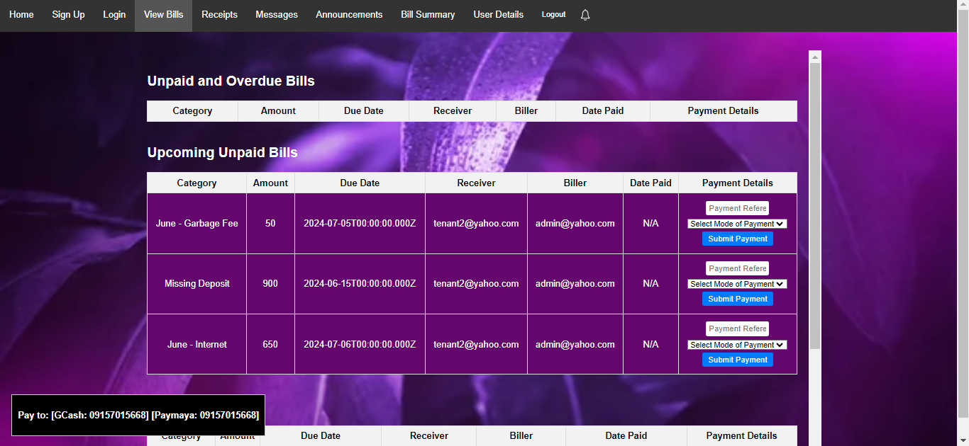

Fig. 4. View Transactions (Tenant)

Depending on their user type, users will either be able to mark bills as paid or submit payment. Only manager-type users can create bills as shown in Figure 5.

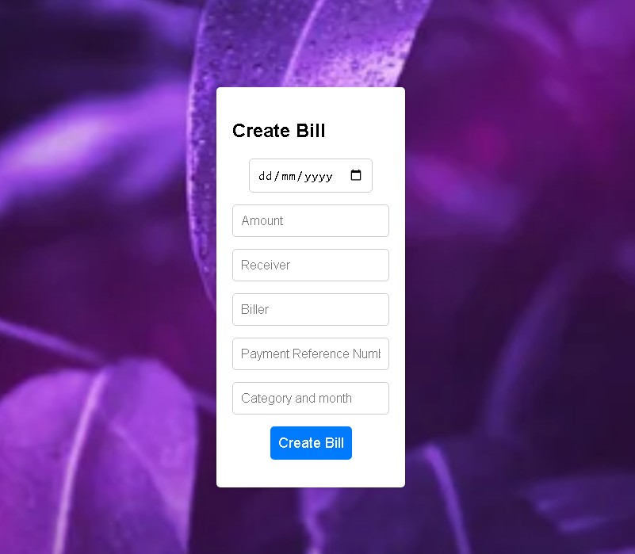

Fig. 5. Create Bill

Upon successful payment, tenant-type users will be able to download a softcopy of their receipt signed by their respective manager.

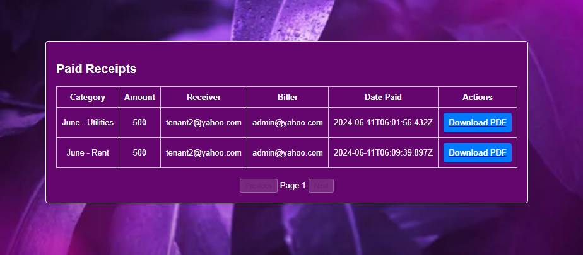

Fig 6. View Receipts

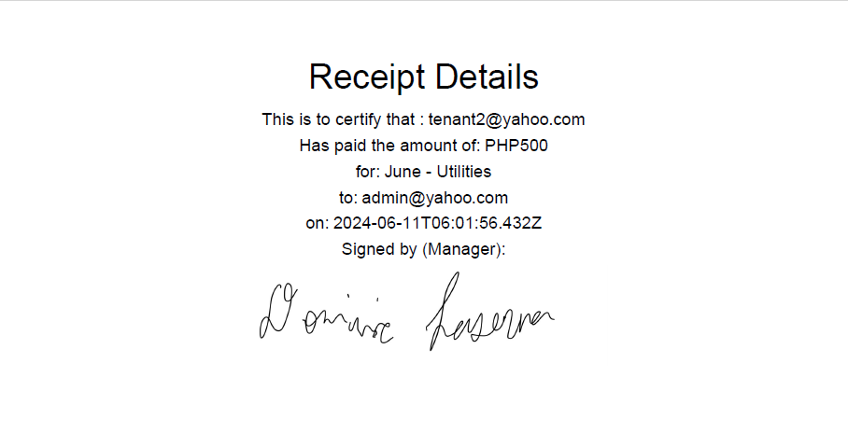

Fig 7. Sample Receipt

A notification will be created for a user if a bill has been created and they are marked as the receiver, a message has been sent to the user, and a bill, where the current logged-in user is the biller, has received a request to be marked as paid.

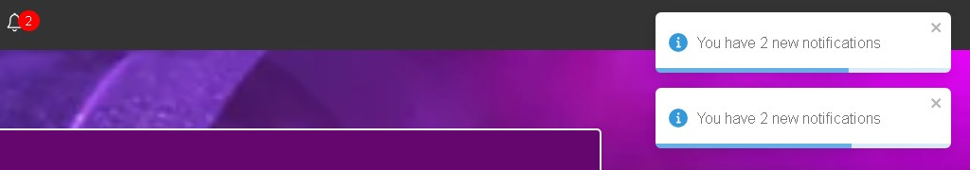

Fig. 8. Notifications

Regardless of the user type, users have the option to create a private message and send it to a receiver of their choice.

Only manager-type users will be able to create an announcement while both user types can view those announcements. If users would like to view an analysis or summary of all their transactions regardless of their user type, users can access the Bill Summary section.

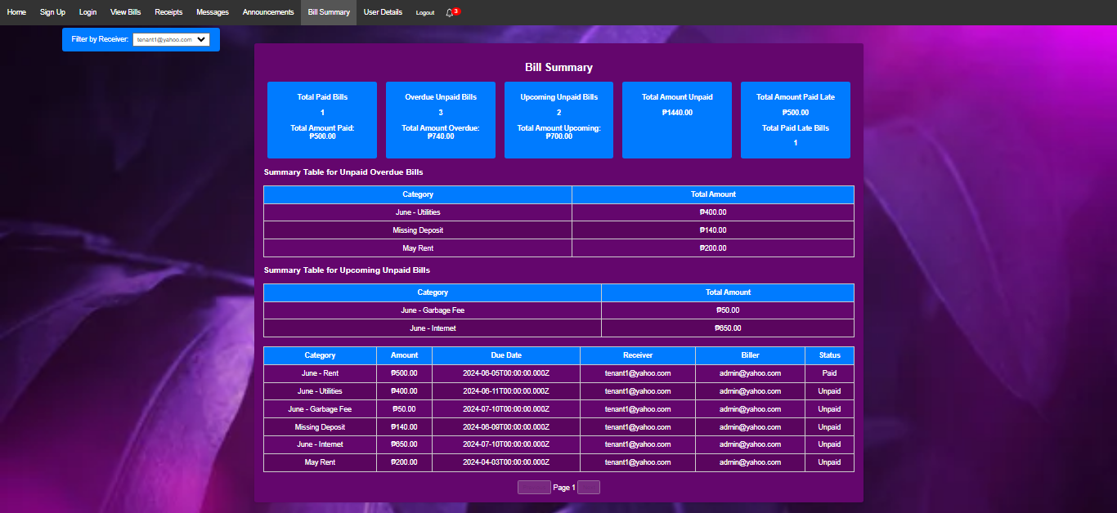

Fig. 9. Bill Summary (Manager)

Lastly, users can view user details by accessing the User Details section.

## Testing and Deployment

After the final deployment of the application, its usability was evaluated. Ten respondents were selected to use the application and provide feedback based on their experience. The respondents accessed the application through a website hosted by Render and evaluated its usability using the System Usability Scale (SUS) on a scale of 1-5. Render is a cloud platform that simplifies the deployment and scaling of applications while System Usability Scale (SUS) is a widely used questionnaire for assessing the perceived usability of systems. The scores range from 1 to 5, with higher scores indicating better usability [5]. Below are the SUS statements used:

SYSTEM USABILITY SCALE (SUS) STATEMENTS

* + 1. I think that I would like to use this system frequently.
    2. I found the system unnecessarily complex.
    3. I thought the system was easy to use.
    4. I think that I would need the support of a technical person to be able to use this system
    5. I found the various functions in this system were well- integrated.
    6. I thought there was too much inconsistency in this system.
    7. I would imagine that most people would learn to use this system very quickly.
    8. I found the system very cumbersome to use.
    9. I felt very confident using the system.
    10. I needed to learn a lot of things before I could get going with this system.

Below are the SUS scores provided by the respondents:

|  |  |  |  |  |  |  |  |  |  |  |
| --- | --- | --- | --- | --- | --- | --- | --- | --- | --- | --- |
| Respondent | S1 | S2 | S3 | S4 | S5 | S6 | S7 | S8 | S9 | S10 |
| 1 | 5 | 2 | 4 | 2 | 5 | 2 | 5 | 2 | 5 | 2 |
| 2 | 5 | 3 | 4 | 2 | 4 | 2 | 5 | 2 | 5 | 2 |
| 3 | 4 | 2 | 5 | 3 | 4 | 2 | 5 | 2 | 4 | 2 |
| 4 | 5 | 2 | 5 | 2 | 4 | 2 | 5 | 2 | 5 | 2 |
| 5 | 4 | 3 | 4 | 2 | 4 | 2 | 5 | 3 | 4 | 2 |
| 6 | 5 | 2 | 5 | 2 | 5 | 2 | 5 | 2 | 5 | 2 |
| 7 | 4 | 2 | 5 | 3 | 4 | 2 | 5 | 2 | 5 | 3 |
| 8 | 5 | 2 | 4 | 2 | 5 | 3 | 5 | 2 | 5 | 2 |
| 9 | 4 | 2 | 5 | 2 | 5 | 2 | 5 | 2 | 4 | 2 |
| 10 | 5 | 2 | 5 | 2 | 5 | 2 | 5 | 2 | 5 | 2 |
| Mean Score | 4.6 | 2.2 | 2.6 | 2.2 | 4.5 | 2.1 | 5.0 | 2.1 | 4.6 | 2.1 |

TABLE III

SYSTEM USABILITY SCALE (SUS) SCORES FOR EACH RESPONDENT

Fig. 10 SUS Scores Per Respondent

|  |  |
| --- | --- |
| Respondent | SUS Score |
| 1 | 80.0 |
| 2 | 75.0 |
| 3 | 75.0 |
| 4 | 80.0 |
| 5 | 72.5 |
| 6 | 80.0 |
| 7 | 75.0 |
| 8 | 77.5 |
| 9 | 75.0 |
| 10 | 80.0 |
| Average | 79.5 |

TABLE IV

FINAL SUS SCORES FOR EACH RESPONDENT

The test gathered an average SUS score of 79.5 indicating that, on average, the respondents found the system to be usable and user-friendly.

Overall, users expressed comfort with using the application and appreciated how it integrated the day-to-day operations of real estate. During the survey, respondents were specifically asked to provide feedback on which features they believed could be improved within the application. The feedback gathered from users was instrumental in identifying key areas for enhancement, their suggestion focused more on UI refinement, such as simplifying menu structures and optimizing layout designs. Despite this suggestion, users expressed that the app is promising and ready for deployment, showing its potential to help users with their real estate management operations.

# CONCLUSION

In conclusion, the development of the real estate management web application has successfully met its objectives of streamlining and making the day-to-day operations of real estate management contactless for both landlords and tenants. The application has effectively provided functionalities such as managing rental payments, tracking property maintenance requests, and facilitating communication between landlords and tenants. Through user feedback and usability testing, the application has been validated as a valuable tool, with users expressing overall satisfaction with its functionality. The application’s ability to make real estate management processes contactless has been particularly appreciated.

.

# RECOMMENDATION

For future work, several enhancements are recommended to further improve the application’s usability and effectiveness. A key area for development is the integration of an exclusive payment gateway system. This feature would provide a more seamless and secure transaction process, enhancing user experience and reliability. Additionally, ongoing refinement of the user interface based on user feedback will ensure the application remains user-friendly and intuitive. These improvements will allow the application to better meet the dynamic needs of its users and solidify its position as a comprehensive tool for real estate management.

# LITERATURE CITED

[1] J. C. Angeles and J. M. Samaniego, “A web-based management reporting system for villa remedios east homeowners association,” Published, June 2023.

[2] A. D. Aswar, D. M. Chhipane, D. C. Sontakke, P. P. Onkar, S. S. Helonde, and S. Sonekar, “A web based billing and payment release system,” Published, 2023.

[3] P. Cheruku, “The benefits of web-based systems for business,” Aezion, Inc., 2023, application Development Lead at Aezion, Inc. [Online]. Available: https://www.aezion.com/the-benefits-of-web-based- systems-for-business.

[4] Y. Waykar, “Role of use case diagram in software development,” International Journal of Management and Economics, January 2015.

[5] J. Brooke, “SUS: A quick and dirty usability scale,” in Usability Evaluation in Industry, P. Jordan, B. Thomas, B. Weerdmeester, and A. McClelland, Eds. London: Taylor and Francis, 1996, pp. 189–194.

[6] Statista, “Topic: Real estate industry in the philippines,” Statista, January 12 2023. [Online]. Available: https://www.statista.com/topics/8509/real- estate-industry-in-the-philippines/topicOverview.

[7] Little Hotelier, What technology does a small property need to succeed?, 2022.