

IFRS / Inglês Instrumental
Profa Cláudia Estima

Estudo da Estratégia de compreensão geral.
Ao lermos um texto, é importante que se estabeleça um propósito de leitura, o qual é fruto das necessidades ou desejos do leitor. A leitura de um texto para a sua compreensão geral visa entender o assunto tratado como um todo, a ideia central do texto. O leitor pode se equivocar e identificar ideias secundárias ou detalhes do assunto tratado como se fossem sua ideia central. Portanto, é importante que se aplique a estratégia adequada conforme a situação requerida. Após a leitura do vídeo no moodle, que traz 3 aspectos importantes a serem considerados para a compreensão geral de um texto, considere o roteiro a seguir e responda as perguntas propostas.

Roteiro de Trabalho:
- Leitura do texto conforme a estratégia Using the dictionary (ler o texto 2-3 vezes, conferir até 8-10 palavras desconhecidas nos dicionários apresentados pela professora – listar aqui as palavras consultadas). Atenção! O texto é longo, portanto, pode-se fazer uma leitura mais rápida, inicialmente. Sublinhar/pintar de amarelo os cognatos presentes no texto.
- Identificar 4-5 (esse número pode variar) palavras que se repetem no texto e redigi-las aqui.
- Sublinhar/pintar de azul as informações não-verbais e destacar algum outro elemento que seja informação não-verbal que compõe o texto e auxilia na compreensão.
- Fazer uso das informações coletadas nos itens anteriores e redigir em 4-5 linhas digitadas, em língua portuguesa, qual foi a sua compreensão geral do texto. Tentar elaborar com base na identificação da situação, do problema apresentado e das possíveis soluções.

O texto trata de forma mais técnica a composição quimica do cérebro e como ela é afetada com o estimulo constante, dando exemplos de jogadores de xadres que apresentam piora no desempenho do jogo depois de 4 a 5 horas jogando. Infelizmente não tem uma solução, apenas descanso e distrações para a mente.

- Enviar por moodle a tarefa.

Text (adapted)
https://www.cnet.com/science/biology/scientists-explain-why-our-brains-feel-tired-after-thinking-really-hard/
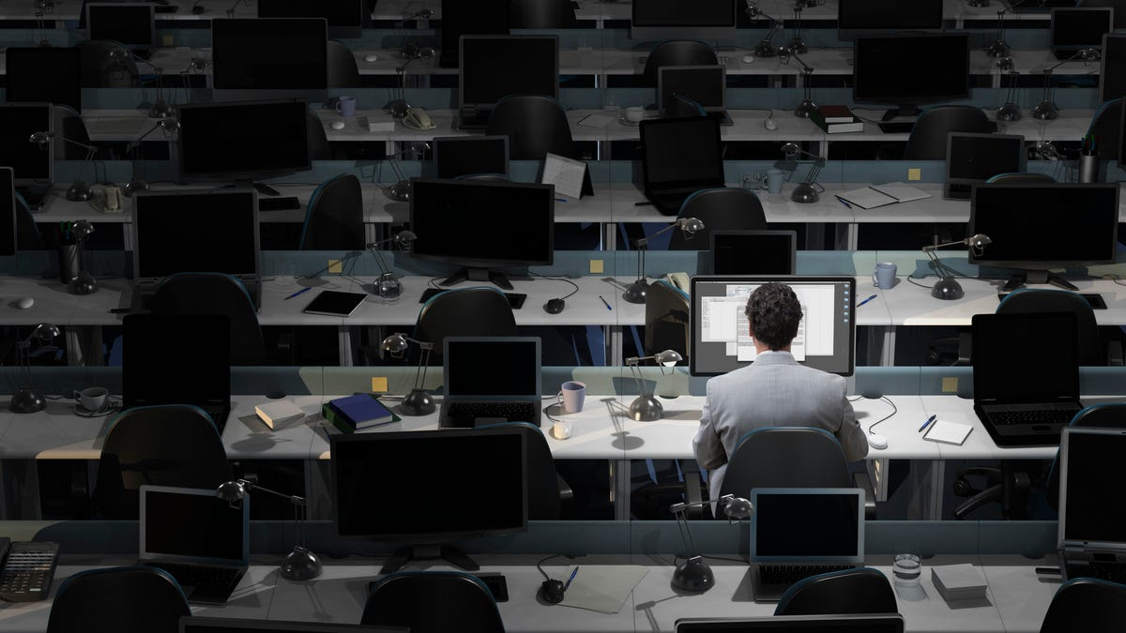

Scientists Explain Why Our Brains Feel Tired After Thinking Really Hard
There could be a reason we can't eternally compute like a computer. Recall a time you stared at your screen for 10 hours to finish a last-minute report for work, a 2,000-word essay on a book you never read, or any other sort of mental marathon. At the end of it all, you probably felt like you needed to dissociate from the world because your brain had turned to Jell-O.
We call that feeling mental fatigue -- it's not that we feel sleepy, exactly, yet our minds are weak and it becomes really hard to do any more complex reasoning than we already have. If we tried to, we'd simply be unwell.

Here's the good news.
This mushy brain sensation probably isn't merely in our heads. According to a study published Thursday in the journal Current Biology, prolonged, intense cognitive activity literally causes potentially toxic byproducts like an amino acid called glutamate to build up in our brains. These byproducts are thought to adjust our decision-making and provoke us to stop thinking so very hard and gravitate toward more relaxing, low-stress activities. And this might be the human body's way of protecting itself from burnout.
"Influential theories suggested that fatigue is a sort of illusion cooked up by the brain to make us stop whatever we are doing and turn to a more gratifying activity," Mathias Pessiglione of Pitié-Salpêtrière University in France, lead author of the study, said in a press release. "But our findings show that cognitive work results in a true functional alteration -- accumulation of noxious substances -- so fatigue would indeed be a signal that makes us stop working but for a different purpose: to preserve the integrity of brain functioning.""Even professional chess players start making mistakes, typically after 4–5 hours in the game, which they would not make when well rested," the study authors write.
Pessiglione and fellow researchers arrived at their conclusion after studying two groups of people with a technique called magnetic resonance spectroscopy, which measures biochemical changes in the brain. The first group was given difficult cognitive tasks, like those involving stressful economic-related decisions. The second had to complete much easier activities, like identifying vowels and consonants with ample break time between each question.
The team's results showed that the group that had to think much harder indicated reduced pupil dilation and higher levels of glutamate in their brain's prefrontal cortex, the part that influences things like cognitive flexibility, attention, decision-making and impulse control.
This then led the researchers to review other relevant brain scan data and eventually conclude that thinking superhard likely leads to glutamate accumulation in the brain, which makes it tougher for us to activate our prefrontal cortex, and therefore hampers our cognitive control and other prefrontal functions. Notably, however, the study warns against taking these findings as causative, stating "our results are only correlational and cannot be taken as proof that what limits cognitive control exertion is the need to prevent glutamate accumulation."
To confirm one way or another, further testing is required. "Nevertheless," the study writes, "glutamate regulation has been pointed out as an essential component in the brain energy budget and discussed as a potential source of cognitive fatigue."
OK, so what's the solution, you ask?
Unfortunately, according to Pessiglione, there isn't one, though the researcher offers that, "I would employ good old recipes: rest and sleep! There is good evidence that glutamate is eliminated from synapses during sleep."
In other words, we might want to consider our mental activity the same way we'd consider our physical activity. To climb a mountain, it's usually best not to sprint, but rather steadily walk -- with some breaks for food, water and even a solid night's sleep.
First published on Aug. 12, 2022 at 2:12 p.m. PT.

