

UNIVERSIDADE FEDERAL DO RIO GRANDE DO SUL PROJETO DE EXTENSÃO - TURMA 6

Professoras: Camila, Érica e Maria Cláudia Nome: IURI DE CARVALHO SALGADO

Clothing (vestuário)

Task 1: Answer the following questions:
- Do you like to pack your bags when you go travelling?
Not too much, I don't care about the clothes, and I always wear something confortable
- Is there an outfit in your closet that you always carry with you? What is it?
Some dryfit tshirts
- Do you like to go out to buy clothes or do you only buy it when you have nothing else to wear?
Only if is necessary
- How would you describe your style/how people describe your style?
A casual or informal style

Task 2: Take a look at the pictures below and describe in detail the outfit that each person is wearing. In your description, don’t forget to mention the color of each outfit and also the accessories (if the person is wearing any). The first one is done for you.

She is wearing a black
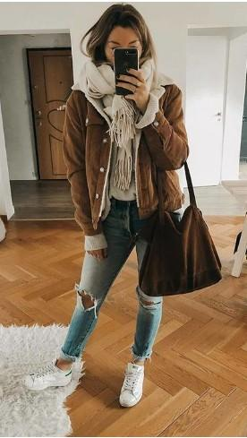
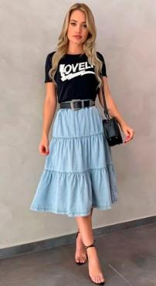
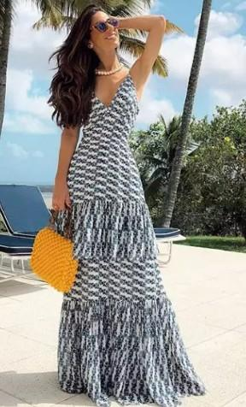
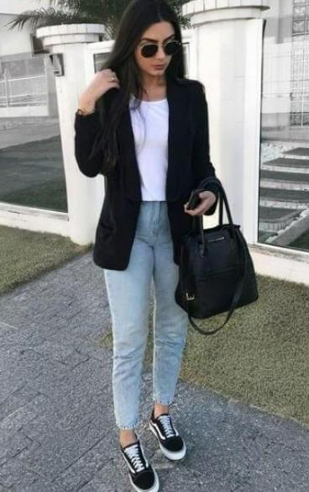
coat, a white blouse, a pair of blue jeans, a pair of sneakers, a black purse and sunglasses.
She’s wearing a black tshirt, a blue skirt and a black purse

She seems to be feeling cold, wearing a jacket, a jeans, a white scarf and a brown purse
She’s wearing a long and clear dress, an orange purge and sunglasses


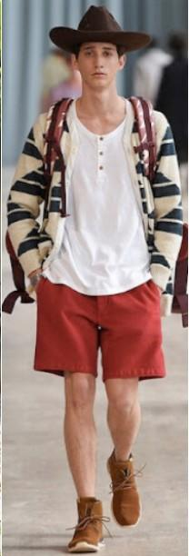
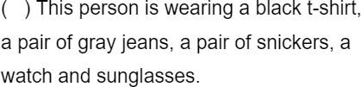
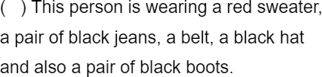

He’s wearing a hat, a white tshirt, a red shorts and a clear coat
He’s weariang a gray tshirt, a jeans and sunglasses

He’s wearing a brown overcoat, a black scarf, a cap and a jeans
He’s wearing a clear shirt and shorts, a baseball cap and a flip-flop

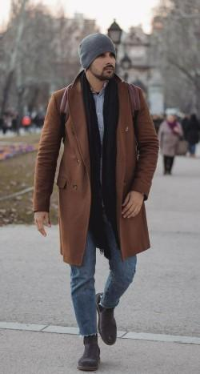

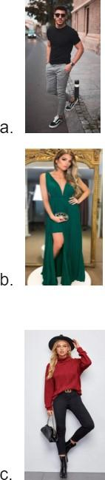
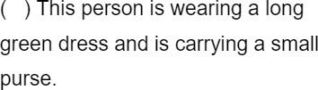
Task 3: Now match the descriptions of the outfits with the people that are wearing it.
B
C
A
Task 4: Now it is your turn to pack your bags! With the vocabulary that you have learned about clothing, search on the internet some pictures of clothes that you would like to take to the trip that you are planning and copy and paste them inside the bag below. Consider the season, the places you will be visiting and how many days you will be staying.

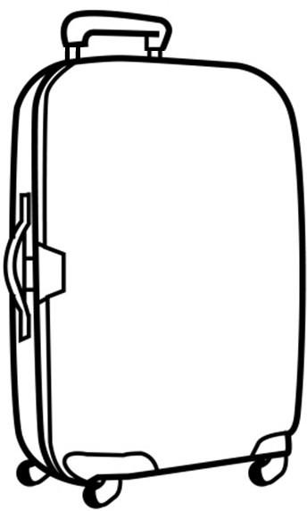
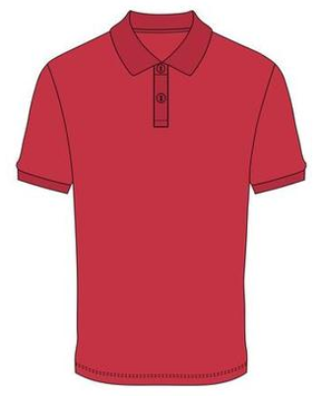
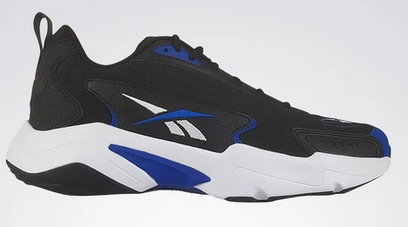
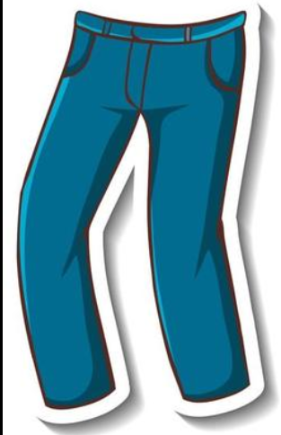
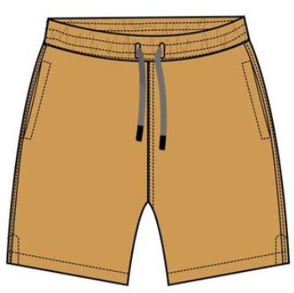
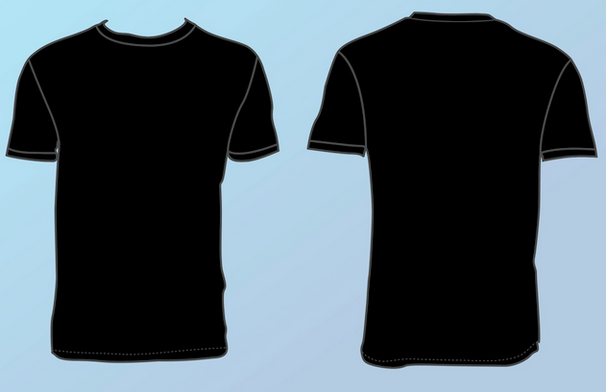
Task 5: Write down the name of each outfit that you will be taking to the trip and also how many of them you are planning to take.

1. Some shirts
2. Some tshirts
3. Some jeans
4. A pair of comfortable sneakers
5. Some shorts
6.
7.
8.
9.
10.

Task 6: Just one more thing (we promise). Considering the places that you plan to visit on your trip, form a few sentences explaining which clothes from your bag you will wear on each visit.

Ex. In my yellow t-shirt I plan to visit the Louvre.
When I visit Central Park I will be wearing my sunglasses and my pair of blue jeans.

1. When I visit a museum I will be wearing a pair of jeans, a shirt and sunglasses
2. When I visit some parks I will be wearing something comfortable, depending on the weather
3. Most part of the time I will be wearing something comfortable
4.
5.
6.
7.
8.
9.
10.

