Conference of Online Social Behavior, 2018

The conference goal is to launch new collaborative research bringing together American and Chinese scholars in big data analyses informed by deeper understanding of the social science mechanisms by which social networks display and affect behavior.
The conference is supported by School of Social Sciences Tsinghua University and Center for Social Network Research,Tsinghua University; co-organized by Tsinghua-Qingdao Institute of Data Science and Tsinghua University Press.

Characteristics of OnLine Networks
Saturday, November 3, 2018
9:30-9:35 | Welcome Speech
9:35-10:35 | James A. Evans ,” Social Limits to Understanding”  University of Chicago
10:35-10:55 | Taking Picture and Tea break
10:55-11:20 | DR.Fu Xiaoming,” Estimating SES from mobility data”  University of Göttingen
11:20-11:45 | Jar-Der Luo,” Predicting Chinese Guanxi: Guess, Who are Your Intimate Friends?”  Tsinghua University
11:45-12:10 | Tao Zhou,” Computational Socioeconomics”  University of Electronic Science and Technology of China
12:10-13:30 | Lunch
13:30-13:55 | Zhiyuan Liu ,” Deep Learning and Computational Social Sciences”  Tsinghua University
13:55-14:20 | Tianguang Meng ,” Bridging Digital Divide: Online Participation and Government Responsiveness in China”  Tsinghua University
14:20-14:45 | Jiang Zhang, Deep Learning on Complex Networks
14:45-15:10 | Yu-Sung Su, Addressing the Non-Representative Issue of the Big Data  Tsinghua University
15:10-15:20 | Tea break
15:20-17:00 | 自由讨论（罗家德、傅晓明、刘知远、孟天广以及苏毓淞作引言人，欢迎与会佳宾提出看法，讨论大数据如何影响社会科学）

开放讨论：参会者可根据下列备选题目，任选其一发言5分钟（非论文自述，语言为中文）
题目包括：
1、社会科学研究的范示转型会是什么？
2、我们如何定义Social Computing?
3、社科新范式主要表现在由理论驱动的社会科学正在向由数据驱动的社会科学转型？会由因果机制的分析转向系统动态的模拟吗？
4、非结构电子印迹数据如何与结构化数据库结合？会从「小数据验证逻辑」转向「大数据发现逻辑」吗？

This is the address
of the conference venue.

The Third conference room,Jin Chun Yuan Hotel

清华大学近春园宾馆第三会议室

Jin Chun Yuan Hotel is up here,close to The Hospital of Tsinghua University , Tel: +8610-62784008

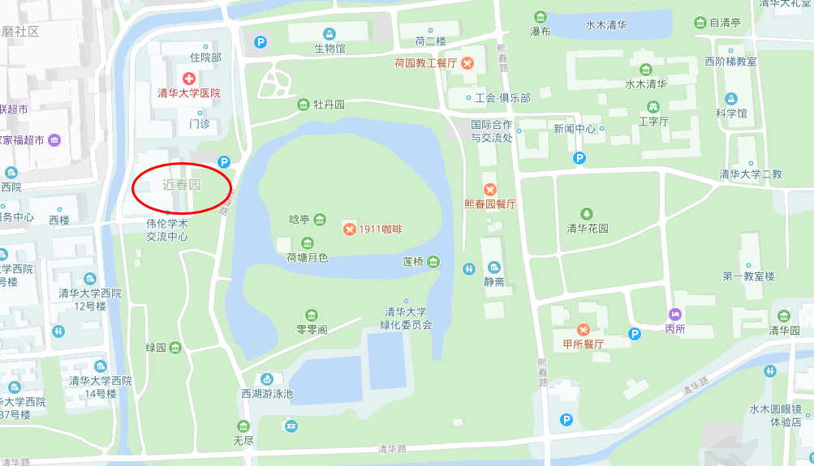

School of Social Sciences Tsinghua University
清华大学社会科学学院
1911年清华学堂（1912年改称清华学校）建立之初，便开设多门政治学、经济学课程。1925年清华学校设立大学部。1926年成立的17个学系就包括社会学系、政治学系、经济学系和教育心理学系。1928年清华学校改名国立清华大学，设文、理、法三个学院共15个学系，其中社会学系、心理学系分别归入文学院和理学院，政治学系和经济学系隶属法学院。
清华大学社会科学的发展秉承“中西融会、文理会通”的学术传统，倡导运用现代科学的思想和研究方法探讨政治、经济和社会现象，坚持学习借鉴国际社会科学的先进经验和国际学术标准，注重研究中国现实问题，以“民族在学术上之独立发展，而完成建设新中国之使命为宗旨”，在治学和人才培养方面取得了世所公认的杰出成就。
一大批学术造诣深厚、社会影响广泛的杰出学者和社会活动家曾在清华社会科学各学系执教或学习，如费孝通、陈岱孙、张奚若、潘光旦、钱端升、萧公权、王铁崖、王亚南、陈达、朱君毅、伍启元、赵元任、戴世光、萧蘧、吴景超、李景汉、陈体强、唐钺等。以他们为代表的清华社会科学师生不但引领科学研究风气之先，而且学以致用，成为中国现代政治、经济和社会建设的一代英才。
1952年全国高等教育院系调整，清华大学成为多科性工业大学。社会科学相关学系和师生并入其他院校或学术机构。20世纪80年代之后，清华大学逐步向综合性大学方向发展，相继复建社会科学学科。1984年清华大学成立社会科学系，1993年成立人文社会科学学院，下设哲学与社会学系、中国语言文学系、历史系、思想文化研究所、科学技术与社会研究所、经济学研究所、教育研究所和艺术教育中心。1997年人文社会科学学院成立国际关系学系）。2000年复建社会学系和政治学系。2008年复建心理学系。2012年，在清华新百年的起始之年，清华大学在原人文社会科学学院基础上，分别成立人文学院和社会科学学院。社会科学学院下设政治学系、国际关系学系、社会学系、心理学系、经济学研究所、科学技术与社会研究所，旨在瞄准国际学术前沿和国家战略需求，再创清华大学社会科学新的辉煌。
社会科学学院的主干学科是：政治学、社会学、经济学、心理学，目前有5个博士学位授予权的一级学科：政治学、社会学、理论经济学、体育学、哲学。4个本科专业：社会科学实验班（含国际政治学、社会学、经济学专业方向）、心理学专业；4个博士后流动站：政治学、社会学、理论经济学、哲学；3个北京市重点学科：国际关系、社会学、科学技术与社会。《国际关系分析》、《马克思主义政治经济学原理》、《邓小平理论与“三个代表”重要思想概论》课程被评为国家级本科精品课。
学院现有教职工83人，其中教授45人，副教授25人，讲师11人，职员2人，在站博士后67人。目前在读学生总数862人，其中本科生358人，硕士研究生281人，博士研究生223人（含留学生151人、港澳台学生13人）。
学院下设4系（政治学系、国际关系学系、社会学系、心理学系）2所（经济学研究所、科学技术与社会研究所），还设有近20个跨学科非实体研究机构。

A B O U T TH E C E N T E R 中心简介
The Tsinghua Center for Social Network Research was founded on Jan. 1st 2013. As a Tsinghua University research center, its purpose is to develop a platform for cooperation among physicists, computer scientists, and social, behavioral and epidemiology researchers, so that they can explore a set of interdisciplinary methodological approaches for studying complex social networks in big data.

Big data brings a lot of opportunities and challenges for interdisciplinary research: Various domains of knowledge have developed and accumulated a large body of hypotheses, models and empirical findings on the structure, dynamic processes, and consequences of social networks.
In order to arrive at a consensus we first need to create a methodological framework that takes data mining as its starting point. The object of research is online big data, which has the untapped potential to yield findings about new social phenomena. The next step is interpreting these findings through various qualitative and survey studies, which will further help us reveal grounded truth to verify theoretical hypotheses. The final step is building a model that encompasses the co-evolution of human actions and network structure based on the operative theories. With a model built on this solid foundation, researchers trained with interdisciplinary methods have the required information to predict new facts from their results.
Running in parallel to our research are real-world surveys that often generate new facts that conflict with our interpretation of the results of data mining. In this kind of scenario, we must return to our data and begin an iterative process of data mining, theory development and dynamic model building; until we can reconcile the two sets of results.
The goal of TCSNR is to develop a series of programs for training students with different research backgrounds, and mesh their different areas of expertise into a methodologically and substantively integrated whole. From this interdisciplinary training method we can expect new results and considerable progress in social network research.

清华大学社会网络研究中心（简称TCSNR），成 立于 2013 年 1 月 1 日。作为清华大学研究中心，其目的是建立平台去推进物理学、计算机科学、和社会科学研究者之间的合作，这样的合作有利于他们探索跨学科方法。
为了有效整合数据挖掘、理论建构与动态复杂系统的预测，我们首先需要创建一个以数据挖掘为出发点的方法论框架。以在线大数据为挖掘对象，可以发现新社会现象，然后通过各种定性和调查研究，解释这些发现，这将进一步帮助我们揭示社会实际情况，并验证理论假说。最后，基于被验证的理论可以建立包括人类行动和网络结构的共同演化模型。跨学科的方法利用在此坚实的理论基础上建立的动态网络模型，从而预测社会系统非线性演化的轨迹。研究在数据挖掘、理论建构与动态复杂系统的预测一轮又一轮进行，使我们能对非线性发展的社会系统中涌现的新生社会现象有所解释与预测。
TCSNR的目标是推进一系列项目，用以培养不同研 究背景的学生，让他们不同的专业领域在方法上和实质上交流、整合并相互印证发明。依靠这样的跨学科培训学生以及联合研究的方法，我们可以期待大数据领域的新发现以及社会网络研究方面的大进展。

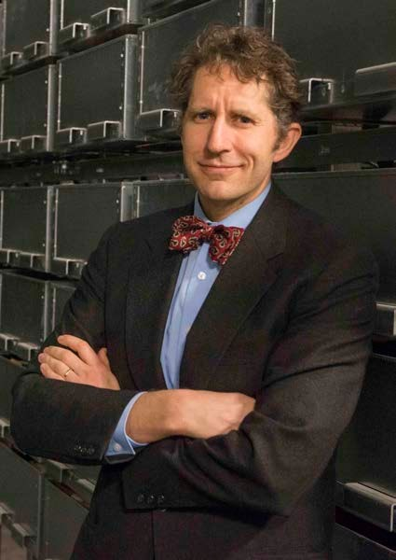

James A. Evans
Professor;Director, Knowledge Lab ; Faculty Director, Masters Program in Computational Social Sciences;
Department of Sociology
University of Chicago

James Evans’work explores the sources,structure,dynamics and consequences of modern knowledge.Evans is particularly interested in there lation of markets to science and knowledge more broadly,and how evolutionary and generative models an informour understanding of collectivere presentations,experiences and certainty.He has studied how industry collaboration shapestheethos,secrecyand organization of academicscience;thewebof individuals and institutions that produce innovations;and markets for ideas and their creators.Evans has also examined the impact of the Interneton knowledge in society.His workuses natural languageprocessing,the analysis of social and semanticnet works,statistic almodeling,and field--based observation and interviews.Evans’research is funded by the National Science Foundation,the National Institutes of Health,the Mellonand Templeton Foundationsand has been published in Science,PNAS,American Journal of Sociology,American Sociological Review,Annual Review of Sociology,Social Studies of Science,Administrative Science Quarterlyand otherjournals.Hisworkhas beenfeatured in Nature,the Economist,Atlantic Monthly,Wired,NPR,BBC,ElPais,CNNandmanyotheroutlets.

James Evans的著作探讨了现代知识的来源、体系、动力和重要性。Evans特别偏好对市场与科学和知识的关系的研究，以及演化和生成模型如何告知我们对于集体表征、经验和确定性的认识。他研究了行业合作如何塑造学术科学的规范、保密性和组织；个人网络与制度网络为创意及其创造者生产新的观念和需求。Evans还对互联网对于社会知识的影响进行了研究。他的工作采用自然语言处理、社会和语义网络分析、统计建模以及实地观察和访谈等方法。
埃文斯的研究获得了美国国家科学基金会、国家卫生研究院、梅隆大学和坦普尔顿基金会资助，并发表于 Science, PNAS, American Journal of Sociology, American Sociological Review, Annual Review of Sociology, Social Studies of Science, Administrative Science Quarterly 等顶级期刊。他的著作被刊登在Nature, the Economist, Atlantic Monthly, Wired, NPR, BBC, El Pais, CNN和许多其他媒体上。
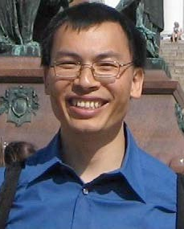

Xiaoming Fu

Professor
Institute of Computer Science
University of Göttingen

Prof Xiaoming Fu received his Ph.D. (2000) degree in Computer Science from Tsinghua University, then worked as a member of scientific staff at the Telecommunications Networks (TKN) group, Technical University Berlin until joining the faculty at the University of Goettingen in 2002, where he has been a full professor since 2007. During 2010-2012 he served as Vice Chair of the Technical Committee on Computer Communications (TCCC), IEEE Communications Society (ComSoc), and during 2011-2013 as Chair of the Internet Technical Committee of the IEEE ComSoc and Internet Society (ISOC). He is a member of Academia Europea, an IEEE senior member and an IEEE distinguished lecturer, a member of ACM, and a Fellow of IET. He was/is coordinator of several EU projects including GreenICN, MobileCloud, CleanSky and ICN2020, and won several best paper awards.

傅晓明2000年获得清华大学计算机系统结构专业博士学位。同年底担任德国柏林工业大学研究员。2002年起任教德国哥廷根大学，创建计算机网络研究实验室，兼任数学与计算机科学学院学术院长、国际办公室主任等职。33岁时，成为哥廷根大学建校270年历史上的第一位华人终身教授（时为全校最年轻的教授），也是德国历史上由中国博士获聘终身教授职位的第一人。
傅晓明的主要研究领域包括互联网、移动计算、云计算、大数据及社会网络。他曾担任IEEE ICNP 2013、ACM ICN 2016等国际学术会议总主席，是中国教育部、清华大学计算机系长江学者讲座教授，美国UCLA富布莱特学者讲座教授，欧洲科学院(Academia Europea)院士、英国工程技术学会(IET)会士、国际电气与电子工程师学会（IEEE）高级会员、IEEE杰出讲演人、美国计算机学会（ACM）及德国计算机学会（GI）会员。他是Green ICN、Mobile Cloud、Clean Sky及ICN 2020等多个欧盟大型科研项目的总负责人、首席科学家。
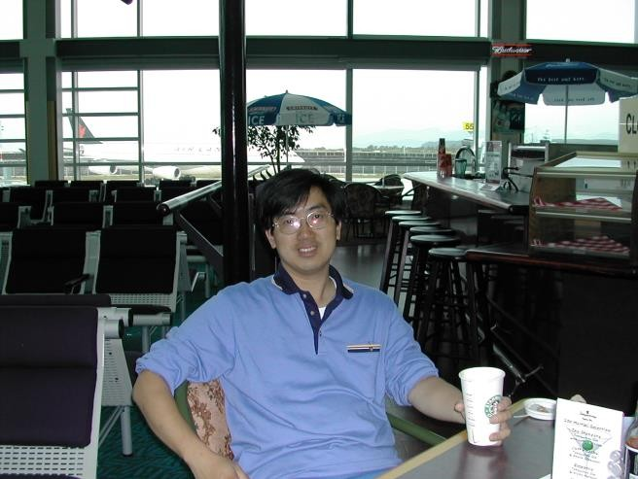

Jarder Luo
Professor of Sociol ogy Dept., Tsinghua University
Chairman of Tsinghua Social Network Research Center

Luo, Jar-Der is a professor of Sociology Dept., Tsinghua University in Beijing, president of Chinese Network for Social Network Studies, and chairman of Tsinghua Social Network Research Center. He earned his Ph.D degree in Sociology Dept. of State U. of New York at Stony Brook. He researches numerous topics in social network studies, including social capital, trust, social network analysis in big data, self-organization process and Chinese indigenous management researches, such as guanxi and guanxi circle.
Luo Jar-Der, with a group of voluntary network theorists, organized Chinese Network for Social Network Studies (in brief, CNSNS) in 2005. Its purposes aim at promoting Network Theories and Social Network Analysis in China and developing network theories suited for Chinese management. Chinese always describe themselves as a “Ren-Ching society”, that is, roughly saying, a society built upon social ties (guanxi) and favor exchanges (Ren-Ching- jiau-huan).
Luo Jar-Der organized Community Revitalization Research Center in Tsinghua U., which aims at doing experiments in communities and establishing a model for sustainable revitalization in urban and rural areas that emphasizes sustainability of the local ecology, economy, and social systems. We will endeavor to implement a revitalization model combining private-public partnership and sustainable concepts into practice, incorporating scientific planning, balanced development, step-by-step implementation and self-reliance of local community into our plan.

罗家德，清华大学社会学系教授、博导， 清华大学社会网络研究中心主任 , 清华大学社会科学学院信义社区营造研究中心主任 , 中国社会学会社会网暨社会资本研究专业委员会创会主席。在学术领域着重于社会网理论研究，大数据中的社会网分析，自组织过程研究，并将中国社会的“关系” 与“圈子”等特质置于中国本土化管理研究之中。著有《中国商道》、《中 国人的信任游戏》、《社会网分析讲义》、《复杂》等书。同时还组织了 社区营造研究中心在灾区乡村以及北京大栅栏地区从事可持续性发展的 社区实验，并举办相关培训，著有《灾区重建纪事》以及《云村重建纪事》 等学术论著。
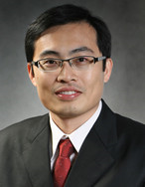

Yu-Sung Su
Associate Professor
Department of political science
Tsinghua University

Dr. Yu-Sung Su is an associate professor of political science department and the director of the Institute of Quantitative Research Methods at Tsinghua University. His research interests involve Comparative Democratization, Political Economy and Political Methodology (Causal Inference, Bayesian Methods, Multilevel Modeling and Game Theory). He published his works in journals such as Annals of Applied Statistics, Journal of Statistical Software, Econometrika, Research Policy, Social Science Quarterly, Global Environmental Change, etc. He also maintains several R packages such as arm, mi, R2jags.

苏毓淞，​清华大学政治学系副教授，2009年毕业于美国纽约市立大学，获政治学博士，2010年哥伦比亚大学博士后出站后，入职清华大学政治学系。主要研究领域：政治学方法论（贝叶斯方法、因果推论、缺失值插补、多层次回归分析、数据可视化）、比较政治学。在定量方法研究上有丰硕的成果，开发的R软件包广为国内外学术界使用。

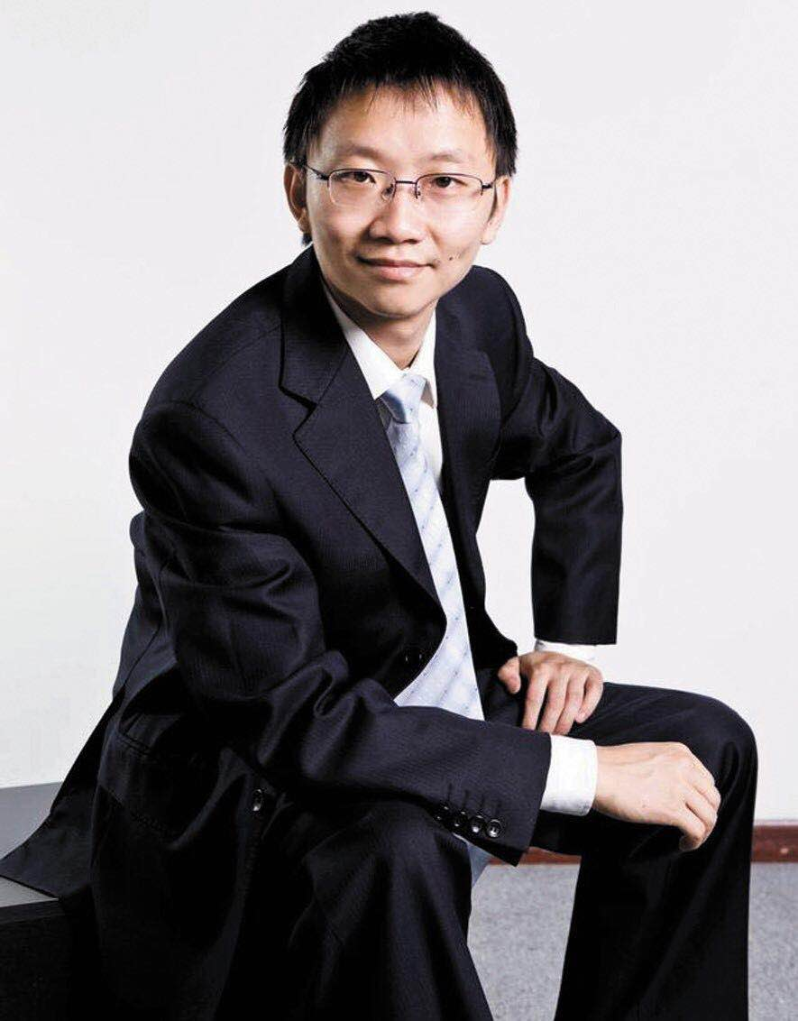

Tao Zhou
Professor
School of Computer Science and Engineering,
University of Electronic Science
and Technology of China

- Experience
2005: Special Class for Gifted Young, University of Science and Technology of China, Bachelor Degree Majoring Physics
2010: Department of Physics, University of Fribourg, Switzerland, PhD Majoring Physics
2010 – Present: Director of the Web Sciences Center, Director of the Big Data Research Center, Full Professor in the University of Electronic Science and Technology of China
- Brief Research Statement
His main research interests include the data mining, network science and collective dynamics. He has published many research articles in prestigious journals (e.g., Physics Reports, PNAS, Nature Communication), which received >20000 citations from the Google Scholar (H-index=68). His works have been reported by several academic medias as Nature News, PNAS News, MIT Technology Review, PhysOrg.com, My Science, TG Daily, Dutch Science Magazine, Chinese Science News, etc. See following the Publications and Citations:
http://scholar.google.com.hk/citations?user=MXgWgmEAAAAJ&hl=zh-CN.
- Selected Awards
- First Prize on Natural Science Progress for “Structure and Dynamics of Networks”, issued by the Education Minister of China, 2009
- Chorafas Prize for Young Scientist (2010)
- The 12th National Award for Young Scientist, 2012
- 10 National Annual Characters (Science and Technology Innovation) in 2015.
- Industrial Practice
He has found three well-known high-tech companies majoring big data and artificial intelligence, namely Union Big Data, BBD and Youe Data. These three companies have in total >2000 employees, with >100000000RMB profit in 2017.

周涛，电子科技大学教授，主要从事统计物理与复杂性方面的研究。在Physics Reports、PNAS、Nature Communications等国际SCI期刊发表300余篇学术论文，引用20000余次，H指数为68。2009年获教育部自然科学一等奖，2011年获第十二届中国青年科技奖，2014年起历年入选Elesvier最具国际影响力中国科学家名单（物理天文类）。2015年当选第十二届中华全国青联常务委员，并担任科学技术界别工作委员会副主任。2015年当选全国十大科技创新人物。2017年获全国创新争先奖。2018年起任四川省政协常委。

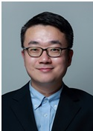

Zhiyuan Liu
Associate professor of the Department of Computer Science and Technology, Tsinghua University

Zhiyuan Liu is an associate professor at the Department of Computer Science and Technology, Tsinghua University. He received his Ph.D. degree in Computer Science from Tsinghua in 2011. His research interests include representation learning, knowledge graphs and social computation, and has published more than 60 papers in top-tier conferences and journals of AI and NLP including ACL, IJCAI and AAAI, cited by more than 3000 according to Google Scholar. He is the recipient of the Excellent Doctoral Dissertation of Tsinghua University, the Excellent Doctoral Dissertation of CAAI (Chinese Association for Artificial Intelligence).

刘知远，清华大学计算机科学与技术系助理研究员，系党委研工组长(2015-)，Frontiers of Computer Science杂志：青年编委YouthAssociate Editor(2013-)，主要研究方向为表示学习、知识图谱和社会计算。2011年获得清华大学博士学位，已在AAAI、IJCAI、ACL等人工智能领域的著名国际期刊和会议发表相关论文30余篇，Google Scholar统计引用超过1200次。承担多项国家自然科学基金。曾获清华大学优秀博士学位论文、中国人工智能学会优秀博士学位论文、清华大学优秀博士后、中文信息学会青年创新奖，入选CCF-Intel青年学者提升计划、中国科协青年人才托举工程。担任中文信息学会青年工作委员会执委、副主任，中文信息学会社会媒体处理专委会委员、秘书，SCI期刊Frontiers of Computer Science青年编委。担任ACL、IJCAI、AAAI、NAACL、EMNLP、WWW、WSDM等著名学术会议的程序委员会委员以及TKDE、TOIS、JCST等著名学术期刊审稿人。

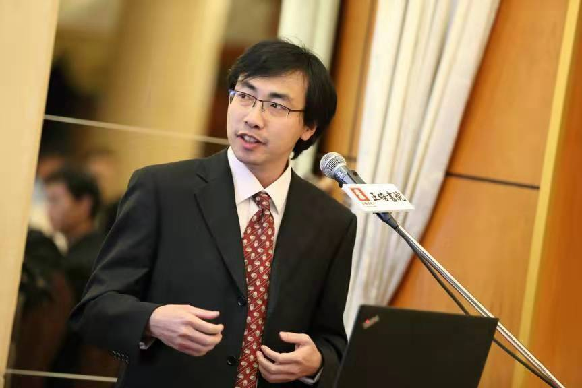

Jiang Zhang
Professor of School of
Systems Science,
Beijing Normal University
Founder of Swarma Club
and Swarma Campus

Jiang Zhang is a professor of School of Systems Science, Beijing Normal University, Founder of Swarma Club and Swarma Campus,Special Advisor in Tencent Research Institute. Zhang has been engaged in scientific research and teaching on complexity science and artificial intelligence for a long time.
Zhang's research Interests include machine learning on graph structure, scaling laws between city and company, and network flow.

张江，北京师范大学系统科学学院教授，集智俱乐部、集智学园创始人，腾讯研究院特聘研究员，长期从事有关复杂性科学、人工智能的科研与教学工作。主要研究兴趣包括图结构上的机器学习，城市与公司的标度律，流网络等。

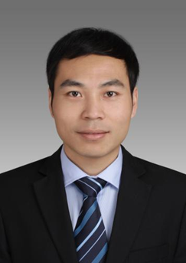

Tianguang Meng
Associate Professor of
the Department of Political Science ,
Tsinghua University

Tianguang Meng is an associate professor at the Department of Political Science, and the adjunct professor at Schwarzman College in Tsinghua University, and the executive director of Tsinghua Computational Social Science Institute. His research interest includes Chinese government and politics, Big data and governance, political economy of development, and computational social science. His articles have been published in Comparative Political Studies, Global Environmental Change, Social Science Research, Policy Study Journal. He earned the B.A. and Ph.D. degrees in political science from Peking University. Previously, He was a visiting scholar in Harvard University and University of California, San Diego.

孟天广，政治学博士，清华大学社会科学学院政治学系副教授。苏世民书院兼职教师，清华大学数据治理研究中心主任，兼任北京大学中国社会调查中心兼职研究员、北京大学中国国情研究中心研究员、加州大学圣地亚哥分校21世纪中国研究项目访问学者。

