Humble smuggle

1. Idea of the game
The aim of the game is to get the most points by collecting high value cards. But watch out! The highest card is often discarded and earns you nothing, so play wisely!

2. Components
White Cards (79 cards)
- Numbered with value 1–79
- Points = tens digit (e.g., 1–9 → 0 pts; 10–19 → 1 pt; 20–29 → 2 pts; …)
- Round Rule Icon: Determines which resolution rule applies
- Optional Symbol: Used for end-game set scoring
- Optional black cards to draw: Gain draws when scored
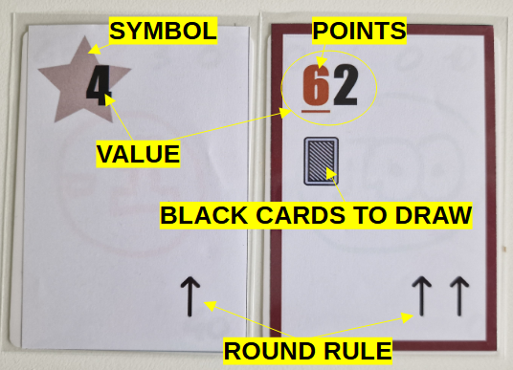Figure 1: White Cards description. Card value 4 is worth 0 points, has a STAR symbol, and a default round rule. Card value 62 is worth 6 points, draws 1 black card, and has a "double up" round rule.
Black Cards (40 cards)
- Hold Cards: Can be kept until end; grant bonus points & symbols
- Play Cards: Attach face-down to any white card to modify its value/effects
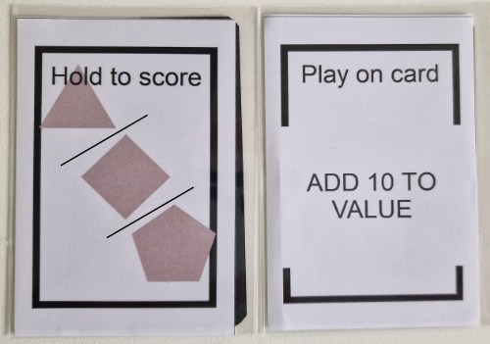Figure 2: Black Cards description. "Hold to score" cards will be worth one of the three symbol on the card at the end of the game. "Play on card" cards can be played on any player covered card before reveal phase.
Reference Cards (5 cards)
- Show icon definitions and symbol-set scoring table
End-of-Game Card
- Numbered with value 80: When revealed in the center, triggers final round
- Cannot be drafted or played
Rulebook
- This document

3. Objective 🎯
Accumulate the highest total score by:
- White Cards you score each round (tens-digit points)
- Symbol Sets from your scored whites & black Hold cards
- Black Hold Bonuses printed on Hold cards
The player with the most points wins!

4. Setup
- Prepare the White Deck
  - Remove the End-of-Game (80) card.
  - Shuffle the remaining 79 white cards.
  - Insert the 80-card at the position indicated for your player count (printed on the card).
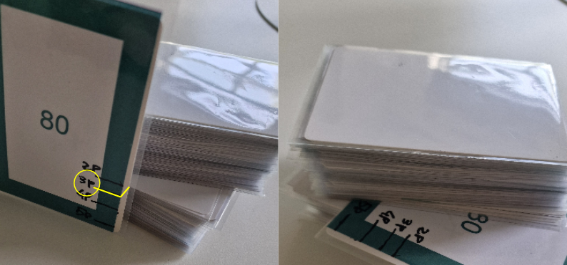Figure 3: Inserting end of game card into the deck for a 3 players game.
- Deal White Cards
  - Each player draws 3 white cards into their hand.
  - Reveal (players + 1) white cards face-up in the center.
- Deal Black Cards
  - Shuffle all black cards.
  - Deal 2 black cards to each player.
- Place Reference Cards
  - Within reach of all players.
- Select First Player
  - The second-oldest player starts.
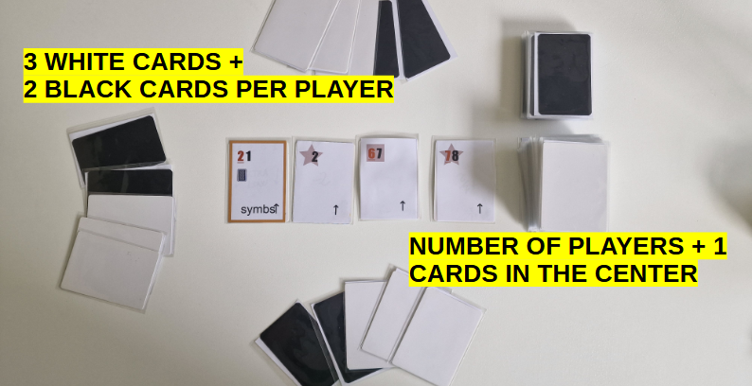Figure 4: Setup for a 3 players game.

5. Round Sequence 🔄
Each round follows these 7 steps. The active rule (see Section 7) is determined by the icon on the one white card left in the center after drafting.

1. Draft Phase
- In turn order (starting with the first player), each player must draft 1 white card from the center into their hand.

2. Selection Phase
- All players secretly choose 1 white card from their hand and place it face-down. White cards not selected remain in their hand for future rounds.

3. Black Card Play Phase
- In no particular order, players may play any number of Play black cards onto any face-down white card (including their own). Multiple Play cards may be attached to the same white card. When all players agree, they can move to the next step.
  - Once placed, these black cards are locked in and cannot be moved or removed.

4. Reveal Phase
- All players simultaneously flip over their selected white cards and any attached black Play cards.

5. Resolution Phase
- Apply the round rule based on the icon on the center card left after drawing to determine which white cards are discarded.
  - Ties: Cards with the same effective value are treated as a group and discarded together if they match the rule’s condition.
  - Scored white cards stay face-up in front of the player.
  - Discarded white cards go to the discard pile and do not score points.
- Black Card Draws:
  - If a scored white card had a “draw X black cards” instruction → Draw that many black cards.
  - If a discarded white card had X Play cards attached → Draw X black cards.
- Hand Limit: Players may not hold more than 3 black cards after any draws. Discard down to 3 immediately if over.
- Examples:
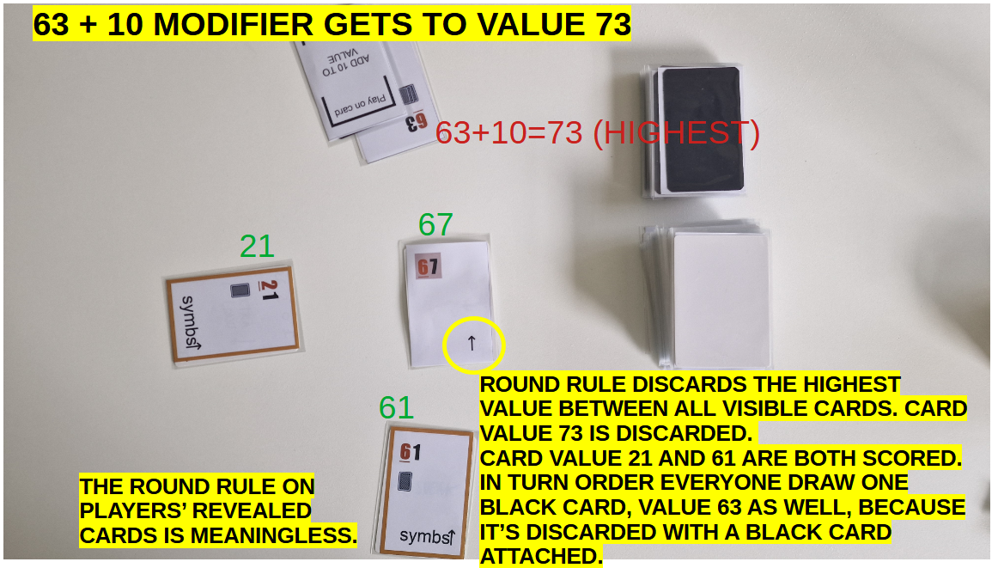
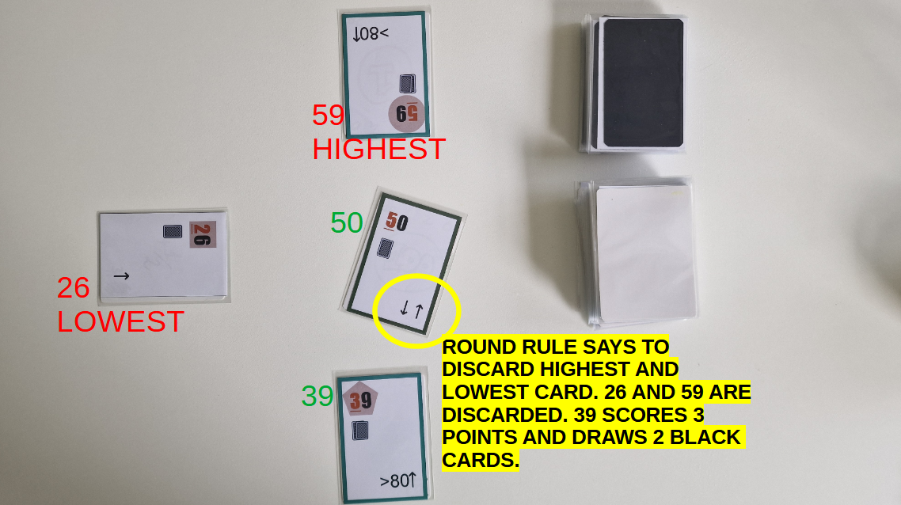
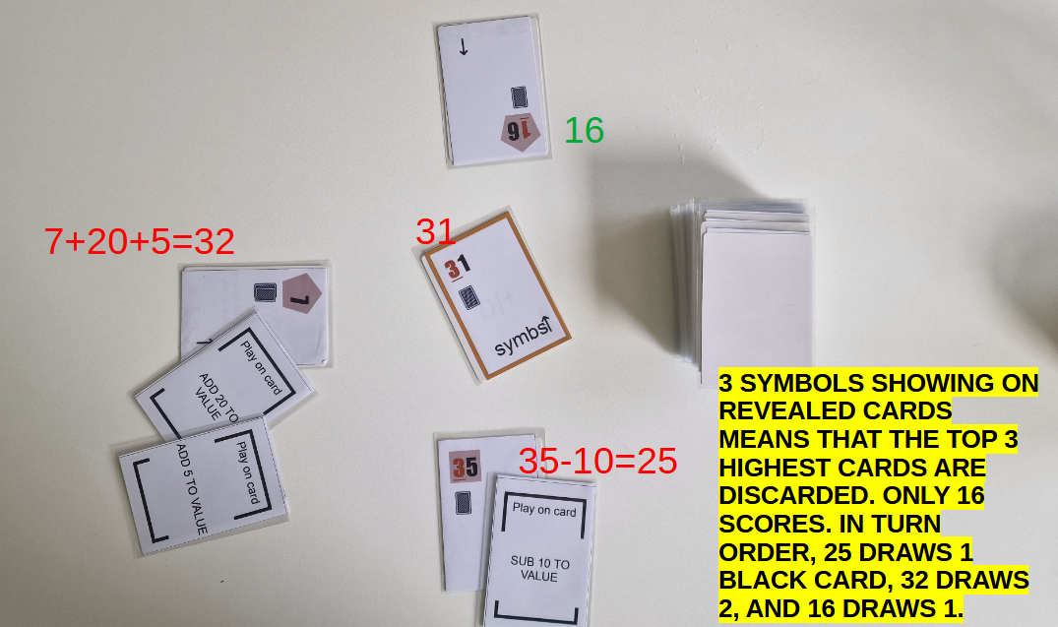

6. Center Cleanup
- Discard the one remaining unchosen white card in the center.
- Refill the center display to (players + 1) cards from the white deck. If the 80-card is revealed when refilling the center display, It may not be drawn, but it signals that the next round will be the last one.

7. First Player Pass
- Pass the first player marker clockwise.
- Begin the next round from Step 1.

6. End of Game 🏁
- The round in which the 80-card appears in the center is the final round.
- The 80-card stays in place and cannot be drafted.
- After resolving that round, proceed to Final Scoring.

7. Scoring 💰
- White Card Points
  - Sum of tens-digit values on all scored white cards.
- Black Hold Bonuses
  - Sum of bonus points on your Hold black cards.
- Symbol Sets
  - Combine symbols from your scored white and black Hold cards.
  - Score per set of identical symbols:
    - 2 → 2 pts
    - 3 → 5 pts
    - 4 → 9 pts
    - 5 → 15 pts
  - ★ Star symbols are wild (each substitutes one missing symbol in a set).
Final Score = White Points + Black Hold Bonuses + Symbol Set Points
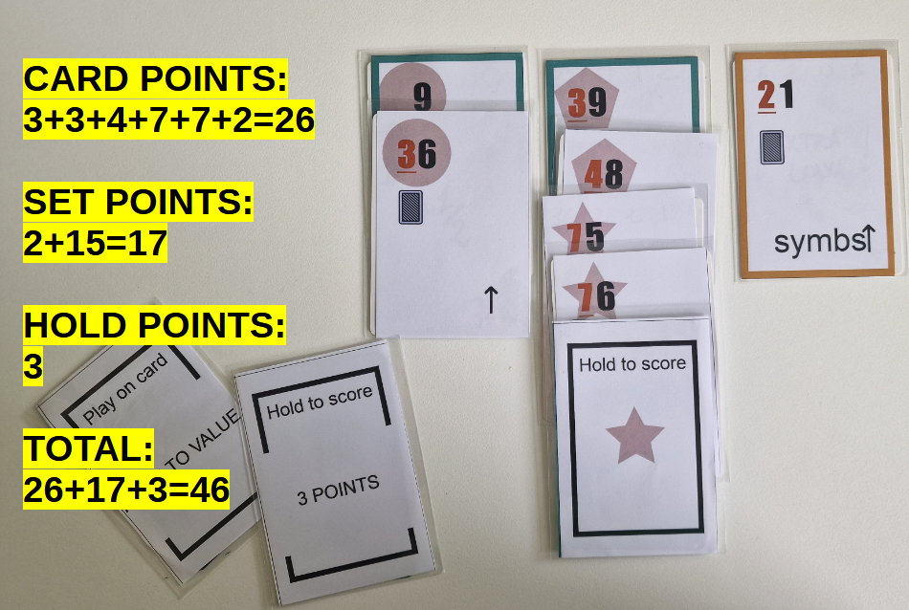Figure 5: During scoring, the player decides what attribute the star symbol will be counting as. "Play on card"cards are worth nothing during scoring phase.
Tiebreakers
- Most scored white cards wins.
- If still tied: share the victory!

8. Round Rules Reference 📜
After all players draft in the Draw Phase, the remaining center card's icon dictates which cards are discarded in Resolution.
Icon | Name | Effect
↑ | Standard | Discard the single highest revealed card (including center).
↑↑ | Double Up | Discard the two highest revealed cards (including center).
↑↓ | High & Low | Discard both the highest and lowest revealed cards (including center).
[Symbol] ↑ | Symbol Up | Count total matching symbols among revealed; discard that many highest cards.
≥80 | Safe Zone | Discard the highest card ≥80;
(See Reference Cards for icon art.)

9. FAQs & Clarifications ❓
Q1: What if the Black deck runs out?
A: Shuffle the black discard pile to form a new deck.
Q2: Can I exceed 3 black cards?
A: No—always discard down to 3 immediately after any draw.
Q3: Can I play on my own card?
A: Yes! You may attach Play cards to your own white cards.
Q4: How do ties work in discards?
A: Tied cards share the same value; if the rule targets that value, all tied cards are discarded.

