Humble smuggle

Idea of the game
Humble smuggle is a light strategy, trick taking, push your luck game. The aim of the game is to get the most points by playing and collecting high value cards. But watch out! The highest card is often discarded and earns you nothing, so play wisely!

Components
- White cards (79 cards, check the end of the rule book for details)
- Black cards (40 cards)
- Reference cards (5 cards)
- End of game 80 card

Setup
- Shuffle the 79 White cards. Shuffle all 40 Black cards.
- Align the Endgame 80 card to the side of the deck. Then, according to the indicated player count line printed on the card, slot the Endgame card into the deck.
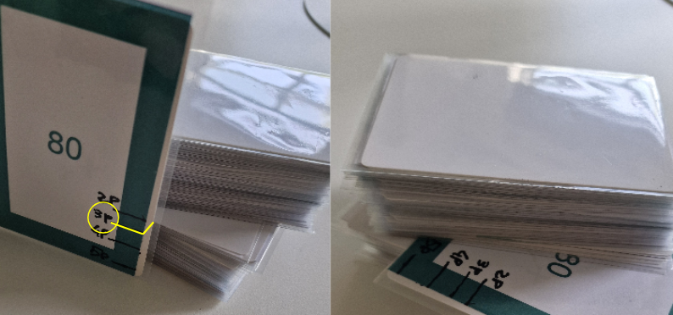Figure 1: Inserting end of game card into the deck for a 3 players game.
- Set both White and Black decks in the middle of the play area.
- Deal 3 White cards and 2 Black cards to each player.
- Reveal White cards equal to the number of players +1 in the center of the table.
- The last player who smuggled something starts first.
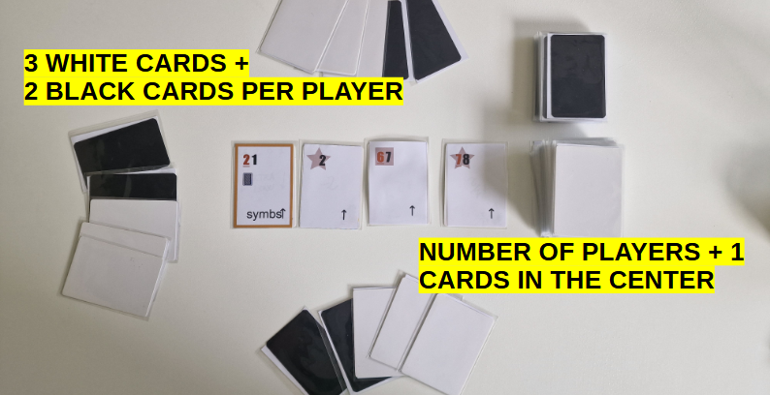Figure 2: Setup for a 3 players game.

Round Sequence 🔄
Each round follows these 6 steps.

1. Draft step
- In turn order (clockwise starting with the first player), each player must draft 1 white card from the center into their hand. One card will be left in the center for the following steps.
- After all players draft in the Draft Phase, the remaining center card's icon dictates which cards are discarded in Resolution (step 5).
Icon | Name | Effect
↑ | Standard | Discard the single highest revealed card (including center).
↑↑ | Double Up | Discard the two highest revealed cards (including center).
↑↓ | High & Low | Discard both the highest and lowest revealed cards (including center).
[Symbol] ↑ | Symbol Up | Count total symbols (shapes overlapped with the card value) revealed; discard that many highest cards.
≥80 | Safe Zone | Discard all the revealed cards with value higher or equal than 80;

2. Selection step
- All players secretly choose 1 white card from their hand and place it face-down. White cards not selected remain in their hand for future rounds.

3. Black Card Play step
- In no particular order, players may play any number of Black play cards onto any face-down white card (including their own). Black cards are played faced down. Multiple Play cards may be attached to the same white card. Once all players declare they are done playing Black cards, move to the next step.
  - Once placed, these black cards are locked in and cannot be moved or removed.

4. Reveal step
- All players simultaneously flip over their selected white cards and any attached black Play cards. Black cards are resolved simultaneously.

5. Resolution step
- Apply the trick rule based on the icon on the bottom right of the card left after drafting to determine which white cards are discarded.
  - Ties: Cards with the same effective value are treated as a group and discarded together if they match the rule’s condition.
  - Scored white cards stay face-up in front of the player.
  - Discarded white cards go to the discard pile and do not score points.
- Black Card Draws:
  - If a scored white card had X black cards pictured under the card value → Draw X black cards.
  - If a discarded white card had X Play cards attached → Draw X black cards.
- When drawing: Players may not hold more than 3 black cards after any draws. Discard down to 3 immediately if over. When the Black deck runs out, shuffle all discarded Black cards to form a new deck and continue drawing, if any.
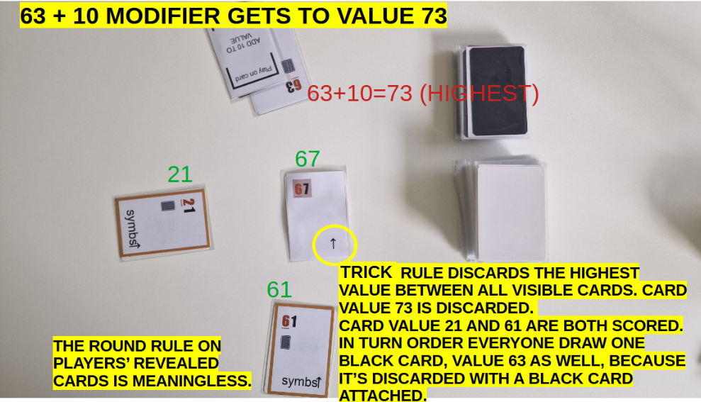Figure 3: Standard trick rule and a black play card

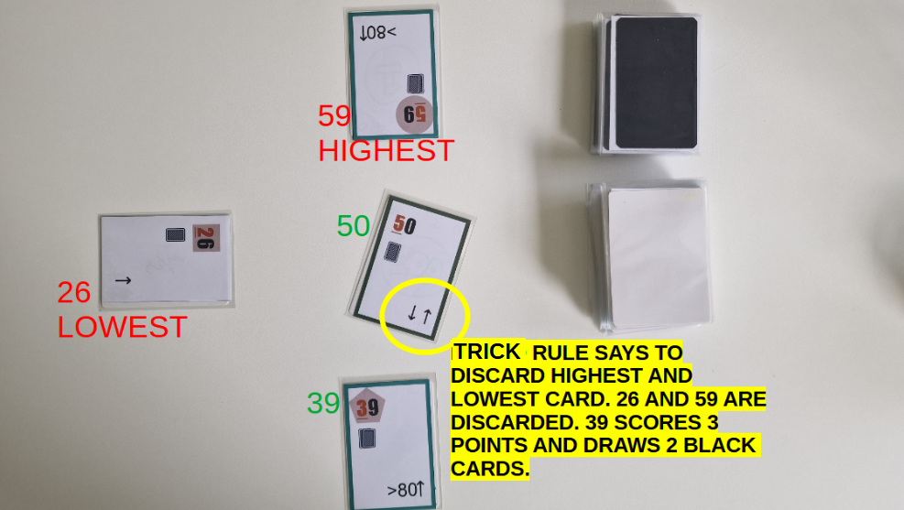Figure 4: High & Low trick rule
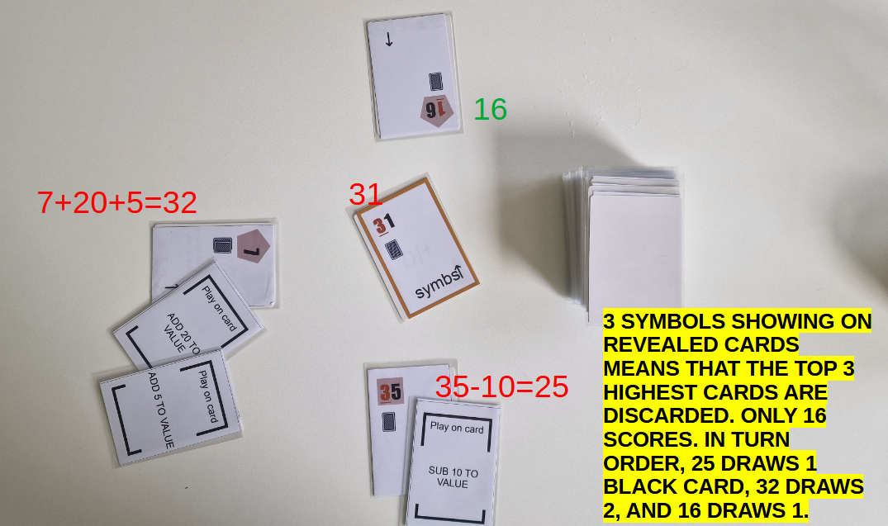Figure 5: Symbol up trick rule and multiple black play cards

6. Cleanup step
- If it wasn’t discarded during the trick, discard the one remaining unchosen white card in the center. If that one remaining card was the End of game 80 card, proceed to the end of game scoring.
- Refill the center display to (players + 1) cards from the white deck. If the End of game 80 card is revealed when refilling the center display, it signals that the next round will be the last one. The 80 card can’t be drafted by the players during last round draft step. It is guaranteed that the last trick highest card value, beside Black play cards modifiers, will be 80.
- Pass the first player marker clockwise.
- Begin the next round from Step 1.

End of Game scoring🏁
Each player totals the points of their collected cards:
- Sum of tens-digit values on all White cards.
- Sum of bonus points on Black Hold cards.
- Variable set scoring from combined White and Black cards, with 2/3/4/5 sets scoring 2/5/9/15 additional points.
NOTE: Star Symbols will substitute any missing sets, up to the maximum of 5 sets.
The player with the highest score wins! On a tie, share the victory!

White cards details
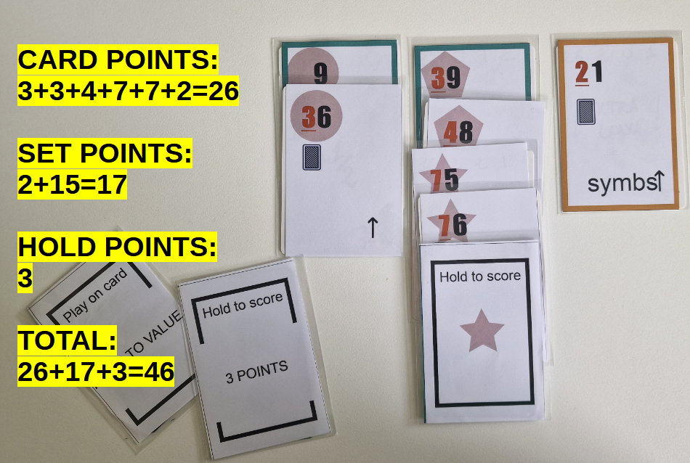Figure 6: During scoring, the player decides what attribute the star symbol will be counting as. "Play on card"cards are worth nothing during scoring phase.
