Statistical inference courese project 1

## Problem explanation

The exponential distribution can be simulated in R with rexp(n, lambda) where lambda is the rate parameter. The mean of exponential distribution is 1/lambda and the standard deviation is also also 1/lambda. Set lambda = 0.2 for all of the simulations. In this simulation, you will investigate the distribution of averages of 40 exponential(0.2)s. Note that you will need to do a thousand or so simulated averages of 40 exponentials.

## Simulation 1000 times for 40 exponentials

lambda = 0.2  
n = 40  
nsims = 1:1000  
set.seed(1000)  
means <- data.frame(x = sapply(nsims, function(x) {mean(rexp(n, lambda))}))  
head(means)

## x  
## 1 4.514  
## 2 5.051  
## 3 3.252  
## 4 3.917  
## 5 4.898  
## 6 3.677

1. Show where the distribution is centered at and compare it to the theoretical center of the distribution.

* Mean of my simulation is 4.987 and Expected mean is 5.
* SD of my simulation is 0.8089 and Expected SD is 0.7906.

1. Show how variable it is and compare it to the theoretical variance of the distribution. x

* Variance of my simulaton is 0.6543 and theoretical variance of the distribution is 0.625.

1. Show that the distribution is approximately normal.

library(ggplot2)  
ggplot(data = means, aes(x = x)) +   
 geom_histogram(aes(y=..density..), fill = I('blue'),   
 binwidth = 0.20, color = I('black')) +  
 stat_function(fun = dnorm, arg = list(mean = 5, sd = sd(means$x)))

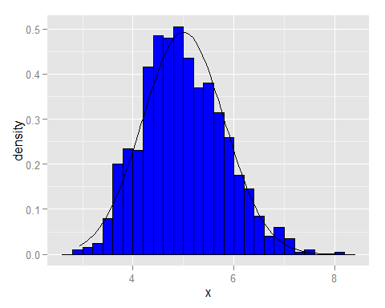

1. Evaluate the coverage of the confidence interval for 1/lambda: X±1.96S/sqrt(n).

mean(means$x) + c(-1,1)*1.96*sd(means$x)/sqrt(nrow(means))

## [1] 4.937 5.037

**As above simulations, we know that the exponential distribution can be simulated and the mean of exponential distribution is 1/lambda and the standard deviation is also also 1/lambda.**