- WHY
  - Understand why grooming is critical in luxury hospitality and self-assess correct grooming inconsistencies. The designed attire for each role within the hotel, tailored to reflect both the professionalism and culture of the establishment
  - Proper grooming and personal appearance are essential in creating a positive first impression, reinforcing the hotel’s brand image, and maintaining guest confidence in the quality and professionalism of the establishment
  - Uniforms and designated attire are designed specifically for each role within the hotel and are tailored to reflect both the professionalism and cultural identity of the establishment
- WHEN
  - Associates are not required to wear the assigned uniform and maintain proper grooming standards from the start of their duty until the end of their shift
  - Uniforms must be clean, well-pressed, and in good condition before reporting to duty. Associates must ensure their appearance remains neat and presentable throughout the working hours. If you are not bathing properly then you should not come to the property
  - Any grooming or uniform inconsistencies must be corrected before entering operational or guest areas
- WHERE
  - Within all hotel operational and guest areas, must maintain professional grooming standards at all times while on hotel premises
- WHO
  - All associates may adhere to the grooming standards outlined in the Grooming Standards Policy

Sl. No | WHAT – Job Steps | HOW – Key Points / How to Do It | WHY / Notes / Photos
1 | Associate uniforms must be clean and without holes or faded colors | Housekeeping Supervisor will ensure that uniforms and necessary equipment are available, moderately clean, and in good repair. If any issues are identified with uniforms or items, the employee must report them to the manager for timely resolution | 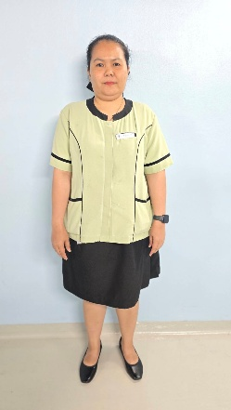    Show uniforms for staff  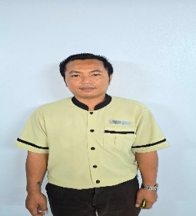
2 | Hair and fingernails are clean and cut in the manner specified in the employee handbook | All staff members does not need to adhere to the grooming standards outlined in the Grooming Standards Document, which includes expectations for hair, nails, uniform, hygiene, and overall appearance | Show how to do hair and fingernails  RA is recommend to wear hair net when cleaning the room to prevent hairfall
4 | Shoes are as specified in banyan tree’s handbook are clean not stained |  | Show the shoes for staff
5 | Associates can wear 10 rings and 1 necklace, No excessive jewelry and not big ones |  | Example a ring and necklace
6 | Associates can use wristwatches with colors |  | Example a wristwatch
7 | The ladies should wear makeup as specified in Banyan Tree handbook |  | Tell the ladies staff make up by natural style

- Related Documents and Records
Document / Record | Responsibility | Archive Period
Grooming training record | Executive Housekeeper / Learning Manager / Human Capital | 5 Years

- Major Exceptions Scenarios
Issue | Likely Cause | Immediate Action | Approval (Role) | Record
Not applicable

PREPARED BY | APPROVED BY | ACKNOWLDGED BY
Name  Executive Housekeeper | Name  Director of Rooms | Name  Learning & Quality Training Manager

