Trading Bot installation and Run Guide v1

Author: SM

Source file: TradingBot_2019_01_29_V1_1_update_final.zip

1. The structure of the trading bot.

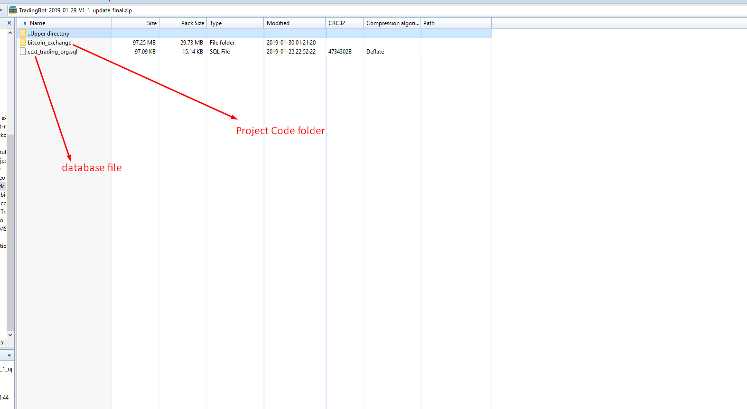

1. Installation.

* Firstly you need to install [Xampp](https://sourceforge.net/projects/xampp/) on your computer.
* After install the xampp, you need to configure the xampp.

Run Xampp and then you can find “Apache (httpd.conf)”, and then click  
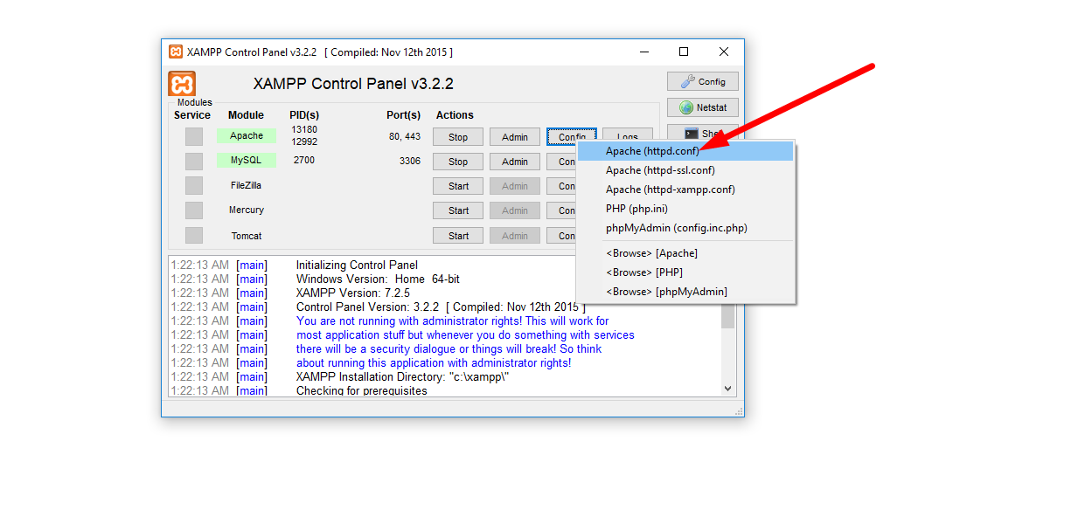

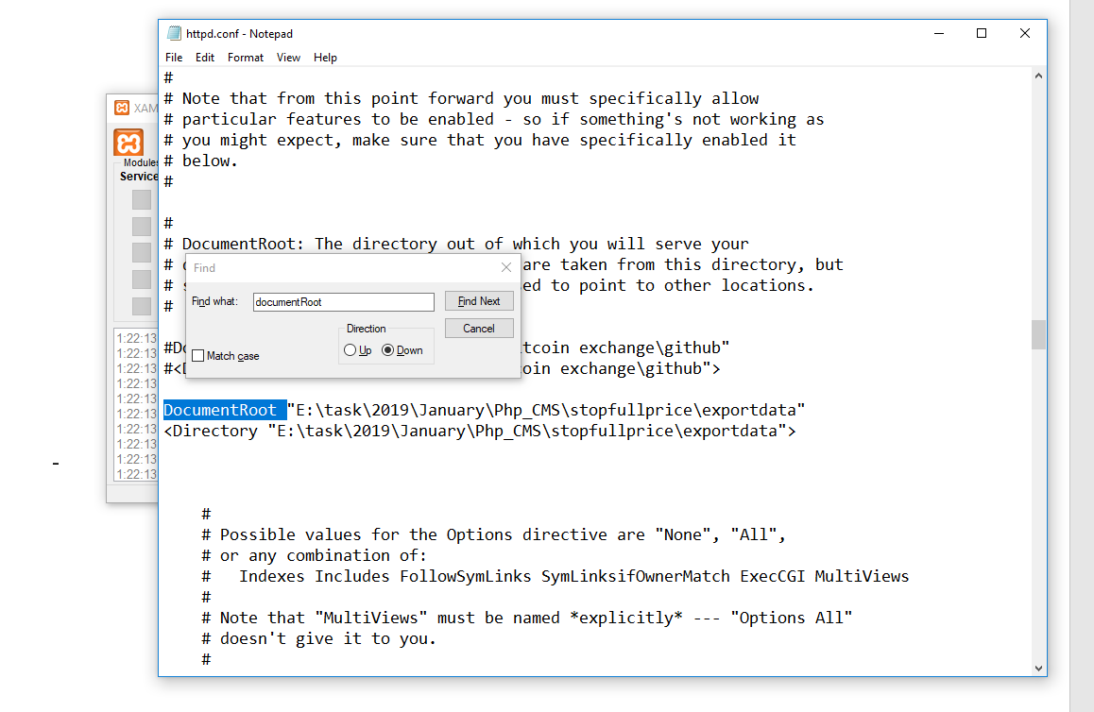

And then please find “documentRoot” string in this file

Please open “bitcoin_exchange” folder(project folder) and then click the “public” folder

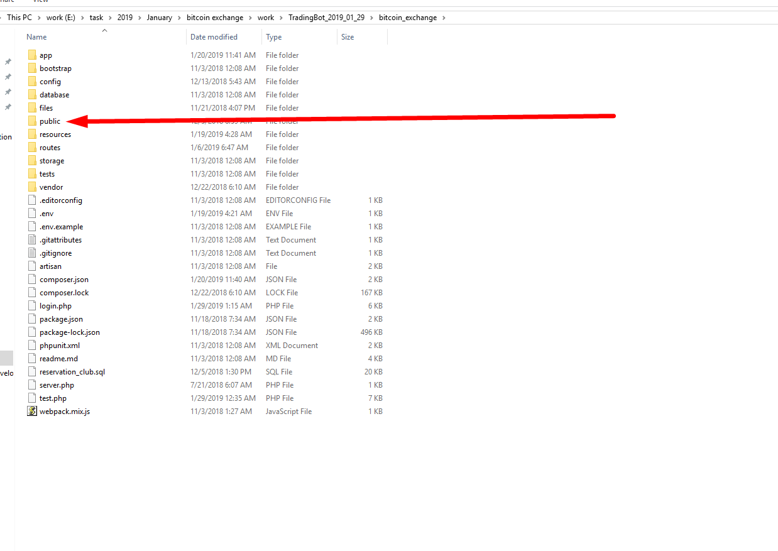

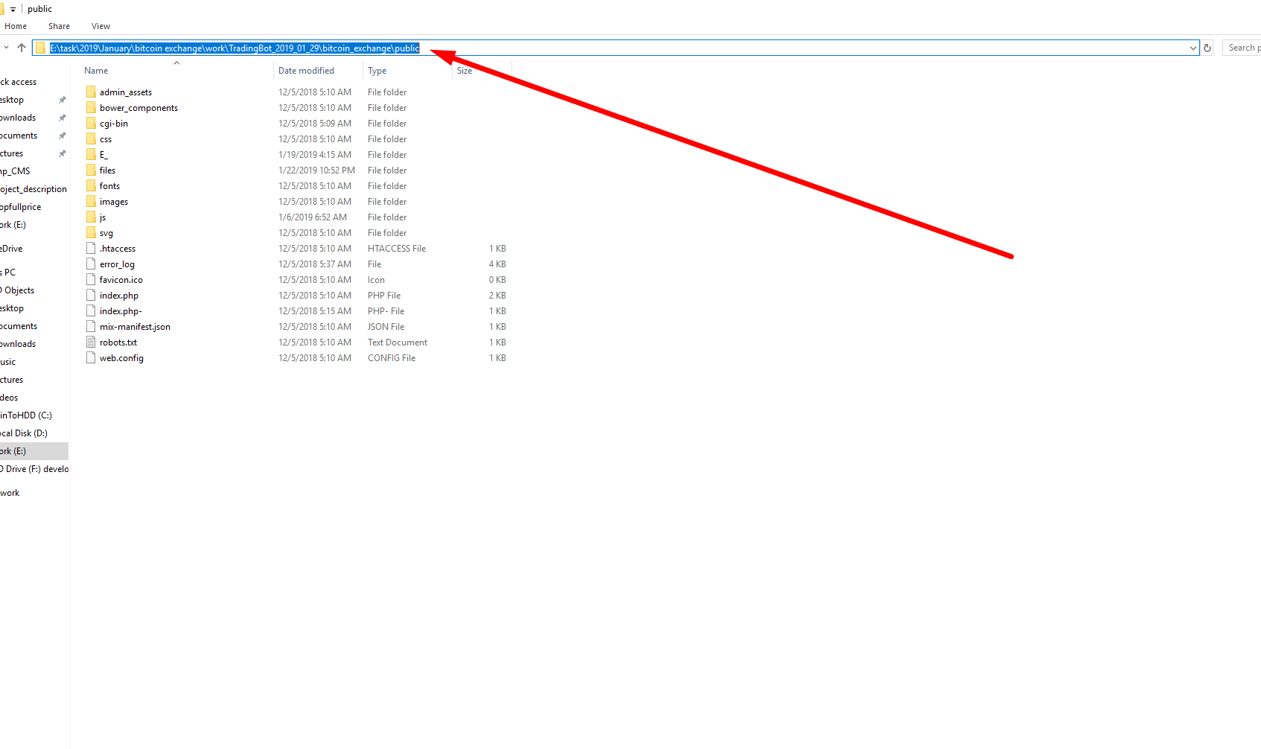

And then copy the address.

Then paste this address to the “documentRoot” part in the second image

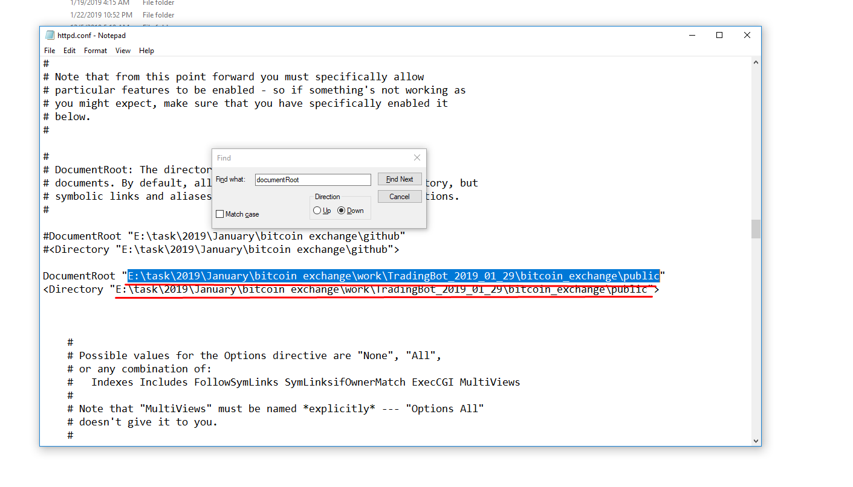

And save the change.

* Next step.

Configure database.

Open web browser and open “localhost/phpmyAdmin”

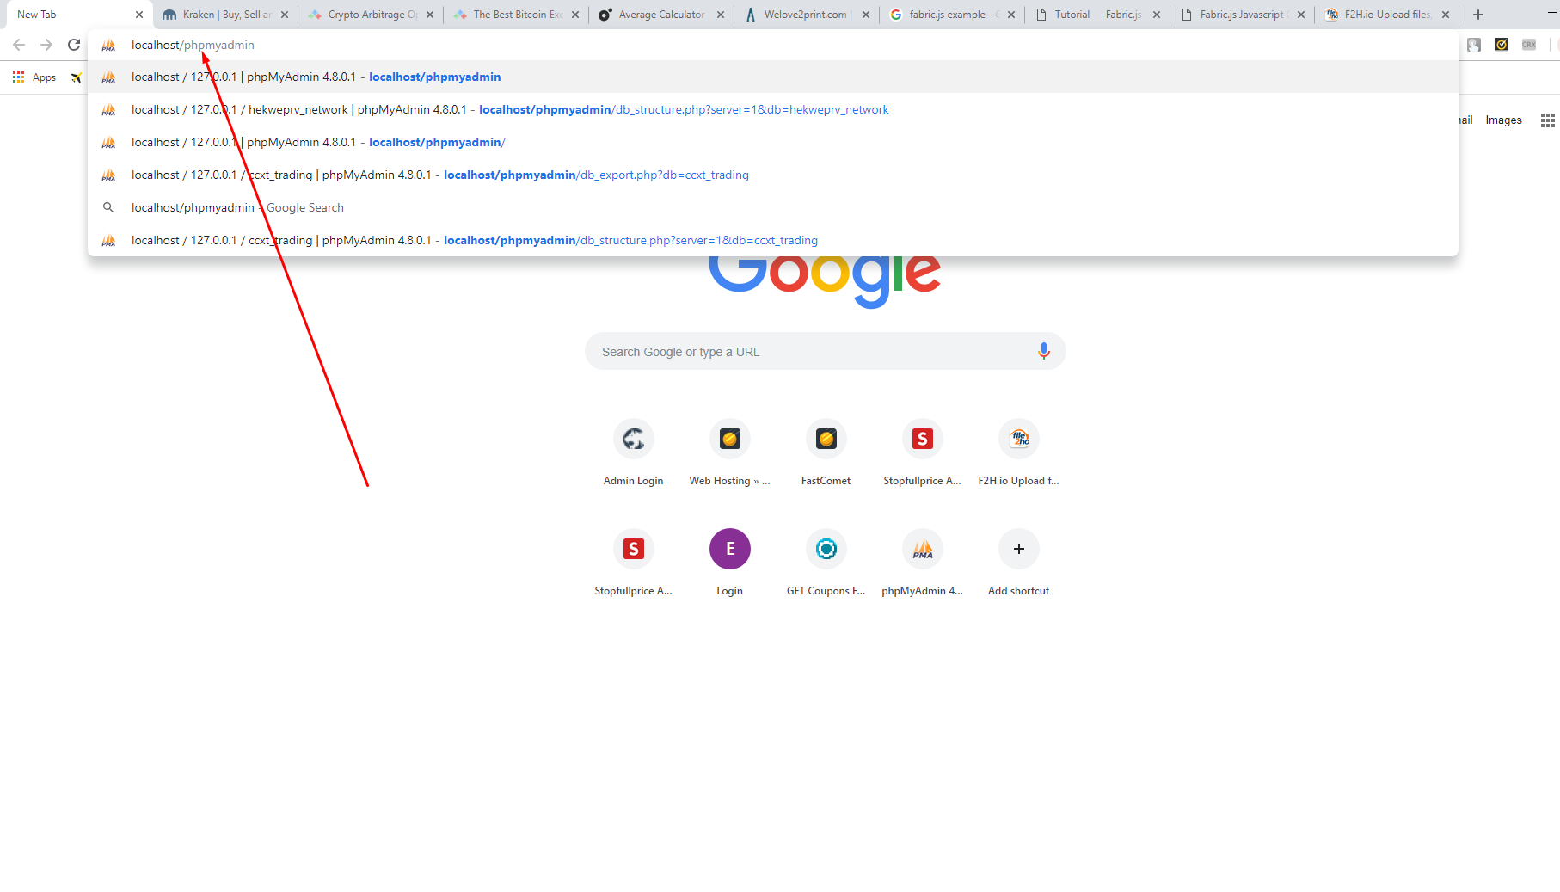

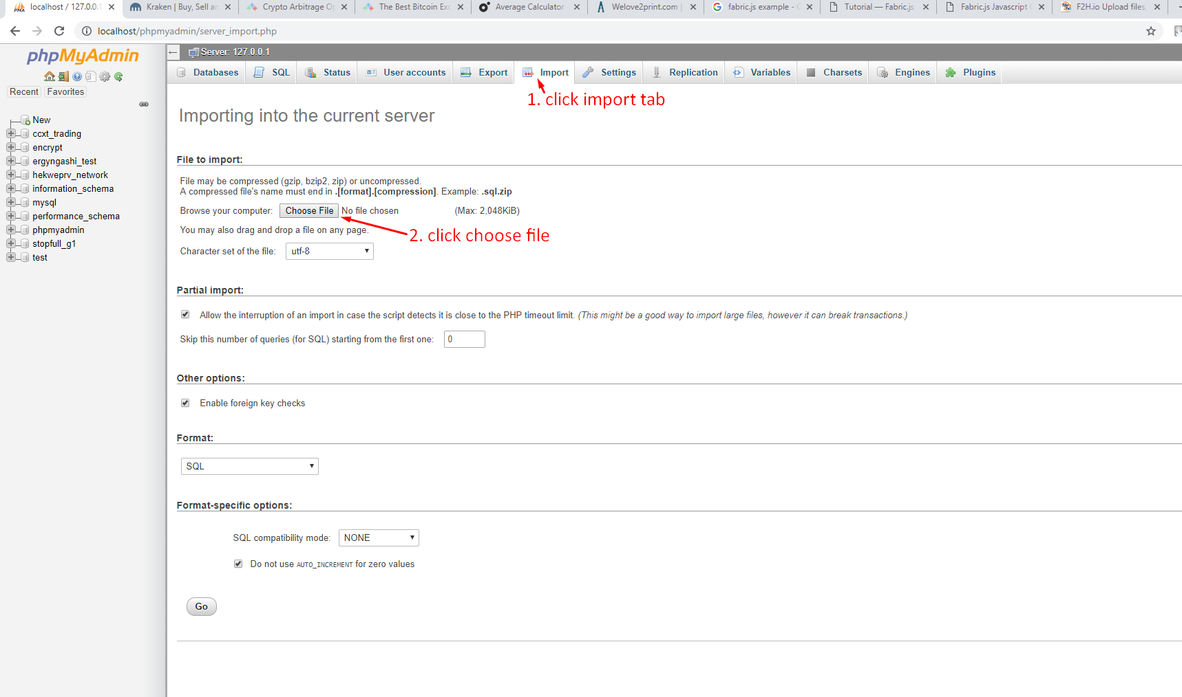

And find the database file(ccxt_trading.sql) and open.

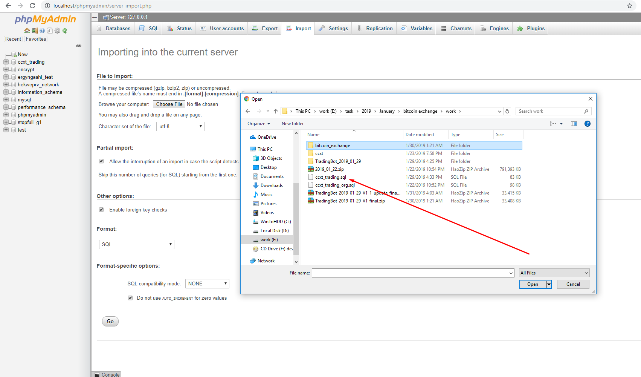

And click the import button

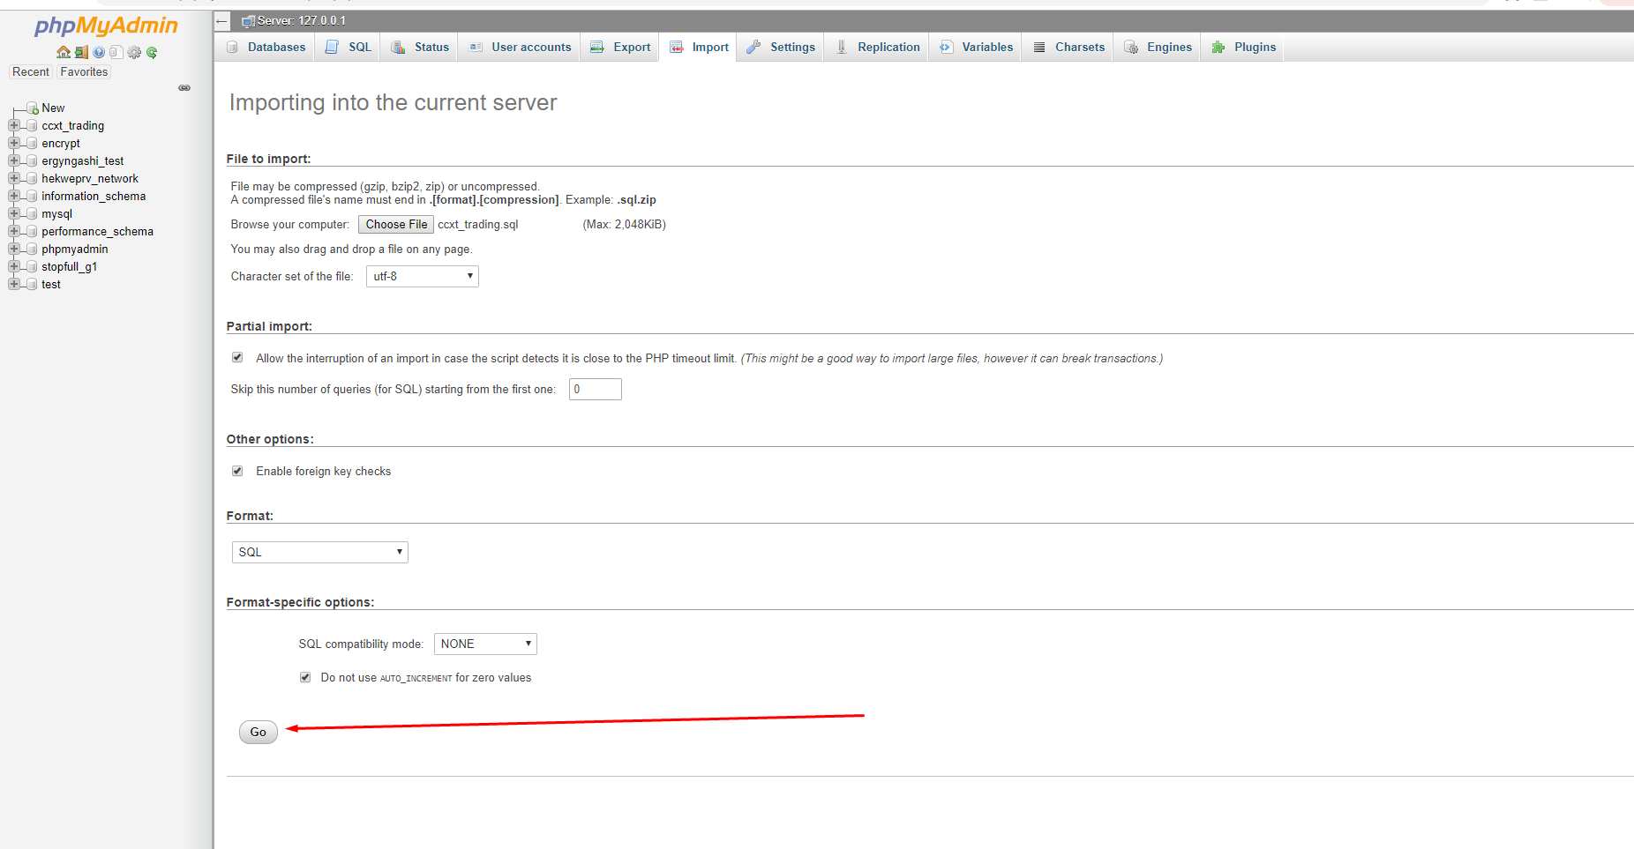

So you have just finished database configuration.

And you have finished xampp configuration.

1. Let’s run trading bot.

* Run the xampp.

Click the both start button and then we can start local serve

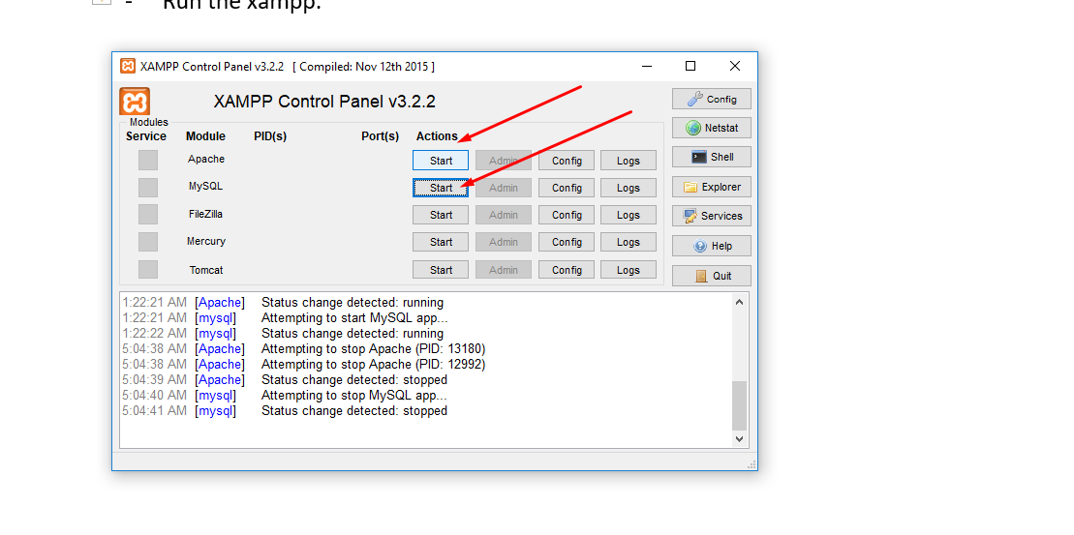

* Open your “localhost” on your web browser.

Then you will be amazing!!!

