TEMPLATE FOR EXTENDED ABSTRACT AND FINAL PAPER

First author[1], Second author[2], Third author[3]

ABSTRACT

Please provide a brief abstract giving an overview, 10 to 15 lines.

# Introduction

This template is both for the initial two-page extended abstract, and for the final full paper. Please prepare the document in Word, using this template. When complete, please save it in PDF format before submitting.

# General

## Title, authors, and affiliation

The title should be bold, capital letters and centred. Author names should be listed in full, with surname last. The affiliation is given in the footnote, with the email address of the main author.

## Size, margins, and numbering

The page size is A4. The margins are set at; Top: 20 mm; Bottom: 20 mm; Inside: 15 mm; Outside: 15 mm. All text should be typed within the margins.

## Sections

The paper starts with the abstract, followed by the numbered main sections. The list of the numbered references should be added at the end, using the format shown.

## Paper length

The initial extended abstract is limited to 2 pages in length. This must include at least 2 diagrams, graphs or images that relate to key aspects of the paper.

The final paper may be up to 10 pages.

## Language

The written language must be English. Please seek external proof-reading before submitting your document.

# Section headings and text style

## Heading 1

Section headings are as shown above. Use consecutive numbering of the sections, using the preset style for Heading 1 and Heading 2. Please limit to two levels of headings.

## Normal text style and list

The normal text is Times New Roman 12 pt, justified with single line spacing. For numbered or bulleted lists please use the same font size and style as the normal text of the paper

1. Numbered list

* Bulleted list.

# Figures, tables and equations

## Tables

Tables should be prepared in Word, as shown in Table 1. The font size should not be less than 10 pt. Table captions should be 10 pt. Tables and captions should be centred on the page.

Table 1. Recommended margins in mm

|  |  |  |  |
| --- | --- | --- | --- |
| Top | Bottom | Inside | Outside |
| 20 | 15 | 25 | 15 |

## Equations

Use the equation editor of Word with the standard settings. Equations should be numbered and referred to as in equation (1).

$σ=\frac{M_{Ed}}{I_{y}}∙z_{max}=235\frac{N}{{mm}^{2}}$ (1)

where *M*Ed is the design bending moment, etc

## Figures, diagrams, illustrations

Figures, diagrams, illustrations must be referred to in the text, as in Figure 1. The captions should be 10 pt.

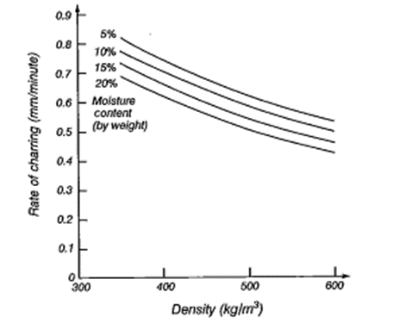

Figure 1. Charring rate as affected by wood density and moisture content.

# CONCLUSIONS

A conclusion section is required. This can be in bullet points if you wish.

References

The references should be in a numbered list in the order the references first appear in the paper. Reference numbers in the paper should be in square brackets, e.g. [1].

1. FPInnovations, 2013. Technical Guide for the Design and Construction of Tall Wood Buildings in Canada. Chapter 5 – Fire Safety and Protection (pp 223-282). FPInnovations, Vancouver, Canada.
2. Buchanan, A.H. and Abu A.K., 2017. Structural Design for Fire Safety. John Wiley and Sons, West Sussex, UK: 415pp.

1. **Title, affiliation,**

   **e-mail:** [firstname.lastname@address](mailto:firstname.lastname@address),
2. **Title, affiliation**
3. **Title, affiliation**