**Steps for Downloading from the App Engine Datastore**:

CD C:\Program Files (x86)\Google\google_appengine

Then used the following command:

appcfg.py create_bulkloader_config --filename=bulkloader.yaml --url=http://csp-cs4hs.appspot.com/_ah/remote_api

**For the Test Course:**

appcfg.py create_bulkloader_config --filename=bulkloadertest.yaml --url=http://test-cs4hs.appspot.com/_ah/remote_api

Format:

appcfg.py create_bulkloader_config --filename=bulkloader.yaml --url=http://<your_app_url> .appspot.com/_ah/remote_api

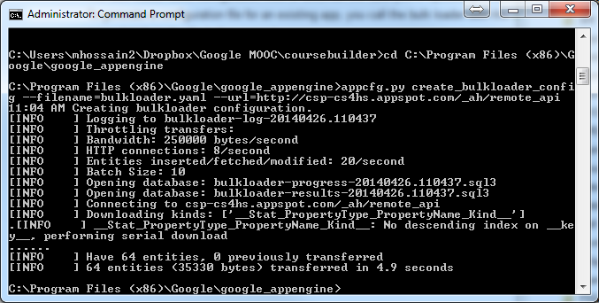

[Did not ask for an email address or password ??]

If asked, I would provide my Email address:: mokter@gmail.com

Provide Application specific Password [Created using 2-step varification pricess]:

tcdg kazu dqcd ufzs [With No space, as follows: tcdgkazudqcdufzs ]

This time I found the following bulkloader files in the C:\Program Files (x86)\Google\google_appengine

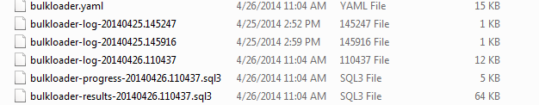

As shown in the following picu=ture:

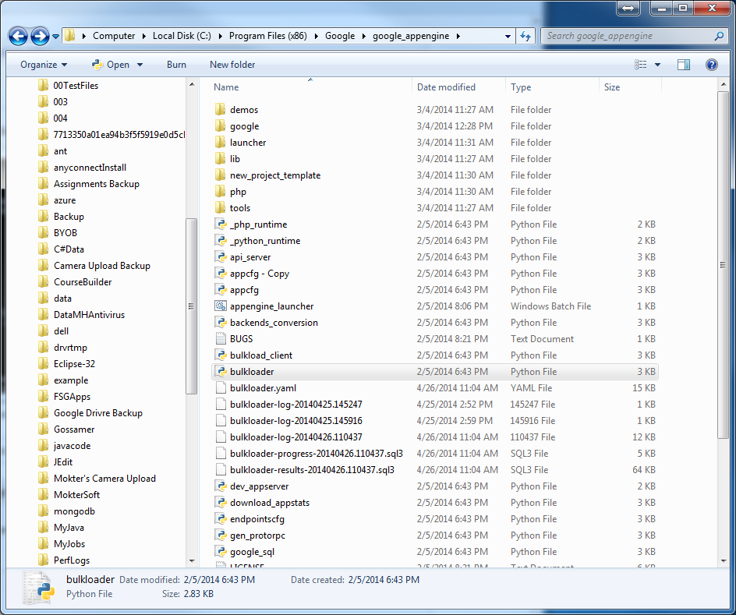

**Step 4. Editing the perviously auto generated \Coursebuilder\bulkloader.yaml File**

See: <https://developers.google.com/appengine/docs/python/tools/uploadingdata#Python_Using_automatic_configuration>

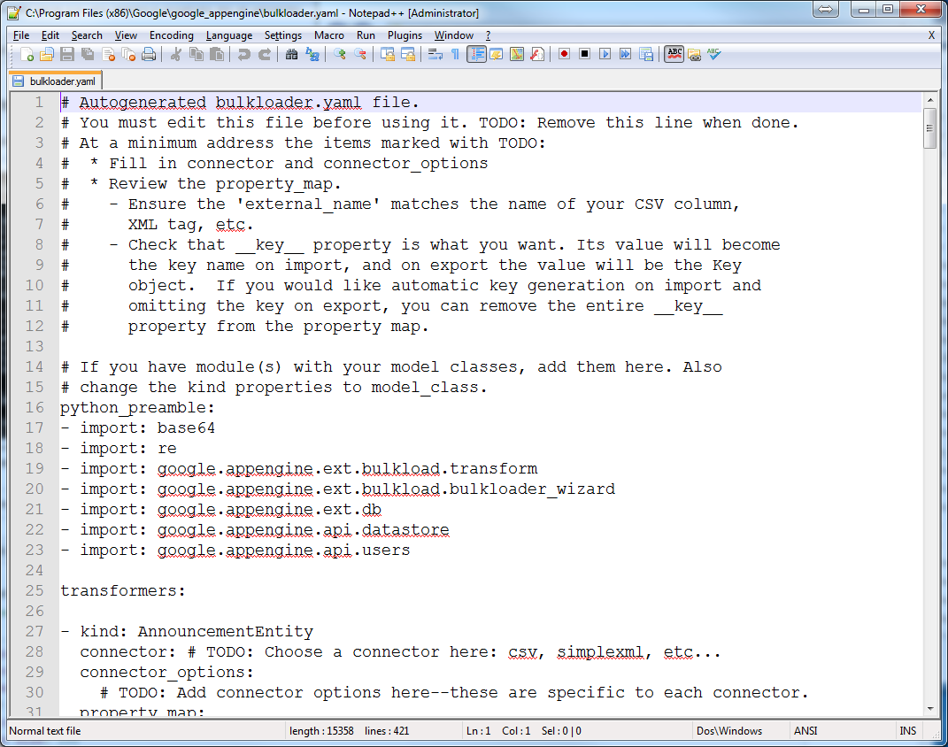

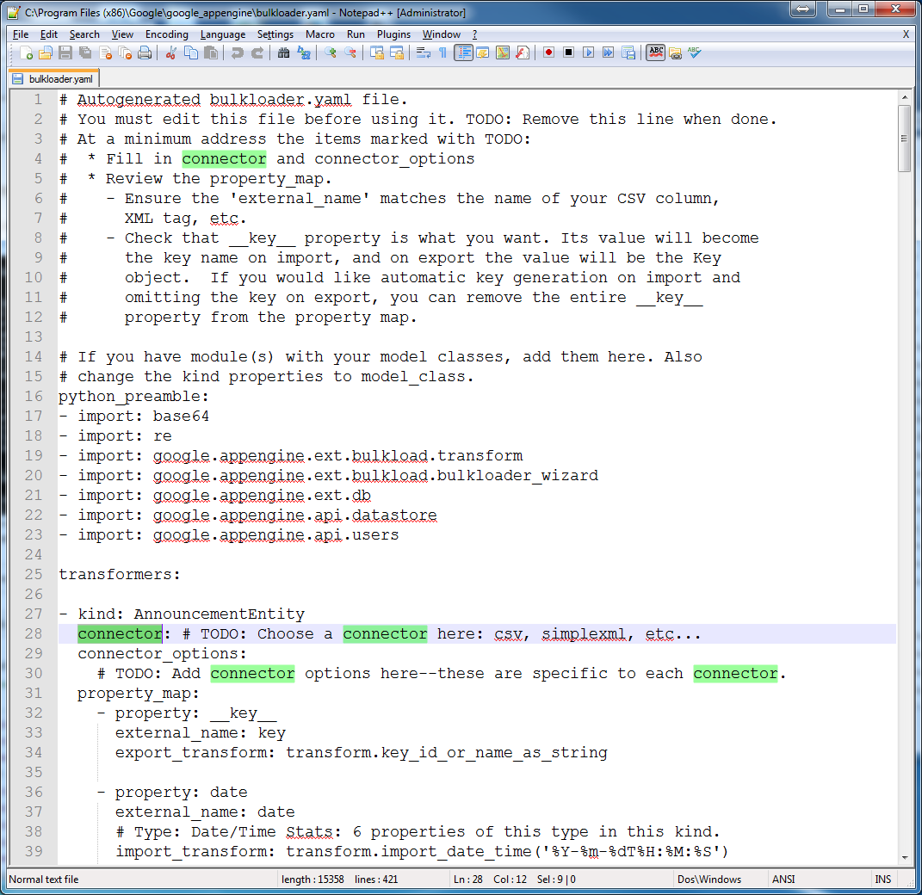

**Editing the autogenerated bulkloader.yaml file**

**I put placed**  connector type as “csv” i**n 15 places as follows, but dit not put anything in the** connector_options:

These were as follows:

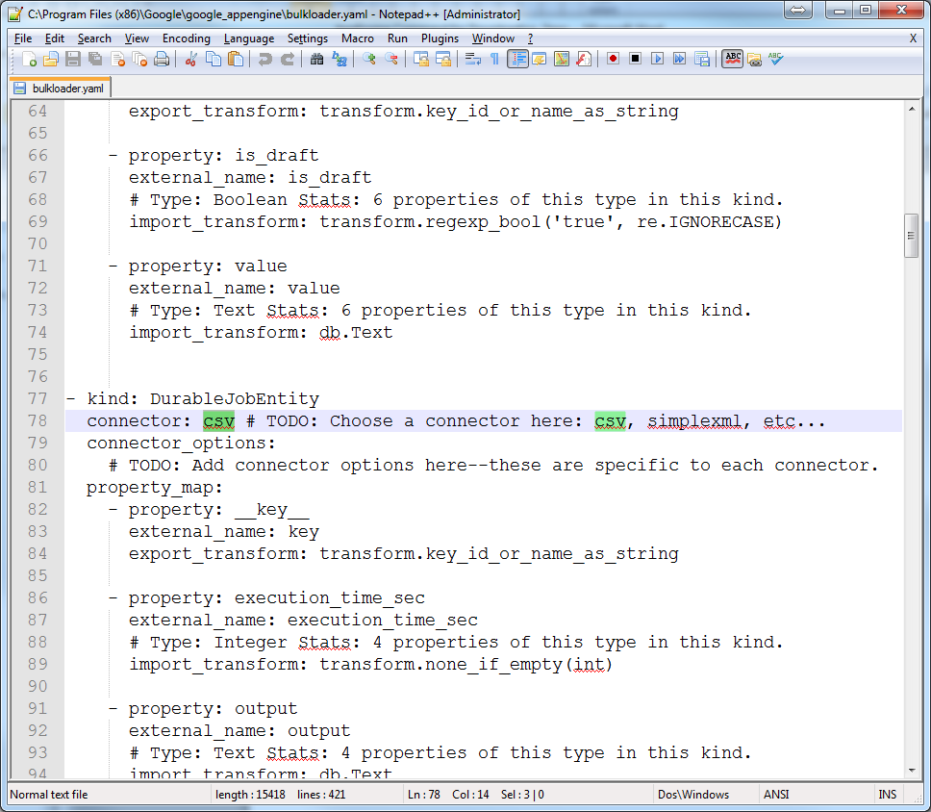

I Also Changed:

import_transform: transform.create_foreign_key('TODO: fill in Kind name')

as

import_transform: transform.create_foreign_key('Reviewee')

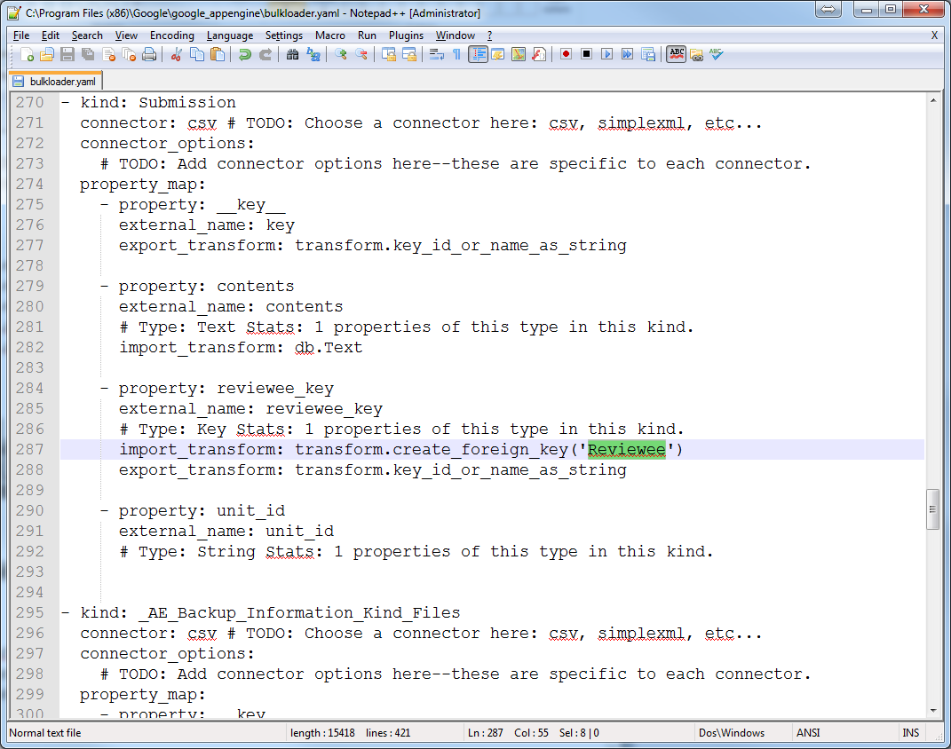

With the Edited bulkloader.yaml file I then executed the following command:

python appcfg.py download_data --config_file=bulkloader.yaml --filename=student.csv --kind=Student --url=http://csp-cs4hs.appspot.com/_ah/remote_api --namespace=ns_CSP4HS

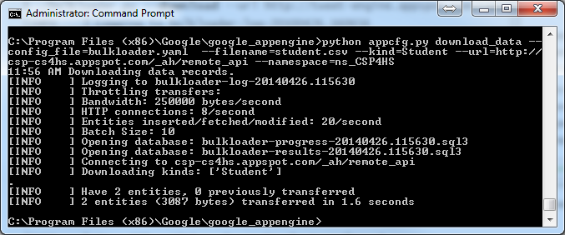

It created a student.csv file in my “C:\Program Files (x86)\Google\google_appengine” folder as follows:

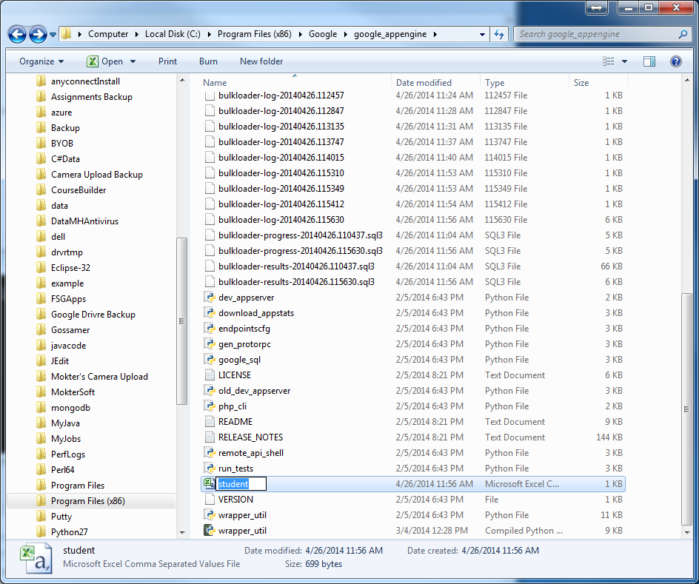

Now I opend it with MS Excel and found the registered studeets as follows:

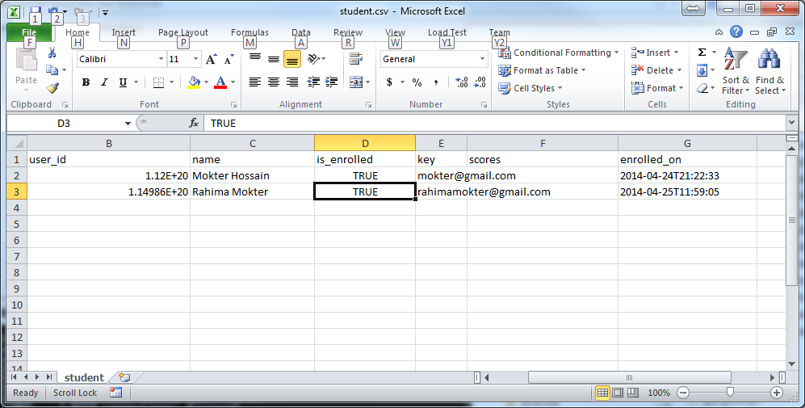

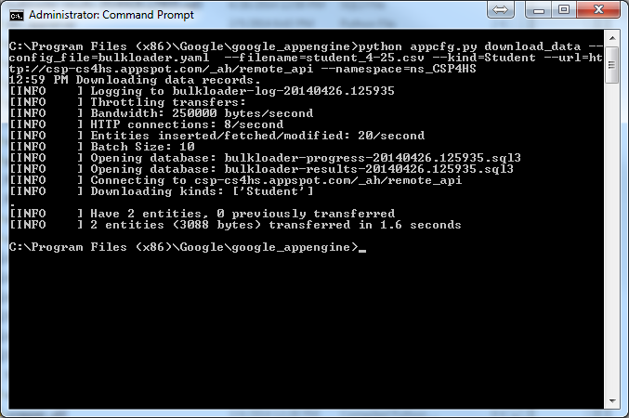

**For ReDownloading Student Entity,**

**Just Just need to change the .csv file name**

**such as:**

python appcfg.py download_data --config_file=bulkloader.yaml --filename=student_4-25.csv --kind=Student --url=http://csp-cs4hs.appspot.com/_ah/remote_api --namespace=ns_CSP4HS



**Will generate a student_4-25.csv file in the Goolge appengine folder.**

**For Downloading of a different class**

**Just need to change the .csv file name and the intended classname in the** ns_CSP4HS

e.g.

python appcfg.py download_data --config_file=bulkloader.yaml --filename=**students-csprinciples**.csv --kind=Student --url=http://csp-cs4hs.appspot.com/_ah/remote_api --namespace=ns_csprinciples

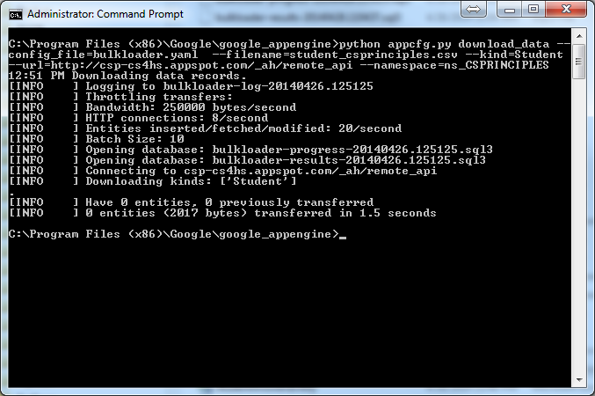

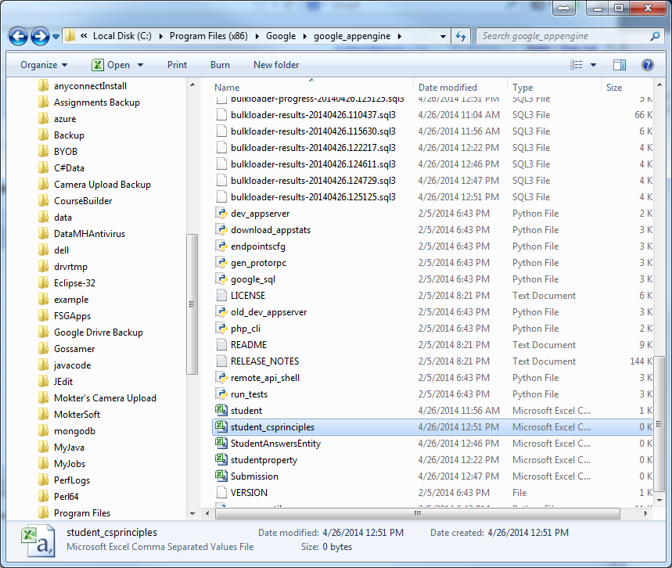

**For Downloading StudentPropertyEntity**

python appcfg.py download_data --config_file=bulkloader.yaml --filename=studentproperty.csv --kind=StudentPropertyEntity --url=http://csp-cs4hs.appspot.com/_ah/remote_api --namespace=ns_CSP4HS

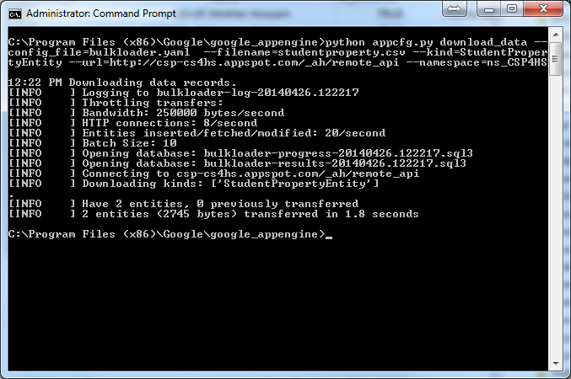

That will generate a studentproperty.csv file in my google_appengine folder as, follows:

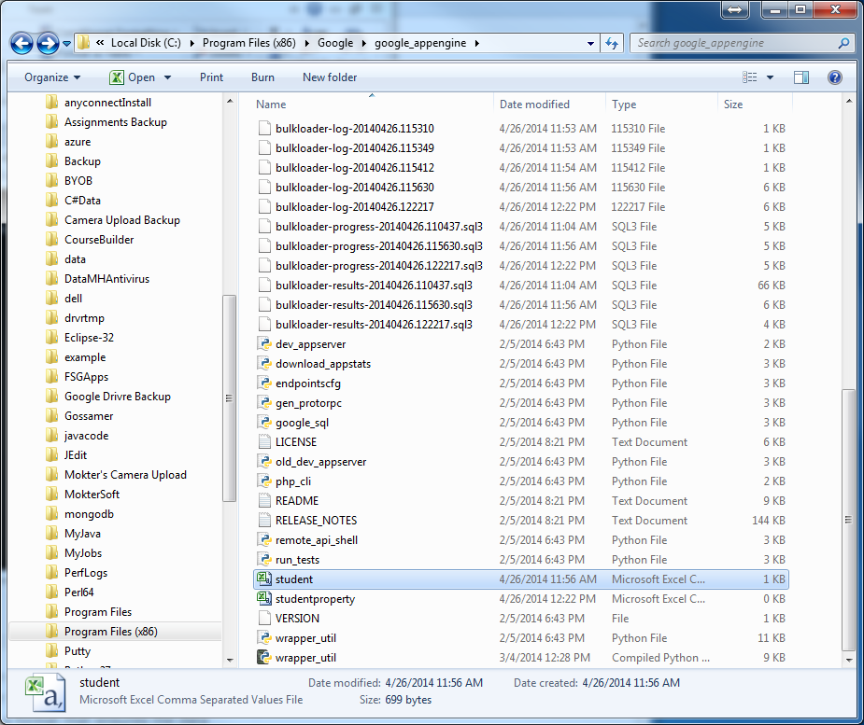

Following above the process we can download other data, shown as Entity Kind in the following figure:

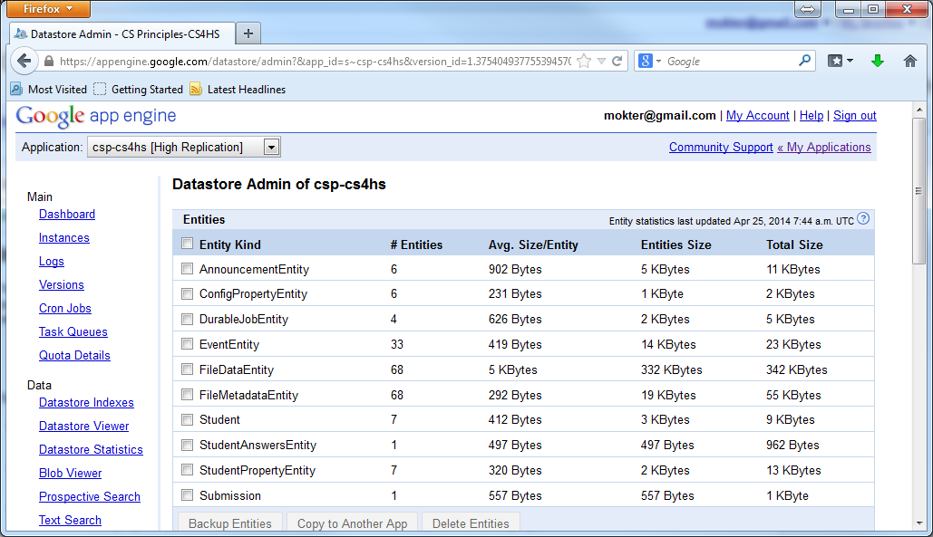

**For Downloading StudentAnswersEntity**

python appcfg.py download_data --config_file=bulkloader.yaml --filename=StudentAnswersEntity.csv --kind=StudentAnswersEntity --url=http://csp-cs4hs.appspot.com/_ah/remote_api --namespace=ns_CSP4HS

**For Downloading Submission**

python appcfg.py download_data --config_file=bulkloader.yaml --filename=Submission.csv --kind=Submission --url=http://csp-cs4hs.appspot.com/_ah/remote_api --namespace=ns_CSP4HS

Note: If an existing .csv file already exists in the Goolge-Appengine folder it will create error [Cannot replace the exisitng one]. In that case, we need to rename/remove the exisitng file or need to change the intended .csv file name:

python appcfg.py download_data --config_file=bulkloader.yaml --filename=Submission_4-25.csv --kind=Submission --url=http://csp-cs4hs.appspot.com/_ah/remote_api --namespace=ns_CSP4HS

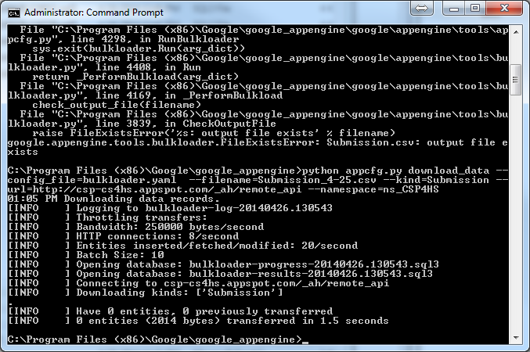

Did not work;

Steps for Downloading Course Data from the App Engine Datastore:

python tools/etl/gcbpaths.py download course /testcs4hs test-cs4hs test-cs4hs.appspot.com --archive_path ./testcs4hs.zip

# Source: https://code.google.com/p/course-builder/wiki/ExportCourseData

1. For Windows create the gcbpaths.py file and save in the \Coursebuilder\tools\etl Folder

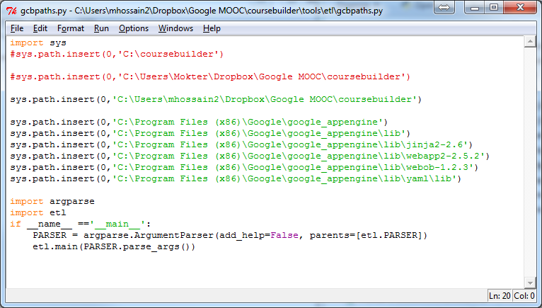

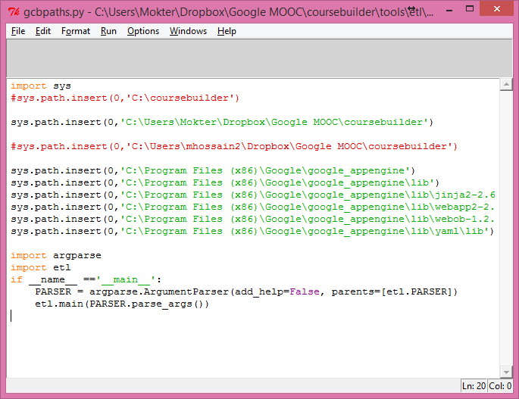

Note: USe the appropriate path for the coursebuilder Folder

## Step 2: Download datastore information [Does not work]

<https://code.google.com/p/course-builder/wiki/ExportCourseData>

Use one of these, which one is appropriate:

cd C:\coursebuilder

cd C:\Users\Mokter\Dropbox\Google MOOC\coursebuilder

cd C:\Users\mhossain2\Dropbox\Google MOOC\coursebuilder

says to use the following command:

python tools/etl/gcbpaths.py download datastore /csp4hs csp4hs csp-cs4hs.appspot.com --archive_path ./csp4hs.zip --datastore_types Student

Format:

python tools/etl/gcbpaths.py download datastore <course_url_prefix> <app_name> <app_server_name> --archive_path <archive_path> --datastore_types <model1,model2>

But it will show the following Error message:

Thus, skip step-2 and use Step-3 instead:

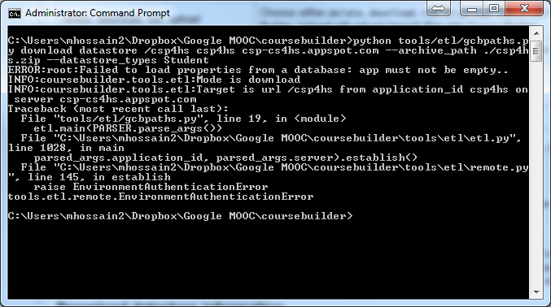

**Step 3. Create a bulkloader.yaml File using the appcfg.py file located in the Coursebuilder:**

Source: https://developers.google.com/appengine/docs/python/tools/uploadingdata#Python_Using_automatic_configuration

Use one of these, which one is appropriate:

cd C:\coursebuilder

cd C:\Users\Mokter\Dropbox\Google MOOC\coursebuilder

cd C:\Users\mhossain2\Dropbox\Google MOOC\coursebuilder

CD C:\Program Files (x86)\Google\google_appengine

Then use the following command:

appcfg.py create_bulkloader_config --filename=bulkloader.yaml --url=http://csp-cs4hs.appspot.com/_ah/remote_api

Format: appcfg.py create_bulkloader_config --filename=bulkloader.yaml --url=http://<your_app_url>.appspot.com/_ah/remote_api

Will be asking authentication email and password:

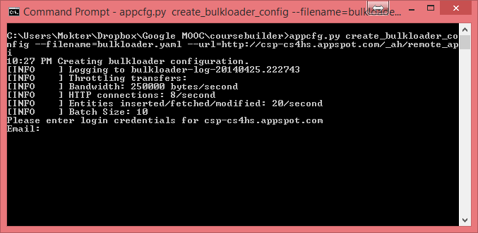

Provided your Email address: : mokter@gmail.com

Provide Application specific Password [Created using 2-step varification pricess]:

tcdg kazu dqcd ufzs [With No space, as follows: tcdgkazudqcdufzs ]

If succeeded, it will shown as follows:

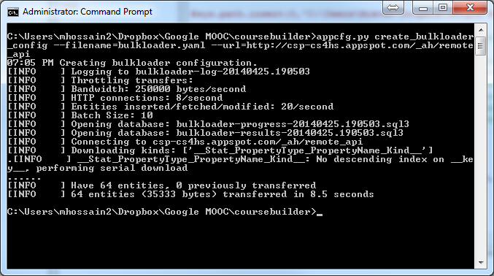

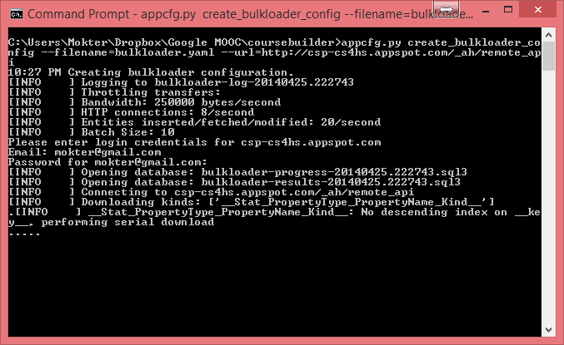

This will generate the bulkloader.yaml file in the \coursebuilder Folder, it showed some Error type messages . Note: If a bulkloader.yaml file already exists in the \coursebuilder floder, you may need to move or rename that.

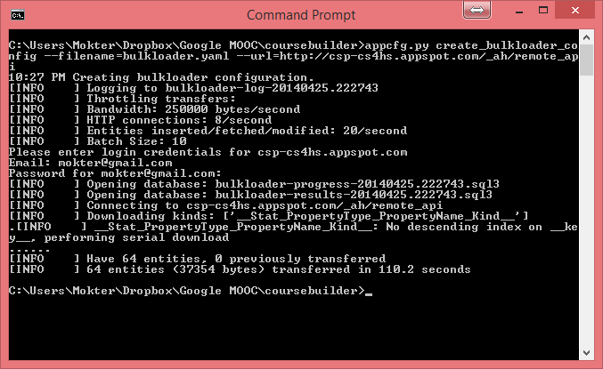

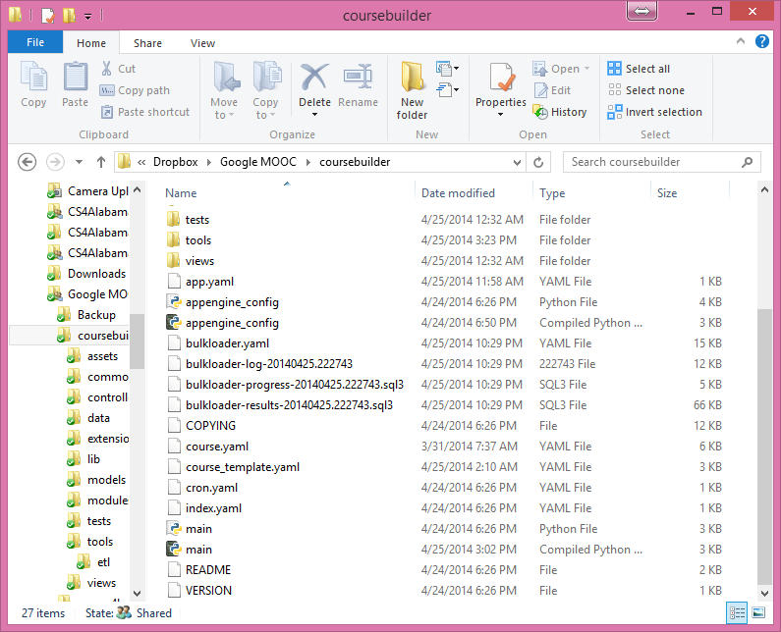

python tools/etl/gcbpaths.py download course /physics zabaione zabaione.appspot.com --archive_path ./physics.zip

**But within the Program Program Files (x86)**

CD C:\Program Files (x86)\Google\google_appengine

Then used the following command:

appcfg.py create_bulkloader_config --filename=bulkloader.yaml --url=http://csp-cs4hs.appspot.com/_ah/remote_api

Format:

appcfg.py create_bulkloader_config --filename=bulkloader.yaml --url=http://<your_app_url> .appspot.com/_ah/remote_api

[Did not ask for an email address or password ??]



This time I found the following bulkloader files in the C:\Program Files (x86)\Google\google_appengine



As shown in the following picu=ture:



**Step 4. Editing the perviously auto generated \Coursebuilder\bulkloader.yaml File**

See: <https://developers.google.com/appengine/docs/python/tools/uploadingdata#Python_Using_automatic_configuration>





- kind: AnnouncementEntity

connector: csv # TODO: Choose a connector here: csv, simplexml, etc...

connector_options:

# TODO: Add connector options here--these are specific to each connector.

property_map:

**Edited in 15 places**

Also Changed:

import_transform: transform.create_foreign_key('TODO: fill in Kind name')

as

import_transform: transform.create_foreign_key('Reviewee')









python appcfg.py download_data --config_file=bulkloader.yaml --filename=studentproperty.csv --kind=StudentPropertyEntity --url=http://csp-cs4hs.appspot.com/_ah/remote_api --namespace=ns_CSP4HS

python appcfg.py download_data --config_file=bulkloader.yaml  --filename=studentproperty.csv --kind=StudentPropertyEntity --url=<http://csp-cs4hs.appspot.com/_ah/remote_api> --namespace=ns_CSP4HS

#With the bulkloader.yaml file complete, we can now import data from an external CSV file to the datastore:

appcfg.py upload_data --config_file=bulkloader.yaml --filename=users.csv --kind=Permission --url=http://csp-cs4hs.appspot.com/_ah/remote_api

#You can use the same bulkloader.yaml file to export data, as in the following example command line:

appcfg.py download_data --config_file=bulkloader.yaml --filename=users.csv --kind=Permission --url=http://csp-cs4hs.appspot.com/_ah/remote_api

To download all entities of all kinds from an app's master/slave datastore, run the following command:

appcfg.py download_data --url=http://csp-cs4hs.appspot.com/_ah/remote_api --filename=Student

Format: appcfg.py download_data --url=http://your_app_id.appspot.com/_ah/remote_api --filename=<data-filename>

To Download course information

Format: python tools/etl/gcbpaths.py download course <course_url_prefix> <app_name> <app_server_name> --archive_path <archive_path>

python tools/etl/gcbpaths.py download course /csp4hs csp-cs4hs csp-cs4hs.appspot.com --archive_path ./csp4hs.zip

python tools/etl/gcbpaths.py download course /csp4hs csp-cs4hs csp-cs4hs.appspot.com --archive_path ./csp4hs.zip

python tools/etl/gcbpaths.py download course /csprinciples ccsprinciples csp-cs4hs.appspot.com --archive_path ./ccsprinciples.zip

# Source: https://code.google.com/p/course-builder/wiki/ExportCourseData

Save this file as gcbpaths.py in the file Coursebuilder\tools\etl Folder

Roles in Association:

<https://www.youtube.com/watch?v=P14hiHnsANY>