**SOFTWARE REQUIREMENTS SPECIFICATION**

DISTRICT

|  |  |  |  |
| --- | --- | --- | --- |
| Details | Prepared By | Reviewed By | Approved By |
| Name | Protester | P Devathilagai | P Devathilagai |
| Role | Quality Assurance Interns | Batch Trainer |  |

Table of Contents

1.Introduction 3

1.1 Intended Audience 3

1.2 Project Scope 3

2. Overall Description 3

2.1 Operating Environment 3

3. Functional Requirements 4

3.1 User Authentication 4

3.2 Event and Activity Listings 4

3.3 Contact Form Automation 5

3.4 Social Media Integration 6

3.5 Data-Driven Testing 7

3.6 Reporting 8

# 1.Introduction

This document outlines the software requirements specification for the District.in Automation Project. The project aims to automate key workflows on the Policybazaar website using BDD with Cucumber, TestNG, and data-driven testing approaches.

## 1.1 Intended Audience

This project is intended for software testers, developers, and QA engineers who are involved in automated web application testing. It is also suitable for project managers and stakeholders interested in understanding the automation framework and its capabilities for the District.in web application

## 1.2 Project Scope

The scope of this project is to automate the testing of key functionalities of the District.in web platform. The automation suite covers user authentication, event and activity listings, contact form submissions, and social media integrations. The project aims to ensure the reliability, usability, and correctness of the web application through comprehensive automated tests using Selenium WebDriver, TestNG, and Cucumber.

# 2. Overall Description

## Operating Environment

* **Operating System:** Windows
* **Browser:** Microsoft Edge (configurable)
* **Programming Language:** Java 8
* **Automation Tools:** Selenium WebDriver, TestNG, Cucumber, Allure Reporting
* **Build Tool:** Maven
* **IDE:** Visual Studio Code (recommended)
* **Dependencies:** Apache POI (for Excel), Log4j (for logging), Allure (for reporting)

# 3. Functional Requirements

## 3.1 User Authentication

* Automated login and logout functionality.
* OTP-based authentication flow.
* Validation of login button state and error handling for incorrect OTP.

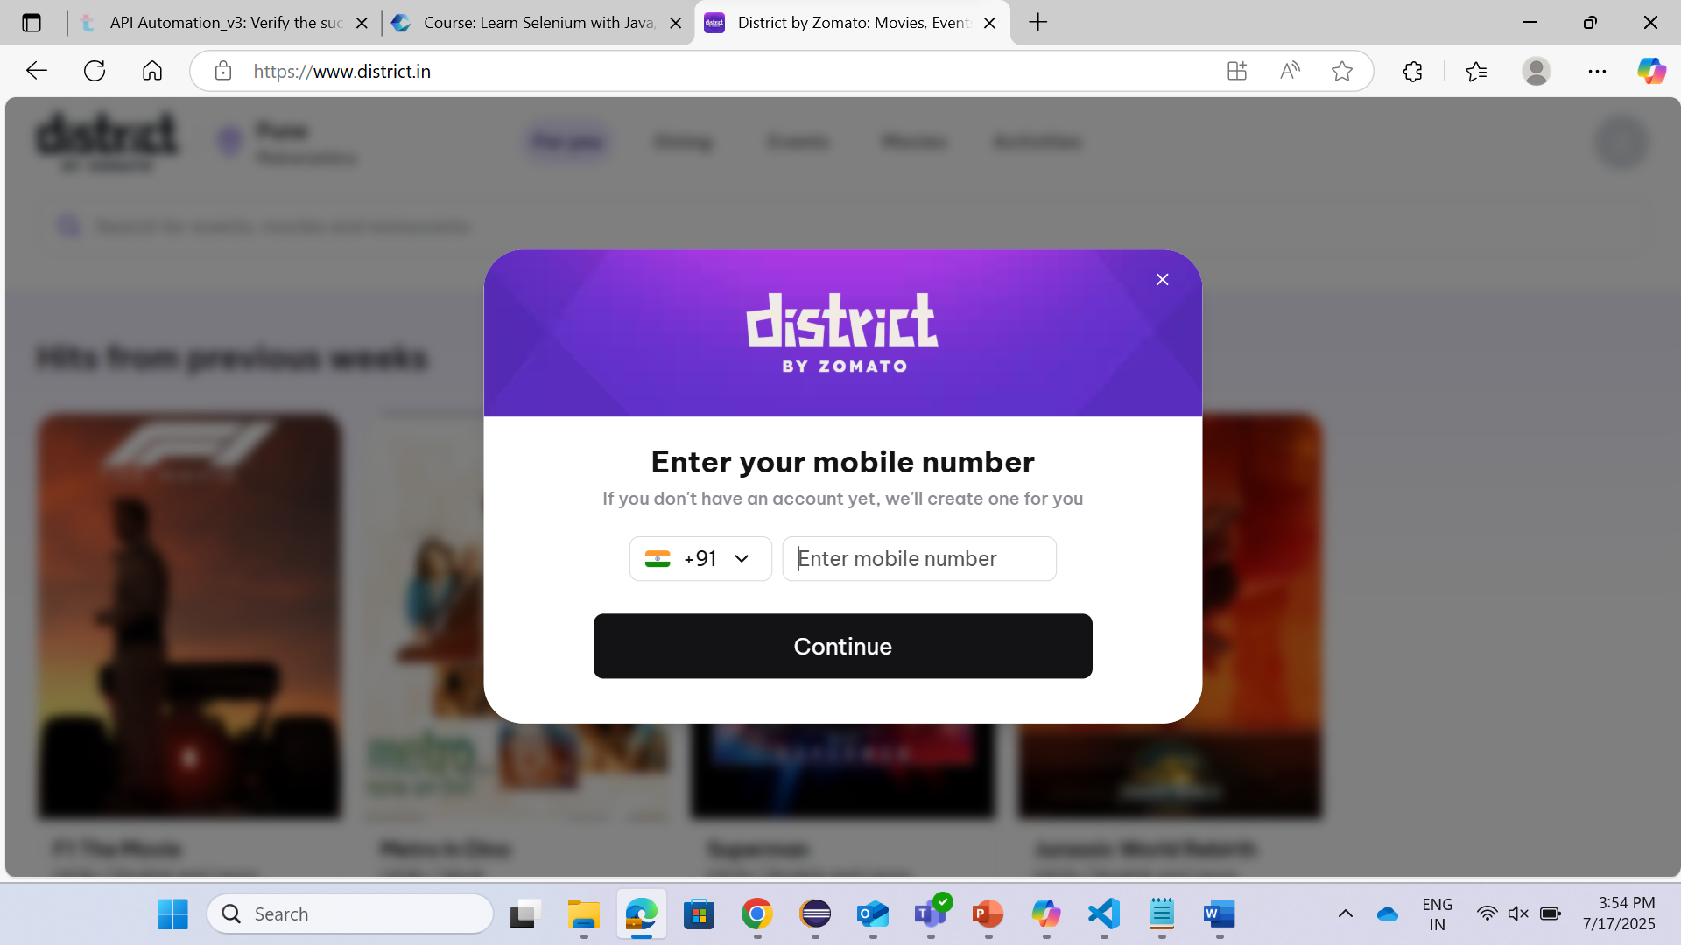

## 3.2 Event and Activity Listings

* Fetch and display events and activities from the District.in platform.
* Sort events and activities by price.
* Filter activities occurring on weekends.
* Parse and validate event/activity details such as date, time, location, and price.

## 3.3 Contact Form Automation

* Automated filling and submission of the contact form.
* Validation of form fields and submission status.

## 3.4 Social Media Integration

* Verification of social media links (Facebook, YouTube) in the website footer.
* Automated navigation and title verification for each social media page.

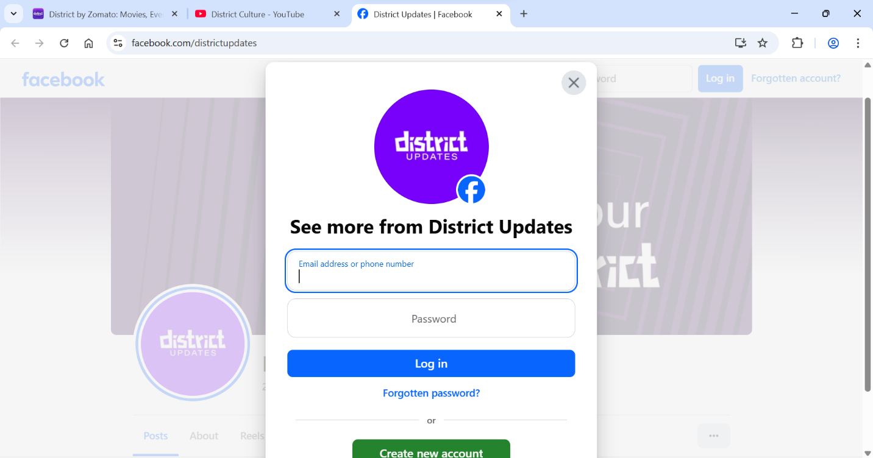

## 3.5 Data-Driven Testing

* Reading and writing test data from Excel sheets using Apache POI.
* Parameterization of test cases using external data sources.

## 3.6 Reporting

* Generation of detailed test execution reports using Allure.
* Integration of reporting with Maven build lifecycle.

