Testing R Markdown Formats

DS-SL

2022-12-17

# 1 Test File of R Markdown

## 1.1 R Notebook

This is an [R Markdown](http://rmarkdown.rstudio.com) file ‘test-rmarkdown.Rmd’ with various output formats, created using ‘RNotebook_Template.Rmd’. When you execute or run a code within the notebook, the results appear beneath the code.

Try executing this chunk by clicking the *Run* button, a triangle pointing right, within the chunk or by placing your cursor inside it and pressing *Ctrl+Shift+Enter* (Win) or *Cmd+Shift+Enter* (Mac).

## 1.2 Test Code Chunk (1)

head(cars)

## speed dist  
## 1 4 2  
## 2 4 10  
## 3 7 4  
## 4 7 22  
## 5 8 16  
## 6 9 10

## 1.3 Test Code Chunk (2)

plot(cars)

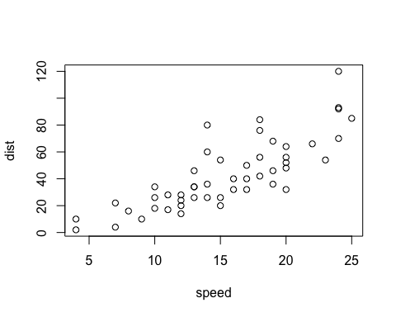

## 1.4 Test Code Chunk (3)

knitr::kable(iris[1:6, ])

| Sepal.Length | Sepal.Width | Petal.Length | Petal.Width | Species |
| --- | --- | --- | --- | --- |
| 5.1 | 3.5 | 1.4 | 0.2 | setosa |
| 4.9 | 3.0 | 1.4 | 0.2 | setosa |
| 4.7 | 3.2 | 1.3 | 0.2 | setosa |
| 4.6 | 3.1 | 1.5 | 0.2 | setosa |
| 5.0 | 3.6 | 1.4 | 0.2 | setosa |
| 5.4 | 3.9 | 1.7 | 0.4 | setosa |

## 1.5 Test Code Chunk (4)

ggplot(iris, aes(x = Petal.Length, y = Petal.Width, col = Species)) +  
 geom_point()

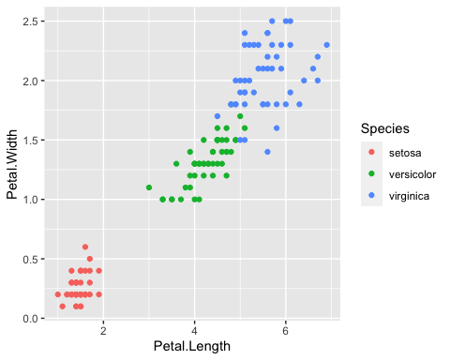

## 1.6 New Code Chunk

Add a new chunk by clicking the *Insert Chunk* button on the toolbar or by pressing *Ctrl+Option+I* (Win) or *Cmd+Option+I* (Mac).

When you save the notebook, an HTML file containing the code and output will be saved alongside it (click the *Preview* button or press *Ctrl+Shift+K* (Win) or *Cmd+Shift+K* (Mac) to preview the HTML file).

The preview shows you a rendered HTML copy of the contents of the editor. Consequently, unlike *Knit*, *Preview* does not run any R code chunks. Instead, the output of the chunk when it was last run in the editor is displayed.

## 1.7 YAML for R Notebook

There are three lines of options in the top YAML. If you delete #, the line becomes active.

* number_sections: yes # for automatic numbering of sections
* toc: true # for table of contents
* toc_float: true # for floating table of contents

## 1.8 YAML for Various Output Formats

output:  
 html_notebook:  
 number_sections: yes  
 html_document:  
 df_print: paged  
 number_sections: yes  
 word_document:   
 number_sections: yes  
 pdf_document:   
 number_sections: yes  
 powerpoint_presentation: default  
 ioslides_presentation:  
 widescreen: yes  
 smaller: yes  
 slidy_presentation: default  
 beamer_presentation: default

# 2 Note

## 2.1 Comments

* For slides, a new slide starts at ##, the second-level heading.
* --- is page break for presentation formats.
* For Word and Powerpoint, you can add your template. See the documents in References

## 2.2 References

* Posit Primers: [Report Reproducibly](https://rmarkdown.rstudio.com/lesson-1.html?_ga=2.60708591.317621277.1671142614-2004472742.1671142614)
* Markdown Quick Reference: Top Menu Bar > Help > Markdown Quick Reference
* Cheat Sheet (Top Menu Bar: Help > Cheat Sheets): RMarkdown Cheat Sheet, RMarkdown Reference Guide
* Books:
  + [R Markdown: The Definitive Guide](https://bookdown.org/yihui/rmarkdown/)
  + [R Markdown Cookbook](https://bookdown.org/yihui/rmarkdown-cookbook/)
* Post error messages to a web search engine.