ConsuMER Profile API

By Raja Khan | 914-310-6271 | [getrk@yahoo.com](mailto:getrk@yahoo.com)

Date: 09/15/2019

**GitHub URL**: [www.github.com/javabrown/consumer_profile](http://www.github.com/javabrown/consumer_profile)

**LIVE API Demo**: <http://35.174.137.88/api/swagger-ui.html#/user-resource>

This is a HATEOAS driven REST-3 APIs application. I developed this project as part of my **ConsumerReports Inc.** assignment. It serves CRUD operation on UserProfile Resource.

Following tools and technology used:

* Java 8
* SpringBoot 2.1 & Spring HATEOAS 0.25.2
* JPA & H2Database
* Springfox-swagger 2.9
* AWS ECS, Docker, ECR
* Terraform (for resource creation & deployment)
* Linux, IntelliJ, Maven

**Endpoints**:

| **Method** | **Endpoints** | **Description** |
| --- | --- | --- |
| GET | /api/users | Returns all user |
| POST | /api/users/ | Create new user |
| PUT | /api/users/{user-id} | Update user info by ID |
| DELETE | /api/users/{user-id} | Delete the user for given ID |
| GET | /api/users/{user-id} | Returns individual user for given ID |

**Core application flow diagram**:

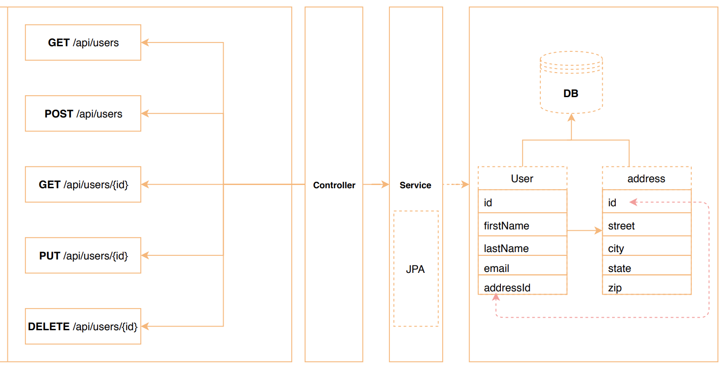

**Sample Request**:

Create User:

**Request**:

**{**

**"email": "getrk@yahoo.com",**

**"firstName": "Raja",**

**"lastName": "Khan",**

**"address": {**

**"city": "string",**

**"state": "string",**

**"street": "string",**

**"zip": "string"**

**}**

**}**

**Response: 200 OK**

**{**

**"response": {…}**

**"_links": {**

**"self": {**

**"href": "http://35.174.137.88/api/users/1"**

**}**

**}**

**}**