

THAPAR INSTITUTE OF ENGINEERING AND TECHNOLOGY
(Deemed to be University)
PATIALA, PUNJAB – 147004
DEPARTMENT OF COMPUTER SCIENCE AND ENGINEERING
UCS503P — SOFTWARE ENGINEERING PROJECT
FINAL PROJECT REPORT
DIGITAL HOSTEL LAUNDRY MANAGEMENT SYSTEM
Submitted to
Stuti Chug
Submitted by
Riddhi Dhawan — 1024030943
Icy Agarwal — 1024030823
Devansh Dhawan — 1024030822
Academic Year 2026–27
Department of Computer Science and Engineering

Certificate
This is to certify that the project report entitled “Digital Hostel Laundry Management System” is a record of the project work carried out by the students named below, of the Department of Computer Science and Engineering, Thapar Institute of Engineering and Technology, Patiala, in partial fulfilment of the requirements of the course UCS503P — Software Engineering Project during the academic year 2026–27.
The work presented in this report is an authentic record of the analysis, design, implementation, and testing carried out by the project team during the current phase of development, under my guidance and supervision. Functionality that has been designed but not yet implemented has been identified as such throughout the report.

_______________________ _______________________
Stuti Chug Head of Department
Project Guide Computer Science and Engineering
Date: ___________________ Place: Patiala

Declaration
We hereby declare that the project report entitled “Digital Hostel Laundry Management System”, submitted in partial fulfilment of the requirements of the course UCS503P — Software Engineering Project, is our own work carried out under the guidance of Stuti Chug, Department of Computer Science and Engineering, Thapar Institute of Engineering and Technology, Patiala.
We further declare that the requirement analysis, system design, database design, and implementation work described in this report have been carried out by us, and that the report honestly distinguishes between functionality that has been implemented and functionality that has been designed or planned for subsequent development phases. The work has not been submitted elsewhere for the award of any other degree or credit.

Name
Riddhi Dhawan — 1024030943 _______________________
(Signature)
Icy Agarwal — 1024030823 _______________________
(Signature)
Devansh Dhawan — 1024030822 _______________________
(Signature)

Date: ___________________ Place: Patiala

Acknowledgement
We would like to express our sincere gratitude to our project guide, Stuti Chug, Department of Computer Science and Engineering, Thapar Institute of Engineering and Technology, for her valuable guidance, feedback, and encouragement throughout the requirement-analysis, design, and development phases of this project.
We are grateful to the Department of Computer Science and Engineering for providing the opportunity to undertake this project as part of the UCS503P course, and for the academic environment and resources that supported our work.
We would also like to thank the hostel laundry staff and the concerned hostel authorities for permitting and participating in our requirement-gathering discussions. Their practical insight into the day-to-day handling of laundry — particularly the importance of reliable verification at the time of collection — directly shaped several of the requirements and design decisions presented in this report.
Finally, we thank our peers and everyone who contributed through discussions, reviews, and suggestions during the development of this project.
Project Team
UCS503P, 2026–27

Abstract
Hostel laundry services in most residential institutions are still managed manually, using paper registers or verbal coordination between students and laundry staff. This leads to lost or misplaced items, unclear turnaround times, and disputes at the time of collection, since there is no verifiable record of who submitted what and when it is due. The Digital Hostel Laundry Management System is a mobile-first application that digitizes this entire workflow — from request submission and staff processing to notification and verified pickup — for a hostel environment.
The system is designed around three principal actors: the student, who submits and tracks laundry requests; the laundry staff, who process and update the status of items; and the administrator, who oversees hostels, users, and complaints. The proposed architecture follows a client–server model, with a React Native and Expo mobile frontend communicating with a Node.js and Express backend, which in turn uses Supabase for authentication and a managed PostgreSQL database. Access is restricted to institutional email addresses through an OTP-based authentication mechanism, and pickup verification is designed around single-use QR tokens to prevent duplicate or unauthorized collection.
At the current stage of development, the team has completed requirement analysis, stakeholder consultation with hostel laundry staff, and the full set of system-design artefacts (use case, activity, class, data-flow, and sequence diagrams), along with a relational database design covering all major entities. On the implementation side, the backend server, Supabase connectivity, and institutional-email OTP authentication (send-OTP and verify-OTP) have been built and tested; the mobile application’s project structure and navigation foundation have also been established. The remaining student, staff, and administrator workflows, the QR-based pickup mechanism, complaints, and notifications are designed and scheduled for the next phase of development. This report presents the problem context, requirements, design, current implementation, and testing carried out so far, along with the limitations and future work required to complete the system.

Keywords: hostel laundry management, mobile application, React Native, Node.js, Supabase, PostgreSQL, OTP authentication, QR-based verification, requirement analysis, system design.

Table of Contents
Certificate i
Declaration ii
Acknowledgement iii
Abstract iv
List of Figures and Tables viii
1. Introduction 1
2. Problem Statement 1
3. Objectives 2
4. Scope 3
4.1 In Scope 3
4.2 Out of Scope 3
5. Existing System and Limitations 3
5.1 Limitations of the Existing System 4
6. Proposed System 4
7. Requirement Analysis 5
7.1 System Actors 5
7.2 Requirement-Gathering Approach 5
8. Functional Requirements 6
8.1 Student 6
8.2 Laundry Staff 6
8.3 Administrator 7
9. Non-Functional Requirements 7
10. System Architecture 7
11. System Design 8
12. Use Case Diagram 8
13. Activity Diagram 9
14. Class Diagram 10
15. Data Flow Diagram 11
15.1 Level 0 (Context Diagram) 11
15.2 Level 1 12
16. Sequence Diagram 12
17. Database Design 13
18. Technology Stack 14
19. Implementation 14
19.1 Project Structure 15
19.2 Frontend Implementation 15
19.3 Backend Implementation 16
19.4 Backend Server 16
19.5 Authentication Implementation 17
19.6 Database Connectivity 18
19.7 API Design 18
19.8 Frontend–Backend Interaction 18
20. Testing and Validation 19
20.1 Authentication Testing 19
20.2 Database Connectivity Testing 19
20.3 API-Level Validation 19
20.4 Future Testing 20
21. Work Completed and Current Results 20
21.1 Requirement Analysis 21
21.2 System Modelling 22
21.3 Database Design 22
21.4 Backend and Authentication 22
21.5 Frontend Development 22
21.6 Current Outcome 22
22. Challenges Encountered 23
22.1 Understanding the Real-World Workflow 23
22.2 Stakeholder Coordination 23
22.3 Designing Reliable Collection Verification 23
22.4 Translating Requirements into System Models 23
22.5 Coordinating Development and Documentation 23
23. Current Limitations 24
24. Future Work 24
24.1 Student Module 25
24.2 Laundry Staff Module 25
24.3 QR-Based Pickup 25
24.4 Notification System 25
24.5 Complaint Management 26
24.6 Administrative Dashboard 26
24.7 Comprehensive Testing 26
24.8 Deployment 26
25. Expected Impact 26
26. Conclusion 27
27. References 28
28. Appendix 28
Appendix A — Project Repository 28
Appendix B — System Diagrams 28
Appendix C — API Endpoints 29
Appendix D — Development Status Legend 29

List of Figures and Tables
Figures
Figure 10.1 — System Architecture
Figure 12.1 — Use Case Diagram
Figure 13.1 — Activity Diagram: Laundry Lifecycle
Figure 14.1 — Class Diagram
Figure 15.1 — DFD Level 0 (Context Diagram)
Figure 15.2 — DFD Level 1
Figure 16.1 — Sequence Diagram: OTP Authentication
Tables
Table 9.1 — Non-Functional Requirements
Table 17.1 — Major Database Entities
Table 18.1 — Technology Stack
Table 19.1 — Implemented API Endpoints
Table 20.1 — Authentication Test Cases
Table 21.1 — Implementation Status Summary

1. Introduction
Laundry management is a routine but operationally significant part of hostel life at most residential institutions. Every day, a large number of students hand over clothes for washing and ironing to hostel-appointed laundry staff, and expect a predictable, transparent process for tracking and reclaiming their items. In practice, however, this process is almost always managed manually — through handwritten registers, verbal token systems, or informal understanding between the student and the laundry worker.
As the number of students in a hostel grows, this manual approach becomes increasingly difficult to sustain. Items get misplaced, turnaround times are unpredictable, and there is no reliable record that can be used to resolve disputes when a student’s laundry is delayed, lost, or handed over incorrectly. The Digital Hostel Laundry Management System is proposed as a software solution to this problem: a mobile application, backed by a structured database and API layer, that brings visibility, accountability, and verification to the entire hostel laundry workflow.
This report documents the problem being addressed, the requirements gathered from students and laundry staff, the system design (architecture, database, and UML/DFD models), the technology stack chosen, and the implementation and testing carried out so far. It also documents the current limitations of the system and the work planned for the next phase of development.

2. Problem Statement
Hostel laundry services in most institutions rely on a manual, paper-based, or purely verbal process for accepting, processing, and returning student laundry. This creates several recurring problems:
- Students have no way to track the status of their laundry request (received, being washed, ready for pickup) without physically visiting the laundry counter.
- There is no digital record linking a specific batch of clothes to a specific student, which makes it difficult to resolve disagreements about lost or delayed items.
- Laundry staff have no structured queue or workflow to organize incoming requests, batches, and pending pickups, especially during peak periods.
- Pickup and collection is typically verified only by informal recognition, with no safeguard against a laundry order being collected more than once or by the wrong person.
- There is no mechanism for students to formally raise and track complaints (e.g., a missing or damaged item), which often leads to unresolved, undocumented grievances.
- Hostel administrators have no consolidated view of laundry operations across hostels, making it difficult to monitor service quality or identify recurring issues.
The Digital Hostel Laundry Management System is proposed to address these problems by digitizing the complete laundry lifecycle — submission, processing, notification, and verified pickup — while giving students, staff, and administrators appropriate visibility into the process relevant to their role.

3. Objectives
The primary objectives of this project are to:
- Provide students with a simple mobile interface to submit laundry requests, specify items, and track the status of each request in real time.
- Give laundry staff a structured, queue-based workflow to verify, tag, process, and update the status of incoming laundry batches.
- Introduce a secure, single-use QR-based pickup verification mechanism to prevent unauthorized or duplicate collection of laundry.
- Restrict system access to verified institutional users through an email-domain-based OTP authentication mechanism.
- Allow students to raise and track complaints related to their laundry requests, and allow staff and administrators to resolve them.
- Notify students automatically of important status changes (received, processing, ready for pickup, collected, complaint updates).
- Provide administrators with a centralized view of hostels, users, laundry activity, and complaints for operational oversight.
- Design the system with a layered client–server architecture and a relational database that can scale to support the complete workflow without requiring a redesign.

4. Scope

4.1 In Scope
- A mobile application (React Native / Expo) for students and laundry staff.
- A backend API (Node.js / Express) that mediates all data access and business logic.
- Institutional-email OTP-based authentication using Supabase Authentication.
- A relational database (PostgreSQL, via Supabase) modelling users, hostels, laundry requests, items, status history, batches, pickup tokens, complaints, notifications, and audit logs.
- A designed (and partially implemented) laundry request lifecycle: submission, verification, processing, return, ready-for-pickup, and QR-based collection.
- A designed complaint-management workflow and in-app notification mechanism.
- An administrative view for managing users and hostels and monitoring complaints and activity.

4.2 Out of Scope
- Payment or billing integration for laundry services.
- Integration with external or commercial laundry vendors outside the hostel’s own laundry staff.
- Native SMS-based OTP delivery (the current design uses email-based OTP only).
- Multi-institution or multi-campus deployment — the current design targets a single institution’s hostel system, restricted by institutional email domain.
- Hardware for QR scanning beyond the staff mobile device’s camera (no dedicated scanner hardware).

5. Existing System and Limitations
In the existing (manual) system, students hand over their laundry directly to hostel laundry staff, who record the handover — if at all — in a physical register or simply by memory. There is typically no receipt or token issued to the student, and no digital record of what was submitted, when, or in what condition.

5.1 Limitations of the Existing System
- No visibility: students cannot check the status of their laundry without visiting the laundry counter in person.
- No accountability: without a digital record, it is difficult to establish what was submitted when an item is reported missing or damaged.
- No structured queue: laundry staff must rely on memory or informal ordering to manage incoming and outgoing batches, especially during high-volume periods.
- No verified pickup: laundry is generally handed back based on informal recognition, creating a risk of incorrect or unauthorized collection.
- No complaint trail: student grievances are raised verbally and are rarely tracked to resolution.
- No operational data: hostel administrators have no aggregated data on turnaround time, volume, or recurring complaints to guide service improvements.
These limitations directly motivate the requirements and design of the proposed system described in the following sections.

6. Proposed System
The proposed Digital Hostel Laundry Management System replaces the manual process with a mobile application backed by a structured backend and database. Every laundry request is recorded as a distinct entity in the system, linked to the submitting student, its items, and a complete status history, so that its state is always verifiable rather than relying on memory or informal record-keeping.
At a high level, the proposed system supports the following workflow:
- A student logs in using an institutional email address, verified via a one-time password (OTP).
- The student submits a laundry request, specifying items and quantities.
- Laundry staff verify and tag the incoming request, and group requests into processing batches.
- As the request moves through processing (washing and ironing) and return, its status is updated and logged.
- Once ready, the student is notified and a pickup token (QR code) associated with the request is activated.
- At the time of collection, the student presents the QR code, which staff scan and validate before marking the request as collected — preventing reuse of an already-collected token.
- If an issue arises at any stage, the student can raise a complaint linked to the specific request, which staff or administrators can track and resolve.

Submitted → Verified → Processing → Returned → Ready for Pickup → Collected
The laundry request state transitions maintained by the system
This workflow is deliberately designed to keep every state transition recorded, so that both students and staff always have an accurate, shared view of where a given laundry request stands.

7. Requirement Analysis
Requirements for the system were gathered through discussion within the project team and direct interaction with hostel laundry staff, who provided insight into the practical, day-to-day workflow of accepting, processing, and returning laundry. This stakeholder interaction was particularly important in identifying operational requirements that would not be obvious from a purely student-facing perspective — most notably, the need for a reliable mechanism to verify collection and prevent an order from being collected more than once.

7.1 System Actors
- Student — submits laundry requests, tracks status, receives notifications, presents the QR code at pickup, and files complaints.
- Laundry Staff — verifies incoming requests, processes and updates status, manages pickup batches, and scans QR codes to confirm collection.
- Administrator — manages users and hostels, and monitors complaints and overall laundry activity.

7.2 Requirement-Gathering Approach
- Team discussions to define the intended student-facing laundry lifecycle.
- Direct coordination and interviews with the hostel laundry coordinator and staff to understand the real-world handling process.
- Translation of the operationally identified needs (particularly around collection verification) into functional requirements and, subsequently, into the pickup-token / QR design described in Section 6.

8. Functional Requirements

8.1 Student
1. The system shall allow a student to register and log in using an institutional email address verified through OTP.
2. The system shall allow a student to submit a laundry request specifying item type(s) and quantity.
3. The system shall allow a student to view the current status and history of each laundry request.
4. The system shall notify a student of status changes to their laundry request.
5. The system shall allow a student to view and present a QR-based pickup token when collecting laundry.
6. The system shall allow a student to submit a complaint linked to a specific laundry request.

8.2 Laundry Staff
1. The system shall allow staff to view an incoming queue of laundry requests.
2. The system shall allow staff to verify and tag a laundry request.
3. The system shall allow staff to group requests into processing batches.
4. The system shall allow staff to update the status of a request as it moves through processing and return.
5. The system shall allow staff to scan and validate a student’s QR pickup token and record the collection.
6. The system shall prevent a pickup token from being used more than once.
7. The system shall allow staff to view and respond to complaints linked to their processed requests.

8.3 Administrator
1. The system shall allow an administrator to manage hostel and user records.
2. The system shall allow an administrator to view aggregated laundry activity across hostels.
3. The system shall allow an administrator to monitor and track the resolution of complaints.
4. The system shall allow an administrator to access audit logs of significant system actions.

9. Non-Functional Requirements
Category | Requirement
Security | Access is restricted to verified institutional email addresses (OTP-based authentication); pickup tokens are single-use to prevent unauthorized collection.
Usability | The mobile interface should allow a student to submit a laundry request and check its status with minimal steps.
Reliability | Status transitions and pickup-token validation must be recorded consistently so that the system state can always be trusted over informal recollection.
Performance | API responses for common operations (login, status check, request submission) should return within a few seconds under normal load.
Scalability | The database schema is designed to accommodate the full set of entities (requests, batches, complaints, notifications, audit logs) from the outset, so that new modules can be added without redesigning the data model.
Maintainability | The frontend and backend are structured as independent components communicating over a REST API, allowing each to evolve separately.
Availability | The backend and database (hosted via Supabase) should remain available during normal hostel operating hours.
Table 9.1 — Non-Functional Requirements

10. System Architecture
The system follows a layered, client–server architecture that separates the mobile frontend, backend application logic, and data and authentication services. This separation allows the user interface and business logic to evolve independently, communicating only through well-defined REST API calls.
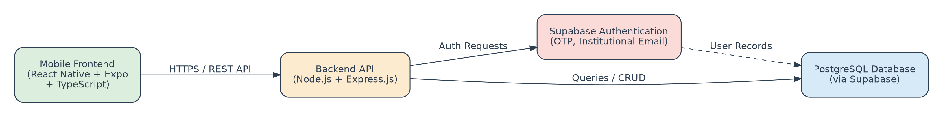
Figure 10.1 — System Architecture
- Mobile Frontend (React Native + Expo + TypeScript) — presents the student and staff interfaces and communicates with the backend over HTTPS.
- Backend API (Node.js + Express.js) — exposes REST endpoints, applies validation and business rules, and mediates all access to authentication and the database.
- Supabase Authentication — handles OTP generation and verification for institutional email addresses.
- PostgreSQL Database (via Supabase) — stores all persistent data: users, hostels, requests, items, status history, batches, pickup tokens, complaints, notifications, and audit logs.
Keeping all business logic in the backend, rather than the mobile client, ensures that validation rules (such as institutional-domain checks and single-use pickup tokens) are enforced centrally and cannot be bypassed by the client application.

11. System Design
Before implementation, the system’s intended behaviour and structure were modelled using standard UML and data-flow techniques. This section presents the use case, activity, class, data-flow, and sequence diagrams prepared for the system. These models serve as a shared reference for the development team and establish the intended behaviour of the system independent of the current implementation stage.

12. Use Case Diagram
The use case diagram below identifies the three system actors — Student, Laundry Staff, and Administrator — and the principal use cases each actor interacts with.
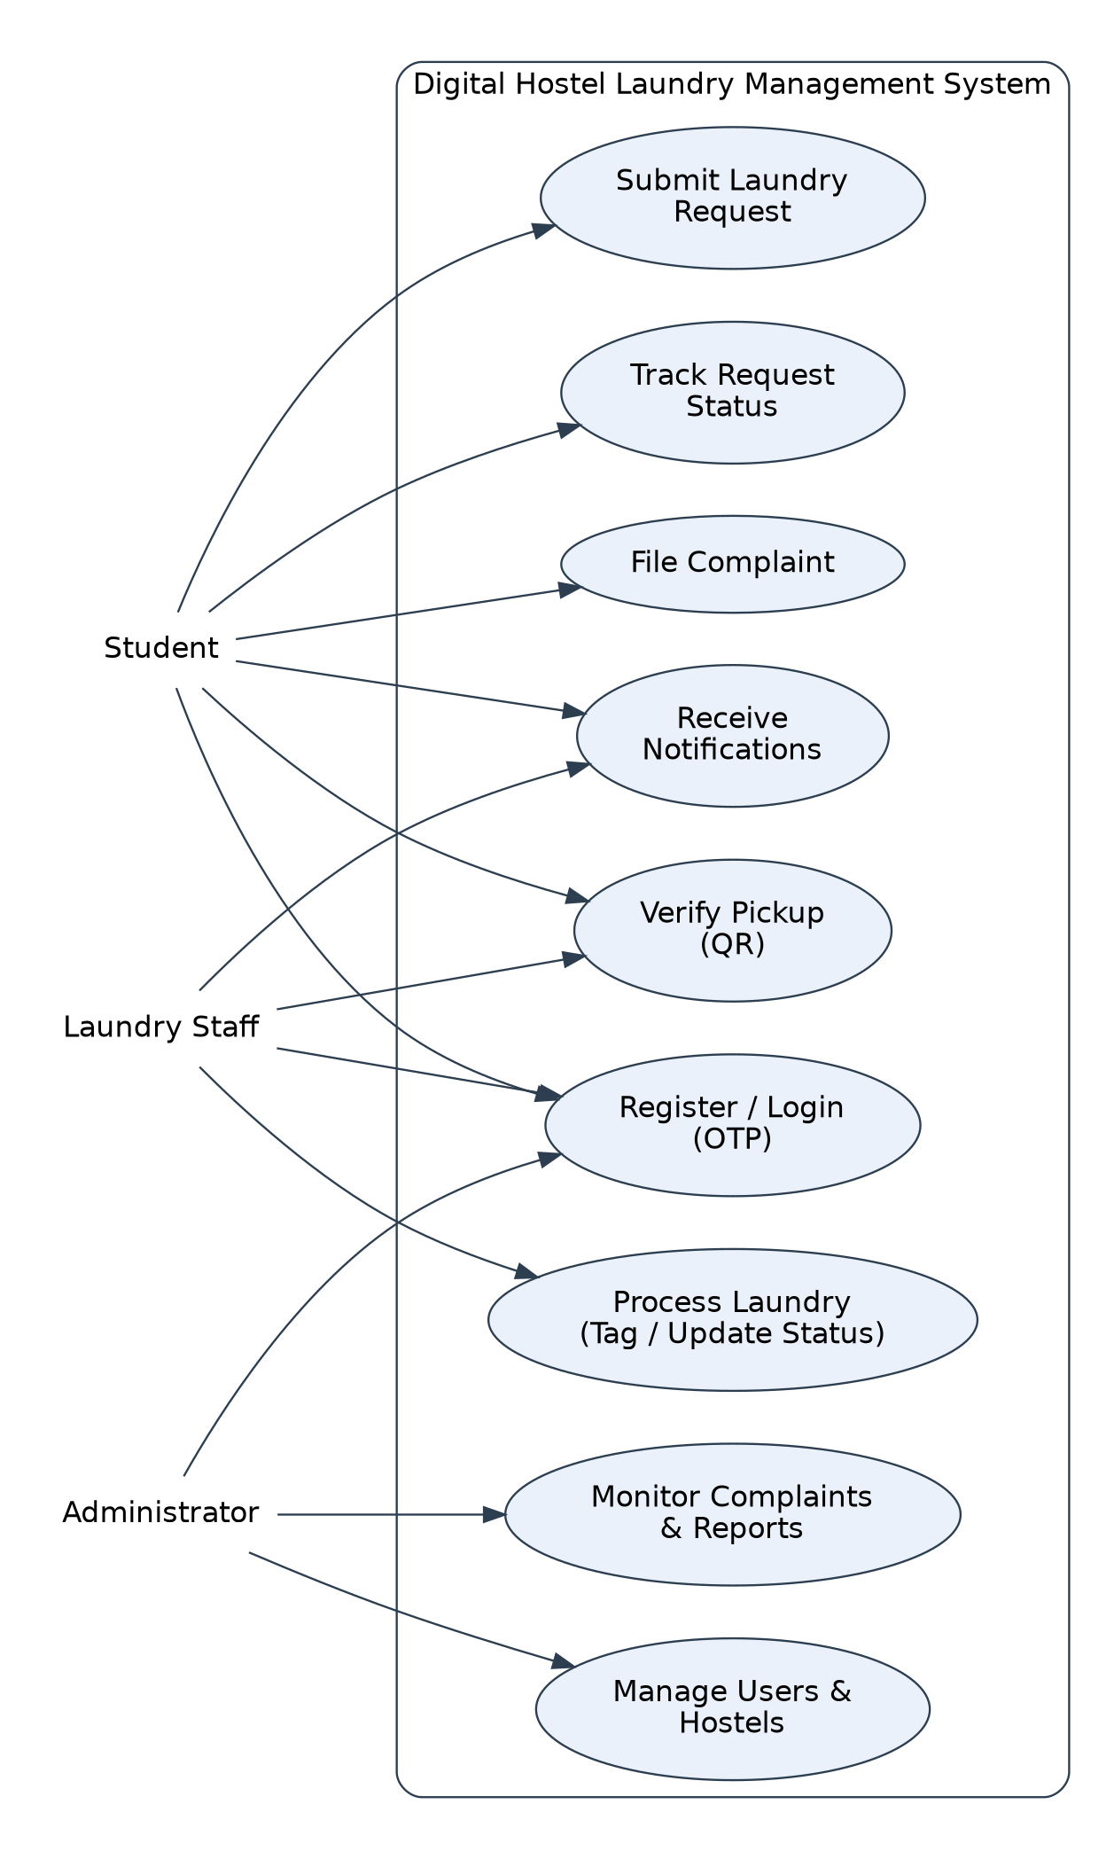
Figure 12.1 — Use Case Diagram

13. Activity Diagram
The activity diagram below models the complete laundry lifecycle from a student’s login through to verified collection, reflecting the workflow described in Section 6.
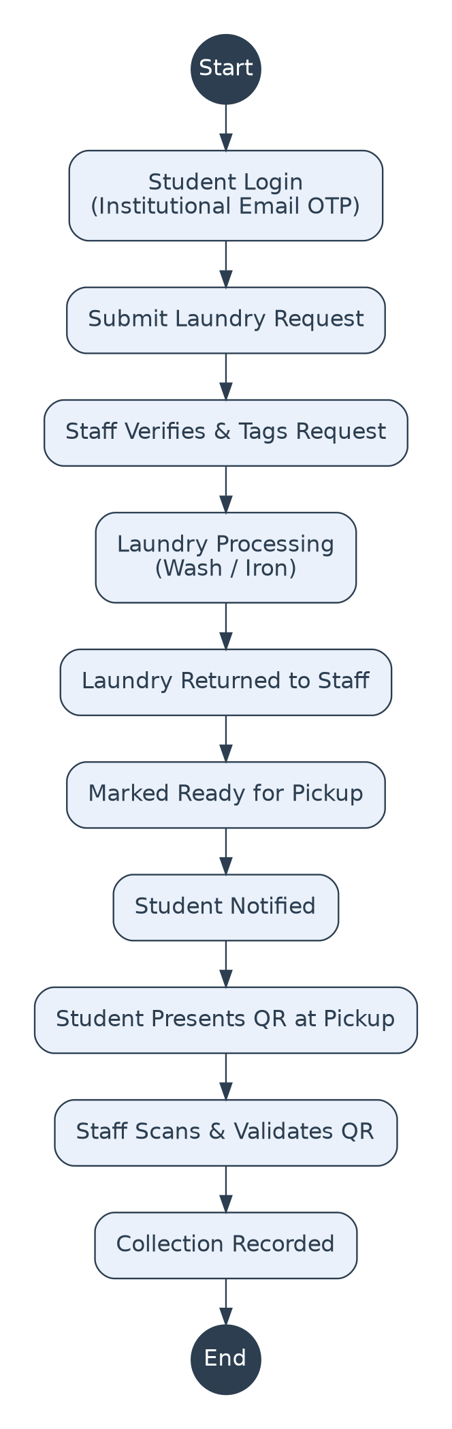
Figure 13.1 — Activity Diagram: Laundry Lifecycle

14. Class Diagram
The class diagram below models the major entities of the system and their relationships. A single User entity is specialized into Student, Staff, and Administrator, reflecting the shared authentication mechanism across all three roles.
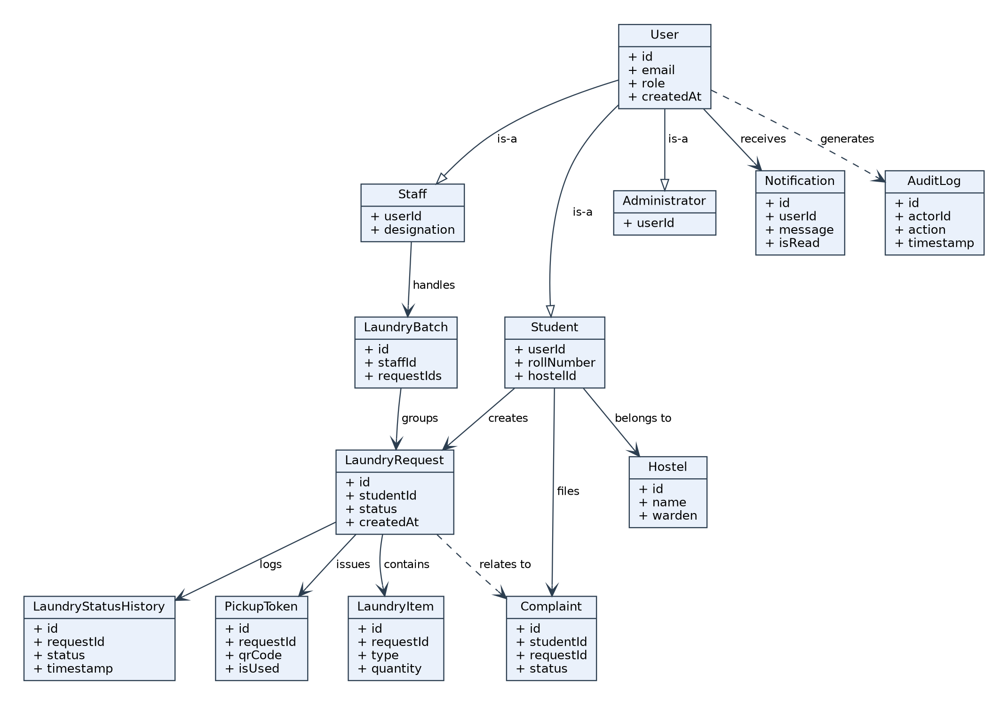
Figure 14.1 — Class Diagram

15. Data Flow Diagram

15.1 Level 0 (Context Diagram)
The context-level DFD treats the entire system as a single process, showing the data exchanged between the system and its three external actors.
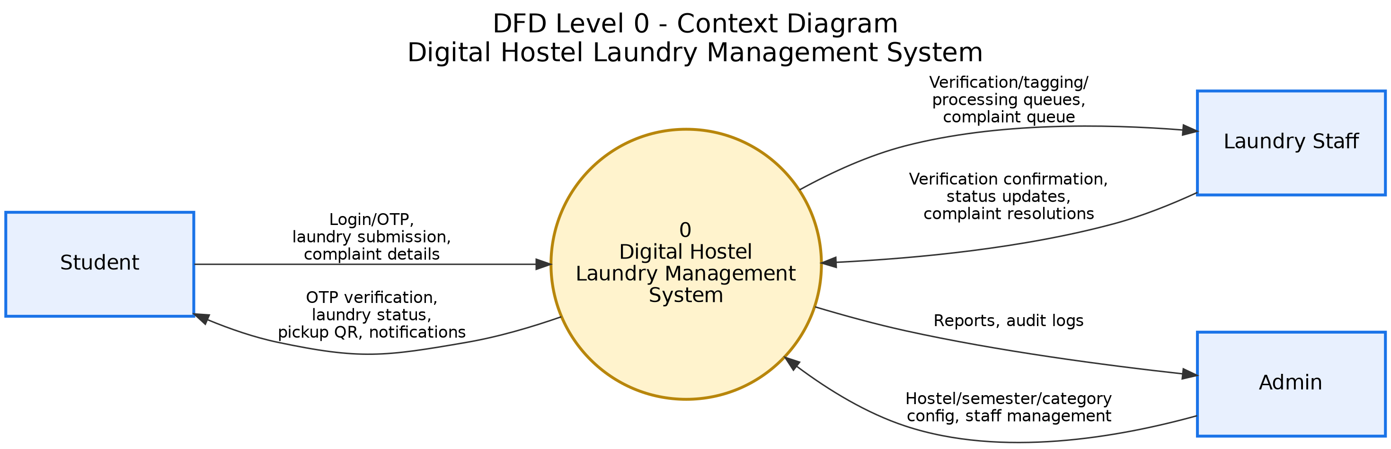
Figure 15.1 — DFD Level 0 (Context Diagram)

15.2 Level 1
The Level 1 DFD decomposes the system into its major functional processes — authentication, request management, processing and tracking, pickup verification, and complaint management — along with the data stores each process reads from or writes to.
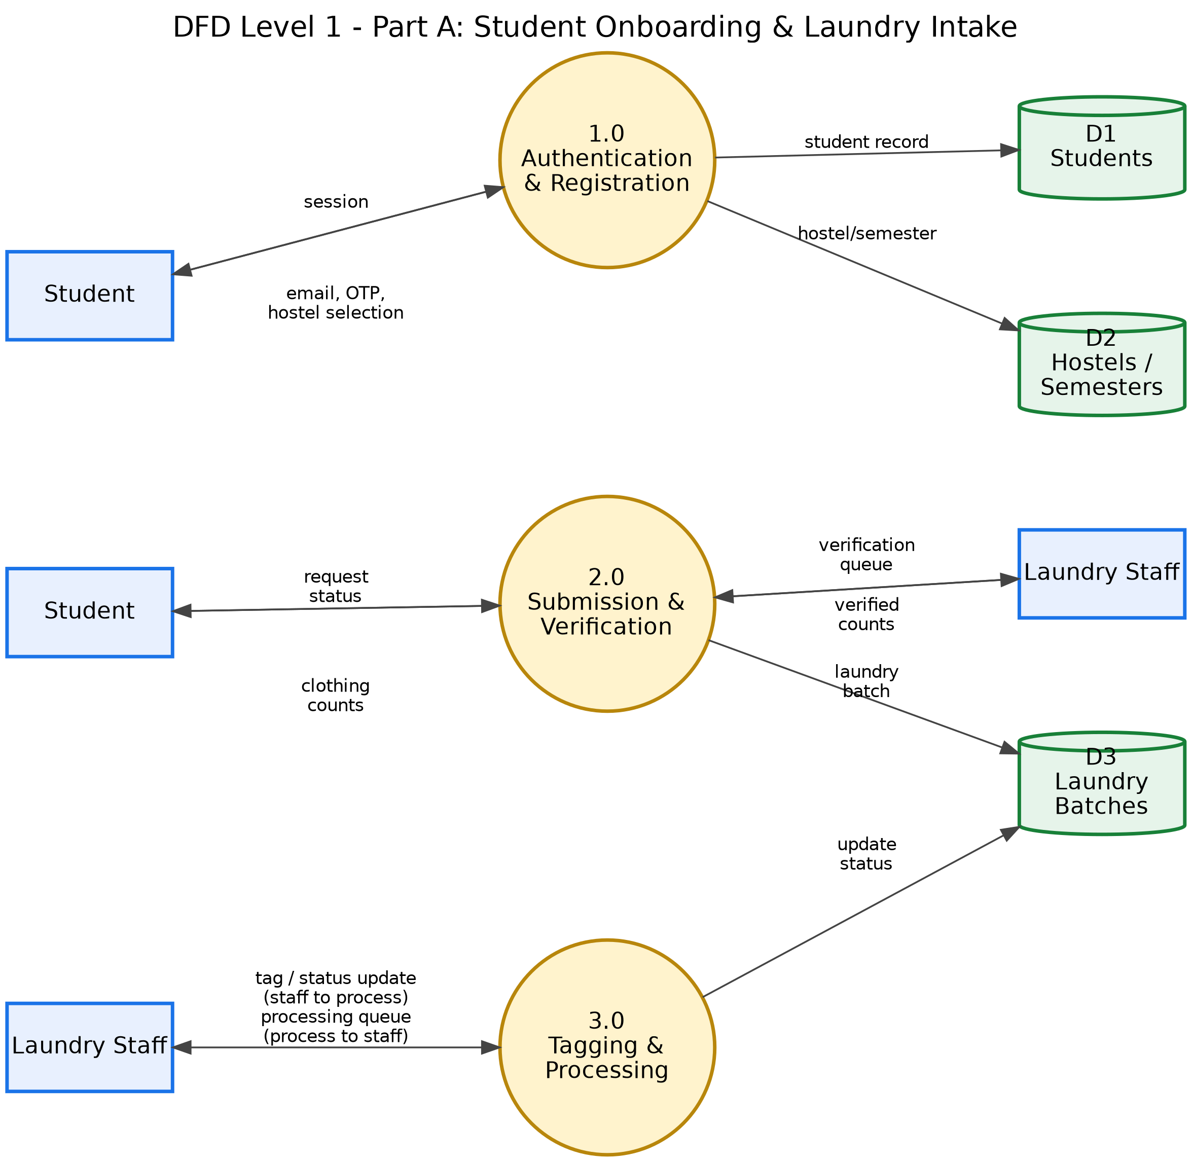
Figure 15.2 — DFD Level 1
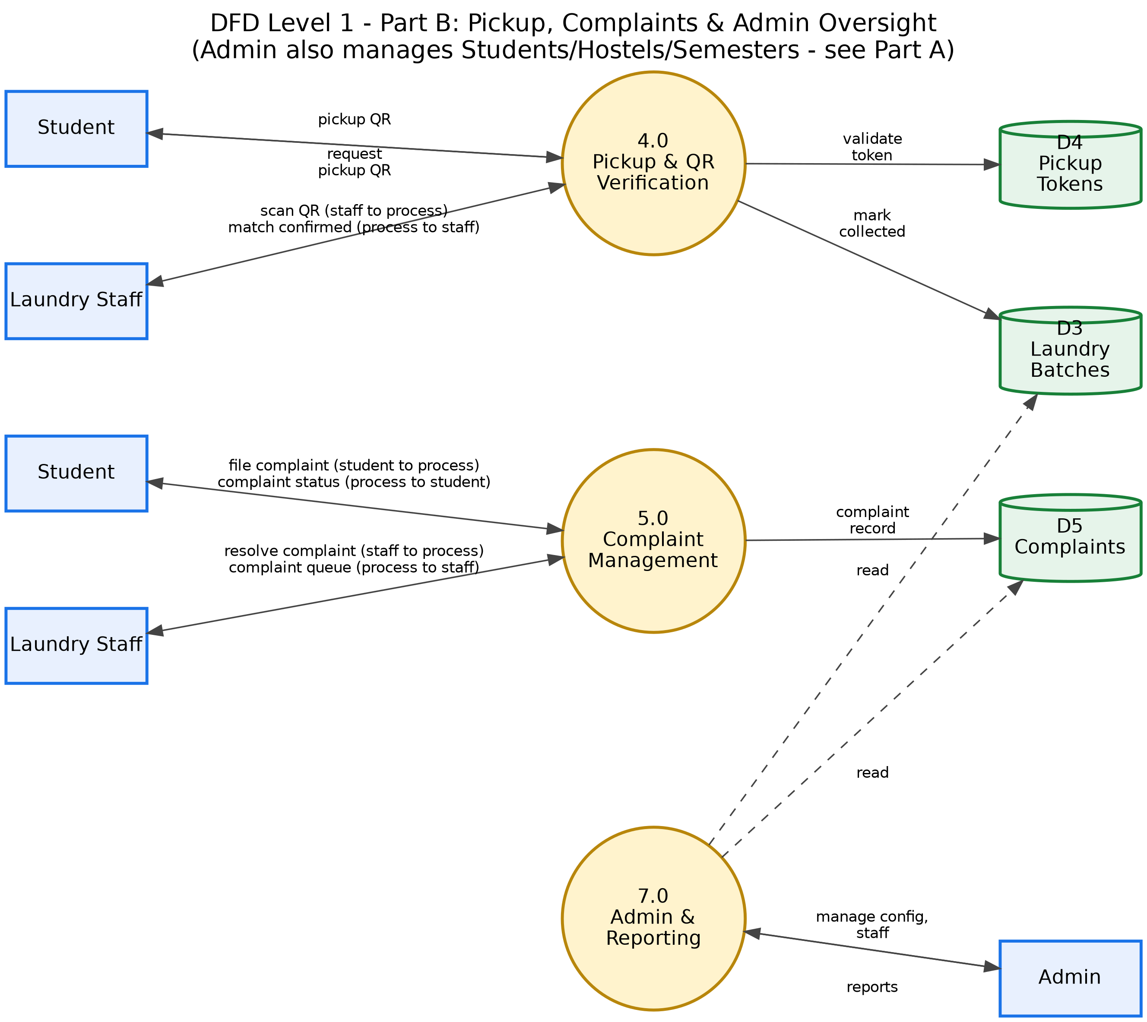
Figure 15.2 (contd.) — DFD Level 1 (Part B)

16. Sequence Diagram
The sequence diagram below illustrates the OTP-based authentication flow, which is the primary feature implemented at the current stage of development. It shows the interaction between the mobile application, the backend server, and Supabase Authentication for both the send-OTP and verify-OTP operations.
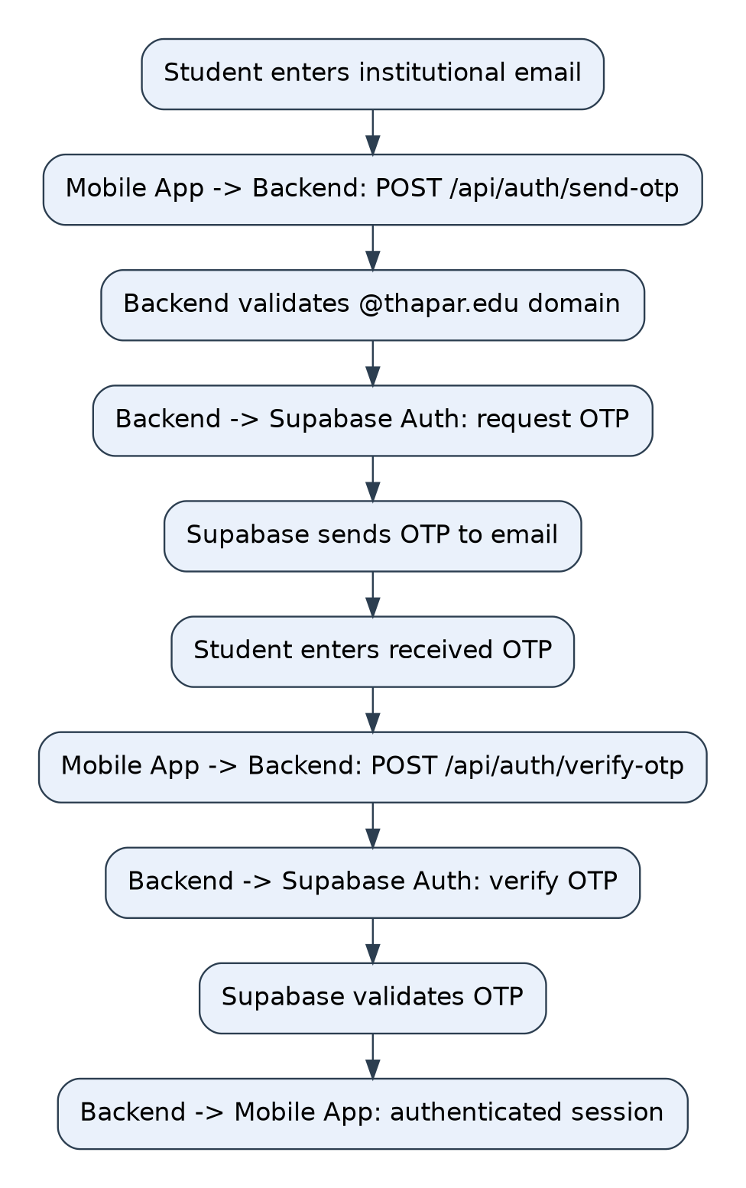
Figure 16.1 — Sequence Diagram: OTP Authentication

17. Database Design
The database is designed as a relational schema hosted on PostgreSQL via Supabase. It was designed with the complete intended system in mind, so that the remaining application modules can be implemented without a fundamental redesign of the data model. The major entities are summarized below.
Entity | Purpose
Users | Base authentication and profile record shared by students, staff, and administrators.
Students | Student-specific details (roll number, associated hostel).
Staff | Laundry-staff-specific details (designation).
Administrators | Administrator-specific account records.
Hostels | Hostel records that students are associated with.
Laundry Requests | Core record of a student’s laundry submission and its current status.
Laundry Items | Individual items and quantities within a laundry request.
Laundry Status History | Append-only log of status transitions for a request.
Laundry Batches | Grouping of requests processed together by staff.
Pickup Tokens | Single-use QR tokens issued per request for verified collection.
Complaints | Student-raised issues linked to a request, with status and resolution.
Notifications | In-app messages sent to users on status or complaint changes.
Audit Logs | Record of significant actions for traceability.
Table 17.1 — Major Database Entities
At the current implementation stage, the Users and Hostels tables and Supabase connectivity have been configured and tested (via a database connectivity test endpoint), while the remaining tables are designed and scheduled for implementation alongside the corresponding application modules (see Sections 19 and 24).

18. Technology Stack
Layer | Technology
Mobile Frontend | React Native, Expo, TypeScript, Expo Router
Backend | Node.js, Express.js
Authentication | Supabase Authentication (institutional email OTP)
Database | PostgreSQL (managed via Supabase)
Version Control | Git and GitHub
Configuration | dotenv (environment-based configuration)
Table 18.1 — Technology Stack

19. Implementation
The implementation phase converts the system requirements and design models presented in Sections 7–17 into a working software foundation. At the current stage, development has focused on establishing the frontend and backend environments, configuring the database and authentication services, and implementing the initial authentication workflow. The project follows a separation between the mobile frontend and backend services, allowing the user interface and application logic to be developed independently while communicating through APIs.

19.1 Project Structure
The project is organized into separate frontend and backend components. The major structure is:
UCS503P-202627-Laundry-Management-System/
│
├── code/
│ ├── frontend/
│ │ ├── src/
│ │ │ ├── app/
│ │ │ ├── components/
│ │ │ ├── constants/
│ │ │ └── hooks/
│ │ └── package.json
│ │
│ └── backend/
│ ├── routes/
│ │ ├── authRoutes.js
│ │ └── studentRoutes.js
│ ├── server.js
│ └── package.json
│
├── docs/
│ ├── requirements.md
│ ├── database.md
│ └── diagrams.md
│
├── journals/
│
└── project-report-final/

This separation into frontend, backend, documentation, and journal components keeps development work and project documentation organized as the project grows.

19.2 Frontend Implementation
The mobile application is being developed using React Native, Expo, and TypeScript. The Expo environment was initialized as the foundation of the mobile application, with source code organized under the src directory, including application routes and screens, reusable UI components, constants, custom hooks, and layout configuration. Expo Router is used to organize application navigation.
At the current stage, the frontend establishes the development foundation and application structure. The complete student-facing laundry workflow — request submission, laundry tracking, QR pickup, complaints, and other operational features — is part of subsequent development.

19.3 Backend Implementation
The backend is implemented using Node.js and Express.js. The backend server performs the initial application-layer responsibilities and provides the API endpoints through which the frontend communicates with backend services. The Express server has been configured with environment-variable loading, JSON request handling, Supabase client initialization, route mounting, database connectivity testing, and server startup configuration. The backend currently runs on a development server listening on port 5000, with authentication routes kept separate from other (future) application routes.

19.4 Backend Server
The main backend entry point is server.js, which performs the following major operations:
1. Environment Configuration — environment variables are loaded using the dotenv package, keeping configuration such as service credentials outside the application source code.
2. Express Initialization — an Express application is created and configured to process JSON requests.
3. Supabase Client — the backend initializes a Supabase client for communication with the project’s Supabase services.
4. Route Registration — authentication routes are mounted under /api/auth, providing a structured endpoint hierarchy.
5. Database Connectivity Test — a test endpoint under /api/test-db performs a query against the hostels table to verify connectivity between the backend and the Supabase database.
6. Server Startup — the Express application starts listening on the configured development port.

19.5 Authentication Implementation
Authentication is one of the main features implemented during the current development stage. The project uses Supabase Authentication together with an institutional email-based OTP mechanism. The authentication flow consists of two primary API operations: POST /api/auth/send-otp and POST /api/auth/verify-otp.

19.5.1 Send OTP
The send-otp endpoint receives a user’s email address. The backend first validates the email domain, currently restricting authentication to the institutional @thapar.edu domain. If the email satisfies this condition, the backend requests Supabase to send an OTP:
User enters email
↓
Frontend sends email to backend
↓
Backend validates institutional domain (@thapar.edu)
↓
Supabase sends OTP
↓
User receives OTP

This provides an initial access-control mechanism ensuring the workflow is restricted to institutional users.

19.5.2 Verify OTP
The verify-otp endpoint is used after the user receives the OTP. The OTP and email are sent to the backend, which passes the verification request to Supabase Authentication:
User enters OTP
↓
Frontend sends email + OTP
↓
Backend requests Supabase verification
↓
Supabase validates OTP
↓
Authenticated session / user returned

If verification succeeds, the backend returns the relevant authentication information to the client. This authentication foundation can subsequently be integrated with role-based access for the student, staff, and administrator modules.

19.6 Database Connectivity
Supabase provides the PostgreSQL database service used by the project. The backend has been connected to Supabase through the Supabase JavaScript client, and a database test endpoint has been included to verify communication with the database. The current test queries the hostels table, validating the following communication chain: Express backend → Supabase client → PostgreSQL database. Successful connectivity establishes the foundation required for implementing the remaining CRUD operations.

19.7 API Design
The backend follows a route-based API structure. The currently implemented authentication API includes:
Method | Endpoint | Purpose | Status
POST | /api/auth/send-otp | Send OTP to institutional email | Implemented
POST | /api/auth/verify-otp | Verify OTP and authenticate user | Implemented
GET | /api/test-db | Test database connectivity | Implemented
Table 19.1 — Implemented API Endpoints
Additional APIs for student laundry requests, staff processing, QR pickup, complaints, notifications, and administrative operations are part of the subsequent development phase.

19.8 Frontend–Backend Interaction
The intended application communication follows a client–server model. For an operation such as authentication:
React Native App
│ HTTP request
↓
Express Backend
│ Supabase API
↓
Supabase Services
↓
PostgreSQL / Auth
│ response
↓
Express Backend
│ JSON response
↓
React Native App

This architecture prevents the mobile application from directly containing backend logic and provides a centralized location for validation and business rules.

20. Testing and Validation
Testing at the current stage has focused primarily on validating the implemented infrastructure rather than the complete laundry workflow, since several application modules are still under development. Comprehensive end-to-end testing will be performed once those modules are implemented and integrated.

20.1 Authentication Testing
The authentication endpoints were tested to validate the institutional email and OTP workflow:
Test Case | Input / Condition | Expected Result
Valid institutional email | Valid @thapar.edu address | OTP request accepted
Non-institutional email | Email outside permitted domain | Request rejected
OTP verification | Valid OTP | User authenticated
Invalid OTP | Incorrect OTP | Authentication rejected
Database connectivity | /api/test-db request | Database query executed
Table 20.1 — Authentication Test Cases

20.2 Database Connectivity Testing
The /api/test-db endpoint provides an initial validation of the backend’s connection to the Supabase database by retrieving information from the hostels table. This validates the basic connection required before implementing database operations for laundry requests, users, complaints, and other entities.

20.3 API-Level Validation
The authentication routes provide an initial API-level testing surface, verifying:
- API endpoint accessibility.
- Request handling.
- Email validation.
- Communication with Supabase Authentication.
- OTP verification.
- Response handling.
- Database connectivity.

20.4 Future Testing
Once the remaining modules are implemented, testing will be expanded to include:
- Functional Testing — each individual feature tested against its functional requirements.
- Integration Testing — frontend, backend, authentication, database, and application modules tested together.
- Workflow Testing — the complete laundry lifecycle tested from submission to collection.
- Security Testing — authentication, authorization, access control, QR verification, and data-access restrictions.
- Usability Testing — evaluating ease of use for students and staff.
- Validation Testing — checking the system against the stakeholder requirements from Section 7.
- End-to-End Testing — the complete workflow tested as: student login → laundry submission → staff verification → processing → return → ready for pickup → QR verification → collection.

21. Work Completed and Current Results
The following table summarizes the implementation status at the time of this report.
Component | Status | Description
Requirement Analysis | Completed | Requirements and actors identified
Stakeholder Analysis | Completed | Practical workflow requirements gathered
System Architecture | Designed | Layered client–server architecture defined
Use Case Diagram | Completed | Actor–system interactions defined
Activity Diagram | Completed | Laundry lifecycle modelled
Class Diagram | Completed | Major entities and relationships modelled
Data Flow Diagram | Completed | Data movement modelled
Sequence Diagram | Completed | System interaction flow modelled
Database Design | Designed | Relational entities and relationships defined
PostgreSQL / Supabase Setup | Implemented | Database platform configured
Backend Setup | Implemented | Node.js and Express foundation established
Supabase Connectivity | Implemented | Backend connected to Supabase
Database Connectivity Test | Implemented | Test endpoint created
Institutional Email Validation | Implemented | @thapar.edu validation added
OTP Authentication | Implemented | Send and verify OTP routes created
React Native / Expo Setup | Implemented | Mobile application foundation established
Student Laundry Workflow | Under Development | Remaining APIs and UI to be implemented
Staff Workflow | Planned | To be implemented
QR Pickup | Designed | Implementation pending
Complaint Management | Designed | Implementation pending
Notifications | Designed | Implementation pending
Admin Dashboard | Planned | Implementation pending
End-to-End Integration | Pending | To be performed after module completion
Table 21.1 — Implementation Status Summary
This status reflects the project’s actual development stage and draws a clear distinction between completed groundwork and future implementation — the database platform and connectivity are implemented and the schema is designed, but the complete operational CRUD layer for laundry requests, for instance, is not yet in place.

21.1 Requirement Analysis
The team studied the existing hostel laundry workflow and identified the major operational requirements of students, laundry staff, and administrators, including the complete intended laundry lifecycle, authentication requirements, pickup-verification requirements, and complaint and notification requirements. Stakeholder interaction helped identify practical operational concerns, particularly the need for reliable verification during laundry collection.

21.2 System Modelling
The team translated the identified requirements into the use case, activity, class, data-flow, and sequence models presented in Sections 12–16. These models provide a common reference for the development team and establish the intended behaviour of the system ahead of implementation.

21.3 Database Design
A relational database structure was designed using PostgreSQL through Supabase, covering all entities described in Section 17. The database model was designed with the complete intended system in mind so that additional application modules can be implemented without a fundamental redesign of the data structure.

21.4 Backend and Authentication
The Node.js and Express backend environment has been established, and the initial authentication workflow has been implemented using Supabase Authentication, validating institutional email addresses and supporting OTP-based authentication. This establishes the first functional interaction between the backend and Supabase’s authentication services.

21.5 Frontend Development
The React Native and Expo environment has been initialized, including the basic application structure, routing configuration, reusable components, constants, and hooks required for further development. The student-facing laundry screens and complete operational workflow are still under development.

21.6 Current Outcome
The current outcome of the project is a working technical foundation accompanied by a complete system design for the proposed solution — the requirements, architecture, data model, backend foundation, authentication mechanism, and frontend foundation required for subsequent development have all been established, and the remaining application modules will build upon this foundation.

22. Challenges Encountered
The development process involved several challenges, particularly during the initial requirement-analysis and system-definition phases.

22.1 Understanding the Real-World Workflow
One of the initial challenges was understanding how laundry is actually received, identified, processed, returned, and collected. A software workflow cannot simply be designed based on assumptions, since the system must correspond to the practical activities performed by laundry staff. Stakeholder interaction was therefore important in converting the real-world process into software requirements.

22.2 Stakeholder Coordination
The early phase involved obtaining appropriate permissions and coordinating discussions with the relevant laundry personnel. This reduced the amount of technical development that could be performed during the initial phase, but it was necessary for establishing realistic requirements.

22.3 Designing Reliable Collection Verification
The collection stage presented an important design challenge: the system must associate a physical laundry order with the correct student and provide a mechanism through which staff can verify collection. This requirement led to the inclusion of the QR-based pickup mechanism and the supporting pickup-token entity described in Sections 6 and 17.

22.4 Translating Requirements into System Models
Another challenge was converting operational requirements into formal software-engineering models — establishing relationships between actors, use cases, activities, classes, data flows, database entities, and API interactions. Creating these models before complete implementation helped establish a structured development direction.

22.5 Coordinating Development and Documentation
Since different aspects of the project were being worked on in parallel, maintaining consistency between the documentation and the actual implementation was an ongoing requirement. This report, in particular, distinguishes explicitly between implemented functionality and planned functionality throughout.

23. Current Limitations
The present version of the project has several limitations because development is still in progress.
1. Incomplete Laundry Workflow — the complete student laundry submission and tracking workflow has not yet been implemented.
2. Staff Module Pending — the staff-side interface and complete staff APIs are yet to be implemented.
3. QR Pickup Pending — although the QR-based pickup mechanism has been designed, its complete implementation and validation are pending.
4. Complaint Module Pending — complaint-management functionality has been included in the system design but has not yet been fully implemented.
5. Notification System Pending — the notification mechanism is part of the proposed architecture but requires further implementation and integration.
6. Administrative Interface Pending — the administrator dashboard and corresponding management functionality remain part of future development.
7. End-to-End Testing Pending — comprehensive end-to-end testing can only be performed after the remaining modules have been implemented and integrated.
8. Current Frontend Scope — the current React Native application establishes the frontend foundation, but the complete user interface for the proposed laundry workflow is still under development.
These limitations represent the current project stage rather than flaws in the overall system design.

24. Future Work
The next development phases will focus on converting the designed system into a complete operational application.

24.1 Student Module
The student application will be extended to support:
- Complete student dashboard.
- Laundry request creation and item entry.
- Request tracking and laundry history.
- Status visualization and pickup information.
- Complaint submission.

24.2 Laundry Staff Module
The staff interface will be developed to provide:
- Incoming laundry queue and request verification.
- Laundry tagging and processing management.
- Status updates and ready-for-pickup management.
- QR scanning and collection confirmation.
- Complaint handling.

24.3 QR-Based Pickup
The planned pickup mechanism will be implemented so that each eligible laundry request can be associated with secure pickup information, following the intended flow:
Laundry Ready → Pickup Token Generated / Activated → Student Presents QR
→ Staff Scans QR → Request Validated → Collection Recorded

Additional validation will be incorporated to prevent reuse of a completed pickup token.

24.4 Notification System
A notification system will be integrated to communicate important laundry-status changes to students, including:
- Laundry received, processing, returned, and ready for pickup.
- Collection completed.
- Complaint updates.

24.5 Complaint Management
The complaint module will be developed to allow students to submit issues and enable authorized users to track and resolve them, maintaining information such as complaint description, related request, submission time, status, resolution information, and relevant staff or admin actions.

24.6 Administrative Dashboard
The administrative module will provide centralized visibility into system activity, including:
- User and hostel management.
- Laundry activity monitoring and record access.
- Complaint monitoring and audit-log access.
- System-level reporting.

24.7 Comprehensive Testing
After implementation, the project will undergo unit, integration, functional, authentication, database, workflow, security, usability, and end-to-end testing, with the final objective of validating the complete workflow against the requirements established in Section 8.

24.8 Deployment
After successful development and testing, the application can be prepared for deployment within the university hostel environment, including:
- Production database and secure environment configuration.
- Backend deployment and mobile application build.
- Authentication configuration and production testing.
- Monitoring and maintenance.

25. Expected Impact
Once the complete system is implemented, the Digital Hostel Laundry Management System is expected to provide a structured digital workflow for hostel laundry operations. The proposed system is intended to:
- Reduce dependence on manual records.
- Improve visibility of laundry status for students.
- Provide structured, verifiable historical records.
- Improve collection verification and reduce ambiguity during handover.
- Provide students with timely information through notifications.
- Improve operational organization for laundry staff.
- Provide administrators with centralized monitoring across hostels.
- Establish better traceability of important system actions through audit logs.
The actual operational impact will need to be evaluated after deployment through user feedback and usage data.

26. Conclusion
The Digital Hostel Laundry Management System addresses the need for a more structured and transparent approach to managing hostel laundry operations. During the current project phase, the team has completed the major requirement-analysis and system-design activities and has established the technical foundation for implementation. The project includes clearly defined actors, functional and non-functional requirements, a complete proposed laundry workflow, database modelling, UML and DFD representations, and a layered application architecture.
From the implementation perspective, the React Native and Expo frontend environment has been initialized, while the Node.js and Express backend has been established and connected to Supabase. The project also includes an institutional email-based OTP authentication workflow, providing an initial working feature of the application.
The system has deliberately been developed in stages. While the complete laundry workflow, staff operations, QR-based collection, complaints, notifications, and administrative functionality are not yet fully implemented, their requirements and architectural foundations have been established. The current work therefore provides a strong foundation for the next phase of development, which will focus on integrating the remaining modules, performing comprehensive testing, and eventually validating the complete system in a real hostel laundry environment.
The project demonstrates the application of software-engineering principles including requirement analysis, stakeholder interaction, system modelling, relational database design, client–server architecture, API development, authentication, modular development, and collaborative version control.

27. References
1. React Native Documentation, Meta Platforms, Inc.
2. Expo Documentation, Expo.
3. Node.js Documentation, OpenJS Foundation.
4. Express.js Documentation.
5. Supabase Documentation.
6. PostgreSQL Documentation.
7. GitHub Documentation.
8. Project-specific requirement and design documentation maintained in the project repository.
9. Stakeholder discussions and requirement-gathering sessions conducted during the project development phase.

28. Appendix

Appendix A — Project Repository
The source code, documentation, diagrams, and development records are maintained in the project’s Git repository.

Appendix B — System Diagrams
The following diagrams are included as part of the project documentation:
- Use Case Diagram (Figure 12.1).
- Activity Diagram (Figure 13.1).
- Class Diagram (Figure 14.1).
- Data Flow Diagrams, Levels 0 and 1 (Figures 15.1 and 15.2).
- Sequence Diagram (Figure 16.1).

Appendix C — API Endpoints
The currently implemented API endpoints are:
Method | Endpoint | Description
POST | /api/auth/send-otp | Sends OTP to an eligible institutional email
POST | /api/auth/verify-otp | Verifies OTP and authenticates the user
GET | /api/test-db | Tests backend-to-database connectivity

Appendix D — Development Status Legend
The project should be interpreted according to the following development categories:
- Completed — work has been completed and documented.
- Implemented — functionality currently exists in the codebase.
- Designed — architecture, schema, or functionality has been specified but implementation is pending.
- Under Development — implementation has started but is not complete.
- Planned — functionality is intended for a subsequent development phase.

