**Result:**

* Data used for the Regression Analysis is: 
* Correlation between the features of Input is given by:

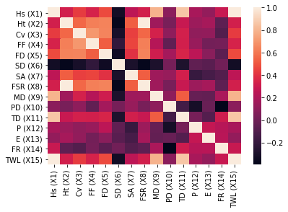

* The results were represented using the plots between Actual Reaction times (Y_test) and Predicted reaction times (Y_pred), after splitting the data into training and test set in the ratio 80:20.
* Here the model score was estimated using Coefficient of determination (R²)
* From the below observations, Polynomial regression with degree three (Cubic regression) with model score of 1.0 and MSE value of 3.870917923036499e-27.

**Results from linear regression:**

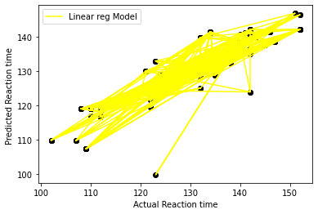

The **Model score** of the linear regression model for the given dataset is: 0.8114035313140626

The **Mean Squared error (MSE)** value of the Linear regression model for given dataset is : 29.886187183738937

**Results from Polynomial regression of degree two:**

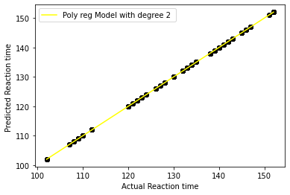

The **Model score** of the polynomial regression model with degree two for the given dataset is: 1.0

The **Mean Squared error(MSE)** value of the Polynomial regression model with degree two for given dataset is : 6.69580159766227e-24

**Results from Polynomial regression of degree three:**

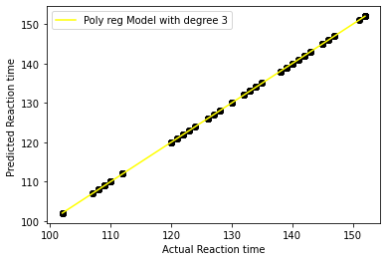

The **Model score** of the polynomial regression model with degree three for the given dataset is: 1.0

The **Mean Squared error(MSE)** value of the Polynomial regression model with degree three for given dataset is : 3.870917923036499e-27

**Results from Polynomial regression of degree four:**

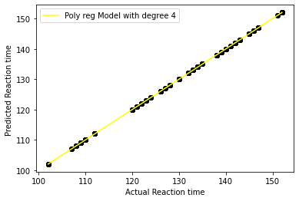

The **Model score** of the polynomial regression model with degree three for the given dataset is: 1.0

The **Mean Squared error(MSE)** value of the Polynomial regression model with degree four for given dataset is : 5.76541021080247e-26

**Results from SVR with linear kernel:**

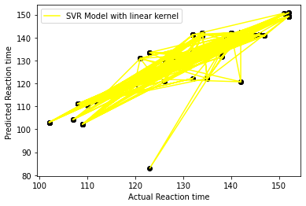

The **Model score** of the SVR model with linear kernel for the given dataset is: 0.8515756494941867

The **Mean Squared error (MSE)** value of the SVR model with Linear kernel for given dataset is : 23.520259699180517

**Results from SVR with polynomial kernel:**

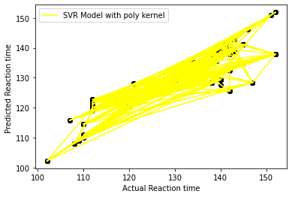

The **Model score** of the SVR model with Polynomial kernel for the given dataset is: 0.7988666776718358

The **Mean Squared error (MSE)** value of the SVR model with Polynomial kernel for given dataset is : 31.87285616676569

**Results from SVR with RBF kernel:**

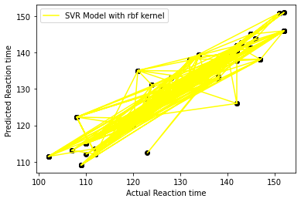

The **Model score** of the SVR model with Radial Basis Function (RBF) kernel for the given dataset is: 0.8942649338671653

The **Mean Squared error (MSE)** value of the SVR model with Radial Basis Function (RBF) kernel for given dataset is : 16.755446166880102