**Indian Institute of Technology Kharagpur**

**Central Time Table**

**Autumn Semester (2019– 2020)**

**TABLE OF CONTENTS**

**March 28, 2019**

|  |  |  |
| --- | --- | --- |
| **No.** | **Item** | **Page** |
|  |  | **No.** |
| **1** | **Important aspects of the Autumn 2019-20 Time Table** | **1** |
| **2** | **Time Table Slotting Pattern** | **2** |
| **3** | **First year Curriculum** | **3** |
| **4** | **Section wise time table for 20 sections of first year** | **4-23** |
| **5** | **Common Subjects/Breadth/HSS/Management Slot Indication (2nd year** | **24-28** |
|  | **and above)** |  |
| **6** | **Slot & Room Allocation for common subjects (2nd year and above)** | **29-35** |

**Important aspects of the Autumn 2019-20 Time Table**

1. **In view of the increased student strength, first year has been subdivided into 20 Sections.**
2. **Deviating from the single section model, first year Mechanics, like the other theory subjects of first year, will be offered in 5 groups, with two sections merged into a single group. This is as per the request of the Department.**
3. **The special classes for first year scheduled from 29 July 2019-23 August 2019 have been indicated in the Section Wise Time Table.**
4. **As proposed by the Department of Mechanical Engineering and approved by the Director, the second year Workshop Classes will be held between 5:30-8:30 PM two days a week.**
5. **For second year and above, slots for Breadth/HSS/Management subjects have been indicated. Academic Units must ensure atleast two out of the three designated breadth slots are available for students.**
6. **Academic Units must schedule all subjects strictly in accordance with the time table slotting pattern. If cross slotting has to be done due to compelling reasons, then it can be done only with one hour of ‘S’ slot along with a regular 3 hour slot.**
7. **Faculty members requiring Audio -Visual facility should inform Audio-Visual Cell separately.**
8. **Room Allocation-**
   1. **PIC CTT is responsible for central class room allocation for regular UG/PG/Research courses, only on class days from 8 AM- 6PM.**
   2. **Class room allocation for any other activity including special classes/tests on weekends/closed holidays and outside class hours on class days is handled by the Academic Section.**
9. **Queries/Clarifications regarding Central Time Table may please be sent to "Professor In Charge Central Time Table" pic.ctt@adm.iitkgp.ernet.in.**

**(Jyotsna Dutta Majumder)**

**Professor-in-Charge, Central Time Table**

**Department of Metallurgy and Materials Engineering**

**Posted in apna.iitkgp.ac.in**

**Central Time Table Autumn 2019– 2020, Version 1.1** **Updated -28 March 2019** **1**

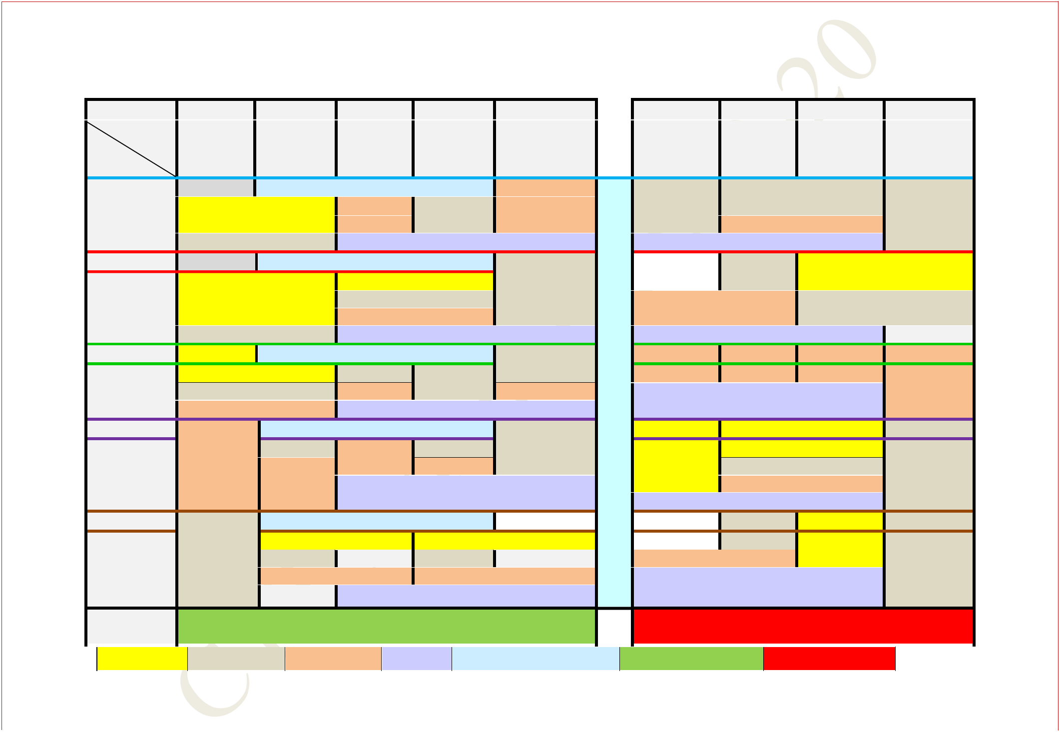**CENTRAL TIMETABLE: AUTUMN SEMESTER (2019– 2020)**

**TABLE-1 - TIME TABLE SLOTTING PATTERN**

|  |  |  |  |  |  |  |  |  |  |  |  |  |  |  |  |  |
| --- | --- | --- | --- | --- | --- | --- | --- | --- | --- | --- | --- | --- | --- | --- | --- | --- |
| **Period** | **1** |  | **2** |  | **3** | **4** | **5** |  |  | **6** |  | **7** | **8** |  | **9** |  |
| **Time** | **8:00** | **AM** | **9:00** | **AM** | **10:00AM** | **11:00 AM-** | **12:00 Noon** | | **2:00** | | **PM -** | **3:00 PM -** | **4:00** | **PM -** | **5:00 PM** |  |
| **Day** | **-8:55** | **AM** | **-9:55** | **AM** | **-10:55** | **11:55 AM** | **-12:55** | **PM** |  |
| **2:55** | | **PM** | **3:55 PM** | **4:55** | **PM** | **5:55 PM** |  |
|  |  |  |  |  | **AM** |  |  |  |  |
|  |  |  |  |  |  |  |  |  |  |  |  |  |  |  |  |

**TUE**

**WED**

**THU**

**FRI**

|  |  |  |  |  |  |  |  |
| --- | --- | --- | --- | --- | --- | --- | --- |
| **A3(1)** | **1st Year LAB SLOT Q-1** | | | | | **D3 (1)** |  |
| **A2** |  | **C3 (1)** |  | **B3(1)** | | **D4 (1)** |  |
|  | **C4 (1)** |  |  |  |
|  |  |  |  |  |  |  |
| **A3(1, 2)** |  |  |  | **LAB SLOT:Q** | |  |  |
|  | **1st Year LAB SLOT K-1** | | | | |  |  |
|  |  |  | **D2** | |  | **A3(3)** |  |
| **B2** |  | **D3(2, 3)** | | |  |  |
|  |  |  |
|  |  | **D4(2, 3)** | | | |  |  |
| **B3(2, 3)** |  |  |  | **LAB SLOT:K** | |  |  |
|  | **1st Year LAB SLOT R-1** | | | | | **E3(1)** |  |
| **C2** |  | **F3(1)** |  |  |  |  |
|  |  | **G3(1)** | |  |  |
| **C3(2, 3)** |  | **F4(1)** |  | **E4(1)** |  |
|  |  |  |  |  |
| **C4(2, 3)** |  |  |  | **LAB SLOT:R** | |  |  |

|  |  |  |  |  |  |  |
| --- | --- | --- | --- | --- | --- | --- |
|  | **1st Year LAB SLOT M-1** | | | |  |  |
| **D4(4)** | **F3(2)** |  | **C4(4)** | **E3(2)** | **G3(2)** |  |
|  |  |  | **E4(2)** |  |  |
|  | **F4(2)** |  |  | **LAB SLOT:M** |  |  |
|  |  |  |  |  |  |
|  | **1st Year LAB SLOT O-1** | | | |  |  |
| **G3(3)** |  | **E2** | | **F2** |  |  |
| **E3(3)** |  |  | **F3(3)** |  |  |
|  |  |  |  |  |
|  | **E4(3, 4)** | | | **F4(3, 4)** | |  |
|  |  |  |  | **LAB SLOT:O** |  |  |

|  |  |  |  |  |  |  |  |
| --- | --- | --- | --- | --- | --- | --- | --- |
|  | **H3(1)** |  |  | **U3(1, 2)** |  |  |  |
|  |  |  |  |  | **S3(1)** |  |
|  |  |  |  | **U4(1, 2)** |  |  |
|  |  |  |  |  |  |  |
| **L** |  | **LAB SLOT:J** | | |  |  |  |
|  |  | **U3(3)** |  | **H2** | |  |
| **U** |  |  |  |  |
|  |  |  |  |  |  |  |
| **U4(3, 4)** | | |  | **H3(2, 3)** | |  |
| **N** |  |  |
|  |  |  |  |  |  |  |
|  | **LAB SLOT:L** | | |  |  |  |
|  |  |  |  |  |
| **C** |  |  |  |  |  |  |  |
| **H** | **X4(1)** |  | **X4(2)** | **X4(3)** |  |  |  |
|  | **LAB SLOT:X** | | |  | **X4(4)** |  |
|  |  |  |  |  |
| **H** |  |  |  | **V2** |  |  |  |
| **O** |  |  |  |  |  |  |
| **I2(1)** |  |  | **V3(1, 2)** |  |  |  |
| **U** |  |  |  | **V4(1, 2)** |  | **S3(2)** |  |
|  | **LAB SLOT:N** | | |  |  |  |

|  |  |  |  |  |
| --- | --- | --- | --- | --- |
| **R** | **V3(3)** |  |  |  |
|  | **I2(2)** | |  |
|  | **V4(3, 4)** |  |
|  |  |  |  |
|  | **LAB SLOT:P** |  | **S3(3)** |  |
|  |  |  |  |

|  |  |  |  |  |  |  |  |  |  |  |  |  |  |  |  |  |  |  |  |  |
| --- | --- | --- | --- | --- | --- | --- | --- | --- | --- | --- | --- | --- | --- | --- | --- | --- | --- | --- | --- | --- |
|  |  | **SAT** | | | | | **EAA** | | |  |  |  |  |  |  |  |  |  |  |  |
|  |  |  |  |  |  |  |  |  |  |  |  |  |  |  |  |  | |  | |  |
|  |  | **2 Hour Slot 3 hour slot** | | | | | **4 Hour Slot** |  | **Lab Slot** | **Lab Slot for 1st year only Special Slot for EAA** | | | | | **Offically No Class** | | | | |  |
|  |  |  |  |  |  |  |  |  |  |  |  |  |  |  |  |  | **AUTUMN** | | |  |
| **Central Time Table Autumn 2019– 2020, Version 1.1** | | | | | | | |  |  | **Updated -28 March 2019** | | | | |  |  |  |
|  |  |  | |  | | **2** |  |
|  |  |  |  |  |  |  |  |  |  |  |  |  |  |  |  |  |  |  |  |  |

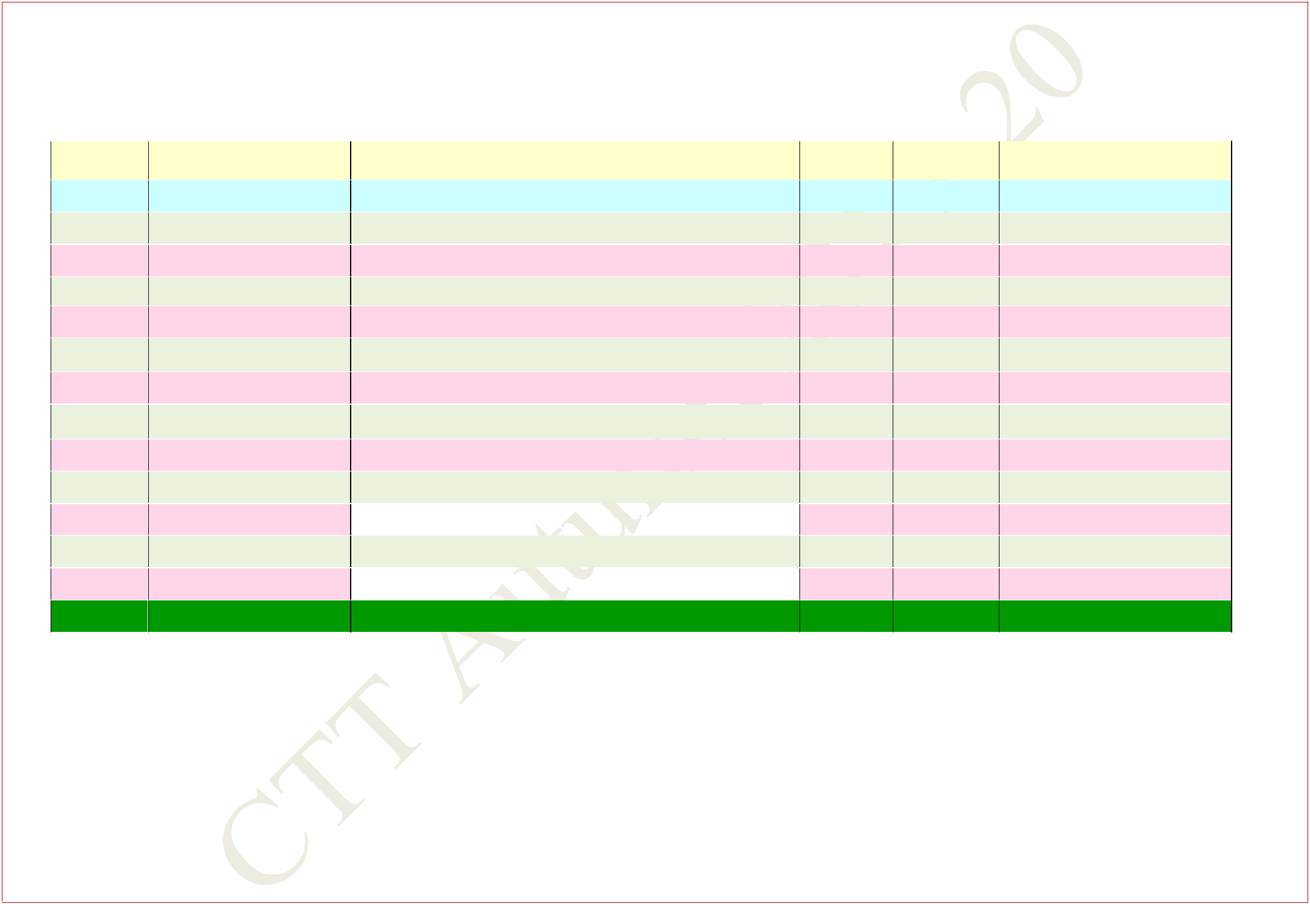**SEMESTER (2019-2020)**

**FIRST YEAR CURRICULUM**

|  |  |  |  |  |  |  |  |
| --- | --- | --- | --- | --- | --- | --- | --- |
| **Sl.No.** | **Subject Number** |  | **Subject Name** | **L-T-P** |  | **Credits** | **Section** |
|  |  |  |  |  |  |  |  |
| **1** | **MA10001** |  | **Mathematics I** | **3-1-0** | **4** | | **All** |
|  |  |  |  |  |  |  |  |
| **2** | **CY11001** |  | **Chemistry** | **3-1-0** | **4** | | **1-10** |
|  |  |  |  |  |  |  |  |
| **3** | **PH11001** |  | **Physics** | **3-1-0** | **4** | | **11-20** |
|  |  |  |  |  |  |  |  |
| **4** | **HS13001** |  | **English for Communication** | **3-0-2** | **4** | | **1-10** |
|  |  |  |  |  |  |  |  |
| **5** | **ME10001** |  | **Mechanics** | **3-1-0** | **4** | | **11-20** |
|  |  |  |  |  |  |  |  |
| **6** | **EE11001** |  | **Electrical Technology** | **3-1-0** | **4** | | **1-10** |
|  |  |  |  |  |  |  |  |
| **7** | **CS10001** |  | **Programming and Data Structures** | **3-0-0** | **3** | | **11-20** |
|  |  |  |  |  |  |  |  |
| **8** | **CY19101** |  | **Chemistry Laboratory** | **0-0-3** | **2** | | **1-10** |
|  |  |  |  |  |  |  |  |
| **9** | **PH19001** |  | **Physics Laboratory** | **0-0-3** | **2** | | **11-20** |
|  |  |  |  |  |  |  |  |
| **10** | **EE19001** |  | **Electrical Technology Laboratory** | **0-0-3** | **2** | | **1-10** |
|  |  |  |  |  |  |  |  |
| **11** | **CS19101** |  | **Programming and Data Structures Laboratory** | **0-1-3** | **3** | | **11-20** |
|  |  |  |  |  |  |  |  |
| **12** | **ME19001** |  | **Introduction to Manufacturing Processes** | **0-0-3** | **2** | | **1-10** |
|  |  |  |  |  |  |  |  |
| **13** | **CE13001** |  | **Engineering Drawing and Computer Graphics** | **1-0-3** | **3** | | **11-20** |
|  |  |  |  |  |  |  |  |
| **14** | **EA10001** |  | **Extra Academic Activity –I** | **0-0-0** | **0** | | **All** |
|  |  |  |  |  |  |  |  |
| **1st year Architecture Students** | | **--To Select a Suitable Section** | |  |  |  |  |

**Central Time Table Autumn 2019– 2020, Version 1.1** **Updated -28 March 2019** **3**

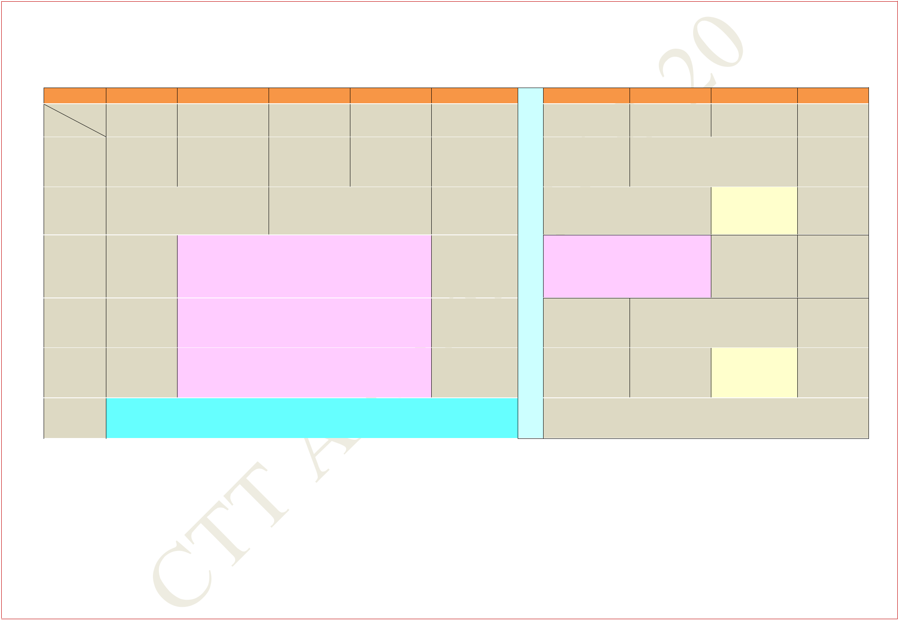**FIRST YEAR TIME TABLE FOR SECTION 1**

**AUTUMN SEMESTER 2019 – 2020**

|  |  |  |  |  |  |  |  |  |  |  |
| --- | --- | --- | --- | --- | --- | --- | --- | --- | --- | --- |
| **Period** |  | **1** |  | **2** | **3** |  | **4** |  | **5** |  |
| **Time** | **8:00** | **AM -** | **9:00** | **AM -** | **10:00** | **AM -** | **11:00** | **AM -** | **12:00 Noon** |  |
| **Day** | **8:55** | **AM** | **9:55** | **AM** | **10:55** | **AM** | **11:55** | **AM** | **- 12:55 PM** |  |
| **MON** |  |  | **HS(Sp)** | | **MA(Sp)** | | **MA** | | **CY** |  |
|  |  |  | **F116** | **F116** | | **F116** | | **F116** |  |
|  |  |  |  |  |
|  |  |  |  |  |  |  |  |  |  |  |
| **TUE** |  |  | **MA** |  |  |  | **CY** |  |  |  |
|  |  | **F116** |  |  | **F116** | |  |  |  |
|  |  |  |  |  |  |  |  |
|  |  |  |  |  |  | | |  |  |  |
| **WED** |  |  |  |  | **CHEMISTRY LAB** | | |  |  |  |
|  |  |  | **(In Chemistry Department)** | | | |  |  |  |
|  |  |  |  |  |  |  |
|  |  |  |  | | | | | |  |  |
| **THU** |  |  | **ELECTRICAL TECHNOLOGY LAB** | | | | | |  |  |
|  |  | **(In Sir J C Bose Laboratory Complex)** | | | | | |  |  |
|  |  |  |  |  |
|  |  |  |  | | | | | |  |  |
| **FRI** |  |  | **INTRO. TO MANUF. PROCESSES LAB** | | | | | |  |  |
|  |  | **(In Mechanical Engineering Department)** | | | | | |  |  |
|  |  |  |  |  |
|  |  |  |  |  |  | |  |  |  |  |
| **SAT** |  |  |  |  | **EAA** | |  |  |  |  |
|  |  |  |  |  |  |  |  |  |  |  |

|  |  |  |  |  |  |  |  |  |
| --- | --- | --- | --- | --- | --- | --- | --- | --- |
|  |  | **6** | **7** |  | **8** |  | **9** |  |
| **2:00** | | **PM -** | **3:00 PM -** | **4:00** | **PM -** | **5:00** | **PM -** |  |
| **L** | **2:55** | **PM** | **3:55 PM** | **4:55** | **PM** | **5:55** | **PM** |  |
|  |  |  | **EE** |  |  |  |  |
| **U** | |  |  |  |  |  |  |
|  |  | **F116** |  |  |  |  |
|  |  |  |  |  |  |  |  |
| **N** |  |  |  |  |  |  |  |  |
|  |  | **EE** | **CY(T)** | |  |  |  |
| **C** | |  |  |  |  |
|  | **F116** | **F131, F132** | |  |  |  |

* **HS LAB**

**(In Language Lab,**

* **Sir J C Bose Laboratory**

**Complex)**

|  |  |  |  |  |
| --- | --- | --- | --- | --- |
| **O** | **CY(Sp)** |  | **HS** |  |
|  |  |  |
| **U** | **F116** |  | **F116** |  |
|  |  |  |  |
| **R** |  |  |  |  |
| **EE(Sp)** | **HS** | **MA(T)** |  |
|  | **F116** | **F116** | **F131, F132** |  |
|  |  |  |  |  |

**MA: Mathematics I** **CY: Chemistry** **HS: English for Communication**

1. **Electrical TechnologyEAA: Extra Academic Activity**

**Sp within brackets indicates Special/Extra Class for the subject from 29 Jul 2019 – 23 Aug 2019**

**(T)- in brackets means Tutorial for that subject.**

**Central Time Table Autumn 2019– 2020, Version 1.1** **Updated -28 March 2019** **4**

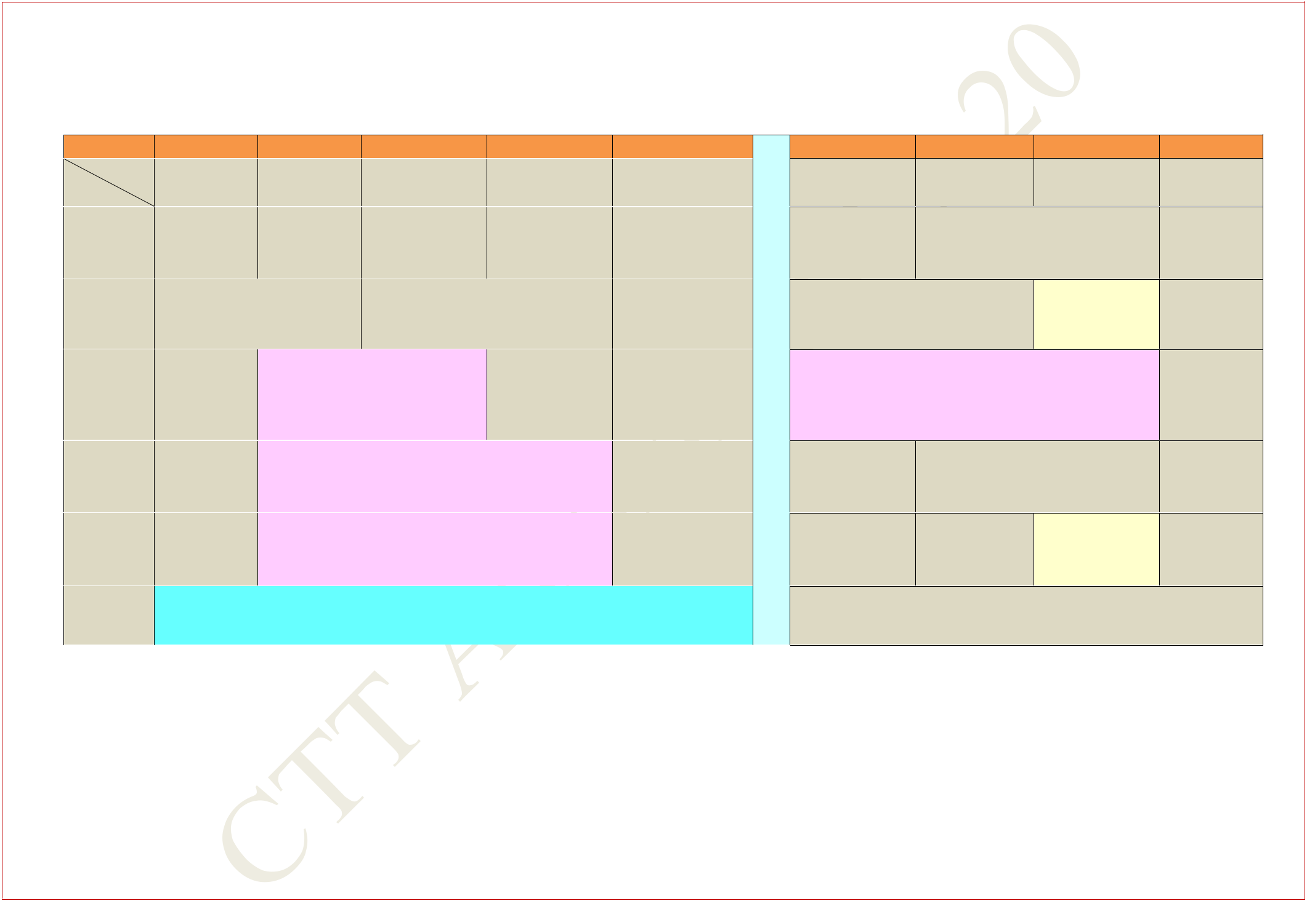**FIRST YEAR TIME TABLE FOR SECTION 2**

**AUTUMN SEMESTER 2019 – 2020**

|  |  |  |  |  |  |  |  |  |  |  |
| --- | --- | --- | --- | --- | --- | --- | --- | --- | --- | --- |
| **Period** |  | **1** |  | **2** |  | **3** |  | **4** |  | **5** |
| **Time** | **8:00** | **AM -** | **9:00** | **AM -** | **10:00** | **AM -** | **11:00** | **AM -** | **12:00** | **Noon -** |
| **Day** | **8:55** | **AM** | **9:55** | **AM** | **10:55** | **AM** | **11:55** | **AM** | **12:55** | **PM** |

|  |  |  |  |  |  |  |  |
| --- | --- | --- | --- | --- | --- | --- | --- |
| **MON** | **HS(Sp)** | **MA(Sp)** | **MA** | **CY** |  | **L** |  |
| **F116** | **F116** | **F116** | **F116** |  |  |
|  |  |  |
|  |  |  |  |  |  | **U** |  |
| **TUE** | **MA** | **CY** |  |  |  |  |
|  |  |  |  |  |
| **F116** | **F116** |  |  |  | **N** |  |
|  |  |  |  |  |
|  |  |  |  |  |  |  |
|  |  | |  |  |  |  |  |
|  | **HS LAB** | |  |  |  | **C** |  |
| **WED** | **(In Language Lab,** | |  |  |  |  |
|  |  |  |  |  |
| **Sir J C Bose Laboratory** | |  |  |  | **H** |  |
|  |  |  |  |  |
|  | **Complex)** | |  |  |  |  |  |
| **THU** |  | **CHEMISTRY LAB** |  |  |  | **H** |  |
| **(In Chemistry Department)** | | |  |  |  |  |
|  |  |  | **O** |  |
|  |  |  |  |  |  |  |
|  | **ELECTRICAL TECHNOLOGY LAB** | | |  |  |
| **FRI** |  |  | **U** |  |
| **(In Sir J C Bose Laboratory Complex)** | | |  |  |  |
|  |  |  |  |  |
|  |  |  |  |  |  | **R** |  |
| **SAT** |  | **EAA** |  |  |  |
|  |  |  |  |  |  |
|  |  |  |  |  |  |  |  |

|  |  |  |  |  |  |  |
| --- | --- | --- | --- | --- | --- | --- |
|  | **6** | **7** |  | **8** |  | **9** |
| **2:00** | **PM -** | **3:00 PM -** | **4:00** | **PM -** | **5:00** | **PM -** |
| **2:55** | **PM** | **3:55 PM** | **4:55** | **PM** | **5:55** | **PM** |
|  |  |  | **EE** |  |  |  |
|  |  |  | **F116** |  |  |  |
|  |  | **EE** | **CY(T)** | |  |  |
|  |  | **F116** | **F233, F234** | |  |  |

**INTRO. TO MANUF. PROCESSES LAB**

**(In Mechanical Engineering Department)**

|  |  |  |
| --- | --- | --- |
| **CY(Sp)** |  | **HS** |
| **F116** |  | **F116** |
| **EE(Sp)** | **HS** | **MA(T)** |
| **F116** | **F116** | **F233, F234** |

**MA: Mathematics I** **CY: Chemistry** **HS: English for Communication**

1. **Electrical TechnologyEAA: Extra Academic Activity**

**Sp within brackets indicates Special/Extra Class for the subject from 29 Jul 2019 – 23 Aug 2019**

**(T)- in brackets means Tutorial for that subject**

**Central Time Table Autumn 2019– 2020, Version 1.1** **Updated -28 March 2019** **5**

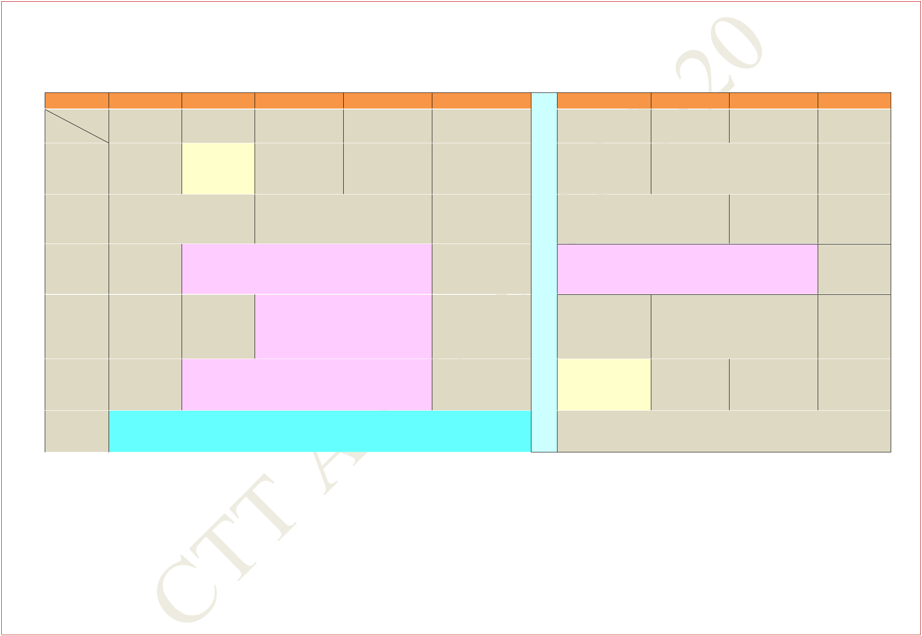**FIRST YEAR TIME TABLE FOR SECTION 3**

**AUTUMN SEMESTER 2019 – 2020**

|  |  |  |  |  |  |  |  |  |  |  |  |
| --- | --- | --- | --- | --- | --- | --- | --- | --- | --- | --- | --- |
| **Period** |  | **1** |  | **2** |  | **3** |  | **4** |  | **5** |  |
| **Time** | **8:00** | **AM -** | **9:00** | **AM -** | **10:00** | **AM -** | **11:00** | **AM -** | **12:00** | **Noon -** |  |
| **Day** | **8:55** | **AM** | **9:55** | **AM** | **10:55** | **AM** | **11:55** | **AM** | **12:55** | **PM** |  |
| **MON** |  |  | **CY(T)** | | **MA(Sp)** | | **MA** | |  | **CY** |  |
|  |  | **F131, F132** | | **F142** | | **F142** | | **F142** | |  |
|  |  |  |  |
|  |  |  | |  |  |  |  |  |  |  |  |
| **TUE** |  | **MA** | |  |  |  | **CY** |  |  |  |  |
|  | **F142** | |  |  |  | **F142** |  |  |  |  |
|  |  |  |  |  |  |  |  |  |
|  |  |  |  | | | | | |  |  |  |
|  |  |  | **INTRO. TO MANUF. PROCESSES LAB** | | | | | |  |  |  |
| **WED** |  |  |  | **(In Mechanical Engineering** | | | | |  |  |  |
|  |  |  |  |  | **Department)** | | |  |  |  |  |
|  |  |  |  |  |  |  | |  |  |  |  |
|  |  |  |  |  |  | **HS LAB** | |  |  |  |  |
| **THU** |  |  |  |  | **(In Language Lab,** | | | |  |  |  |
|  |  |  |  | **Sir J C Bose Laboratory** | | | |  |  |  |
|  |  |  |  |  |  |  |  |
|  |  |  |  |  |  | **Complex)** | |  |  |  |  |
| **FRI** |  |  |  | **CHEMISTRY LAB** | | | |  |  |  |  |
|  |  |  | **(In Chemistry Department)** | | | | |  |  |  |
|  |  |  |  |  |  |  |
|  |  |  |  |  |  |  | |  |  |  |  |
| **SAT** |  |  |  |  |  | **EAA** | |  |  |  |  |
|  |  |  |  |  |  |  |  |  |  |  |  |

|  |  |  |  |  |  |  |  |  |
| --- | --- | --- | --- | --- | --- | --- | --- | --- |
|  |  | **6** | **7** |  | **8** |  | **9** |  |
| **2:00** | | **PM -** | **3:00 PM -** | **4:00** | **PM -** | **5:00** | **PM -** |  |
|  | **2:55** | **PM** | **3:55 PM** | **4:55** | **PM** | **5:55** | **PM** |  |
| **L** | |  |  | **EE** |  |  |  |  |
| **U** |  |  |  | **F142** |  |  |  |  |
|  |  |  |  |  |  |  |
| **N** | | **EE** |  | **HS(Sp)** | |  |  |  |
|  |  | **F142** |  | **F142** | |  |  |  |

**C**

**ELECTRICAL TECHNOLOGY LAB**

* **(In Sir J C Bose Laboratory Complex)**

|  |  |  |  |  |
| --- | --- | --- | --- | --- |
| **H** | **CY(Sp)** |  | **HS** |  |
|  |  |  |
| **O** | **F142** |  | **F142** |  |
| **U** |  |  |  |  |
| **MA(T)** | **HS** | **EE(Sp)** |  |
|  |  |
| **R** | **F131, F132** | **F142** | **F142** |  |
|  |  |  |  |  |

**MA: Mathematics I** **CY: Chemistry** **HS: English for Communication**

1. **Electrical TechnologyEAA: Extra Academic Activity**

**Sp within brackets indicates Special/Extra Class for the subject from 29 Jul 2019 – 23 Aug 2019**

**(T)- in brackets means Tutorial for that subject.**

**Central Time Table Autumn 2019– 2020, Version 1.1** **Updated -28 March 2019** **6**

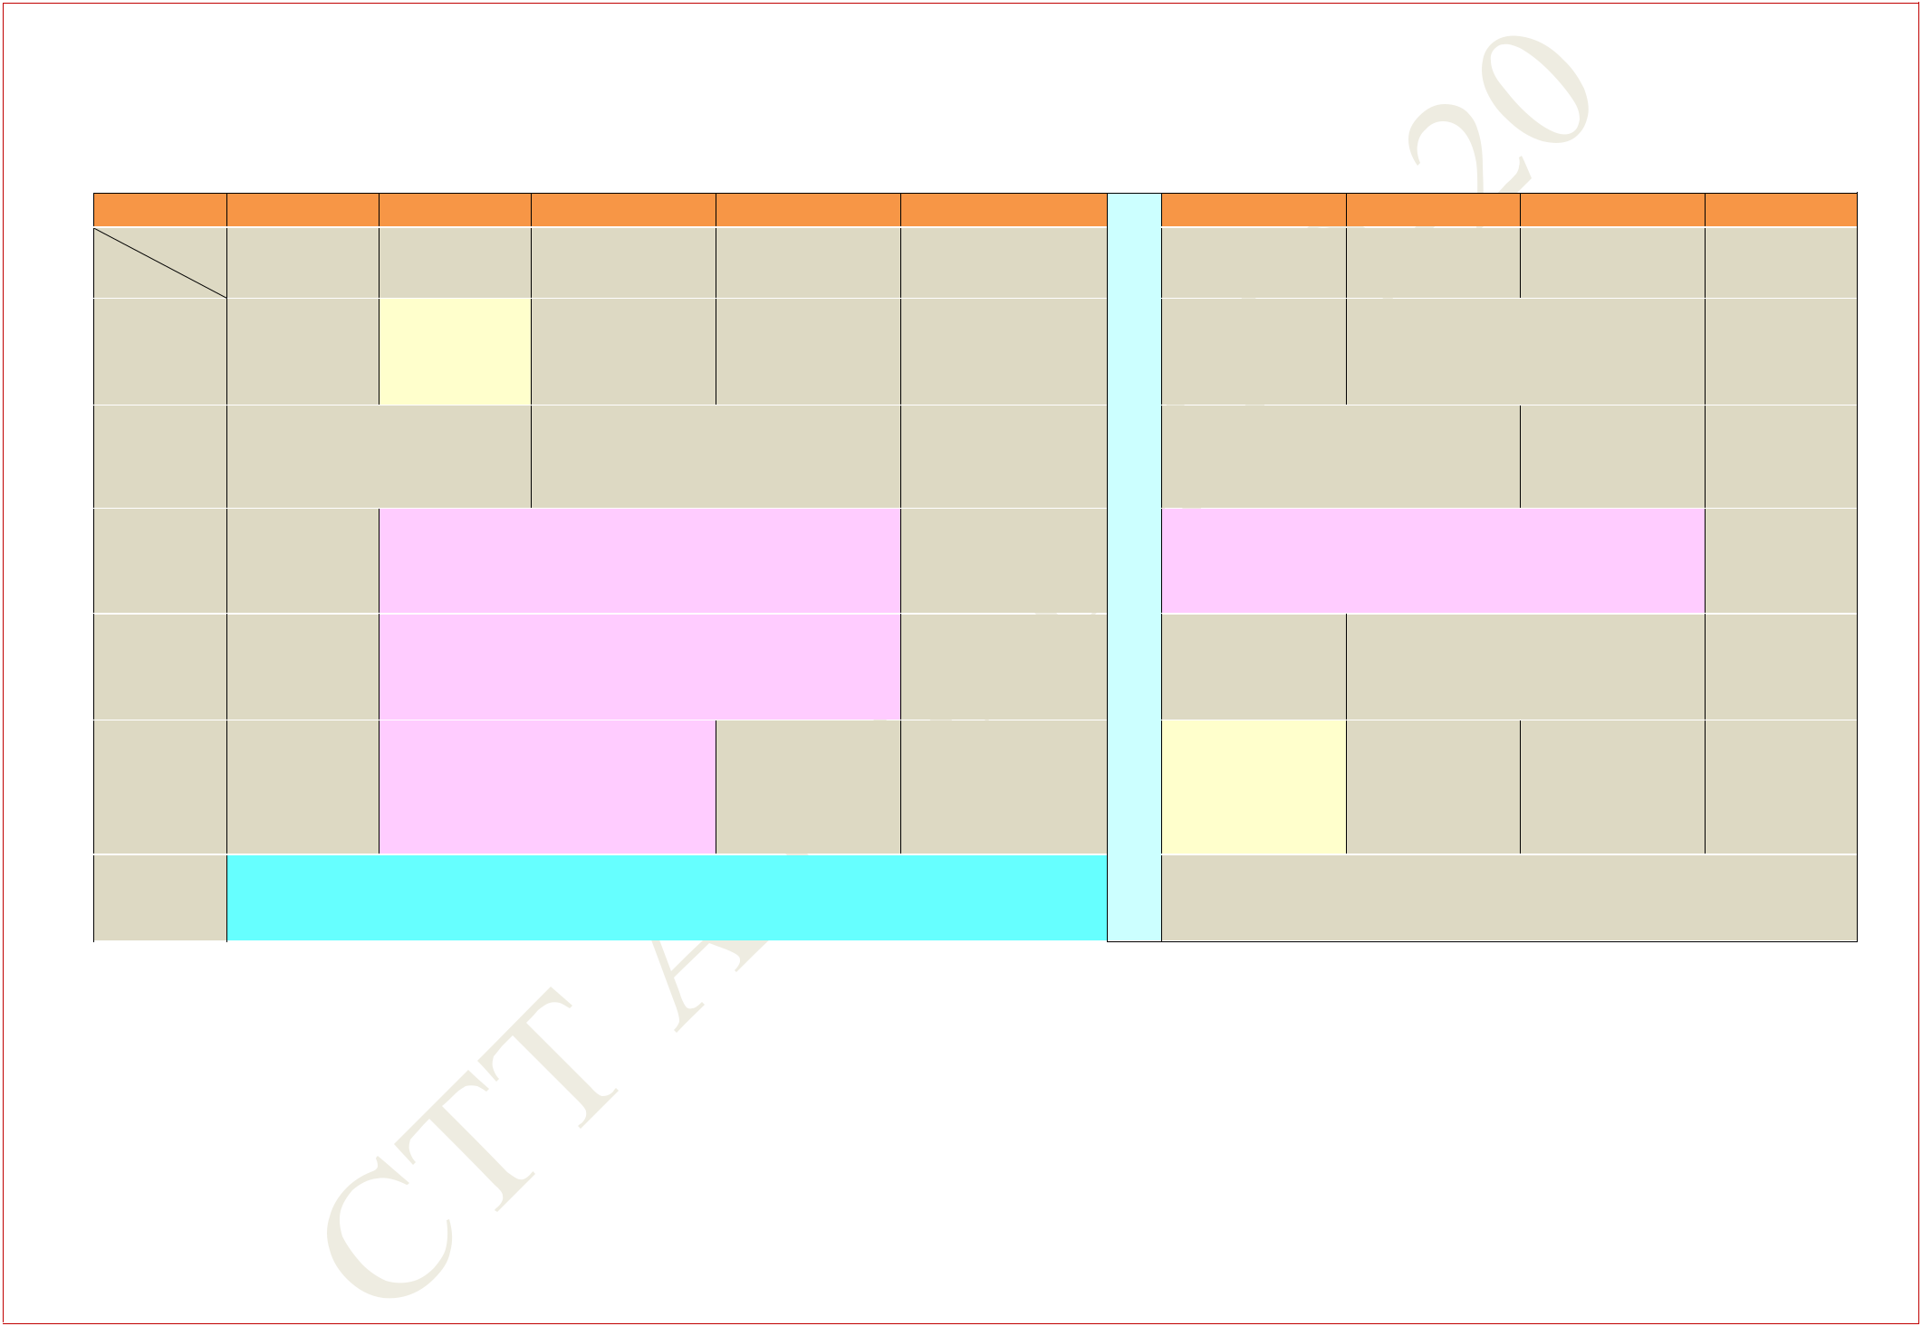**FIRST YEAR TIME TABLE FOR SECTION 4**

**AUTUMN SEMESTER 2019 – 2020**

|  |  |  |  |  |  |  |  |  |  |  |  |
| --- | --- | --- | --- | --- | --- | --- | --- | --- | --- | --- | --- |
| **Period** |  | **1** |  | **2** |  | **3** |  | **4** |  | **5** |  |
| **Time** | **8:00** | **AM -** | **9:00** | **AM -** | **10:00** | **AM -** | **11:00** | **AM -** | **12:00** | **Noon -** |  |
| **Day** | **8:55** | **AM** | **9:55** | **AM** | **10:55** | **AM** | **11:55** | **AM** | **12:55** | **PM** |  |
| **MON** |  |  | **CY(T)** | | **MA(Sp)** | | **MA** | |  | **CY** |  |
|  |  | **F233,F234** | | **F142** | | **F142** | | **F142** | |  |
|  |  |  |  |
|  |  |  | |  |  |  | |  |  |  |  |
| **TUE** |  | **MA** | |  |  | **CY** | |  |  |  |  |
|  | **F142** | |  |  | **F142** | |  |  |  |  |
|  |  |  |  |  |  |  |  |
|  |  |  |  | | | | | |  |  |  |
| **WED** |  |  | **ELECTRICAL TECHNOLOGY LAB** | | | | | |  |  |  |
|  |  | **(In Sir J C Bose Laboratory Complex)** | | | | | |  |  |  |
|  |  |  |  |  |  |
|  |  |  |  | | | | | |  |  |  |
|  |  |  | **INTRO. TO MANUF. PROCESSES LAB** | | | | | |  |  |  |
| **THU** |  |  |  | **(In Mechanical Engineering** | | | | |  |  |  |
|  |  |  |  |  | **Department)** | |  |  |  |  |  |
|  |  |  |  |  | |  |  |  |  |  |  |
|  |  |  |  | **HS LAB** | |  |  |  |  |  |  |
| **FRI** |  |  | **(In Language Lab,** | | | |  |  |  |  |  |
|  |  | **Sir J C Bose Laboratory** | | | |  |  |  |  |  |
|  |  |  |  |  |  |  |  |
|  |  |  |  | **Complex)** | |  |  |  |  |  |  |
| **SAT** |  |  |  |  |  | **EAA** |  |  |  |  |  |
|  |  |  |  |  |  |  |  |  |  |  |  |

|  |  |  |  |  |  |  |  |  |
| --- | --- | --- | --- | --- | --- | --- | --- | --- |
|  |  | **6** | **7** |  | **8** |  | **9** |  |
|  | **2:00** | **PM -** | **3:00 PM -** | **4:00** | **PM -** | **5:00** | **PM -** |  |
|  | **2:55** | **PM** | **3:55 PM** | **4:55** | **PM** | **5:55** | **PM** |  |
| **L** |  |  |  | **EE** |  |  |  |  |
| **U** |  |  |  | **F142** |  |  |  |  |
|  |  |  |  |  |  |  |  |
| **N** |  |  | **EE** | **HS(Sp)** | |  |  |  |
| **C** |  | **F142** | | **F142** | |  |  |  |
|  |  |  |  |  |  |  |  |
|  | **CHEMISTRY LAB** | | |  |  |  |  |
| **H** |  |  |  |  |  |
|  | **(In Chemistry Department)** | | | |  |  |  |
|  |  |  |  |  |
| **H** |  | |  |  |  |  |  |  |
| **CY(Sp)** | |  | **HS** |  |  |  |  |
| **O** | **F142** | |  | **F142** |  |  |  |  |
|  |  |  |  |  |  |  |  |
| **U** | **MA(T)** | | **HS** | **EE(Sp)** | |  |  |  |
| **R** | **F233,F234** | | **F142** | **F142** | |  |  |  |
|  |  |  |  |  |  |  |  |
|  |  |  |  |  |  |  |  |  |

**MA: Mathematics I** **CY: Chemistry** **HS: English for Communication**

1. **Electrical TechnologyEAA: Extra Academic Activity**

**Sp within brackets indicates Special/Extra Class for the subject from 29 Jul 2019 – 23 Aug 2019**

**(T)- in brackets means Tutorial for that subject**

**Central Time Table Autumn 2019– 2020, Version 1.1** **Updated -28 March 2019** **7**

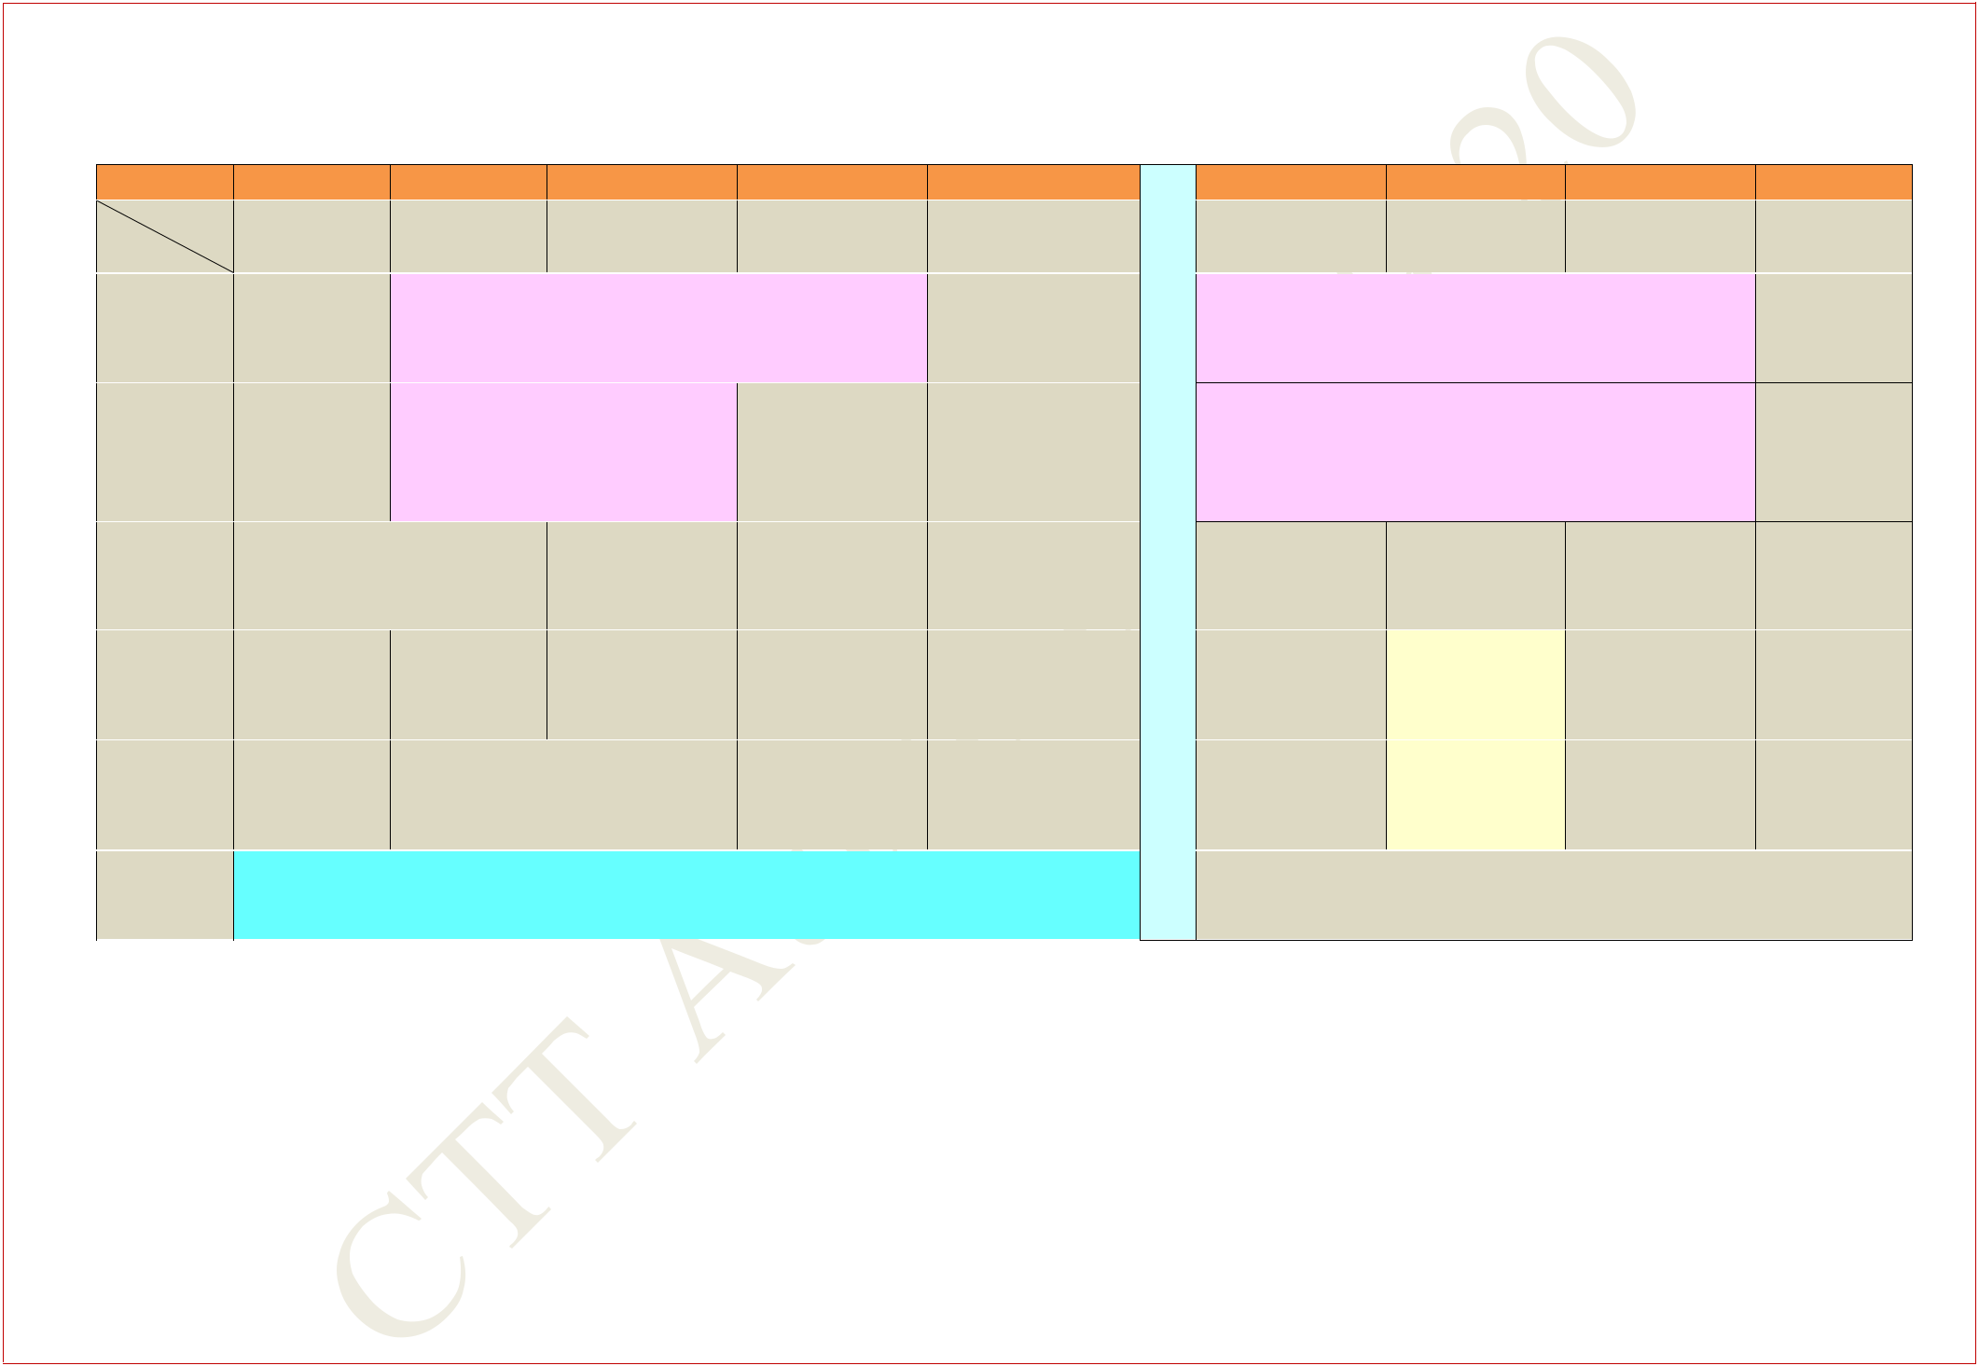**FIRST YEAR TIME TABLE FOR SECTION 5**

**AUTUMN SEMESTER 2019 – 2020**

|  |  |  |  |  |  |  |  |  |  |  |  |
| --- | --- | --- | --- | --- | --- | --- | --- | --- | --- | --- | --- |
| **Period** |  | **1** |  | **2** |  | **3** |  | **4** |  | **5** |  |
| **Time** | **8:00** | **AM -** | **9:00** | **AM -** | **10:00** | **AM -** | **11:00** | **AM -** | **12:00** | **Noon -** |  |
| **Day** | **8:55** | **AM** | **9:55** | **AM** | **10:55** | **AM** | **11:55** | **AM** | **12:55** | **PM** |  |
|  |  |  | **INTRO. TO MANUF. PROCESSES LAB** | | | | | |  |  |  |
| **MON** |  |  |  | **(In Mechanical Engineering** | | | | |  |  |  |
|  |  |  |  |  | **Department)** | |  |  |  |  |  |
|  |  |  |  |  | |  |  |  |  |  |  |
|  |  |  |  | **HS LAB** | |  |  |  |  |  |  |
| **TUE** |  |  | **(In Language Lab,** | | | |  |  |  |  |  |
|  |  | **Sir J C Bose Laboratory** | | | |  |  |  |  |  |
|  |  |  |  |  |  |  |  |
|  |  |  |  | **Complex)** | |  |  |  |  |  |  |
| **WED** |  | **CY** | |  | **HS** | | **MA** | |  | **EE** |  |
|  | **F116** | |  | **F116** | | **F116** | | **F116** | |  |
|  |  |  |  |
|  |  | |  | |  | |  | |  | |  |
| **THU** | **HS(Sp)** | | **HS** | | **CY** | | **EE** | | **MA** | |  |
| **F116** | | **F116** | | **F116** | | **F116** | | **F116** | |  |
|  |  |
|  |  | |  |  |  |  |  | |  | |  |
| **FRI** | **MA** | |  |  | **EE** |  | **HS** | | **CY(Sp)** | |  |
| **F116** | |  |  | **F116** |  | **F116** | | **F116** | |  |
|  |  |  |  |  |
|  |  |  |  |  |  |  |  |  |  |  |  |
| **SAT** |  |  |  |  |  | **EAA** |  |  |  |  |  |
|  |  |  |  |  |  |  |  |  |  |  |  |

|  |  |  |  |  |  |  |
| --- | --- | --- | --- | --- | --- | --- |
|  | **6** | **7** |  | **8** |  | **9** |
| **2:00** | **PM -** | **3:00 PM -** | **4:00** | **PM -** | **5:00** | **PM -** |
| **2:55** | **PM** | **3:55 PM** | **4:55** | **PM** | **5:55** | **PM** |

* **CHEMISTRY LAB**
* **(In Chemistry Department)**
* **ELECTRICAL TECHNOLOGY LAB**
* **(In Sir J C Bose Laboratory Complex)**

|  |  |  |  |
| --- | --- | --- | --- |
| **H** | **EE(Sp)** | **MA(Sp)** |  |
|  |  |
|  | **F116** | **F116** |  |
| **H** |  |  |  |
| **CY(T)** |  |  |
| **O** |  |  |
| **F131,F132** |  |  |
| **U** |  |  |  |
| **MA(T)** |  |  |
| **R** |  |  |
| **F131,F132** |  |  |
|  |  |  |  |

**MA: Mathematics I** **CY: Chemistry** **HS: English for Communication**

1. **Electrical TechnologyEAA: Extra Academic Activity**

**Sp within brackets indicates Special/Extra Class for the subject from 29 Jul 2019 – 23 Aug 2019**

**(T)- in brackets means Tutorial for that subject**

**Central Time Table Autumn 2019– 2020, Version 1.1** **Updated -28 March 2019** **8**

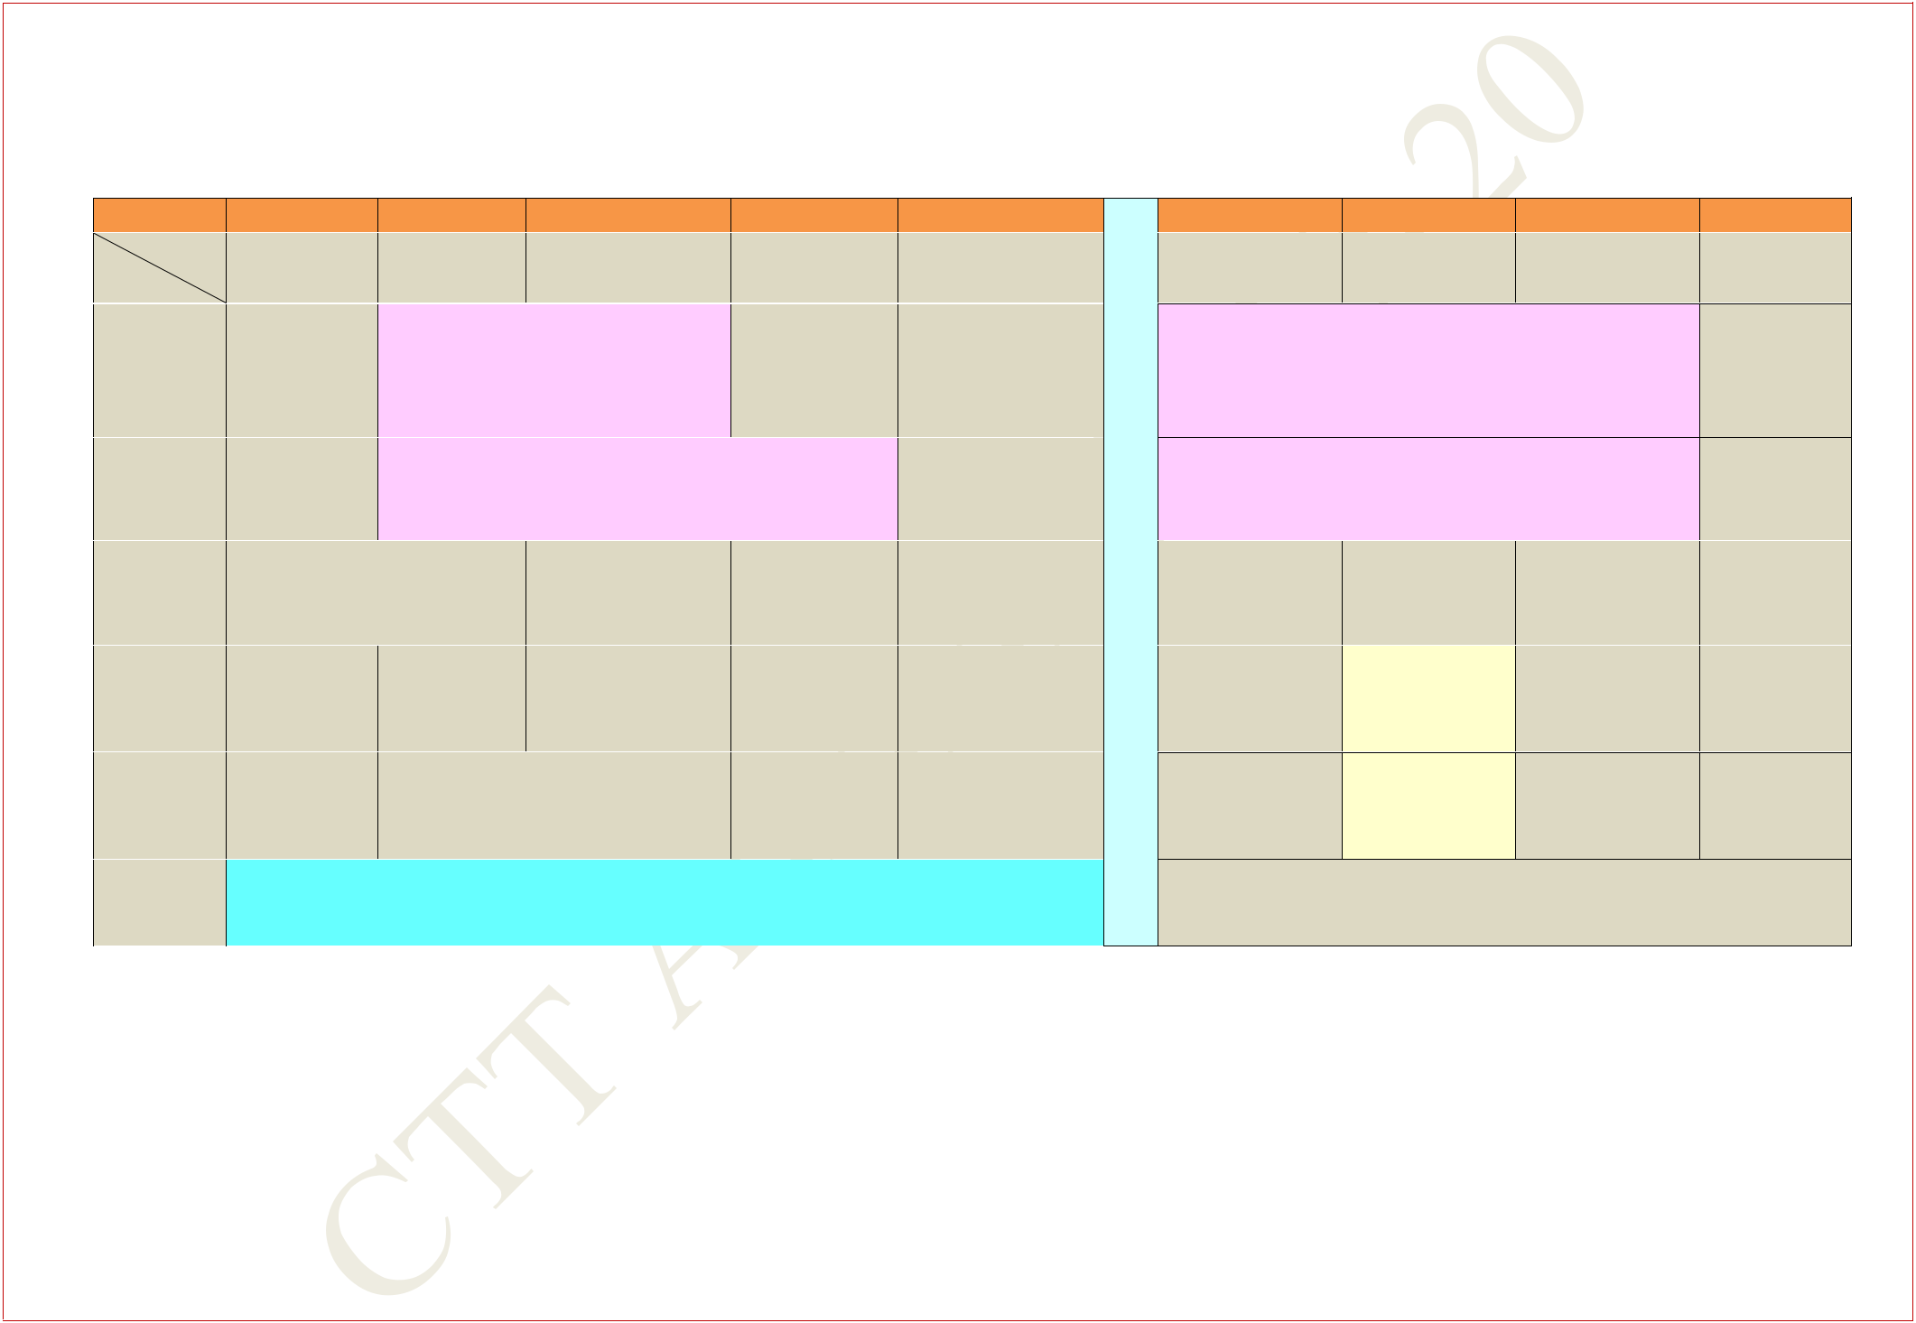**FIRST YEAR TIME TABLE FOR SECTION 6**

**AUTUMN SEMESTER 2019 – 2020**

|  |  |  |  |  |  |  |  |  |  |  |  |
| --- | --- | --- | --- | --- | --- | --- | --- | --- | --- | --- | --- |
| **Period** |  | **1** | **2** |  |  | **3** | **4** |  |  | **5** |  |
| **Time** | **8:00** | **AM -** | **9:00** | **AM** | **10:00** | **AM -** | **11:00** | **AM -** | **12:00** | **Noon -** |  |
| **Day** | **8:55** | **AM** | **-9:55** | **AM** | **10:55** | **AM** | **11:55** | **AM** | **12:55** | **PM** |  |
|  |  |  |  |  | **HS LAB** |  |  |  |  |  |  |
| **MON** |  |  | **(In Language Lab,** | | | |  |  |  |  |  |
|  |  | **Sir J C Bose Laboratory** | | | |  |  |  |  |  |
|  |  |  |  |  |  |  |  |
|  |  |  |  | **Complex)** | | |  |  |  |  |  |
|  |  |  | **INTRO. TO MANUF. PROCESSES LAB** | | | | | |  |  |  |
| **TUE** |  |  |  | **(In Mechanical Engineering** | | | |  |  |  |  |
|  |  |  |  |  | **Department)** | |  |  |  |  |  |
| **WED** |  | **CY** | |  |  | **HS** | **MA** | |  | **EE** |  |
|  | **F116** | |  | **F116** | | **F116** | | **F116** | |  |
|  |  |  |  |
|  |  | |  | |  |  |  | |  | |  |
| **THU** | **HS(Sp)** | | **HS** | |  | **CY** | **EE** | | **MA** | |  |
| **F116** | | **F116** | | **F116** | | **F116** | | **F116** | |  |
|  |  |
|  |  | |  |  |  |  |  | |  | |  |
| **FRI** | **MA** | |  |  | **EE** |  | **HS** | | **CY(Sp)** | |  |
| **F116** | |  |  | **F116** |  | **F116** | | **F116** | |  |
|  |  |  |  |  |
|  |  |  |  |  |  |  |  |  |  |  |  |
| **SAT** |  |  |  |  |  | **EAA** |  |  |  |  |  |
|  |  |  |  |  |  |  |  |  |  |  |  |

|  |  |  |  |  |  |  |  |
| --- | --- | --- | --- | --- | --- | --- | --- |
|  |  | **6** | **7** |  | **8** |  | **9** |
| **L 2:00** | | **PM -** | **3:00 PM -** | **4:00** | **PM -** | **5:00** | **PM -** |
| **2:55** | | **PM** | **3:55 PM** | **4:55** | **PM** | **5:55** | **PM** |

**U**

**ELECTRICAL TECHNOLOGY LAB**

* **(In Sir J C Bose Laboratory Complex**

**C**

|  |  |  |  |
| --- | --- | --- | --- |
| **H** | **CHEMISTRY LAB** |  |  |
| **(In Chemistry Department)** | |  |
|  |  |
| **H** |  |  |  |
| **EE(Sp)** | **MA(Sp)** |  |
| **O** | **F116** | **F116** |  |
|  |  |  |
| **U** | **CY(T)** |  |  |

**F233,F234**

**R**

**MA(T)**

**F233,F234**

**MA: Mathematics I** **CY: Chemistry** **HS: English for Communication**

1. **Electrical TechnologyEAA: Extra Academic Activity**

**Sp within brackets indicates Special/Extra Class for the subject from 29 Jul 2019 – 23 Aug 2019**

**(T)- in brackets means Tutorial for that subject**

**Central Time Table Autumn 2019– 2020, Version 1.1** **Updated -28 March 2019** **9**

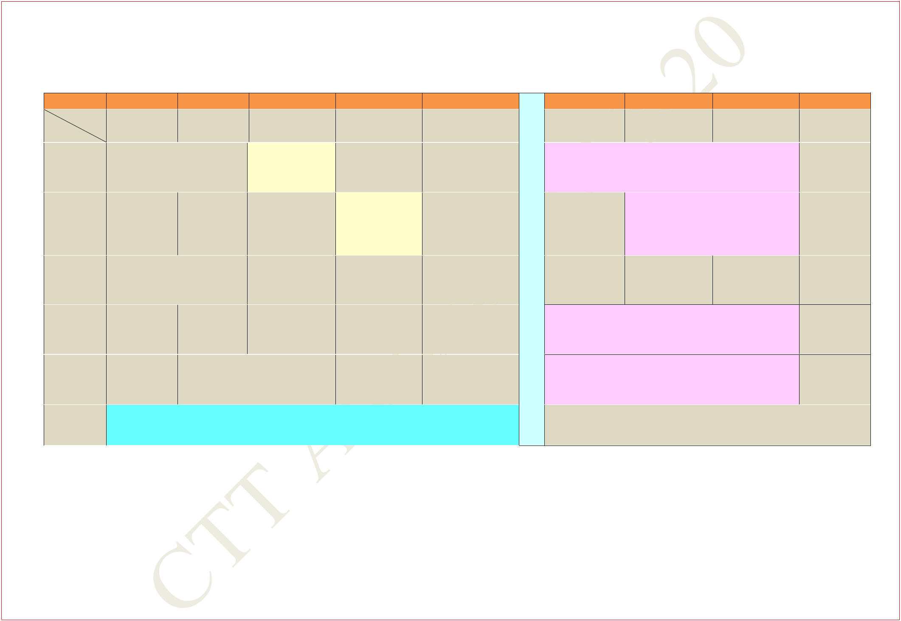**FIRST YEAR TIME TABLE FOR SECTION 7**

**AUTUMN SEMESTER 2019 – 2020**

|  |  |  |  |  |  |  |  |  |  |  |  |
| --- | --- | --- | --- | --- | --- | --- | --- | --- | --- | --- | --- |
| **Period** |  | **1** |  | **2** |  | **3** |  | **4** |  | **5** |  |
| **Time** | **8:00** | **AM -** | **9:00** | **AM -** | **10:00** | **AM -** | **11:00** | **AM -** | **12:00** | **Noon -** |  |
| **Day** | **8:55** | **AM** | **9:55** | **AM** | **10:55** | **AM** | **11:55** | **AM** | **12:55** | **PM** |  |
|  |  | **MA** | |  | **CY(T)** | |  |  |  |  |  |
| **MON** |  | **F142** | |  |  |  |  |  |  |
|  |  | **F131,F132** | |  |  |  |  |  |
|  |  |  |  |  |  |  |  |  |  |
|  |  |  |  |  |  |  |  | |  | |  |
| **TUE** |  |  |  |  |  |  | **MA(T)** | | **MA** | |  |
|  |  |  |  |  |  | **F131,F132** | | **F142** | |  |
|  |  |  |  |  |  |  |  |
|  |  |  | |  |  | |  | |  |  |  |
| **WED** |  | **CY** | |  | **HS** | | **EE(Sp)** | |  | **EE** |  |
|  | **F142** | |  | **F142** | | **F142** | | **F142** | |  |
|  |  |  |  |
|  |  | |  | |  | |  | |  |  |  |
| **THU** | **HS(Sp)** | | **HS** | | **CY** | | **EE** | |  |  |  |
| **F142** | | **F142** | | **F142** | | **F142** | |  |  |  |
|  |  |  |  |
|  |  | |  |  |  |  |  | |  |  |  |
| **FRI** | **CY(Sp)** | |  |  | **EE** |  | **HS** | |  |  |  |
| **F142** | |  |  | **F142** |  | **F142** | |  |  |  |
|  |  |  |  |  |  |  |
|  |  |  |  |  |  |  |  |  |  |  |  |
| **SAT** |  |  |  |  |  | **EAA** |  |  |  |  |  |
|  |  |  |  |  |  |  |  |  |  |  |  |

|  |  |  |  |  |  |  |
| --- | --- | --- | --- | --- | --- | --- |
|  | **6** | **7** |  | **8** |  | **9** |
| **2:00** | **PM -** | **3:00 PM -** | **4:00** | **PM -** | **5:00** | **PM -** |
| **2:55** | **PM** | **3:55 PM** | **4:55** | **PM** | **5:55** | **PM** |

* **INTRO. TO MANUF. PROCESSES LAB**
* **(In Mechanical Engineering Department)**

|  |  |  |
| --- | --- | --- |
| **N** | **HS LAB** |  |
| **(In Language Lab,** |  |
| **C** | **Sir J C Bose Laboratory** |  |
| **Complex)** |  |
|  |  |
| **H** | **MA(Sp)** |  |
|  |  |
|  | **F142** |  |

* **CHEMISTRY LAB**

**O** **(In Chemistry Department**

* **ELECTRICAL TECHNOLOGY LAB**

|  |  |  |
| --- | --- | --- |
| **R** | **(In Sir J C Bose Laboratory Complex)** |  |
|  |  |
|  |  |  |

**MA: Mathematics I** **CY: Chemistry** **HS: English for Communication**

1. **Electrical TechnologyEAA: Extra Academic Activity**

**Sp within brackets indicates Special/Extra Class for the subject from 29 Jul 2019 – 23 Aug 2019**

**(T)- in brackets means Tutorial for that subject**

**Central Time Table Autumn 2019– 2020, Version 1.1** **Updated -28 March 2019** **10**

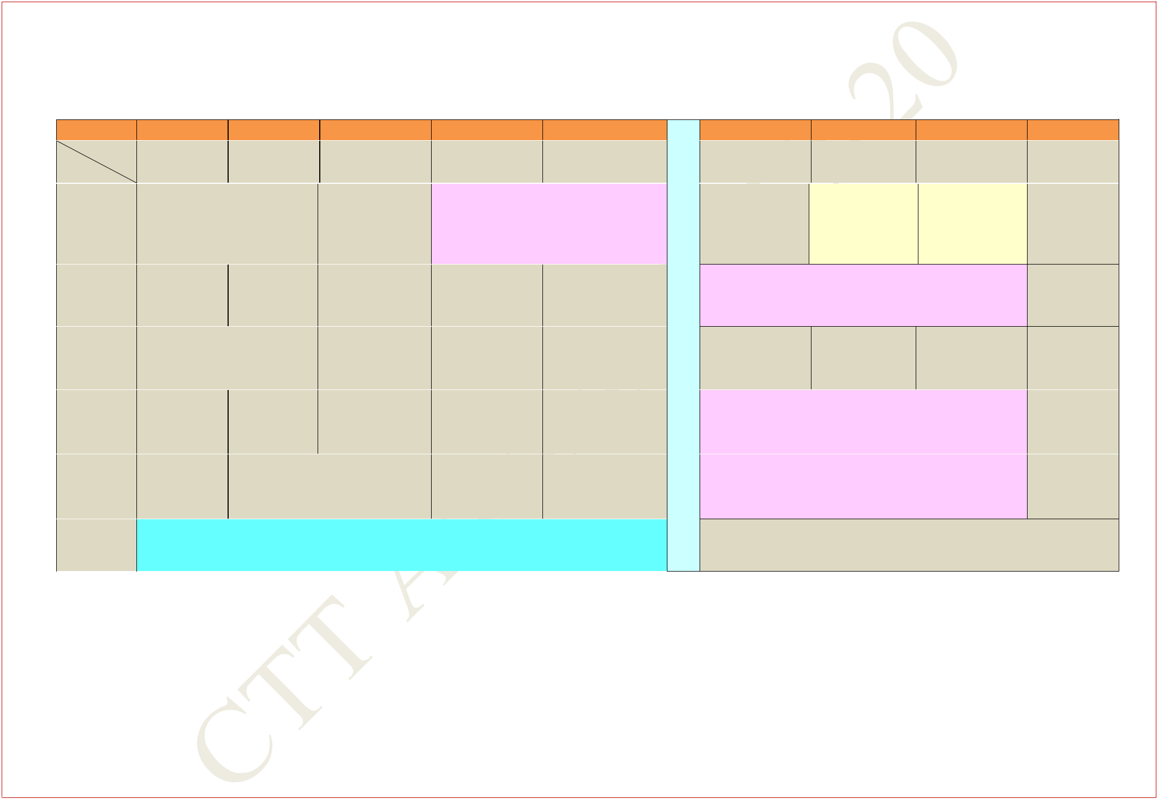**FIRST YEAR TIME TABLE FOR SECTION 8**

**AUTUMN SEMESTER 2019 – 2020**

|  |  |  |  |  |  |  |  |  |  |  |
| --- | --- | --- | --- | --- | --- | --- | --- | --- | --- | --- |
| **Period** |  | **1** |  | **2** |  | **3** |  | **4** |  | **5** |
| **Time** | **8:00** | **AM -** | **9:00** | **AM -** | **10:00** | **AM -** | **11:00** | **AM -** | **12:00** | **Noon -** |
| **Day** | **8:55** | **AM** | **9:55** | **AM** | **10:55** | **AM** | **11:55** | **AM** | **12:55** | **PM** |

|  |  |  |  |  |  |  |
| --- | --- | --- | --- | --- | --- | --- |
|  |  |  |  | **HS LAB** |  |  |
| **MON** | **MA** |  |  | **(In Language Lab,** | |  |
| **F142** |  |  | **Sir J C Bose Laboratory** | |  |
|  |  |  |  |
|  |  |  |  | **Complex)** |  |  |
| **TUE** |  |  |  |  | **MA** |  |
|  |  |  |  | **F142** |  |
|  |  |  |  |  |  |
|  |  |  |  |  |  |  |
| **WED** | **CY** |  | **HS** | **EE(Sp)** | **EE** |  |
| **F142** |  | **F142** | **F142** | **F142** |  |
|  |  |  |
|  |  |  |  |  |  |  |
| **THU** | **HS(Sp)** | **HS** | **CY** | **EE** |  |  |
| **F142** | **F142** | **F142** | **F142** |  |  |
|  |  |  |
|  |  |  |  |  |  |  |
| **FRI** | **CY(Sp)** |  | **EE** | **HS** |  |  |
| **F142** |  | **F142** | **F142** |  |  |
|  |  |  |  |
|  |  |  |  |  |  |  |
| **SAT** |  |  | **EAA** |  |  |  |
|  |  |  |  |  |  |  |

|  |  |  |  |  |  |  |
| --- | --- | --- | --- | --- | --- | --- |
|  | **6** | **7** |  | **8** |  | **9** |
| **2:00** | **PM -** | **3:00 PM -** | **4:00** | **PM -** | **5:00** | **PM -** |
| **2:55** | **PM** | **3:55 PM** | **4:55** | **PM** | **5:55** | **PM** |

|  |  |  |  |
| --- | --- | --- | --- |
| **L** | **CY(T)** | **MA(T)** |  |
|  |  |
| **U** | **F233,F234** | **F233,F234** |  |

* **INTRO. TO MANUF. PROCESSES LAB**
* **(In Mechanical Engineering Department)**

|  |  |  |
| --- | --- | --- |
| **H** | **MA(Sp)** |  |
|  | **F142** |  |
| **H** |  |  |
| **ELECTRICAL TECHNOLOGY LAB** |  |
| **O** |  |
| **(In Sir J C Bose Laboratory Complex)** |  |
| **U** |  |  |
| **CHEMISTRY LAB** |  |
|  |  |

* **(In Chemistry Department)**

**MA: Mathematics I** **CY: Chemistry** **HS: English for Communication**

1. **Electrical TechnologyEAA: Extra Academic Activity**

**Sp within brackets indicates Special/Extra Class for the subject from 29 Jul 2019 – 23 Aug 2019**

**(T)- in brackets means Tutorial for that subject**

**Central Time Table Autumn 2019– 2020, Version 1.1** **Updated -28 March 2019** **11**

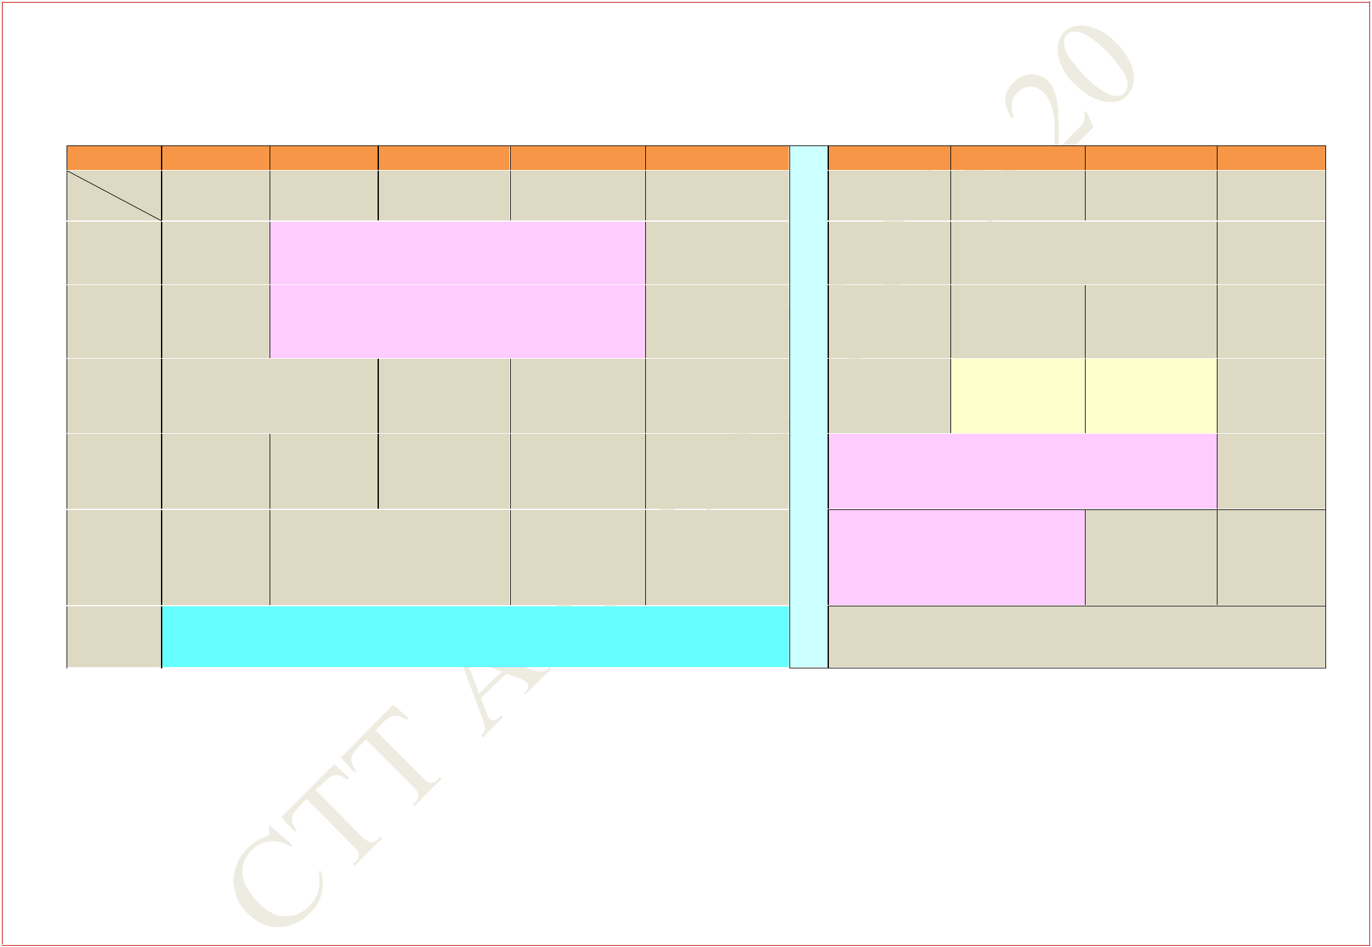**FIRST YEAR TIME TABLE FOR SECTION 9**

**AUTUMN SEMESTER 2019 – 2020**

|  |  |  |  |  |  |  |  |  |  |  |  |
| --- | --- | --- | --- | --- | --- | --- | --- | --- | --- | --- | --- |
| **Period** |  | **1** |  | **2** |  | **3** |  | **4** |  | **5** |  |
| **Time** | **8:00** | **AM -** | **9:00** | **AM -** | **10:00** | **AM -** | **11:00** | **AM -** | **12:00** | **Noon -** |  |
| **Day** | **8:55** | **AM** | **9:55** | **AM** | **10:55** | **AM** | **11:55** | **AM** | **12:55** | **PM** |  |
| **MON** |  |  |  |  | **CHEMISTRY LAB** | | |  |  |  |  |
|  |  |  | **(In Chemistry Department)** | | | | |  |  |  |
|  |  |  |  |  |  |  |
|  |  |  |  | | | | | |  |  |  |
| **TUE** |  |  | **ELECTRICAL TECHNOLOGY LAB** | | | | | |  |  |  |
|  |  | **(In Sir J C Bose Laboratory Complex)** | | | | | |  |  |  |
|  |  |  |  |  |  |
|  |  |  | |  |  | |  | |  |  |  |
| **WED** |  | **CY** | |  | **HS** | | **EE(Sp)** | |  | **EE** |  |
|  | **V1** | |  | **V1** | | **V1** | |  | **V1** |  |
|  |  |  |  |  |
|  |  | |  | |  | |  | |  |  |  |
| **THU** | **HS(Sp)** | | **HS** | | **CY** | | **EE** | |  |  |  |
| **V1** | | **V1** | | **V1** | | **V1** | |  |  |  |
|  |  |  |  |
|  |  | |  |  |  |  |  | |  |  |  |
| **FRI** | **CY(Sp)** | |  |  | **EE** |  | **HS** | |  |  |  |
| **V1** | |  |  | **V1** |  | **V1** | |  |  |  |
|  |  |  |  |  |  |  |
|  |  |  |  |  |  |  |  |  |  |  |  |
| **SAT** |  |  |  |  |  | **EAA** |  |  |  |  |  |
|  |  |  |  |  |  |  |  |  |  |  |  |

|  |  |  |  |  |  |  |  |  |
| --- | --- | --- | --- | --- | --- | --- | --- | --- |
|  |  | **6** | **7** |  | **8** |  | **9** |  |
|  | **2:00** | **PM -** | **3:00 PM -** | **4:00** | **PM -** | **5:00** | **PM -** |  |
|  | **2:55** | **PM** | **3:55 PM** | **4:55** | **PM** | **5:55** | **PM** |  |
| **L** |  |  |  | **MA** |  |  |  |  |
| **U** |  |  |  | **V1** |  |  |  |  |
|  |  |  |  |  |  |  |  |
| **MA** | | **MA(Sp)** |  |  |  |  |  |
| **N** |  |  |  |  |  |
|  | **V1** | **V1** |  |  |  |  |  |
| **C** |  |  |  |  |  |  |  |  |
|  |  | **CY(T)** | **MA(T)** | |  |  |  |
|  |  |  |  |  |  |
| **H** |  |  | **F131,F132** | **F131,F132** | |  |  |  |
|  |  |  |  |  |  |  |  |  |

* **INTRO. TO MANUF. PROCESSES LAB (In Mechanical Engineering Department)**
* **HS LAB**
* **(In Language Lab,**

**Sir J C Bose Laboratory**

* **Complex)**

**MA: Mathematics I** **CY: Chemistry** **HS: English for Communication**

1. **Electrical TechnologyEAA: Extra Academic Activity**

**Sp within brackets indicates Special/Extra Class for the subject from 29 Jul 2019 – 23 Aug 2019**

**(T)- in brackets means Tutorial for that subject**

**Central Time Table Autumn 2019– 2020, Version 1.1** **Updated -28 March 2019** **12**

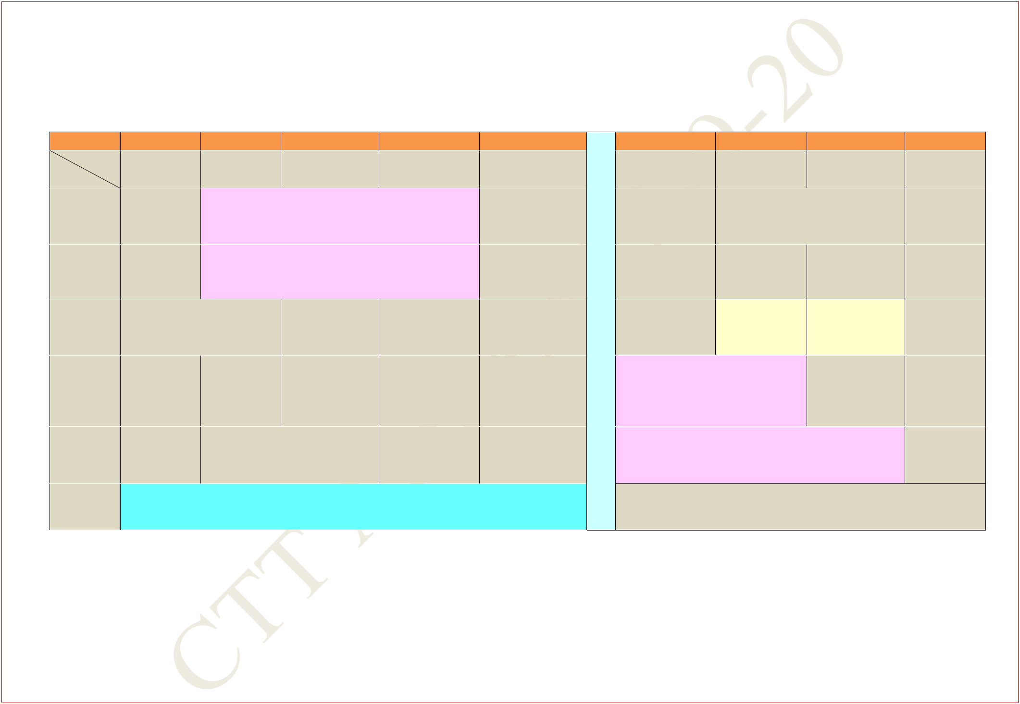**FIRST YEAR TIME TABLE FOR SECTION 10**

**AUTUMN SEMESTER 2019 – 2020**

|  |  |  |  |  |  |  |  |  |  |  |  |
| --- | --- | --- | --- | --- | --- | --- | --- | --- | --- | --- | --- |
| **Period** |  | **1** |  | **2** |  | **3** |  | **4** |  | **5** |  |
| **Time** | **8:00** | **AM -** | **9:00** | **AM -** | **10:00** | **AM -** | **11:00** | **AM -** | **12:00** | **Noon -** |  |
| **Day** | **8:55** | **AM** | **9:55** | **AM** | **10:55** | **AM** | **11:55** | **AM** | **12:55** | **PM** |  |
| **MON** |  |  | **ELECTRICAL TECHNOLOGY LAB** | | | | | |  |  |  |
|  |  | **(In Sir J C Bose Laboratory Complex)** | | | | | |  |  |  |
|  |  |  |  |  |  |
|  |  |  |  |  |  | | |  |  |  |  |
| **TUE** |  |  |  |  | **CHEMISTRY LAB** | | |  |  |  |  |
|  |  |  | **(In Chemistry Department)** | | | | |  |  |  |
|  |  |  |  |  |  |  |
|  |  |  | |  |  | |  | |  |  |  |
| **WED** |  | **CY** | |  | **HS** | | **EE(Sp)** | |  | **EE** |  |
|  | **V1** | |  | **V1** | | **V1** | |  | **V1** |  |
|  |  |  |  |  |
|  |  | |  | |  | |  | |  |  |  |
| **THU** | **HS(Sp)** | | **HS** | | **CY** | | **EE** | |  |  |  |
| **V1** | | **V1** | | **V1** | | **V1** | |  |  |  |
|  |  |  |  |
|  |  | |  |  |  |  |  | |  |  |  |
| **FRI** | **CY(Sp)** | |  |  | **EE** |  | **HS** | |  |  |  |
| **V1** | |  |  | **V1** |  | **V1** | |  |  |  |
|  |  |  |  |  |  |  |
|  |  |  |  |  |  |  |  |  |  |  |  |
| **SAT** |  |  |  |  |  | **EAA** |  |  |  |  |  |
|  |  |  |  |  |  |  |  |  |  |  |  |

|  |  |  |  |  |  |  |  |  |
| --- | --- | --- | --- | --- | --- | --- | --- | --- |
|  |  | **6** | **7** |  | **8** |  | **9** |  |
| **2:00** | | **PM -** | **3:00 PM -** | **4:00** | **PM -** | **5:00** | **PM -** |  |
|  | **2:55** | **PM** | **3:55 PM** | **4:55** | **PM** | **5:55** | **PM** |  |
| **L** | |  |  | **MA** |  |  |  |  |
| **U** |  |  |  | **V1** |  |  |  |  |
|  |  |  |  |  |  |  |
| **N** | | **MA** | **MA(Sp)** |  |  |  |  |  |
| **C** |  | **V1** | **V1** |  |  |  |  |  |
|  |  |  |  |  |  |  |  |
|  |  | **CY(T)** | **MA(T)** | |  |  |  |
|  |  |  |  |  |  |
| **H** | |  | **F233,** | **F233,** | |  |  |  |
|  |  |  | **F234** | **F234** | |  |  |  |

|  |  |  |
| --- | --- | --- |
| **H** | **HS LAB** |  |
| **(In Language Lab,** |  |
|  |  |

* **Sir J C Bose Laboratory**

**Complex)**

* **INTRO. TO MANUF. PROCESSES LAB**
* **(In Mechanical Engineering Department)**

**MA: Mathematics I** **CY: Chemistry** **HS: English for Communication**

1. **Electrical TechnologyEAA: Extra Academic Activity**

**Sp within brackets indicates Special/Extra Class for the subject from 29 Jul 2019 – 23 Aug 2019**

**(T)- in brackets means Tutorial for that subject**

**Central Time Table Autumn 2019– 2020, Version 1.1** **Updated -28 March 2019** **13**

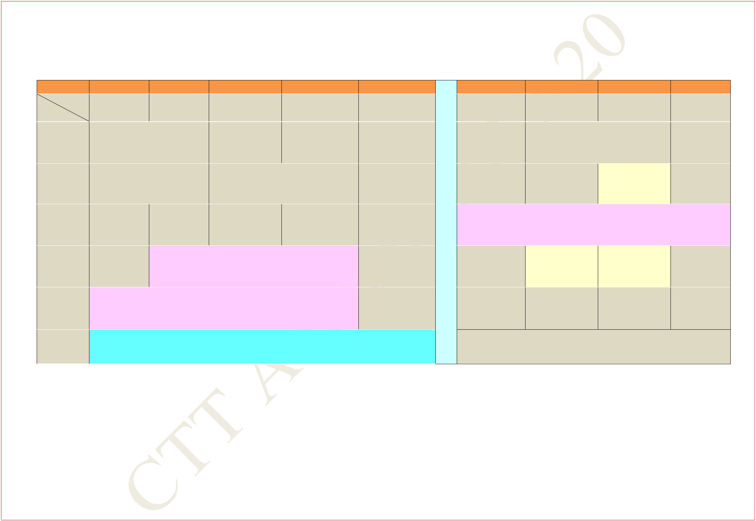**FIRST YEAR TIME TABLE FOR SECTION 11**

**AUTUMN SEMESTER 2019 – 2020**

|  |  |  |  |  |  |  |  |  |  |  |  |
| --- | --- | --- | --- | --- | --- | --- | --- | --- | --- | --- | --- |
| **Period** |  | **1** |  | **2** |  | **3** |  | **4** |  | **5** |  |
| **Time** | **8:00** | **AM -** | **9:00** | **AM -** | **10:00** | **AM -** | **11:00** | **AM -** | **12:00** | **Noon -** |  |
| **Day** | **8:55** | **AM** | **9:55** | **AM** | **10:55** | **AM** | **11:55** | **AM** | **12:55** | **PM** |  |
| **MON** |  | **CS** | |  | **MA(Sp)** | | **MA** | | **PH** | |  |
|  | **NR122** | |  | **NR122** | | **NR122** | | **NR122** | |  |
|  |  |  |  |
|  |  |  | |  |  |  |  |  |  | |  |
| **TUE** |  | **MA** | |  |  |  | **PH** |  | **CS** | |  |
|  | **NR122** | |  |  | **NR122** | |  | **NR122** | |  |
|  |  |  |  |  |  |
|  |  | |  | |  |  |  |  |  |  |  |
| **WED** | **PH(Sp)** | | **CS(Sp)** | |  |  |  |  |  |  |  |
| **NR122** | | **NR122** | |  |  |  |  |  |  |  |
|  |  |  |  |  |  |  |  |
|  |  |  |  |  |  | | |  |  |  |  |
| **THU** |  |  |  |  | **PHYSICS LAB** | | |  |  |  |  |
|  |  | **(In Sir J C Bose Laboratory Complex)** | | | | | |  |  |  |
|  |  |  |  |  |  |
|  |  | | | | | | | |  |  |  |
| **FRI** | **ENGG. DRAWING AND COMPUTER GRAPHICS** | | | | | | | |  |  |  |
|  |  |  |  | **(S301)** |  |  |  |  |  |  |
|  |  |  |  |  |  |  |  |  |  |  |
|  |  |  |  |  |  |  |  |  |  |  |  |
| **SAT** |  |  |  |  |  | **EAA** |  |  |  |  |  |
|  |  |  |  |  |  |  |  |  |  |  |  |

|  |  |  |  |  |  |  |  |  |  |
| --- | --- | --- | --- | --- | --- | --- | --- | --- | --- |
|  |  | **6** | **7** |  |  | **8** |  | **9** |  |
|  | **2:00** | **PM -** | **3:00 PM -** |  | **4:00** | **PM -** | **5:00** | **PM -** |  |
|  | **2:55** | **PM** | **3:55 PM** |  | **4:55** | **PM** | **5:55** | **PM** |  |
| **L** |  |  |  | **ME** | |  |  |  |  |
| **U** |  |  |  | **NR122** | |  |  |  |  |
|  |  |  |  |  |  |  |  |  |
| **N** |  |  | **ME** |  | **ME(T)** | |  |  |  |
| **C** |  |  | **NR122** |  | **NR122** | |  |  |  |
|  |  |  |  |  |  |  |  |  |
| **PROGAMMING AND DATA STRUCTURE LAB** | | | | | | | |  |
| **H** |  |
|  |  | **(In CIC Lab.)** | | |  |  |  |  |
|  |  |  |  |  |  |  |
| **H** |  |  |  |  |  | |  |  |  |
|  |  | **MA(T)** |  | **PH(T)** | |  |  |  |
| **O** |  |  | **NC121, NC122** | | **NC121, NC122** | |  |  |  |
|  |  |  |  |  |  |  |  |  |

* **ME(Sp)**

**NR122**

**R**

**MA: Mathematics I** **PH: Physics** **CS: Programming & Data Structure**

**ME: Mechanics** **EAA: Extra Academic Activity**

**Sp within brackets indicates Special/Extra Class for the subject from 29 Jul 2019 – 23 Aug 2019**

**(T)- in brackets means Tutorial for that subject**

**Central Time Table Autumn 2019– 2020, Version 1.1** **Updated -28 March 2019** **14**

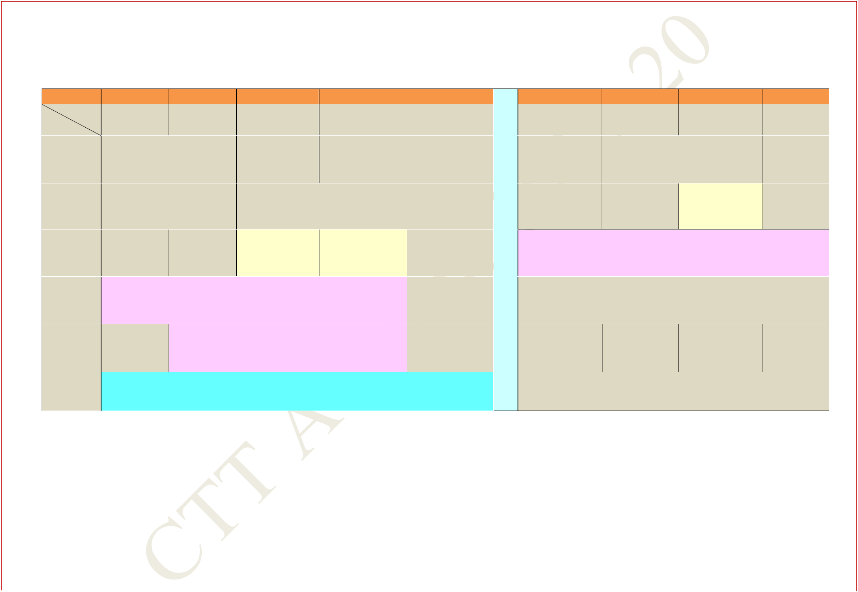**FIRST YEAR TIME TABLE FOR SECTION 12**

**AUTUMN SEMESTER 2019 – 2020**

|  |  |  |  |  |  |  |  |  |  |  |  |
| --- | --- | --- | --- | --- | --- | --- | --- | --- | --- | --- | --- |
| **Period** |  | **1** |  | **2** |  | **3** |  | **4** |  | **5** |  |
| **Time** | **8:00** | **AM -** | **9:00** | **AM -** | **10:00** | **AM -** | **11:00** | **AM -** | **12:00** | **Noon -** |  |
| **Day** | **8:55** | **AM** | **9:55** | **AM** | **10:55** | **AM** | **11:55** | **AM** | **12:55** | **PM** |  |
| **MON** |  | **CS** | |  | **MA(Sp)** | | **MA** | | **PH** | |  |
|  | **NR122** | |  | **NR122** | | **NR122** | | **NR122** | |  |
|  |  |  |  |
|  |  |  | |  |  |  |  |  |  | |  |
| **TUE** |  | **MA** | |  |  |  | **PH** |  | **CS** | |  |
|  | **NR122** | |  |  | **NR122** | |  | **NR122** | |  |
|  |  |  |  |  |  |
|  |  | |  | |  | |  | |  |  |  |
| **WED** | **PH(Sp)** | | **CS(Sp)** | | **MA(T)** | | **PH(T)** | |  |  |  |
| **NR122** | | **NR122** | | **NC121, NC122** | | **NC121, NC122** | |  |  |  |
|  |  |  |  |
|  |  | | | | | | | |  |  |  |
| **THU** | **PROGAMMING AND DATA STRUCTURE LAB** | | | | | | | |  |  |  |
|  |  |  | **(In CIC Lab.)** | | |  |  |  |  |  |
|  |  |  |  |  |  |  |  |  |
|  |  |  |  |  |  | | |  |  |  |  |
| **FRI** |  |  |  |  | **PHYSICS LAB** | | |  |  |  |  |
|  |  | **(In Sir J C Bose Laboratory Complex)** | | | | | |  |  |  |
|  |  |  |  |  |  |
|  |  |  |  |  |  |  |  |  |  |  |  |
| **SAT** |  |  |  |  |  | **EAA** |  |  |  |  |  |
|  |  |  |  |  |  |  |  |  |  |  |  |

|  |  |  |  |  |  |  |  |  |
| --- | --- | --- | --- | --- | --- | --- | --- | --- |
|  |  | **6** | **7** |  | **8** |  | **9** |  |
| **2:00** | | **PM -** | **3:00 PM -** | **4:00** | **PM -** | **5:00** | **PM -** |  |
|  | **2:55** | **PM** | **3:55 PM** | **4:55** | **PM** | **5:55** | **PM** |  |
| **L** | |  |  | **ME** |  |  |  |  |
| **U** |  |  |  | **NR122** |  |  |  |  |
|  |  |  |  |  |  |  |
| **N** | |  | **ME** | **ME(T)** | |  |  |  |
|  |  |  | **NR122** | **NR122** | |  |  |  |

**C**

|  |  |  |
| --- | --- | --- |
| **H** | **ENGG. DRAWING AND COMPUTER GRAPHICS** |  |
|  | **(S301)** |  |
| **H** |  |  |
|  |  |
| **O** |  |  |
| **U** | **ME(Sp)** |  |
| **R** | **NR122** |  |
|  |  |
|  |  |

**MA: Mathematics I** **PH: Physics** **CS: Programming & Data Structure**

**ME: Mechanics** **EAA: Extra Academic Activity**

**Sp within brackets indicates Special/Extra Class for the subject from 29 Jul 2019 – 23 Aug 2019**

**(T)- in brackets means Tutorial for that subject**

**Central Time Table Autumn 2019– 2020, Version 1.1** **Updated -28 March 2019** **15**

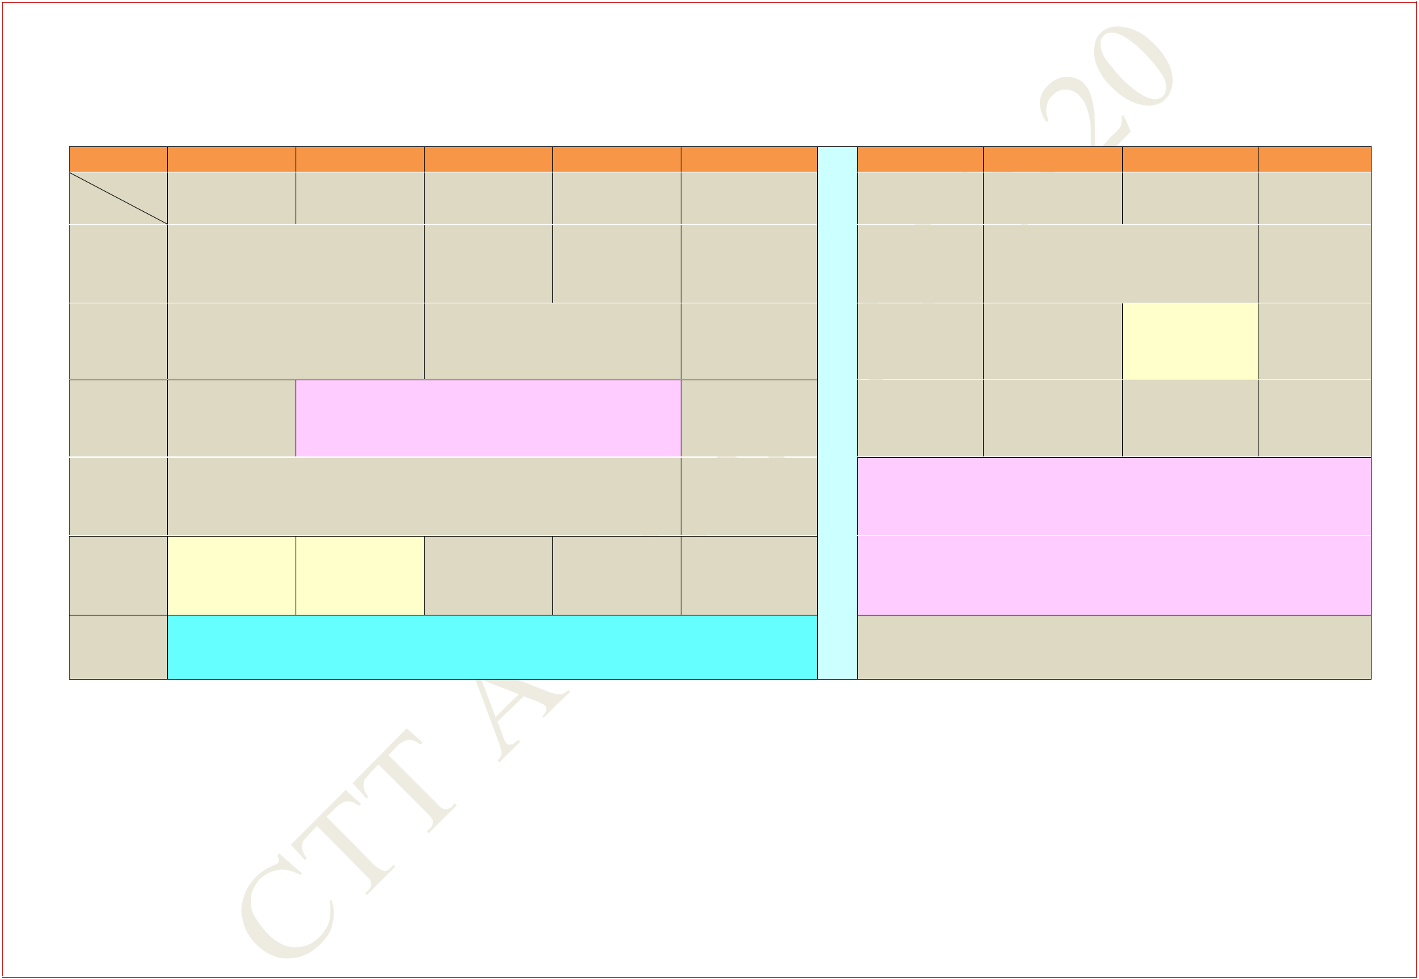**FIRST YEAR TIME TABLE FOR SECTION 13**

**AUTUMN SEMESTER 2019 – 2020**

|  |  |  |  |  |  |  |  |  |  |  |
| --- | --- | --- | --- | --- | --- | --- | --- | --- | --- | --- |
| **Period** |  | **1** |  | **2** | **3** |  | **4** |  | **5** |  |
| **Time** | **8:00** | **AM -** | **9:00** | **AM -** | **10:00** | **AM -** | **11:00** | **AM -** | **12:00 Noon** |  |
| **Day** | **8:55** | **AM** | **9:55** | **AM** | **10:55** | **AM** | **11:55** | **AM** | **- 12:55 PM** |  |
| **MON** |  |  | **CS** |  | **MA(Sp)** | | **MA** | | **PH** |  |
|  | **NR222** | |  | **NR222** | | **NR222** | | **NR222** |  |
|  |  |  |  |
|  |  |  |  |  |  |  |  |  |  |  |
| **TUE** |  |  | **MA** |  |  |  | **PH** |  | **CS** |  |
|  | **NR222** | |  |  | **NR222** | |  | **NR222** |  |
|  |  |  |  |  |  |

|  |  |  |
| --- | --- | --- |
| **WED** | **PHYSICS LAB** |  |
| **(In Sir J C Bose Laboratory Complex)** |  |
|  |  |
|  |  |  |
| **THU** |  |  |

**FRI** **PH(T)** **MA(T)**

**NC121,NC122 NC121,NC122**

**SAT** **EAA**

|  |  |  |  |  |  |  |  |  |
| --- | --- | --- | --- | --- | --- | --- | --- | --- |
|  |  | **6** | **7** |  | **8** |  | **9** |  |
|  | **2:00** | **PM -** | **3:00 PM -** | **4:00** | **PM -** | **5:00** | **PM -** |  |
|  | **2:55** | **PM** | **3:55 PM** | **4:55** | **PM** | **5:55** | **PM** |  |
| **L** |  |  |  | **ME** |  |  |  |  |
| **U** |  |  |  | **NR222** |  |  |  |  |
|  |  |  |  |  |  |  |  |
| **N** |  |  | **ME** | **ME(T)** | |  |  |  |
| **C** |  |  | **NR222** | **NR222** | |  |  |  |
|  |  |  |  |  |  |  |  |
| **CS(Sp)** | | **PH(Sp)** | **ME(Sp)** | |  |  |  |
| **H** |  |  |  |
| **NR222** | | **NR222** | **NR222** | |  |  |  |
|  |  |  |  |

* **PROGAMMING AND DATA STRUCTURE LAB**

|  |  |  |
| --- | --- | --- |
| **O** | **(In CIC Lab.)** |  |
|  |  |

* **ENGG. DRAWING AND COMPUTER GRAPHICS**

**(S301)**

**R**

**MA: Mathematics I** **PH: Physics** **CS: Programming & Data Structure**

**ME: Mechanics** **EAA: Extra Academic Activity**

**Sp within brackets indicates Special/Extra Class for the subject from 29 Jul 2019 – 23 Aug 2019**

**(T)- in brackets means Tutorial for that subject**

**Central Time Table Autumn 2019– 2020, Version 1.1** **Updated -28 March 2019** **16**

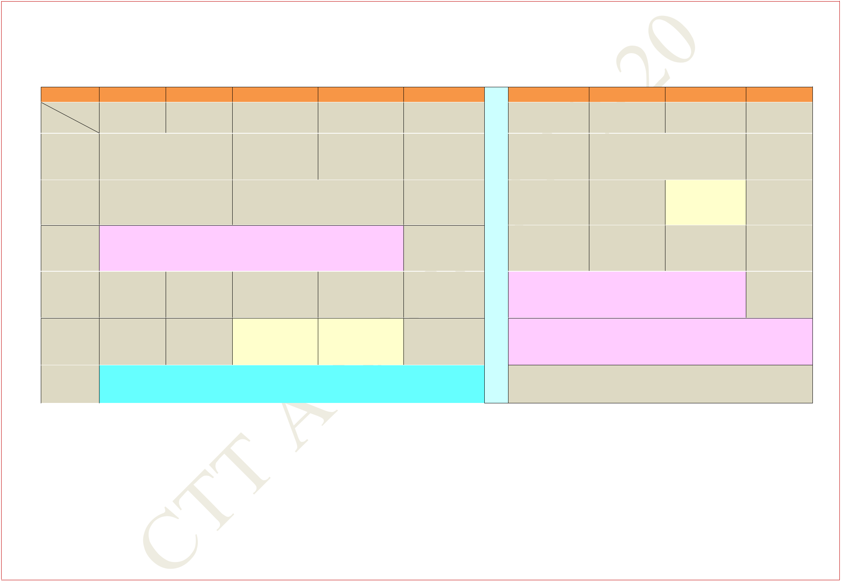**FIRST YEAR TIME TABLE FOR SECTION 14**

**AUTUMN SEMESTER 2019 – 2020**

|  |  |  |  |  |  |  |  |  |  |  |
| --- | --- | --- | --- | --- | --- | --- | --- | --- | --- | --- |
| **Period** |  | **1** |  | **2** |  | **3** |  | **4** | **5** |  |
| **Time** | **8:00** | **AM -** | **9:00** | **AM -** | **10:00** | **AM -** | **11:00** | **AM -** | **12:00 Noon** |  |
| **Day** | **8:55** | **AM** | **9:55** | **AM** | **10:55** | **AM** | **11:55** | **AM** | **- 12:55 PM** |  |
| **MON** |  | **CS** | |  | **MA(Sp)** | | **MA** | | **PH** |  |
|  | **NR222** | |  | **NR222** | | **NR222** | | **NR222** |  |
|  |  |  |  |
|  |  |  | |  |  |  |  |  |  |  |
| **TUE** |  | **MA** | |  |  |  | **PH** |  | **CS** |  |
|  | **NR222** | |  |  |  | **NR222** |  | **NR222** |  |
|  |  |  |  |  |  |  |

|  |  |  |
| --- | --- | --- |
| **WED** | **PROGAMMING AND DATA STRUCTURE LAB** |  |
| **(In CIC Lab.)** |  |
|  |  |
|  |  |  |
| **THU** |  |  |

|  |  |  |  |
| --- | --- | --- | --- |
| **FRI** | **PH(T)** | **MA(T)** |  |
| **NC121, NC122** | **NC121, NC122** |  |
|  |  |
|  |  |  |  |
| **SAT** | **EAA** |  |  |
|  |  |  |  |

|  |  |  |  |  |  |  |  |  |
| --- | --- | --- | --- | --- | --- | --- | --- | --- |
|  |  | **6** | **7** |  | **8** |  | **9** |  |
|  | **2:00** | **PM -** | **3:00 PM -** | **4:00** | **PM -** | **5:00** | **PM -** |  |
|  | **2:55** | **PM** | **3:55 PM** | **4:55** | **PM** | **5:55** | **PM** |  |
| **L** |  |  |  | **ME** |  |  |  |  |
| **U** |  |  |  | **NR222** |  |  |  |  |
|  |  |  |  |  |  |  |  |
| **N** |  |  | **ME** | **ME(T)** | |  |  |  |
| **C** |  |  | **NR222** | **NR222** | |  |  |  |
|  |  |  |  |  |  |  |  |
| **CS(Sp)** | | **PH(Sp)** | **ME(Sp)** | |  |  |  |
| **H** |  |  |  |
| **NR222** | | **NR222** | **NR222** | |  |  |  |
|  |  |  |  |
| **H** |  |  |  | |  |  |  |  |
|  |  | **PHYSICS LAB** | |  |  |  |  |

**(In Sir J C Bose Laboratory Complex)**

**O**

* **ENGG. DRAWING AND COMPUTER GRAPHICS**

**(S302)**

**R**

**MA: Mathematics I** **PH: Physics** **CS: Programming & Data Structure**

**ME: Mechanics** **EAA: Extra Academic Activity**

**Sp within brackets indicates Special/Extra Class for the subject from 29 Jul 2019 – 23 Aug 2019**

**(T)- in brackets means Tutorial for that subject**

**Central Time Table Autumn 2019– 2020, Version 1.1** **Updated -28 March 2019** **17**

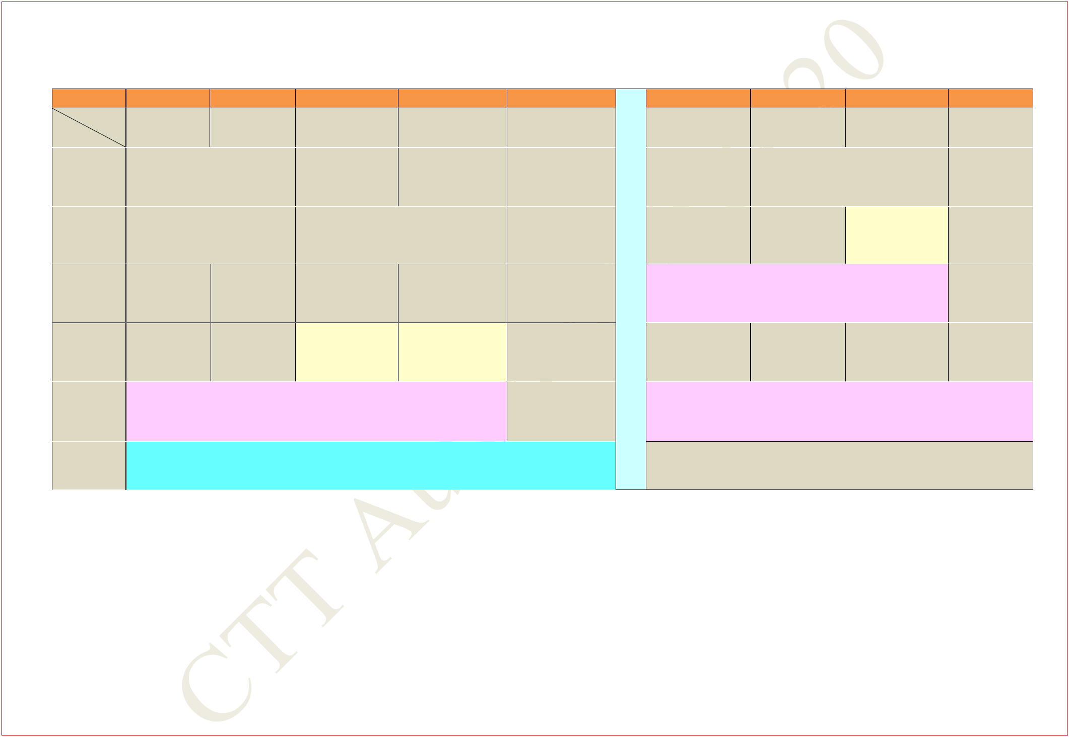**FIRST YEAR TIME TABLE FOR SECTION 15**

**AUTUMN SEMESTER 2019 – 2020**

|  |  |  |  |  |  |  |  |  |  |  |  |
| --- | --- | --- | --- | --- | --- | --- | --- | --- | --- | --- | --- |
| **Period** | **1** | |  | **2** |  | **3** |  | **4** |  | **5** |  |
| **Time** | **8:00** | **AM** | **9:00** | **AM -** | **10:00** | **AM -** | **11:00** | **AM -** | **12:00** | **Noon -** |  |
| **Day** | **-8:55** | **AM** | **9:55** | **AM** | **10:55** | **AM** | **11:55** | **AM** | **12:55** | **PM** |  |
| **MON** |  |  | **CS** |  | **MA(Sp)** | | **MA** | | **PH** | |  |
|  | **NR121** | |  | **NR121** | | **NR121** | | **NR121** | |  |
|  |  |  |  |
|  |  |  |  |  |  |  |  |  |  | |  |
| **TUE** |  |  | **MA** |  |  |  | **PH** |  | **CS** | |  |
|  | **NR121** | |  |  | **NR121** | |  | **NR121** | |  |
|  |  |  |  |  |  |
|  |  |  |  |  |  |  |  |  |  |  |  |

**WED**

|  |  |  |  |
| --- | --- | --- | --- |
| **THU** | **PH(T)** | **MA(T)** |  |
| **NC121, NC122** | **NC121, NC122** |  |
|  |  |
|  |  | |  |
| **FRI** | **ENGG. DRAWING AND COMPUTER GRAPHICS** | |  |
| **(S302)** |  |  |
|  |  |  |
|  |  |  |  |
| **SAT** | **EAA** |  |  |
|  |  |  |  |

|  |  |  |  |  |  |  |  |  |
| --- | --- | --- | --- | --- | --- | --- | --- | --- |
|  |  | **6** | **7** |  | **8** |  | **9** |  |
|  | **2:00** | **PM -** | **3:00 PM -** | **4:00** | **PM -** | **5:00** | **PM -** |  |
|  | **2:55** | **PM** | **3:55 PM** | **4:55** | **PM** | **5:55** | **PM** |  |
| **L** |  |  |  | **ME** |  |  |  |  |
| **U** |  |  |  | **NR121** |  |  |  |  |
|  |  |  |  |  |  |  |  |
| **N** |  |  | **ME** | **ME(T)** | |  |  |  |
| **C** |  |  | **NR121** | **NR121** | |  |  |  |
|  |  |  |  |  |  |  |  |
|  |  | **PHYSICS LAB** | |  |  |  |  |
| **H** |  |  |  |  |  |  |
| **(In Sir J C Bose Laboratory Complex)** | | | | |  |  |  |
|  |  |  |  |
| **H** |  | |  |  | |  |  |  |
| **PH(Sp)** | | **CS(Sp)** | **ME(Sp)** | |  |  |  |
| **O** | **NR121** | | **NR121** | **NR121** | |  |  |  |
|  |  |  |  |  |  |  |  |

* **PROGAMMING AND DATA STRUCTURE LAB**

**(In CIC Lab.)**

**R**

**MA: Mathematics I** **PH: Physics** **CS: Programming & Data Structure**

**ME: Mechanics** **EAA: Extra Academic Activity**

**Sp within brackets indicates Special/Extra Class for the subject from 29 Jul 2019 – 23 Aug 2019**

**(T)- in brackets means Tutorial for that subject**

**Central Time Table Autumn 2019– 2020, Version 1.1** **Updated -28 March 2019** **18**

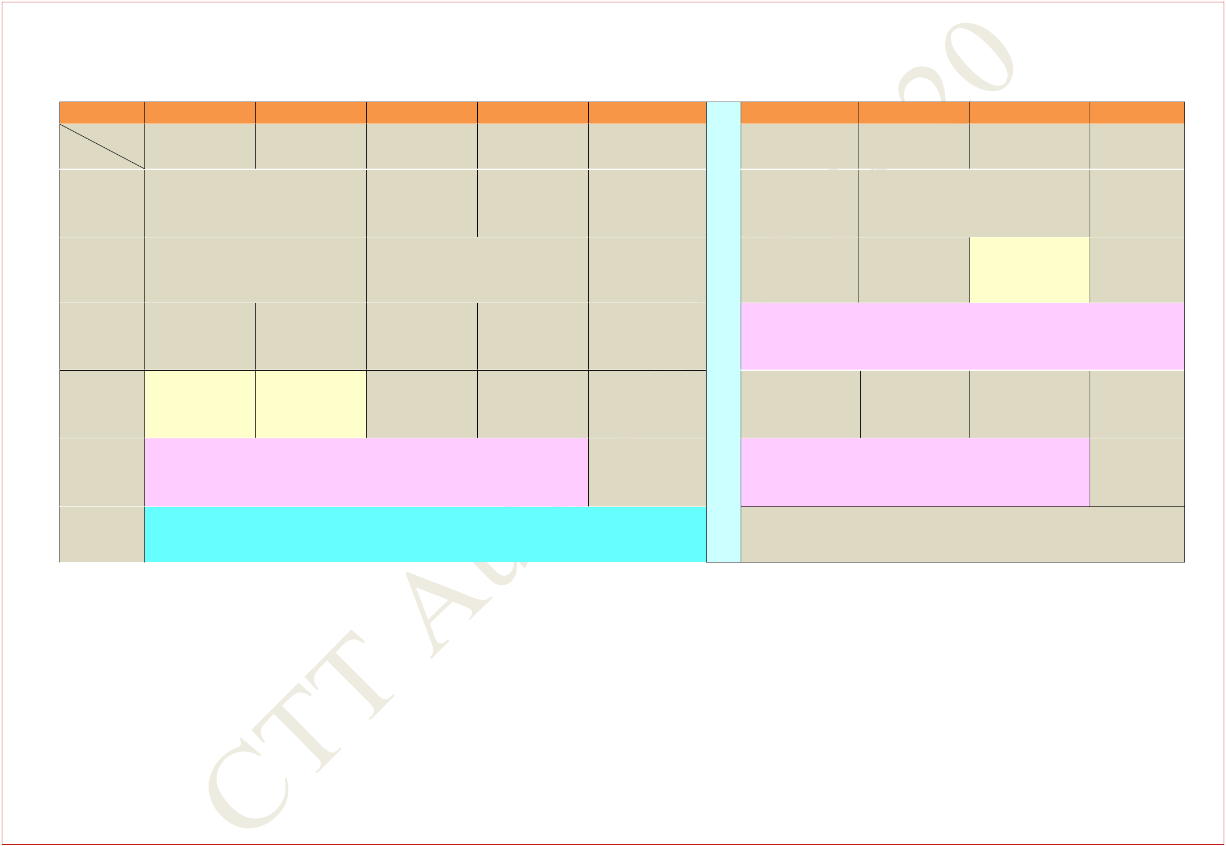**FIRST YEAR TIME TABLE FOR SECTION 16**

**AUTUMN SEMESTER 2019 – 2020**

|  |  |  |  |  |  |  |  |  |  |  |
| --- | --- | --- | --- | --- | --- | --- | --- | --- | --- | --- |
| **Period** |  | **1** |  | **2** | **3** |  | **4** |  | **5** |  |
| **Time** | **8:00** | **AM -** | **9:00** | **AM -** | **10:00** | **AM -** | **11:00** | **AM -** | **12:00 Noon** |  |
| **Day** | **8:55** | **AM** | **9:55** | **AM** | **10:55** | **AM** | **11:55** | **AM** | **- 12:55 PM** |  |
| **MON** |  |  | **CS** |  | **MA(Sp)** | | **MA** | | **PH** |  |
|  | **NR121** | |  | **NR121** | | **NR121** | | **NR121** |  |
|  |  |  |  |
|  |  |  |  |  |  |  |  |  |  |  |
| **TUE** |  |  | **MA** |  |  |  | **PH** |  | **CS** |  |
|  | **NR121** | |  |  | **NR121** | |  | **NR121** |  |
|  |  |  |  |  |  |
|  |  |  |  |  |  |  |  |  |  |  |

**WED**

|  |  |  |  |
| --- | --- | --- | --- |
| **THU** | **MA(T)** | **PH(T)** |  |
| **NC121,NC122** | **NC121,NC122** |  |
|  |  |
|  |  | |  |
| **FRI** | **PROGAMMING AND DATA STRUCTURE LAB** | |  |
|  | **(In CIC Lab.)** |  |
|  |  |  |
|  |  |  |  |
| **SAT** |  | **EAA** |  |
|  |  |  |  |

|  |  |  |  |  |  |  |  |  |
| --- | --- | --- | --- | --- | --- | --- | --- | --- |
|  |  | **6** | **7** |  | **8** |  | **9** |  |
|  | **2:00** | **PM -** | **3:00 PM -** | **4:00** | **PM -** | **5:00** | **PM -** |  |
|  | **2:55** | **PM** | **3:55 PM** | **4:55** | **PM** | **5:55** | **PM** |  |
| **L** |  |  |  | **ME** |  |  |  |  |
| **U** |  |  |  | **NR121** |  |  |  |  |
|  |  |  |  |  |  |  |  |
| **N** |  |  | **ME** | **ME(T)** | |  |  |  |
| **C** |  |  | **NR121** | **NR121** | |  |  |  |
|  |  |  |  |  |  |  |  |
| **ENGG. DRAWING AND COMPUTER GRAPHICS** | | | | | | |  |
| **H** |  |
|  |  |  | **(S302)** | |  |  |  |  |
| **H** |  | |  |  | |  |  |  |
| **PH(Sp)** | | **CS(Sp)** | **ME(Sp)** | |  |  |  |
| **O** | **NR121** | | **NR121** | **NR121** | |  |  |  |
|  |  |  |  |  |  |  |  |
| **U** |  |  | **PHYSICS LAB** | |  |  |  |  |
|  | **(In Sir J C Bose Laboratory Complex)** | | | | |  |  |  |

**R**

**MA: Mathematics I** **PH: Physics** **CS: Programming & Data Structure**

**ME: Mechanics** **EAA: Extra Academic Activity**

**Sp within brackets indicates Special/Extra Class for the subject from 29 Jul 2019 – 23 Aug 2019**

**(T)- in brackets means Tutorial for that subject**

**Central Time Table Autumn 2019– 2020, Version 1.1** **Updated -28 March 2019** **19**

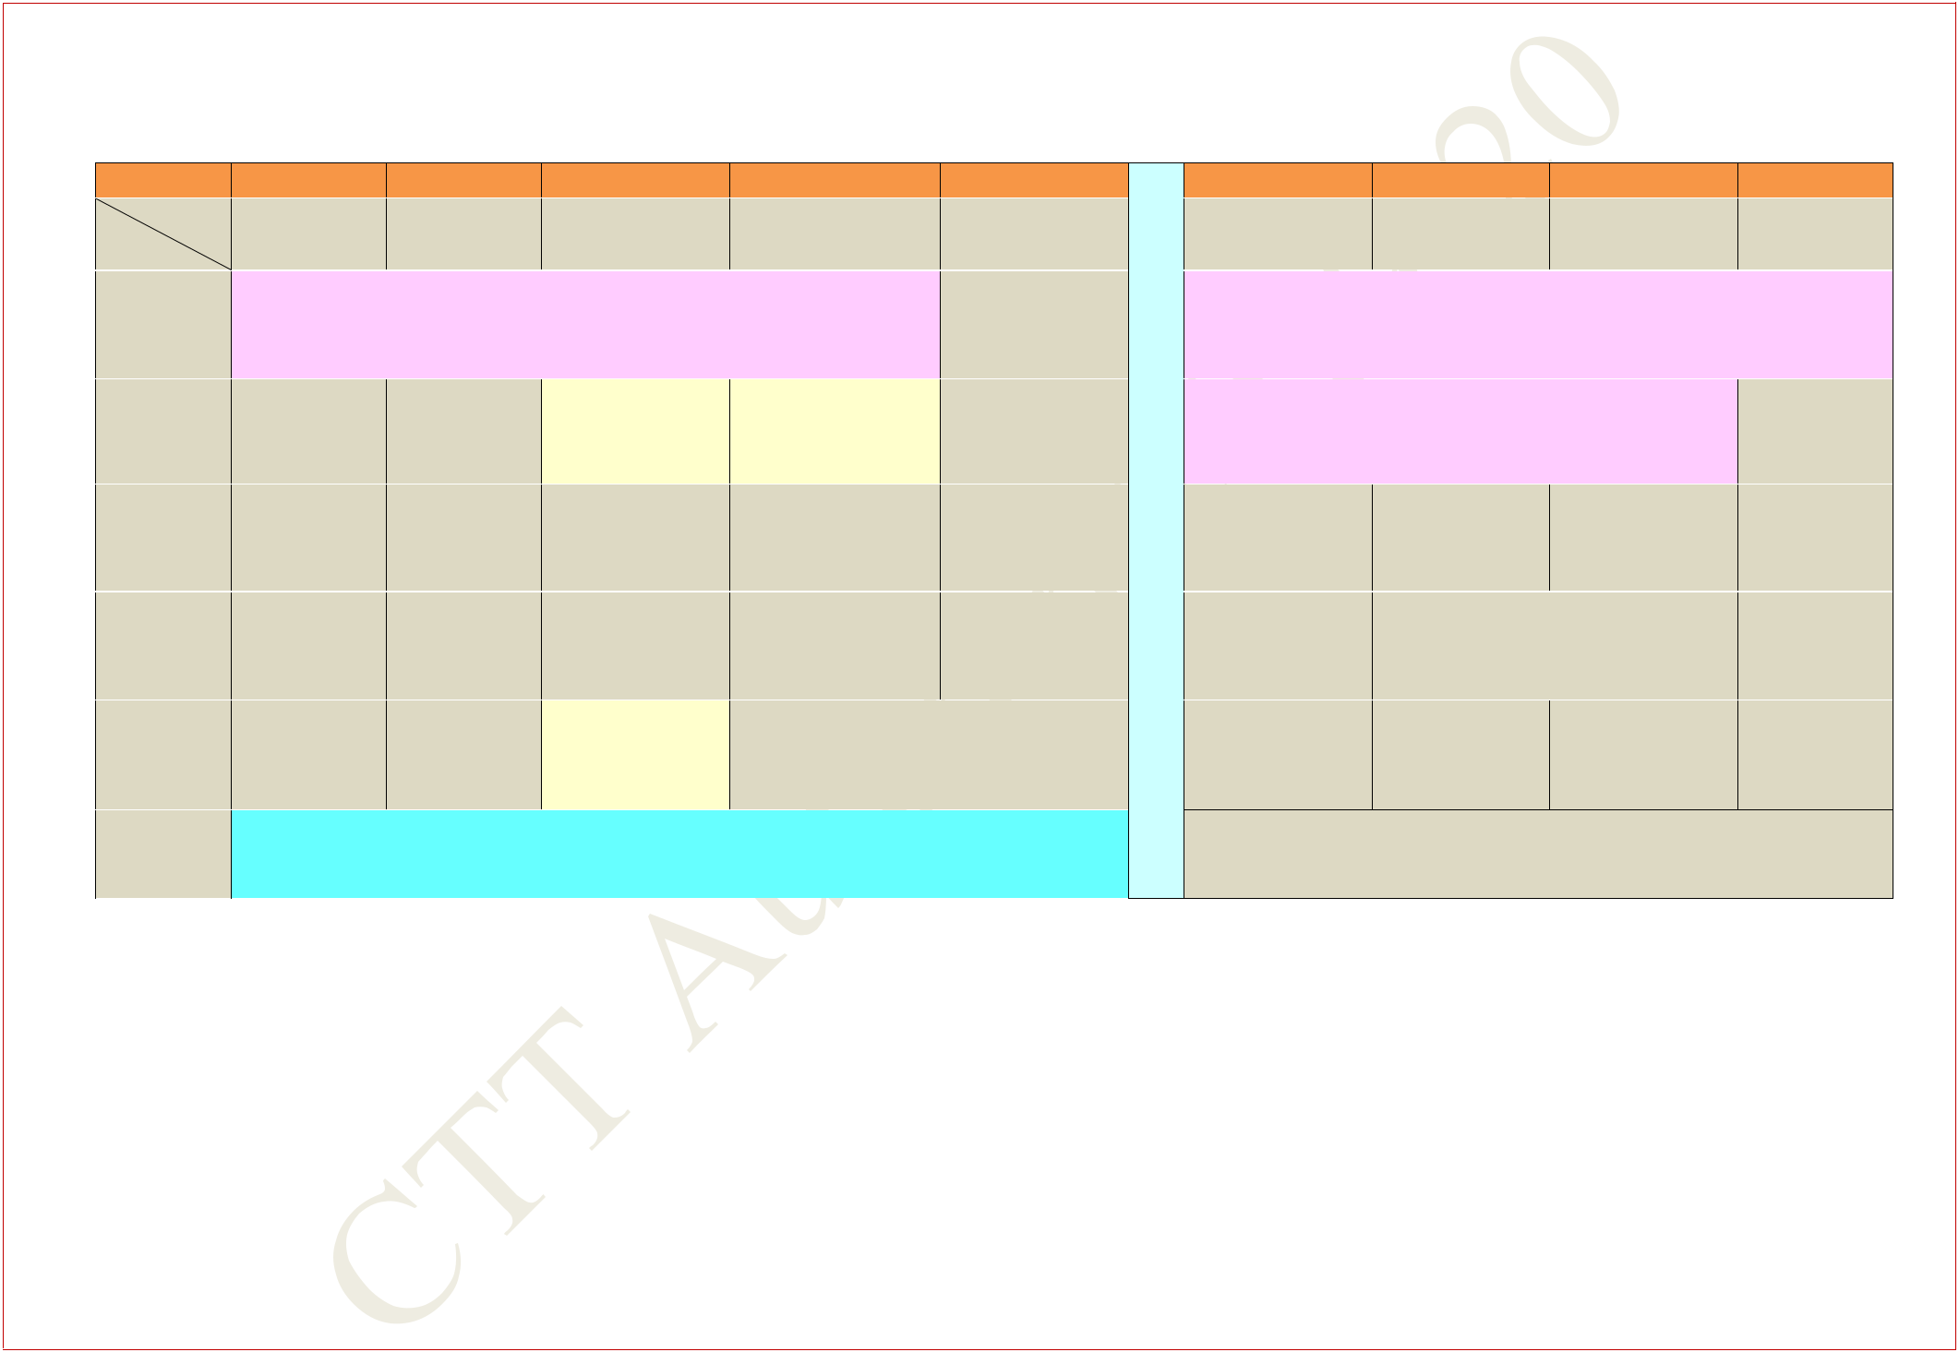**FIRST YEAR TIME TABLE FOR SECTION 17**

**AUTUMN SEMESTER 2019 – 2020**

|  |  |  |  |  |  |  |  |  |  |  |
| --- | --- | --- | --- | --- | --- | --- | --- | --- | --- | --- |
| **Period** |  | **1** |  | **2** |  | **3** |  | **4** | **5** |  |
| **Time** | **8:00** | **AM -** | **9:00** | **AM -** | **10:00** | **AM -** | **11:00** | **AM -** | **12:00 Noon** |  |
| **Day** | **8:55** | **AM** | **9:55** | **AM** | **10:55** | **AM** | **11:55** | **AM** | **- 12:55 PM** |  |
| **MON** | **ENGG. DRAWING AND COMPUTER GRAPHICS** | | | | | | | |  |  |
|  |  |  |  | **(S301)** |  |  |  |  |  |
|  |  |  |  |  |  |  |  |  |  |
|  |  |  |  |  |  | |  | |  |  |
| **TUE** |  |  |  |  | **MA(T)** | | **PH(T)** | |  |  |
|  |  |  |  | **NC121, NC122** | | **NC121, NC122** | |  |  |
|  |  |  |  |  |  |  |
|  |  |  |  |  |  | |  | |  |  |
| **WED** |  |  |  |  | **MA(Sp)** | | **MA** | | **ME** |  |
|  |  |  |  | **NR122** | | **NR122** | | **NR122** |  |
|  |  |  |  |  |  |
|  |  |  |  | |  | |  |  |  |  |
| **THU** |  |  | **CS** | | **CS(Sp)** | |  | **ME** | **MA** |  |
|  |  | **NR122** | | **NR122** | | **NR122** | | **NR122** |  |
|  |  |  |  |
|  |  | |  | |  | |  |  |  |  |
| **FRI** | **MA** | | **ME** | | **ME(T)** | |  | **CS** |  |  |
| **NR122** | | **NR122** | | **NR122** | |  | **NR122** | |  |
|  |  |  |
|  |  |  |  |  |  |  |  |  |  |  |
| **SAT** |  |  |  |  |  | **EAA** |  |  |  |  |
|  |  |  |  |  |  |  |  |  |  |  |

|  |  |  |  |  |  |  |
| --- | --- | --- | --- | --- | --- | --- |
|  | **6** | **7** |  | **8** |  | **9** |
| **2:00** | **PM -** | **3:00 PM -** | **4:00** | **PM -** | **5:00** | **PM -** |
| **2:55** | **PM** | **3:55 PM** | **4:55** | **PM** | **5:55** | **PM** |

* **PROGAMMING AND DATA STRUCTURE LAB**

|  |  |  |  |
| --- | --- | --- | --- |
| **U** | **(In CIC Lab.)** | |  |
|  |  |  |
| **N** | **PHYSICS LAB** | |  |
| **C** | **(In Sir J C Bose Laboratory Complex)** | |  |
|  |  |  |
| **ME(Sp)** |  |  |
| **H** |  |  |
| **NR122** |  |  |
|  |  |  |
| **H** |  |  |  |
|  | **PH** |  |
| **O** |  | **NR122** |  |
|  |  |  |
| **U** | **PH** | **PH(Sp)** |  |
|  | **NR122** | **NR122** |  |

**R**

**MA: Mathematics I** **PH: Physics** **CS: Programming & Data Structure**

**ME: Mechanics** **EAA: Extra Academic Activity**

**Sp within brackets indicates Special/Extra Class for the subject from 29 Jul 2019 – 23 Aug 2019**

**(T)- in brackets means Tutorial for that subject**

**Central Time Table Autumn 2019– 2020, Version 1.1** **Updated -28 March 2019** **20**

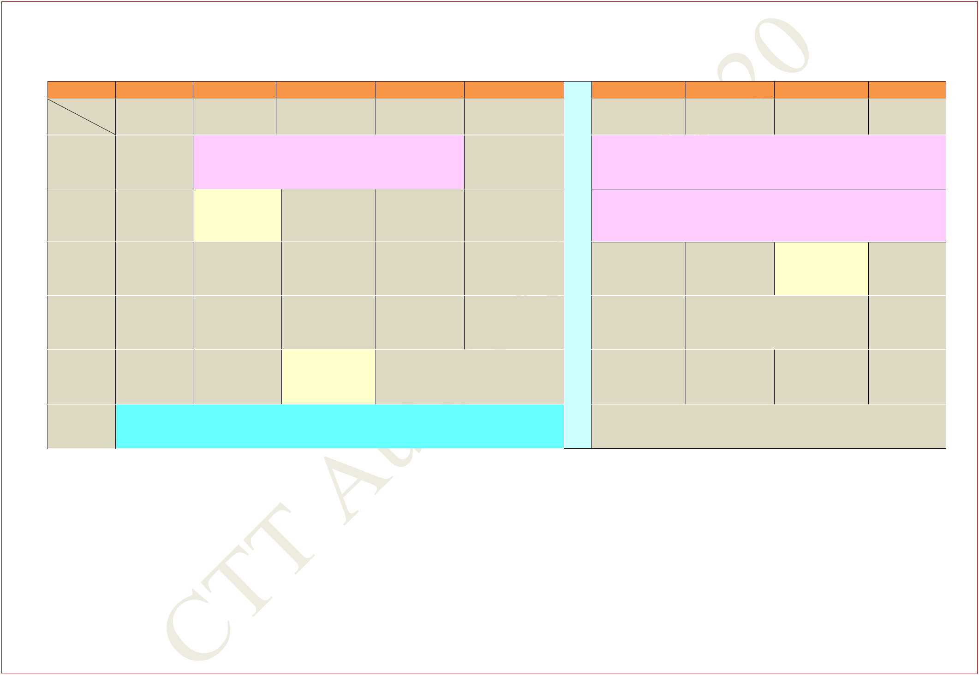**FIRST YEAR TIME TABLE FOR SECTION 18**

**AUTUMN SEMESTER 2019 – 2020**

|  |  |  |  |  |  |  |  |  |  |  |  |
| --- | --- | --- | --- | --- | --- | --- | --- | --- | --- | --- | --- |
| **Period** |  | **1** |  | **2** |  | **3** | **4** |  |  | **5** |  |
| **Time** | **8:00** | **AM -** | **9:00** | **AM -** | **10:00** | **AM -** | **11:00** | **AM -** | **12:00** | **Noon -** |  |
| **Day** | **8:55** | **AM** | **9:55** | **AM** | **10:55** | **AM** | **11:55** | **AM** | **12:55** | **PM** |  |
| **MON** |  |  |  |  | **PHYSICS LAB** | |  |  |  |  |  |
|  |  | **(In Sir J C Bose Laboratory Complex)** | | | | | |  |  |  |
|  |  |  |  |  |  |
|  |  |  |  | |  |  |  |  |  |  |  |
| **TUE** |  |  | **MA(T)** | |  |  |  |  |  |  |  |
|  |  | **NC121,NC122** | |  |  |  |  |  |  |  |
|  |  |  |  |  |  |  |  |  |  |
|  |  |  |  |  |  | |  | |  | |  |
| **WED** |  |  |  |  | **MA(Sp)** | | **MA** | | **ME** | |  |
|  |  |  |  | **NR122** | | **NR122** | | **NR122** | |  |
|  |  |  |  |  |  |
|  |  |  |  |  |  | |  | |  | |  |
| **THU** |  |  |  | **CS** | **CS(Sp)** | | **ME** | | **MA** | |  |
|  |  | **NR122** | | **NR122** | | **NR122** | | **NR122** | |  |
|  |  |  |  |
|  |  | |  | |  | |  |  |  |  |  |
| **FRI** | **MA** | | **ME** | | **ME(T)** | |  |  | **CS** |  |  |
| **NR122** | | **NR122** | | **NR122** | |  | **NR122** | |  |  |
|  |  |  |  |
|  |  |  |  |  |  |  |  |  |  |  |  |
| **SAT** |  |  |  |  |  | **EAA** |  |  |  |  |  |
|  |  |  |  |  |  |  |  |  |  |  |  |

|  |  |  |  |  |  |  |
| --- | --- | --- | --- | --- | --- | --- |
|  | **6** | **7** |  | **8** |  | **9** |
| **2:00** | **PM -** | **3:00 PM -** | **4:00** | **PM -** | **5:00** | **PM -** |
| **2:55** | **PM** | **3:55 PM** | **4:55** | **PM** | **5:55** | **PM** |

* **ENGG. DRAWING AND COMPUTER GRAPHICS**

**U** **(S301)**

* **PROGAMMING AND DATA STRUCTURE LAB**

**(In CIC Lab.)**

**C**

|  |  |  |  |
| --- | --- | --- | --- |
| **H** | **ME(Sp)** | **PH(T)** |  |
| **NR122** | **NC121,NC122** |  |
|  |  |
| **H** |  |  |  |
|  | **PH** |  |
| **O** |  | **NR122** |  |
|  |  |  |
| **U** | **PH** | **PH(Sp)** |  |
| **R** | **NR122** | **NR122** |  |
|  |  |  |
|  |  |  |

**MA: Mathematics I** **PH: Physics** **CS: Programming & Data Structure**

**ME: Mechanics** **EAA: Extra Academic Activity**

**Sp within brackets indicates Special/Extra Class for the subject from 29 Jul 2019 – 23 Aug 2019**

**(T)- in brackets means Tutorial for that subject**

**Central Time Table Autumn 2019– 2020, Version 1.1** **Updated -28 March 2019** **21**

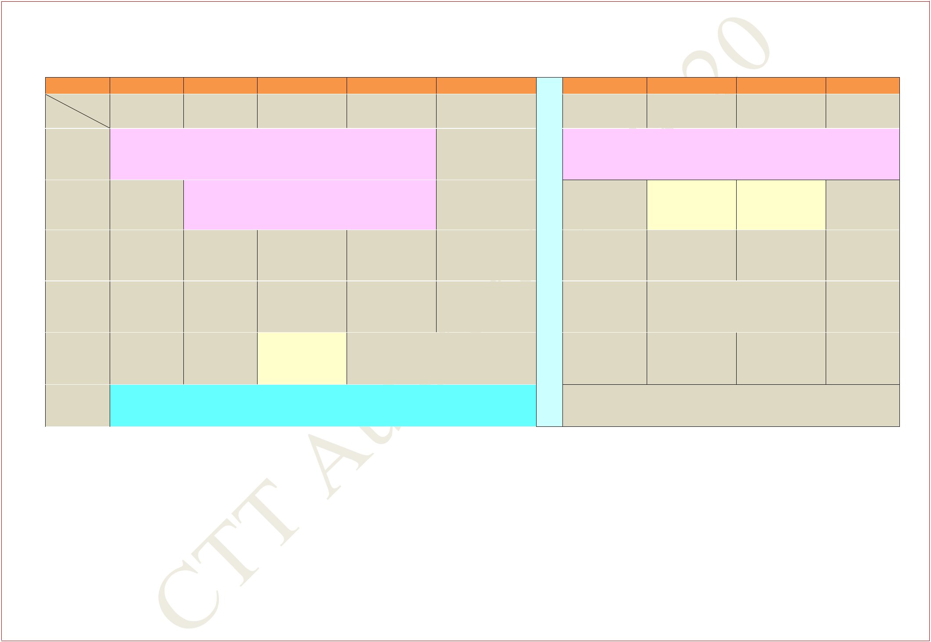**FIRST YEAR TIME TABLE FOR SECTION 19**

**AUTUMN SEMESTER 2019 – 2020**

|  |  |  |  |  |  |  |  |  |  |  |  |
| --- | --- | --- | --- | --- | --- | --- | --- | --- | --- | --- | --- |
| **Period** |  | **1** |  | **2** |  | **3** |  | **4** |  | **5** |  |
| **Time** | **8:00** | **AM -** | **9:00** | **AM -** | **10:00** | **AM -** | **11:00** | **AM -** | **12:00** | **Noon -** |  |
| **Day** | **8:55** | **AM** | **9:55** | **AM** | **10:55** | **AM** | **11:55** | **AM** | **12:55** | **PM** |  |
| **MON** | **PROGAMMING AND DATA STRUCTURE LAB** | | | | | | | | |  |  |
|  |  |  | **(In CIC Lab.)** | | |  |  |  |  |  |
|  |  |  |  |  |  |  |  |  |
|  |  |  |  |  |  | | |  |  |  |  |
| **TUE** |  |  |  |  | **PHYSICS LAB** | | |  |  |  |  |
|  |  | **(In Sir J C Bose Laboratory Complex)** | | | | | | |  |  |
|  |  |  |  |  |
|  |  |  |  |  |  | |  | |  |  |  |
| **WED** |  |  |  |  | **MA(Sp)** | | **MA** | |  | **ME** |  |
|  |  |  |  | **NR222** | | **NR222** | | **NR222** | |  |
|  |  |  |  |  |  |
|  |  |  |  | |  | |  | |  | |  |
| **THU** |  |  | **CS** | | **CS(Sp)** | | **ME** | | **MA** | |  |
|  |  | **NR222** | | **NR222** | | **NR222** | | **NR222** | |  |
|  |  |  |  |
|  |  | |  | |  | |  |  |  |  |  |
| **FRI** | **MA** | | **ME** | | **ME(T)** | |  |  | **CS** |  |  |
| **NR222** | | **NR222** | | **NR222** | |  |  | **NR222** |  |  |
|  |  |  |  |  |
|  |  |  |  |  |  |  |  |  |  |  |  |
| **SAT** |  |  |  |  |  | **EAA** |  |  |  |  |  |
|  |  |  |  |  |  |  |  |  |  |  |  |

|  |  |  |  |  |  |  |
| --- | --- | --- | --- | --- | --- | --- |
|  | **6** | **7** |  | **8** |  | **9** |
| **2:00** | **PM -** | **3:00 PM -** | **4:00** | **PM -** | **5:00** | **PM -** |
| **2:55** | **PM** | **3:55 PM** | **4:55** | **PM** | **5:55** | **PM** |

* **ENGG. DRAWING AND COMPUTER GRAPHICS**

**U** **(S302)**

|  |  |  |  |  |
| --- | --- | --- | --- | --- |
| **N** | **PH(T)** |  | **MA(T)** |  |
| **C** | **NC121, NC122** | | **NC121, NC122** |  |
|  |  |  |  |
| **ME(Sp)** |  |  |  |
| **H** |  |  |  |
| **NR221** |  |  |  |
|  |  |  |  |
| **H** |  |  | |  |
|  | **PH** | |  |
| **O** |  | **NR222** | |  |
|  |  |  |  |
| **U** | **PH** |  | **PH(Sp)** |  |
|  | **NR222** |  | **NR222** |  |

**R**

**MA: Mathematics I** **PH: Physics** **CS: Programming & Data Structure**

**ME: Mechanics** **EAA: Extra Academic Activity**

**Sp within brackets indicates Special/Extra Class for the subject from 29 Jul 2019 – 23 Aug 2019**

**(T)- in brackets means Tutorial for that subject**

**Central Time Table Autumn 2019– 2020, Version 1.1** **Updated -28 March 2019** **22**

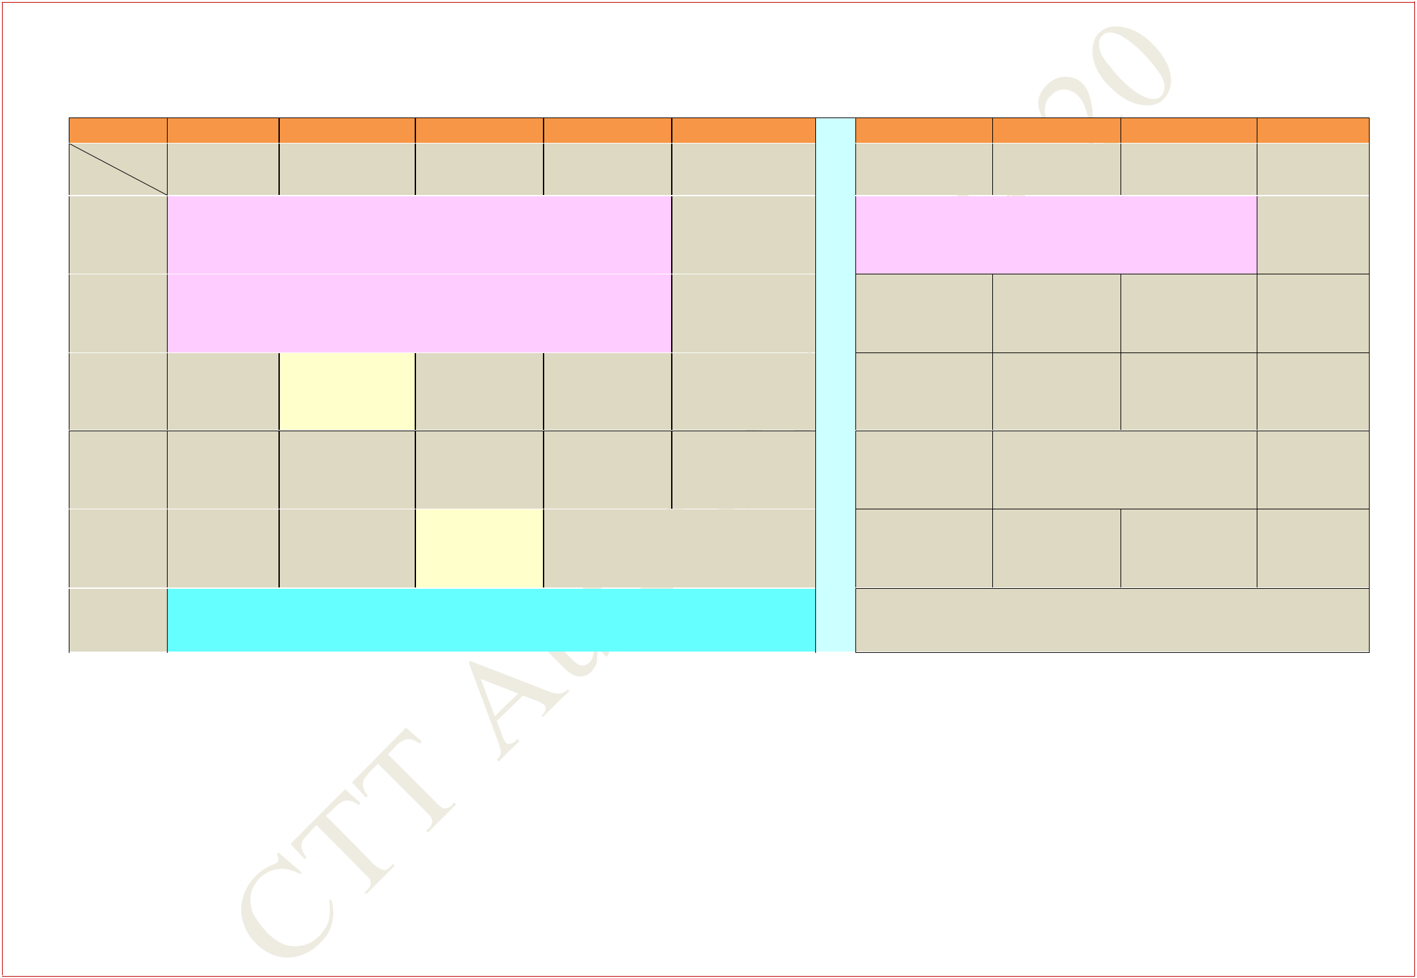**FIRST YEAR TIME TABLE FOR SECTION 20**

**AUTUMN SEMESTER 2019 – 2020**

|  |  |  |  |  |  |  |  |  |  |  |  |
| --- | --- | --- | --- | --- | --- | --- | --- | --- | --- | --- | --- |
| **Period** |  | **1** |  | **2** | **3** |  | **4** |  |  | **5** |  |
| **Time** | **8:00** | **AM -** | **9:00** | **AM -** | **10:00** | **AM -** | **11:00** | **AM -** | **12:00** | **Noon -** |  |
| **Day** | **8:55** | **AM** | **9:55** | **AM** | **10:55** | **AM** | **11:55** | **AM** | **12:55** | **PM** |  |
| **MON** | **ENGG. DRAWING AND COMPUTER GRAPHICS** | | | | | | | |  |  |  |
|  |  |  | **(S302)** | |  |  |  |  |  |  |
|  |  |  |  |  |  |  |  |  |  |
|  |  | | | | | | | |  |  |  |
| **TUE** | **PROGAMMING AND DATA STRUCTURE LAB** | | | | | | | |  |  |  |
|  |  |  | **(In CIC Lab.)** | |  |  |  |  |  |  |
|  |  |  |  |  |  |  |  |  |  |
|  |  |  |  | |  | |  | |  | |  |
| **WED** |  |  | **PH(T)** | | **MA(Sp)** | | **MA** | | **ME** | |  |
|  |  | **NC121, NC122** | | **NR222** | | **NR222** | | **NR222** | |  |
|  |  |  |  |

|  |  |  |  |  |  |  |  |
| --- | --- | --- | --- | --- | --- | --- | --- |
|  |  | **6** | **7** |  | **8** |  | **9** |
| **2:00** | | **PM -** | **3:00 PM -** | **4:00** | **PM -** | **5:00** | **PM -** |
|  | **2:55** | **PM** | **3:55 PM** | **4:55** | **PM** | **5:55** | **PM** |
| **L** | |  | **PHYSICS LAB** |  |  |  |  |

* **(In Sir J C Bose Laboratory Complex)**
* **MA(T)**

**NC121, NC122**

**C**

|  |  |  |
| --- | --- | --- |
| **H** | **ME(Sp)** |  |
| **NR221** |  |
|  |  |

|  |  |  |  |  |  |  |  |
| --- | --- | --- | --- | --- | --- | --- | --- |
| **THU** |  | **CS** | **CS(Sp)** | **ME** | **MA** | **H** |  |
|  | **NR222** | **NR222** | **NR222** | **NR222** | **O** |  |
|  |  |  |
|  |  |  |  |  |  |  |
| **FRI** | **MA** | **ME** | **ME(T)** | **CS** |  | **U** |  |
| **NR222** | **NR222** | **NR222** | **NR222** |  |  |  |
|  |  | **R** |  |
|  |  |  |  |  |  |  |
| **SAT** |  |  | **EAA** |  |  |  |
|  |  |  |  |  |  |
|  |  |  |  |  |  |  |  |

**PH**

**NR222**

**PH** **PH(Sp)**

**NR222** **NR222**

**MA: Mathematics I** **PH: Physics** **CS: Programming & Data Structure**

**ME: Mechanics** **EAA: Extra Academic Activity**

**Sp within brackets indicates Special/Extra Class for the subject from 29 Jul 2019 – 23 Aug 2019**

**(T)- in brackets means Tutorial for that subject**

**Central Time Table Autumn 2019– 2020, Version 1.1** **Updated -28 March 2019** **23**

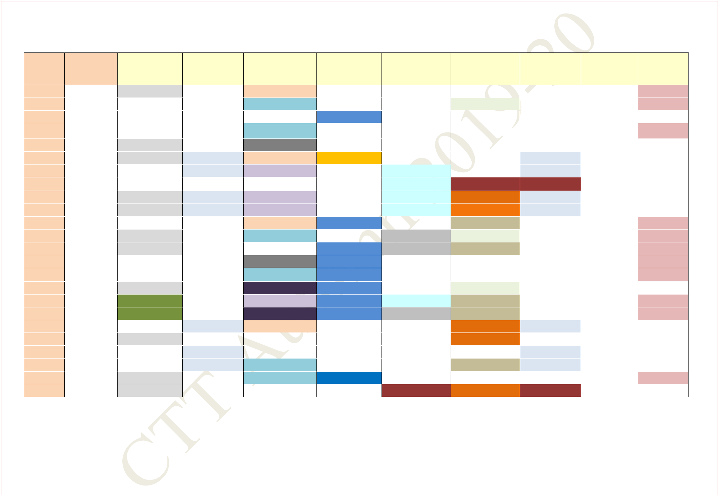**COMMON SUBJECTS AND BREADTH SLOTS FOR SECOND YEAR**

**DEPARTMENTS MAY FIX THE REMAINING CORE/ELECTIVE SUBJECTS IN THE AVAILABLE SLOTS**

|  |  |  |  |  |  |  |  |  |  |  |  |  |  |  |  |  |  |
| --- | --- | --- | --- | --- | --- | --- | --- | --- | --- | --- | --- | --- | --- | --- | --- | --- | --- |
|  | **Course** |  | **No. of** | **A3** | **B3** |  | **C3/4** |  |  | **D3/4** |  | **E3/4** | **F4** |  | **G3** | **U3/4** | **X** |
|  |  |  | **Students** |  |  |  |  |  |  |  |  |  |  |  |  |  |  |
|  |  |  |  |  |  |  |  |  |  |  |  |  |  |  |  |  |  |
|  | **AE** | **51** | | **MA20101** |  |  | **EC21101** |  |  |  |  |  |  |  |  | **Closed** | **BS/EV** |
|  | **AG** | **66** | |  |  |  | **MA20103** |  |  |  |  |  | **ME21101** |  |  |  | **BS/EV** |
|  | **AR** | **35** | |  |  |  |  |  |  | **HS20001** |  |  |  |  |  |  |  |
|  | **BT** | **49** | |  |  |  | **MA20103** |  |  |  |  |  |  |  |  |  | **BS/EV** |
|  | **CE** | **89** | | **MA20101** |  |  | **CE21005** |  |  |  |  |  |  |  |  |  |  |
|  | **CH** | **85** | | **MA20101** | **HSS** |  | **EC21101** |  |  | **CH21103** |  |  |  |  | **HSS** |  |  |
|  |  |  |  |  |  |  |  |  |  |  |  |  |  |  |  |  |  |
|  | **CS** | **107** | |  | **HSS** |  | **EE21101** |  |  |  |  | **EC21103** |  |  | **HSS** | **Closed** |  |
|  |  |  |  |  |  |  |  |  |  |  |  |  |  |  |  |  |  |
|  | **EC** | **113** | | **MA20107** |  |  |  |  |  |  |  | **EC21103** | **B** |  | **B** |  | **Closed** |
|  |  |  |  |  |  |  |  |  |  |  |  |  |  |  |  |  |  |
|  | **EE** | **86** | | **MA20101** | **HSS** |  | **EE21101** |  |  |  |  | **EC21103** | **PH20003** |  | **HSS** |  | **Closed** |
|  |  |  |  |  |  |  |  |  |  |  |  |  |  |  |  |  |  |
|  | **IE** | **32** | | **MA20101** | **HSS** |  | **EE21101** |  |  |  |  | **EC21103** | **PH20003** |  | **HSS** |  | **Closed** |
|  |  |  |  |  |  |  |  |  |  |  |  |  |  |  |  |  |  |
|  | **IM** | **55** | |  |  |  | **EC21101** |  |  | **HS20001** |  |  | **IM21003** |  | **MA20105** | **Closed** | **BS/EV** |
|  |  |  |  |  |  |  |  |  |  |  |  |  |  |  |  |  |  |
|  | **ME** | **130** | | **MA20101** |  |  | **MA20103** |  |  |  |  | **ME20001** | **ME21101** |  |  |  | **BS/EV** |
|  |  |  |  |  |  |  |  |  |  |  |  |  |  |  |  |  |  |
|  | **MF** | **51** | | **MA20101** |  |  |  |  |  | **HS20001** |  | **ME20001** | **IM21003** |  |  |  | **BS/EV** |
|  |  |  |  |  |  |  |  |  |  |  |  |  |  |  |  |  |  |
|  | **MI** | **83** | |  |  |  | **CE21005** |  |  | **HS20001** |  |  |  |  |  |  | **BS/EV** |
|  |  |  |  |  |  |  |  |  |  |  |  |  |  |  |  |  |  |
|  | **MT** | **69** | |  |  |  | **MA20103** |  |  | **HS20001** |  |  |  |  |  |  | **BS/EV** |
|  |  |  |  |  |  |  |  |  |  |  |  |  |  |  |  |  |  |
|  | **NA** | **58** | | **MA20101** |  |  | **ME21103** |  |  | **HS20001** |  |  | **ME21101** |  |  |  |  |
|  |  |  |  |  |  |  |  |  |  |  |  |  |  |  |  |  |  |
|  | **QE** | **7** | | **MT30001** |  |  | **EE21101** |  |  | **HS20001** |  | **EC21103** | **IM21003** |  |  | **Closed** | **EV** |
|  |  |  |  |  |  |  |  |  |  |  |  |  |  |  |  |  |  |
|  | **QM** | **7** | | **MT30001** |  |  | **ME21103** |  |  | **HS20001** |  | **ME20001** | **IM21003** |  |  |  | **BS/EV** |
|  |  |  |  |  |  |  |  |  |  |  |  |  |  |  |  |  |  |
|  | **CY** | **27** | |  | **HSS** |  | **EC21101** |  |  |  |  |  | **PH20003** |  | **HSS** |  |  |
|  |  |  |  |  |  |  |  |  |  |  |  |  |  |  |  |  |  |
|  | **EX** | **30** | | **MA20101** |  |  |  |  |  |  |  |  | **PH20003** |  |  |  |  |
|  |  |  |  |  |  |  |  |  |  |  |  |  |  |  |  |  |  |
|  | **GG** | **31** | |  | **HSS** |  |  |  |  |  |  |  |  |  | **HSS** |  |  |
|  |  |  |  |  |  |  |  |  |  |  |  |  |  |  |  |  |  |
|  | **HS** | **43** | |  | **HSS** |  | **MA20103** |  |  |  |  |  | **IM21003** |  | **HSS** |  |  |
|  |  |  |  |  |  |  |  |  |  |  |  |  |  |  |  |  |  |
|  | **MA** | **53** | | **MA20101** |  |  | **MA20103** |  |  | **HS20001** |  |  |  |  |  |  | **BS/EV** |
|  |  |  |  |  |  |  |  |  |  |  |  |  |  |  |  |  |  |
|  | **PH** | **31** | | **MA20101** |  |  |  |  |  |  |  | **B** | **PH20003** |  | **B** |  |  |
|  |  |  |  |  |  |  |  |  |  |  |  |  |  |  |  |  |  |
| **B: - Breadth Subjects (Allocation will be made in these slots)** | | | | | | | | **EAA is scheduled on SATURDAY morning between 8:00 AM -12:55 PM** | | | | | | | | |  |

**BS: BS20001 –Biological Science & EV: EV20001- Environmental Science Scheduled in X4(1, 2) & X4(3,4) respectively. Interdisciplinary EP subject scheduled in S3 slot. Student strength in July 2019 may vary (max inc/dec.10%) due to Branch Change. Slots for Common Labs on Page :30-31.**

**Central Time Table Autumn 2019– 2020, Version 1.1** **Updated -28 March 2019** **24**

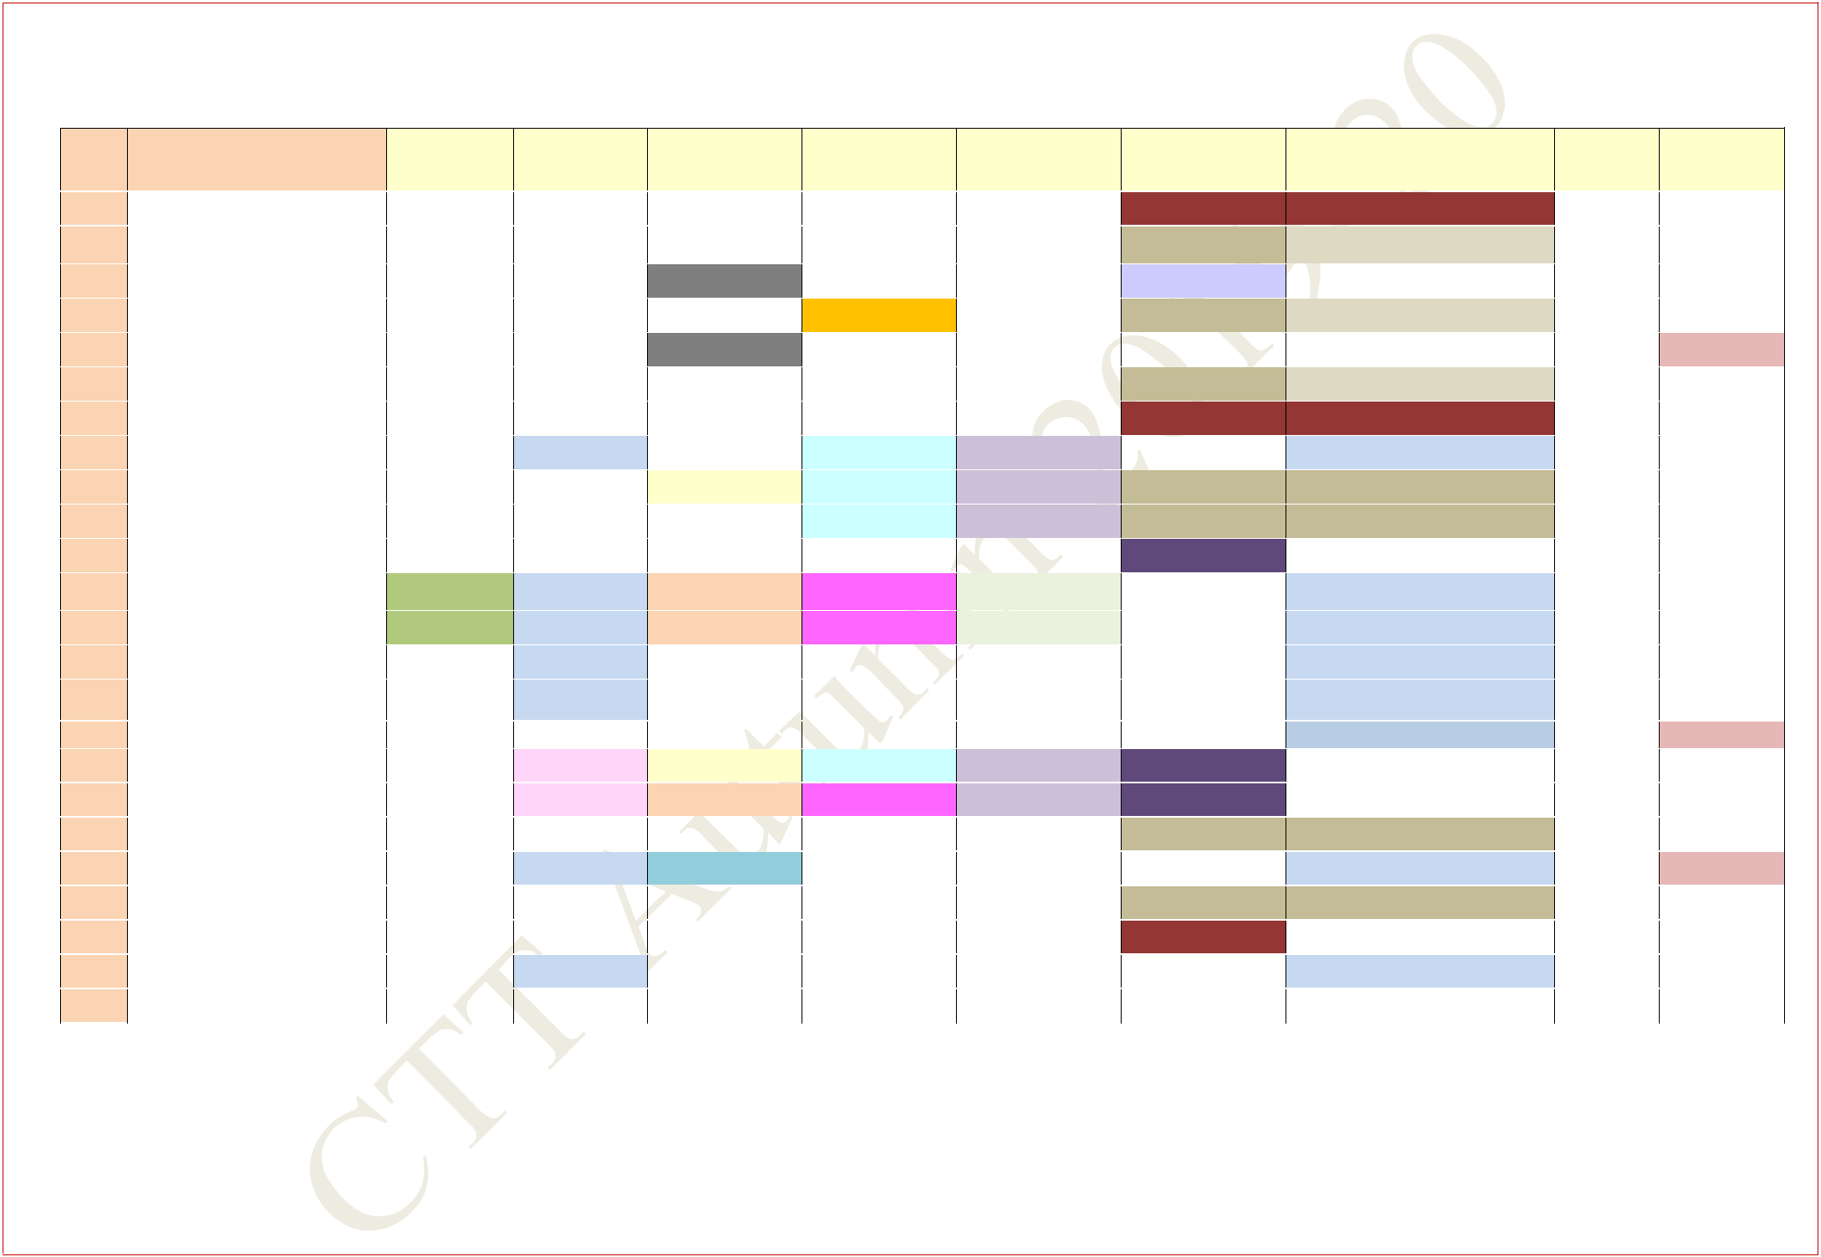**COMMON SUBJECTS AND BREADTH SLOTS FOR THIRD YEAR**

**DEPARTMENTS MAY FIX THE REMAINING CORE/ELECTIVE SUBJECTS IN THE AVAILABLE SLOTS**

|  |  |  |  |  |  |  |  |  |  |  |  |  |  |  |  |  |  |  |  |  |  |
| --- | --- | --- | --- | --- | --- | --- | --- | --- | --- | --- | --- | --- | --- | --- | --- | --- | --- | --- | --- | --- | --- |
| **CC** | | | **No. of** | | **A3** |  | **B3** |  | **C3/4** | | | **D4** | |  |  | **E3/4** | **F4** | **G3** | **U3/4** | **X** |  |
|  |  |  | **Students** | |  |  |  |  |  |  |  |  |  |  |  |  |  |  |  |  |  |
| **AE** | | | **46 + 1(FP) +1(EP)** | |  |  |  |  |  |  |  |  |  |  |  |  | **B** | **B/ MA31020*/EP** |  |  |  |
|  |  |  |  | |  |  |  |  |  |  |  |  |  |  |  |  |  |  |  |  |  |
| **AG** | | | **52 + 2(FP) +4(EP)** | |  |  |  |  |  |  |  |  |  |  |  |  | **M** | **M/MA31020*/EP** |  |  |  |
|  |  |  |  |  |  |  |  |  |  |  |  |  |  |  |  |  |  |  |  |  |  |
| **AR** | | | **38** |  |  |  |  |  | **CE31001** | | |  |  |  |  |  | **EE30024** | **HS30003** |  |  |  |
| **BT** | | | **38+1(EP)** | |  |  |  |  | **CH31001** | | | **CH21103** | |  |  |  | **M** | **M//EP** |  |  |  |
|  |  |  |  |  |  |  |  |  |  |  |  |  |  |  |  |  |  |  |  |  |  |
| **CE** | | | **75** |  |  |  |  |  | **CE31001** | | |  |  |  |  |  |  |  |  | **BS/EV** |  |
|  |  |  |  | |  |  |  |  |  |  |  |  |  |  |  |  |  |  |  |  |  |
| **CH** | | | **84+3(FP)** | |  |  |  |  | **CH31001** | | |  |  |  |  |  | **M** | **M/MA31020\*** |  |  |  |
|  |  |  |  |  |  |  |  |  |  |  |  |  |  |  |  |  |  |  |  |  |  |
| **CS** | | | **105** |  |  |  |  |  |  |  |  |  |  |  |  |  | **B** | **B** |  |  |  |
|  |  |  |  |  |  |  |  |  |  |  |  |  |  |  |  |  |  |  |  |  |  |
| **EC** | | | **112** |  |  |  | **HSS** |  |  |  |  | **EC31003** | |  |  | **EE31009** |  | **HSS** |  |  |  |
|  |  |  |  |  |  |  |  |  |  |  |  |  |  |  |  |  |  |  |  |  |  |
| **EE** | | | **85** |  |  |  |  |  | **EE31011** | | | **EC31003** | |  |  | **EE31009** | **M** | **M** |  |  |  |
|  |  |  |  |  |  |  |  |  |  |  |  |  |  |  |  |  |  |  |  |  |  |
| **IE** | | | **35** |  |  |  |  |  | **CH31001** | | | **EC31003** | |  |  | **EE31009** | **M** | **M** |  |  |  |
|  |  |  |  | |  |  |  |  |  |  |  |  |  |  |  |  |  |  |  |  |  |
| **IM** | | | **50+6(FP)** | |  |  |  |  |  |  |  |  |  |  |  |  |  | **MA31020\*** |  |  |  |
|  |  |  |  | |  |  |  |  |  |  |  |  |  |  |  |  |  |  |  |  |  |
| **ME** | | | **125+ 2(FP)** | | **MT30001** |  | **HSS** |  | **ME30005** | | | **ME31007** | |  | **ME31013** | |  | **HSS/ MA31020\*** |  |  |  |
|  |  |  |  | |  |  |  |  |  |  |  |  |  |  |  |  |  |  |  |  |  |
| **MF** | | | **40+ 1(FP)** | | **MT30001** |  | **HSS** |  | **ME30005** | | | **ME31007** | |  | **ME31013** | |  | **HSS/ MA31020\*** |  |  |  |
|  |  |  |  | |  |  |  |  |  |  |  |  |  |  |  |  |  |  |  |  |  |
| **MI** | | | **61+2(FP) +1(EP)+3(PT)** | |  |  | **HSS** |  |  |  |  |  |  |  |  |  |  | **HSS/MA31020 * /PT/EP** |  |  |  |
|  |  |  |  |  |  |  |  |  |  |  |  |  |  |  |  |  |  |  |  |  |  |
| **MT** | | | **55+2(FP)** | |  |  | **HSS** |  |  |  |  |  |  |  |  |  |  | **HSS/ MA31020\*** |  |  |  |
|  |  |  |  |  |  |  |  |  |  |  |  |  |  |  |  |  |  |
|  |  |  |  | |  |  |  |  |  |  |  |  |  |  |  |  |  |  |  |  |  |
| **NA** | | | **45 + 1(FP)+ 2(EP)** | |  |  |  |  |  |  |  |  |  |  |  |  |  | **MA31020* /EP** |  | **BS/EV** |  |
| **QE** | | | **8** |  |  |  | **IM31011** |  | **EE31011** | | | **EC31003** | |  |  | **EE31009** | **IM31005** |  |  |  |  |
|  |  |  |  |  |  |  |  |  |  |  |  |  |  |  |  |  |  |  |  |  |  |
| **QM** | | | **6** |  |  |  | **IM31011** |  | **ME30005** | | | **ME31007** | |  |  | **EE31009** | **IM31005** |  |  |  |  |
|  |  |  |  |  |  |  |  |  |  |  |  |  |  |  |  |  |  |  |  |  |  |
| **CY** | | | **26** |  |  |  |  |  |  |  |  |  |  |  |  |  | **M** | **M** |  |  |  |
|  |  |  |  |  |  |  |  |  |  |  |  |  |  |  |  |  |  |  |  |  |  |
| **EX** | | | **30** |  |  |  | **HSS** |  | **MA20103** | | |  |  |  |  |  |  | **HSS** |  | **BS/EV** |  |
|  |  |  |  | |  |  |  |  |  |  |  |  |  |  |  |  |  |  |  |  |  |
| **GG** | | | **30+2(PT)** | |  |  |  |  |  |  |  |  |  |  |  |  | **M** | **M /PT** |  |  |  |
|  |  |  |  |  |  |  |  |  |  |  |  |  |  |  |  |  |  |  |  |  |  |
| **HS** | | | **50** |  |  |  |  |  |  |  |  |  |  |  |  |  | **B** | **MA31020\*** |  |  |  |
|  |  |  |  |  |  |  |  |  |  |  |  |  |  |  |  |  |  |  |  |  |  |
| **MA** | | | **55** |  |  |  | **HSS** |  |  |  |  |  |  |  |  |  |  | **HSS** |  |  |  |
|  |  |  |  |  |  |  |  |  |  |  |  |  |  |  |  |  |  |  |  |  |  |
| **PH** | | | **33** |  |  |  |  |  |  |  |  |  |  |  |  |  |  |  |  |  |  |
|  |  |  |  | |  |  |  |  |  |  |  |  |  |  |  |  |  |  |  |  |  |
|  | | | **B: - Breadth Subjects (Allocation will be made in these slots)** | | | | | | | | |  |  | **M - Management Breadth** | | | |  |  |  |  |
|  | | | **FP** | **Interdisciplinary Dual Degree Program of Financial Engineering *MA31020 ,is 4crd and will run in S3(1) + G3** | | | | | | | | | | | | | | |  |  |  |
|  | | |  |  | | | | |  | | | |  | | |  | | |  |  |  |
| **EP** | **Interdisciplinary Dual Degree Program of Engineering Entrepreneurship EP60004 in G3 slot for Interdisciplinary EP students.** | | | | | | | | | | | | | | |  |  |  |
|  | | |  |  | | | | |  | | | | |  |  |  |  |  |  |  |  |
| **PT** | **Dual Degree Program in Petroleum Engineering –HS30037 in G3** | | | | | | | | | |  |  |  |  |  |  |  |  |

**BS: BS20001 –Biological Science & EV: EV20001- Environmental Science Scheduled in X1, X2 & X3, X4 respectively.**

**Central Time Table Autumn 2019– 2020, Version 1.1** **Updated -28 March 2019** **25**

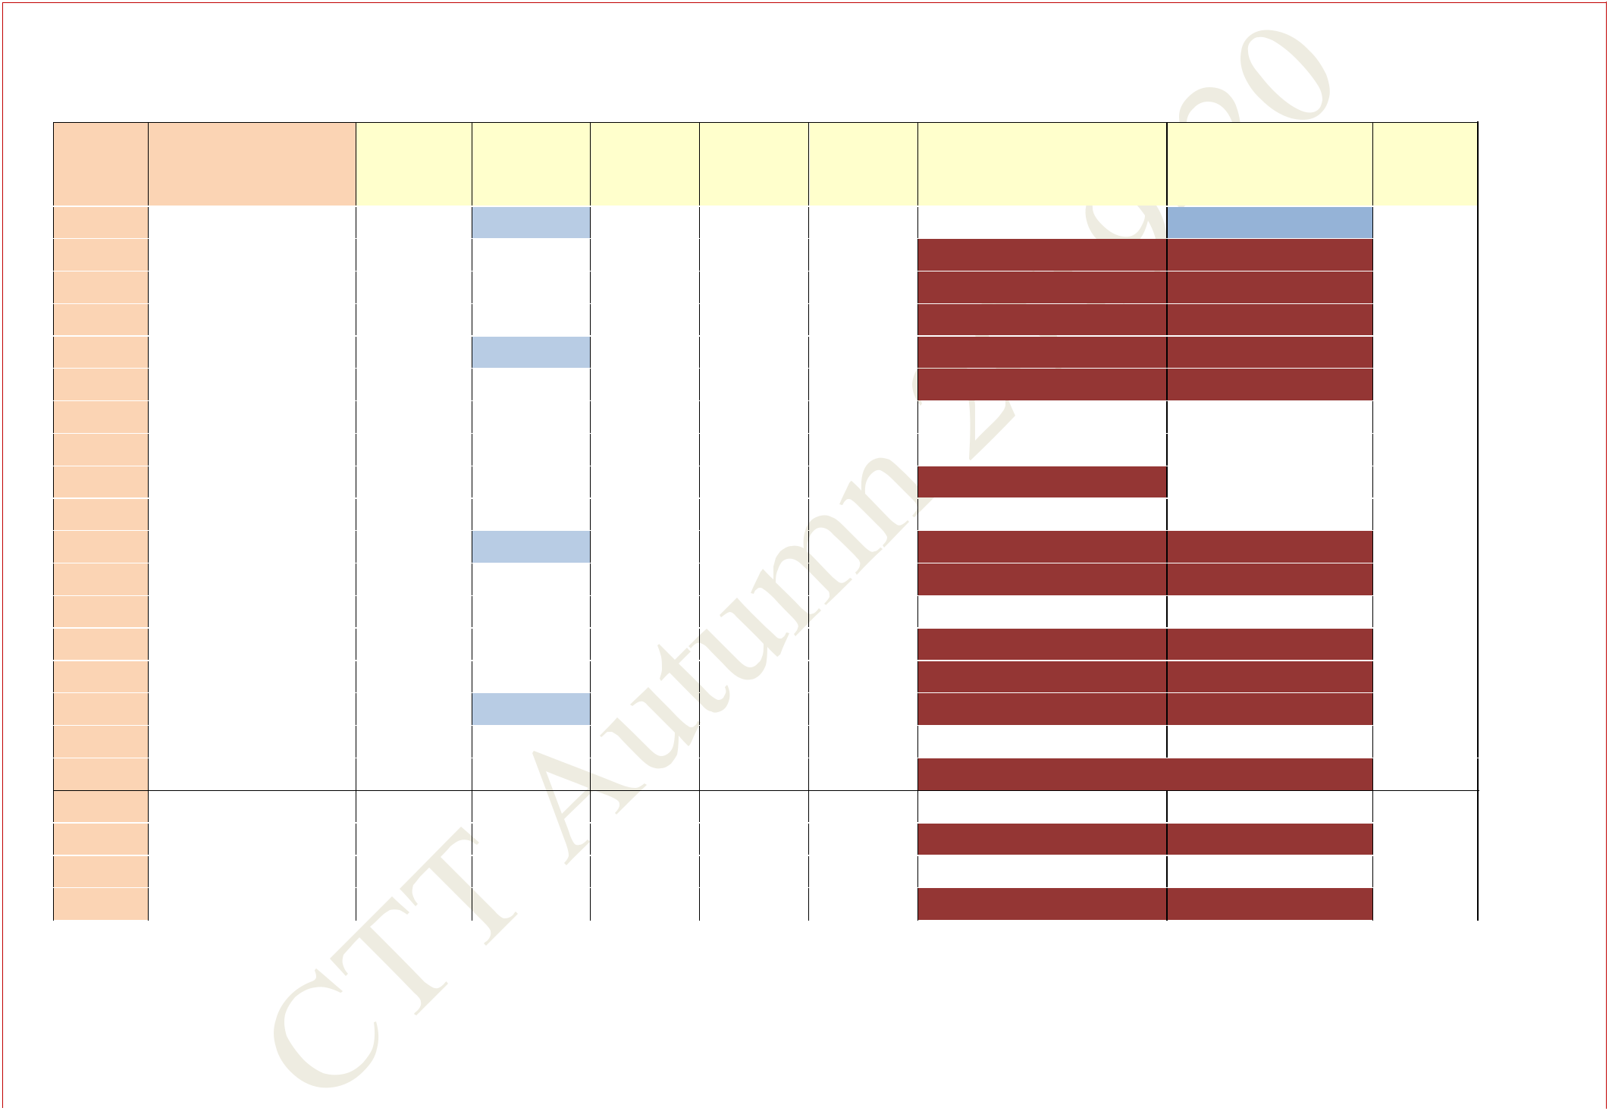**COMMON SUBJECTS AND BREADTH SLOTS FOR FOURTH YEAR**

**DEPARTMENTS ARE MAY FIX THE REMAINING CORE/ELECTIVE SUBJECTS IN THE AVAILABLE SLOTS**

|  |  |  |  |  |  |  |  |  |  |
| --- | --- | --- | --- | --- | --- | --- | --- | --- | --- |
| **Course** | **No. of** | **A3** | **B3** | **C4** | **D3/4** | **E3/4** | **F4** | **G3** | **U3/4** |
|  | **Students** |  |  |  |  |  |  |  |  |
|  |  |  |  |  |  |  |  |  |  |
| **AE** | **29** |  | **HSS** |  |  |  |  | **HSS** |  |
|  |  |  |  |  |  |  |  |  |  |
| **AG** | **30+3(FP)+ 6(EP)** |  |  |  |  |  | **B/ MA41031 /EP60005** | **B/ BM60023** |  |
|  |  |  |  |  |  |  |  |  |  |
| **AR** | **37** |  |  |  |  |  | **B** | **B** |  |
|  |  |  |  |  |  |  |  |  |  |
| **BT** | **23** |  |  |  |  |  | **B** | **B** |  |
|  |  |  |  |  |  |  |  |  |  |
| **CE** | **57+3(FP)** |  | **HSS** |  |  |  | **MA41031** | **HSS/ BM60023** |  |
|  |  |  |  |  |  |  |  |  |  |
| **CH** | **54+3(FP)+ 2(PT)** |  |  |  |  |  | **B/ MA41031** | **B/ BM60023/PT** |  |
|  |  |  |  |  |  |  |  |  |  |
| **CS** | **61** |  |  |  |  |  |  |  |  |
|  |  |  |  |  |  |  |  |  |  |
| **EC** | **68** |  |  |  |  |  |  |  |  |
|  |  |  |  |  |  |  |  |  |  |
| **EE** | **61+1(EP)** |  |  |  |  |  | **EP60005** |  |  |
|  |  |  |  |  |  |  |  |  |  |
| **IE** | **35** |  |  |  |  |  |  |  |  |
|  |  |  |  |  |  |  |  |  |  |
| **IM** | **32+3(FP)** |  | **HSS** |  |  |  | **MA41031** | **HSS/ BM60023** |  |
|  |  |  |  |  |  |  |  |  |  |
| **ME** | **72+1(FP)** |  |  |  |  |  | **MA41031** | **BM60023** |  |
|  |  |  |  |  |  |  |  |  |  |
| **MF** | **32** |  |  |  |  |  |  |  |  |
|  |  |  |  |  |  |  |  |  |  |
| **MI** | **32+3(FP) )+ 1(EP)+ 3(PT)** |  |  |  |  |  | **MA41031/EP60005** | **BM60023/PT** |  |
|  |  |  |  |  |  |  |  |  |  |
| **MT** | **33+1(FP) +1(EP)** |  |  |  |  |  | **MA41031 /EP60005** | **BM60023** |  |
|  |  |  |  |  |  |  |  |  |  |
| **NA** | **24+3(FP)** |  | **HSS** |  |  |  | **MA41031 /EP60005** | **HSS/ BM60023** |  |
|  |  |  |  |  |  |  |  |  |  |
| **CY** | **22** |  |  |  |  |  |  |  |  |
|  |  |  |  |  |  |  |  |  |  |
| **EX** | **29+2(PT)** |  |  |  |  |  | **M** | **M /PT** |  |

1. **27**

|  |  |  |  |  |  |
| --- | --- | --- | --- | --- | --- |
| **HS** | **49** |  |  | **M** | **M** |
|  |  |  |  |  |  |
| **MA** | **55** |  |  |  |  |
|  |  |  |  |  |  |
| **PH** | **34** |  |  | **M** | **M** |
|  |  |  |  |  |  |

**FP Indicates students from Interdisciplinary Dual Degree Program : Financial Engineering: MA41031 and BM60023 for FP students only**

**EP Indicates students from Interdisciplinary Dual Degree Program : Engineering Entrepreneurship EP60005 for EP students only,**

**PT Dual Degree Program in Petroleum Engineering—PE40001**

|  |  |  |
| --- | --- | --- |
| **B: - Breadth Subjects (Allocation will be made in these slots)** | **M:- Management Breadth** |  |
| **Central Time Table Autumn 2019– 2020, Version 1.1** | **Updated -28 March 2019** | **26** |
|  |  |  |

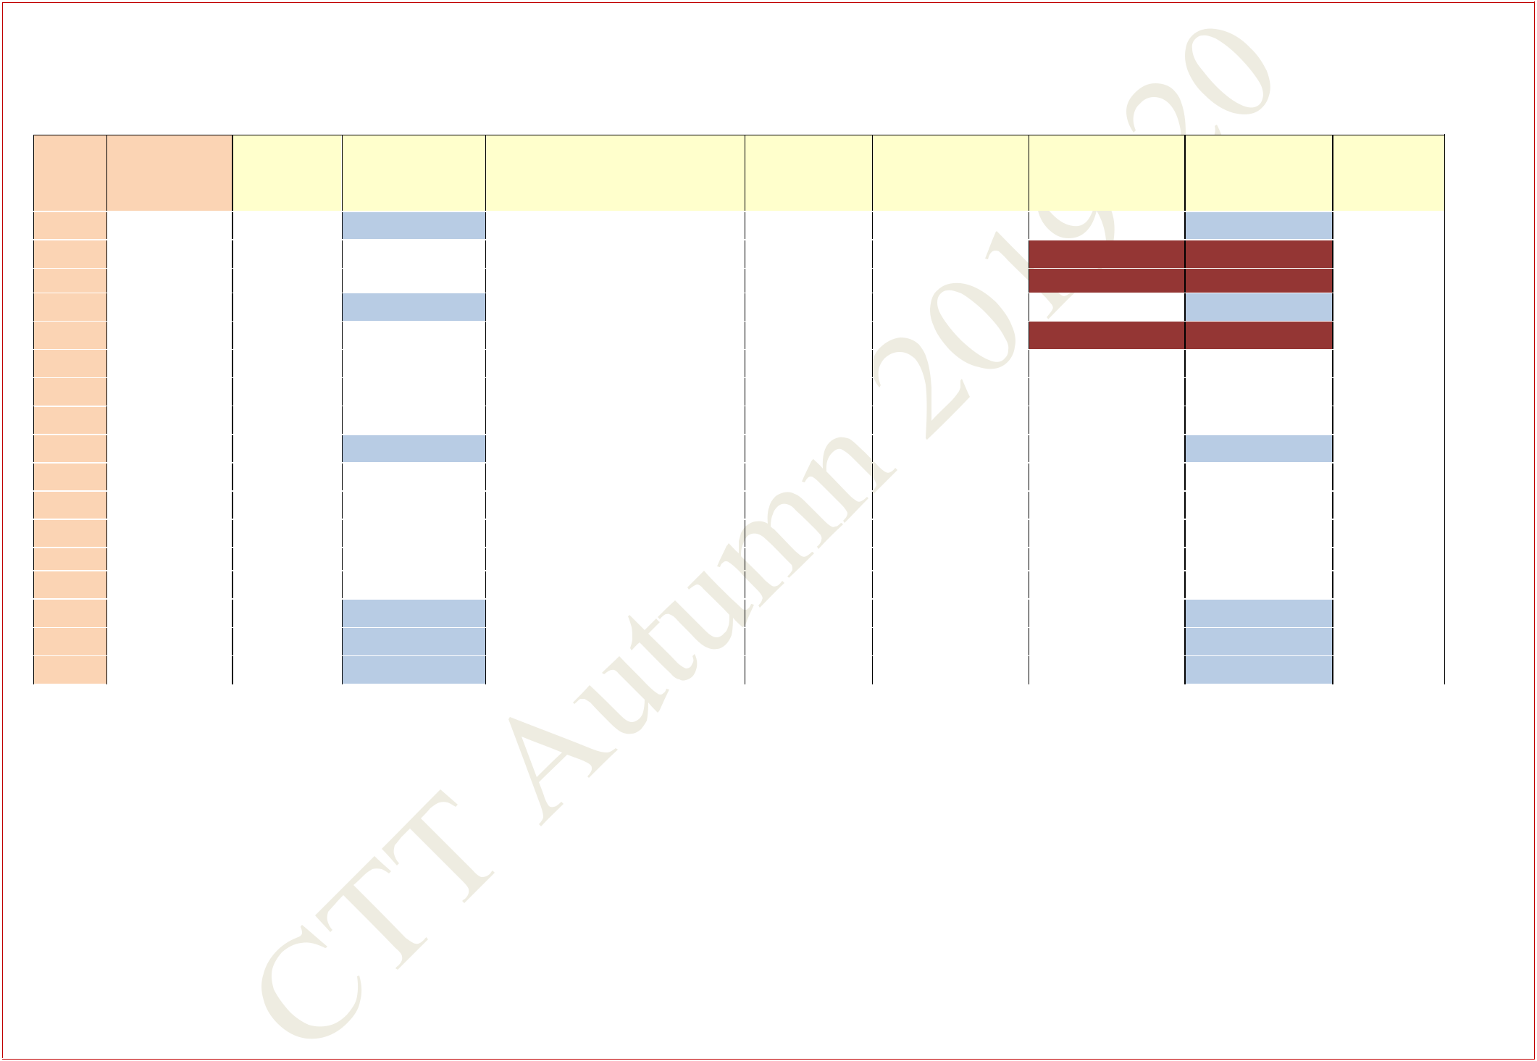**COMMON SUBJECTS AND BREADTH SLOTS FOR FOURTH YEAR (DUAL-DEGREE)**

**DEPARTMENTS MAY FIX THE REMAINING CORE/ELECTIVE SUBJECTS IN THE AVAILABLE SLOTS**

|  |  |  |  |  |  |  |  |  |  |  |  |  |  |  |  |  |  |
| --- | --- | --- | --- | --- | --- | --- | --- | --- | --- | --- | --- | --- | --- | --- | --- | --- | --- |
| **DEPT** |  | **No. of** |  | **A3** | **B3** |  | **C4** |  | **D3/4** |  | **E3/4** |  | **F4** |  | **G3** | **U3/4** |  |
|  | **Students** |  |  |  |  |  |  |  |
|  |  |  |  |  |  |  |  |  |  |  |  |  |  |  |  |  |
|  |  |  |  |  |  |  |  |  |  |  |  |  |  |  |  |  |  |
| **AE1** | **15** | |  |  | **HSS** |  |  |  |  |  |  |  |  |  | **HSS** |  |  |
| **AGD** | **23** | |  |  |  |  |  |  |  |  |  |  | **B** |  | **B** |  |  |
|  |  |  |  |  |  |  |  |  |  |  |  |  |  |  |  |  |  |
| **BT1** | **22** | |  |  |  |  |  |  |  |  |  |  | **B** |  | **B** |  |  |
| **CED** | **19** | |  |  | **HSS** |  |  |  |  |  |  |  |  |  | **HSS** |  |  |
| **CH1** | **28** | |  |  |  |  |  |  |  |  |  |  | **B** |  | **B** |  |  |
|  |  |  |  |  |  |  |  |  |  |  |  |  |  |  |  |  |  |
| **CS2** | **44** | |  |  |  |  |  |  |  |  |  |  |  |  |  |  |  |
|  |  |  |  |  |  |  |  |  |  |  |  |  |  |  |  |  |  |
| **ECD** | **44** | |  |  |  |  |  |  |  |  |  |  |  |  |  |  |  |
|  |  |  |  |  |  |  |  |  |  |  |  |  |  |  |  |  |  |
| **EED** | **23** | |  |  |  |  |  |  |  |  |  |  |  |  |  |  |  |
|  |  |  |  |  |  |  |  |  |  |  |  |  |  |  |  |  |  |
| **IM1** | **21** | |  |  | **HSS** |  |  |  |  |  |  |  |  |  | **HSS** |  |  |
| **MED** | **53** | |  |  |  |  |  |  |  |  |  |  |  |  |  |  |  |
|  |  |  |  |  |  |  |  |  |  |  |  |  |  |  |  |  |  |
| **MF1** | **16** | |  |  |  |  |  |  |  |  |  |  |  |  |  |  |  |
|  |  |  |  |  |  |  |  |  |  |  |  |  |  |  |  |  |  |
| **MI1** | **13** | |  |  |  |  |  |  |  |  |  |  |  |  |  |  |  |
|  |  |  |  |  |  |  |  |  |  |  |  |  |  |  |  |  |  |
| **MI3** | **14** | |  |  |  |  |  |  |  |  |  |  |  |  |  |  |  |
| **MT1** | **17** | |  |  |  |  |  |  |  |  |  |  |  |  |  |  |  |
|  |  |  |  |  |  |  |  |  |  |  |  |  |  |  |  |  |  |
| **NA1** | **17** | |  |  | **HSS** |  |  |  |  |  |  |  |  |  | **HSS** |  |  |
|  |  |  |  |  |  |  |  |  |  |  |  |  |  |  |  |  |  |
| **QE** | **7** | |  |  | **HSS** |  |  |  |  |  |  |  |  |  | **HSS** |  |  |
|  |  |  |  |  |  |  |  |  |  |  |  |  |  |  |  |  |  |
| **QM** | **7** | |  |  | **HSS** |  |  |  |  |  |  |  |  |  | **HSS** |  |  |
|  |  |  |  |  |  |  |  |  |  |  |  |  |  |  |  |  |  |
|  |  | **B: - Breadth Subjects (Allocation will be made in these slots)** | | | | | |  | **M: - Management Breadth** | | |  |  |  |  |  |  |

**Central Time Table Autumn 2019– 2020, Version 1.1** **Updated -28 March 2019** **27**

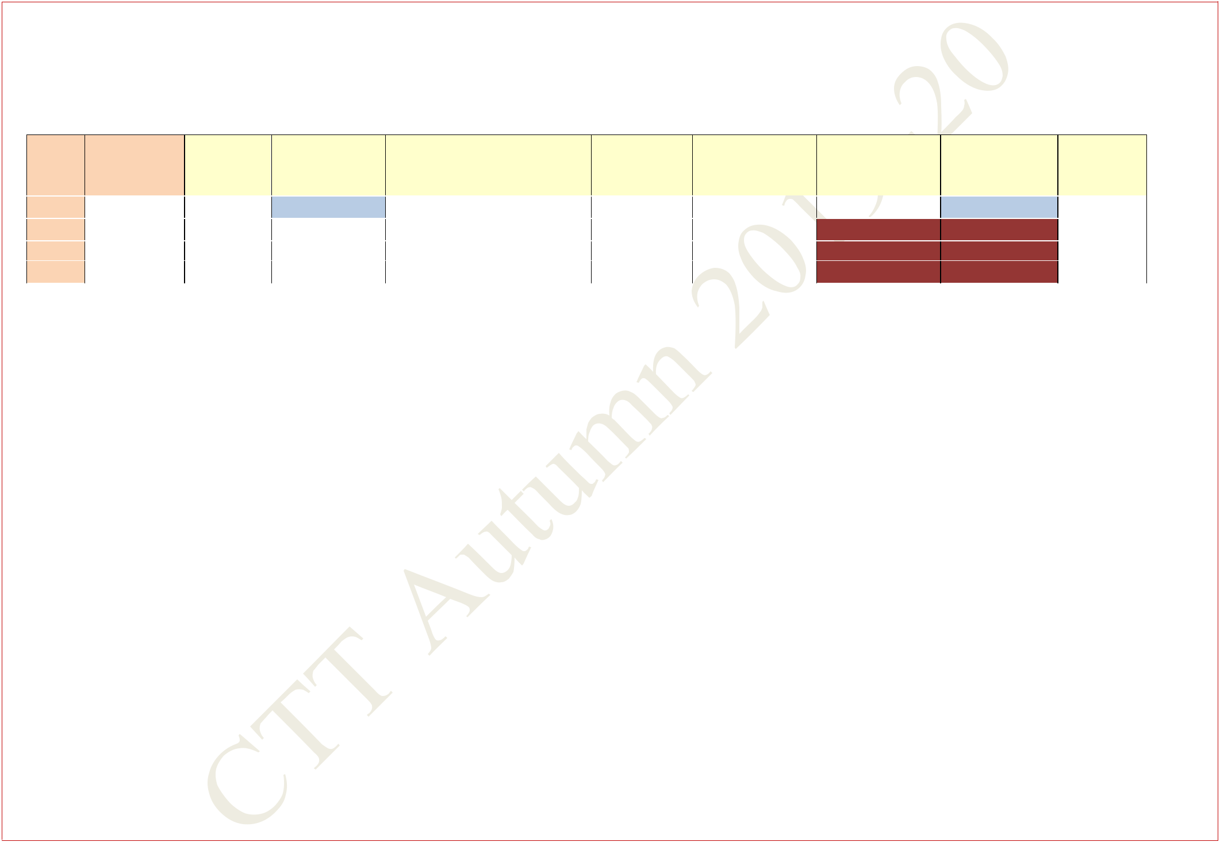**COMMON SUBJECTS AND BREADTH SLOTS FOR FIFTH YEAR**

**Only the following disciplines have Breadth/HSS components**

**THESE AND THE OTHER DEPARTMENTS MAY TO FIX THE REMAINING CORE/ELECTIVE SUBJECTS IN THE AVAILABLE SLOTS**

|  |  |  |  |  |  |  |  |  |  |  |  |  |  |  |  |  |  |
| --- | --- | --- | --- | --- | --- | --- | --- | --- | --- | --- | --- | --- | --- | --- | --- | --- | --- |
| **DEPT** |  | **No. of** |  | **A3** | **B3** |  | **C4** |  | **D3/4** |  | **E3/4** |  | **F4** |  | **G3** | **U3/4** |  |
|  | **Students** |  |  |  |  |  |  |  |
|  |  |  |  |  |  |  |  |  |  |  |  |  |  |  |  |  |
|  |  |  |  |  |  |  |  |  |  |  |  |  |  |  |  |  |  |
| **AR** | **34** | |  |  | **HSS** |  |  |  |  |  |  |  |  |  | **HSS** |  |  |
| **EX** | **24** | |  |  |  |  |  |  |  |  |  |  | **B** |  | **B** |  |  |
|  |  |  |  |  |  |  |  |  |  |  |  |  |  |  |  |  |  |
| **GG** | **20** | |  |  |  |  |  |  |  |  |  |  | **B** |  | **B** |  |  |
| **HS** | **47** | |  |  |  |  |  |  |  |  |  |  | **B** |  | **B** |  |  |
|  |  |  |  |  |  |  |  |  |  |  |  |  |  |  |  |  |  |

**Central Time Table Autumn 2019– 2020, Version 1.1** **Updated -28 March 2019** **28**

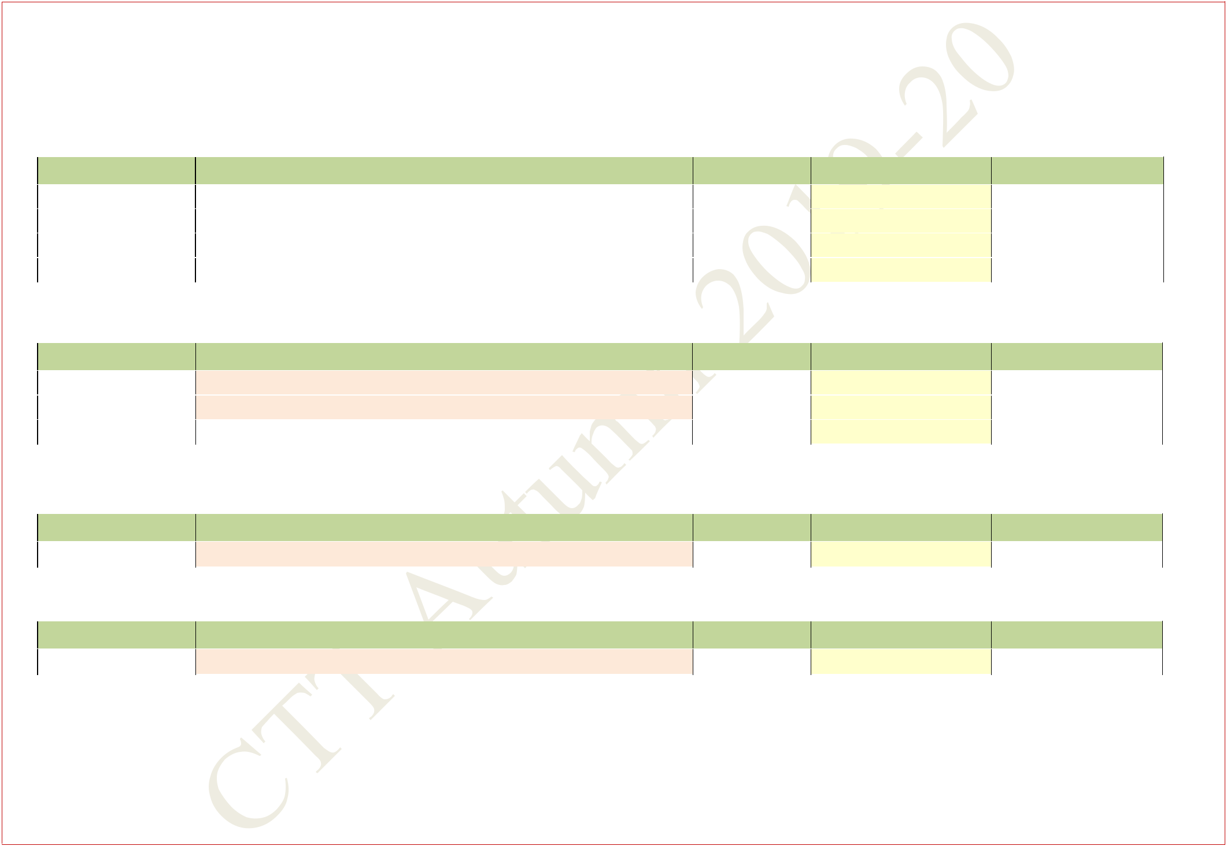**SLOT ALLOCATION FOR COMMON SUBJECTS OF SECOND, THIRD AND FOURTH YEAR**

|  |  |  |  |  |  |  |  |
| --- | --- | --- | --- | --- | --- | --- | --- |
| **1. MA20101** | | **Transform Calculus** | |  |  | **3-0-0** |  |
|  |  |  | |  |  |  |  |
|  | **Section** | **Departments** | |  | **Room No.** | **No. of Students** | **Slot** |
|  | |  | |  |  |  |  |
|  | **1** | **AE (51) + ME (130)** | |  | **NR321** | **181** | **A3** |
|  | |  |  |  |  |  |  |
|  | **2** | **CE (89)** | **+ EX (30) + NA (58)** |  | **NR322** | **177** | **A3** |
|  | |  |  |  |  |  |  |
|  | **3** | **CH (85)** | **+ MF (51) + PH (31)** |  | **NR421** | **167** | **A3** |
|  | |  | |  |  |  |  |
|  | **4** | **EE (86) + MA (53) + IE (32)** | |  | **NR422** | **171** | **A3** |
|  |  |  |  |  |  |  |  |

|  |  |  |  |  |  |
| --- | --- | --- | --- | --- | --- |
| **2. MA20103** | | **Partial Differential Equations** |  | **3-0-0** |  |
|  |  |  |  |  |  |
|  | **Section** | **Departments** | **Room No.** | **No. of Students** | **Slot** |
|  | |  |  |  |  |
|  | **1** | **AG (66) + EX 3rd Yr (31) + MT (69)** | **NR321** | **166** | **C3** |
|  | |  |  |  |  |
|  | **2** | **BT (49) + HS (43) + MA (53)** | **NR322** | **145** | **C3** |
|  | |  |  |  |  |
|  | **3** | **ME (130)** | **NR421** | **130** | **C3** |
|  |  |  |  |  |  |

|  |  |  |  |  |  |  |  |  |
| --- | --- | --- | --- | --- | --- | --- | --- | --- |
| **3. MA20105** | | **Linear Algebra** |  |  |  | **3-0-0** | |  |
|  |  |  |  |  |  |  |  |  |
|  | **Section** |  | **Departments** |  | **Room No.** | **No. of** | **Students** | **Slot** |
|  | |  |  |  |  |  |  |  |
|  | **1** |  | **IM(55)** |  | **NC141** |  | **55** | **G3** |
|  |  |  |  |  |  |  | |  |
| **4. MA20107** | | **Matrix Algebra** |  |  |  | **3-0-0** | |  |
|  |  |  |  |  |  |  |  |  |
|  | **Section** |  | **Departments** |  | **Room No.** | **No. of** | **Students** | **Slot** |
|  | |  |  |  |  |  |  |  |
|  | **1** |  | **EC(113)** |  | **NC142** |  | **113** | **A3** |
|  |  |  |  |  |  |  |  |  |

**Central Time Table Autumn 2019– 2020, Version 1.1** **Updated -28 March 2019** **29**

|  |  |  |  |  |  |  |  |  |  |  |  |
| --- | --- | --- | --- | --- | --- | --- | --- | --- | --- | --- | --- |
| **5. EC21101** | |  | **Basic Electronics (for Non Electrical Sciences)** | | |  |  | **3-1-0** |  |  |  |
|  |  |  |  | | |  |  |  |  |  |  |
|  | **Section** |  | **Departments** | | |  | **Room No.** | **No. of Students** | | | **Slot** |
|  |  |  |  | | |  |  |  |  |  |  |
|  | **1** |  | **AE (51) + CH (85) + CY (27) + IM (55)** | | |  | **NR221** | **218** |  |  | **C4** |
| **6. EC29001** | | **Basic Electronics Lab. (for Non Electrical Sciences)** | | | |  |  | **0-0-3** |  |  |  |
|  |  |  |  | | |  |  |  |  |  |  |
|  | **Section** |  | **Departments** | | |  | **Room No.** | **No. of Students** | | | **Slot** |
|  |  |  |  |  |  |  |  |  |  |  |  |
|  | **1** |  | **AE (51)** | **+** | **IM (55)** |  | **In Deptt.** | **106** |  |  | **J** |
|  |  |  |  |  |  |  |  |  |  |  |  |
|  | **2** |  | **CY (27)** | **+** | **CH (85)** |  | **In Deptt.** | **112** |  |  | **N** |
|  |  |  |  | | |  |  |  |  |  |  |
| **7.** | **EC21103** |  | **Introduction to Basic Electronics (for Electrical Sciences)** | | | | | **3-1-0** |  |  |  |
|  | **Section** |  | **Departments** | | |  | **Room** | **No. of Students** | | | **Slot** |
|  |  |  |  | | |  |  |  |  |  |  |
|  | **1** |  | **EE (86) + EC (113)** | | |  | **NR321** | **199** |  |  | **E4** |
|  |  |  |  |  | |  |  |  |  |  |  |
|  | **2** |  | **CS (107) +** | **IE (32) + QE (7)** | |  | **NR322** | **146** |  |  | **E4** |
|  |  |  |  | | |  |  |  |  |  |  |
| **8.** | **EC29003** |  | **Introduction to Basic Electronics Lab. (for Electrical Sciences)** | | | | | **0-0-3** |  |  |  |
|  |  |  |  | | |  |  |  |  |  |  |
|  | **Section** |  | **Departments** | | |  | **Room** | **No. of Students** | | | **Slot** |
|  |  |  |  | | |  |  |  |  |  |  |
|  | **1** |  | **CS (107) + QE (7)** | | |  | **In Deptt.** | **114** |  |  | **L** |
|  | **2** |  | **EC (113)** | | |  | **In Deptt.** | **113** |  |  | **X** |
|  | **3** |  | **EE (86) + IE (32)** | | |  | **In Deptt.** | **118** |  |  | **P** |
| **9.** | **BS20001** |  | **Biological Science (Coordinated by BT)** | | |  |  | **2-0-0** |  |  |  |
|  |  |  |  | | |  |  |  |  |  |  |
|  | **Section** |  | **Departments** | | |  | **Room No.** | **No. of Students** | | | **Slot** |
|  |  |  |  | | |  |  |  |  |  |  |
|  | **1** |  | **BT (49)+ IM (55) + MA (53) + EX (3rd year)(31)** | | |  | **NR321** | **188** |  |  | **X1,X2** |
|  |  |  |  | | |  |  |  |  |  |  |
|  | **2** |  | **AE (51) + MF (51) +CE ( 3rd year)(75)+QM(7)** | | |  | **NR322** | **184** |  |  | **X1,X2** |
|  |  |  |  | | |  |  |  |  |  |  |
|  | **3** |  | **AG (66) + ME (130)** | | |  | **NR421** | **196** |  |  | **X1,X2** |
|  |  |  |  | | |  |  |  |  |  |  |
|  | **4** |  | **MI (83) + MT (69) + NA (3rd year)(48)** | | |  | **NR422** | **200** |  |  | **X1,X2** |
|  |  |  |  |  |  |  |  |  |  |  |  |

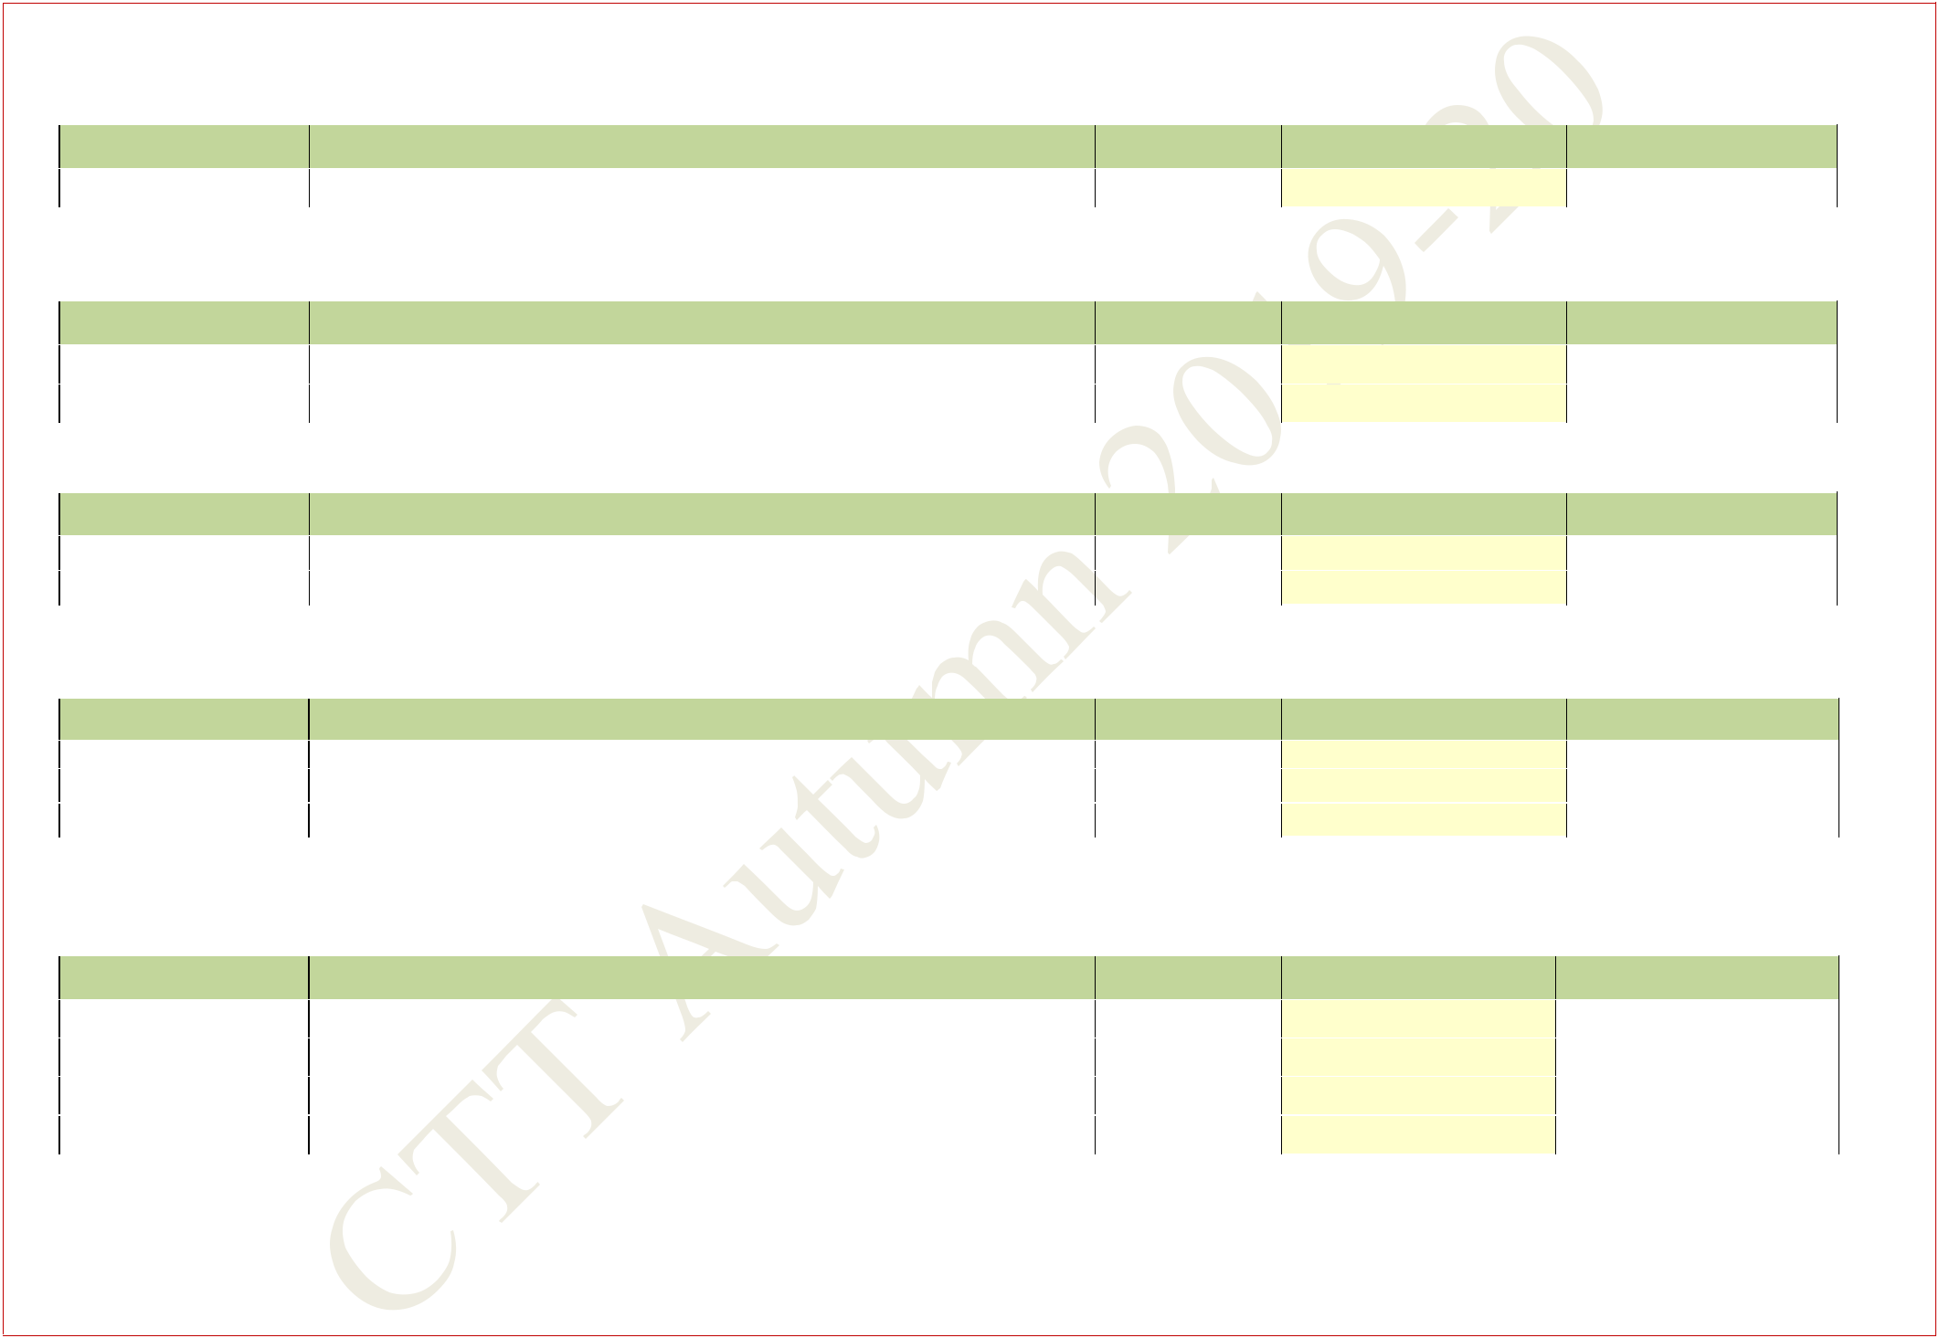

**Central Time Table Autumn 2019– 2020, Version 1.1** **Updated -28 March 2019** **30**

|  |  |  |  |  |  |  |
| --- | --- | --- | --- | --- | --- | --- |
| **10. EV20001** | | **Environmental Science (Coordinated by CE)** |  |  | **2-0-0** |  |
|  |  |  |  |  |  |  |
|  | **Section** | **Departments** |  | **Room No.** | **No. of Students** | **Slot** |
|  | |  |  |  |  |  |
|  | **1** | **AE (51)+ AG (66)** |  | **NR321** | **117** | **X3,X4** |
|  | |  |  |  |  |  |
|  | **2** | **BT (49)+ CE ( 3rd year)(75)** |  | **NR322** | **124** | **X3,X4** |
|  | |  |  |  |  |  |
|  | **3** | **EX (3rd year)(31)+ )+ IM (55) + MA (53)** |  | **NR421** | **139** | **X3,X4** |
|  | |  |  |  |  |  |
|  | **4** | **ME(130)** |  | **NR422** | **130** | **X3,X4** |
|  | |  |  |  |  |  |
|  | **5** | **MI (83)+ MF (51)** |  | **NR221** | **134** | **X3,X4** |
|  | |  |  |  |  |  |
|  | **6** | **MT (69) + NA (3rd year)(48) +QD(14)** |  | **NR121** | **131** | **X3,X4** |
|  |  |  |  |  |  |  |

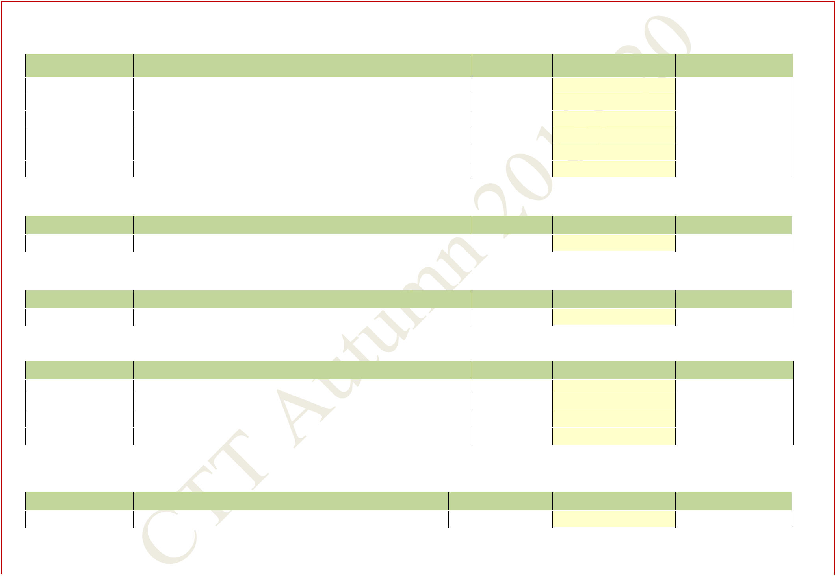

|  |  |  |  |  |  |  |  |  |  |  |
| --- | --- | --- | --- | --- | --- | --- | --- | --- | --- | --- |
| **11. PH20003** | | **Physics-II** |  |  |  |  | **3-1-0** |  |  |  |
|  |  |  |  |  |  |  |  |  | |  |
|  | **Section** | **Departments** |  |  |  | **Room No.** | **No. of Students** | **Slot** |  |  |
|  |  |  | |  |  |  |  |  |  |  |
|  | **1** | **CY (27) + EE (86) + EX (30) + IE (32) + PH (31)** | |  |  | **NR321** | **206** | **F4** | | |
|  |  |  |  |  |  |  |  |  |  |  |
| **12. EE21101** | | **Signals and Networks** |  |  |  |  | **3-1-0** |  |  |  |
|  |  |  |  |  |  |  |  |  |  |  |
|  | **Section** | **Department** |  |  |  | **Room No.** | **No. of Students** | **Slot** | | |
|  |  |  | |  |  |  |  |  |  |  |
| **1** | | **EE (86) + IE (32) + CS (107) + QE(7)** | |  |  | **NR422** | **232** | **C4** | | |
|  |  |  |  |  |  |  |  |  |  |  |
| **13. EE29001** | | **Signals and Networks Lab.** |  |  |  |  | **0-0-3** |  |  |  |
|  | **Section** | **Department** |  |  |  | **Room No.** | **No. of Students** | **Slot** | |  |
|  |  |  |  |  |  |  |  |  | |  |
|  | **1** | **EE (BTech Only)** |  |  |  | **In Deptt.** | **60** | **N** | |  |
|  | **2** | **CS (Dual Degree)(46) + QE (7)** | |  |  | **In Deptt.** | **53** | **J** | | |
|  |  |  |  |  |  |  |  |  | |  |
| **3** | | **CS (BTech Only)** |  |  |  | **In Deptt.** | **61** | **P** | | |
|  |  |  | |  |  |  |  |  | |  |
|  | **4** | **EE (Dual Degree)(26) + IE (32)** | |  |  | **In Deptt.** | **58** | **X** | | |
|  |  |  |  |  |  |  |  |  |  |  |
| **14. IM21003** | | **Operations Research -I** |  |  |  |  | **3-1-0** |  |  |  |
|  |  |  |  |  | | |  |  |  | |
|  | **Section** | **Departments** |  | **Room No.** | | | **No. of Students** | **Slot** | | |
|  |  |  | |  |  |  |  |  |  | |
| **1** | | **IM (55) + MF (51) + HS (43) + QD (14)** | |  |  | **NR322** | **163** | **F4** | | |
|  |  | |  |  | | |  |  |  | |
| **Central Time Table Autumn 2019– 2020, Version 1.1** | | | **Updated -28 March 2019** | | | |  | **31** | | |
|  |  |  |  |  |  |  |  |  |  |  |

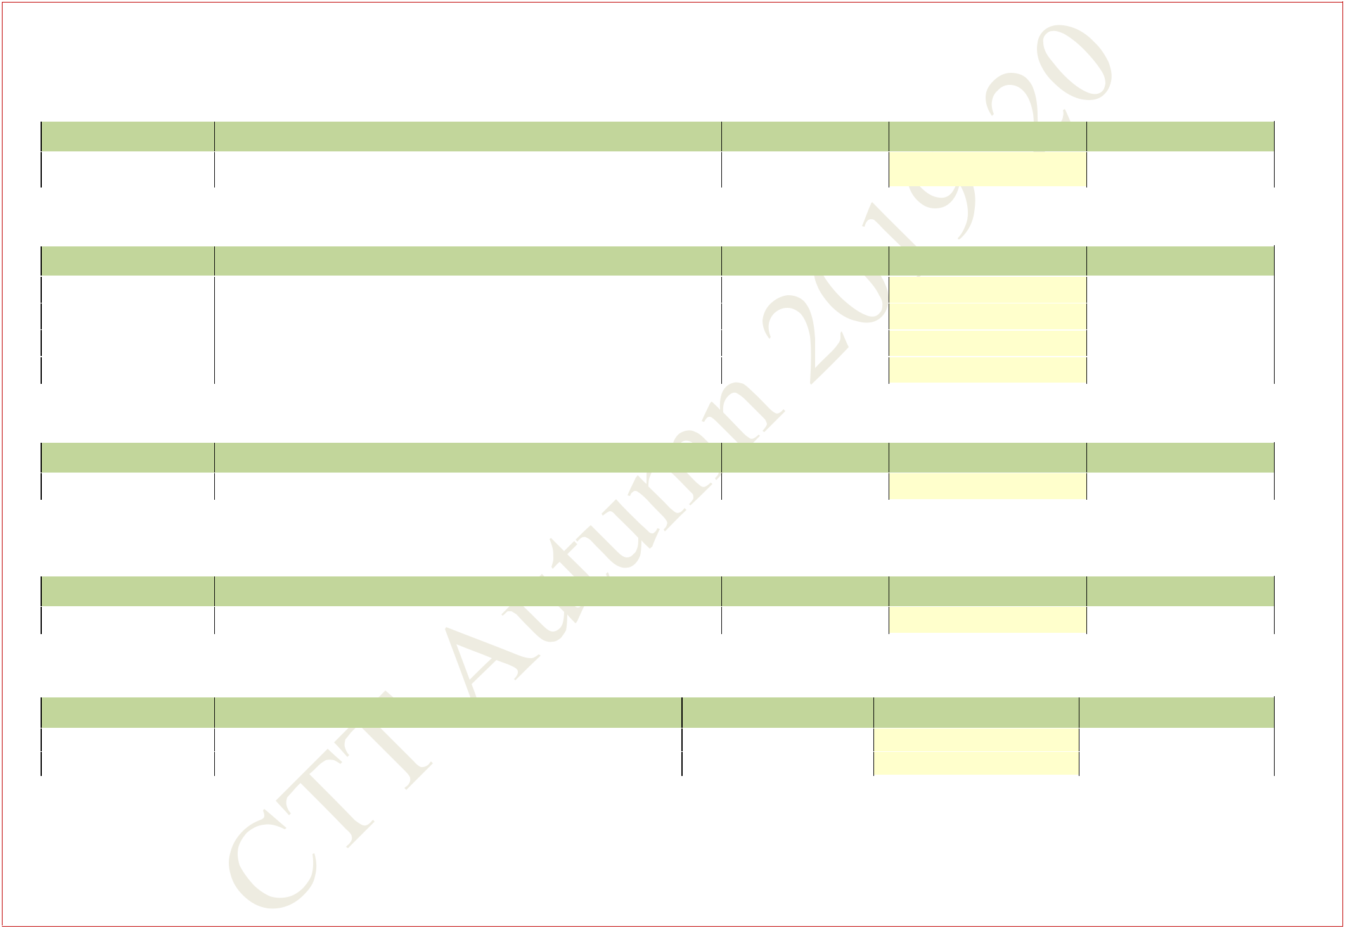

|  |  |  |  |  |  |  |  |  |  |  |
| --- | --- | --- | --- | --- | --- | --- | --- | --- | --- | --- |
| **15. CH21103** | | **Chemical Process Calculations** | | |  | **3-1-0** |  |  |  |  |
|  |  |  |  |  |  |  |  |  |  |  |
|  | **Section** | **Departments** | | | **Room No.** | **No. of Students** | | | **Slot** |  |
|  |  |  |  |  |  |  |  |  |  |  |
| **1** | | **CH (85) + BT 3rd year (39)** | | | **NC141** | **124** |  |  | **D4** |  |
|  |  |  |  |  |  |  |  |  |  |  |
| **16. ME21101** | | **Fluid Mechanics** | | |  | **3-1-0** |  |  |  |  |
|  |  |  |  |  |  |  |  |  |  |  |
|  | **Section** | **Department** | | | **Room No.** | **No. of Students** | | | **Slot** |  |
|  | |  |  |  |  |  |  |  |  |  |
|  | **1** | **ME (130) + NA (58) + AG (66)** | | | **NC241** |  |  |  | **F4** |  |
|  |  |  |  |  |  |  |  |
| **2** | | **NC242** | **254** |  |  | **F4** |  |
|  |  |  |  |  |  |
|  |  |  |  |  |  |  |  |  |  |  |
| **3** | | **(Section Division To Be Done By The Department)** | | | **NC243** |  |  |  | **F4** |  |
|  | |  |  |  |  |  |  |  |  |  |
|  | **4** |  |  |  | **NC244** |  |  |  | **F4** |  |
|  |  |  |  |  |  |  |  |  |  |  |
| **17. CE21005** | | **Solid Mechanics** | | |  | **3-1-0** |  |  |  |  |
|  |  |  |  |  |  |  |  |  |  |  |
|  | **Section** | **Department** | | | **Room No.** | **No. of Students** | | | **Slot** |  |
|  | |  |  |  |  |  |  |  |  |  |
|  | **1** | **CE (89) + MI (83)** | | | **NC241,242** | **172** |  |  | **C4** |  |
|  |  |  |  |  |  |  |  |  |  |  |
| **18. ME20001** | | **Dynamics** | | |  | **3-1-0** |  |  |  |  |
|  |  |  |  |  |  |  |  |  |  |  |
|  | **Section** | **Department** | | | **Room No.** | **No. of Students** | | | **Slot** |  |
|  |  |  |  |  |  |  |  |  |  |  |
| **1** | | **ME (130) + MF (51) + QM(7)** | | | **NR421** | **188** |  |  | **E4** |  |
|  |  |  |  |  |  |  |  |  |  |  |
| **19. EC31003** | | **Digital Electronic Circuits** | | |  | **3-1-0** |  |  |  |  |
|  |  |  |  |  |  |  |  |  |  |  |
|  | **Section** | **Departments** | | | **Room** | **No. of Students** | | | **Slot** |  |
|  | |  |  |  |  |  |  |  |  |  |
|  | **1** | **EE (85) + IE (35)** | | | **NC241** | **120** |  |  | **D4** |  |
|  | **2** | **EC (112) + QE (8)** |  |  | **NC242** | **120** |  |  | **D4** |  |

**Central Time Table Autumn 2019– 2020, Version 1.1** **Updated -28 March 2019** **32**

|  |  |  |  |  |  |  |  |  |  |
| --- | --- | --- | --- | --- | --- | --- | --- | --- | --- |
| **20. CE31001** | | **Design of RC Structures** | |  |  |  | **3-0-0** |  |  |
|  |  |  | |  |  |  | |  |  |
|  | **Section** | **Department** | |  | **Room** | **No. of Students** | |  | **Slot** |
|  |  |  | |  |  |  |  |  |  |
|  | **1** | **CE (75 ) + AR(38)** | |  | **NC243** |  | **113** |  | **C4** |
| **21. CH31001** | | **Mass Transfer - I** |  |  |  |  | **3-1-0** |  |  |
|  |  |  | |  |  |  | |  |  |
|  | **Section** | **Department** | |  | **Room** | **No. of Students** | |  | **Slot** |
|  | |  | |  |  |  |  |  |  |
|  | **1** | **BT (39) + CH (87) + IE (35)** | |  | **V3** |  | **161** |  | **C4** |
| **22. EE31009** | | **Control System Engineering** | |  |  |  | **3-1-0** |  |  |
|  |  |  | |  |  |  | |  |  |
|  | **Section** | **Department** | |  | **Room** | **No. of Students** | |  | **Slot** |
|  | |  |  |  |  |  |  |  |  |
|  | **1** | **EE(85) + EC (112) +** | **IE (35) + QD (14)** |  | **V2** |  | **246** |  | **E4** |
|  |  |  |  |  |  |  |  |  |  |
| **23. ME31013** | | **Mechanics of Solids** |  |  |  |  | **3-1-0** |  |  |
|  |  |  | |  |  |  |  |  |  |
|  | **Section** | **Departments** | |  | **Room** | **No. of** | **Students** |  | **Slot** |
|  |  |  | |  |  |  |  |  |  |
|  | **1,2** | **ME 3rd Yr (127) + MF 3rd Yr (41)** | |  | **NC233,234** |  | **168** |  | **E4** |
| **24. ME21103** | | **Mechanics of Solids** | **(for Non Mechanical Students)** | | |  | **3-1-0** |  |  |
|  |  |  | |  |  |  |  |  |  |
|  | **Section** | **Departments** | |  | **Room** | **No. of** | **Students** |  | **Slot** |
|  |  |  | |  |  |  |  |  |  |
|  | **1** | **QM 2nd Yr (7) + NA (58) 2nd Yr** | |  | **NC142** |  | **65** |  | **C4** |
| **.25. MT30001** | | **Materials Engineering** | |  |  |  | **3-0-0** |  |  |
|  |  |  | |  |  |  | |  |  |
|  | **Section** | **Department** | |  | **Room** | **No. of Students** | |  | **Slot** |
|  |  |  | |  |  |  |  |  |  |
| **1** | | **MF (41) + ME (127) + QD 2nd Year(14)** | |  | **V2** |  | **182** |  | **A3** |
|  |  |  |  |  |  |  |  |  |  |

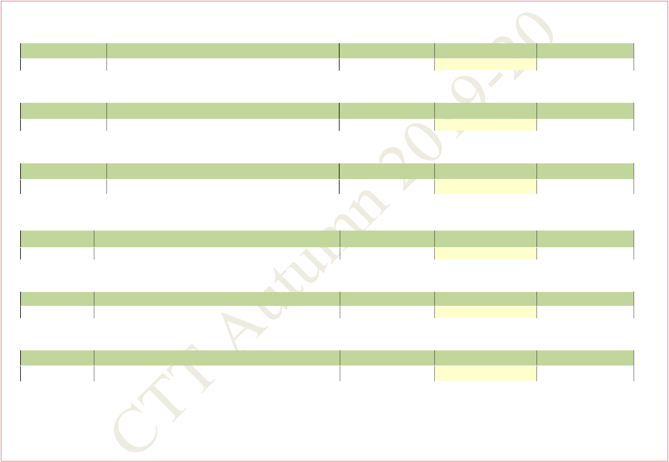

**Central Time Table Autumn 2019– 2020, Version 1.1** **Updated -28 March 2019** **33**

|  |  |  |  |  |  |  |  |  |
| --- | --- | --- | --- | --- | --- | --- | --- | --- |
| **26. ME30005** | | **Heat Transfer** |  |  | **3-1-0** |  |  |  |
|  |  |  |  |  |  |  |  |  |
|  | **Section** | **Department** |  | **Room** | **No. of Students** |  | **Slot** |  |
|  |  |  |  |  |  |  |  |  |
| **1** | | **MF (41) + ME (127) + QM (7)** |  | **NC233** | **175** |  | **C4** |  |
|  |  | **(Section Division To Be Done By The Department)** |  |  |  |  |
| **2** | |  | **NC234** |  |
|  |  |  |  |  |
|  |  |  |  |  |  |  |  |  |

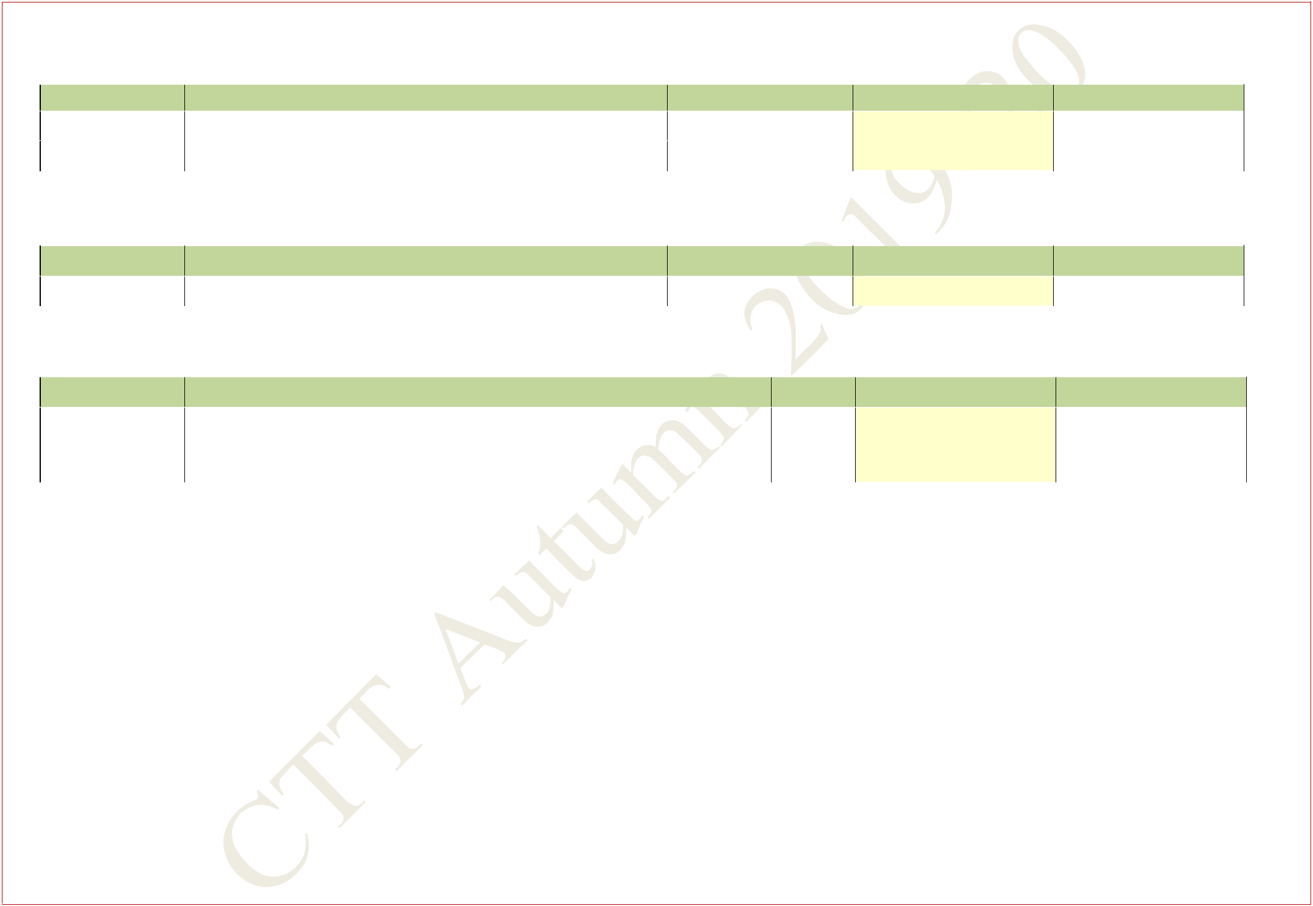

|  |  |  |  |  |  |  |  |  |  |  |  |  |  |  |  |  |
| --- | --- | --- | --- | --- | --- | --- | --- | --- | --- | --- | --- | --- | --- | --- | --- | --- |
| **27. ME31007** | | | **Casting Forming and Welding** | |  |  |  |  | **3-1-0** | | |  |  |  |  |  |
|  |  |  |  |  |  |  | |  |  |  |  |  |  |  |  |  |
|  | **Section** | |  | **Department** |  | **Room** | | |  |  | **No. of Students** |  |  | **Slot** |  |  |
|  |  |  |  | |  |  | |  |  |  |  |  |  |  |  |  |
| **1** | |  | **MF (41) + ME (127) + QM (7)** | |  | **NR321** | | | **175** | | |  |  | **D4** |  |  |
|  |  |  |  |  |  |  |  |  |  |  |  |  |  |  |  |  |
| **28. HS20001** | | | **Economics** |  |  |  |  |  | **3-1-0** | | |  |  |  |  |  |
|  |  | |  |  |  |  |  |  |  |  |  |  |  |  |  |  |
|  | **Section** | |  | **Department** |  |  |  | **Room** |  |  | **No. of Students** |  |  | **Slot** |  |  |
|  |  |  |  |  |  |  |  |  |  |  |  |  |  |  |  |  |
| **1** | |  | **AR(35)+IM(55)+MF(51)+MI(83)+MT(69)+NA(58)+QD(14)+MA(53)** | | | |  | **NR322,** | **418** | | |  |  | **D4** |  |  |
|  |  | **NR323,** |  |  |  |  |
|  |  |  |  |  |  |  |  |  |  |  |  |  |  |  |  |
|  |  |  |  |  |  |  |  | **NR324** |  |  |  |  |  |  |  |  |
|  |  | |  |  | | |  |  |  |  |  |  |  |  |  |  |
| **29. HSS Subjects** | | | **B3/G3** | **SLOT (For 4 crd subjects B3+S3(2) slot)** | | | | | **3-0/1-0** | | |  |  |  |  |  |

**HSS department may please indicate the subjects and slots (B3/G3) for** **HSS subjects on ERP . For 4 crd subjects B3+S3(2)**

**slot may be used.**

1. **Slots for Breadth Subjects (F3/4, G3/U3/4) slots. Any two slots must be available for the student.**

**Total of 653 {91(5th year) + 217(4th year ) + 201(3rd year) +136 (2nd year)} students to take Breadth Subjects. This excludes the backlogs. .**

1. **Slot for Management Subjects F4/G3 slots**

**Total of 462 {350(3rd year) +112(4th year )} students to take Management Subjects . This excludes the backlogs. Since the participating departments for 2nd year are not known EP60020 is scheduled in S3 slot.**

**Central Time Table Autumn 2019– 2020, Version 1.1** **Updated -28 March 2019** **34**

1. **Extra Academic Activity---EAA**

|  |  |  |
| --- | --- | --- |
| **Slot/Time** |  | **Rooms** |
| **Saturday 8:00 AM -12:55PM** |  | **NR121, NR122** |
| **NSS** |  |  |
| **Saturday 9:00 AM-12:55PM** |  | **NR321,NR322(NCC-EME)** |
|  |  |  |
| **Saturday 9:00 AM-12:55PM** |  | **NR221,NR222(NCC-AR)** |
|  |  |  |

**Central Time Table Autumn 2019– 2020, Version 1.1** **Updated -28 March 2019** **35**