TECHNICAL SYSTEM REPORT / 技術系統報告
NewsAgg
Transformer-Based News Aggregation and Sentiment Analytics
基於 Transformer 的新聞聚合與情緒分析平台
Current implementation, automation, deployment, verification, and limitations
現行實作、自動化、部署、驗證與限制
VERSION 4.0 · VERIFIED CURRENT-STATE EDITION · 16 SEPTEMBER 2026
English + Traditional Chinese / 英文＋繁體中文

Document Map / 文件導覽
1. Abstract / 1. 摘要 3
2. Introduction / 2. 簡介 3
2.1 Motivation and Scope / 2.1 動機與範圍 3
2.2 Research Questions / 2.2 研究問題 4
3. News Categories and Sources / 3. 新聞分類與來源 4
3.1 Diverse Top-News Ordering / 3.1 多來源焦點新聞排序 4
4. Sentiment Methodology / 4. 情緒分析方法 5
4.1 Model Routing / 4.1 模型路由 5
4.2 Probability, Polarity, and Label / 4.2 機率、極性與標籤 6
4.3 Worked Example / 4.3 計算範例 6
5. End-to-End Architecture / 5. 端到端架構 7
5.1 Persistence and Retention / 5.1 持久化與保留 7
6. Backend / 6. 後端 7
7. Frontend, UI, and UX / 7. 前端、介面與使用者體驗 8
8. Automation and Deployment / 8. 自動化與部署 9
9. Verification Results / 9. 驗證結果 10
10. Limitations and Ethics / 10. 限制與倫理 11
11. Conclusion / 11. 結論 11

1. Abstract / 1. 摘要
NewsAgg is an end-to-end news intelligence prototype that crawls section-index pages from CNN, BBC, Al Jazeera, and Yahoo Taiwan; extracts and cleans article bodies; enriches each record with transformer-based sentiment, topic relevance, named entities, summaries, toxicity, keywords, and readability; persists the results in Neon PostgreSQL; and serves an interactive React interface through an Express API.
NewsAgg 是一套端到端新聞情報原型系統。系統從 CNN、BBC、Al Jazeera 與 Yahoo Taiwan 的分類索引頁擷取連結，清理文章正文，透過 Transformer 模型產生情緒、主題關聯性、命名實體、摘要、毒性、關鍵字與可讀性欄位，再寫入 Neon PostgreSQL，最後由 Express API 與 React 介面提供查詢與互動。
Version 4.0 reflects the actually running laptop-server configuration: Docker Desktop hosts the client and API, a Cloudflare Quick Tunnel exposes the client, GitHub Actions runs the cloud scraper at 03:00 Asia/Taipei, and a self-hosted Windows runner rotates the tunnel and sends a bilingual editorial email at 05:00. The public UI exposes English and Traditional Chinese only.
第 4.0 版反映目前實際運作的筆電伺服器配置：Docker Desktop 執行前端與 API，Cloudflare Quick Tunnel 對外公開網站；GitHub Actions 於台北時間 03:00 執行雲端爬蟲；自架 Windows runner 於 05:00 輪替公開網址並寄送英語／繁體中文編輯摘要。公開介面僅提供 English 與繁體中文。
At the verification snapshot, the database contained 8,491 articles across eight categories and four sources. The latest 30-hour window contained 358 articles. The first 20 All Categories results were exactly balanced at five items per source. These are observed operational facts, not performance claims.
驗證快照顯示資料庫共有 8,491 篇文章、涵蓋八個分類與四個來源；最近 30 小時共有 358 篇。All Categories 首 20 筆結果恰好為每個來源各五筆。以上為當下觀測到的運作事實，並非模型效能宣稱。

2. Introduction / 2. 簡介

2.1 Motivation and Scope / 2.1 動機與範圍
Readers encounter fragmented reporting, inconsistent category labels, and little transparent analytical context. NewsAgg consolidates multiple editorial perspectives and exposes both the model outputs and the calculation path behind the sentiment label. It is scoped as a university final-project demonstration, not a commercial newsroom or a fact-checking system.
讀者面對分散的新聞來源、不一致的分類與缺乏透明度的分析。NewsAgg 整合多個編輯觀點，並公開情緒標籤所依據的模型輸出與計算流程。本系統定位為大學專題展示，並非商業新聞室或事實查核系統。

2.2 Research Questions / 2.2 研究問題
• Can four structurally different publishers be normalized into one traceable schema?
• 能否把四個結構不同的出版來源正規化為同一套可追溯資料結構？
• Can multilingual sentiment be computed once during scraping and served without changing the result in the frontend?
• 能否在爬取時一次完成多語情緒計算，並讓前端顯示時不改變判定結果？
• Can a laptop-hosted Docker stack be exposed and operated automatically for a final-project demonstration?
• 能否把筆電上的 Docker 系統對外公開，並為專題展示自動化維運？

3. News Categories and Sources / 3. 新聞分類與來源
The canonical taxonomy is Business, Climate, Health, Lifestyle, Politics, Science, Sport, and World. English sources are filtered with multilingual zero-shot natural-language inference at a relevance threshold of 0.38. Yahoo Taiwan uses trusted section-to-topic mapping because its section pages are already categorized and require JavaScript rendering.
標準分類為 Business、Climate、Health、Lifestyle、Politics、Science、Sport 與 World。英語來源使用多語零樣本自然語言推論，關聯性門檻為 0.38；Yahoo Taiwan 的分類頁已具備明確欄目，且需要 JavaScript 渲染，因此直接信任欄目到主題的對應。
Source / 來源 | Language / 語言 | Acquisition / 取得方式 | Coverage / 涵蓋
CNN | English | HTML section indexes | All eight categories
BBC | English | HTML section indexes | All eight categories
Al Jazeera | English | HTML section indexes | Sport, Health, Business, World, Science, Climate
Yahoo TW | 繁體中文 | Playwright-rendered indexes | Politics, Business, Sport, Science, Lifestyle, World

3.1 Diverse Top-News Ordering / 3.1 多來源焦點新聞排序
The All Categories feed uses sort=top. Each candidate receives 0.5 × absolute sentiment polarity + 0.3 × AI relevance + 0.2 × normalized recency. A row number is then assigned within each source, and results are ordered by source position before rank score. This round-robin pattern prevents a high-volume publisher from monopolizing the landing page while retaining importance within each source.
All Categories 使用 sort=top。每筆候選的分數為 0.5×情緒極性絕對值＋0.3×AI 關聯性＋0.2×正規化新鮮度；接著在各來源內計算列序，再先依來源位置、後依排名分數排序。此輪替方式避免高產量來源壟斷首頁，同時保留各來源內的重要性排序。
$$rank = 0.5|polarity| + 0.3(relevance) + 0.2(normalized recency)$$
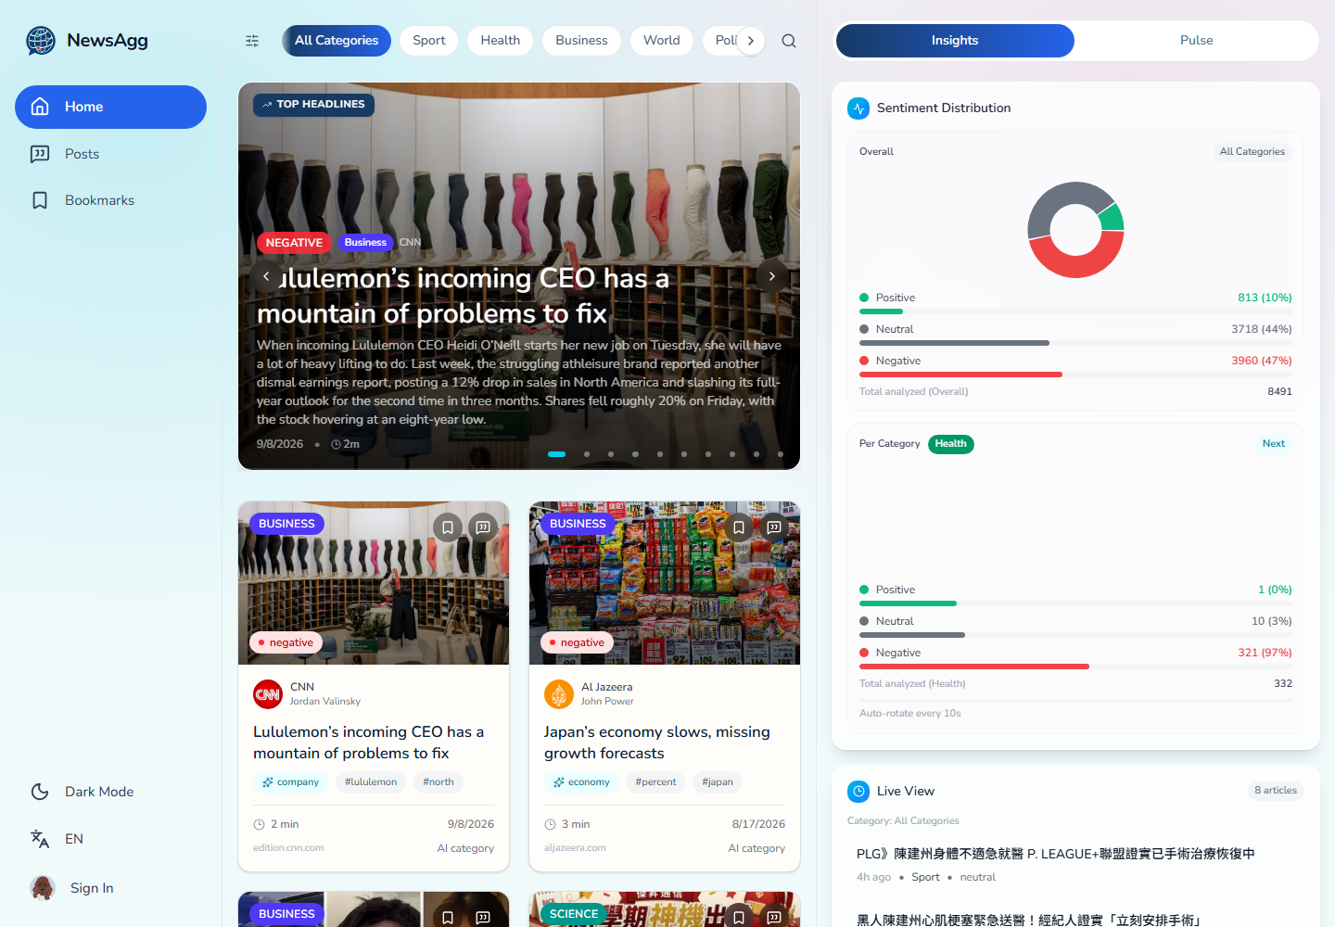
Figure 1. Verified English home page. The visible top feed includes CNN and Al Jazeera, while the API check returned five items from each of the four sources in the first 20 results (captured 2026-09-16).

4. Sentiment Methodology / 4. 情緒分析方法

4.1 Model Routing / 4.1 模型路由
General sentiment uses cardiffnlp/twitter-xlm-roberta-base-sentiment. English Business articles use ProsusAI/finbert for financial tone; non-English Business articles fall back to the multilingual general model. The leading 1,500 characters are sent to a tokenizer capped at 512 tokens.
一般情緒使用 cardiffnlp/twitter-xlm-roberta-base-sentiment。英語 Business 文章改用 ProsusAI/finbert 分析金融語氣；非英語 Business 文章回退至多語一般模型。輸入取正文前 1,500 個字元，tokenizer 最多處理 512 tokens。
Output / 輸出 | Implementation / 實作 | Language behavior / 語言行為
Sentiment | XLM-R; FinBERT for English Business | Native multilingual; financial route is English-only
Topic relevance | MoritzLaurer/mDeBERTa-v3-base-mnli-xnli | English-source title screening; Yahoo section trusted
Named entities | Davlan/xlm-roberta-base-ner-hrl | Multilingual PER/ORG/LOC/MISC
Summary | facebook/bart-large-cnn | Abstractive for English; extractive CJK-aware fallback
Toxicity | unitary/toxic-bert | English only; non-English stored as NULL
Readability | textstat | Flesch, Flesch–Kincaid, SMOG, word count, reading time

4.2 Probability, Polarity, and Label / 4.2 機率、極性與標籤
Model logits are converted to positive, neutral, and negative probabilities. The implementation defensively clamps each score to [0,1] and divides by the total. Polarity is the positive probability minus the negative probability.
模型 logits 轉換為正向、中性與負向機率。實作會先把各分數限制在 [0,1]，再除以總和進行防禦性正規化。情緒極性定義為正向機率減去負向機率。
$$P(c_i) = exp(z_i) / Σ_j exp(z_j)$$
$$P_i' = P_i / (P_neg + P_neu + P_pos)$$
$$polarity = P_pos - P_neg, polarity ∈ [-1, 1]$$
Decision / 判定 | Condition / 條件
neutral / 中性 | P_neu ≥ 0.52 and |polarity| ≤ 0.18
positive / 正向 | polarity ≥ +0.10
negative / 負向 | polarity ≤ −0.10
argmax(P) | otherwise / 其他情況

$$score = P(selected label), score ∈ [0, 1]$$

4.3 Worked Example / 4.3 計算範例
For (P_neg, P_neu, P_pos) = (0.08, 0.27, 0.65), polarity = 0.65 − 0.08 = +0.57. The neutral condition fails and +0.57 ≥ +0.10, therefore the label is positive and the confidence score is 0.65.
若 (P_neg, P_neu, P_pos) = (0.08, 0.27, 0.65)，則 polarity = 0.65−0.08=+0.57。中性條件不成立，且 +0.57≥+0.10，因此標籤為 positive，信心分數為 0.65。
The thresholds are heuristic values from manual trials. NewsAgg has not yet been evaluated against a human-labelled gold dataset, so this report does not claim accuracy, macro-F1, or calibrated probabilities.
上述門檻來自人工試驗的啟發式設定。NewsAgg 尚未使用人工標註的黃金資料集進行評估，因此本報告不宣稱準確率、macro-F1 或機率校準結果。

5. End-to-End Architecture / 5. 端到端架構
The system is divided into acquisition, enrichment, persistence, serving, presentation, and operation. Boundaries are explicit: the scraper owns analytical decisions; the API owns secure data access and aggregation; the client only renders stored results; automation owns scheduling, tunnel rotation, and reporting.
系統分為取得、增強、持久化、服務、呈現與維運。責任邊界清楚：爬蟲負責分析判定；API 負責安全資料存取與聚合；前端只呈現已儲存結果；自動化負責排程、tunnel 輪替與報告寄送。
Stage / 階段 | Main components / 主要元件 | Output / 輸出
Acquire | requests + Playwright + newspaper3k | Candidate URLs and parsed metadata
Clean | CSS selectors → trafilatura → newspaper3k fallback | Body ≥300 chars; English ≥80 words; ≤25,000 chars
Enrich | Transformers + textstat + NLTK | Sentiment, topic, entities, summary, toxicity, keywords, readability
Persist | psycopg2 → Neon PostgreSQL | Canonical URL hash, normalized source/author, upserted article
Serve | Express + TypeScript + pg | REST endpoints, stats, auth, translation, chat
Present | React + Vite + React Query + Tailwind | Responsive feed, insights, accounts, posts, bookmarks
Operate | Docker, Cloudflare, GitHub Actions, Windows runner | Public demo URL and bilingual daily brief

5.1 Persistence and Retention / 5.1 持久化與保留
The canonical URL is normalized and hashed with SHA-256; the first 16 hexadecimal characters become the article ID. Upsert logic distinguishes inserted, updated, and unchanged records. Weekly cleanup deletes articles older than 45 days unless a bookmark or post attachment protects them, then vacuums the database.
系統正規化 canonical URL，使用 SHA-256 雜湊，前 16 個十六進位字元作為文章 ID。Upsert 會區分 inserted、updated 與 unchanged。每週清理刪除超過 45 天的文章，但書籤或貼文附件所引用的文章會保留，之後執行 VACUUM。

6. Backend / 6. 後端
The backend is an Express/TypeScript service connected to Neon through node-postgres with TLS. Helmet, CORS, compression, JSON size limits, request validation, rate limiting, structured logging, and bounded TTL caches protect the service and reduce repeated database egress.
後端為 Express／TypeScript 服務，透過 node-postgres 與 TLS 連接 Neon。Helmet、CORS、壓縮、JSON 大小限制、請求驗證、速率限制、結構化日誌與有界 TTL cache 共同保護服務，並降低重複資料庫流量。
Group / 群組 | Representative endpoints / 代表端點
News | GET /api/news-from-db; GET /api/articles/:id
Analytics | GET /api/stats/overview; /trending; /business-trend
Markets and quotes | GET /api/markets/summary; /api/quotes/random|list
Accounts | register/login/Google, verification, reset, profile/password/avatar/delete
User content | bookmarks; posts; likes; attached articles
AI services | article translation (cache-first); grounded multi-turn article chat

News list requests can filter by category, source, sentiment, and literal text; choose latest, rank, or top ordering; limit results to a recent-hour window; and request a summary column set. SQL performs filtering, ranking, source diversification, pagination, and total counts before data reaches the client.
新聞列表可依分類、來源、情緒與文字篩選；可選 latest、rank 或 top 排序；可限制最近若干小時；也可要求精簡欄位。篩選、排名、來源多樣化、分頁與總數均在 SQL 端完成，再傳送至前端。

7. Frontend, UI, and UX / 7. 前端、介面與使用者體驗
The responsive React interface uses a three-column desktop shell and a compact mobile navigation pattern. React Query manages server state, infinite lists, retries, cache invalidation, and optimistic mutations. The public language controls expose only English and Traditional Chinese; previously stored Indonesian or Simplified Chinese interface choices are normalized back to English.
響應式 React 介面在桌面採三欄配置，行動裝置使用精簡導覽。React Query 管理伺服器狀態、無限列表、重試、cache 失效與樂觀更新。公開語言控制只顯示 English 與繁體中文；先前儲存的印尼文或簡體中文介面偏好會正規化回 English。
• Home: filter-aware headline carousel, mixed-source ranked feed, search and source/sentiment filters.
• 首頁：依篩選條件更新的焦點輪播、多來源排名新聞、搜尋與來源／情緒篩選。
• Insights: overall and per-category sentiment, live view, trending topics, dataset snapshot, and Business market widgets.
• 洞察：整體與各分類情緒、即時列表、熱門主題、資料集快照，以及 Business 市場元件。
• Article: full body, source attribution, sentiment explanation, translation, related items, bookmark, and grounded AI chat.
• 文章頁：全文、來源註明、情緒說明、翻譯、相關文章、書籤與以本文為依據的 AI 對話。
• Account/Pulse: email or Google authentication, profile controls, posts, likes, and article attachments.
• 帳號／Pulse：電子郵件或 Google 驗證、個人資料控制、貼文、按讚與文章附件。
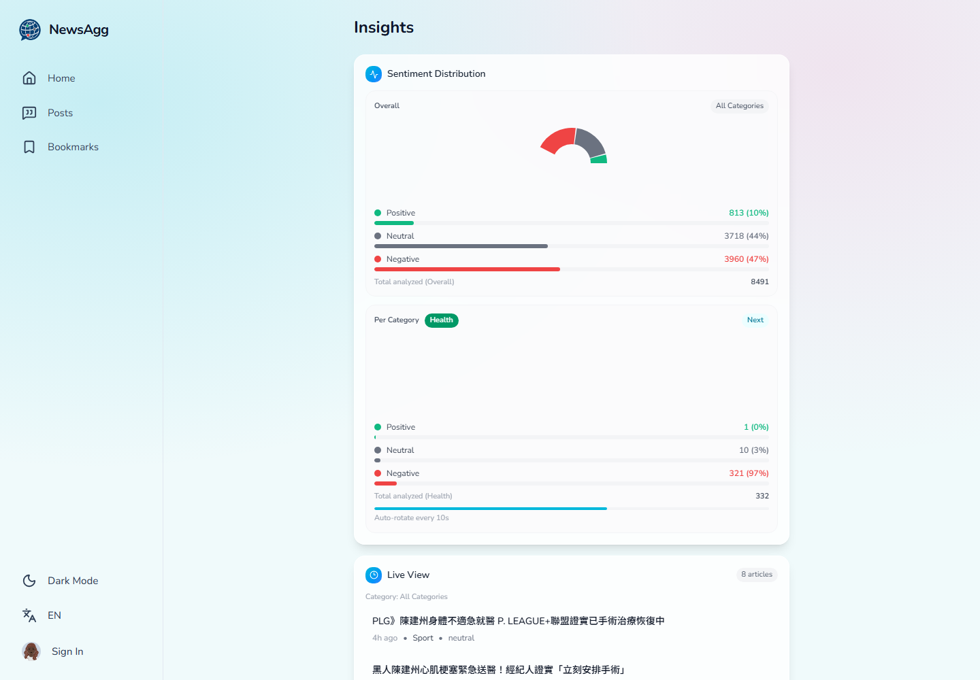
Figure 2. Verified analytics page. The snapshot displays 8,491 analyzed articles and the stored three-class sentiment distribution (captured 2026-09-16).

8. Automation and Deployment / 8. 自動化與部署
The laptop acts as the demo host. Docker Compose binds the client to 127.0.0.1:8080 and the API to 127.0.0.1:3000, so neither service is directly exposed to the LAN or Internet. cloudflared reaches the client through the private Compose network and provides HTTPS through a temporary trycloudflare.com address. IIS is not part of the active request path and is unnecessary for this configuration.
筆電作為展示主機。Docker Compose 將前端綁定至 127.0.0.1:8080、API 綁定至 127.0.0.1:3000，因此兩者不直接暴露於區域網路或網際網路。cloudflared 透過 Compose 私有網路連接前端，並以臨時 trycloudflare.com 網址提供 HTTPS。IIS 不在目前請求路徑中，此配置不需要 IIS。
Time / 時間 | Runner / 執行環境 | Action / 動作
03:00 Asia/Taipei daily | GitHub-hosted Ubuntu, 4-source matrix | Scrape and NLP enrichment; one source failure does not cancel the others
05:00 Asia/Taipei daily | Self-hosted Windows X64 | Build/start client+API, refresh cache, rotate Quick Tunnel, send bilingual report
03:00 UTC Sunday | GitHub-hosted Ubuntu | Delete unprotected records older than 45 days and vacuum
On demand | GitHub Actions workflow_dispatch | Scrape, cleanup, backfill language, or change report recipients

The email is generated from the current 30-hour top-diverse API snapshot. It reports database and fresh-story counts, leading sources, coverage mix, sentiment mix, and six leading developments in English and Traditional Chinese. SMTP credentials remain GitHub Actions secrets; spaces are stripped from the 16-character Google App Password before authentication.
電子郵件直接依目前 API 的最近 30 小時 top-diverse 快照產生，包含資料庫與新文章數量、主要來源、主題組成、情緒組成，以及六則焦點發展，並同時提供英語與繁體中文。SMTP 憑證保存在 GitHub Actions secrets；驗證前會移除 16 字元 Google App Password 中的空白。
A Quick Tunnel is appropriate for a short-lived university demo but has no uptime guarantee and changes address when recreated. A stable public product should use a registered domain and a named Cloudflare Tunnel or managed hosting.
Quick Tunnel 適合短期大學專題展示，但沒有正常運作時間保證，重新建立後網址也會改變。若要成為穩定公開產品，應使用註冊網域與命名 Cloudflare Tunnel，或改採受管理的託管服務。

9. Verification Results / 9. 驗證結果
Verification was performed against the current repository and running stack on 16 September 2026 before generating this report. The values below are reproducible functional observations; they are not a benchmark of scraping recall, classification accuracy, or uptime.
本報告產生前，已於 2026 年 9 月 16 日針對目前程式庫與運作中的系統進行驗證。下列數值為可重現的功能觀測，不代表爬取召回率、分類準確率或正常運作時間基準。
Check / 檢查 | Observed result / 觀測結果
Automated tests | Server 8/8 passed; client 4/4 passed
Production builds | TypeScript server and Vite client completed successfully
Containers | client healthy; server healthy; tunnel running
Public website | HTTPS landing page returned HTTP 200
Database snapshot | 8,491 articles; 4 sources; 8 categories; latest scrape 2026-09-15T15:32:50Z
Latest 30 hours | 358 articles; sampled digest page contained all four sources
All Categories diversity | First 20 top results: Al Jazeera 5, BBC 5, CNN 5, Yahoo TW 5
Sentiment totals | Positive 813; neutral 3,718; negative 3,960
Daily publish job | Latest self-hosted runner execution completed with job result Succeeded

10. Limitations and Ethics / 10. 限制與倫理
Limitation / 限制 | Impact and mitigation / 影響與改善
Model-domain mismatch | General model was trained on social text; evaluate or fine-tune on labelled news.
Cross-lingual transfer | Traditional Chinese relies on multilingual transfer; validate separately on zh-TW samples.
Context truncation | Only the first 1,500 characters / 512 tokens are classified; chunk long articles later.
Heuristic thresholds | 0.52/0.18/0.10 are not statistically optimized; grid-search on a validation split.
No formal evaluation | No accuracy or macro-F1 can be claimed until a human-labelled gold dataset exists.
Publisher bias | Four outlets represent particular editorial/geographic viewpoints; keep source labels visible.
Not fact checking | Sentiment and topic models do not verify claims; do not present output as truth scoring.
Temporary hosting | Quick Tunnel URLs rotate and lack an SLA; use named infrastructure for longer deployment.

The system stores publisher content and derived metadata for educational analysis. Source attribution and outbound canonical links must remain visible. Operators should respect publisher terms, robots policies, copyright, privacy, rate limits, and data-minimization principles. Secrets must never be committed to Git; leaked credentials should be revoked and replaced.
本系統為教育分析而儲存出版內容與衍生中繼資料，必須保留來源標示與 canonical 外部連結。維運者應遵守出版者條款、robots 規則、著作權、隱私、速率限制與資料最小化原則。Secrets 不得提交至 Git；若憑證外洩，應立即撤銷並更換。

11. Conclusion / 11. 結論
NewsAgg v4 is a functioning, traceable final-project system: a modular four-source scraper, multilingual NLP enrichment, normalized PostgreSQL persistence, a secure Express API, an English/Traditional-Chinese React experience, a source-diverse editorial feed, Dockerized laptop deployment, and scheduled bilingual reporting. The deployed behavior and report content have been synchronized with the repository and current runtime.
NewsAgg v4 是一套可運作且可追溯的專題系統：模組化四來源爬蟲、多語 NLP 增強、正規化 PostgreSQL 儲存、安全 Express API、英語／繁體中文 React 體驗、多來源焦點排序、Docker 筆電部署，以及排程式雙語報告。部署行為與本報告內容已與目前程式庫及執行狀態同步。

