

**DIPLOMA IN INFORMATION TECHNOLOGY**

**Software Engineering (CIT2E08)**

**AY2016/2017 April Semester**

## **Submission** of **MBDP Assignment**

Class: **_________________P02_________**

Tutor: **__________Ms Ho Li Chin _**

|  |  |
| --- | --- |
| **Student name** | **Admission number** |
| Esther Leong (Beth) | 1400652B |
| Jordan Tan Ren Jie | 1402818G |

Temasek Polytechnic

School of Informatics and IT

**Diploma in Information Technology (IT)**

Software Requirement Specifications (SRS)

**Project Particulars**

|  |  |
| --- | --- |
| **Tutor** | Ms. Ho Li Chin |
| **Class** | P02 |
| **Project Title** | Delonix Regia Hotel Management System |

**Project Team’s Particulars**

|  |  |
| --- | --- |
| **Matric Number** | **Student Name** |
| 1400652B | Esther Leong (Beth) |
| 1402818G | Jordan Tan Ren Jie |

**Table of Contents**

**Submission** of **MBDP Assignment** 1

1. DISTRIBUTION OF WORKLOAD 4

2. OVERVIEW OF REQUIREMENTS 4

**2.1** **System Functions** 4

**2.2** **User Characteristics** 7

**2.3** **General Constraints** 9

**2.4** **Functional Requirements** 10

**2.5** **Data Requirements** 12

**2.6** **User Interface Requirements** 16

**2.7** I**nterface with Other Systems** 18

3 OPERATIONAL AND QUALITY REQUIREMENTS 19

**3.1** **Operating Environment** 19

**3.2** **Development Constraints** 19

**3.3** **Performance** 19

**3.4** **Availability** 21

**3.5** **Security and Access Control Requirements** 22

1. DISTRIBUTION OF WORKLOAD 25

2. ARCHITECTURE DESIGN 25

3. USER INTERFACE (UI) DESIGN 26

4. PROGRAM DESIGN 28

5. DATABASE DESIGN 29

# **DISTRIBUTION OF WORKLOAD**

*[Determine which members of the team will be responsible for which areas in the requirement gathering process. Individual’s responsibilities should be clearly spelt out.]*

|  |  |
| --- | --- |
| **Requirement Gathering** | **Members** |
| Login ( user & super user ) | Esther Leong |
| Room availability & Booking | Esther Leong |
| Housekeeping & Staff management | Jordan Tan |

|  |  |
| --- | --- |
| **Questions** | **Member** |
| 1,2.1,2.2,2.3,2.4,2.5,2.6,3.1,3.2,3.3,3.4,3.5 | Esther Leong |
| 2.1,2.2,2.3,2.4,2.5,2.7,3.1,3.2,3.3,3.4,3.5 | Jordan Tan |

# **OVERVIEW OF REQUIREMENTS**



## **System Functions**

*[List and give a brief description of the functions of the systems that are to be implemented.]*

For Esther Leong ‘s part, it is as following,

User Login module

In User Login, there will 2 sides, one will be for super admin, which refers to Mr. Wang while the other is for the admin.

For admin, the login function, acts like a security check that it is really the staff who is in the system, and upon clearing login, the staff will be able to proceed to do his/ her job. Admin will be for receptionist or management users like managers.

As for super admin, same function as admin however, for super admin, they have the ability of creation, creating of accounts for staff to be exact. Therefore, also meaning, Mr. Wang is able to issue accounts to staff, for example, there’s a new staff, hence, Mr. Wang giving him an account so he can start work. Mr. Wang will be able to create staff account, retrieve staff account in case there is a need to retrieve data of staff, update staff details like maybe their work position and also to delete staff in case a staff is no longer working in the company.

Room Availability & Booking module

As for room booking, just like its name suggest, it deals with the hotel rooms. For this module, users are able retrieve hotel rooms availability and update the rooms and users can also create hotel room booking, retrieve hotel room booking, update hotel room booking, deleting of booking.

At this module, both admin and super admin is able to use room booking module. Though at this point, it will be the receptionist who will be the one handling the room booking module most as they are the first point of contact for the hotel. Whereas the managers and Mr. Wang will check on the system when needed.

As for what information is required for a valid booking are as following:

* First name
* Last name
* Number of adult and number of child
* Mobile number
* Date of birth (dd/mm/yyyy)
* NRIC / Passport number
* Mailing address with postal code and indicate which country
* Payment details (via Credit card or Cash)
* *If Credit card*, client will be required to input data like CCV, expiry date etc.

Upon checking into the hotel, apart from the above information which is needed, the following are what customers have to check:

* Check in date and time
* Expected check out timing and date
* Additional remarks (like if they want a smoking or non-smoking room? & which size bed is preferred or any additional pax)
* Indicate if guest will check out later than expected

As for checking out, it starts from 11 till 12 noon and during this period is also one of the peak period for the hotel and also when all the staff is the busiest.

The process for hotel check out is of the following:

* Guest pack up by 11 am
* Bring baggage to receptionist area
* Return room key to receptionist
* Receptionist check if guest consume any item from the mini bar located in their room

*If yes,*

* Cleaner will take note when cleaning room
* Upon confirmation from cleaner, receptionist generate invoice
* Bill to client

*If No,*

* Generate invoice
* Bill to client

For room availability and booking module , I feel that the additional features which I would like to add is somewhat like what Mr. Wang have mention in the interview , I feel that there is a need for admin and super admin to be able to edit guest records and also when guest check in , when they are communicating with admin , and if they have any request , the admin will be able to input it into the system rather than having the guest to do it manually , as I feel that when guest come to a hotel , what they want is to have a holiday to relax , however if they have to do so much paper work , they will not feel relax and therefore , Delonix Regia Hotel isn’t able to let their guest feel welcome. Furthermore, customer tend to read reviews and tend to believe in word of mouth, hence, if this goes out, it will not reflect well on Delonix Regia Hotel. Therefore, maybe letting admin to be able to edit data could be implemented as an additional feature.

For Jordan Tan’s part, it is as following,

For the system, I am going to implement functions such as the bookings of Laundry Services and Meals. I am also going to implement the Transport system which can be booked by the customers with an extra cost.

For Laundry Services, there will be a function where the customers are able to book for Laundry Services like the washing of clothes and ironing. There will be an additional service charge of 10 per cent.

As for the Meals, this system will enable the automatic calculation of the total amount charged for the meals. Room service would be referred to the amount of meals provided to the guest by the hotel. This too, would come with an additional service charge of 10 percent.

For the transport system, it would have information of the transport services provided by the hotel at an extra cost. The customers would be charged based on the type of vehicle used.

## **User Characteristics**

*[Describe the characteristics of the users of the systems and the role they play.]*

For the user characteristics for Esther Leong’s parts are as the following:

They will be going by hierarchy, from the highest rank to the lowest.

Mr. Wang and Mrs. Wang

Presumed to be the owner of Delonix Regia Hotel and manage everything in the company. Mr. and Mrs. Wang will be the super admin, as mention in the above section 2.1, in user login module, super admin are able to do creation of staff accounts, retrieving of staff accounts, updating staff accounts and also deleting staff accounts, apart from that they can also manage the hotel room availability. Like retrieving data for availability of rooms and updating the room status. As for hotel room management, super admin can create room booking, retrieve room booking, updating of room booking and also deleting of room booking.

Furthermore, as super admin, Mr. and Mrs. Wang have access to all part of the system, an example will be the housekeeping module.

Management users

Management user also refers to managers for managers, they will be admin. As mention above, for admin, the login function, acts like a security check that it is really the staff who is in the system, and upon clearing login, the staff will be able to proceed to do his/ her job. However, for management users account, they are able to have access to all 3 modules, which are, room booking and availability, housekeeping and reporting. However, depending on which module they are in charge of, for example if they are in charge of room keeping and availability module, they are able to make the following changes:

Room keeping and availability module

* Retrieving data of available room
* Updating room availability
* Creating room booking
* Retrieving room booking
* Updating room booking
* Deleting room booking

Receptionist

Receptionist also refers to the receptionist who will be the first point of contact with the guest at the front desk, they will also be admin. As mention above, for admin, the login function, acts like a security check that it is really the staff who is in the system, and upon clearing login, the staff will be able to proceed to do his/ her job. Receptionist have only full access to room availability and booking.

The following are what the receptionist is able to do,

* Retrieving data of available room
* Updating room availability
* Creating room booking
* Retrieving room booking
* Updating room booking
* Deleting room booking

However, if there is anything apart from what is being mention above, then the management level staff or Mr. or Mrs. Wang will need to step in the handle the issue.

For the user characteristics for Jordan Tan’s parts are as the following:

The users of the systems would vary depending on the systems that they are using. For instance, the Laundry System, it would be the customers who would require a wash of their clothes or they would like to send their clothes for ironing.

The users of the Meals System who likely be people who wants to have food at their room instead of going to the restaurants in the hotel itself. They would perhaps want a midnight snack which too, they can order it through the Room service which will enter it into the Meal System to get the food they the customers want.

The uses of the Transport System would be people who require transport services to their desired location. The users could also be away from the hotel and require a way back to the hotel. They then, can use the Transport System to get back to the hotel.

## **General Constraints**

*[Highlight any constraints such as dependency on other systems, existing hardware/software platform or technology, restriction due to organization policy or legal requirements.]*

For the General Constraints for Esther Leong’s parts are as the following:

As assumed in the previous assignment, that there is no current software, therefore no upgrade is needed and since the budget that Mr. Wang is giving is 70 Thousand Dollars, the whole software should be well funded. However, Mr. Wang mention in the interview that this software will only be used on the only computer at the front desk and the speed that it was running at is rather slow speed. hence, I guess the only 2 constraints that can be having only 1 working station and slow internet speed.

Having only 1 work station, during peak hours, I am worried that guest might get frustrated with the waiting as sometimes there might be a queue and given that Delonix Regia Hotel is a hotel for relaxation, we will not want guest to have any negative feelings hence, if there can be a few more work station, it will be able to speed up work timing, lessen the chance of having queue and giving guest less waiting time and therefore improving the customer service of Delonix Regia Hotel.

Having slow internet speed can also cause a delay in work efficiency, hence, can also cause a queue regardless of number of working station, therefore having good and fast internet connection, is also important in order to give good customer service to guest.

For the General Constraints for Jordan Tan’s parts are as the following:

The constraints faced by the system would be that there is currently no system at all to upgrade. This would be costly as creating a new system would not be a simple task. Another constraint is that all the systems depends on the User Management System which contains all the User’s details.

## **Functional Requirements**

*[Function requirements state what the system should do e.g. the system shall allow library items to be search by Keywords, Author, Title, and Call Number.]*

For the Functional Requirements for Esther Leong’s parts are as the following:

For Login module,

As for information that is required to create an account for staff are as following:

* First name
* Last name
* Date of birth (dd/mm/yyyy)
* NRIC / Passport number
* Rank
* Mobile number
* Work ID
* Address

The login system would allow super admin to input data liker work ID, NRIC, mobile number into system. Upon inputting either one of the details into the system, the system will search and show relevant staff data. for example, a staff receive a promotion from a receptionist to a manager, Super admin will just need to search for staff work id and is able to retrieve the staff detail and update the staff’s rank. Upon finding relevant data, super admin is able to create staff account in case staff do not have an account, retrieve staff detail, update staff detail in case needed and also to delete staff in case staff is no longer working in Delonix Regia Hotel.

For Room availability & Booking module,

As for information that is required for a valid booking are as following:

* First name
* Last name
* Number of adult and number of child
* NRIC / Passport number
* Mobile number
* Date of birth (dd/mm/yyyy)
* Mailing address with postal code and indicate which country
* Payment details (via Credit card or Cash)
* *If Credit card*, client will be required to input data like CCV, expiry date etc.

The booking system would allow the user to input details like NRIC, mobile number, name into system. Upon inputting either one of the details into the system, the system will search for the relevant booking. For example, guest can go to the front desk and by using their NRIC number, they can make changes to their booking, like to add an addition pax to stay in their hotel room. Upon finding relevant data, super admin or admin is able to retrieve data for room availability, update room status, create room booking, retrieve room booking, update room booking and also delete room booking.

For the Functional Requirements for Jordan Tan’s parts are as the following:

The users of the systems would vary depending on the systems that they are using. For instance, the Laundry System, it would be the customers who would require a wash of their clothes or they would like to send their clothes for ironing.

The users of the Meals System who likely be people who wants to have food at their room instead of going to the restaurants in the hotel itself. They would perhaps want a midnight snack which too, they can order it through the Room service which will enter it into the Meal System to get the food they the customers want.

The uses of the Transport System would be people who require transport services to their desired location. The users could also be away from the hotel and require a way back to the hotel. They then, can use the Transport System to get back to the hotel

## **Data Requirements**

*[Data that is stored within the system e.g. Info about books in library, member’s details]*

For the Data Requirements for Esther Leong’s parts are as the following:

For Login module,

Create of new staff account

As for information that is required to create an account for staff are as following:

* First name
* Last name
* Date of birth (dd/mm/yyyy)
* NRIC / Passport number
* Rank
* Mobile number
* Work ID
* Address

Retrieval of a staff account

The list of information that is required to retrieve a staff account are as following however for retrieval of staff account having just one of the following can be sufficient:

* Work ID
* Mobile number
* NRIC/ Passport number
* Address
* First name and last name
* Rank

Updating of staff account

The list of information that is required to update a staff account are as following however for updating of staff account having just one of the following can be sufficient:

* Work ID
* Mobile number
* NRIC/ Passport number
* Address
* First name and last name
* Rank

Deleting of staff account

The list of information that is required to delete a staff account are as following however for deleting of staff account having just one of the following can be sufficient, but due to security issues, super admin is required to input their Work ID, in order for the deletion to occur.

The following information are:

* Work ID
* Mobile number
* NRIC/ Passport number
* Address
* First name and last name
* Rank

For Room availability & booking module,

Creating of room booking

As for information that is required to create a room booking are as following:

* First name
* Last name
* Number of adult and number of child
* NRIC / Passport number
* Mobile number
* Date of birth (dd/mm/yyyy)
* Mailing address with postal code and indicate which country
* Payment details (via Credit card or Cash)
* *If Credit card*, client will be required to input data like CCV, expiry date etc.

Retrieval of hotel room booking

The list of information that is required to retrieve a hotel room booking are as following however for retrieval of hotel room booking it will just need one of the following and it will be sufficient:

* First name and last name
* Hotel room number
* NRIC / Passport number
* Mobile number

Updating of hotel room booking

The list of information that is required to update a hotel room booking are as following however for updating of hotel room booking it will just need one of the following and it will be sufficient:

* First name and last name
* Hotel room number
* NRIC / Passport number
* Mobile number

Deleting of hotel room booking

The list of information that is required to delete a hotel room booking are as following however for deleting of hotel room having just one of the following can be sufficient, but due to security issues, super admin or admin is required to input their Work ID, in order for the deletion to occur.

The following information are:

* First name and last name
* Hotel room number
* NRIC / Passport number
* Mobile number

For the Data Requirements for Jordan Tan’s parts are as the following:

Laundry System

- Name of the Customer (First and Last)

-Customer’s ID

-Type of clothes

-The linen of the clothes

-The total number of clothes

-Total Amount Charged

-Mode of Payment

Meal System

- Name of the Customer (First and Last)

-Customer’s ID

-Room Number of the customer

-Type of Meal

-Total amount Charged

-Mode of Payment

Transport System

-Date of Usage

-Name of the Customer (First and Last)

-Type of Vehicle to be sent

-Total amount Charged

-Mode of Payment

## **User Interface Requirements**

*[Describe any user interface diagram or draft screen shot drawn out during the requirements gathering process. You may also describe the navigation mechanism if necessary.]*

For the first page where all the super admin and admin will first encounter. The Login page, will look like the picture shown below.

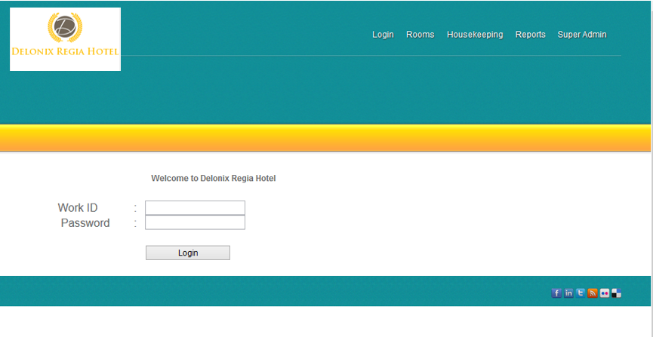

Admin(s) will have to log on to this page and once they pass this page, they can begin to do their work like for the receptionist, they can start to help guest check availability of rooms or if guest wants to check in or out of the hotel.

As for super admin page, as the name suggest, it is for super admin to login and also to act like a security measure to assure that it is really the super admin who is logging in.

The following picture is the Super Admin login page , it is somewhat similar to the login page but just that it is for the super admin. Therefore, meaning, only super admin has access to it.

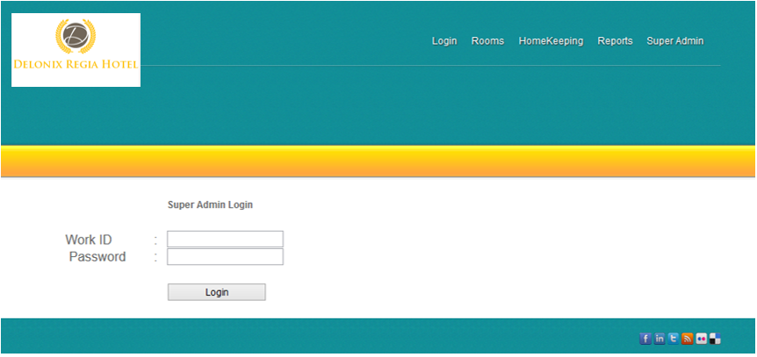

Upon logging in as super admin, the super admin will face this page, this is the page where super admin can do the creation of staff account, retrieval of staff data , update staff data and delete staff .

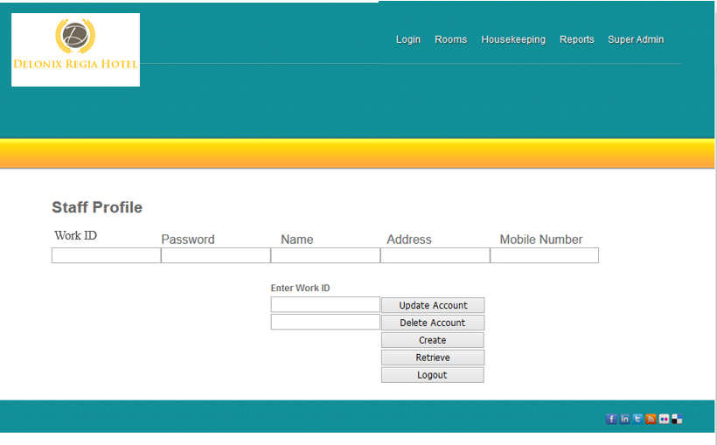

The picture above is roughly what the page will look like.

The above few illustration is the draft screen shot of the software will roughly look like and with a few of what the page is able to do. As this is the draft, thus not completed however, the actual software will somewhat look and appear as what have been seen above.

## I**nterface with Other Systems**

*[Describe any requirements to interface with other system, either new or existing. List any specifications for interfacing and the required data format for communication between the systems. Include any security considerations for such data transfer.]*

Requirements

There are currently no requirements needed to interface with other systems as currently, Mr. Wang does not have any systems that he is using. Therefore, everything that is to be created is new and because we are creating it, we will ensure that the systems that we are creating are able to interface with each other via the shared database.

Security considerations

During data transmission data should be encrypted and decrypted at the backup centre. Access privileges shall be enacted to control access of users to valuable data and information to uphold data security.

# **OPERATIONAL AND QUALITY REQUIREMENTS**

## **Operating Environment**

*[Describe the actual operating environment that the system will be deployed.]*

As mention in the interview with Mr. Wang, he mentioned that that there will only be one working station for this software, and it will be located at the front desk, hence meaning, only 1 staff can use the computer at one go therefore it would affect the work progress. This software we are developing is web-based and will be hosted by a web server and also linked to a database. This web page can be view on any web browser, some examples are google chrome, Mozilla and internet explorer. This whole software will be tested with various web browser to check for faults before releasing the software to Delonix Regia Hotel.

## **Development Constraints**

*[List any constraints that are given during the development of the system. (e.g. schedule, platform, etc.).]*

Due to the slow internet connection, we are worried that when syncing data to database, it will take longer than expected or there might be some faults leading to loss of data.

## **Performance**

*[List the acceptable system response time for each function during time of operations; on the average and during peak hours.]*

For the Performance for Esther Leong’s parts are as the following:

Login module

As login page is the first contact of all super admin and admin, hence it is important that this page be readily available. As, if this page is down and there isn’t any advance notice to the staff, it might cause a panic amongst them and furthermore, the receptionist will not be able to work once the page is down and will need to do the checking in manually, which gives it a slight chance of human error to occur. As for management level staff will also have a chance of being delayed in their work progress and if super admin needed to create an account for new staff during the period when the login page is down, it will definitely lead to everyone work productivity to be delayed and if the page being down occur during the peak periods, it might cause a slight unhappiness amongst the guest, thus, the hotel might need to compensate the guest and that will cause a sum.

However, if the system is running perfectly fine, for each click, the function should take maximum 7 seconds. 7 seconds as, it is the common human responds time therefore, users will be able to cope with the software.

Room availability and booking module

For room availability and booking module, as mention in the login system, I will also recommend for each function to react within 7 seconds, as it is the respond time for human, furthermore when the receptionist is facing guest when they check in and all, the guest first requirement will be for service to be fast therefore, if the system can react faster than human respond time, it will allow the system to be ahead of the guest therefore leading to be more efficient. Therefore, letting the guest feel that we can provide fast and efficient service.

For the Performance for Jordan Tan’s parts are as the following:

For the Laundry System, it will run at a average of 8 working hours. The acceptable system response time would be an average of 5 seconds max per response so as to ensure the usability of the system itself.

For the Meal System, it will run at a 24 hour rate as people might be urging for a meal at any time of the day. Room service will be provided at 24/7 therefore, with the peak hour in mind, the system will have to respond at 3 seconds for each function. However, overcrowding of server might incur and this might cos the system to work at an estimated 30 seconds. During non-peak hours, system would be required to respond at 3 seconds.

The transport system will require a 24/7 timestamp too. During peak hours, system would be required to respond at an average speed of 3 seconds for both peak and non-peak hours.

## **Availability**

*[State the system availability requirements e.g. the system is required to run 24 by 7 or the system is required to run during normal working hours (8am to 6pm) from Monday to Friday. State also the acceptable down time for maintenance and data backup. For example, 2 hours per week.]*

For the Availability for Esther Leong’s parts are as the following:

Login module

As mention above, Login is the first point of contact that every staff will encounter when they use the software, hence it is important or rather essential for this page to be up and running 24 by 7. As login do not require database to record every entry, it therefore doesn’t require having any down time for syncing to database. But however, for the super admin account, it will require an hour to sync all the staff, as there might be creation of new staff, updating of staff details or deletion of staff. therefore, for super admin login, is mandatory for a down time to back up the changes made and sync the data to be in sync with the database. As hotel staff are to work by roaster and they usually go by 8-12 hours shift, therefore, the only or rather most preferred timing for update will be during non-peak hours of the day which is during 2- 3 am in the morning, however, since it is not every day that changes are made to staff, so I will recommend staff data to be back up every two weeks during 2-3 am timing.

Room availability and booking module

As Room availability and booking schedule changes every single day and it has to be updated hence, I will recommend for it to be done every single day also at 2-3 am as that is non-peak timing and will let the update have the littlest error occurring. Though it is updated every single day, data that are being back up will be saved for 5 years as of the date in the data storage.

For the Availability for Jordan Tan’s parts are as the following:

Laundry System

The system would be required to run during normal working hours at 9am to 6pm. The down time for back up and maintenance would be 1hour per week.

Meal System

The system would be required to run 24 by7. The down time would be an average of 3 hours per week.

Transport System

The system would be required to run 24 by7. The down time would be an average of 3 hours per week.

## **Security and Access Control Requirements**

*[Specify the user groups that can have access to the respective functions and the user locations (if this is a distributed system). Specify user authority to facilitate control over system access and data access. Identify any log required for audit purpose. List any other security requirements such as data encryption or authentication.]*

For Security and Access Control Requirements for Esther Leong’s parts are as the following:

Login module

As mention above, in login module, every staff is to login to their accounts before they can start work hence, that is the first level of security being implemented. As the system has 3 level of users, the receptionist, the management level and Mr. and Mrs. Wang.

For receptionist, they are only grant access for their job which is to manage the hotel room availability as well as the hotel room booking. For Management level, they have access to all 3 modules, which are room availability and booking module, report module, housekeeping module. however, they can only have full access to the module which they are in charge of. As for Mr. and Mrs. Wang, them being the super admin has the ability of deleting staff, hence for the second level of security will be implemented when they are about to delete a staff, they will need to input their Work ID as well as their password to ensure that it is really deleted by the super admin. furthermore, for all the staff , when they are about to delete anything , for example , will be to delete a hotel room booking , they are to input their Work ID as well as their password to ensure that it is really that staff whom is deleting the booking. Furthermore, when staff are created or updated and when they are in sync to the database, it will be transfer through file transfer method to the clouds, and during this process, the data being transported will be encrypted and hashed with salt to ensure the high level of security. It is for integrity and also to protect the staff of Delonix Regia Hotel.

Room availability and booking module

Just as mention as above, during this process, the data that Delonix Regia Hotel is dealing with are customers. As they are the guest of Delonix Regia Hotel, ensuring their privacy and their data not to be leaked is Delonix Regia Hotel priority. As, if customer details get leaked, customer will lose confidence in Delonix Regia Hotel and it will definitely be very damaging to Delonix Regia Hotel’s image and reputation. Hence, in order to prove the best service, Delonix Regia Hotel ensure customer that such issues will not happen through having high security and also protecting data through encryption with hash and salt.

For Security and Access Control Requirements for Jordan Tan’s parts are as the following:

The Helpdesk and Customer Service would have access to the system, however, accessing of the database would be forbidden. The Managers would too, have access to the system, they would have to ability to override several operations made by the Helpdesk or Customer Service if deemed unfit by them. They would be able to access the database to view only specific details (customer’s Name and ID). They would not be able to access details like Customer’s card details.

Lastly, the admins who are doing all the backups and maintenance would be allowed full access to everything.

Temasek Polytechnic

School of Informatics and IT

**Diploma in Information Technology (IT)**

Software Design Specifications (DS)

**Project Particulars**

|  |  |
| --- | --- |
| **Tutor** | Ms. Ho Li Chin |
| **Class** | P02 |
| **Project Title** | Delonix Regia Hotel Management System |

**Project Team’s Particulars**

|  |  |
| --- | --- |
| **Matric Number** | **Student Name** |
| 1400652B | Esther Leong (Beth) |
| 1402818G | Jordan Tan Ren Jie |

# **DISTRIBUTION OF WORKLOAD**

*[Determine which members of the team will be responsible for which areas of design. Individual’s responsibilities should be clearly spelt out.]*

|  |  |
| --- | --- |
| **Design** | **Members** |
| Login ( user & super user ) | Esther Leong |
| Room availability & Booking | Esther Leong |
| Housekeeping & Staff management | Jordan Tan |

|  |  |
| --- | --- |
| **Questions** | **Member** |
| 1,2,3,4 | Esther Leong |
| 5 | Jordan Tan |

# **ARCHITECTURE DESIGN**

*[Describe the proposed system architecture design e.g. 2-tier comprising of client-data? Or 3-tier comprising of client-business-data? Include diagram to illustrate the different tiers in the architecture.]*

The proposed system architecture is 3-tier comprising of client-business-data.

3-tier works is by client – server – database

Client server, by using HTML, web browser on client device, client device, input data into system, after which being pass to server for information processing and then pass to data base, for information storage.

Client will be receptionist, inputting guest data then passing it to the webserver which is consider the backend, the backend then pass data received into database

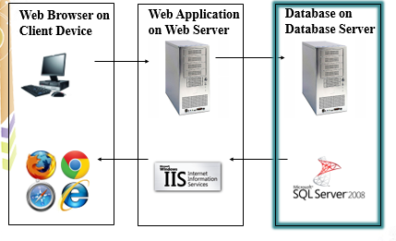

# **USER INTERFACE (UI) DESIGN**

*[Document the user interface design decisions and considerations. This should not be a mere capture of all UI forms but a reflection of UI design considerations. Is web or windows or other forms of UI used? Why did you choose that particular UI? How does the UI design impact usability and why adopt certain UI controls than others?]*

For the first page where all the super admin and admin will first encounter. The Login page, will look like the picture shown below.

**

Admin(s) will have to log on to this page and once they pass this page, they can begin to do their work like for the receptionist, they can start to help guest check availability of rooms or if guest wants to check in or out of the hotel.

As for super admin page, as the name suggest, it is for super admin to login and also to act like a security measure to assure that it is really the super admin who is logging in.

The following picture is the Super Admin login page , it is somewhat similar to the login page but just that it is for the super admin. Therefore, meaning, only super admin has access to it.



Upon logging in as super admin, the super admin will face this page, this is the page where super admin can do the creation of staff account, retrieval of staff data , update staff data and delete staff .



The picture above is roughly what the page will look like.

The above few illustration is the draft screen shot of the software will roughly look like and with a few of what the page is able to do. As this is the draft, thus not completed however, the actual software will somewhat look and appear as what have been seen above.

# **PROGRAM DESIGN**

*[Describe how program design is done. What are the programs making up each system/software module?]*

How program design is done?

Upon knowing what Mr. Wang wants, the team define the output as well as the data flow. hence we go with the schedule, doing data analysis, know what Mr. Wang want, how we can achieve it, check if there are any faults, implementation, developing, testing and releasing.

What are the programs making up each system / software modules?

For our program, we will be using visual studio and MySQL to create the software.

# **DATABASE DESIGN**

*[Document the database design. What considerations and decisions went into the design of the database schema? How does your database design solve your data storage requirements? Are there any limitations? Highlight portions of the database schema that needs explanation. Highlight also interesting/innovative portions of your database design.]*

Booking Table

-Date

-CustomerID

-First Name

-Last Name

-Nationality

-Gender

-Contact

-Address

-Email

Explanation: the Booking table is created to contain customer details when customers book into the hotel. For booking to be done, customers are able to do it via online booking, personal visit or phone calls to the booking office. For online booking, customers will be able to fill in their personal details in a booking form provided by the system.

Admission Table

-RegNo. (Registration number)

-CustomerID

-First Name

-Last Name

-Nationality

-Gender

-Check in

-Check out

-RoomNo.

Explanation: the Admission table contains customer details input upon admission into the hotel. This information keeps track of the time period of the customer who stayed at the hotel. If the customer intends to extend their stay, they would have to do it at the booking office. The customer luggage information is also entered into the system to ensure the security of the luggage at the hotel.

Accommodation Table

-RegNo. (Registration number)

-RoomType

-CustomerID

-First Name

-Last Name

-Nationality

-Gender

-Charges

-Payment

-TotalAmt. (Total Amount)

Explanation: This table contains the accommodation detail of the customer. These details help to identify the many different customers with their room and the services that will be provided with the room.

Meals Table

-RegNo. (Registration number)

-CustomerID

-First Name

-Last Name

-RoomNo.

-RoomService

-Charges

-Payment

-TotalAmt. (Total Amount)

-Recpt.No. (Receipt Number)

Explanation: this table contains information about the hotel catering services offered to the customers. The system will enable auto calculation of the total amount charged for the meals. Room service refers to the meals provided by the hotel to the customer’s rooms.

Laundry Table

-Date

-CustomerID

-First Name

-Last Name

-RoomNo.

-Linen

-Type (Type of cloths)

-Charges

-Payment

-TotalAmt. (Total Amount)

-Recpt.No. (Receipt Number)

Explanation: this table contains information for clothes that are to be washed by the hotel laundry service.

Transport Table

-Date

-CustomerID

-First Name

-Last Name

-RoomNo.

-Vehicle

-Charges

-Payment

-TotalAmt. (Total Amount)

-Recpt.No. (Receipt Number)

Explanation: this table contains information of the transport services provided by the hotel at an extra cost. The customers are to be charged depending on the type of vehicle used.

Temasek Polytechnic

School of Informatics and IT

**Diploma in Information Technology (IT)**

Meeting Minutes

**Project Particulars**

|  |  |
| --- | --- |
| **Tutor** | Ms. Ho Li Chin |
| **Class** | P02 |
| **Project Title** | Delonix Regia Hotel Management System |

**Project Team’s Particulars**

|  |  |
| --- | --- |
| **Matric Number** | **Student Name** |
| 1400652B | Esther Leong (Beth) |
| 1402818G | Jordan Tan Ren Jie |

|  |  |  |  |
| --- | --- | --- | --- |
| Date: | 23/05/2016 | |  |
|  |  | |  |
| Venue: | Meeting room | |  |
|  |  | |  |
| Present: | Esther Leong, Jordan Tan Ren Jie | |  |
|  |  |
| Absent with apologies: | -Nil- | |  |

| **1** | **Agenda Topic: Introductions** | **Action By** |
| --- | --- | --- |
|  | *Introductions made by all members and a process is used to identify representatives.* | *Both members were asked to appoint alternates to serve as themselves in the situation that they are absent for the next meeting* |
| **2** | **Agenda Topic: SRS** |  |
|  | *Budget and Constraints are discussed. The type of system is proposed to Mr. Wang.*  *Acknowledgments was given by Mr. Wang to do up the sample system.* | *Sample System to be done by both Elizabeth Esther Leong and Jordan Tan Ren Jie* |
| **3** | **Agenda Topic: SDS** |  |
|  | *Software proposed to Mr. Wang. The*  *Mockup design shown to Mr. Wang.*  *Acknowledgments was given by Mr. Wang to do up the sample system.* | *SDS to be completed by Elizabeth*  *Esther Leong and Jordan Tan Ren Jie* |
|  |  |  |

Meeting ended at 7:49 pm

Recorded by: Jordan Tan Ren Jie

Vetted by: Mr. Wang

Temasek Polytechnic

School of Informatics and IT

**Diploma in Information Technology (IT)**

Team/Peer Evaluation

|  |  |
| --- | --- |
| **Project Title:**  Delonix Regia Hotel Management System | |
| **Student No:** | **Student Name:** |

|  |  |  |  |  |  |
| --- | --- | --- | --- | --- | --- |
| Rate the overall team performance against each criterion. Circle one number from  1 (inadequate) to 5 (superior) | | | | | |
| Team spirit | **1** | **2** | **3** | **4** | **5** |
| Overall effectiveness | **1** | **2** | **3** | **4** | **5** |
| Rewarding experience | **1** | **2** | **3** | **4** | **5** |
| Team productivity | **1** | **2** | **3** | **4** | **5** |
| Process quality | **1** | **2** | **3** | **4** | **5** |
| Product quality | **1** | **2** | **3** | **4** | **5** |

|  |  |  |  |  |  |
| --- | --- | --- | --- | --- | --- |
| Rate the contribution of each team member (including yourself). Circle one number from  1 (inadequate) to 5 (superior) | | | | | |
| Myself | **1** | **2** | **3** | **4** | **5** |
| <State name of Team Member 1> | **1** | **2** | **3** | **4** | **5** |
| <State name of Team Member 2> | **1** | **2** | **3** | **4** | **5** |
| <State name of Team Member 3> | **1** | **2** | **3** | **4** | **5** |

|  |  |  |  |  |  |
| --- | --- | --- | --- | --- | --- |
| Rate the quality of work (including timeliness) of each team member (including yourself). Circle one number from 1 (inadequate) to 5 (superior) | | | | | |
| Myself | **1** | **2** | **3** | **4** | **5** |
| <State name of Team Member 1> | **1** | **2** | **3** | **4** | **5** |
| <State name of Team Member 2> | **1** | **2** | **3** | **4** | **5** |
| <State name of Team Member 3> | **1** | **2** | **3** | **4** | **5** |
| Rate the help and support you have received from each team member. For yourself, rate the support and help you have given to other team members. Circle one number from  1 (inadequate) to 5 (superior) | | | | | |
| Myself | **1** | **2** | **3** | **4** | **5** |
| <State name of Team Member 1> | **1** | **2** | **3** | **4** | **5** |
| <State name of Team Member 2> | **1** | **2** | **3** | **4** | **5** |
| <State name of Team Member 3> | **1** | **2** | **3** | **4** | **5** |

|  |
| --- |
| **Comments:** |
|  |
|  |
|  |
|  |
|  |
|  |
|  |

**Signature: ____________________________ Date: ______________________**

Temasek Polytechnic

School of Informatics and IT

**Diploma in Information Technology (IT)**

Team/Peer Evaluation

|  |  |
| --- | --- |
| **Project Title:**  Delonix Regia Hotel Management System | |
| **Student No:** | **Student Name:** |

|  |  |  |  |  |  |
| --- | --- | --- | --- | --- | --- |
| Rate the overall team performance against each criterion. Circle one number from  1 (inadequate) to 5 (superior) | | | | | |
| Team spirit | **1** | **2** | **3** | **4** | **5** |
| Overall effectiveness | **1** | **2** | **3** | **4** | **5** |
| Rewarding experience | **1** | **2** | **3** | **4** | **5** |
| Team productivity | **1** | **2** | **3** | **4** | **5** |
| Process quality | **1** | **2** | **3** | **4** | **5** |
| Product quality | **1** | **2** | **3** | **4** | **5** |

|  |  |  |  |  |  |
| --- | --- | --- | --- | --- | --- |
| Rate the contribution of each team member (including yourself). Circle one number from  1 (inadequate) to 5 (superior) | | | | | |
| Myself | **1** | **2** | **3** | **4** | **5** |
| <State name of Team Member 1> | **1** | **2** | **3** | **4** | **5** |
| <State name of Team Member 2> | **1** | **2** | **3** | **4** | **5** |
| <State name of Team Member 3> | **1** | **2** | **3** | **4** | **5** |

|  |  |  |  |  |  |
| --- | --- | --- | --- | --- | --- |
| Rate the quality of work (including timeliness) of each team member (including yourself). Circle one number from 1 (inadequate) to 5 (superior) | | | | | |
| Myself | **1** | **2** | **3** | **4** | **5** |
| <State name of Team Member 1> | **1** | **2** | **3** | **4** | **5** |
| <State name of Team Member 2> | **1** | **2** | **3** | **4** | **5** |
| <State name of Team Member 3> | **1** | **2** | **3** | **4** | **5** |
| Rate the help and support you have received from each team member. For yourself, rate the support and help you have given to other team members. Circle one number from  1 (inadequate) to 5 (superior) | | | | | |
| Myself | **1** | **2** | **3** | **4** | **5** |
| <State name of Team Member 1> | **1** | **2** | **3** | **4** | **5** |
| <State name of Team Member 2> | **1** | **2** | **3** | **4** | **5** |
| <State name of Team Member 3> | **1** | **2** | **3** | **4** | **5** |

|  |
| --- |
| **Comments:** |
|  |
|  |
|  |
|  |
|  |
|  |
|  |

**Signature: ____________________________ Date: ______________________**