

**DIPLOMA IN INFORMATION TECHNOLOGY**

**Software Engineering (CIT2E08)**

**AY2016/2017 April Semester**

## **Submission** of **MBDP Assignment**

Class: **_________________P02_________**

Tutor: **__________Ms Ho Li Chin _**

|  |  |
| --- | --- |
| **Student name** | **Admission number** |
| Esther Leong (Beth) | 1400652B |
| Jordan Tan Ren Jie | 1402818G |

Q1. A short description to explain the meaning of Software Development Life Cycle   
(SDLC). Do ensure that you include three (3) software development models in  
your explanation. [5 marks - Individual]

Done by Esther Leong (Beth)

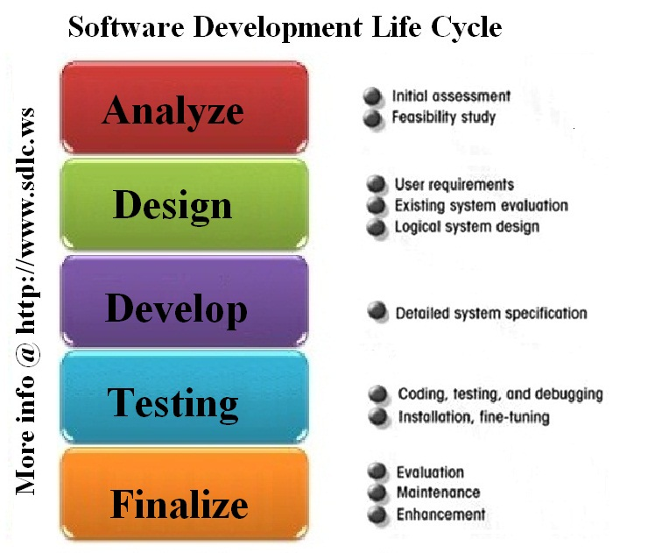

Steps of Software Development Life Cycle ( SDLC) starts from requirement gathering , analysis data , design , implementation , testing , deployment . The goal is to build a product or to enhance an existing software. The cycle defines a cycle for improving software and for development process.

Most software model have all the steps mention above but some might not be in the same order. I will be writing about a few software development model. They are the following.

Waterfall model

Waterfall model or also known as linear-sequential life cycle model. The steps need to be done in sequential order and no overlapping is allow. The following image is an illustration of how waterfall model works.

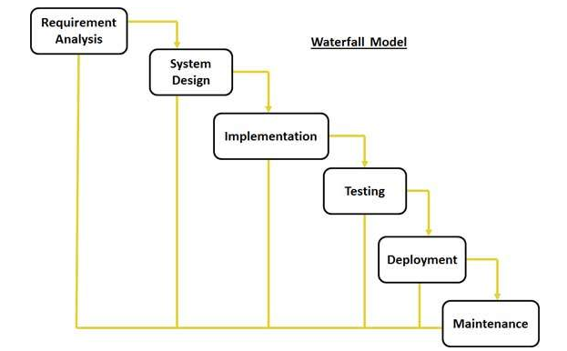

Steps:

Done by Esther Leong (Beth)

Requirement Gathering and Analysis

* Having to gather all the relevant information required for every phase and to be very detailed and documented.
* Analysis and see what system needs
* Fundamental step

System design

* This step defines the overall architecture of the system
* It also the process of choosing system which are compatible so that in the future steps it doesn’t crash

Implementation

* At this phase, a team of developers come in and implement what is specified in the document which was put together in the first stage of requirement analysis.
* The team of developer will each work on their area of strength. Hence, software is being break into a few units.

Testing

* Integration among the units take place
* Work being checked to check it’s quality
* Post integration stage , check if the entire system is free of faults

Deployment

* Upon approval from client , software is being release at client side

Maintenance

* Upon deployment, client will use the software and if they ask enhancement or changes, it will be made during this stage.

SDLC happens in Waterfall model which is also one of the type of software model. Though it is great as it phrases is to be complete one by one however it can be tedious when changes are to be made. Furthermore, it ultimately depends on what type of software it is to choose a right SDLC method.

Agile Model

Agile model, is a combination of the incremental process model and iterative model and is a method which exist to provide a best fit solution for project requirement.in agile, all the task is being divided into small time frames for specific task for release. Agile model is being break down into 3 iteration. Each iteration is an incremental in term of features and the final build has all the featured required. A few popular agile methods include Scrum and Extreme programming, they are also referred as Agile Manifesto. SDLC happens in agile model as well however it is uses the combination of iterative and incremental process to reach an ideal product fast for the client.

Done by Esther Leong (Beth)

The following image is an illustration of how agile model works

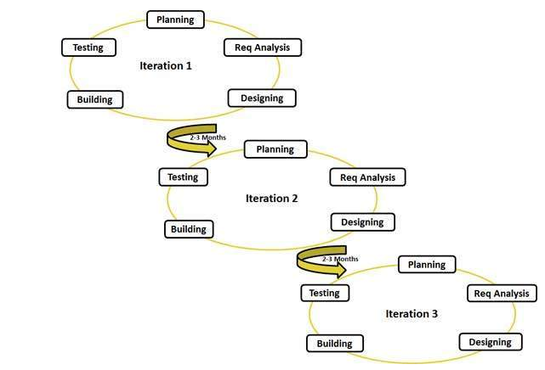

Comparing agile and traditional SDLC model

Waterfall method is more of a predictive approach while agile method is based on software adaptive development.

Waterfall method requires detailed planning and a forecast for the subsequent task during the life cycle of the product. Predictive methods depend entirely on the requirement analysis. Agile however have no detailed planning but when the feature or task is being carried out, in case of any doubt, clarification takes place. The team is able to accommodate the dynamic changing of the product. The product is being tested frequently to reduce or rather minimise the risk of any failure.

In agile method , communicating with customer is essential and with an open communication and minimum documentation is a define feature of agile method , agile team work hand in hand with each other and is very often located in the same location.

Done by Esther Leong (Beth)

SDLC happens in agile model which is also one of the type of software model. Though it is breaks down into smaller task, require a lot of communication and is able to get the task done at a faster rate, it ultimately depends on what type of software it is to choose a right SDLC method.

V-Model

V- Model or also known as verification and validation model. Just like its name, how v model works in a sequential manner in V-shape. V model is an extension of waterfall model. After every development stage, there is a direct associated testing phase and like the waterfall model, it only start on the next phrase upon completion of the current phrase.

The following image is an illustration of how V-Model works

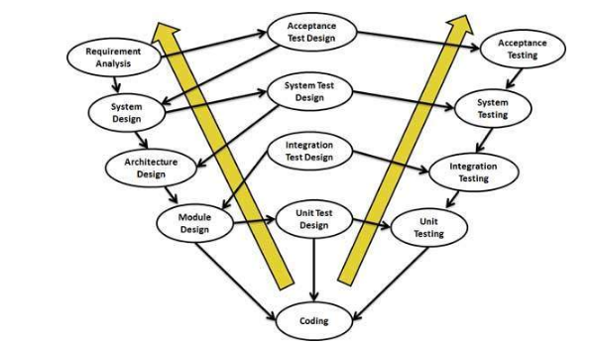

Verification Phase:

Business requirement analysis

* First phase in development cycle , understanding customer perspective and gathering product requirement
* Fundamental step
* Acceptance test design is a test to see if business requirement is met
* Acceptance testing is carried out using the business requirement as an input
* Upon completing this step, a clear and detailed product requirement will be derived.

Done by Esther Leong (Beth)

System design

* Designing the system upon understanding product requirement
* This stage includes understanding and detailing the hardware system
* Communication setup for product
* System test plan would be developed based on the system design
* System test is to check if the system is entirely functional and able to be integrated with the external systems.

Architectural design

* At this stage, architectural specification is being understood and designed.
* A few technical approach will be proposed but the final decision will be made based on financial and technical feasibility.
* High Level Design (HLD) which is also the process where system design is being broken down into module which would be taking up different functionality
* Data transfer and communication is possible at this stage as it is being integrated
* At this stage ,integration test can be designed and documented

Module Design

* Low Level Design (LLD) refers to the process where detail internal design is being specified.
* It is essential for all the modules in the system and external system to be compatible

Coding Phase:

Upon being decided in the design phase , coding will take place based on architectural and system requirement , the most suitable programming language will be decided and the coding would be done according to coding guideline, it will review several times to be free of faults and the final codes will be checked into repository.

SDLC happens in V-model which is also one of the type of software model. Though it is somewhat similar to the waterfall model as it does its task sequentially and requirements are to be very detailed, it is still slightly different but it ultimately depends on what type of software it is to choose a right SDLC method.

In conclusion, SDLC happens in several forms , but it is ultimately depends on what type of software or system is to build , financial and technical feasibility , duration given , the above are a few factor that is to be considered before one can say which model is to be used.

Done by Esther Leong (Beth)

Esther’s Reference

<http://www.tutorialspoint.com/sdlc/sdlc_overview.htm>

<https://en.wikipedia.org/wiki/Systems_development_life_cycle>

<http://www.tutorialspoint.com/sdlc/sdlc_waterfall_model.htm>

<http://www.tutorialspoint.com/sdlc/sdlc_agile_model.htm>

<http://www.the-software-experts.com/e_dta-sw-process-model-V.php>

<http://www.tutorialspoint.com/sdlc/sdlc_software_prototyping.htm>

<http://searchsoftwarequality.techtarget.com/definition/systems-development-life-cycle>

<http://www.technotrice.com/what-is-waterfall-model-software-engineering/>

<http://www.ibuzzle.com/articles/waterfall-model-life-cycle.html>

<https://technologyconversations.com/2014/01/10/software-development-models-waterfall/>

<http://www.tutorialspoint.com/sdlc/sdlc_agile_model.htm>

<http://istqbexamcertification.com/what-is-agile-model-advantages-disadvantages-and-when-to-use-it/>

<http://www.seguetech.com/blog/2013/07/05/waterfall-vs-agile-right-development-methodology>

<http://emete.com/blog/en/20130617/when-should-an-agile-method-be-used-in-a-project/>

<http://www.the-software-experts.com/e_dta-sw-process-model-V.php>

<http://www.tutorialspoint.com/sdlc/sdlc_v_model.htm>

<http://istqbexamcertification.com/what-is-v-model-advantages-disadvantages-and-when-to-use-it/>

# Definition of SDLC

Done by Jordan Tan

SDLC, also known as system development life cycle, is a term used in project management which describes the different stages involved in planning, creating and the deployment in an information system, from its original feasibility study through the maintenance of the completed application.

It is a system development life cycle which is composed of six clearly defined work phases which are being used by system engineers and developers to create new information systems. Like any system, SDLC is made as a step-by-step guide to building high quality systems which will meet its customer’s requirements and expectations. Computer systems are more often than not, complex and linked to multiple different traditional systems that may be provided by the software vendors when needed to create software systems. To maintain the complexity of the system, SDLC models or methodologies are created. Some examples like the "waterfall"; "spiral"; "Agile software development"; "rapid prototyping"; "incremental"; and "synchronize and stabilize" are SDLC models that are used by system engineers.

Most of the times, SDLC conceptual models are combined into some sort of hybrid methodology to fulfil the customer’s demands. Documentation is always needed regardless the method used or improvised for any system, and it is usually done alongside with the development of the system. Some methods work better for specific systems whereas some do not, however in the final analysis, the most important factor for the success of a system may be how closely the particular plan was followed and executed.

# Phases in SDLC

* Requirement gathering and analysis.

The Requirement analysis phase is the deciding step in creating a successful system, by which during this phase, we have to decide exactly what we want to do by the creation of the system and the problems we are trying to solve, by:

* Firstly, defining the key problems, the main objectives and the amount of resources needed such as staff members needed to maintain the newly created system and costs of development of the system.
* Next, studying the ability of offering different alternative solutions after meeting with clients, suppliers, consultants and employees and learning about the system that we are trying to create.
* Lastly would be studying how to make our product better than our competitors’. How this works is that we have to have a consultant with the support personal and gain information about the competitors and gaining an insight about how the systems work and thus, creating one which will out compete with their system.

After analysing all this data you will have three choices: develop a new system, improve the current system or leave the system as it is.

Planning is for the quality assurance requirements and identification of the risks associated with the system that will be created. The outcome of the technical feasibility study is to define the various technical approaches that can be followed to implement the project successfully with minimum risks.

Done by Jordan Tan

Once the requirement analysis is done we have to clearly define and document the product requirements and get them approved from the customer or the market analysts. How this is done is through a S.R.S. (Software Requirement Specification) document which consists of all the system requirements that are to be designed and developed.

* Design.

In this phase the system and software design is prepared from the requirement specifications, SRS document; which were studied in the first phase. Based on the requirements proposed in SRS, usually multiple design approaches for the new system are thought out and documented in a DDS – Design Document Specification.

This DDS is reviewed by all the important figures at the company and based on various limitations such as risk assessment, design modularity, budget and time constraints, the best design approach is then selected for the product.

* Implementation or coding.

This phase comes after a complete understanding of system requirements and specifications and it is the actual construction process after having a complete and illustrated design for the requested system.

In the Software Development Life Cycle (SDLC), the actual codes are written here, and if the system contains any hardware, then the implementation phase will contain configuration and fine-tuning for the hardware to meet its requirements and functions.

During this phase, the system is ready to be deployed and installed in the customer’s premises, ready to become running, live and productive. However, training may be required for end users to make sure they know how to use the system and to get familiar with it. This implementation phase may take a long time depending on the complexity of the system and the solution it presents.

* Testing.

After the code is developed it is tested against the requirements to make sure that the product is actually solving the needs addressed and gathered during the requirements phase. During this phase all types of functional testing like unit testing, integration testing, system testing, acceptance testing are done as well as non-functional testing are also done either manually or using automated testing tools which will ensure that every component of the software works fine. Once everything is tested and error-free, it is then moved on to the next stage, Deployment.

* Deployment.

Done by Jordan Tan

In this stage, if the software is run on various systems by users. If it runs smoothly on these systems without any flaw, then it is considered ready to be launched.

As soon as the product is given to the customers they will first do the beta testing. If any bugs are found, they will then report it back to the engineering team which will make changes to fix the bugs.

Then based on the feedback, the product may be released as it is or with suggested enhancements in the targeting market segment.

* Maintenance.

For this final phase, the customers starts using the developed system, the actual problems comes up and needs to be solved from time to time. This process where the changes are taken is known as Maintenance.

# Cite three (3) software development models and its working concept

Spiral Model

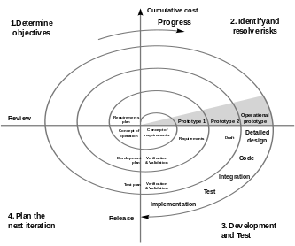

*The spiral model is a risk-driven process model generator for software projects. Based on the unique risk patterns of a given project, the spiral model guides a team to adopt elements of one or more process models, such as incremental, waterfall, or evolutionary prototyping-Wikipedia.org/wiki/Spiral_model*

Description

Done by Jordan Tan

What the spiral model does is that it combines both the design and prototyping-in-stages, to combine both advantages of top-down and bottom-up concepts. This model of development combines both the features of a waterfall and prototyping model. The spiral model is favoured in large and expensive projects due to its flexibility. This model uses many same phases as the waterfall model, in the same order only separated by planning, risk assessment and the building of porotypes and simulations.

Usage

It is used in shrink-wrap large applications and systems which built-in small phases or segments.

Advantages and Disadvantages

|  |  |
| --- | --- |
| **Advantages** | **Disadvantages** |
| * Estimates (i.e. budget, schedule, etc.) become more realistic as work progresses, because important issues are discovered earlier. * Early involvement of developers· Manages risks and develops system into phases | * High cost and time to reach the final product. * Needs special skills to evaluate the risks and assumptions. * Highly customizable thus, limiting re-usability. |

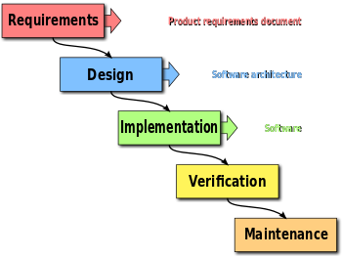Waterfall Model

*The waterfall model is a sequential design process, used in software development processes, in which progress is seen as flowing steadily downwards (like a waterfall) through the phases of conception, initiation, analysis, design, construction, testing, production/implementation and maintenance.- Wikipedia.org/wiki/Waterfall_model*

Done by Jordan Tan

Description

The waterfall Model is a linear sequential flow which progress is seen as flowing steadily downwards (like a waterfall) through the phases of software implementation. This means that the following phase in the development process begins only if the previous phase is complete. The waterfall approach does not define the process to go back to the previous phase to handle changes in requirement. The waterfall approach is the first ever approach that was used for software development.

Usage

Projects which are not focused on changing the requirements. For instance, projects initiated from request for proposals or any small scale projects that do not require much changes made in previous steps.

Advantages and Disadvantages

|  |  |
| --- | --- |
| **Advantages** | **Disadvantages** |
| * Easy to explain to the user. Structural approach. * Stages and activities are well defined· Helps to plan and schedule the project easily· Verification at each stage ensures early detection of errors. * Each phase has specific deliverables. | * Assumes that the requirements of a system are fixed· Very difficult to go back to any stage to alter the details after it is finished. * Little flexibility and adjusting scope is difficult and expensive. * Costly and required more time, in addition to detailed plan. |

V-shaped model

Done by Jordan Tan

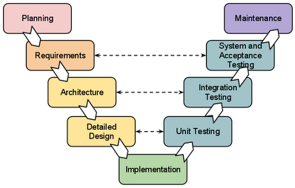

*In software development, the V-shaped model represents a development process that may be considered an extension of the waterfall model, and is an example of the more general V-shaped model.-Wikipedia.org/wiki/V-Model_(software_development)*

Description

Also known as the Verification and Validation model, the V-shaped model grew out of Waterfall and is characterized by a corresponding testing phase for each development stage. Like Waterfall, each stage begins only after the previous one has ended. This model is useful when there are no unknown requirements, as it’s still difficult to go back and make changes. The major difference between the V-shaped model and Waterfall model is the early test planning in the V-shaped model.

Usage

Software requirements for the project are clearly defined and known and the software development technologies and tools are well-known and clear to the project engineers which then this method can be used.

Advantages and disadvantages

|  |  |
| --- | --- |
| **Advantages** | **Disadvantages** |
| * Simple and easy to use. * Each phase has specific deliverables. Better compared to waterfall method due to the testing done during its life cycle. * Works well when requirements are understood and clearly stated. | * Inflexible, like the waterfall method. * Little flexibility and adjusting the scope is difficult and expensive. * Software being developed during implementation phase, thus no prototypes of software are produced. |

# Application of any theoretical mentions to project

Done by Jordan Tan

Jordan’s References

<https://en.wikipedia.org/wiki/Systems_development_life_cycle>

<http://istqbexamcertification.com/what-are-the-software-development-life-cycle-sdlc-phases>

<https://melsatar.wordpress.com/2012/03/15/software-development-life-cycle-models-and-methodologies/>

<https://www.roberthalf.com/technology/blog/6-basic-sdlc-methodologies-the-pros-and-cons>

<http://www.slideshare.net/RiantSoft123/different-types-of-software-development-model>

Temasek Polytechnic

School of Informatics and IT

**Diploma in Information Technology (IT)**

Project Plan

**Project Particulars**

|  |  |
| --- | --- |
| **Tutor** | Ms Ho Li Chin |
| **Class** | P02 |
| **Project Title** | Delonix Regia Hotel Management System |

**Project Team’s Particulars**

|  |  |
| --- | --- |
| **Matric Number** | **Student Name** |
| **1400652B** | **Esther Leong (Beth)** |
| **1402818G** | **Jordan Tan Ren Jie** |

Table of Contents

1. Introduction
   1. Objectives and scope of the project
   2. Assumptions and constraints
   3. Definitions and acronyms
2. Roles and responsibilities
3. Estimates and project schedule
   1. Work breakdown structure
   2. Project schedule
   3. Budget summary
4. Risk management plan

Project Plan

1 Introduction

1.1 Objectives and scope of the project

*[Describe the objectives of the project and the list of features that will be developed (the scope). Give brief descriptions of what deliverables the project is expected to deliver at the end of the project]*

As part of our Student Internship Programme (SIP), our boss have allocated us to this project which is regarding to the development of hotel management system for Delonix Regia. We are told that Delonix Regia is managed by Mr. and Mrs. Wang and is located at a reasonably good district however, it is hasn’t been doing well.

For the deliverables , we have in plan will be a system which is able to managing bookings like the change of date or change or adding of rooms , able to manage the cleaning schedule of rooms , extra options like able to add on an extra breakfast or the rental of bikes , having a system that is able to automatically generate email to be sent to guests like a certain days before they check in , or after they check-in to wish them to have a good stay or a day before their check-out drop them an email to remind them when is the check-out timing and also maybe attached a feedback form to see how the hotel can be better or to see what the hotel is already doing good enough.

1.2 Assumptions and constraints

*[Any assumptions underlying the project are stated here, together with constraints such as the delivery date, hardware/software availability etc. that will affect project management]*

Based on reading the assignment specification, it seems that currently Mr. and Mrs. Wang is using the manual system now hence , the picking up and understanding of this system might take a while hence it might affect the way they used to manage.

As most of the data was previously hand written, there might be concern over book-keeping matters, like is all the data required available, and furthermore, human error is unavoidable. Hence, when doing data entry to input the data into the database, not only might have time consuming, there is also chances of data being input in wrongly.

Most system when managing their database, they will have a set data purging as system needs to make more space for other data. However, one of the concern is that, what if data is being purged incorrectly.

Database issue. Most company have two database , for one works as a backup copy , hence , usually they would get a routine sync , so that both database will be up to date . however , as hotel service line is to be available 247 for client , If the client were to do make an reservation during the syncing of data , there might be chances that the back end database don’t have it in its database , hence it might create an issue.

1.3 Definitions and acronyms

*[This ensures that the project plan is understood the same way by everyone]*

* Student internship programme (SIP)
* Solid-state drive (SSD)
* Western Digital (WD)
* Operating system (OS)
* Search engine optimization (SEO)
* Pay per Click (PPC)
* Content management System (CMS)
* Unique Selling Preposition (USP)

2 Roles and responsibilities

*[Every team member is responsible for the analysis, design, implementation and testing of some features of the system. Describe who is responsible for which features. A particular feature can have more than one member responsible for it]*

|  |  |
| --- | --- |
| Name | Responsibility |
| Esther Leong (Beth) | * Managing booking * Accepting booking * Multi user account |
| Jordan Tan | * Extra options * Email generation |

3 Estimates and project schedule

3.1 Work breakdown structure

*[The work breakdown structure is a list of tasks that, if completed, will produce the final product. In general, any project can be broken down into 10-20 tasks. Organize the tasks based on phases and/or iterations. Break a large task into several sub-tasks if necessary. For each task, estimate the effort required in terms of days and decide who will be responsible for the completion of the task. Identify all major milestones and important release points]*

* Developing the system; Booking in and Checkout (using SDLC) – 40 to 56 days
* Planning and information gathering

During this step, we have to gain information about other hotel management systems and plan what we are going to have in our own system. We have to check the system’s requirements and work towards it.

* Designing the system

Planning the hardware and the system design is part of this step.

Risk management is part of this phase too as the budget constraints are all discussed.

* Implementation

The coding is done here. Database information and tables are all done during this step and fine tuning the configuration of the hardware is also done during this step.

* Testing

During this step, all systems are done and ready to be tested by end users.

* Further development of the system (Facilities)-21 days

Extra features offered in the hotel management system is done here. For instance, Meals and Clothes services (ironing, washing).

* Security system implementation-40 days

Enable firewall to prevent viruses and have a DDL trigger such that the database is protected and would prevent unauthorized changes to the database system.

* Training of staff members

This step is done once the system is fully developed and ready to use. Training of the staff members is required to ensure that they would know how to use the newly developed system.

3.2 Project Schedule

*[Use Microsoft Project 2003 to draw a detailed schedule, showing target dates for completion of iterations and phases, release points, demos and other milestones. It should also show the dependencies between activities, the estimated time required to reach each milestone and the allocation of people to activities]*

3.3 Budget Summary

*[Give a summary of the estimated budget required to complete the project. Compute 1) manpower costs – based on the monthly salary of a typical software engineer and the duration of the project; 2) hardware costs e.g. PCs/servers, printers, scanners etc; 3) software costs e.g. microsoft visual studio, rational functional tester, microsoft project, macromedia dreamweaver etc]*

|  |  |  |
| --- | --- | --- |
|  | Cost | Total cost |
| Man Power cost |  |  |
| Monthly salary (engineer) | 3200 |  |
|  |  | 3200 |
| Software |  |  |
| CMS | 100 |  |
| Blog | 100 |  |
| Landing page | 100 |  |
| Domain name | 100 |  |
| Analytics | 100 |  |
| Hosting | 100 |  |
| SEO | 300 |  |
| Microsoft suite | 200 |  |
| Antivirus | 100 |  |
|  |  | 12000 |
|  |  |  |
| Design |  |  |
| Images | 250 |  |
| Template | 250 |  |
|  |  | 500 |
|  |  |  |
| Hardware |  |  |
| 2X 2TB WD SSD | 300 |  |
| 2 X computer | 1000 |  |
| Printer | 300 |  |
| Fax machine | 200 |  |
| Scanner | 100 |  |
|  |  | 1900 |
|  | Total: | 17600 |

4 Risk Management Plan

*[Describe possible project risks, the likelihood of these risks arising and the risk reduction strategies that are proposed]*

By assigning values to categories:

High = 3 (red)

Medium=2 (yellow)

Low =1 (green)

|  |  |  |  |
| --- | --- | --- | --- |
| Type of risk | Degree of Damage | Chances of occurrence | Risk exposure  (Impact x likelihood) |
| 1. Funding being cut | High | Low | 3X1=3 |
| 1. Developer resign | High | High | 3X3=9 |
| 1. Miscalculation of due date | High | Low | 3X1=3 |
| 1. Miscommunication with client | High | High | 3X3=9 |
| 1. Being hacked | High | Low | 3X1=3 |
| 1. Bug in database | Medium | Medium | 2X2=4 |

Above a to f are some of the possible risk that can happen during the project, there is a variety of high, medium and low. Some risk reduction strategies , they are either to go around the situation alternatively is to take action against all the possible negative impact , like for example , to avoid being hacked in database , developer can add salt and encrypt important details like password or credit card ccv. Furthermore, determining mitigation plans, to understand what the user’s needs, is the best way to avoid any risk of faults.

Temasek Polytechnic

School of Informatics and IT

**Diploma in Information Technology (IT)**

Terms of Reference

**Project Particulars**

|  |  |
| --- | --- |
| **Tutor** | Ms Ho Li Chin |
| **Class** | P02 |
| **Project Title** | Delonix Regia Hotel Management System |

**Project Team’s Particulars**

|  |  |
| --- | --- |
| **Matric Number** | **Student Name** |
| **1400652B** | **Esther Leong (Beth)** |
| **1402818G** | **Jordan Tan Ren Jie** |

**1. Introduction**

*Give a short introduction to the project. You may include information such as the purpose of the project, any relevant background information, the users and usage of the system, brief description of problems faced thereby leading to the need for this system, etc.*

As part of our Student Internship Programme (SIP), our boss have allocated us to this project which is regarding to the development of hotel management system for Delonix Regia. We are told that Delonix Regia is managed by Mr. and Mrs. Wang and is located at a reasonably good district however, it is hasn’t been doing well.

**2. Objectives of the Project**

Describe the objectives that you want to achieve through this project. Objectives may be both technical and non-technical.

Objective is to have a software system for Delonix Regia Hotel , which allows help manage booking , for example to change of dates or the change of adding of rooms and also the adding of extras , like for example , rental of bike or even an extra breakfast . The system is also able to arrange housekeeping matters, such as manage the cleaning schedule of rooms, and also able to auto generate emails to clients to remind them of maybe check out timing or rules and regulations of the hotel.

**3. Scope of the Project**

Describe the key features of the software system you are developing. This description does not need to be detailed; it can simply be a few sentences that give a general explanation of the feature.

The key feature as the following:

Esther’s

* Mange booking of hotel suite
* Manage changes in appointment
* Adding to extras to cart / top-up to current package
* Ability to arrange housekeeping
* Ability to auto generate email reminders
* Collate feedback forms

Jordan’s

* Enable booking online
* Enable efficient communication within hotel system
* Easy authorized modification to database
* Ensure security of database records

**4. Distribution of Workload**

Determine which members of the team will be responsible for what areas of project work. Individual’s responsibilities should be clearly spelt out.

|  |  |
| --- | --- |
| **Objectives/Deliverables** | **Members** |
| Report (Individual ) | Esther Leong (Beth)  Jordan Tan |
| Project Plan 1.1 ,1.2,1.3,2, 3.3,4 | Esther Leong |
| Project Plan 1.1 , 3.1 ,3.2 | Jordan Tan |
| TOR 1,2,3,4,6,7,8 | Esther Leong (Beth) |
| TOR 3, 4,5,6,8 | Jordan Tan |
| Peer evaluation | Esther Leong(Beth)  Jordan Tan |

**5. Constraints**

List any constraints that you expect to face e.g. lab opening hours, different timetable schedules, etc.

* Different lifestyle ; leading to difficulties to meet up
* Part-time jobs that’s may clash with the little free time that we have
* The task that we have for committees

**6. Resources**

List the hardware and software resources that your project will need.

The list is as following:

Hardware

* 2TB SSD, WD brand preferred
* Computer ram of 4GB or above , running on quad core processor
* Keyboards
* Mouse
* Monitors
* Speakers
* Printer
* Fax machine
* Scanner

Software

* Microsoft Word
* Microsoft Excel
* Microsoft PowerPoint
* Antivirus
* Database
* Device driver
* Outlook / Lotus note
* Internet browser ( google chrome / Firefox)
* Windows 10 OS

**7. Product Positioning in the Market/Company**

Describe how your product differentiates itself from similar products in the market. Describe any interesting or unique features that your product has.

Product differentiation

Frankly, there are already such soft wares available online, what makes our software even better is that it is tailor made, in a way, we understand what the company need and try our best to fulfil every requirement which is needed, furthermore, every company is different hence by having a personalize system, the business can work better and therefore is ahead of others.

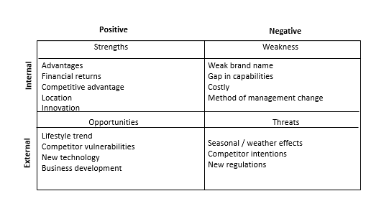

SWOT Analysis

SWOT Analysis

SWOT stands for strength, weakness, opportunities and threats, it is the business version of routine maintenance is an analysis of the business practice.

The Strength of the business is based on a few factors:

As the hotel is located at a reasonably good location, there will definitely be a market of people who want to stay there and with the innovative of having a software and also a website, the company though pay for the system but however they gain traffic and more acknowledgment of their existence and hence boost sale therefore making a define return financially.

The Weakness of the business is based on a few factors:

As the hotel hasn’t had much business , therefore it results to having a weak brand name , thus when the software and website is being implemented , there will be a traffic but the staff in the hotel might not be used to coping with such crowd can lead to having a gap in capability. Furthermore, as Mr. and Mrs. Wang as middle-aged, they might not be able to grasp the concept of the new software fast, hence it might lead to management facing some management issues.

The Opportunities of the business is based on a few factors:

With the demographic of the location, I will believe that it is a hot spot for relaxing or tourism , therefore base on the current first world lifestyle trend , consumers are very willing to spend and given the great location where the hotel is being located at , business is guaranteed.

The Threats of the business is based on a few factors:

Given that it is a relaxing hot spot or tourism hot spot , it is unavoidable that the business is affected by the seasons hence that’s one of the business threat company can face. Else is if the government wants to implement a new set of regulation on how hotels must be , apart from that I believe with the system , the hotel has the upper hand.

Unique selling Proposition (USP)

The most important selling point of Delonix Regia Hotel Management System is that it is personal, as this system is tailor made for Delonix Regia Hotel. Hence, it will consist of all the features that is needed. It is crucial as since the hotel is paying the money to develop, hence of course they would want it to be usable and since it is for a business, it is important that it meets what the customer wants and give it to them.

**8. Approach and Methodology of the Project**

Describe the development model your team will be adopting for the project. Describe any potential risks or problems your team might have adopting the development model and what you can do to overcome them.

After discussion, our team have decided on adopting the V-model for the project. We decided to use this as we feel that as it is for a hotel, the management method is very unlikely to be changed. Furthermore , though there is readily available software , we feel that the one that is customize by our team will be more personalize as in V-model there is more communication and more testing , meaning that we know more in depth on what Mr. and Mrs. Wang wants and with a lot of testing , it has less tendency to have issues .

Possible risk, would be efficiency weakness, performance degradation, security flaws and appearance of the webpage. It happens as IT is advancing everyday hence, we believe with regulate maintenance the website will be alright as prevention is key, we shouldn’t wait till the problem arises before we fix it, hence, with being regularly maintained, we can overcome these issues.

Temasek Polytechnic

School of Informatics and IT

**Diploma in Information Technology (IT)**

Team/Peer Evaluation

|  |  |
| --- | --- |
| **Project Title:**  Delonix Regia Hotel Management System | |
| **Student No: 1400652B** | **Student Name: Esther Leong (Beth)** |

|  |  |  |  |  |  |
| --- | --- | --- | --- | --- | --- |
| Rate the overall team performance against each criterion. Circle one number from  1 (inadequate) to 5 (superior) | | | | | |
| Team spirit | **1** | **2** | **3** | **4** | **5** |
| Overall effectiveness | **1** | **2** | **3** | **4** | **5** |
| Rewarding experience | **1** | **2** | **3** | **4** | **5** |
| Team productivity | **1** | **2** | **3** | **4** | **5** |
| Process quality | **1** | **2** | **3** | **4** | **5** |
| Product quality | **1** | **2** | **3** | **4** | **5** |

|  |  |  |  |  |  |
| --- | --- | --- | --- | --- | --- |
| Rate the contribution of each team member (including yourself). Circle one number from  1 (inadequate) to 5 (superior) | | | | | |
| Myself | **1** | **2** | **3** | **4** | **5** |
| <State name of Team Member 1> | **1** | **2** | **3** | **4** | **5** |
| <State name of Team Member 2> | **1** | **2** | **3** | **4** | **5** |
| <State name of Team Member 3> | **1** | **2** | **3** | **4** | **5** |

|  |  |  |  |  |  |
| --- | --- | --- | --- | --- | --- |
| Rate the quality of work (including timeliness) of each team member (including yourself). Circle one number from 1 (inadequate) to 5 (superior) | | | | | |
| Myself | **1** | **2** | **3** | **4** | **5** |
| <State name of Team Member 1> | **1** | **2** | **3** | **4** | **5** |
| <State name of Team Member 2> | **1** | **2** | **3** | **4** | **5** |
| <State name of Team Member 3> | **1** | **2** | **3** | **4** | **5** |
| Rate the help and support you have received from each team member. For yourself, rate the support and help you have given to other team members. Circle one number from  1 (inadequate) to 5 (superior) | | | | | |
| Myself | **1** | **2** | **3** | **4** | **5** |
| <State name of Team Member 1> | **1** | **2** | **3** | **4** | **5** |
| <State name of Team Member 2> | **1** | **2** | **3** | **4** | **5** |
| <State name of Team Member 3> | **1** | **2** | **3** | **4** | **5** |

|  |
| --- |
| **Comments:** |
|  |
|  |
|  |
|  |
|  |
|  |
|  |

**Signature: ____________________________ Date: ______________________**

Temasek Polytechnic

School of Informatics and IT

**Diploma in Information Technology (IT)**

Team/Peer Evaluation

|  |  |
| --- | --- |
| **Project Title:**  Delonix Regia Hotel Management System | |
| **Student No: 1402818G** | **Student Name: Jordan Tan** |

|  |  |  |  |  |  |
| --- | --- | --- | --- | --- | --- |
| Rate the overall team performance against each criterion. Circle one number from  1 (inadequate) to 5 (superior) | | | | | |
| Team spirit | **1** | **2** | **3** | **4** | **5** |
| Overall effectiveness | **1** | **2** | **3** | **4** | **5** |
| Rewarding experience | **1** | **2** | **3** | **4** | **5** |
| Team productivity | **1** | **2** | **3** | **4** | **5** |
| Process quality | **1** | **2** | **3** | **4** | **5** |
| Product quality | **1** | **2** | **3** | **4** | **5** |

|  |  |  |  |  |  |
| --- | --- | --- | --- | --- | --- |
| Rate the contribution of each team member (including yourself). Circle one number from  1 (inadequate) to 5 (superior) | | | | | |
| Myself | **1** | **2** | **3** | **4** | **5** |
| <State name of Team Member 1> | **1** | **2** | **3** | **4** | **5** |
| <State name of Team Member 2> | **1** | **2** | **3** | **4** | **5** |
| <State name of Team Member 3> | **1** | **2** | **3** | **4** | **5** |

|  |  |  |  |  |  |
| --- | --- | --- | --- | --- | --- |
| Rate the quality of work (including timeliness) of each team member (including yourself). Circle one number from 1 (inadequate) to 5 (superior) | | | | | |
| Myself | **1** | **2** | **3** | **4** | **5** |
| <State name of Team Member 1> | **1** | **2** | **3** | **4** | **5** |
| <State name of Team Member 2> | **1** | **2** | **3** | **4** | **5** |
| <State name of Team Member 3> | **1** | **2** | **3** | **4** | **5** |
| Rate the help and support you have received from each team member. For yourself, rate the support and help you have given to other team members. Circle one number from  1 (inadequate) to 5 (superior) | | | | | |
| Myself | **1** | **2** | **3** | **4** | **5** |
| <State name of Team Member 1> | **1** | **2** | **3** | **4** | **5** |
| <State name of Team Member 2> | **1** | **2** | **3** | **4** | **5** |
| <State name of Team Member 3> | **1** | **2** | **3** | **4** | **5** |

|  |
| --- |
| **Comments:** |
|  |
|  |
|  |
|  |
|  |
|  |
|  |

**Signature: ____________________________ Date: ______________________**