Prof. Brewer could we meet to discuss these ideas please?
Project Ideas for 262A course project.
Idea 1:
One idea I have is to create a bare iron scheduler/OS for PTIDES on a 32bit embedded machine. I’d like to incorporate the idea in TinyOS to use interrupts as the only form of mutual exclusion.
PTIDES actors, sensors, and actuators follow discrete event semantics. A simple diagram is shown below.

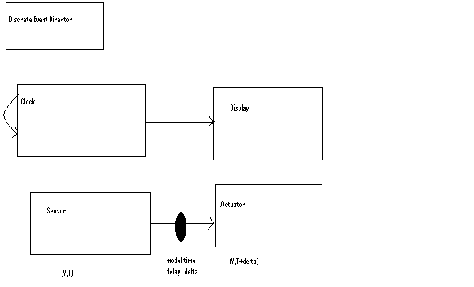
Figure 1. Simple PTIDES diagram

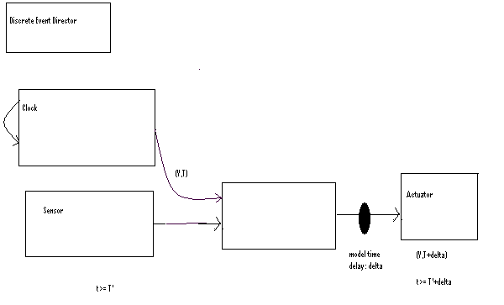
Figure 2: Slightly more complex PTIDES diagram
At the high level the thought initially is to have a main thread that initializes all the actors. The clock actor would be initialized with the value 0, and would post and event on the event queue. When that event is processed it would pass 0 to the display and 1 back to the clock.
The initialization code for the sensor could set up an interrupt service routine which triggers periodically to read information from a location, and create an event on the event queue.
The main thread would look like something along the lines of
-initialize all actors
While(1)
{
-fire next fireable event if there is one
}

Sensor int_service routine
- Post sensor on the event queue
- Schedule the next interrupt if necessary
While(fireable)
{
Fire Next Fireable event
}
Things that could get a little tricky include determining how to make sure that if the main thread is preempted by an interrupt service routine the event is has begun processing doesn’t get processed in the interrupt handler.
There is also the need to determine what order things should be done in if events have equivalent time stamps. One suggestion of how to handle this that I’ve gotten thus far is to use the approach by Chandy and Misrah (I’ll need to look this up to be more familiar with their apporach) and another suggestion I’ve gotten is to reference the text Real-Time Systems by Jane S. S. Liu for scheduling semantics for real-time systems.

And Event consists of :
-value
-timestamp
-delta: real time over timestamp when it is safe to proceed (delta =-infinity is an acceptable assignment in some cases)
-destination (could be a port or a function pointer.)

The catch part is determining when something is fireable since: the sensor will have the value and timestamp (V,T) at time t>= T . It is essential that we introduce a model time delay to assure the correct functionality of the actuator since we know that the actuator will have its value at a time t<=T. This would require that the sensor and actuator react simultaneously and that is not possible. So, the actuator can get its information (is fireable) at time t<=T+delta.
Since the clock and display actors don’t have a timing dependency as soon as the clock produces and event it can be sent to the display. The clock display interaction is interruptible by the Sensor ISR handler and it will process the next fireable event. The next fireable event may be one posted by the clock or it may be one posted by the sensor.

I’m not sure exactly which subinstances I’ll start with, and I’d gladly take suggestions .
Idea 2: ( Idea 2 is a special case of idea 1, you could assume that the delay is set to the period of a task.. or it can be thought of as a separate idea)
I’d like to use the concepts in the attached PDF to generate a prototype OS for the PRET processor. PRET currently has 6 hardware threads and a suggestion I’ve gotten is to use one hardware thread as the scheduler for the OS. Another suggestion I’ve gotten is to use the OS to enable the use of more than 6 threads and having the OS do thread switching. Writing the OS for PRET is slightly scary b/c at the moment I don’t think there are any interrupt available to do thread switching.
Please see attached PDF and feel free to share your thoughts, comments, and suggestions.They would be greatly appreciated.

