The Fifth Biennial Ptolemy Miniconference

Tentative Program
The program includes invited speakers from organizations worldwide, plus members of the Ptolemy project describing current research at Berkeley. Topics include:
- Project Status
- Distributed Ptolemy Models
- Code Generation
- Hardware Synthesis
- Java/C++ hybrid simulation
- Actor Definition Languages
- Evolutionary Programming
- Hybrid System Modeling
- Model-Driven Architecture
- Composition of Web Services
- Modeling of Control Systems
- Image and Video Processing
- Communications Systems Modeling
- Distributed Process Networks



Ptolemy Project
Dept. of Electrical Engineering and Computer Sciences
University of California at Berkeley
Berkeley, CA 94720
http://ptolemy.eecs.berkeley.edu

Contact: Peggy Kingsley
(510) 642-1818
Fax: (510) 642-2379
peggyk@eecs.berkeley.edu
Ptolemy
Miniconference
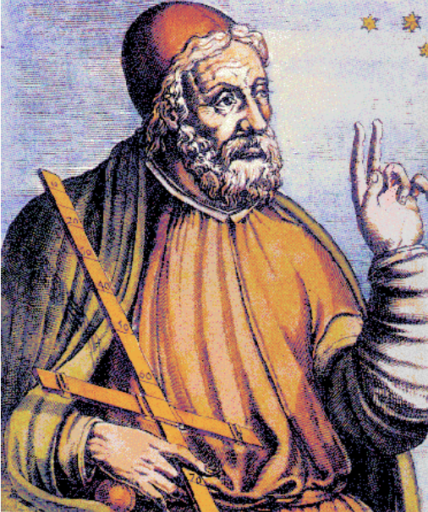Friday
May 9, 2003
Claremont Hotel, Berkeley
Announcing the Fifth Biennial Ptolemy Miniconference for friends of the Ptolemy Project.
http://ptolemy.eecs.berkeley.edu/ptconf

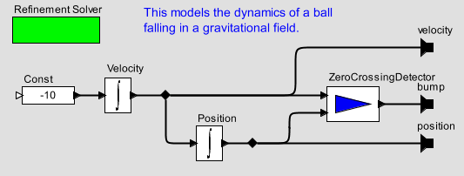
When and Where?
May 9, 2003
8:30 AM – 5:15 PM + reception
Claremont Hotel
41 Tunnel Road
Berkeley, CA 94705
1-800-551-7266
http://www.claremnt.com/

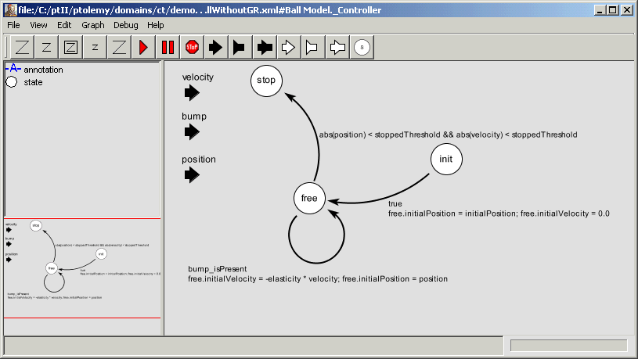How To Register
Register on-line by May 1, 2003 at:
http://ptolemy.eecs.berkeley.edu/ptconf
Or send your name and email address:
ptconf03@ptolemy.eecs.berkeley.edu
Advance registration is strongly advised, since previous instances of this conference have sold out.

Conference Fee
The conference fee is $200, waived for students, sponsors, presenters.

About the Ptolemy Project
The Ptolemy Project focuses on system-level modeling, simulation, and design of reactive and real-time embedded systems. It has developed an open software architecture that provides high-level support for signal processing, communications, and real-time control. The key principle of the project is the use of multiple concurrent models of computation in a hierarchical and heterogeneous design environment.
Ptolemy II model illustrating a hybrid system model.
