The Seventh Biennial Ptolemy Miniconference

Tentative Program
The program includes invited speakers from organizations worldwide, plus members of the Ptolemy project describing current research at Berkeley. Topics include:
- Ptolemy Project Overview
- Kepler Project Overview
- The Kepler Actor Repository
- Leveraging synchronous language principles for CT, DE, and hybrid models
- Scheduling Data-Intensive Workflows
- Programming Distributed Embedded Systems
- Flexible Scientific Workflow with Dynamic Embedding
- Partial Evaluation for Optimized Compilation of Actor-oriented Models
- Correctness in Causal Systems
- Causality Interfaces for Actor Networks
- Collection-Oriented Modeling of Workflows
- Higher-Order Components
- Viptos: A Development Environment for TinyOS-based Wireless Sensor Networks
- Synthesizing Models to FPGA using CAL
- Cyber-Physical Systems: A Vision of the Future



Ptolemy Project
Dept. of Electrical Engineering and Computer Sciences
University of California at Berkeley
Berkeley, CA 94720
http://ptolemy.eecs.berkeley.edu

Contact: Tracey Richards
(510) 642-2352
Fax: (510) 642-2718
tracet@erso.berkeley.edu

Ptolemy
Miniconference
Tuesday
February 13, 2006
Soda Hall, UC Berkeley
Announcing the Seventh Biennial Ptolemy Miniconference for friends of the Ptolemy Project.
http://ptolemy.eecs.berkeley.edu/ptconf

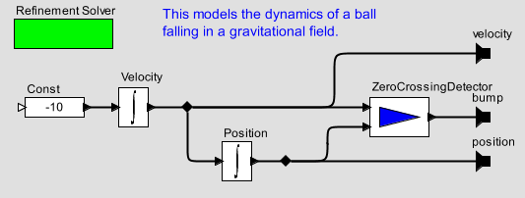
When and Where?
February 13, 2007
8:30 AM – 5:00 PM + reception
HP Auditorium
Soda Hall
University of California, Berkeley

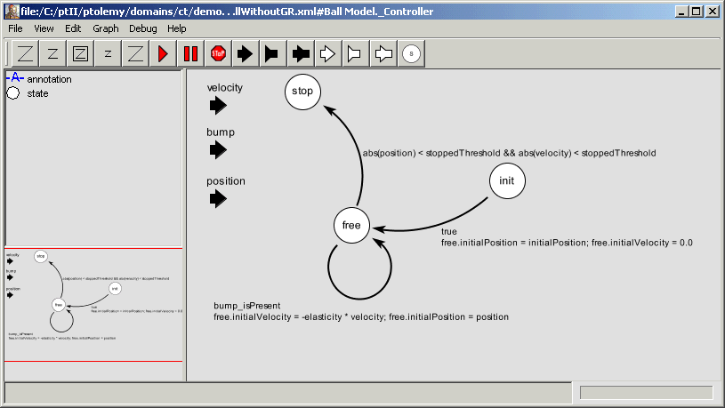How To Register
Register on-line by February 2, 2006 at:
http://ptolemy.eecs.berkeley.edu/ptconf
Or send your name and email address:
ptconf07@ptolemy.eecs.berkeley.edu
Advance registration is strongly advised, since previous instances of this conference have sold out.

Conference Fee
The conference fee is $100, waived for students, sponsors, presenters.

About the Ptolemy Project
The Ptolemy Project focuses on system-level modeling, simulation, and design of reactive and real-time embedded systems. It has developed an open software architecture that provides high-level support for signal processing, communications, and real-time control. The key principle of the project is the use of multiple concurrent models of computation in a hierarchical and heterogeneous design environment.
Ptolemy II model illustrating a hybrid system model.
