PROJECT SUMMARY

AO Number: J655

Contract Number: F33615-00-C-1703

Organization: UC Berkeley

Subcontractors: University of Maryland

Principal Investigators:
Lee, Edward, eal@eecs.berkeley.edu, 510-642-0455, 518 Cory Hall, Berkeley, CA 94720.
Henzinger, Tom, tah@eecs.berkeley.edu, 510- 643-2430, 517 Cory Hall, Berkeley, CA 94720

Financial POC: Ortiz, Sonia, sortiz@eecs.berkeley.edu, (510) 643-3299, 545B Cory Hall,
Berkeley, CA 94720-1774

Title of Effort: Process Based Software Components for Networked Embedded Systems

Period of performance: June 2000 – November 2003.

Approach: Our focus is on the models of computation for model-based design and on runtime environments for embedded systems. The emphasis of this project is on the dynamics of the components, including the communication protocols that they use to interface with other components and the modeling of their state. The objective is to provide mechanisms for both modeling and code generation. The focus is on real-time applications, which implies that models of time are a critical part of the abstractions that we are developing. Specifically:
- We augment component interfaces to capture dynamic properties (concurrency and communication protocols).
- We define models of computation (MoC) and their software realizations. The MoCs are given as sets of compatible dynamic types.
- We construct code generators that exploit interface definitions to create correct-by-construction embedded software with real-time behavior.

FY 02 Accomplishments:
- Defined a behavioral type system that captures the essential features of a model of computation and actors within it in a type-theoretic framework.
- Built a Ptolemy II domain for representing and manipulating behavioral type definitions in the form of interface automata.
- Demonstrated import and export of hybrid system models from Charon to and from Ptolemy II models. Started a similar interface to HSIF.
- Constructed V2V and ETC models in Ptolemy II, demonstrating the use of hierarchical heterogeneous compositions of models of computation.
- Constructed a Giotto domain in Ptolemy II with code generation to Giotto textual syntax, where Giotto is a time-driven, periodic hard-real-time model of computation.
- Demonstrated synthesis of embedded machine (EM) code from Giotto models, where EM is a virtual machine that we have developed for real-time software.
- Defined the timed multitasking (TM) model of computation for real-time, aperiodic tasks. TM has similar semantics to Giotto, but adapted for aperiodic tasks.
- Organized and held the First International Workshop on Embedded Software, EMSOFT 2001.
- Demonstrated co-compilation from synchronous dataflow models to Java and JHDL (for hardware synthesis).
- Integrated Ptolemy II with MATLAB, built a modular unit system, improved the modal modeling capability, and made many other software infrastructure improvements.

Specific FY 03 Objectives:
- Complete ETC and V2V models and code generators.
- In the actor definition framework, define meta-semantics for domain-polymorphic actors.
- For behavioral types, support reflection and real-time properties as dependent types.
- Complete SDF code generation with token unboxing, elimination of dynamic memory management, and 100% of test suite passing.
- Code generate Ptolemy II expressions to enable the use of expression actor in models.
- Implement FSM code generation to support modal models.
- Complete C code generation and support a key subset of Java libraries.
- Integrate heterogeneous code generators by systematizing hierarchy support.
- Define the Java subset that generates well to C and ensure that generated code matches.
- Define actor meta-model and specification language for domain-polymorphic actors.

Technology Transition: Ptolemy II will be distributed in open-source form with sophisticated web-based installers and the traditional liberal Berkeley copyright agreement, which permits commercialization of the software and derivative works. This mechanism has proved extremely effective at technology transfer. Software published under this mechanism in the past has found its way into numerous commercial products, non-commercial tools, and research enterprises.

Although technically we do not provide support for such software, we have in the past been able to provide some support through newsgroups, e-mail mailing lists, and the World Wide Web. We plan to continue this informal support network for software developed under this project, and to extend it with the use of applets for dissemination and education of potential users.

Funding Received to Date: Total funding received to date since the inception of the project under this specific DARPA program is $1,236,575.35 of a total award of $1,611,820 through November 2002. The original anticipated Total Project Funding is $2,437,000 from May 2000 through November 2003. The total award through November 2002 includes the modified awarded amount for the third year of the project, November 2, 2001 to November 30, 2002, from $679,560 to $533,940.

Unexpended Funds: This is the end of the second quarter of the funding cycle of the Processed-Based Software Components for Networked Embedded Systems grant. The figure below represents the financial history of MOBIES, its plans, and current status.

Attached to the report is a summary spreadsheet in which the numbers used to generate these charts are included.
Figure 1 below represents the DARPA/MOBIES budget and expenses this year 2002. The left-hand ordinate axis shows values for each quarter and the right-hand ordinate axis shows cumulative values; the "ceiling" amount is fixed at $533,940 and is constant over the period of the grant. Note that the yellow column is the sum of the DARPA increments cumulative. DARPA billings are represented by the yellow line graph.

Figure 1 depicts the 2002 DARPA/MOBIES budget and expenses for the first 6 months of 2002 and 1 month of 2001. The 2002 Actuals Cumulative line shows that the expenses of MOBIES are not in parallel with our Planned Spending, Cumulative. This is due to the carryforward of $131,968 from 2000-2001. June 2002-November 2002 is presented as projections. June is shown as a projection since the Berkeley Financial System reporting module has not yet been released forJune.

For the third year of the project, November 2001-November 2002, total actual expenditures through June 30, 2002 will be $416,089. Unexpended funds as of June 30, 2002 will be $117,851 of $533,940.

We are spending in accordance to the total awarded amount in conjunction with the carryforward. To date all of DARPA billings are current as of May 2002 and will be billed in full through November 2002. Please refer to Figure 1 below.

Figure 1

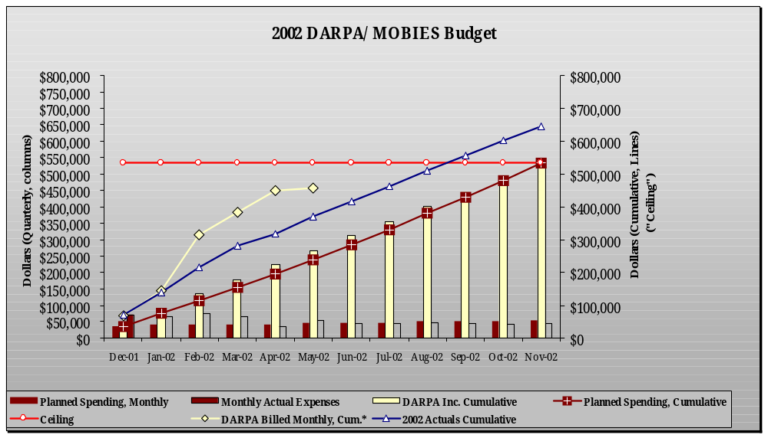

Date Unexpended Funds Will Be Depleted: Unexpended funds will be depleted by December 2002, in accordance to our projections.

Required Funding: FY03 Funding required for performance through 12/31/03 is $679,560.

Latest Invoice: Invoices are submitted by our Extramural Funds Accounting office, by Award Analyst Barbara Romero. The last invoice is in the amount of $64,335.89 dated June 27, 2002.

Date Prepared: July 15, 2002.

