Coordination Plan
Mobies Phase 1, UC Berkeley
Edward A. Lee
June 12, 2001

The following Gantt chart illustrates the planned schedule of technology delivery of capabilities. The challenge problems are listed below for reference, and a description of each task is given.

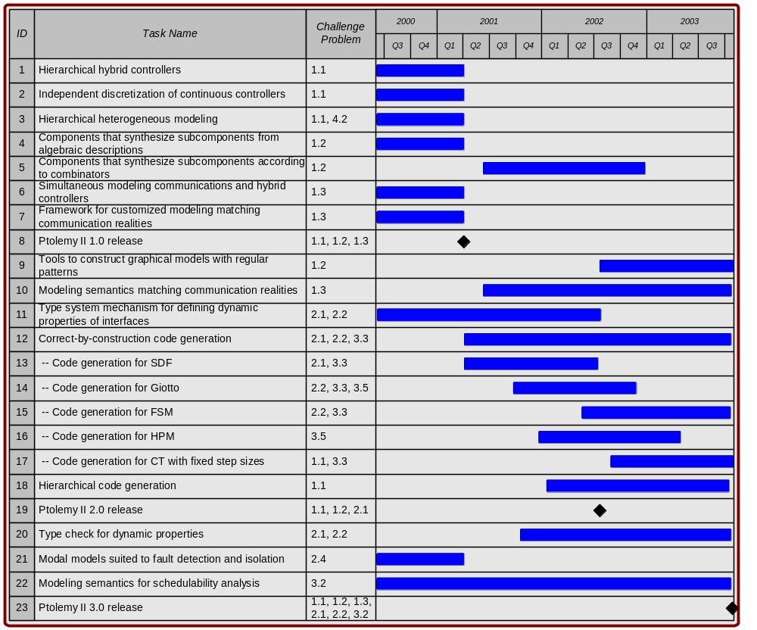

Table of Challenge Problems

1. Modeling
1.1 Multiple-view modeling
1.2 Automated composition of sub-components
1.3 Communication models
2. Model Analysis
2.1 Automatic test generation
2.2 Verification
2.3 Synthesis of switching
2.4 Performance
3. Implementation
3.1 Test vector generation
3.2 Schedulability analysis
3.3 Code generation
3.4 Code debugging and testing
3.5 RTOS generation
3.6 Allocation to distributed platforms
4. Integration
4.1 Model translation
4.2 Integration of different models of computation
4.3 Tool Integration
4.4 Software/hardware Integration

Description of capabilities

All capabilities will be demonstrated and delivered in executable software built on the Ptolemy II platform. Note that some of these capabilities, as noted below, have been developed under other programs. They are included here because of their pertinence to the automotive OCP.

- A mechanism for hierarchically modeling hybrid controllers.
Schedule: done (mostly under Composite CAD program).
- A mechanism for discretizing continuous-time models at multiple independent sample rates. This gets us from “level 1” to “level 2” as posed by challenge problem 1.1.
Schedule: done.
- A mechanism for hierarchically combining multiple modeling techniques, where for example a component representing a model of a software realization of a controller realized in an RTOS can be embedded in a continuous-time model of the plant and controller working together.
Schedule: done (mostly under Composite CAD program).
- Components that synthesize complex models from algebraic descriptions of functionality.
Schedule: done (under SEC).
- Components that synthesize complex models from particular combinators.
Schedule: started. We expect the first releasable version by mid 2002, final versions by the end of 2002.
- A framework that can simultaneously model communication networks (as in Opnet) and contollers and plants (as in Simulink), each using a modeling strategy suited to the problem being modeled. What we are delivering is ability to hierarchically compose distinct modeling strategies, not the libraries of modeling components that are needed to construct nontrivial network models.
Schedule: done (mostly under Composite CAD program).
- A framework that supports customization of the modeling semantics to match the realities of the communication network being used. For example, if a communication network with unreliable delivery is being used, then one might wish to construct a model of application by connecting components with unreliable communication links.
Schedule: done (mostly under Composite CAD program).
- Milestone: Ptolemy II 1.0 release. This release was completed in March 2001 and includes all the capabilities that are marked “done” here.
- Tools that help in the construction of graphical models that follow regular patterns. These are visual renditions of the combinators above.
Schedule: planned for end of 2003.
- Particular modeling semantics that tolerate communication latencies in communication systems by defining communication to be delayed. Giotto is one first example of such a modeling semantics. We are working on at least one other one that does not require the periodic structure of Giotto.
Schedule: started. Expect first versions released in mid 2002. Elaborations in 2003.
- A mechanism for defining dynamic properties of interfaces (such as that new inputs are required on all ports to react).
Schedule: first version done using FSMs and reported in http://ptolemy.eecs.berkeley.edu/publications/papers/00/systemLevel/. A second version interface automata (by Luca de Alfaro) has also been done, but not yet reported. Expect completion by mid 2002.
- Generators that produce code that is “correct by construction” in that it matches the (narrow) semantics of a well-understood model that does not therefore require elaborate verification. Giotto and synchronous dataflow, for example, are modeling frameworks with sufficiently narrow semantics that strong properties can be asserted about any correct-by-construction implementation.
Schedule: started. Complete by end of 2003.
- Code generation for SDF.
Schedule: concept demonstration completed by adapting Titanium compiler. We are rearchitecting the framework to use the Soot tools from McGill, and expect a new code generator by the end of 2001.
- Code generation for Giotto.
Schedule: by mid 2002.
- Code generation for FSM. This will allow for hierarchical code generation of hybrid controllers.
Schedule: by end of 2003.
- Code generation for HPM (hierarchical priority-driven multitasking), developed under SEC. This is our principle “RTOS generation” strategy.
Schedule: by end of 2002.
- Code generation for CT with fixed step sizes, providing easy migration from continuous controller designs to discrete versions.
Schedule: by end of 2003.
- Hierarchical code generation. This will allow heterogeneous models to be nested hierarchically with code generators for each layer producing atomic components for the layer above.
Schedule: to start in 2002. Complete by end of 2003.
- Ptolemy II 2.0 release. This will include all capabilities completed in time.
- A mechanism for composing interface definitions to perform “type check” statically.
Schedule: started. First version expected by mid 2002. A complete theory and software support is expected by end 2003, perhaps.
- Modal models suited to fault detection and isolation.
Schedule: done (mostly under Composite CAD program).
- Modeling semantics such as Giotto where schedulability analysis is greatly simplified by disciplining the inter-component interactions (data dependencies and synchronization). This will include modeling semantics that are applicable to other sorts of problems than Giotto, such as event-based problems.
Schedule: This is pretty open-ended work, hard to pin down to a schedule. Under the SEC project, we have developed an RTOS domain in Ptolemy II that has semantics somewhere between Giotto and a conventional RTOS. We are studying this to see how to adapt it to the automotive OEP scenario. Complete by end of 2003.
- Ptolemy II 3.0 release. This will be the final release under the Mobies project, and will include all capabilities developed.

Integration with other Mobies technology components

Code generators will produce code that can execute on OEP platforms. In addition, integration is possible at the tool level. Our platform for experimentation is Ptolemy II, which provides extensive infrastructure and an open architecture that are not available on any competing alternative. Ptolemy II is relatively easy to integrate to and to customize.

Risk analysis and risk management plan

The principal risk is that many of the Mobies participants are focused on a competition between tools, such as Simulink, Teja, and the Boeing OEP. Capabilities such as we describe here cannot be developed with Simulink without considerable cooperation from The MathWorks. However, the principle use of Simulink leverages real-time workshop to generate code to execute on the control platform. Our work is to develop technology that might eventually replace or enhance RTW in this role. The Boeing OEP is a suitable target for code generation. We currently have no strategy for working with Teja.

The use of Java in Ptolemy II and in the code generation framework creates its own risks. We believe that the code generation framework can be adapted to synthesize C code for execution on embedded microcontrollers, in case Java does not take off in embedded platforms. We have subcontracted the University of Maryland to help us explore this option.

Dialog with Phase 1 Team

The phase 1 team has raised the following questions about this plan:

- Coming from an application focus, it's tough to discern:
  - the particular experiments to which you will hook Ptolemy II;
  - the nuts-and-bolts on companion Phase II effort, that is, to what extent do we work with your folks -- for what period(s) of time, what emphasis, etc.
- And since the granularity on your Gantt chart is low, it's difficult to understand:
  - nearer term interactions required, namely the call for "capability demonstrations"
  - the nature of exchange, such as information, data, embellishments to our models, etc
- Finally, it would be nice (and a bonus) if we could receive an estimate of the types of improvements in our process -- which ostensibly mirrors the state of practice -- that your work could offer:
  - "-ilities": dependability, reliability, extensibility
  - measures of the above, e.g. 50% reduction in XYZ
  - again, this bullet is strictly a bonus, at least from our point of view

These are valid an useful questions, to which we reply:

- Our strategy is to understand the essential computational issues in the application models and address the manner in which such models can be constructed. Thus, instead of building elaborate powertrain controllers ourselves, something that we are not qualified to do, our goal is to understand how powertrain controllers are synchronized to the varying periodic camshaft rate, and what implications this has on computational models. Thus, a key question becomes, for example, how a computation should be specified where portions of the computation are synchronized to the varying periodic rate of the camshaft, other portions are synchronized to real-time periodic rates, and yet other portions are irregular and reactive. Thus, the inputs we expect from phase 1 are the computational structure of models (not the detailed control algorithms, which are largely irrelevant), and the nature of the interactions between various real time activities. The results we provide will be Ptolemy II models that illustrate how models computation may be selected and combined to construct suitable models.

- An example of an effective exchange is the interaction we had recently with Paul Griffiths, where we sat down with him and worked through a Matlab model that he had constructed for a powertrain throttle control problem, and we constructed a Ptolemy II model for the same controller. We learned that this controller followed exactly a pattern that we have been working on in the context of simpler controllers, where a continuous time plant is modeled interacting with a discrete-time controller. The discrete-time controller is defined in a manner suitable for code generation. As it currently stands, the computational structure of this model is extremely simple, much simpler than the models we have been working on. It has no modal behavior, no multitasking, and only simple periodic timing. Thus, the next step is to explore how one would combine this throttle controller with other powertrain and vehicle control actions, and how the model needs to be elaborated to encompass modal behavior and more elaborate timing properties. Note that this interaction required a one-on-one interchange, because we would not have been able to figure out the significance of the Matlab code without having Paul there to explain it. From a control systems perspective, the code is quite sophisticated. From a software perspective, its structure is extremely simple. Separating the two is difficult without access to the domain expert.
- The primary improvement we expect is “understandability.” We believe that most of the other “ilities” will follow from having models that are understandable. In particular, we need for the temporal properties and requirements of the models and their modal behavior to be transparent. We have no idea how to measure understandability, so I doubt we will be able to provide any metrics here.

