Solving Rubik cube with different algorithm
CS7IS2 Project (2021-2022)
Bo Peng, Wanying Jiang, Xiang Mao, Xiangyu Zheng, Yigao Xie
pengb@tcd.ie, jiangwa@tcd.ie, maoxi@tcd.ie, xizheng@tcd.ie, xieyi@tcd.ie
Abstract. The Rubik's Cube, an educational toy invented in 1974, has always been popular with adults and children alike. People are also constantly researching the principles and applications of the Rubik's Cube itself, and there has been a lot of research on how to restore it. In this paper, algorithms from different fields(A*, q-learning, Genetic Algorithm, Simulated Annealing) are implemented to try to restore the traditional third-order Rubik's cube from the perspective of artificial intelligence, and these algorithms are evaluated and compared in order to find algorithms suitable for solving Rubik's cube restoration.
1 Introduction
Combinatorial optimisation is a widely used class of topics for finding the optimal object in a finite set of objects. Common combinatorial optimisation problems include the traveller problem, the backpacking problem, etc. This approach has been applied to but is not limited to supply chain optimisation, parcel delivery optimisation studies, etc. As a problem of combinatorial optimisation with a large set of objects, the Rubik's Cube has also been used by many people for AI algorithm research, so we choose the Rubik's Cube as our research problem and try to complete the algorithm to reduce the Rubik's Cube to explore the algorithm to solve the combinatorial optimisation problem.
The Rubik's Cube is a renowned puzzle created in 1974 by Ern Rubik, a Hungarian academic. The puzzle consists of a large cube that has been broken into 333 smaller cubes, each of which can spin 360 degrees. Each side of the cube is given a colour, and the cube is regarded as solved when each side has just one colour. There are 43 quintillion (43,000,000,000,000,000,000) potential scramble states in the Rubik's Cube. Solve the cube in stages, reducing the number of potential combinations until just a few scrambles remain.
In this paper, we use the A* search algorithm, simulated annealing algorithm, genetic
algorithm and q-learning reinforcement learning. We use these algorithms to restore a Rubik's cube in the same disrupted manner in different situations and evaluate the algorithms by comparing the success rate, the average number of steps to restore and other metrics.
This section should also contain the link to the recording of your presentation (college OneDrive link – please make sure sharing permissions are such that everyone with tcd email can access it)
2 Related Work
Based on previous research(McAleer et al., 2018 & Agostinelli et al., 2019), deep reinforcement learning is commonly used to solve Rubik's Cube reduction problem. Q Learning, a basic algorithm in reinforcement learning, performs poorly when faced with problems where states and actions are continuous values, for the reason that discrete values can lead to the curse of dimensionality. The problem of restoring a Rubik's cube is similar to this situation, where the number of states of the cube is enormous. We chose Q Learning in order to explore the performance of the algorithm when faced with problems with a large number of states and to explore whether Q Learning can be made applicable to the Rubik's Cube restoration problem by reducing the number of states through methods such as incorporating Rubik's Cube restoration formulas. [1],[2]
Shahram Saeidi’s research in 2018, used MATLAB to simulate. Simulated Annealing(SA) and Genetic Algorithm(GA) were used to restore the Rubik's cube. 100 random samples were tested for restoration and in the test results it was found that the GA outperformed the SA algorithm in finding shorter restoration paths, but the SA performed better due to the GA algorithm in terms of convergence speed and computing time. [4]
And during the research, another common algorithm is the hill-climbing algorithm, but in the case of the hill-climbing algorithm, since it only accepts operations that bring it closer to the goal state, the hill-climbing algorithm is very easily limited to locally optimal solutions and does not have any advantage over SA and GA if it is used to restore a Rubik's cube.
About Search algorithms. A search algorithm is a method of solving a problem by purposefully exhausting all possible scenarios for the problem. There are three search algorithms considered, BFS, DFS, and A-star. The final choice is A-star. Breadth-first search (BFS) Algorithm: A breadth-first search algorithm[5] restores the cube by traversing all possible scenarios when the cube has been unscrewed a small number of times. However, as the number of moves increases, the number of calculations increases exponentially, making it difficult to restore. Depth-first search (DFS) Algorithm: The depth-first search algorithm[5] will always prefer a certain state for the next iteration, but the tesseract can be searched continuously along with a certain state and has almost no endpoint, so if the end state of the tesseract is not on the path of the starting state, the tesseract problem will not be solved. A-star Algorithm: A-star differs from BFS and DFS in two ways. The first is that it calculates the total cost of node selection from the heuristic function and the cost of each step, thus generating a priority. The second is that each search selects the node with the lowest cost. Since each selection is made closer to the endpoint, nodes that would be searched in BFS and DFS with high cost are not searched in A-star, and therefore A-star has less search volume for the same search result. The A-star algorithm shows better performance in search than the depth-first[6] and breadth-first algorithms. Therefore, A-star is more suitable for solving the Rubik's Cube problem than BFS and DFS.
3 Problem Definition and Algorithm
The application scenario in this paper is to disrupt a classical 3 x 3 Rubik’s Cube and attempt to restore it by means of algorithms.
We define 27 rotation actions and 9 tumbling actions for the Rubik’s Cube (Appendix 1). For each selected algorithm, we disrupt the cube with the same initial state. In addition, we added to the algorithm solution process the already established Rubik's Cube rotation reduction formula (combination of actions), as shown in Appendix 2 below. We perform this set of combined action formulas to reduce the number of potential scramble states that need to be considered and increase the probability and speed of Rubik Cube restoration. Each execution of a set of action formulas will add all the actions included in the formula to the total solution set.
A total of four algorithms, A*, simulated annealing, Q-learning, and Genetic Algorithm, were selected for reduction testing in this paper, and their detailed descriptions are as follows:
- A-star algorithm
The A-star algorithm is a search algorithm that requires knowledge of the starting state and the ability to estimate the distance between each step and the final state. The shortest path is obtained step by step. The main features of the A-star algorithm compared to other algorithms are:
- Heuristic function. The result of the heuristic function is used to estimate the distance between the current state and the target state, i.e., f(n)=g(n)+h(n).
- State recording. Each iteration stores a list of states that can be used for the iteration and a list of states that have been processed.
- Select the optimal. At each iteration, an optimal next step is chosen from the list of states available for iteration to continue the procedure, and the nodes in the list of processed states are not computed again.
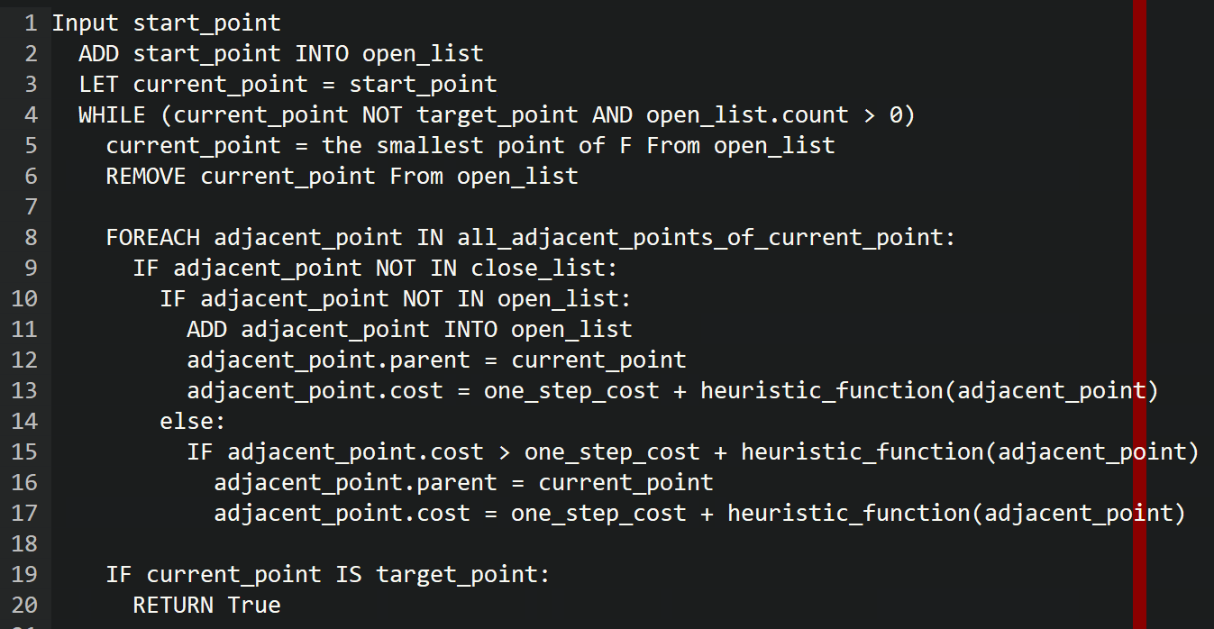
- Simulated Annealing
The simulated annealing algorithm is based on the principle of solid annealing, where a solid is heated to a sufficiently high temperature and then allowed to cool slowly, with the particles inside the solid becoming disordered as the temperature rises and the internal energy increasing, while the particles gradually become ordered as they cool, reaching equilibrium at each temperature and finally reaching the ground state at room temperature, where the internal energy is reduced to a minimum.
The process of simulated annealing is to find the global optimum of the objective function randomly in the solution space by starting from a high initial temperature and decreasing the temperature parameter, combined with certain probabilistic jump properties, i.e. the local optimum solution can probabilistically jump out and eventually converge to the global optimum.
The probability calculation here follows the Metropolis criterion and is used to determine whether to accept a new solution. The flow chart of the algorithm is shown in Figure 2 below.
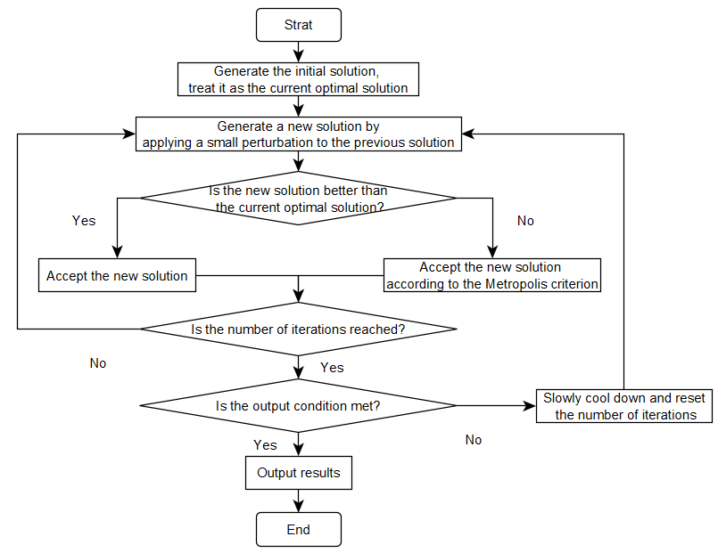
Figure 2
The pseudo-code is as follows (Figure 3)：
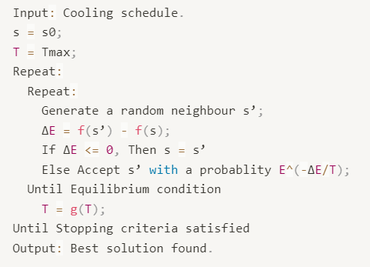
Figure 3
There are several very critical parameters in simulated annealing and their impact on the algorithm and their choice in the Rubik's Cube is analysed as follows.
1. Annealing start and end temperatures: determine the initial solution and end conditions of the algorithm. The higher the starting temperature, the easier it is to receive poor solutions and the greater the randomness of state jumps. The termination temperature determines the bottom line of convergence when the algorithm is about to stop. Generally the termination temperature is one thousandth of the starting temperature or less. After several tests, we found that the starting temperature did not have a significant effect on the solution of the algorithm in 1, 5, 10 and 100, and that at smaller starting temperatures the algorithm was able to reduce the computation time. We therefore chose a starting temperature of 1 and an ending temperature of 0.000000001.
2. Cooling rate: the smaller the value of cooling rate, the faster the cooling rate, but if it is set too small, the algorithm will not have time to fully find the best. We have chosen 0.99 as the cooling rate. In particular, we set an additional parameter for the cooling rate, also 0.99, so that as the temperature drops, the cooling rate also drops, which speeds up the convergence of the algorithm.
3. Number of iterations: controls the adequacy of the algorithm's search for the optimal solution. Theoretically, more iterations can make the search for the optimal solution more adequate. When the number of iterations increases to a certain number, the result may have reached stability, but there is still some time before the end of the algorithm. Based on the characteristics of the Rubik's Cube, we choose 10000 as the maximum number of iterations. If the algorithm does not cool down to below the termination temperature within the number of iterations, the algorithm is terminated as a condition and the output is "can not find the solution".
- Q-learning
Q Learning is a model-free algorithm in reinforcement learning. The main idea of the algorithm is to construct a Q-values table based on all states and actions, where the Q-values represent the benefits that can be obtained by taking action A in a particular state S. According to the Q-values table, the action with the greatest benefit can be selected.
Initially, all Q values in the Q-value table are zero. For each round (episode), from the initial state, the action is selected based on an ε-greedy strategy, with a probability of ε to select the action randomly and a probability of (1 - ε) to select the action with the highest Q value. Based on the selected action, the reward of reaching the next state is calculated and the Q-value of the corresponding (state, action) is updated. When the target state is reached, the round (episode) is finished and goes to the next round (episode).
The pseudo code is as follow (Figure 4):
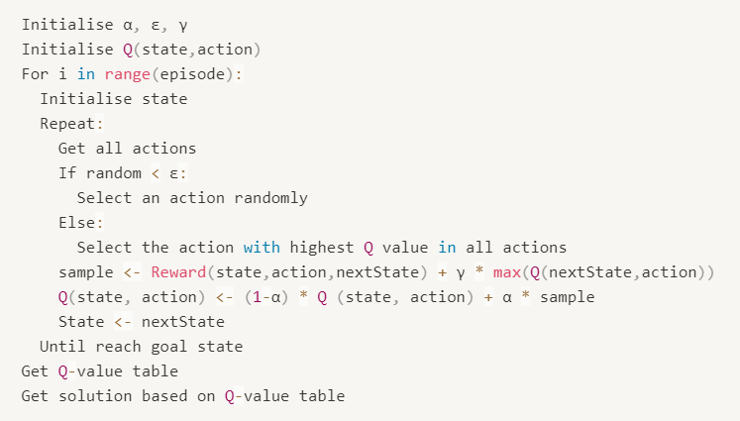
Figure 4
The parameters to be considered in this algorithm are the learning rate α, the epsilon greedy ε and the discount factor γ.
1． The learning rate is a parameter that weighs the previous learning results against the current learning results. If the learning rate is set too small, it will cause the agent to care much about the previous learning results and ignore the new reward. In this experiment, the learning rate was set to 0.5, in order to balance the previous learning with the new rewards.
2． The role of ε is a trade-off between exploration and exploitation. The higher the value of ε, the higher the probability that the agent will try a random action and be exposed to more states. The lower the value of ε, the greater the probability that the agent will choose an action based on the Q-value table it has already learned, which may lead to an error in the solution or failure to find the solution. In this experiment, ε was set to 0.2, which allows the agent to explore more states to some extent and focus on the Q-value table.
3． The role of the discount factor γ is to control the degree of influence of future rewards. If the value of γ is too small, the rewards of the target state cannot be spread and may cause the agent to fail to learn a solution that reaches the target state. In this experiment, γ was set to 0.9, which allowed future rewards to be fully considered.
- Genetic Algorithm
Genetic algorithm is a classic heuristic algorithm. It inherits excellent genes by simulating the evolutionary process of organisms: replication, crossover, mutation, etc. It is characterized by relatively strong global search ability. Algorithms are widely used in combinatorial optimization, machine learning, and signal processing.
At the beginning of the algorithm, a population will be selected, and then the computer will select some of the better genes, replicate and spread to the entire population, while eliminating the relatively weak genes. The variation of genes helps to maintain the diversity of the population and help to get out of the local optimal solution.
4 Experimental Results
This section should provide the details of the evaluation. Specifically: For the four algorithms selected, the following evaluation criteria were developed:
The same test cases were executed for all algorithms, with each test case containing an increasing number of random disruptions from 1-10. Each algorithm was then run 10 times in each case to see if the algorithm was able to restore the cube, and the success rate of the algorithm was calculated statistically.
If the success rate of an algorithm is greater than 0, we calculate the average number of steps used to solve the algorithm.
If an algorithm has a success rate equal to 0, we consider the algorithm to be limited and look for the cause of this result.
If more than one algorithm is able to restore the cube in the same case, then we consider the algorithm with the lower average number of steps used to be superior.
In the following, we present the test results for each of these algorithms.
- star
The performance of the A-star search algorithm is evaluated by the solution time. Since the A-star algorithm solves for the shortest path, the test result will always be less than or equal to the number of times the cube was initially twisted, and the search effect directly influences the reduction effect, so the time taken to reduce is chosen as the evaluation criterion.
The cube can be restored if the initial state of the cube has been twisted less than or equal to 7 times.
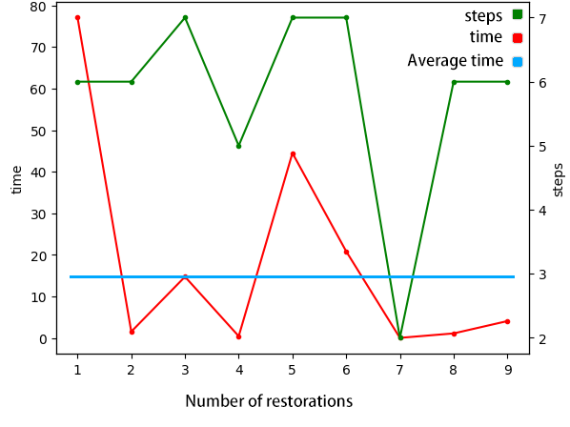
Figure 4.1
Discussion: The A-star algorithm solves the Rubik's Cube problem by selecting the node with the lowest current arrival cost and calculating 21 different next states and calculating the arrival cost of the next state, which is determined by adding up the cost of each step and the heuristic function.
The advantage of A-star is that it will find the least reduction method. In contrast to the Q-leaning algorithm, A-star does not calculate all states before reaching the destination at the beginning but rather starts the next search by continuously finding the nodes that are most necessary for the search.
The disadvantage is that as the number of times the cube is initially twisted increases, the time required to restore it increases more quickly, so it is not as fast as the genetic algorithm when solving more complex cases.
In contrast to genetic algorithms, the cost of each step of the A-star calculation is greatly influenced by the heuristic function, which can seriously affect the selection of nodes when the distance between the current position and the target position cannot be effectively estimated, thus seriously affecting the search results. For example, in the problem of restoring a Rubik's cube, the 21 different states can be interpreted as a point in a two-dimensional plane, which can move in 21 different directions in the next step, but once it moves four steps in any direction, it returns to the origin, which is very different from the motion of a point in a typical Cartesian coordinate system, and therefore cannot be evaluated by If the heuristic function is evaluated by the number of small squares in the correct position, this is valid when the number of initial moves is small, but as the number of moves increases, the confusion of the imitation stabilises, but the difficulty of restoration continues to increase, and the heuristic function cannot be evaluated accurately, which is a weakness of A-star.
- Simulated annealing
The test results are shown below. Figure 3 shows the success rate of the simulated annealing algorithm after disrupting 1-10 times.
As can be seen from the graph, the overall success rate of the algorithm tends to decrease as the complexity of the initial state of the tesseract increases. However, up until the number of disrupted rotations of the tesseract is 10, there is still a 30% probability that the simulated annealing can be solved.
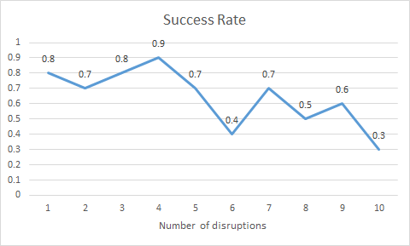
Figure 3
Figure 4 shows the average number of steps required by the algorithm for a successful restoration of the Rubik Cube.
As can be seen from the graph, the overall trend in the number of steps required to solve the problem increases as the complexity of the initial state of the tesseract increases, although it still has a large fluctuation. This is because the simulated annealing algorithm itself contains Metropolis, so there is some randomness in how many steps the algorithm requires. It is possible that simulated annealing will use more steps to solve a simple disrupted state, or it may use fewer steps to find a solution quickly.
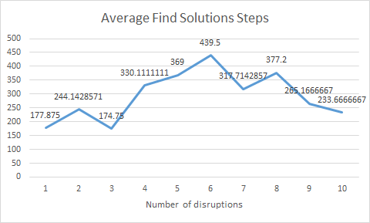
Figure 4
- Genetic algorithm

- Q Learning
For the Q Learning algorithm, our experimental results is that the algorithm is not suitable for solving the Rubik's Cube problem. The reason is that the Rubik's Cube has too many states and actions, which would make the Q-value table too large. Although we tried to include the Rubik's Cube restore formula to reduce the number of intermediate states, we were ultimately unable to achieve the construction of the Q-value table (after 24 hours of learning, the agent still could not reach the target state and complete the first round of Q-value table updating).
5 Conclusions
Q Learning is not suitable for solving Rubik's Cube restoration problems, due to the excessive number of total states and actions. Further, we may attempt to improve Q Learning into Approximate Q Learning, which generalises states that share the same features by the feature function, thus allowing for a reduction in the number of states stored in the Q-value table. This would speed up the construction of the Q-value table.

It has been observed experimentally that the A-star algorithm can solve the Rubik's Cube problem if the level of confusion is not too high. The reason for not being able to restore the cube after the level of confusion has stabilised is that the heuristic function uses the correct rate at which the cube is restored, and when the level of confusion has stabilised, the heuristic function does not correctly evaluate the correct rate, regardless of the direction of the cube's next state. A possible improvement would be to modify the way in which the degree of confusion is evaluated, for example, by making the correctness rate the sum of the distances of each piece from its starting position.
References
- Stephen McAleer, Forest Agostinelli, Alexander Shmakov, Pierre Baldi: Solving the Rubik's Cube Without Human Knowledge. https://doi.org/10.48550/arXiv.1805.07470
- F. Agostinelli, S. McAleer, A. Shmakov, and P. Baldi, “Solving the Rubik’s cube with deep reinforcement learning and search,” Nature Machine Intelligence, Jul. 2019, doi: 10.1038/s42256-019-0070-z.
- S. Corli, L. Moro, D. Galli, and E. PRATI, “Solving Rubik’s Cube via Quantum Mechanics and Deep Reinforcement Learning,” Journal of Physics A: Mathematical and Theoretical, Sep. 2021, doi: 10.1088/1751-8121/ac2596.
- S. Saeidi, Solving the Rubik’s Cube using Simulated Annealing and Genetic Algorithm, International Journal of Education and Management Engineering, vol. 8, no. 1, pp. 1–10, Jan. 2018, doi: 10.5815/ijeme.2018.01.01.
- 5. Goodrich, Michael T., Roberto Tamassia, and Michael H. Goldwasser. Data structures and algorithms in Python. John Wiley & Sons Ltd, 2013.
- 6. Liu, Xiang, and Daoxiong Gong. "A comparative study of A-star algorithms for search and rescue in perfect maze." In 2011 international conference on electric information and control engineering, pp. 24-27. IEEE, 2011.
APPENDIX
ACTIONS:
All 27 rotation actions:
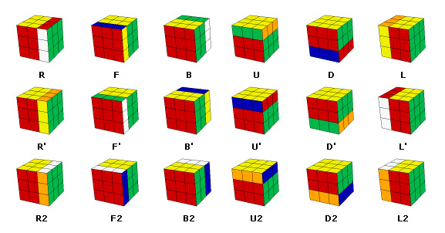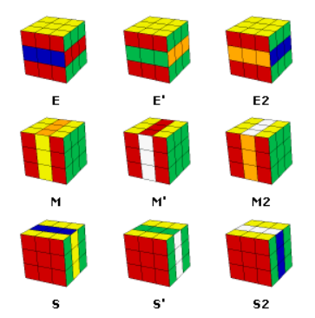
Tumbling actions samples：
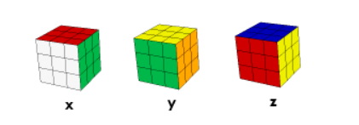
PERMUTATIONS List:
# permutes two edges: U face, bottom edge and right edge
F' L' B' R' U' R U' B L F R U R' U
# permutes two edges: U face, bottom edge and left edge
F R B L U L' U B' R' F' L' U' L U'
# permutes two corners: U face, bottom left and bottom right
U2 B U2 B' R2 F R' F' U2 F' U2 F R'
# permutes three corners: U face, bottom left and top left
U2 R U2 R' F2 L F' L' U2 L' U2 L F'
# permutes three centers: F face, top, right, bottom
U' B2 D2 L' F2 D2 B2 R' U'
# permutes three centers: F face, top, right, left
U B2 D2 R F2 D2 B2 L U
# U face: bottom edge <-> right edge, bottom right corner <-> top right corner
D' R' D R2 U' R B2 L U' L' B2 U R2
# U face: bottom edge <-> right edge, bottom right corner <-> left right corner
D L D' L2 U L' B2 R' U R B2 U' L2
# U face: top edge <-> bottom edge, bottom left corner <-> top right corner
R' U L' U2 R U' L R' U L' U2 R U' L U'
# U face: top edge <-> bottom edge, bottom right corner <-> top left corner
L U' R U2 L' U R' L U' R U2 L' U R' U
# permutes three corners: U face, bottom right, bottom left and top left
F' U B U' F U B' U'
# permutes three corners: U face, bottom left, bottom right and top right
F U' B' U F' U' B U
# permutes three edges: F face bottom, F face top, B face top
L' U2 L R' F2 R
# permutes three edges: F face top, B face top, B face bottom
R' U2 R L' B2 L
# H permutation: U Face, swaps the edges horizontally and vertically
M2 U M2 U2 M2 U M2

