**If you have any questions, please contact zheng.xiangyu.2020@mumail.ie**

1. Download IntelliJ IDEA from <https://www.jetbrains.com/idea/>
2. Download JDK1.8 and configure environment variables
3. Download apache-maven-3.6.3.rar from <https://gitlab.cs.nuim.ie/u210251/cs335-surveys_maker/tree/zhengxiangyu2> and unzip the file.
4. Create a folder for maven repository
5. **Idea environment configuration**

Open the IntelliJ IDEA and Configure maven environment

Click File-settings in the upper left corner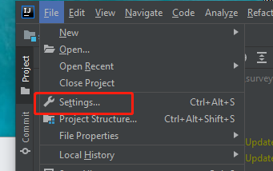

Enter maven in the search box. Click maven.

Set the maven home path to the folder after decompressing apache-maven-3.63.rar just now

Set the user settings file to conf/setting.xml under apache-maven-3.63 just now

Set the local repository to the folder just created for the maven repository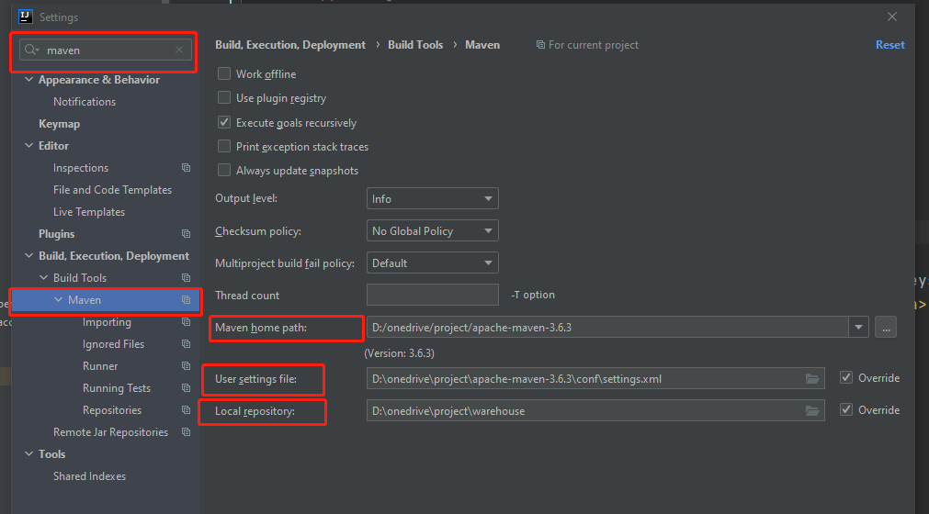

1. Download the source code from <https://gitlab.cs.nuim.ie/u210251/cs335-surveys_maker/tree/zhengxiangyu2> and click File-open in the upper left corner. Find the code you just downloaded and open it
2. Configure the project jdk environment. Click File-project structure in the upper left corner, click SDKs, click the + sign, click add JDK to select the location where the second JDK1.8 is decompressed

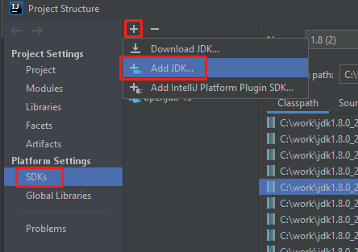

1. Find the project directory on the left, if your pom.xml file is red, right-click and click "add as maven project"

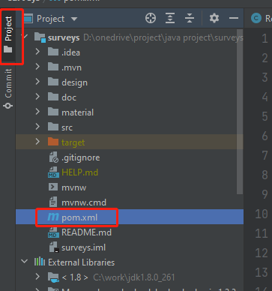

1. Find the maven directory on the right, click the surveys-project name, and click the refresh button. At this time, idea will automatically download the jar package it depends on

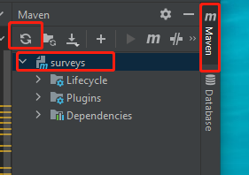

1. **Start the project.**

At this time, the project should have no red line and error. Open the src/main/java/com/surveys/SurveysApplication file under the selected project. Right-click on the main method and click run'surveysApplication'. After a few seconds, the project will start up, and then enter'localhost:8080/surveys/surveys-detail' in the browser input box. You can see the page. If you have any questions, please contact [zheng.xiangyu.2020@mumail.ie](mailto:zheng.xiangyu.2020@mumail.ie)

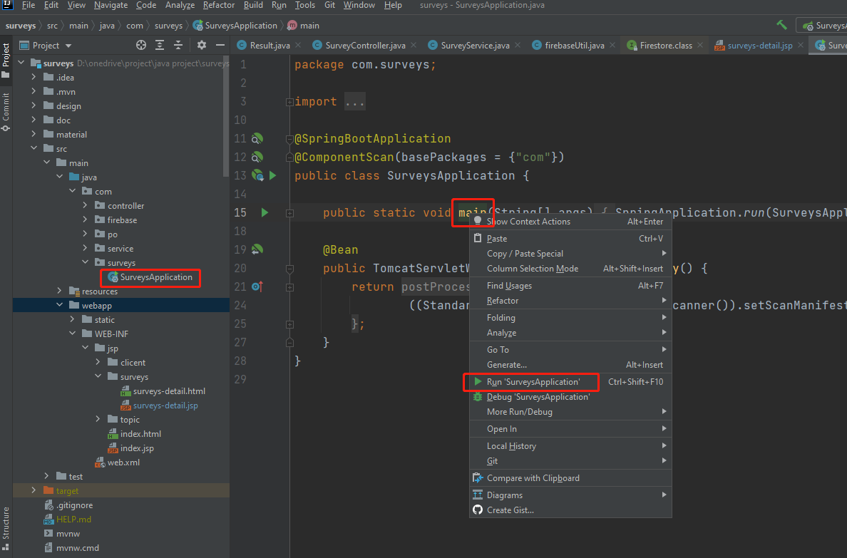

1. **Project development.**

The front-end files are all under webapp/WEB-INF/jsp/, ending with a .jsp file

The back-end files are all under src/main/java/com/

You can refer to

1.webapp/WEB-INF/jsp/surveys-detail.jsp

2.src/main/java/com/controller/SurveyController

3.src/main/java/com/service/SurveyService

This is a complete development process

1. **Hot deployment (you don't need to restart the project to see the changes after the jsp page is changed)**

Step 1: Open IDEA, select File→Settings→Build, Execution, Deployment→Compiler, check Build project automatically, and click OK. As shown below.

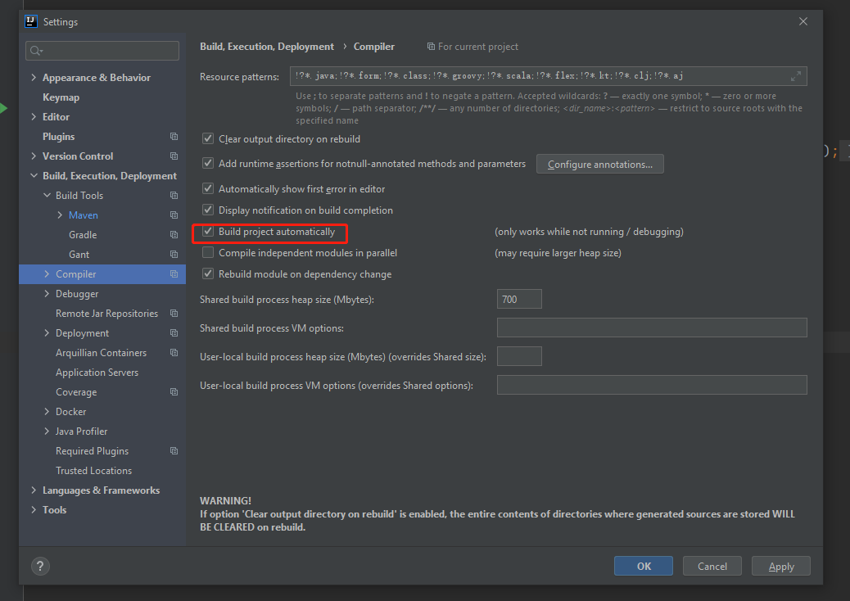

Step 2: Use the shortcut key Ctrl + Shift + A to search for commands in IDEA, enter registry, select the first one, and check compiler.automake.allow.when.app.running.

1. **Code submission**

The first step is to download git from https://git-scm.com/downloads and install

The second step, click file-settings, enter git in the search box. Find the location of git.exe on your computer in Path to git executable

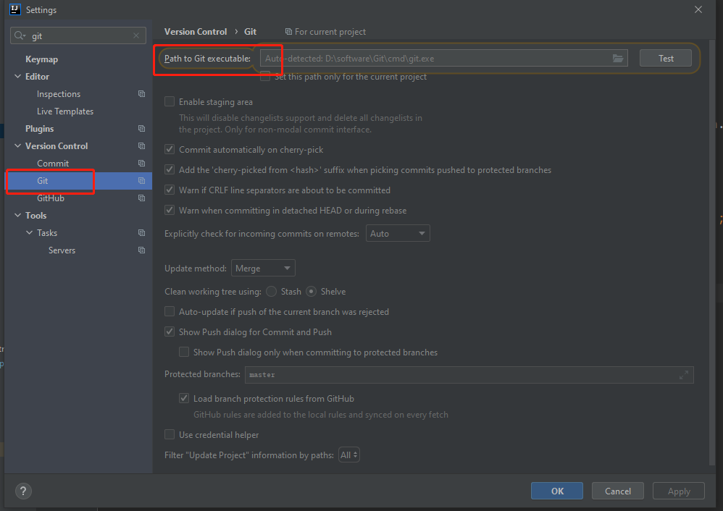

The third step, click on the project to put VCS. Click Create Git Repository. Select the location of your project.

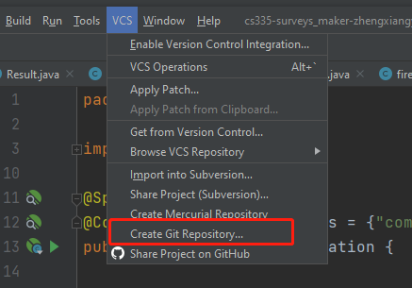

the fourth step. Click the Git button above, and click manage remotes..

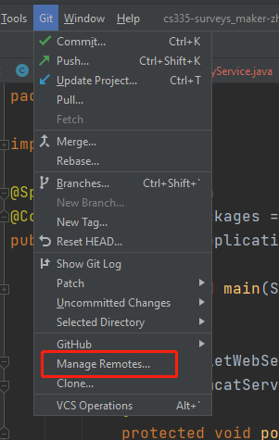

The fifth step, copy the clone link in the gitlab(https://gitlab.cs.nuim.ie/u210251/cs335-surveys_maker) project to the location of the url in the idea

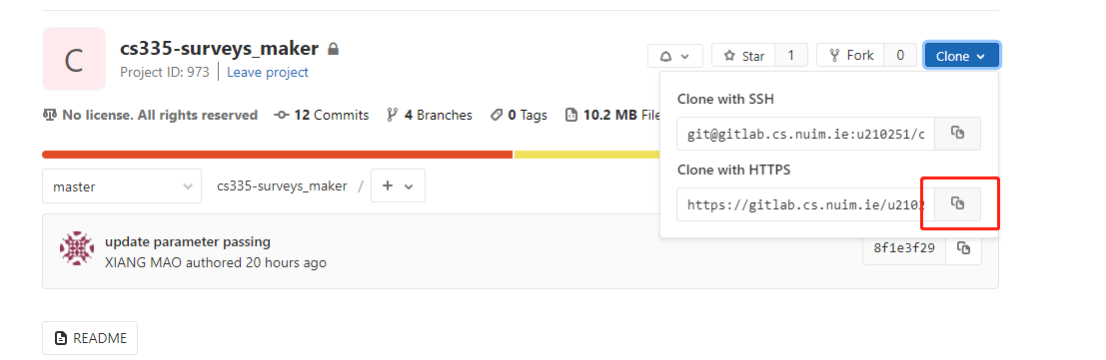

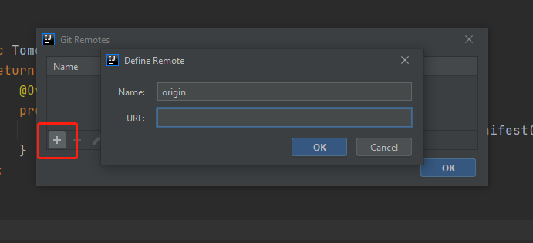

Click OK

At this time, you can find the git branch information at the bottom right of the idea

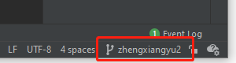

Create your own branch

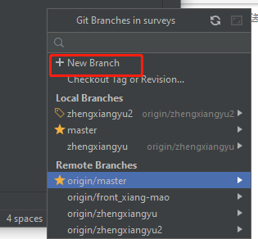

**Pull the master branch every time you want to submit the code**

**Select your project and right click, git- pull**

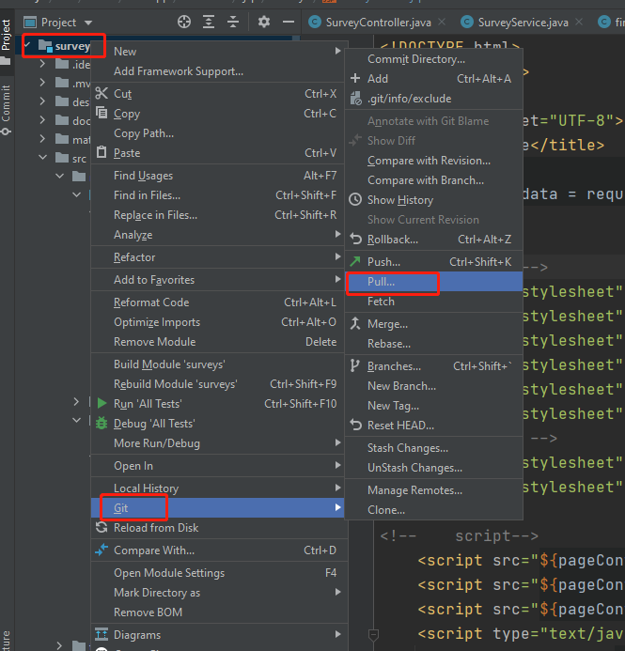

Select the master branch, click pull

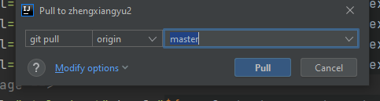

**Code submission**

When you change the code and different with the master branch, the file always shows blue.

Select your project and right click -git-commit directory, Enter your remarks, then click commit, and then it will be stored in your local code warehouse

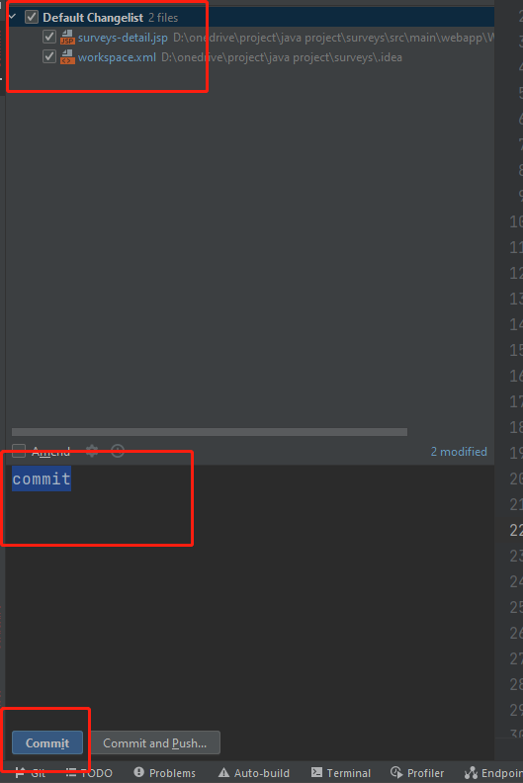

**Select your project, right click -Git-push,**

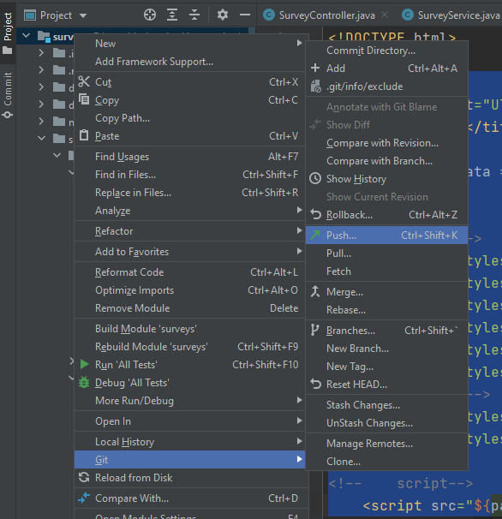

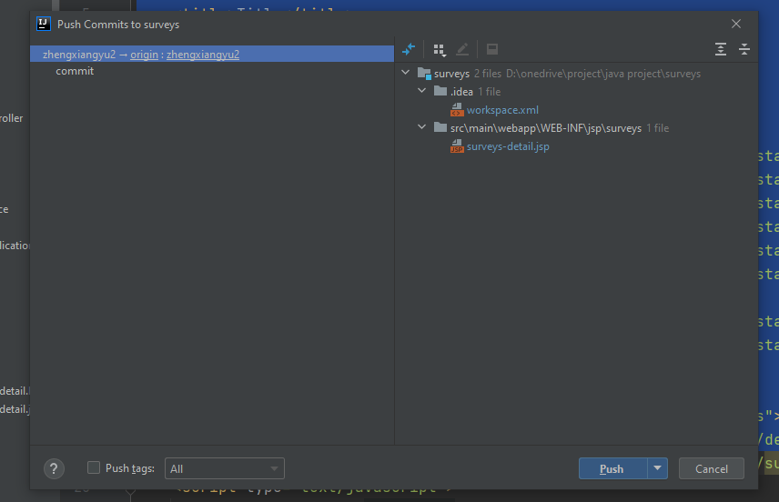

**Select your own branch, click push, and the gitlab remote warehouse will be submitted. If you need to merge into the master branch, please contact xiang.mao.2021@mumail.ie. If you have any questions, please contact zheng.xiangyu.2020@mumail.ie**