网安“计算机安全与保密技术”课程
实验报告
姓名 | 王波 |  | 学号 | 19122557 | 院系 |  | 计算机学院
课程号 | 08A65002 |  | 任课教师 | 戴佳筑 | 指导教师 |  | 戴佳筑
实验地点 | 计算机大楼704 |  |  | 实验时间 | 2021.1.7
出勤、表现得分  （10分） |  | 实验结果得分  （50分） |  | 实验报告得分  （40分） |  | 实验总分

实验五 Linux防火墙实验
- 实验目的：深入理解防火墙的工作原理。

- 实验环境:
软件：SEED Labs安全实验平台

- 实验内容：使用Linux中的防火墙；开发一个简单的防火墙；避开防火墙的过滤功能。
- 实验步骤
- 使用LKM和Netfilter分别实现一个简单的防火墙
TaskA：
内核：
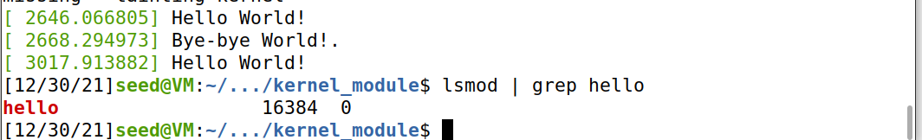
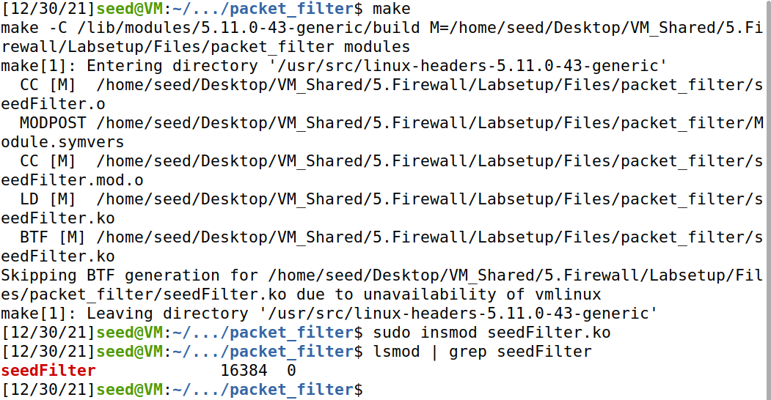
开启：
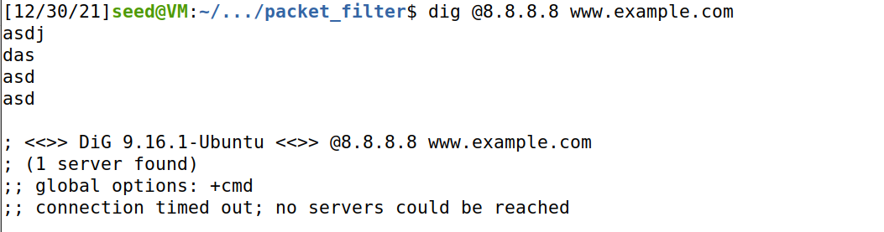
关闭：
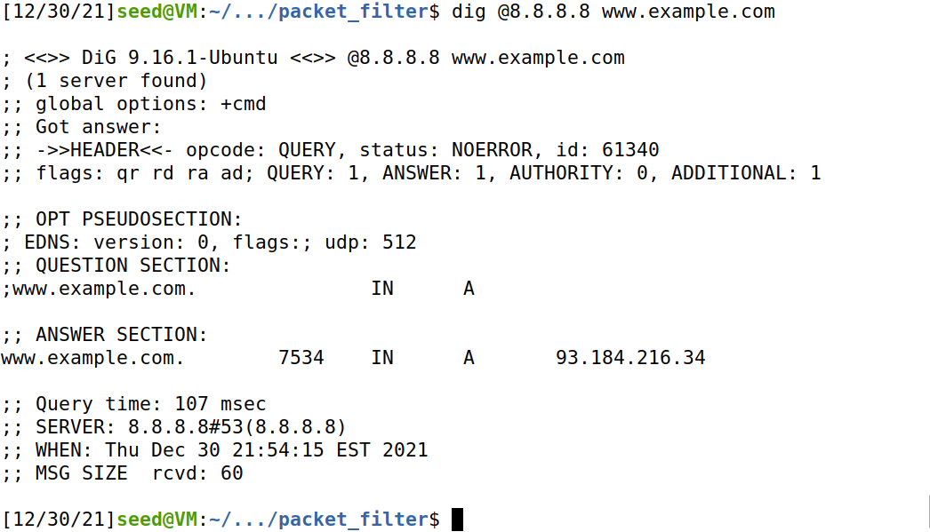
Task2：
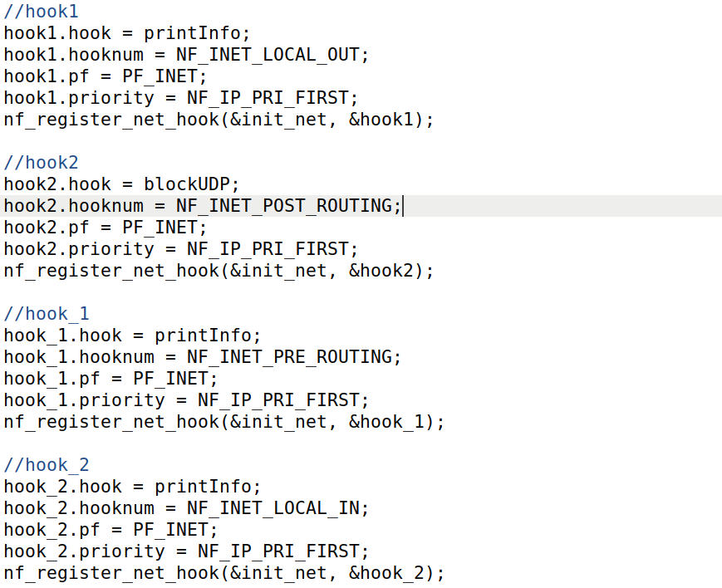
一个钩子，注册多个钩子函数。
hook点选择LOCAL_IN
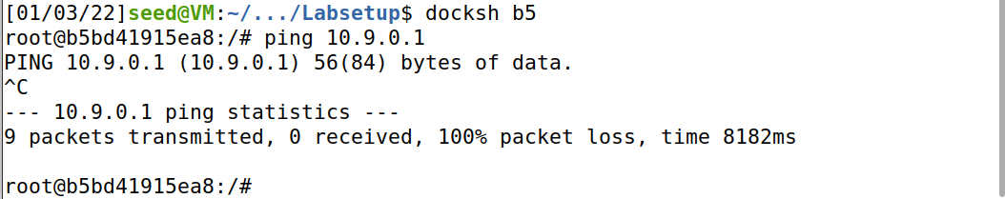
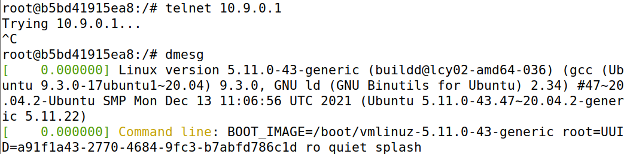
2.使用Linux自带的iptables建立防火墙
TaskA：INPUT 和 OUTPUT 的默认 policy 为 DROP，仅仅对于ICMP可行，对于ping可以，但是无法telnet到seed-router
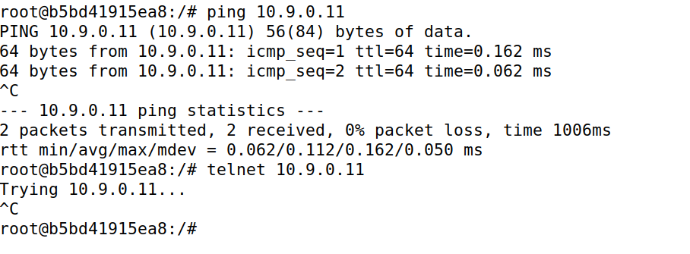
TaskB: 要实现路由器所连的两网的相互隔离，仅允许内部主机ping 外部主机，需要添加FORWARD规则，用 -i/-o 参数指定来去的设备名，需注意icmp request 和 reply 双向各自要 ACCEPT。
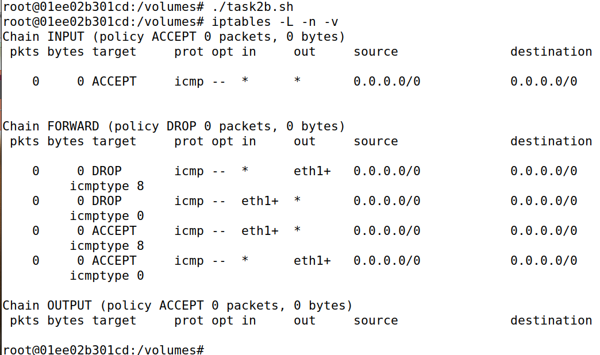
TaskC: 要实现外部仅能访问内网中指定主机上的telnet服务，还是添加FORWARD规则，用-d指定目标IP，-dport指定目标端口号，仍然需要注意双向ACCEPT
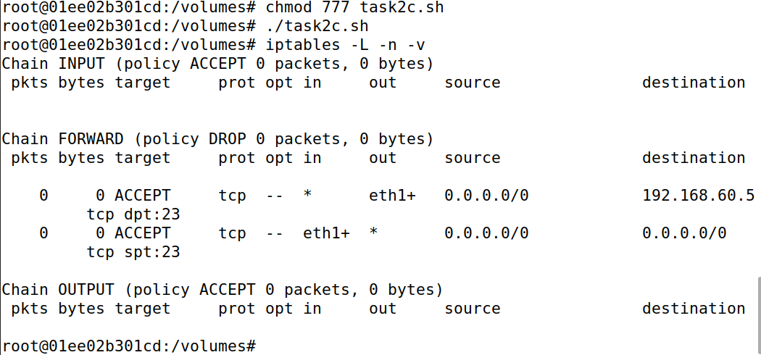
- 记录链接及建立状态防火墙
TaskA：
测试ICMP,UDP,TCP链接状态
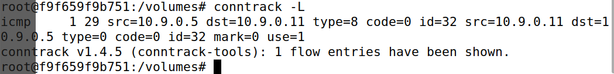
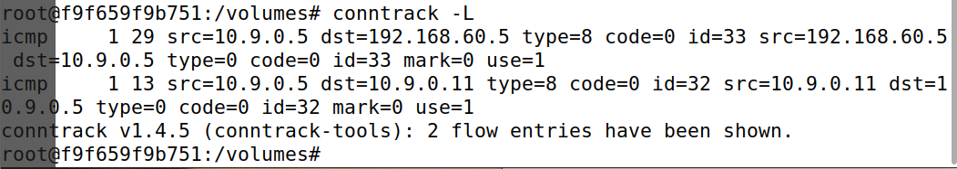
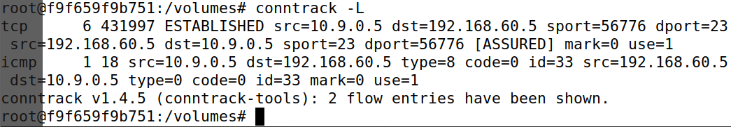
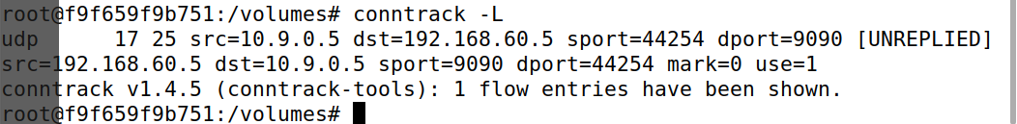
ICMP和UDP都是无连接的，conntrack中状态持续时间约为30秒。
TCP在连接ESTABLISHED后，状态持续时间为432000秒，断开连接进入TIME_WAIT状态，持续时间为120秒。
TaskB：
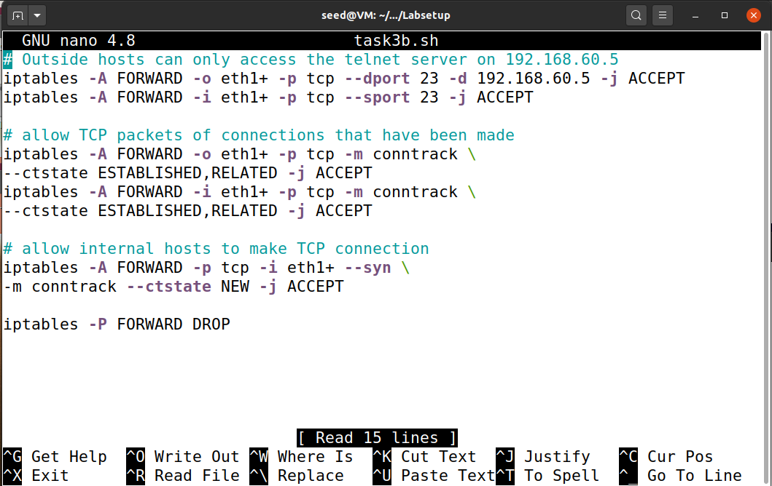
Task 2.C中的防火墙规则，但这一次，我们将添加一条允许内部主机访问任何外部服务器的规则。使用conntrack模块，只放行新的TCP SYN包和已有TCP连接的数据包，否则无法确定需要放行哪些传入内网的数据包。
- 限制网络数据传输
使用limit在放行请求时设置频率和连续次数。
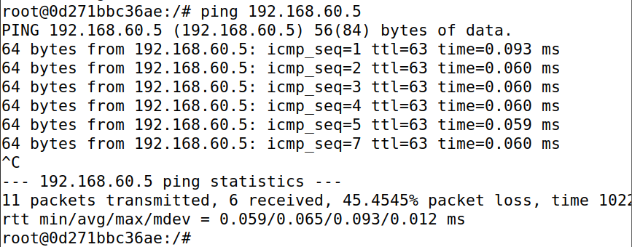
下面表示未设置DROP
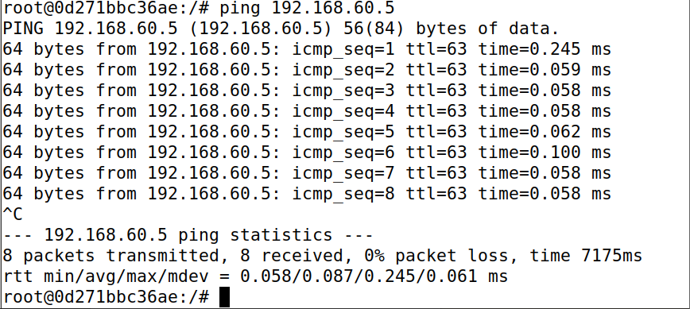
- 负载平衡
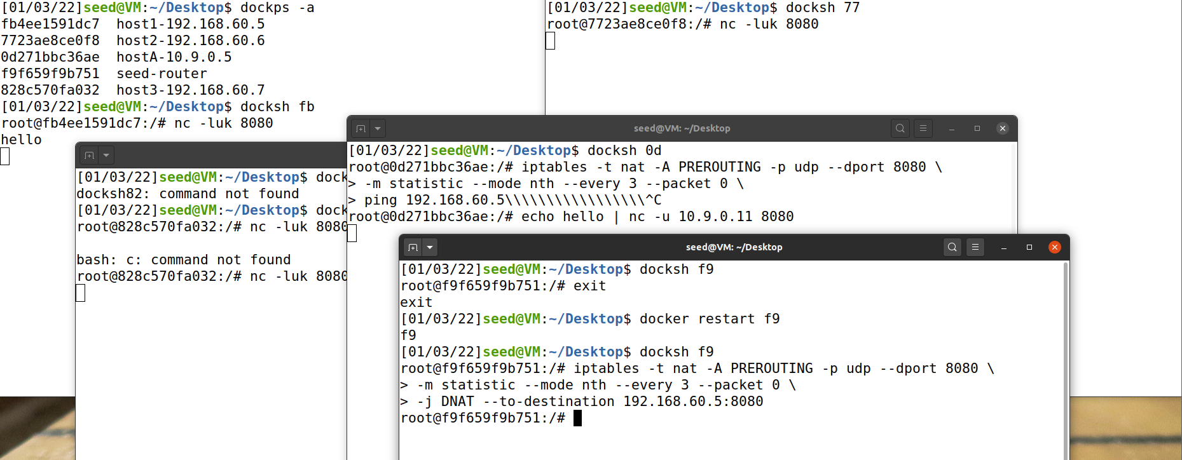
使用statistic模块负载均衡，使用-j DNAT --to-destination ip:port指定负载均衡目标，由于是UDP所以只用改destination。
-P 表示概率。
附相应的源程序清单（加注释）
// Task2a.sh
ptables -A INPUT -p icmp --icmp-type echo-request -j ACCEPT
iptables -A OUTPUT -p icmp --icmp-type echo-reply -j ACCEPT
iptables -P OUTPUT DROP # Set default rule for OUTPUT
iptables -P INPUT DROP # Set default rule for INPUT
// Task2b.sh
# Outside hosts cannot ping internal hosts on eth1(192.168.60.0/24)
iptables -A FORWARD -p icmp --icmp-type echo-request -o eth1+ -j DROP
iptables -A FORWARD -p icmp --icmp-type echo-reply -i eth1+ -j DROP

# Outside hosts can ping the router
iptables -A INPUT -p icmp -j ACCEPT

# Internal hosts in eth1(192.168.60.0/24) can ping outside hosts
iptables -A FORWARD -p icmp --icmp-type echo-request -i eth1+ -j ACCEPT
iptables -A FORWARD -p icmp --icmp-type echo-reply -o eth1+ -j ACCEPT

# block all other packets between internal and external networks
iptables -P FORWARD DROP
# block all other packets between internal and external networks
iptables -P FORWARD DROP
// Task2c.sh
# Outside hosts can only access the telnet server on 192.168.60.5
iptables -A FORWARD -o eth1+ -p tcp --dport 23 -d 192.168.60.5 -j ACCEPT
iptables -A FORWARD -i eth1+ -p tcp --sport 23 -j ACCEPT

iptables -P FORWARD DROP
// Task3c.sh
# Outside hosts can only access the telnet server on 192.168.60.5
iptables -A FORWARD -o eth1+ -p tcp --dport 23 -d 192.168.60.5 -j ACCEPT
iptables -A FORWARD -i eth1+ -p tcp --sport 23 -j ACCEPT

# allow TCP packets of connections that have been made
iptables -A FORWARD -o eth1+ -p tcp -m conntrack \
--ctstate ESTABLISHED,RELATED -j ACCEPT
iptables -A FORWARD -i eth1+ -p tcp -m conntrack \
--ctstate ESTABLISHED,RELATED -j ACCEPT

# allow internal hosts to make TCP connection
iptables -A FORWARD -p tcp -i eth1+ --syn \
-m conntrack --ctstate NEW -j ACCEPT

iptables -P FORWARD DROP
// seedFilter.c
#include <linux/in.h>
#include <linux/kernel.h>
#include <linux/module.h>
#include <linux/netfilter.h>
#include <linux/netfilter_ipv4.h>
#include <linux/ip.h>
#include <linux/tcp.h>
#include <linux/udp.h>
#include <linux/if_ether.h>
#include <linux/inet.h>

static struct nf_hook_ops hook1, hook2, hook3, hook4;
static struct nf_hook_ops hooks[NF_INET_NUMHOOKS];

unsigned int blockUDP(void *priv, struct sk_buff *skb,
const struct nf_hook_state *state)
{
struct iphdr *iph;
struct udphdr *udph;

u16 port = 53;
char ip[16] = "8.8.8.8";
u32 ip_addr;

if (!skb) return NF_ACCEPT;

iph = ip_hdr(skb);
// Convert the IPv4 address from dotted decimal to 32-bit binary
in4_pton(ip, -1, (u8 *)&ip_addr, '\0', NULL);

if (iph->protocol == IPPROTO_UDP) {
udph = udp_hdr(skb);
if (iph->daddr == ip_addr && ntohs(udph->dest) == port){
printk(KERN_WARNING "*** Dropping %pI4 (UDP), port %d\n", &(iph->daddr), port);
return NF_DROP;
}
}
return NF_ACCEPT;
}

unsigned int blockPing(void *priv, struct sk_buff *skb,
const struct nf_hook_state *state)
{
struct iphdr *iph;

if (!skb) return NF_ACCEPT;

iph = ip_hdr(skb);

if (iph->protocol == IPPROTO_ICMP) {
printk(KERN_WARNING "*** Dropping ICMP from %pI4 to %pI4\n", &(iph->saddr), &(iph->daddr));
return NF_DROP;
}
return NF_ACCEPT;
}

unsigned int blockTelnet(void *priv, struct sk_buff *skb,
const struct nf_hook_state *state)
{
struct iphdr *iph;
struct tcphdr *tcph;
u16 port = 23;

if (!skb) return NF_ACCEPT;

iph = ip_hdr(skb);

if (iph->protocol == IPPROTO_TCP) {
tcph = tcp_hdr(skb);
if (ntohs(tcph->dest) == port) {
printk(KERN_WARNING "*** Dropping Telnet from %pI4:%d to %pI4:%d\n", &(iph->saddr), ntohs(tcph->source), &(iph->daddr), port);
return NF_DROP;
}
}
return NF_ACCEPT;
}

unsigned int printInfo(void *priv, struct sk_buff *skb,
const struct nf_hook_state *state)
{
struct iphdr *iph;
char *hook;
char *protocol;

switch (state->hook){
case NF_INET_LOCAL_IN: hook = "LOCAL_IN"; break;
case NF_INET_LOCAL_OUT: hook = "LOCAL_OUT"; break;
case NF_INET_PRE_ROUTING: hook = "PRE_ROUTING"; break;
case NF_INET_POST_ROUTING: hook = "POST_ROUTING"; break;
case NF_INET_FORWARD: hook = "FORWARD"; break;
default: hook = "IMPOSSIBLE"; break;
}
printk(KERN_INFO "*** %s\n", hook); // Print out the hook info

iph = ip_hdr(skb);
switch (iph->protocol){
case IPPROTO_UDP: protocol = "UDP"; break;
case IPPROTO_TCP: protocol = "TCP"; break;
case IPPROTO_ICMP: protocol = "ICMP"; break;
default: protocol = "OTHER"; break;

}
// Print out the IP addresses and protocol
printk(KERN_INFO " %pI4 --> %pI4 (%s)\n",
&(iph->saddr), &(iph->daddr), protocol);

return NF_ACCEPT;
}

int registerFilter(void) {
int i;
printk(KERN_INFO "Registering filters.\n");

// hook1.hook = printInfo;
// hook1.hooknum = NF_INET_LOCAL_OUT;
// hook1.pf = PF_INET;
// hook1.priority = NF_IP_PRI_FIRST;
// nf_register_net_hook(&init_net, &hook1);

hook2.hook = blockUDP;
hook2.hooknum = NF_INET_POST_ROUTING;
hook2.pf = PF_INET;
hook2.priority = NF_IP_PRI_FIRST;
nf_register_net_hook(&init_net, &hook2);

hook3.hook = blockPing;
hook3.hooknum = NF_INET_LOCAL_IN;
hook3.pf = PF_INET;
hook3.priority = NF_IP_PRI_FIRST;
nf_register_net_hook(&init_net, &hook3);

hook4.hook = blockTelnet;
hook4.hooknum = NF_INET_LOCAL_IN;
hook4.pf = PF_INET;
hook4.priority = NF_IP_PRI_FIRST;
nf_register_net_hook(&init_net, &hook4);

for (i = 0; i < NF_INET_NUMHOOKS; i++) {
hooks[i].hook = printInfo;
hooks[i].hooknum = i;
hooks[i].pf = PF_INET;
hooks[i].priority = NF_IP_PRI_FIRST;
nf_register_net_hook(&init_net, &hooks[i]);
}

return 0;
}

void removeFilter(void) {
int i;
printk(KERN_INFO "The filters are being removed.\n");
// nf_unregister_net_hook(&init_net, &hook1);
nf_unregister_net_hook(&init_net, &hook2);
nf_unregister_net_hook(&init_net, &hook3);
nf_unregister_net_hook(&init_net, &hook4);
for (i = 0; i < NF_INET_NUMHOOKS; i++) {
nf_unregister_net_hook(&init_net, &hooks[i]);
}
}

module_init(registerFilter);
module_exit(removeFilter);

MODULE_LICENSE("GPL");

